The QDL Installer
QDL has an installer that manages the distribution. It allows for a fresh install, un-install and upgrades. It will install QDL, and it can also manage the syntax highlighting for vim and nano.

Getting it
The installer is always available as qdl-installer.jar from the QDL releases page.

Using it
Once downloaded, it is a standalone, executable jar, so to show the current help issue
java -jar qdlinstaller.jar
QDL installer version …
This will install QDL to your system. Options are:
(none) = same as help
install = install
upgrade = upgrade
… more

starting it with no arguments, displays help. The basic operation is

operation arguments options

where the supported operations are install, upgrade, remove, list and help.

The arguments at this point is a single pair,

-dir root_directory

which specifies the root directory of the install. It is possible to have multiple installs of QDL (though relatively rare). If you have installed it and set your QDL_HOME variable, you should use that.

options are
- -all = all components
- -qdl = QDL only
- -vim = syntax highlighting for vim
- -nano = syntax highlighting for the nano editor, version 4+.

Editors
If you need an older version of nano, there is a qdl.nanorc-2.3.1 file in $QDL_HOME/etc. You should link to that in you ~/.nanorc file.

Note that both nano and vim support simply link to your existing QDL install,, so that upgrades take place automatically once installed. These set the type to *.qdl (qdl script) and *.mdl (module) and invoking either of those editors on one of those file types will turn on syntax highlighting for QDL.

Also, your workspace default editor for QDL buffers will be set to whatever you have chosen. If you have specified both, then the default is set to vim. If you have neither, then the built in line editor will be used. These editor choices only apply to running QDL in a terminal. If you start it in swing mode, then it has its own editor.

Example of editing session in VIM with syntax highlighting enabled.
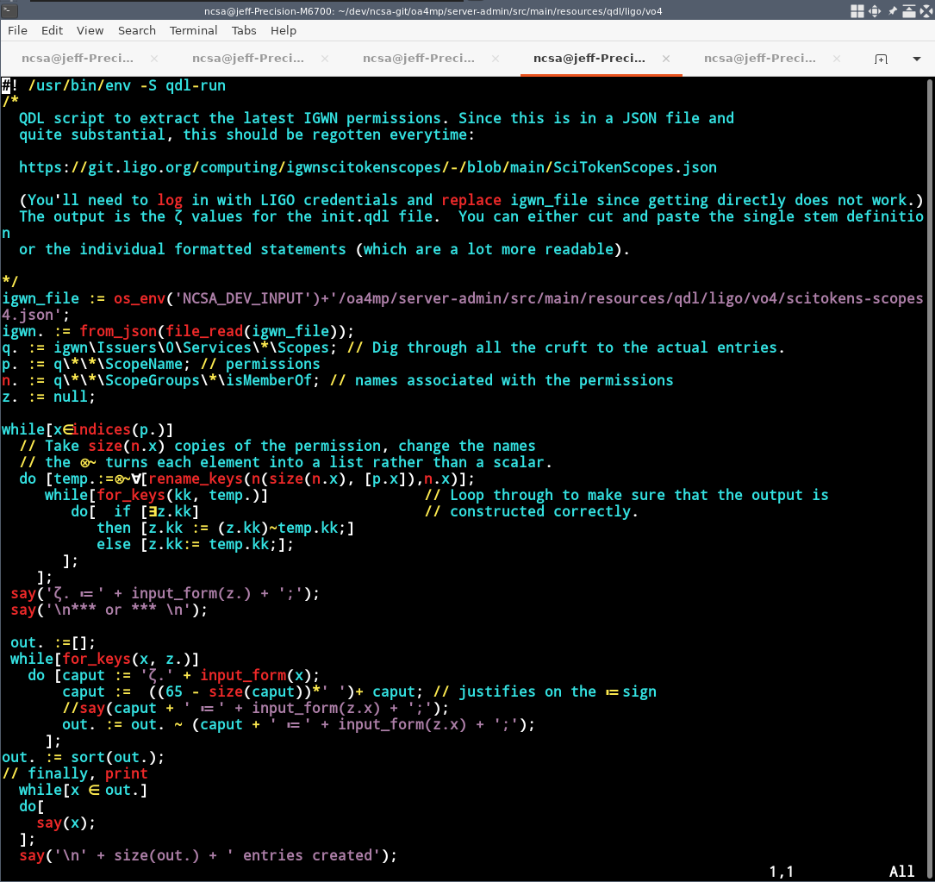

Install
You can install any of the main components, the QDL language and syntax highlighting for vim or nano. The QDL distribution includes a great deal of documentation, various modules and examples.
A typical installation
java -jar qdl-installer.jar install -dir /path/to/qdl -qdl -nano

In which case qdl and support for nano are installed and QDL will be put into the directory /path/to/qdl. Note that if you did not specify the directory, the installer would prompt you.

Upgrade
You may also use this tool to upgrade your current install. So if you have an existing version with everything installed, you might want to issue
java -jar qdl-installer.jar upgrade -dir $QDL_HOME -all

Most files are overwritten except for the cfg-min.xml (default minimal configuration) since it is assumed you may have tinkered with that. Modules, documentation and examples will be replaced.

Remove
You may also remove any component. Note that the -qdl flag will remove everything in the specified directory.

Other operations
You may also pass in the list operation which will list all of the files in the installer’s distribution. In the same way, the operation help will print out the help. Since the installer is just a jar file, if you want to unjar it and pick and choose the distribution, feel free to.

Sample installation
Here is a sample session. It downloads the installer and then sets the actual QDL directory to be a subdirectory (qdl) the current directory ($PWD). It installs all components
>mkdir my_install
>cd my_install
>wget https://github.com/ncsa/qdl/releases/download/v1.6/qdl-installer.jar
. . . bunch of stuff
> ls
qdl-installer.jar (maybe others)
>java -jar qdl_installer.jar install -dir $PWD/qdl -all
QDL installer version 1.6
(. . . bunch of messages)
Done! You should add
export QDL_HOME="/path/to/your/qdl"
to your environment and
$QDL_HOME/bin"
to your PATH

(N.B. /path/to/your/qdl will be the actual install directory for QDL.) So this installs it and vim support. You ought to add $QDL_HOME as a variable to your environment and add $QDL_HOME/bin to your path. The installer will not updated your system configuration (like ~/.bashrc) since it is too easy to make a mistake if it is complex, and trash your system. You have to do this change manually.
Testing QDL
Starting from where the above left off, the simplest way is to go to the QDL directory, henceforth $QDL_HOME, and issue
>cd $QDL_HOME
>bin/qdl
-- -- @ -- / -- @ @ / @ -- @ @
.g8""8q. `7MM"""Yb. `7MMF'
.dP' `YM. MM `Yb. MM
dM' `MM MM `Mb MM
MM MM MM MM MM
MM. ,MP MM ,MP MM ,
`Mb. ,dP' MM ,dP' MM ,M
`"bmmd"' .JMMmmmdP' .JMMmmmmMMM
MMb
`bood'
-- -- @ -- / -- @ @ / @ -- @ @
Welcome to the QDL Workspace
Version 1.6
Type )help for help.
*****************************************
ISO 6429 terminal

If you have set your PATH and QDL_HOME, then you can run scripts from the command line. Here is a test running one of the example scripts.

>cd $QDL_HOME/examples
>./hello_world.qdl
Hello world!

Not surprisingly, this script is the ubiquitous and gratuitous hello world program. If it runs, you can now run QDL scripts like any other scripting language on your system, You should look at the script reference (also qdl_scripting.pdf is included in the $QDL_HOME/docs directory).
Testing your external editor
If you installed, e.g. vim, then you should be able to create a memory buffer and edit it exactly using vim. Once QDL comes up issue
)b create t -m
0|m|t: t
)edit 0

and you should shell out to vim. You can enter QDL commands and they should highlight.

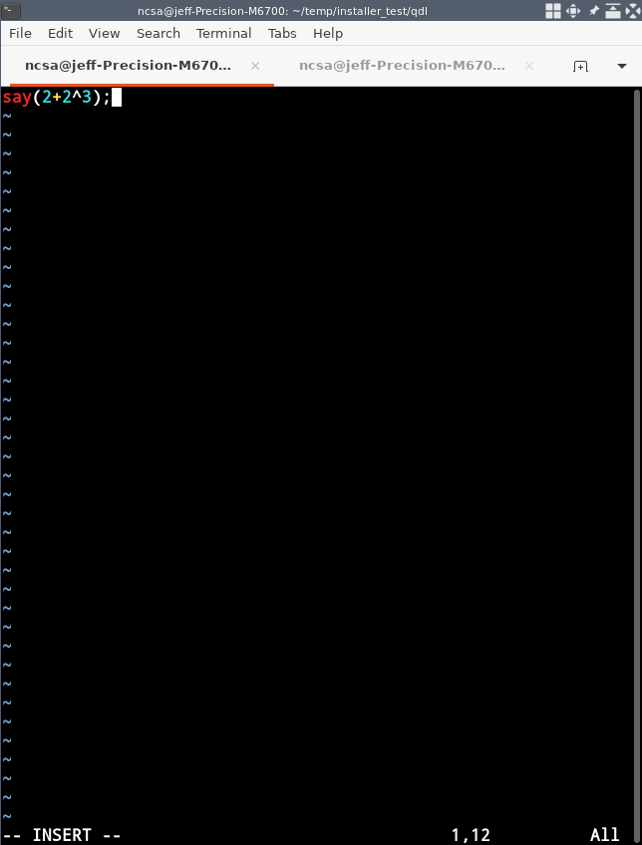

When you save then exit, you will end up back in the workspace and can execute the buffer by issuing

) 0
10

Note that 10 = 2 + 2^3.
Documentation
A standard QDL install includes $QDL_HOME/docs which is an extensive collection of PDFs including the reference manual and pretty much anything else you need. If you are on a reasonably modern unix system, then the command less is usually pdf aware and you can therefore either read the manual at the command line or just bring up the formatted text in a PDF reader.

