QDL’s GUI
Introduction
QDL comes with a built in Swing GUI (Graphical User Interface). This is intended to keep with the philosophy that QDL “just works” out of the box everywhere. As long as your environment supports graphics, it should function. QDL is used heavily for server-side work and these generally have no graphical user environment. As such, the character mode workspace will continue to be the de facto work environment.

Getting started
To invoke the GUI, you simply add the -gui flag to the command line
java -jar qdl.jar -cfg path/to/config.xml -name config_name -gui

And you will be greeted with this
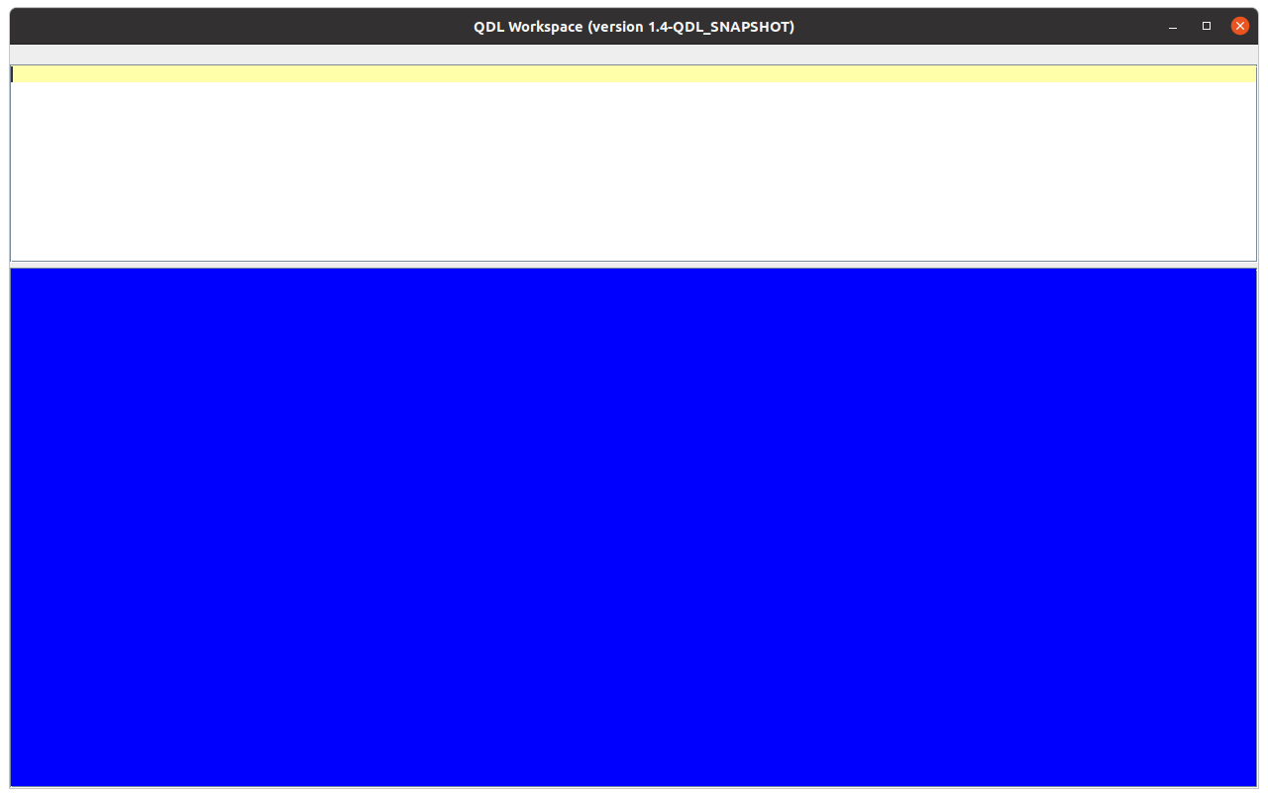
This has an input area (white) and an output area (blue). The output area is not editable, but you can certainly copy things from it. In both areas, highlighting a work and hitting F1 will pop up help for that topic.
The Bottom Line
The usual modus operandi of QDL remain the same: type in QDL expressions or workspace commands, get results. This entire interface just allows for more convenience input. The major innovation is that the line editor is replaced with a much snazzier dedicated QDL editor. Everything in the workspace is still there and everything works the same from the command line. You still make buffers, execute them, etc. Since the input area is now a full fledged QDL-aware , multi-line editor, you will need a lot fewer buffers in practice.

The Input Area
This supports (unlike the command line version) multiple lines and statements. Simply type as per normal. To execute, enter ctrl+enter. The result will display in the blue area.
The input area supports
- QDL’s keyboard (view mappings with )help keyboard)
- syntax highlighting
- auto complete (type ctrl+space)
- auto-indent and parenthesis/bracket matching.
- local clipboard history (ctrl+shift+v)
It should be noted that the syntax highlighting could be better. This is because ideally every keystroke would run the entire input through the lexer and pick it apart, but that makes performance miserable after a point (type a key, go get a cup of coffee…) Therefore, regular expressions are used to more or less identify syntax. This allows for real time typing and a responsive interface.
(QDL is backed by a grammar and uses ANTLR, which is an industrial strength parser generator precisely because it is in general impossible for regular expressions to parse such a language.)
Shorthand

Edit Operations
Key | Type | Description
^a | E | Select all text
^c | E | Copy current selection to clipboard or current line (no selection)
^d | E | delete current line
^j | E | join next line to current
^h | B | run check_syntax on the selected text or current input.
^k | E | goes to next occurrence of occurrence of selected text
^@k | E | goes to previous occurrence of selected text
^m | E | toggle comment for line or selection.
^q | W | Quit QDL (w/ save prompt)
^Q | W | Quit QDL (no prompt)
^r | E | replicate current line or selection
^s | E | save workspace
^v | E | Paste from clipboard
^@v | E | Show local clipboard history
^x | E | Cut current selection to clipboard
^y | E | redo last action
^z | E | undo last action
^backspace | E | delete previous word
^enter | E | Complete word
^@enter | W | execute current code
^@page up | B | Go to previous entry in history
^@page down | B | Got to next entry in history
@+up | B | move line up in buffer
@+down | B | move line down in buffer
Key:
^a = ctrl + a
@a = alt + a
^@a = ctrl + alt + a
Types:
B = buffer operation
E = edit operation
W = workspace operation

Buffer Operations

Special characters
The QDL keyboard supports many special characters. These are typically accessed with @+key (@ = alt), so that @+p inserts the Greek letter π (pi). Help for the workspace (under keyboard if you want to see the layout, or unicode if you just want a list) is provided.

The Output Area
The output area is, indeed, simply a read-only area that captures the output.

The Editor
Buffers work as per usual, and instead of the line editor, there is a graphical editor. This is really just an input area with no execution. It has exactly three operations

- F1 – displays a help message

Most importantly, the editor is multi-threaded, so if you have an editor window open, you can save it (ctrl+s) and the result is immediately available in the workspace to run or work with. You can just leave the window open if you want and test out snippets of code then update the window, for instance. Do remember that operations on the editor will update the QDL workspace, but you may need to use )b save handle to save files. (If you are saving your workspace and forget, QDL will save the pending changes there so you can just save them later, though you should make sure you proactively keep your files updated as you want them to be.)
Hey, you should make a full featured GUI with menus etc…
Yes I should. At this writing (Aug. 2022) it is clear that Swing in Java is going the way of the Dodo. Largely this is due to vastly improved graphics (so Swing applications looks awful without a lot of platform and hardware specific tweaking, which defeats the purpose) or people are just interested in phone apps. It will remain as a basic cross-platform solution for some time to come (though it will officially cease upgrades in 2026 and go into maintenance mode). The designated successor, JavaFX, was removed in toto from the most recent Java release because few used it and it was more of a scripting language, not a GUI development language in the final analysis. At some point, a full featured GUI for QDL is certainly planned, but it is unclear where or how that should be written. Perhaps in Ко́тлин...

