**Seamless data and maps of soil properties, capacity and function.**

Our national soil survey is one the most complex spatial datasets in the world for a reason: careful land use and conservation planning require detailed descriptions of our soil resource. USDA-NRCS soil conservationists are able to translate complexities into customized conservation plans tailored to each landscape and customer. However, this complexity can interfere with additional ways in which our data can (and should) be used—usually at the state or continental scale. For example, a map representing soil pH within the top 10 inches conveys a tremendous amount of knowledge about soil geography, climate, geology, soil management, and many other topics. In the hands of a skilled educator, these type of maps can complement many aspects of STEM curriculum in K-12 and college courses. In the hands of scientist, the source data represent a convenient input to broad-scale modeling of near-surface processes.

NRCS SSD staff in SSR2 have compiled over 40 new maps of soil properties, capacity, and function for both internal and external use. A seamless coverage was generated at a nominal grid size of 800 meters, using our best available soil survey data. Raw data will be available for scientists and technical customers through the USDA-NRCS Geospatial Data Gateway. Thematic maps oriented towards educators and the public will be provided through a partnership with the Land, Air and Water Resources Department at UC Davis.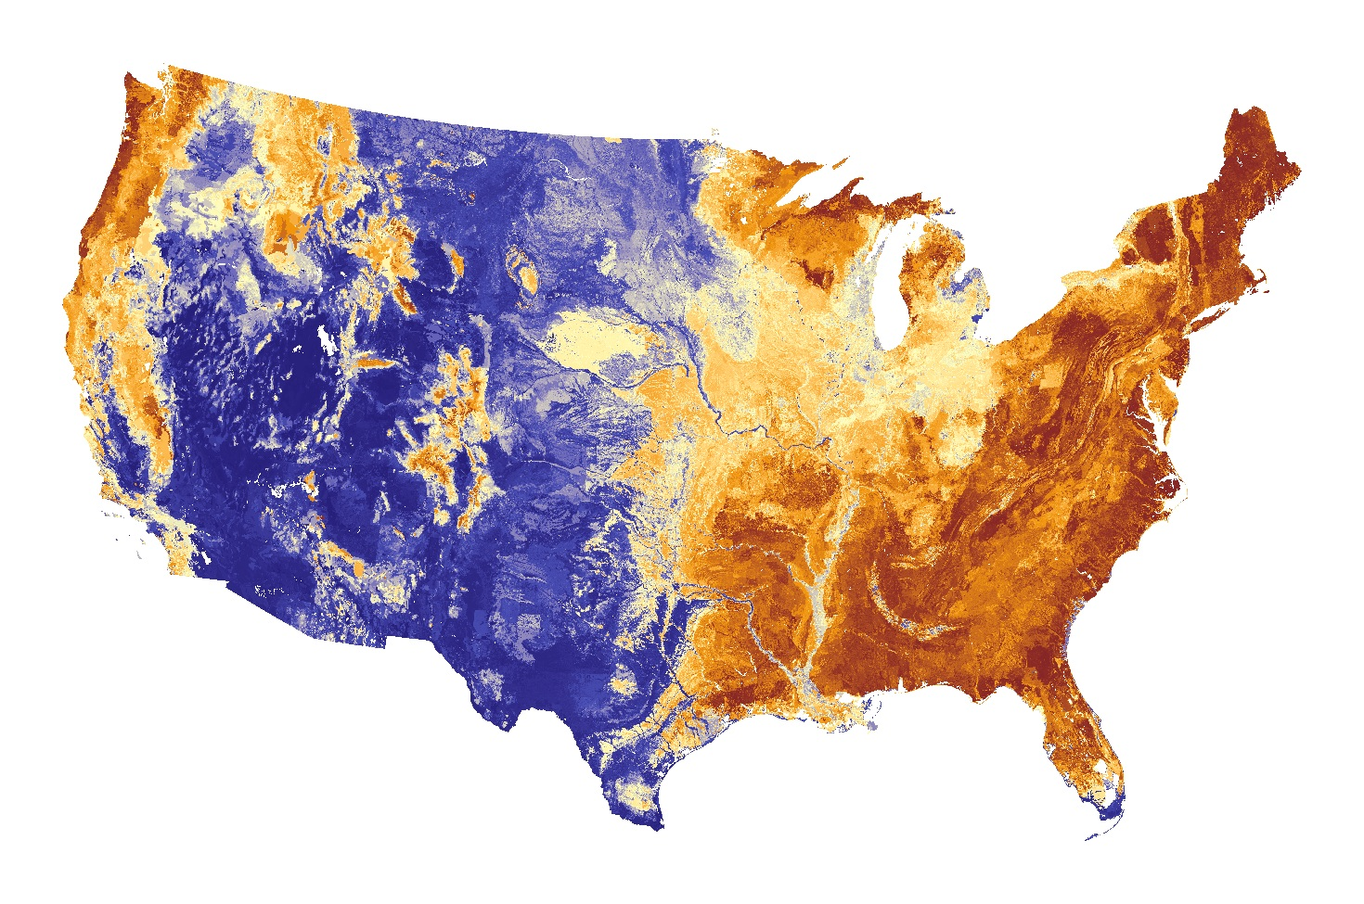

Soil pH within the top 10 inches. Blue colors represent alkaline conditions, red colors represent acid conditions. The pH of the soil affects the balance of nutrients available to crops, corrosion of steel and concrete, fate and transport of heavy metals, and many other important processes that affect every American on a daily basis. Each pixel (there are 12,146,248) within this image represents hundreds of hours of time in the field and office, contributed to the National Cooperative Soil Survey effort.