# 11 Algorithms for Quantitative Pedology

D.E. Beaudette, J. Skovlin, A.G. Brown, P. Roudier, and S.M. Roecker

## Abstract

The Algorithms for Quantitative Pedology (AQP) project consists of a suite of packages for the **R** programming language that simplify quantitative analysis of soil profile data. The “aqp” package provides a vocabulary (functions and data structures) tailored to the complexity of soil profile information. The “soilDB” package provides interfaces to databases and web services, leveraging the “aqp” vocabulary. The “sharpshootR” package provides tools to assist with summary and visualization. Bridging the gap between pedometric theory and practice is central to the purpose of the AQP project. The AQP **R** packages have been extensively tested and documented, applied to projects involving hundreds of thousands of soil profiles, and integrated into widely used tools such as SoilWeb. These packages serve an important role in routine data analysis within the U.S. Department of Agriculture and in other soil survey programs worldwide.

## 11.1 Introduction

Soil survey data is a rich source of soil parent material information and observations relating to the distribution and extent of surficial deposits and geologic stratigraphy. The overlap of the domains of pedology and geomorphology, referred to as geopedology (Zinck 2016), emphasizes the need for clear relationships between soil parent materials and geomorphic concepts. Soil is the dynamic interface connecting the biosphere and the lithosphere (Wysocki, Schoeneberger, and LaGarry 2005). Soil provides a medium and conduit for water storage and nutrient flow. The development of soil properties is largely determined by the inherent nature of surficial deposits or soil parent material from which they originate. While soil survey has historically been grounded in a soil-landscape paradigm (Hudson, 1992), geopedologic concepts aim to further integrate geomorphic concepts with soil survey information for broader application within the earth science community.

Data alone cannot support decisions, generate useful conclusions, or convey embedded relationships without thoughtful analysis and processing. The wide array of data sources, formats, and conventions (even within a single institution) can further complicate efforts to synthesize soil information from soil data sources. Growth in promising tools that link database APIs, spatial data, and enable the analysis of complex soil description data are expanding the potential for soil science data analysis within programming environments like **R** (R Core Team 2022).

The Algorithms for Quantitative Pedology (AQP) project is a suite of packages for the **R** programming language that simplify many facets of soil data analysis. The project began in 2006 as a loosely coordinated collection of **R** scripts used to support the management, analysis, and visualization of digital soil morphology records. By 2010, it became clear that an **R** package (code, manual pages, and example data following strict guidelines) hosted by CRAN would be the best route forward. The first version of the *aqp* package was submitted to CRAN in May of 2010; with a name and core functionality inspired by the concept of “quantitative pedology” (Jenny 1941), analysis by regular depth-intervals (Harradine 1963; Moore, Russell, and Ward 1972), and the characterization of depth-functions (Myers et al. 2011). A companion article by Beaudette, Roudier, and O’Geen (2013) contained a detailed description and simple demonstrations of the main package features.

As functionality evolved, the *aqp* package was split into three main categories which became **R** packages to increase modularity and divide administrative tasks: *aqp* (soil-specific data structures, profile sketches, color conversion, pedotransfer functions, etc.), *soilDB* (wrapper and convenience functions for accessing APIs and harmonization of results), and *sharpshootR* (specialized tasks and visualizations designed for use with soil database connections provided by *soilDB* and data structures provided by *aqp*). Like most **R** packages, the AQP suite of packages depends on other packages for optimized computation (Dowle and Srinivasan 2021), color conversion (Pedersen et al., 2021; Zeileis et al. 2020), numerical classification (Maechler et al. 2021), and methods for compositional data (e.g., sand, silt, and clay content) (Moeys 2018; van den Boogaart, Tolosana-Delgado, and Bren 2021), to name a few. The authors hope that other scientists will find a suitable foundation in *aqp*, *soilDB*, and *sharpshootR*, upon which more specialized tools can be built, documented, and delivered in the form of new **R** packages.

Since 2011, the AQP suite of **R** packages has been extensively updated and documented by U.S. Department of Agriculture - Natural Resources Conservation Service (USDA-NRCS) Staff to support routine operations within the Soil and Plant Science Division. Some examples include aggregation and synthesis of field data to support initial soil survey (new mapping), graphical comparisons and correlation analysis to support soil survey update projects (refinement of existing mapping), and visual presentation of soil survey data to the public via tools like SoilWeb (O’Geen, Walkinshaw, and Beaudette 2017). The *soilDB* package has become one of the most widely used interfaces to USDA-NRCS data sources, with support for queries that accept (and return) mixtures of spatial and tabular data from the Soil Survey Geographic Database (SSURGO) (Soil Survey Staff 2022b). Spatial formats defined by the *sf* (Pebesma 2018) and *raster* (Hijmans 2021) **R** packages are used extensively by the *soilDB* package to minimize data conversion or pre-processing steps.

### 11.1.1 Example Data: Clarksville Soil Series

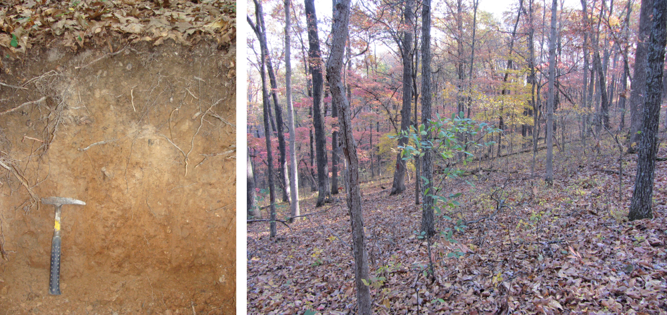

Figure 11.1: Clarksville series soil profile (left) and associated representative landscape (right). Soil profile photo: Satchel Gaddie, landscape photo: Jayme LeBrun.

A curated set of soil morphologic and laboratory characterization data correlated to the Clarksville soil series (Loamy-skeletal, siliceous, semiactive, mesic Typic Paleudults) is used to demonstrate key functionality and visualization possibilities provided by the AQP suite of **R** packages. These data represent a very deep (> 150cm), somewhat excessively drained soil of large extent in the Ozark Highlands of southern Missouri, USA. Clarksville soils are formed in residual and colluvial soil parent materials of cherty dolomite or cherty limestone (Kabrick et al. 2008). These soils typically occur on ridges and steep side slopes, spanning summit, shoulder, and backslope positions of an idealized 2D hillslope. Mean annual air temperature ranges from 13–15 degrees C, mean annual precipitation ranges from 1150–1250 mm, with most precipitation falling as rain.

Clarksville soils are generally highly weathered, acidic with low to moderate base saturation, low cation exchange capacity and nutrient limiting for available phosphorus, calcium and magnesium (Kabrick et al. 2011; Singh, Goyne, and Kabrick 2015). Morphology of Clarksville soils commonly include soil textures high in silt with thick accumulations of translocated clay at depth. Although soils are generally high in rock fragments, silt-rich soil textures dominate surface soil horizons due the influence of wind-blown loess parent material. These landscapes support a mixed forest of black oak (*Q. velutina* Lam.), white oak (*Quercus alba* L.), blackjack oak (*Q. marilandica* Muench.), post oak (*Q. stellata* Wangenh.), shortleaf pine (*Pinus echinata* Mill.), black hickory (*Carya texana* Buckl.), red maple (*A. rubrum* L.), and dogwood (*Cornus florida* L.).

## 11.2 Representing Collections of Soil Profiles in R

Soil profile data are complex, and typically consists of site description, soil morphologic description, and optionally laboratory data. The SoilProfileCollection (SPC) is a data structure which attempts to capture this complexity and is designed to coordinate linkages between those elements. Functions operating on the SoilProfileCollection include special constraints to ensure linkages aren’t broken during routine operations such as editing, sub-setting, or combining collections.

The first level of abstraction involves two main tiers: “site” and “horizon” data. “Site” data refers to above-ground or those properties that are specific to a single soil profile description (e.g., surface slope). “Horizon” data refers to below-ground or those properties that are specific to a single genetic soil horizon or layer. An additional level of abstraction is used to store spatial data (coordinates and coordinate reference system) and depth-interval information such as diagnostic horizons. The SoilProfileCollection structure provides a means of storing user-defined metadata such as units of measure, horizon designation column name, data source, and data citation. The SoilProfileCollection object was designed with data analysis in mind; as compared to other (more complex) data structures used for archival purposes, such as those used within the USDA-NRCS National Soil Information System (NASIS).

Of primary importance are the horizon data, or the layers that comprise the profiles in the collection. The SoilProfileCollection is “horizon data forward,” in that a user starts with a table of horizon data. Each horizon record must have an upper and lower boundary, a unique ID linking to a single soil profile observation, and any other observed or measured properties. There are no set limits on the number of horizons per profile, or profiles per collection, but available memory will dictate practical limitations. Horizon depths should be specified as integers (typically centimeters) and should not overlap.

A SoilProfileCollection is created through “promotion” of an **R** data.frame with the depths() function. Other data.frame-like objects such as tibble (Müller and Wickham 2021) or data.table (Dowle and Srinivasan 2021) can be used as input. Promoting a data.frame to SoilProfileCollection requires the following parameters: profile_id (the name of a column containing unique profile IDs), top_depth (the name of a column containing horizon upper depths) and bottom_depth (the name of a column containing horizon lower depths) along with any additional horizon data associated with the horizons in the profile. For example, the promotion of a data.frame called x to SoilProfileCollection would follow: depths(x) <- profile_id ~ top_depth + bottom_depth.

In the **R** language, the tilde symbol ~ separates the left and right-hand sides of a formula. Commonly ~ is used in formulas to mean “modeled as.” In a SoilProfileCollection the geometry and ordering of horizons within each unique profile using the upper and lower depths is “modeled.” Performing this operation automatically sorts horizon data first by profile ID and then by horizon top depth.

The site()<- method is used to move site-level data from horizon-level records (necessary when starting with a mixture of horizon and replicated site data in the same table), or to merge a new table of site-level data via common ID and left join (missing records in the new table are filled with NA). In a similar manner, the horizons()<- method is used to merge a new table of horizon-level data into the SoilProfileCollection object via common ID (unique to specific horizons) and left join. Additional site and horizon data can be created or extracted one by one using the $ or [[ methods. When creating a new variable, the SoilProfileCollection will check whether the length of the vector matches either the number of “sites” or the number of “horizons.” Extracting horizon or site-level data as plain data.frame objects is performed with the horizons() and site() functions. A detailed explanation of the SoilProfileCollection object and associated methods for manipulation of these objects is presented in the “Introduction to SoilProfileCollection Objects” tutorial (Beaudette 2022).

The *soilDB* package for **R** provides a common interface to many of the National Cooperative Soil Survey databases. Several functions from this package return data as a SoilProfileCollection object: fetchKSSL() (laboratory characterization data), fetchOSD() (basic soil morphology from the Official Series Description), fetchSDA() (SSURGO and STATSGO data from Soil Data Access), and fetchNASIS (National Soil Information System).

### 11.2.1 Subsetting

The “bracket” methods are one of the primary ways that objects in **R** can be subset by rows and columns (e.g., data.frame) or element (e.g., list, vector, etc.). The SoilProfileCollection builds on these patterns to extract specific profiles and/or horizon collections based on numeric or logical indices.

The syntax used by the SoilProfileCollection bracket method is: x[i, j, k]; where x is a SoilProfileCollection object, i is a profile index, j is a within-profile horizon index and k represents optional special functions that can operate on the horizon data in the collection to replace the profile-specific j-index (Figure 11.2). To obtain the first profile in the collection use the syntax x[1, ]. For the first horizon in each profile use x[, 1]. To get the last horizon of each profile, use x[, , .LAST] where .LAST is a special “keyword” that can identify the j-index of the deepest horizon in each profile. Subsets based on i, j and k indices of the SoilProfileCollection can be combined, for instance: x[1:2, 1:2] gives the first two horizons of the first two profiles. Also, the k index can be combined with the i index, for instance x[1:2, , .LAST] gives the last horizon of the first two profiles (Figure 11.2).

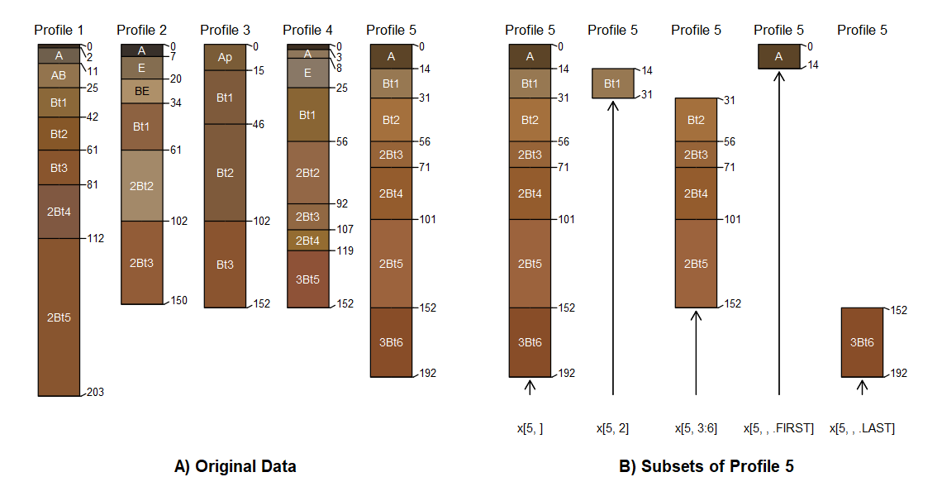

Figure 11.2: Five soil profiles correlated to the Clarksville soil series (A). Examples of bracket methods for subsetting profiles, sequences of horizons and top or bottom horizons (B).

The representation of horizon position with the j-index can be extended to develop other “horizon spatial predicates” such as hzAbove(), hzBelow() and hzOffset(). The former two take logical expressions to match horizons and return the part of the collection adjacent to the match (above or below respectively). The hzOffset() function allows arbitrary horizon indices and offsets to be calculated. This type of logic is further helpful for inspecting and fixing horizon geometry for errors or inconsistencies.

Common querying operations with criteria in the form of logical expressions can be used to subset profiles or horizons in a collection that meet specific criteria of interest. The *aqp* functions subset() and subsetHz() can be used with logical expressions in terms of the site or horizon variables to specify the constraints. These expressions make use of site or horizon-level variables in the collection. The subset() function returns whole profiles, if criteria were specified for horizon data then only some of the horizons of those profiles may meet criteria. More specifically, subsetHz() requires horizon-level expressions and returns only the portion of horizons within profiles that meet criteria.

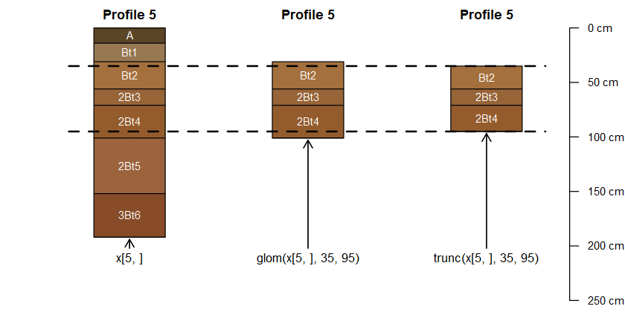

Figure 11.3: A demonstration of selecting horizons that overlap with a depth interval via glom() and truncation to that interval via trunc().

Partitioning soil profile collections on logical expressions of site and horizon level properties is powerful, but soil scientists often need to extract data within or overlapping specific depths. Two methods: glom(x, z1, z2, ...) and trunc(x, z1, z2, ...) facilitate this in *aqp*. The glom() f unction returns the subset of horizons in a collection that overlap with a specific depth interval [z1, z2]. The depth interval could be a point (only z1 specified) or a range (z1 and z2 specified) (Figure 11.3).

The interval [z1, z2] can be constant across the collection or unique to each profile. By default, the whole horizon is returned unmodified whether it falls fully within the range or not – creating a “ragged” SoilProfileCollection (Figure 11.3). The upper and lower boundaries of the resulting horizons will be cleanly cut to the interval specified using glom(truncate=TRUE) or via trunc(), and resulting profiles will have consistent upper and lower boundaries assuming there are no missing data in the specified interval.

### 11.2.2 Data Quality and Repairs

The *aqp* package provides several methods for identifying problematic profile geometry and attempts to “correct” it. Most soil databases and methods for storing soils information do not have front end validations that prevent entry of data with “illogical” content. Some analyses rely on having only one record of data per depth/profile combination such as those involving depth-weighted averages or those that rely on having a “complete” set of records in all profiles over a particular interval.

The *aqp* function checkHzDepthLogic() inspects a SoilProfileCollection object looking for four common errors in horizon depths: bottom depth shallower than top depth, equal top and bottom depth, missing top or bottom depths, and gap or overlap between adjacent horizons. With byhz = TRUE it is possible to perform the first three of the above logic checks on individual horizons.

Assumptions concerning horizon order based on horizon top depth are tested by the repairMissingHzDepths() function. This can be used to fill in some missing (bottom) horizon depths. This function will set missing bottom depths of a horizon to the next deepest (adjacent) top depth. Also, it adds a constant vertical offset to the top depth of bottom-most horizons missing bottom depth.

The fillHzGaps() function attempts to find “gaps” in the horizon records of a SoilProfileCollection object and fill with placeholder horizons (profile ID, horizon ID, top/bottom depths, all else NA). This function is for filling profiles to a static top and bottom depth. For instance, a morphologic description containing horizons with omitted upper or undetermined lower depth as in the case of undescribed organic horizons or soil profiles that have variable bedrock depth below depth of excavation.

## 11.3 Soil Morphology

The field description of a soil profile (genetic horizon depths, boundaries, color, soil texture, rock fragment volume, structure, etc.) is typically the foundation upon which additional sampling, laboratory characterization, or soil survey are based. In aggregate, a complete collection of horizons, associated properties, and landscape context (e.g., catenary position or other geomorphic description) represent an atomic unit of pedologic inquiry: the pedon (Soil Survey Staff, 2017). The AQP family of **R** packages and the SoilProfileCollection data structure were designed specifically to elevate the pedon (and collections of pedons) to a convenient abstraction (an object), enabling a simpler interface to what would otherwise be a complex hierarchy of above and below-ground records. In *aqp*, the more generic term “profile,” is used instead of pedon to accommodate incomplete data (missing above-ground information) or otherwise truncated horizon observations. Central to this approach is the specification of profile IDs and horizon depths, above-ground (“site”) vs. below-ground (“horizon”) attributes, and ideally horizon designation with associated attributes such as soil color.

### 11.3.1 Soil Color

The color of soil material observed during field investigations is one of the most striking and useful properties recorded as part of a soil profile description. Typically recorded in the Munsell system (Munsell 1947; Simonson 1993; Soil Survey Staff 2017) in the form of “hue, value/chroma,” the three components of this notation provide interpretive suggestions about iron oxides and oxidation state (hue and chroma) (Schwertmann 1993; Scheinost and Schwertmann 1999), soil carbon (value) (Wills, Burras, and Sandor 2007; Liles et al. 2013), as well as hints about the relative importance of catenary relationships (Brown, Clayton, and McSweeney 2004). Several color-based metrics of soil development (Buntley and Westin 1965; Harden 1982), rubification (Barron and Torrent 1986; Hurst 1977), and melanization (Harden 1982; Thompson and Bell 1996) are implemented in the *aqp* package.

#### 11.3.1.1 Color Conversion

The *aqp* package provides several interfaces for conversion between Munsell notation and sRGB or CIELAB color spaces, largely based on the 1943 Munsell renotation table (Centore 2012). Forward conversion from standard Munsell notation (e.g., 10YR 3/4) is performed via look-up table, derived from the renotation table, and interpolated to include odd chroma and 2.5 value. The function munsell2rgb() performs a direct transformation to sRGB-encoded colors in hexadecimal (#5C4222), sRGB coordinates scaled to the interval of 0–1 ([0.36187, 0.25989, 0.13375]), or CIELAB coordinates ([30.273, 7.2731, 23.753]) (Beaudette, Roudier, and O’Geen 2013). Inverse transformation from sRGB coordinates is performed by the rgb2munsell() function, approximated by nearest-neighbor search of the Munsell-sRGB look-up table using the CIE2000 color contrast metric (Pedersen et al., 2021). All color space coordinates are referenced to the CIE standard illuminant D65, which is a close approximation to average midday sunlight in the northern hemisphere (Marcus 1998). sRGB and CIELAB color spaces were selected to address two common applications: sRGB, for digital representation of color on computer screens or reproduction on printed media, and CIELAB for the convenient alignment of axes and common pigments in the soil environment (Viscarra Rossel et al. 2006; Liles et al. 2013).

Non-standard notation of Munsell colors (e.g., 10.6YR 3.3/5.5), as collected by digital colorimeter, can be converted to approximate sRGB coordinates using the getClosestMunsellChip() function. However, this approach uses rounding of value and chroma and snapping to the nearest standard hue (10YR). Exact conversion of non-standard Munsell notation can be performed using the *munsellinterpol* **R** package (Gama, Centore, and Davis 2021).

#### 11.3.1.2 Color Contrast

Color contrast (perceptual difference between two colors) within a soil sample is an important component of field-described redoximorphic features, concentrations, and mottles (Schoeneberger et al. 2012). Soil Survey products and wetland delineation protocols adopted by the National Cooperative Soil Survey (NCSS) currently use *contrast classes* (faint, distinct, and prominent) to describe color contrast, based on differences in Munsell hue, value, and chroma (Soil Survey Staff 2022c). The colorContrast() function in *aqp* computes differences in Munsell (hue, value/chroma), soil color contrast class, and the CIE2000 color contrast metric (Sharma, Wu, and Dalal 2005) for pairs of colors specified in Munsell notation. The function is fully vectorized meaning that multiple comparisons can be generated without explicit looping (Table 11.1).

Table 11.1: Output from the colorContrast() function includes: change in hue (dH), change in value (dV), change in chroma (dC), CIE2000 color contrast (dE00), and NCSS soil color contrast class (CC).

|  |  |  |  |  |  |  |
| --- | --- | --- | --- | --- | --- | --- |
| Color 1 | Color 2 | dH | dV | dC | dE00 | CC |
| 10YR 3/3 | 10YR 3/4 | 0 | 0 | 1 | 3.13 | Faint |
| 7.5YR 6/6 | 5YR 4/6 | 1 | 2 | 0 | 21.1 | Distinct |
| 2.5Y 2/2 | 5G 4/8 | 9 | 2 | 6 | 30.5 | Prominent |

Tabular color contrast output can be convenient when used as an intermediate step in a more complex workflow but can be difficult for non-specialists to interpret. A graphical representation of these data are created by the colorContrastPlot() function provided by *aqp*. For example, the differences between typical dry and moist soil colors for the Musick soil series (Fine-loamy, mixed, semiactive, mesic Ultic Haploxeralfs) are demonstrated in Figure 11.4. While exact replication of Munsell colors isn’t possible on un-calibrated displays or printers, the sRGB approximation is sufficient to demonstrate relative differences in hue, value, and chroma.

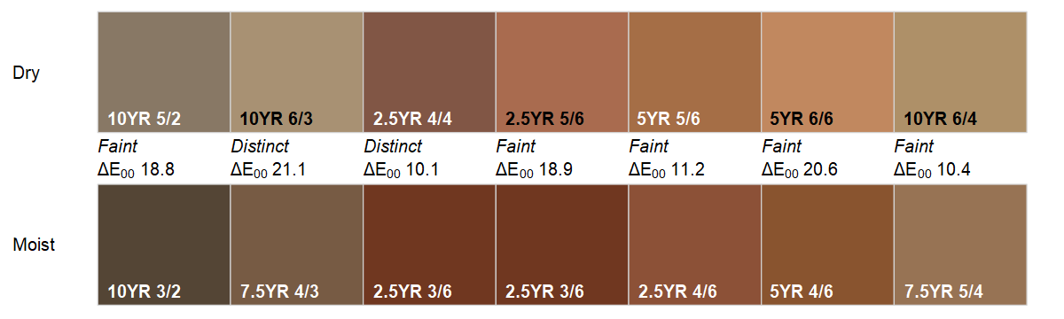

Figure 11.4: Color contrast plot, comparing the moist and dry soil colors of the Musick soil series. CIE2000 color contrast values are printed below soil color contrast classes. Smaller values describe smaller perceptual differences between colors.

To further aid with the calculation and interpretation of color contrast, “color contrast charts” can be created with the contrastChart() function provided by *aqp*. These charts are based on a source color in Munsell notation (e.g., 7.5YR 4/3) and select pages of Munsell hue. Pair-wise metrics of color contrast are evaluated between all color “chips” and the source color (outlined in red). Hue is split across panels in a familiar format with Munsell chroma on the x-axis and value on the y-axis. Soil color contrast class and CIE2000 values are printed below each color “chip” (Figure 11.5).

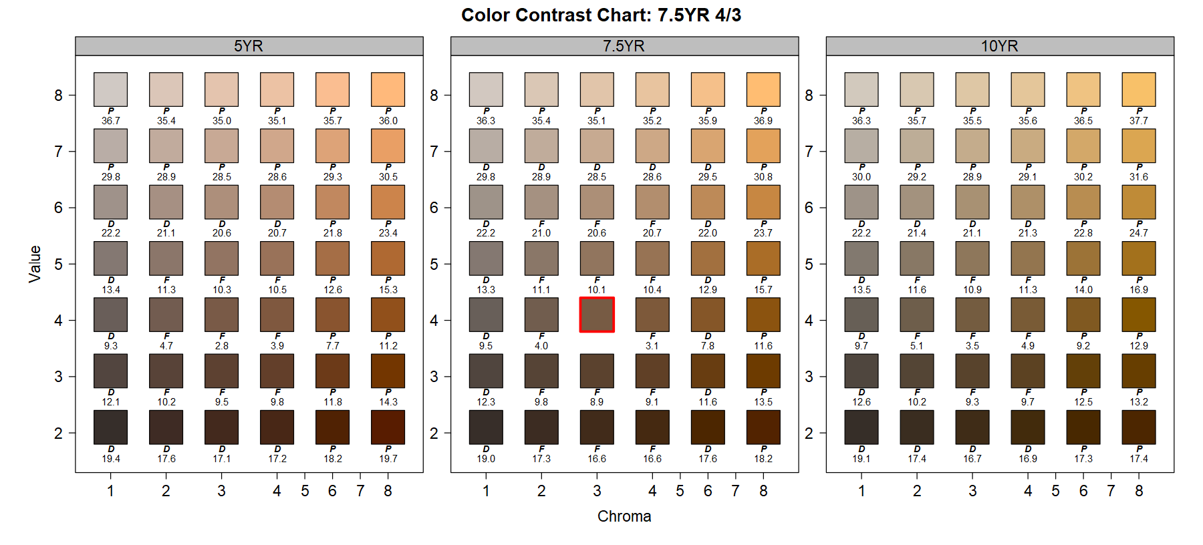

Figure 11.5: Color contrast chart for 7.5YR 4/3 (chip outlined in red), including reference 5YR, 7.5YR, and 10YR hue pages. Soil color contrast classes are abbreviated as F (faint), D (distinct), and P (prominent). Numbers are CIE2000 values.

### 11.3.2 Soil Profile Sketches

Conceptual sketches of soil profiles that illustrate variation in morphology (e.g., horizon depths, horizon designations, color, texture, etc.) in relation to transect or catenary position are a pedologic staple. Either hand-drawn in field notes or carefully produced as part of a final soil survey manuscript, these sketches represent an important vehicle for communicating observation and context to technical and non-technical audiences. A data-driven approach to creating soil profile sketches was one the of the original motivations for the *aqp* **R** package (Beaudette, Roudier, and O’Geen 2013). Since 2010, the profile sketch authoring tools in *aqp* have progressed from basic layout of filled rectangles (profiles and horizons) to thematic coloring of horizons based on properties or classes, encoding of horizon boundary information, and handling of label collision.

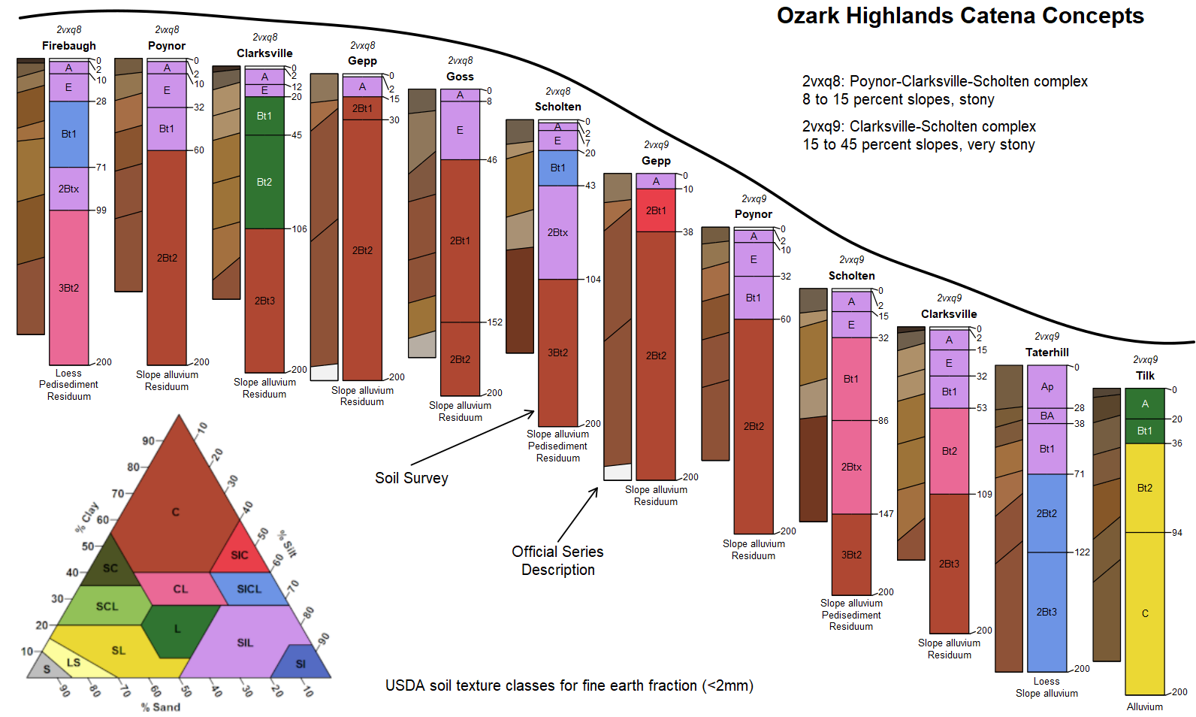

Figure 11.6: Illustration of an idealized hillslope catena for soil components from two adjacent map units within the Ozark Highlands. SSURGO map unit soil components are placed within a geomorphic hillslope sequence to convey soil property to soil parent material relationships. Munsell soil colors from each official series description are displayed in tandem companion profiles.

The plotSPC() function in the *aqp* package is the primary tool for creating soil profile sketches from SoilProfileCollection objects, using **R**’s “base graphics” system. Figure 11.6 demonstrates several possible data sources, processing steps, and output generated from plotSPC(). Soil components (retrieved from the detailed Soil Survey via fetchSDA() as a SoilProfileCollection) within map unit “2vxq8” occur on summit and shoulder hillslope positions while components in map unit “2vxq9” occur on backslope, footslope and toeslope positions. USDA soil texture classes (<2 mm fraction) of each horizon are symbolized with color to show the variation of textures within the catena. Labeling of horizon depths (vs. common depth axis), leader lines, and collision detection (common with thin horizons) are optional enhancements to the standard output, specified via function arguments (Soil Survey Staff 2022a). Narrower profiles to the left of each component sketch represent data from the Official Series Descriptions via fetchOSD(). These data represent the typical morphology (horizon depths, designations, colors, etc.) for all soil series used in the US Soil Survey. Munsell colors (moist conditions) have been converted to sRGB coordinates using munsell2rgb(), and horizon boundary distinctness codes have been converted into vertical offsets using hzDistinctnessCodeToOffset(). The plotSPC() function can encode horizon distinctness offsets as diagonal horizon boundaries, where increasingly steeper angles represent the following sequence of boundary distinctness: “very abrupt,” “abrupt,” “clear,” “gradual,” “diffuse” (Schoeneberger et al. 2012). A visual explanation of the many arguments to plotSPC() is provided via explainPlotSPC() which shows the usage of ordering vectors, graphical offsets and scaling factors within the graphical space. Detailed examples of plotSPC() usage are available in the function documentation (Soil Survey Staff 2022a) and associated tutorials (Beaudette 2022). Future developments to plotSPC() will include conversion to the more advanced “grid” graphics system, pattern fills (e.g., geologic and stratigraphic symbols), and tighter integration with other plotting libraries such as *lattice* and *ggplot2*.

### 11.3.3 Functional Horizon Aggregation

Soil scientists use a common language of horizon designation nomenclature to describe and articulate the observed differences in soil horizons within a soil profile. These basic notations and the act of “naming” genetic horizons distills important information in the form of master horizons, characteristic subscripts, horizon and pedogenic sequences, and parent material discontinuities. Horizon designations convey a qualitative description of soil properties and process while allowing flexibility in how horizon designations are applied. Experienced soil scientists will generally apply horizon nomenclature consistently from site to site and through time due to the rigid guidelines and definitions of their application. However, among a group of soil scientists there will be variability in the exact designations used—each having their own unique training, field experiences, and tendencies towards “lumping” (describing fewer and thicker horizons) or “splitting” (describing more and thinner horizons).

Building on the interpretation of horizon designations, the Generalized Horizon Label (GHL) concept seeks to unify functionally similar horizon designations for the purpose of aggregation, analysis, and summary operations (Beaudette, Roudier, and Skovlin 2016; Roecker et al. 2016). The conceptual approach of functional aggregations of horizons within collections of soil profiles has been attempted as a framework for developing pedotransfer functions (Wagenet, Bouma, and Grossman 1991). The process of applying GHL to a collection of soil profiles involves a series of micro-correlations made by a soil scientist to determine which horizons have similar soil morphology and properties to be grouped together for aggregation across horizons within a SoilProfileCollection.

The application of GHL to a SoilProfileCollection is driven by Regular Expression (REGEX) pattern matching. REGEX provides a rich syntax for string-matching of horizon designation sets into unified horizon GHL groups. A user developed set of REGEX rules are matched to an identified vector of horizonation by the generalize.hz() function in the *aqp***R** package.

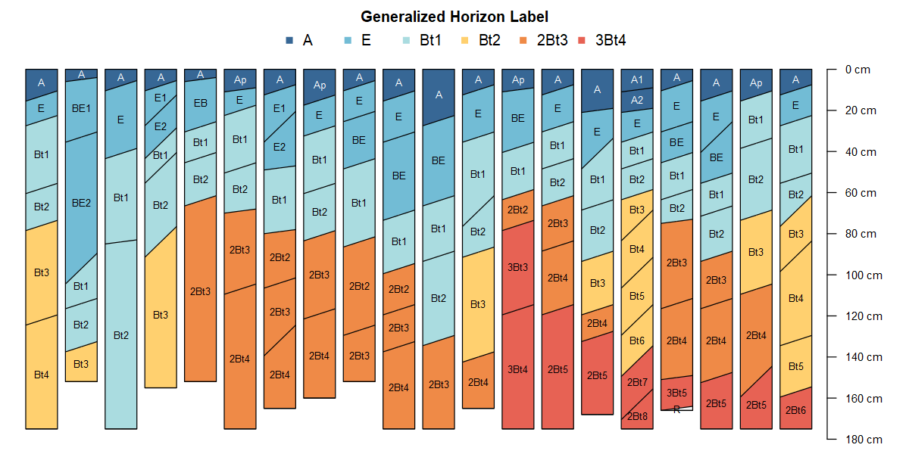

Figure 11.7: A series of generalized horizon labels (GHL) applied to a collection of soil profiles of the Clarksville soil series from the Ozark Highlands, Missouri. Horizon labels within each soil profile show the original horizon designations while colors indicate assigned GHL.

Features unique to the Clarksville soil series are argillic diagnostic horizons and parent material discontinuities as horizons transition along boundaries between cherty dolomite slope alluvium and colluvium over dolomite residuum. GHL can be used to identify these common features in a set of soils once applied (Figure 11.7).

The depthOf() family of functions also utilize REGEX pattern matching of horizon designations to determine the depth to horizons with matching designation. For example, the pattern “Bt” would match all horizon designations containing “Bt” (case sensitive). Within a SoilProfileCollection, the minDepthOf() and maxDepthOf() operations provide additional utility to find either the top (shallowest) or bottom (deepest) depth to a matching horizon pattern. These functions provide convenience handling for missing values or when target patterns are not found within a profile. Results are returned as a numeric vector for single profiles or a data.frame of results with profile ID, horizon ID, top or bottom depths, horizon designation and pattern provided. Profile sketches in Figure 11.7 have been sorted by values returned by the depthOf() function, first according to depth of “3Bt4” GHL and second according to depth of “2Bt3” GHL.

### 11.3.4 Change of Depth Support

Soil data are typically collected either by genetic horizon with varying horizon depths, at regular depth intervals (every 10cm), or from composite samples representing specified depth intervals (0-10cm, 10-25cm, etc.). The structure of these depth intervals will typically vary from one profile to the next. To facilitate analysis throughout the profile collection, profile horizon depths may need to be modified and/or harmonized comprising a change of depth support. A simple down-scaling of horizons (without interpolation) into a regular sequence of thinner depth slices, referred to as “slicing,” is implemented in the dice() function (Figure 11.8A). The segment() function offers another approach to restructuring horizon depths, using horizon-thickness weighted mean values for conversion to fixed depth intervals (e.g., 0-25cm). This is a common step in the thematic mapping of soil property data. A more complex change of horizon depths can be achieved using constrained interpolation. This method, popular for applications such as digital soil mapping (or other tasks requiring harmonized horizon depths) uses mass-preserving splines (Bishop, McBratney, and Laslett 1999). In *aqp*, this type of down-scaling is performed with the spc2mpspline() function which provides a convenient interface to the *mpspline2* package (O’Brien 2020) suitable for SoilProfileCollection objects.

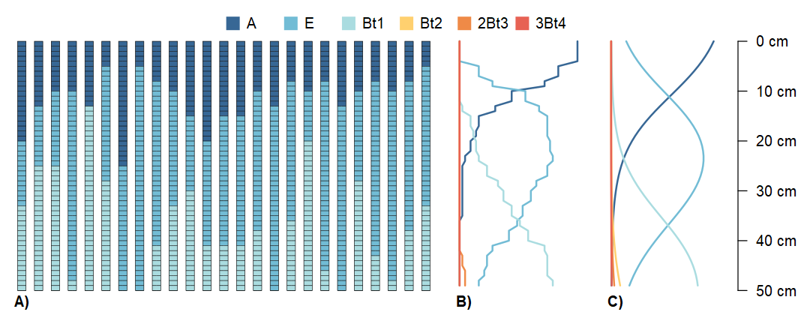

Figure 11.8: Change of support demonstration using 25 pedons correlated to the Clarksville soil series. Generalized horizon labels (GHL) have been resampled to 1cm slices (A) via dice(), aggregated across slices to GHL proportions (B) via slab(), and modeled via proportional-odds logistic regression (C).

A change of support operation performed over all profiles in a collection result in a statistical summary of that collection. The slab() function performs this kind of operation by “slicing” horizon data (continuous or categorical) into 1cm-thick depth intervals (Figure 11.8A), then aggregating “across” those depth intervals (Harradine 1963; Beaudette, Roudier, and O’Geen 2013). Continuous values are reduced to select percentiles (or any user-defined function) per slice, and categorical values are reduced to proportions (Figure 11.8B) (Beaudette, Dahlgren, and O’Geen 2013). Alternatively, sliced categorical data such as GHL can be aggregated using statistical models for ordinal data, such as the proportional-odds logistic regression model (Figure 11.8C) (Beaudette, Roudier, and Skovlin 2016).

## 11.4 Numerical Classification of Soils

Since the 1960’s (likely corresponding with increased availability of computing hardware) there has been considerable interest in the development of numerical alternatives to traditional soil classification systems such as Soil Taxonomy (Soil Survey Staff 1999) and World Reference Base (Chesworth et al. 2008). A “numerical taxonomy” (Sneath and Sokal 1973) of soil horizons or collections of horizons (i.e., soil profiles or aggregation thereof) relies on a deliberate selection of characteristics (soil properties), distance metric (e.g., Euclidean) and criteria used to identify clusters (e.g., hierarchical vs. partitioning methods) (Arkley 1976). Selection of characteristics is complex because a limited set of soil properties cannot universally describe differences between individuals, and the use of all measurable properties is unfeasible – requiring a selection to be made prior to analysis (Sarkar, Bidwell, and Marcus 1966; Arkley 1971). Furthermore, a generalized approach to the numerical classification of soil profiles is complicated by the hierarchical nature of linked site and horizon-level properties, sampling style (depth-intervals vs. genetic horizons) and subtle differences in horizon designation (through time, regionally, etc.). Despite the many challenges, there have been many successful applications of numerical taxonomy to soil science and soil classification (Hole and Hironaka 1960; Rayner 1966; Moore, Russell, and Ward 1972; Dale, McBratney, and Russell 1989; Carré and Jacobson 2009).

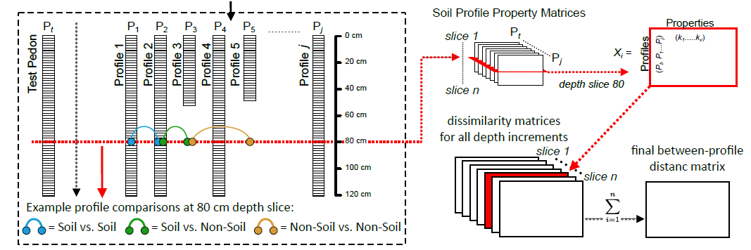

Figure 11.9: Graphical outline of the Numerical Classification of Soil Profiles (NCSP) algorithm. Figure c/o Jon Maynard, adapted from Maynard et al. (2020).

The NCSP (Numerical Comparison of Soil Profiles) algorithm, implemented in the *aqp* package for **R**, attempts to address many of the long-standing difficulties with a numerical classification of entire soil profiles (Beaudette, Roudier, and O’Geen 2013; Maynard et al. 2020). Building on methods suggested by Moore, Russell, and Ward (1972), pair-wise distances (between soil profiles) are evaluated along regular depth-slices by Gower’s distance metric (Gower 1971), using any combination of continuous, categorical, or boolean attributes (Figure 11.9). Total pair-wise dissimilarity is computed by taking the sum of slice-wise dissimilarities, to a user-defined depth. Variation in profile depth is accounted for by assigning maximum slice-wise dissimilarity to comparisons between soil and non-soil. Further customization of the NCSP algorithm is described in Beaudette, Roudier, and O’Geen (2013). The resulting dissimilarity matrix can be used to assist with topics ranging from initial mapping (“similar/dissimilar” soils), comparisons below family-level classification in Soil Taxonomy, soil series correlation, map unit harmonization, and correlation between different taxonomic systems.

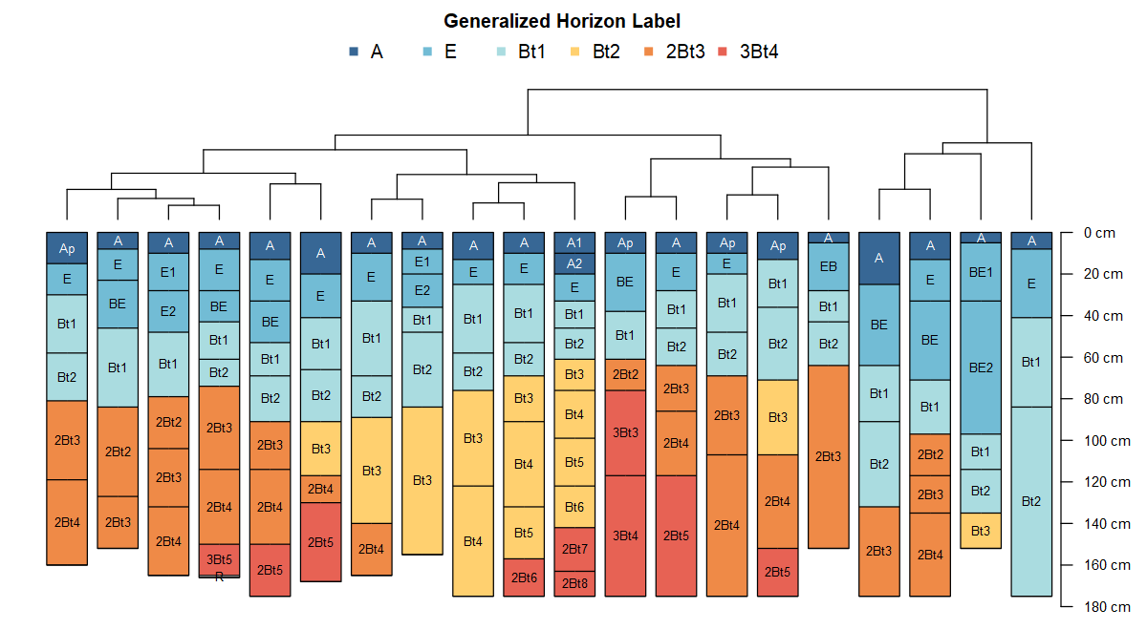

Figure 11.10: Soil profile sketches from Figure 7, arranged according to divisive hierarchical clustering of the distance matrix generated by the Numerical Classification of Soil Profiles (NCSP) algorithm.

Applied to the same set of soil profiles highlighted in Figure 11.7, the NCSP algorithm was used to generate a distance matrix using only the GHL classes (ordinal values) to a depth of 175cm (Figure 11.10). A dendrogram was created from the distance matrix via divisive hierarchical clustering (Kaufman and Rousseeuw 2005), and combined with profile sketches with the plotProfileDendrogram() function from the *sharpshootR* package. Profiles with similar GHL assignments, occurring at similar depths, are allocated to clusters defined by branching near the bottom of the dendrogram. When a combination of site (e.g., slope, drainage class, geoform, etc.) and horizon-level properties are requested, the final distance matrix is developed from a weighted average of the site and horizon-level distance matrices. Pair-wise distances between soil profiles can be difficult to interpret when a large number of properties are included in the calculation and may require a different approach to thematic coloring of profile sketches such as principal component analysis of the property matrix or principal coordinate analysis of the distance matrix scores. An alternative presentation of the data is possible by arranging profile sketches (with plotSPC()) according to the new axes created by 2-dimensional ordination, typically via non-Metric Multidimensional Scaling (nMDS) of the distance matrix.

## 11.5 Water Balance

The soil forming state factor of climate and the interactions and timing of moisture and temperature are pivotal in understanding soil formation and describing site dynamics at local and regional scales. Water balance model accounting for inputs of precipitation and losses to evapotranspiration (Thornthwaite 1948) have evolved as a valuable tool for exploring the nuances of climate at a given point on the landscape. Water balance metrics relate to soil storage and the downward and upward flux of water through soil and associated soil property development as the soil acts as a sponge responding to atmospheric supply and demand (Arkley and Ulrich 1962). Correlation of water balance metrics to vegetation growth at sites has become an important tool for the study of site conditions related to existing vegetation distribution (Stephenson 1998; Lutz, Franklin, and Wagtendonk 2010) and forecasting site climate trajectories. High quality, widely accessible gridded climate data has increased the use of soil water balance models.

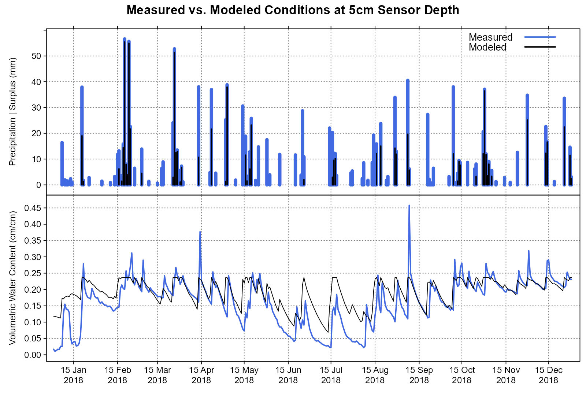

Figure 11.11: Comparison of annual water balance metrics (volumetric water content and precipitation) for 2018 at Soil Climate Analysis Network (SCAN) station 2194 in the Ozark Highlands.

The *sharpshootR* package provides methods (via dependencies on the *elevatr*, *daymetr*, *Evapotranspiration*, and *hyrdomad* packages) for calculating water balance variables of precipitation (PPT), potential evapotranspiration (PET), actual evapotranspiration (AET), deficit (D), soil moisture storage (S), surplus (U), volumetric water content (VWC) on monthly and daily time steps (monthlyWB() and dailyWB() functions). The prepareDailyClimateData() function assembles the available water-holding capacity (AWC) values derived for major components in soil map units of the US Soil Survey for specific point coordinates. Gridded DAYMET climate data (Thornton et al. 2020) is then downloaded for the specified location and daily water balance metrics are estimated via dailyWB_SSURGO().

The *soilDB* package provides query access to the station data in the USDA-NRCS Soil Climate Analysis Network (SCAN). These stations provide above and below ground climate sensor networks that measure soil temperature, soil moisture, air temperature and precipitation. Many stations have associated soil characterization data in the Kellogg Soil Survey Laboratory (KSSL) records. The data in Figure 11.11 were assembled through separate calls to fetchSCAN() for the SCAN climate station data and dailyWB_SSURGO() which derives AWC for the Scholten soil component sampled at SCAN station 2194, assembles DAYMET data for the SCAN station location and runs a daily water balance model. Comparisons of modeled and measured values allow for evaluation of water balance model utility and function.

## 11.6 Conclusions

Pedology and geomorphology are inherently visual, field-based sciences that share a common paradigm and fundamental units of description. Geomorphic description of landforms or geoforms and a merging of these disciplines functionally defined as geopedology is a progression that elevates the geoform as a primary landscape concept that can guide the operational inventory and integrated study of soil geomorphic relationships. Understanding the relevance and importance of contextual linkages to geomorphology in soil survey products adds value and integrates the information with other environmental data and is critical to informing the public and the wider scientific community. Embracing a visual, quantitative analytical approach to collections of soil profiles and varying formats of soil survey data allows for creative abstraction of geopedologic concepts.

Complex data structures and increasing volumes of available data demand progress in methods that allow iterative aggregation, summary, and graphical expression of soil data. The AQP suite of packages works to provide examples and routines that meet these challenges with an emphasis on generalized methods that can be applied to common data structures. This collection of tools leverages the open source flexibility and extensibility of the **R** programming environment and the progress that can be gained from collaborative effort to solve common challenges in working with soil data. Providing visual alternatives for viewing soil morphologic data and improving the quality and accessibility of soil survey data will foster greater use and application of soil survey data to inform all users.

# Supplementary Information

Annotated **R** code used to create the figures and table within this chapter are posted at https://github.com/ncss-tech/geopedology-chapter. The following package versions were used during the preparation of this content: *aqp* 1.42, *soilDB* 2.6.14, and *sharpshootR* 1.9.1.

# References

Arkley, R. J. 1971. “Factor Analysis and Numerical Taxonomy of Soils.” *Soil Science Society of America Journal* 35 (2): 312–15. <https://doi.org/10.2136/sssaj1971.03615995003500020038x>.

Arkley, R. J. 1976. “Statistical Methods in Soil Classification Research.” *Advances in Agronomy* 28: 37–70. <https://doi.org/10.1016/S0065-2113(08)60552-0>.

Arkley, R. J., and R. Ulrich. 1962. “The Use of Calculated Actual and Potential Evapotranspiration for Estimating Potential Plant Growth.” *Hilgardia* 32 (10): 443–62.

Barron, V, and J Torrent. 1986. “Use of the Kubelka-Munk Theory to Study the Influence of Iron Oxides on Soil Colour.” *Journal of Soil Science* 37 (4): 499—510. <https://doi.org/10.1111/j.1365-2389.1986.tb00382.x>.

Beaudette, D. E. 2022. “Introduction to SoilProfileCollection Objects.” <http://ncss-tech.github.io/AQP/aqp/aqp-intro.html>.

Beaudette, D. E., R. A. Dahlgren, and A. T. O’Geen. 2013. “Terrain-Shape Indices for Modeling Soil Moisture Dynamics.” *Soil Science Society of America Journal* 77. <https://doi.org/10.2136/sssaj2013.02.0048>.

Beaudette, D. E., P. Roudier, and A. T. O’Geen. 2013. “Algorithms for Quantitative Pedology: A Toolkit for Soil Scientists.” *Computers & Geosciences* 52: 258–68.

Beaudette, D. E., P. Roudier, and J. Skovlin. 2016. “Probabilistic Representation of Genetic Soil Horizons.” In *Digital Soil Morphometrics*, edited by Alfred E. Hartemink and Budiman Minasny, 281–93. Springer International Publishing. <https://doi.org/10.1007/978-3-319-28295-4_18>.

Bishop, TFA, AB McBratney, and GM Laslett. 1999. “Modelling Soil Attribute Depth Functions with Equal-Area Quadratic Smoothing Splines.” *Geoderma* 91 (1-2): 27–45.

Brown, David J., Murray K. Clayton, and Kevin McSweeney. 2004. “Potential Terrain Controls on Soil Color, Texture Contrast and Grain-Size Deposition for the Original Catena Landscape in Uganda.” *Geoderma* 122 (1): 51–72. https://doi.org/<http://dx.doi.org/10.1016/j.geoderma.2003.12.004>.

Buntley, G. J., and F. C. Westin. 1965. “A Comparative Study of Developmental Color in a Chestnut-Chernozem-Brunizem Soil Climosequence.” *Soil Science Society of America Journal* 29 (5): 579–82. https://doi.org/<https://doi.org/10.2136/sssaj1965.03615995002900050029x>.

Carré, F., and M. Jacobson. 2009. “Numerical Classification of Soil Profile Data Using Distance Metrics.” *Geoderma* 148: 336–45. <https://doi.org/10.1016/j.geoderma.2008.11.008>.

Centore, Paul. 2012. “An Open-Source Inversion Algorithm for the Munsell Renotation.” *Color Research & Application* 37: 455–64.

Chesworth, Ward, Marta Camps Arbestain, Felipe Macías, Otto Spaargaren, Otto Spaargaren, Y. Mualem, H. J. Morel‐Seytoux, et al. 2008. “Classification of Soils: World Reference Base (WRB) for Soil Resources.” In *Encyclopedia of Soil Science*, edited by Ward Chesworth, 120–22. Dordrecht: Springer Netherlands. <https://doi.org/10.1007/978-1-4020-3995-9_104>.

Dale, M. B., A. B. McBratney, and J. S. Russell. 1989. “On the Role of Expert Systems and Numerical Taxonomy in Soil Classification.” *Journal of Soil Science* 40 (2): 223–34. https://doi.org/<https://doi.org/10.1111/j.1365-2389.1989.tb01268.x>.

Dowle, Matt, and Arun Srinivasan. 2021. *Data.table: Extension of ‘Data.frame‘*. <https://CRAN.R-project.org/package=data.table>.

Gama, Jose, Paul Centore, and Glenn Davis. 2021. *Munsellinterpol: Interpolate Munsell Renotation Data from Hue/Chroma to CIE/RGB*. <https://CRAN.R-project.org/package=munsellinterpol>.

Gower, J. C. 1971. “A General Coefficient of Similarity and Some of Its Properties.” *Biometrics* 27 (4): 857–71. <http://www.jstor.org/stable/2528823>.

Harden, Jennifer W. 1982. “A Quantitative Index of Soil Development from Field Descriptions: Examples from a Chronosequence in Central California.” *Geoderma* 28 (1): 1–28. https://doi.org/<https://doi.org/10.1016/0016-7061(82)90037-4>.

Harradine, Frank. 1963. “Morphology and Genesis of Noncalcic Brown Soils in California.” *Soil Science* 96: 277–87.

Hijmans, Robert J. 2021. *Raster: Geographic Data Analysis and Modeling*. <https://CRAN.R-project.org/package=raster>.

Hole, F. D., and M. Hironaka. 1960. “An Experiment in Ordination of Some Soil Profiles.” *Proceedings of the Soil Science Society of America 24* 24: 309–12.

Hudson, B. D. 1992. “The Soil Survey as Paradigm-Based Science.” *Soil Science Society of America Journal* 56: 836–41.

Hurst, Vernon J. 1977. “Visual estimation of iron in saprolite.” *GSA Bulletin* 88 (2): 174–76. [https://doi.org/10.1130/0016-7606(1977)88<174:VEOIIS>2.0.CO;2](https://doi.org/10.1130/0016-7606(1977)88%3c174:VEOIIS%3e2.0.CO;2).

Jenny, Hans. 1941. *Factors of Soil Formation: A System of Quantitative Pedology*. New York: McGraw-Hill.

Kabrick, John M., Daniel C. Dey, Randy G. Jensen, and Michael Wallendorf. 2008. “The Role of Environmental Factors in Oak Decline and Mortality in the Ozark Highlands.” *Forest Ecology and Management* 255: 1409–17.

Kabrick, John M., Daniel C. Dey, Randy G. Jensen, and Michael Wallendorf. 2011. “Landscape Determinants of Exchangeable Calcium and Magnesium in Ozark Highland Forest Soils.” *Soil Sci. Soc. Am. J.* 75: 164–80.

Kaufman, Leonard, and Peter J. Rousseeuw, eds. 2005. *Finding Groups in Data*. Wiley Series in Probability and Statistics. Hoboken, NJ, USA: John Wiley & Sons, Inc. <https://doi.org/10.1002/9780470316801>.

Liles, G. C., D. E. Beaudette, A. T. O’Geen, and W. R. Horwath. 2013. “Developing Predictive Soil c Models for Soils Using Quantitative Color Measurements.” *Soil Science Society of America Journal* 77. <https://doi.org/10.2136/sssaj2013.02.0057>.

Lutz, James A., Jerry F. Franklin, Jan W. Van Wagtendonk. 2010. “Climatic Water Deficit, Tree Species Ranges, and Climate Change in Yosemite National Park.” *Journal of Biogeography* 37 (5): 936–50.Maechler, Martin, Peter Rousseeuw, Anja Struyf, Mia Hubert, and Kurt Hornik. 2021. *Cluster: Cluster Analysis Basics and Extensions*. <https://CRAN.R-project.org/package=cluster>.

Marcus, R. T. 1998. “The Measurement of Color.” In *Color for Science, Art and Technology*, edited by K. Nassau, 31–96. Elsivier.

Maynard, Jonathan J., Shawn W. Salley, Dylan E. Beaudette, and Jeffery E. Herrick. 2020. “Numerical Soil Classification Supports Soil Identification by Citizen Scientists Using Limited, Simple Soil Observations.” *Soil Science Society of America Journal* 84 (5): 1675–92. https://doi.org/<https://doi.org/10.1002/saj2.20119>.

Moeys, Julien. 2018. *Soiltexture: Functions for Soil Texture Plot, Classification and Transformation*. <https://CRAN.R-project.org/package=soiltexture>.

Moore, A. W., J. S. Russell, and W. T. Ward. 1972. “Numerical Analysis of Soils: A Comparison of Three Soil Profile Models with Field Classification.” *Journal of Soil Science* 23: 194–209.

Müller, Kirill, and Hadley Wickham. 2021. *Tibble: Simple Data Frames*. <https://CRAN.R-project.org/package=tibble>.

Munsell, A. H. 1947. *A Color Notation*. 10th ed. Munsell Color Company, Inc.Myers, D. Brenton, Newell R. Kitchen, Kenneth A. Sudduth, Randall J. Miles, E. John Sadler, and Sabine Grunwald. 2011. “Peak Functions for Modeling High Resolution Soil Profile Data.” *Geoderma* 166 (1): 74–83. https://doi.org/<https://doi.org/10.1016/j.geoderma.2011.07.014>.

O’Brien, Lauren. 2020. *Mpspline2: Mass-Preserving Spline Functions for Soil Data*. <https://CRAN.R-project.org/package=mpspline2>.

O’Geen, A., M. Walkinshaw, and D. Beaudette. 2017. “SoilWeb: A Multifaceted Interface to Soil Survey Information.” *Soil Science Society of America Journal* 81. <https://doi.org/10.2136/sssaj2016.11.0386n>.

Pebesma, Edzer. 2018. “Simple Features for R: Standardized Support for Spatial Vector Data.” *The R Journal* 10 (1): 439–46. <https://doi.org/10.32614/RJ-2018-009>.

Pedersen, Thomas Lin, Berendea Nicolae, and Romain François. 2021. *Farver: High Performance Colour Space Manipulation*. <https://CRAN.R-project.org/package=farver>.

R Core Team. 2022. *R: A Language and Environment for Statistical Computing*. Vienna, Austria: R Foundation for Statistical Computing. <http://www.R-project.org/>.

Rayner, J. H. 1966. “Classification of Soils by Numerical Methods.” *Journal of Soil Science* 17: 79–92.

Roecker, Stephen, Jay Skovlin, Dylan Beaudette, and Skye Wills. 2016. “Digital Summaries of Pedon Descriptions.” In *Digital Soil Morphometrics*, edited by Alfred E. Hartemink and Budiman Minasny, 267–79. Springer International Publishing. <https://doi.org/10.1007/978-3-319-28295-4_17>.

Sarkar, P. K., O. W. Bidwell, and L. F. Marcus. 1966. “Selection of Characteristics for Numerical Classification of Soils.” *Soil Sci Soc Am Proc* 30: 269–72.

Scheinost, A. C., and U. Schwertmann. 1999. “Color Identification of Iron Oxides and Hydroxysulfates: Use and Limitations.” *Soil Sci Soc Am J* 63 (5): 1463–71. <http://soil.scijournals.org/cgi/content/abstract/soilsci;63/5/1463>.

Schoeneberger, P. J., D. A. Wysocki, E. C. Benham, and Soil Science Division Staff. 2012. *Field Book for Describing and Sampling Soils, Version 3.0*. Natural Resources Conservation Service, National Soil Survey Center.

Schwertmann, U. 1993. “Relations Between Iron Oxides, Soil Color, and Soil Formation.” In *Soil Color, SSSA Special Publication Number 31*, edited by J. M. Bigham and E. J. Ciolkosz, 1–20. Soil Science Society of America, Inc.

Sharma, Gaurav, Wencheng Wu, and Edul N. Dalal. 2005. “The Ciede2000 Color-Difference Formula: Implementation Notes, Supplementary Test Data, and Mathematical Observations.” *Color Research & Application* 30 (1): 21–30. https://doi.org/<https://doi.org/10.1002/col.20070>.

Simonson, R. W. 1993. “Soil Color Standards and Terms for Field Use—History of Their Development.” In *Soil Color, SSSA Special Publication Number 31*, edited by J. M. Bigham and E. J. Ciolkosz, 1–20. Soil Science Society of America, Inc.

Singh, Gurbir, Keith W. Goyne, and John M. Kabrick. 2015. “Determinants of Total and Available Phosphorus in Forested Alfisols and Ultisols of the Ozark Highlands, USA.” *Geoderma Regional* 5: 117–26.

Sneath, Peter H. A., and Robert R. Sokal. 1973. *Numerical Taxonomy*. W.H. Freeman; Company.

Soil Survey Staff. 1999. *Soil Taxonomy: A Basic System of Soil Classification for Making and Interpreting Soil Surveys, u.s. Department of Agriculture Handbook 436*. 2nd ed. Natural Resources Conservation Service.

Soil Survey Staff. 2022a. “Online Manual for the AQP Package.” <http://ncss-tech.github.io/aqp/>.

Soil Survey Staff. 2022b. “Soil Survey Geographic (SSURGO) Database.” Edited by Natural Resources Conservation Service, United States Department of Agriculture. <https://sdmdataaccess.sc.egov.usda.gov/>.

Soil Survey Staff. 2022c. “Soil Survey Technical Note 2.” Edited by Natural Resources Conservation Service, United States Department of Agriculture. <https://www.nrcs.usda.gov/wps/portal/nrcs/detail/soils/ref/?cid=nrcs142p2_053569>.

Staff, Soil Science Division. 2017. *Soil Survey Manual*. Edited by C. Ditzler, K. Scheffe, and H. C. Monger. USDA Handbook 18. Government Printing Office.

Stephenson, Nathan L. 1998. “Actual Evapotranspiration and Deficit: Biologically Meaningful Correlates of Vegetation Distribution Across Spatial Scales.” *Journal of Biogeography* 25 (5): 855–70.

Thompson, James A., and James C. Bell. 1996. “Color Index for Identifying Hydric Conditions for Seasonally Saturated Mollisols in Minnesota.” *Soil Science Society of America Journal* 60 (6): 1979–88. https://doi.org/<https://doi.org/10.2136/sssaj1996.03615995006000060051x>.

Thornthwaite, C. W. 1948. “An Approach Toward a Rational Classification of Climate.” *Geographical Review* 38 (1): 55–94. <http://www.jstor.org/stable/210739>.

Thornton, M. M., R. Shrestha, Y. Wei, P. E. Thornton, S. Kao, and B. E. Wilson. 2020. “Daymet: Daily Surface Weather Data on a 1-Km Grid for North America, Version 4.” ORNL Distributed Active Archive Center. <https://doi.org/10.3334/ORNLDAAC/1840>.

van den Boogaart, K. Gerald, Raimon Tolosana-Delgado, and Matevz Bren. 2021. *Compositions: Compositional Data Analysis*. <https://CRAN.R-project.org/package=compositions>.

Viscarra Rossel, R. A., B. Minasny, P. Roudier, and A. B. McBratney. 2006. “Colour Space Models for Soil Science.” *Geoderma* 133 (3): 320–37. https://doi.org/<https://doi.org/10.1016/j.geoderma.2005.07.017>.

Wagenet, R. J., J. Bouma, and R. B. Grossman. 1991. “Minimum Data Sets for Use of Soil Survey Information in Soil Interpretive Models.” In *Spatial Variabilities of Soils and Landforms. SSSA Spec. Publ. 28.*, edited by M. J. Mausbach and L. P. Wilding, 161–82. Madison, WI: SSSA.

Wills, Skye A., C. Lee Burras, and Jonathan A. Sandor. 2007. “Prediction of Soil Organic Carbon Content Using Field and Laboratory Measurements of Soil Color.” *Soil Sci Soc Am J* 71 (2): 380–88. <https://doi.org/10.2136/sssaj2005.0384>.

Wysocki, A Douglas, P. J. Schoeneberger, and H. E. LaGarry. 2005. “Soil Surveys: A Window to the Subsurface.” *Geoderma* 126 (1): 167–80.

Zeileis, A., Fisher, J.C., Hornik, K., Ihaka, R., McWhite, C.D., Murrel,l P., Stauffer, R., and Wilke, C.O. 2020. “Colorspace: A Toolbox for Manipulating and Assessing Colors and Palettes.” *Journal of Statistical Software* 96: 1–49.

Zinck, J. A. 2016. “The Geopedologic Approach.” In *Geopedology*, edited by Metternicht Zinck J. A. and H. Francisco Del Valle, 27–59. Springer International Publishing. <https://doi.org/10.1007/978-3-319-19159-1_4>.