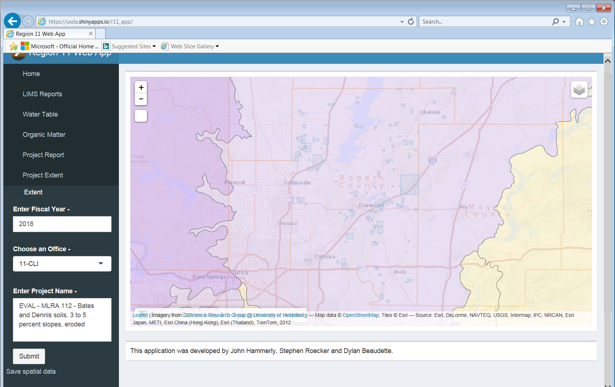
Could you have the MLRA’s display either with more transparency or below the Mapunit and roads as those to features are the most important in my mind.
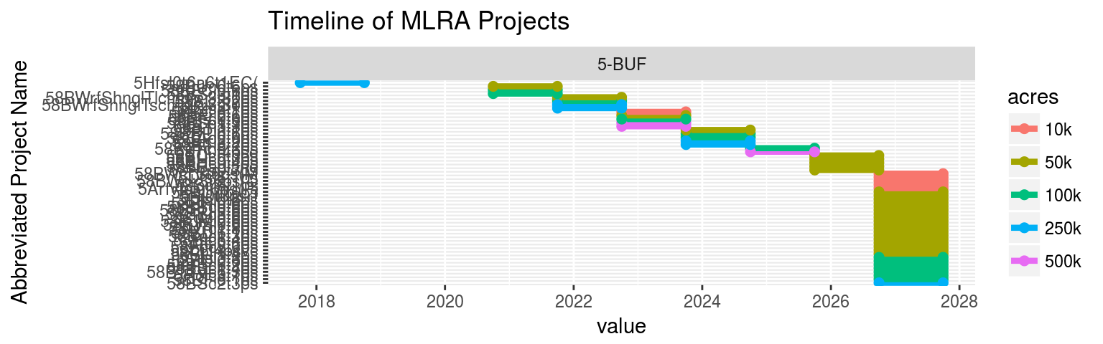
This is what I see in the report

