**T-BAS v2.1 How to Use the T-BAS Color Editor**

1) When T-BAS creates a tree it randomly assigns colors to attributes from all colors in the spectrum. For each attribute the rows in the legend are arranged by color so that one can try to find the label of a color by looking in the legend. The colors can be changed in the color editor. However, the order of entries in the legend remains as for the original colors assigned.

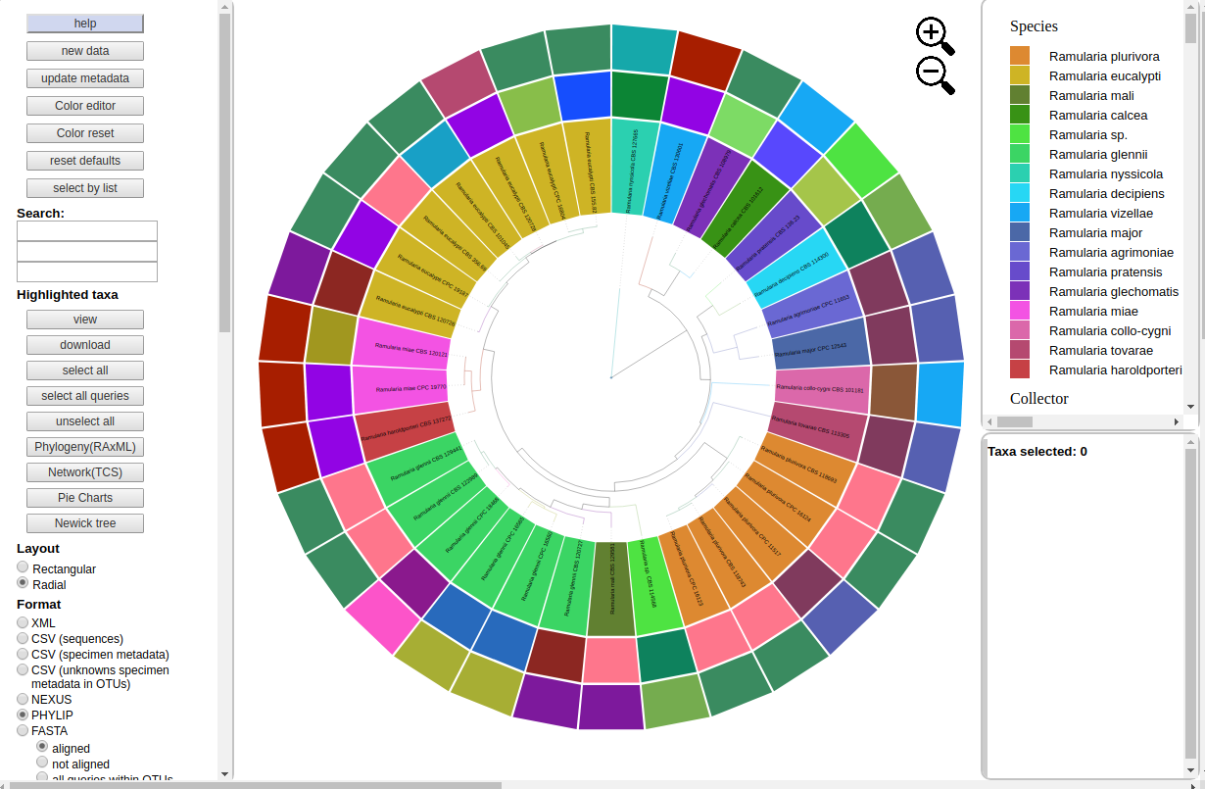

2) To change the colors click the color editor button and the color editor window will pop up. The section on the right is used to visually set a color if the desired hex color value is not known. It is used by moving the mouse to the center of one of the 3 rows indicating HSL (hue, saturation, lightness). Click one of the bars and move it to see the new color.

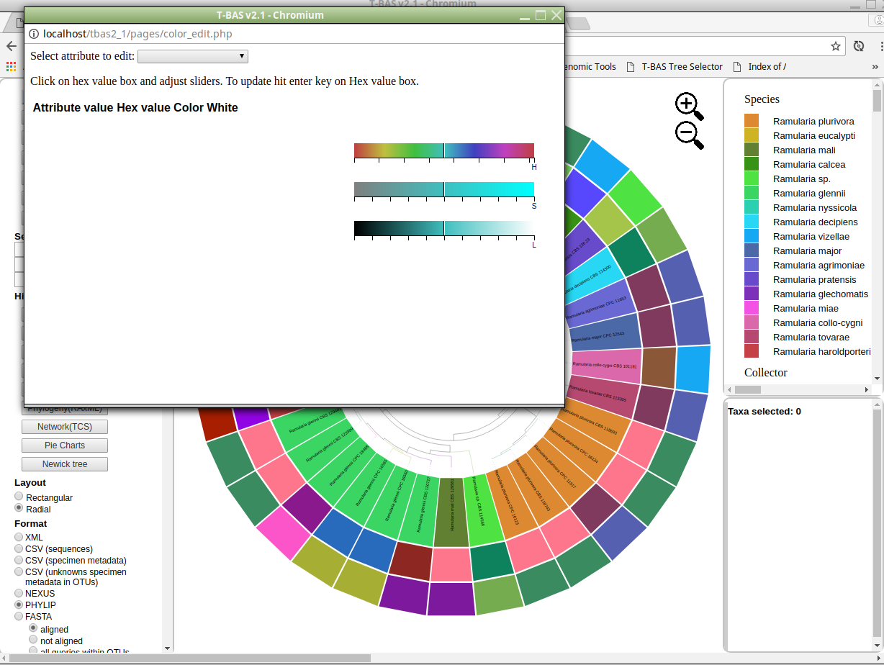

3) Select an attribute to edit and the current legend and colors will show. In the example the color for Ramularia eucalypti was changed from tan to light blue. To do this click in the box for the hex value of Ramularia eucalypti and then move one of the bars on the right to select a new color. As you move the bar the number in the hex value box will change the colors in the editor will change. When the desired color appears click again in the hex box and hit enter. The colors will be udpated in the color editor, in the tree and the legend.

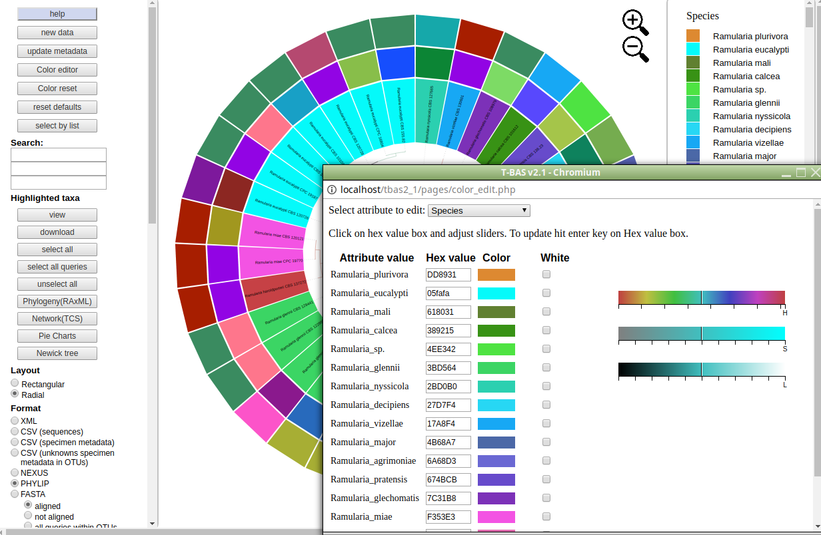

4) Edit as many values or attributes that you like. The second band is collector. The example shows the slider on the second bar moved to the right. This is then updated to change the color for P.W. Crous.

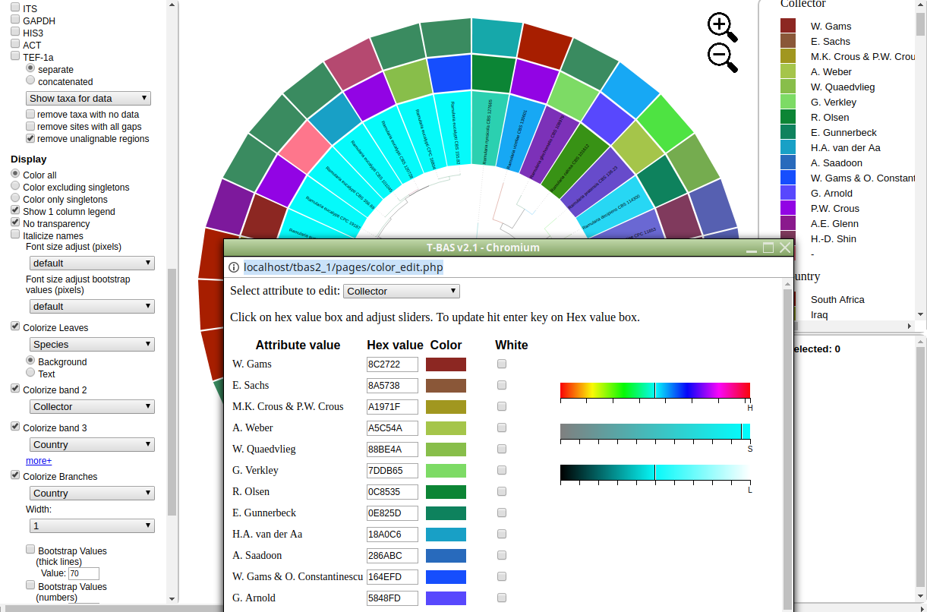

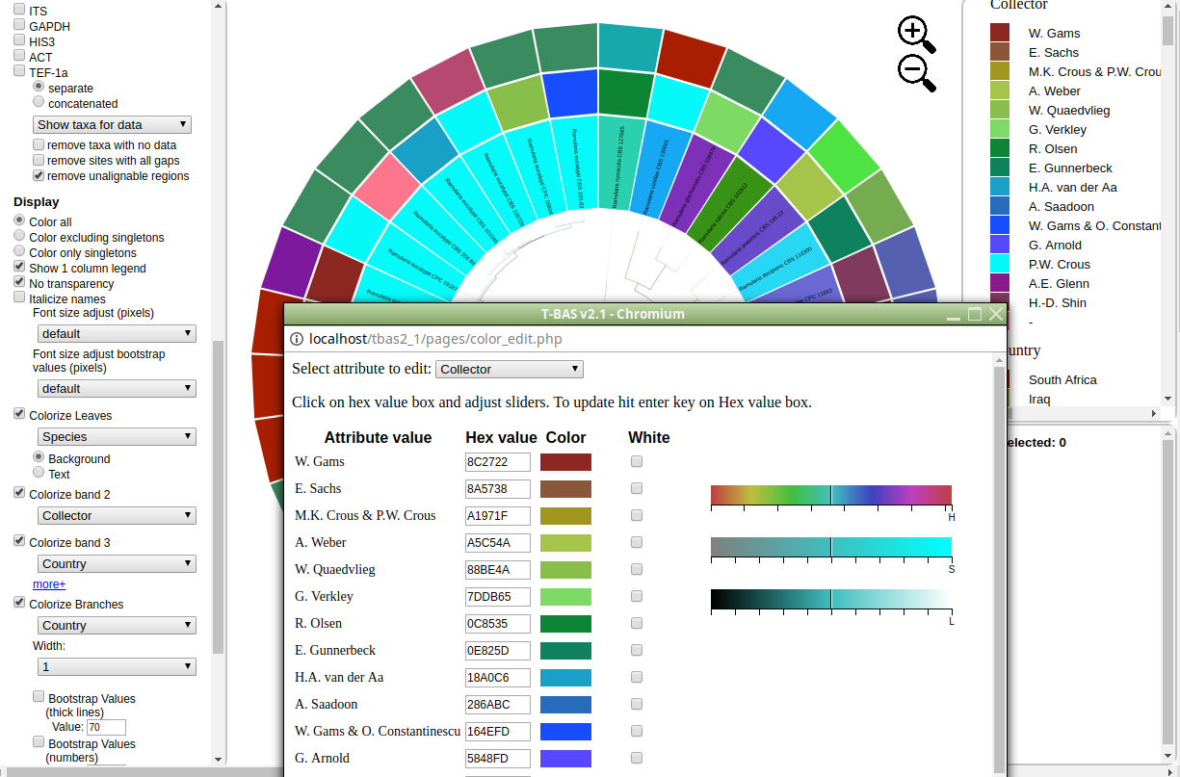

5) Clicking the color reset button below the color editor button will undo all changes. To copy a color scheme from one tree to another copy hex values and then enter them in the the color editor on the second tree.