**T-BAS v2.1 Tutorial 4: Using cifr phyloXML to Create New Trees**

1) Select Upload tree page and click the Newick tree radio button. Use example tree, sequence and metadata. Edit the partition block changing the names from locus1, locus2 … to the actual names.

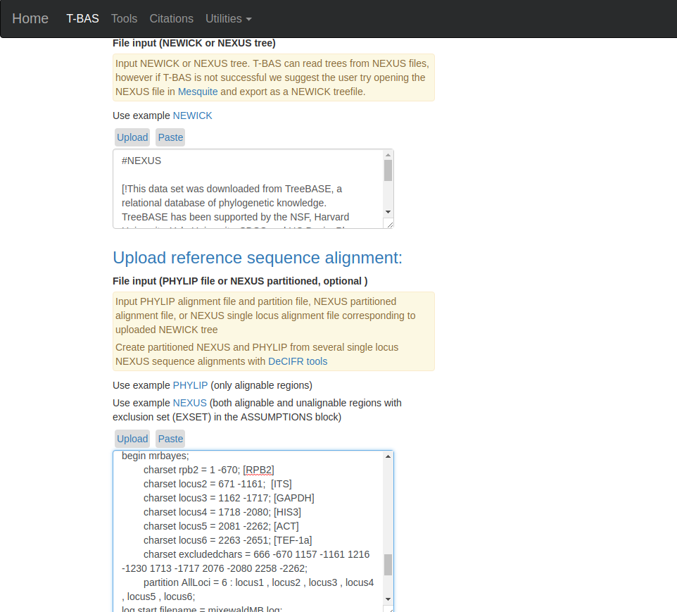

2) Open the placement analysis section but selecting the yes radio button, and select unknowns ITS file 1.

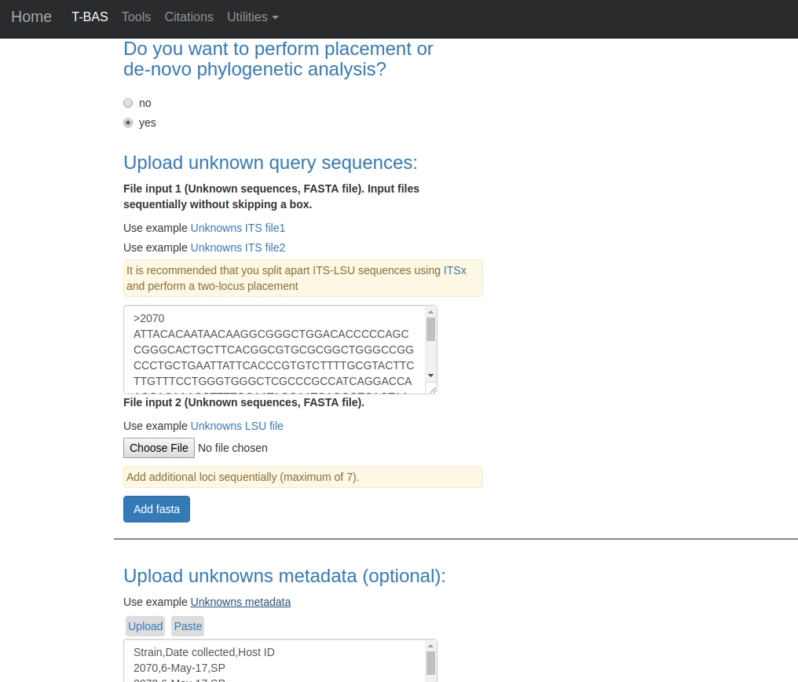

Next, in Cluster options, select skip, and for RaxML options select backbone constrain tree, and click submit.

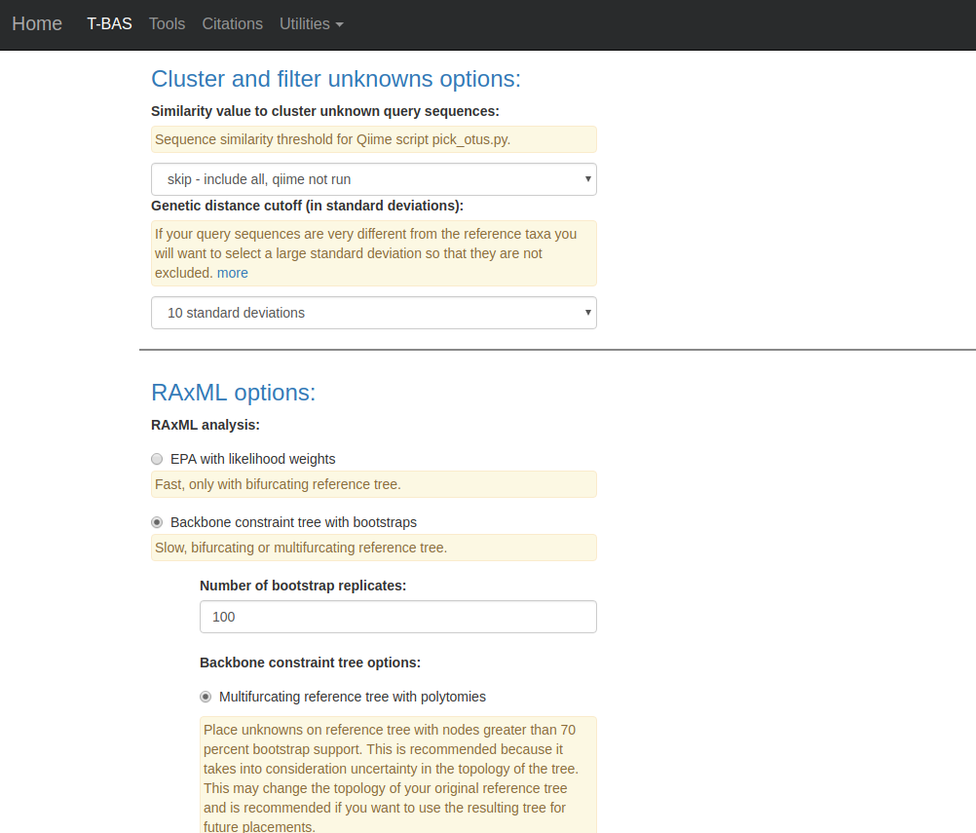

3) On the next page select the its partition for alignment of unknowns and submit.

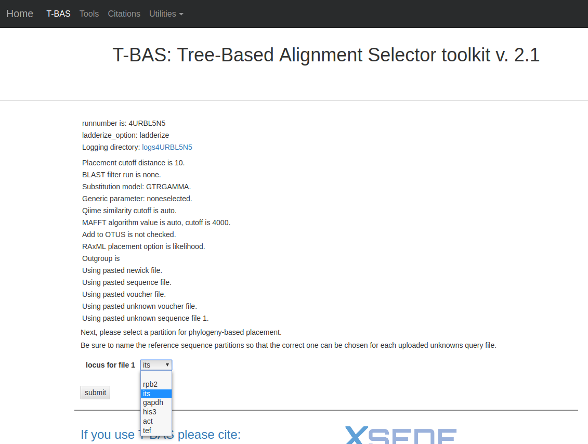

4) When the run is finished click view tree to see the placements.

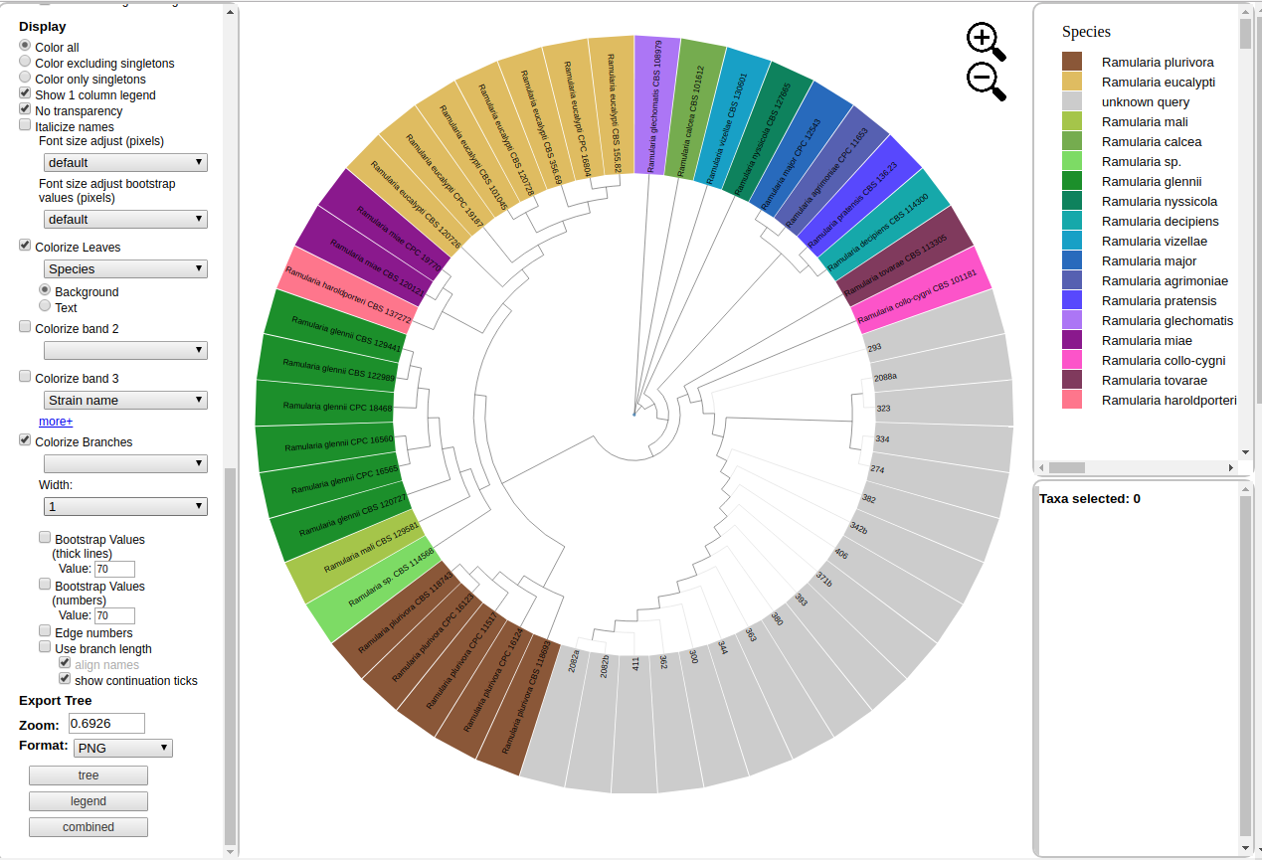

5) Next click on the update metadata button to edit the attributes table.

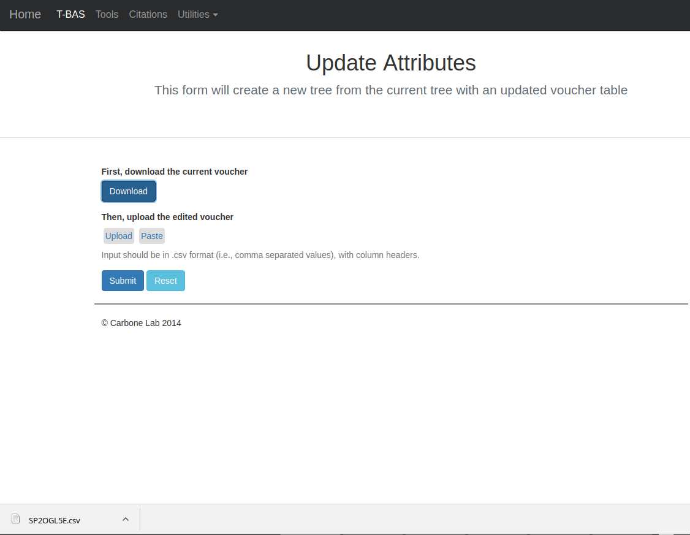

6) Clicking the download button will download the current attribute table. Open this is a spreadsheet program. Here the species column is sorted so that all queries, which have the Species value unknown_query are together.

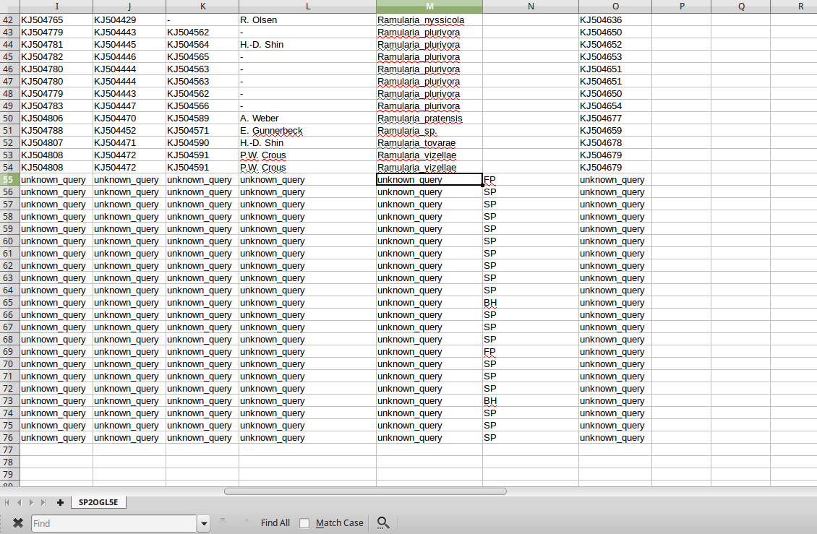

Next edit these species entries to the match in the placement, which was Ramularia_collo-cygna, save this file, click the upload button, select the edited file and submit.

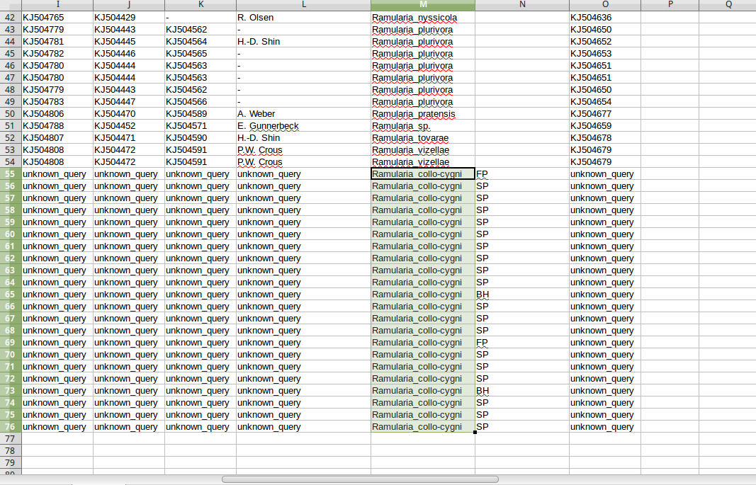

A new tree is created with the edited values.

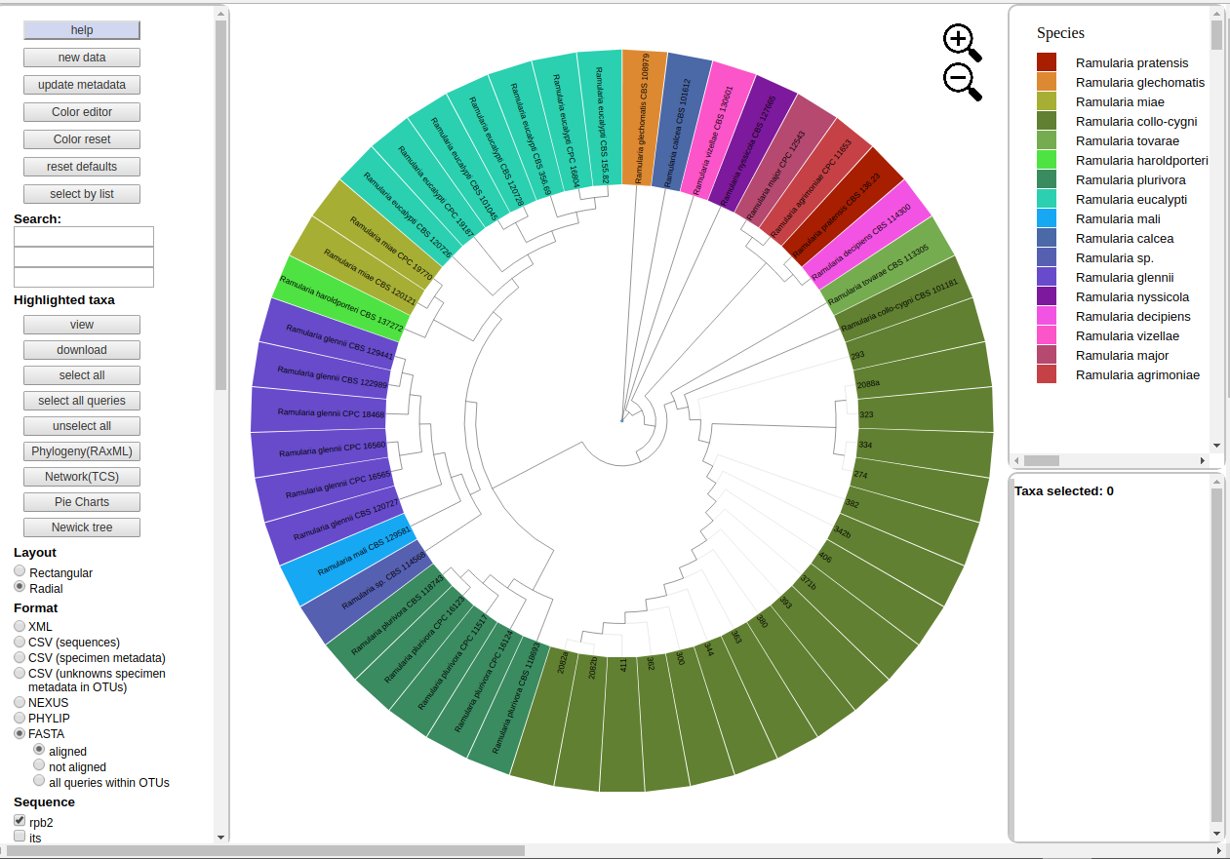

7)

There is a link after the edit attributes is finished for an XML file. Save this. Optionally you can uncompress and view the file. Here is the top of the file viewed in an XML viewer program.

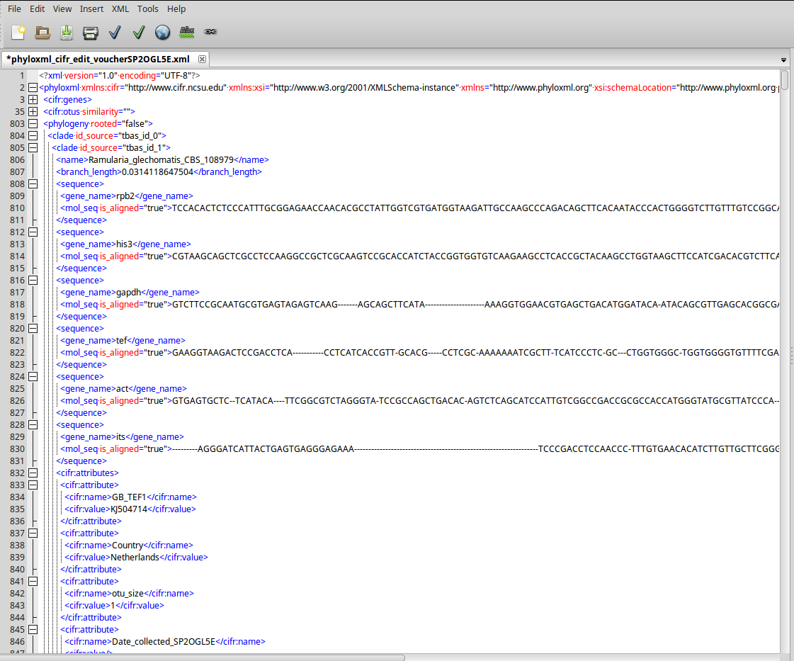

8)

Return to the Upload tree page and select upload tree as cifr phyloXML. Select the XML file that was saved in the edit attributes step. Also, since the edit attributes is optional there is a link on the run page to download the unedited XML file.

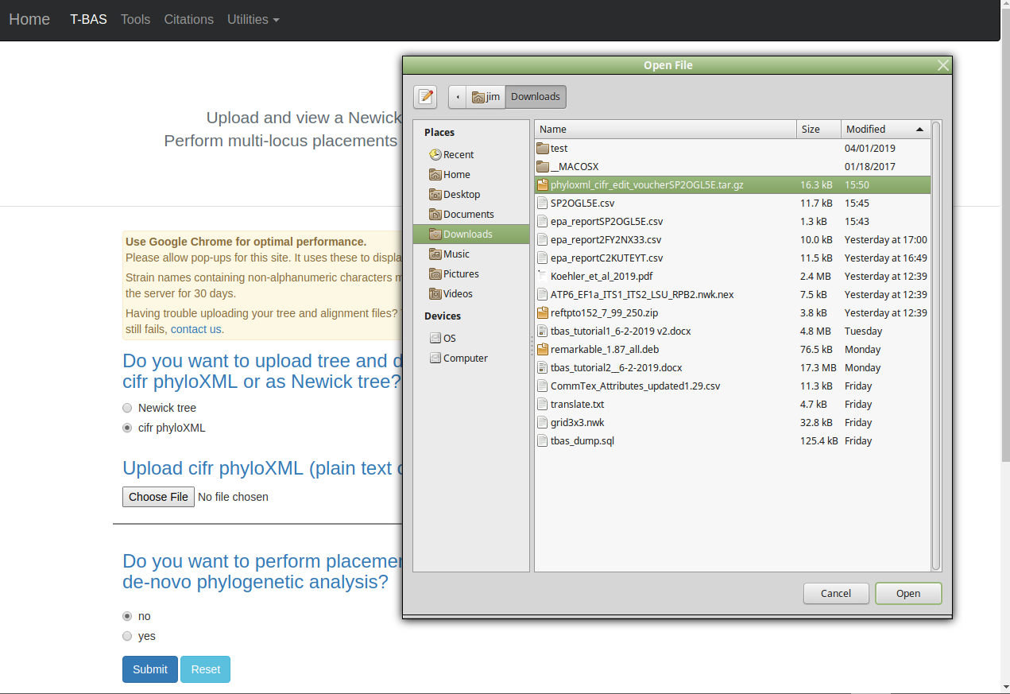

9) For placement select the same options as above but select the second ITS example file and run. The tree created by the second run is displayed.

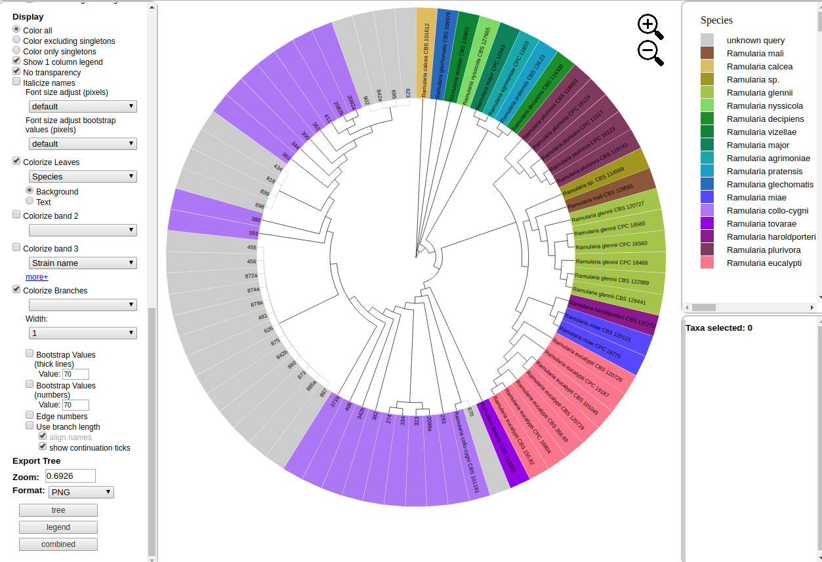

10) The assignments file now shows the species level assignments as Ramularia collo-cygni from the edit made to the attributes table species column of the first run

