Topic: Data models

# Introduction

Task, motivation

# Methods

The raster and vector data were added to the layer management tools and displayed at appropriate spatial extent and resolution using the default color maps and basic line symbols. Spatial extent for our study area was set and resolution was defined at 30m …

Metadata information stored with each map layer was used to identify the original raster data resolution, spatial extent and range of values…

# Results

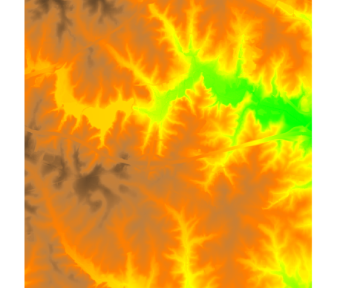The data set includes raster and vector data layers for North Carolina at several spatial extents and resolutions. The elevation and road map for the study area is in the Fig. 1…..

The state wide DEM and climate data points are in Fig. 10

Figure 1: Elevation raster

We set the computational region to match the raster elevation (When showing textual output of a module, use style Verbatim which uses monospace font):

projection: 99 (Lambert Conformal Conic)

zone: 0

datum: nad83

ellipsoid: a=6378137 es=0.006694380022900787

north: 734132.59185159

south: 731672.4061379

west: 2092185.68036389

east: 2094646.84229405

nsres: 6.00045296

ewres: 6.00283398

rows: 410

cols: 410

cells: 168100

# Discussion

Displaying the data in both systems was straightforward. The default color table for the elevation data was fuzzy, classification into fewer discrete classes in ArcGIS or conversion to integers brings out the contours. More detailed representation was achieved by relief shading.

I could not get GRASS to display points using the circle symbol – I was getting the following error. It was impossible to find where to set the resolution when displaying the elevation data in ArcGIS

# What I learned

I got familiar with GRASS basics and with the data set. I learned how to identify the resolution of my raster data in ArcGIS and that it can be different from the resolution of the displayed raster.