Tools for open geospatial science

Make your science stronger by making it transparent and reproducible.
New course, Fall 2017
GIS 610-003 and -603
On campus and Distance
The course will:
- focus on open science and reproducibility of geospatial analyses,
- use geospatial open source tools,
- introduce general-purpose and text authoring tools,
- and uncover mysteries of open source.
The students will:
- understand the emerging field of open science,
- gain hands-on experience with variety of open source tools,
- try tools used useful in science and heavily used in industry,
- and see how to use the same approaches in their own research. Why to take it?
Why to take it?
- I want my computations validated by other researchers.
- I want my research to be reused by a wider community.
- I want to learn about science, but also gain knowledge marketable in industry.
Why not to take it?
- I don't like other people using my research because only I understand it.
- I don't want people finding mistakes in my calculations.
- I like to send my documents through email with names like joes_corrections_FINAL_3.
Some of the software covered: Jupyter Notebook, QGIS, Markdown, Authorea, Linux, Git, Overleaf, GRASS GIS, GDAL, Leaflet, Docker
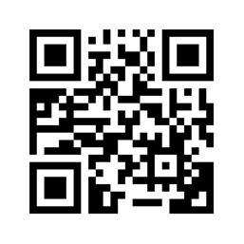
Lecture combined with hands-on exercise which overlaps with a short homework
Distance or Wed 3:00pm - 4:50pm (110 min), Jordan Hall 5119, S/U, 1 credit
Contact: Vaclav (Vashek) Petras, vpetras@ncsu.edu
URL: https://goo.gl/0xpyYk

