Intro to Graphing in Excel Activity Guide

Adapted from Duke University Library’s [Advanced Excel for Data Projects](https://duke.app.box.com/v/advexcelspring2016)

### Download the data: [go.ncsu.edu/excelgraphs](https://go.ncsu.edu/excelgraphs)

### Super fast overview of excel

* 1. Cells contain values, formulas (i.e. =3+2), functions (=SUM(3,2))
  2. Range (a collection of two or more cells)
  3. Copy and paste values

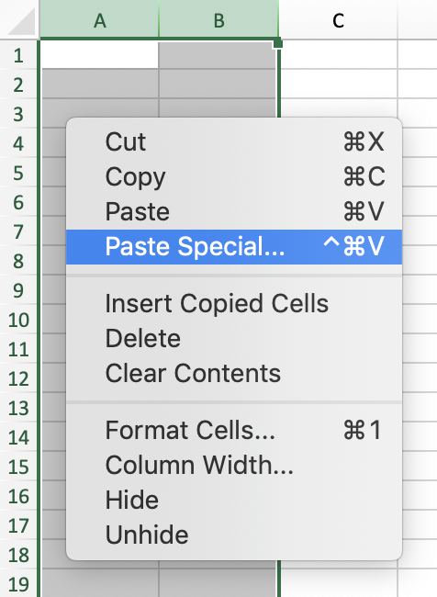 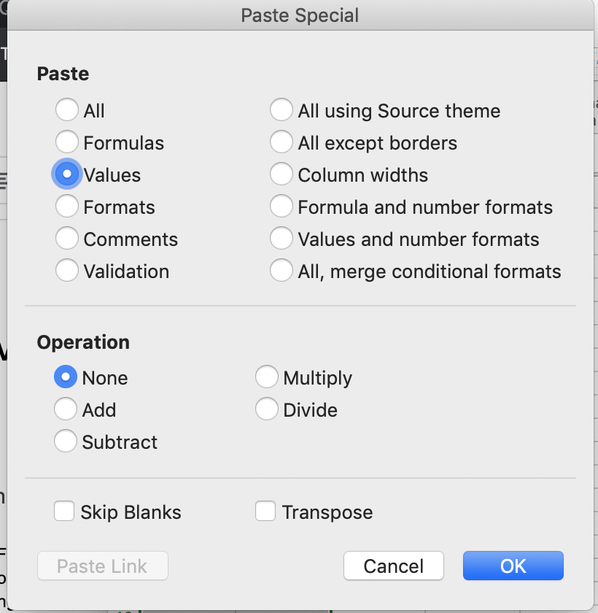

* 1. Fill a range (same number down one column) & auto-fill cells
  2. One awesome shortcut (Command + up, command + down (mac) OR ctrl + up, ctrl + down (PC)

### Prepping data: create a new category to distinguish between hosts with one property or multiple properties listed

* 1. Select Column B and then click on “Data” > “Advanced” (Filter). 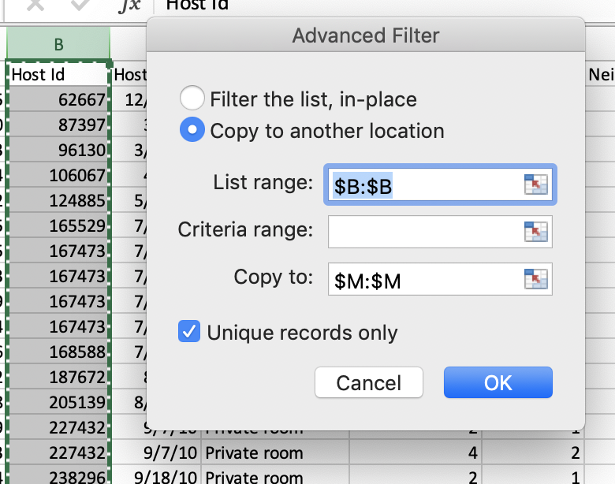
  2. Click on “Copy to another location,” List range should automatically fill with $B:$B, and Copy to $M:$M (the easiest way to enter a range is to select it on the spreadsheet). Check “Unique Records only.”
  3. In the column next to the unique host IDs (Column N), enter the following calculation:

=COUNTIF(B:B,M2)

and auto-fill down the column by double-clicking on the bottom right corner of cell N2

* 1. Copy Column M and N (command + c or ctrl + c). Navigate to a new worksheet and right-click column A > Paste special > Values.
  2. Sort using the largest to smallest sort button and click sort.

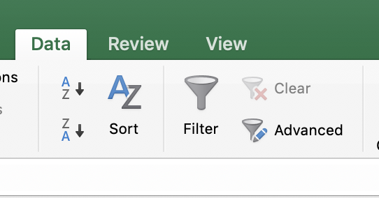

* 1. In the new worksheet, next to Column A, enter the following calculation

=IF(B2>1,"multiple","single") and auto-fill down the column

* 1. Use VLookUp to match HostID with appropriate category. Go back to the original sheet, add a column to the right side of the Host ID column (Column C)

=VLOOKUP(airbnb_asheville_excel!B4, Sheet1!A:C, 3)

### **Creating pivot tables** help us summarize data so we can answer questions, i.e. What zip-code had the highest number of listings per year? What zip code has the most hosts who list multiple properties?

* 1. Select the PropNum column
  2. Under the Insert tab, select “Pivot Table”
  3. Check PropNum and drag it under both Rows and Values
  4. Copy the table (omitting the totals row) and paste the values only below the pivot table. This copied table is what we will use to create a graph.
  5. Go back to the original worksheet and select column PropNum and Neighborhood. Under the Insert tab, select “Pivot Table”
  6. Check Neighborhood Zip and drag it under both Rows and Values. Make sure the Neighborhood Zip under Values says Count of Neighborhood Zip, and not Sum of Neighborhood Zip. To change it, double click on the ‘i’ icon next to it and select Count.
  7. Select the arrow next to Row Labels, and select Descending order, and use the drop down list to sort by Count of Neighborhood Zip 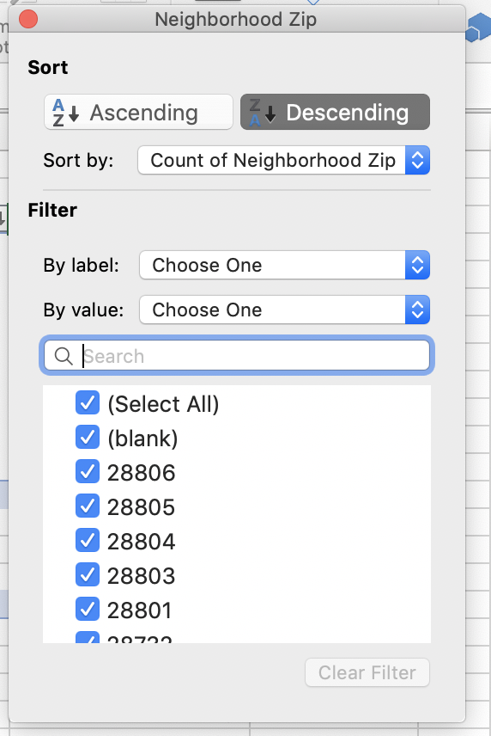
  8. Drag and drop the PropNum under Columns.
  9. Copy the table (omitting the totals row) and paste the values only below the pivot table. This copied table is what we will use to create a graph.

### Creating graphs using pivot tables

* 1. Simple bar chart & pie chart
     1. Go to the sheet with the counts of multiple vs single listings
     2. Select the values only table > Insert > Recommended charts > Clustered Chart
     3. In the Chart Design tab:
        1. Select “Add Chart Element” > Data Labels > Outside End
        2. Select “Add Chart Element” > Gridlines > uncheck “Primary Major Horizontal”
     4. In the “Format” tab:
        1. Select “Chart Title” > Home and change font size to 14
        2. Select “Series “Count of PropNum” > “Series Options” and change the Gap Width to 50%
        3. Select “Series “Count of PropNum” Data Labels > Home and change font size to 10
        4. Select “Chart Area” OR double-click on the chart, in a blank space, next to the bars. Under Fill, select “No fill”
     5. Right-click on the chart and select “Save as Picture” > barChart.png. This will let you save this chart with a transparent background so you can add to presentations with solid backgrounds.
     6. Convert to a pie chart by right-clicking on the chart and selecting “Change Chart Type” > selecting “Pie” and choosing the first option under 2D.
     7. Select “Add Chart Labels” > “Data Labels” > “More Data Label Options” > check “category name”
  2. Stacked bar chart
     1. Go to the sheet with the counts of multiple vs single listings by zip code
     2. Select the values only table > Insert > Column Chart > Stacked Column
     3. Right-click on the chart and select “Select Data”
        1. Select Row Labels and remove it from the Legend entries (series) list by selecting the - sign.
        2. In the Horizontal (category) axis label, select all the zipcodes.
     4. Follow the steps above to format the title, font size, and labels on the columns to re-create this chart:

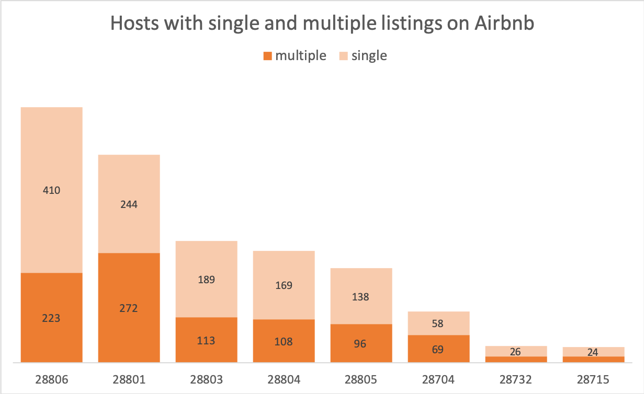

* 1. Scatterplot
     1. Go to the sheet with the raw data (the main sheet) and select the columns with Price and Ratings
     2. Insert > Column Chart > Scatterplot
     3. Use the Chart Design and Format tabs to edit the chart.

### Try it yourself!

* 1. What room type do most hosts list? Do hosts with multiple properties listed tend to list a specific type of room type?

# Resources

* Data and visualization workshops: <https://www.lib.ncsu.edu/workshops/category/data-and-visualization>
* Data and visualization services portal: <https://www.lib.ncsu.edu/services/data-visualization>
* Drop-in help with data science at Hill and Hunt libraries: <https://www.lib.ncsu.edu/spaces/dataspace>
* LinkedIn Learning Tutorial - Excel Charts in Depth: <https://www.linkedin.com/learning/excel-charts-in-depth/add-power-to-your-data-with-charts>
* Duke Libraries' Excel Guide: <https://guides.library.duke.edu/excel>
* Exercise references
  + Line chart exercise adapted from "Choosing a Chart Type" by Noreen Brown, Barbara Lave, Julie Romey, Mary Schatz, Diane Shingledecker under a Creative Commons Attribution 4.0 International License from <https://openoregon.pressbooks.pub/beginningexcel/chapter/4-1-choosing-a-chart-type>
  + Clustered column exercise adapted from "Choosing a Chart Type" by Noreen Brown, Barbara Lave, Julie Romey, Mary Schatz, Diane Shingledecker under a Creative Commons Attribution 4.0 International License from <https://openoregon.pressbooks.pub/beginningexcel/chapter/4-1-choosing-a-chart-type>
  + Pie chart exercise adapted from "Choosing a Chart Type" by Noreen Brown, Barbara Lave, Julie Romey, Mary Schatz, Diane Shingledecker under a Creative Commons Attribution 4.0 International License from <https://openoregon.pressbooks.pub/beginningexcel/chapter/4-1-choosing-a-chart-type>
  + Pie Chart Best Practices: <https://www.excelcampus.com/charts/pie-charts-best-practices>
  + Pie chart data source: <https://www.tsp-data-portal.org/Breakdown-of-Energy-Production-Statistics>
  + Trendline exercise adapted from Vanderbilt University Libraries Excel Reference and Statistics Manual under a Creative Commons Attribution-ShareAlike 4.0 International License from <http://researchguides.library.vanderbilt.edu/c.php?g=69346&p=855833>
  + Sparklines data source: National Oceanic and Atmospheric Administration. (1910-2015). Climate at a glance [Data file]. Retrieved from <http://dx.doi.org/10.4135/9781473995390>