Getting Started with Tableau

*We will create several charts and a map to explore airbnb data in Asheville, North Carolina. We will use data prepared from* [*http://insideairbnb.com.*](http://insideairbnb.com)

### Download the data: [go.ncsu.edu/begintableau](https://go.ncsu.edu/begintableau)

### Getting Started

* 1. Open Tableau Public.
  2. Under ‘Connect To a File’ select ‘Text file.’
  3. Navigate to the folder containing the downloaded data from Step 1 and select ‘airbnb_asheville.csv’.
  4. The file will appear as a connection in the ‘Data Source’ tab.

### Create a bar chart to learn more about airbnb hosting trends in Asheville, NC.

* 1. Create a new sheet named “Stacked Bar Chart”
  2. Click and drag the ‘Neighborhood Zip’ pill under ‘Dimensions’ to ‘Columns’
  3. Click and drag ‘*Number of Records*’ under ‘Measures’ to ‘Rows’
  4. Click and drag the ‘PropertyNum” pill under ‘Dimensions’ to the ‘Color’ button. Click on ‘Color’ to edit colors.
  5. Click and drag the ‘*Number of Records*’ pill under ‘Measures’ to the ‘Label’ button. Click on ‘Label’ to format label text.
  6. In the menu at the top of the worksheet, click  to sort the chart in descending order.

### Create a line chart to visualize number of new hosts that manage single properties and multiple property annually

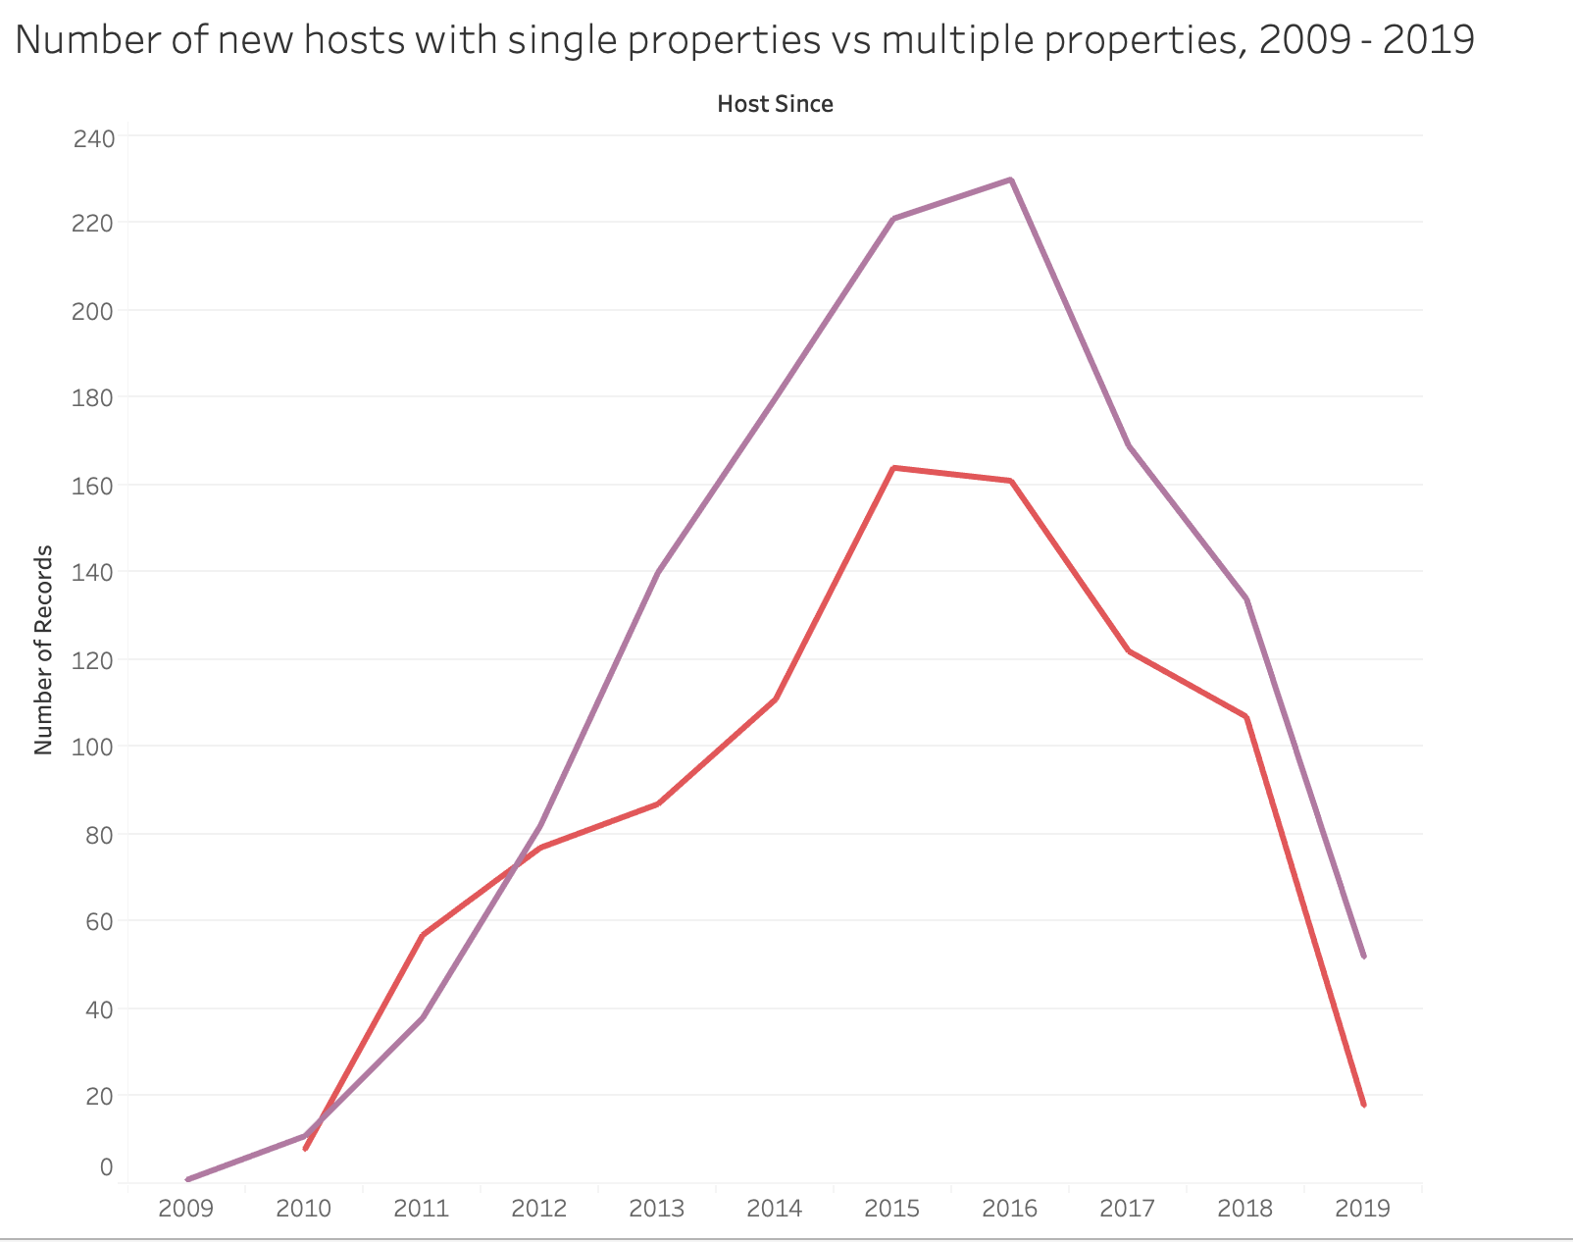

* 1. Create a new sheet named “Line Chart”
  2. Click and drag the “Host since” pill under “Dimension” to ‘Columns’ (X-axis)
  3. Click and drag the “Number of Records” pill under “Measures” to ‘Rows’ (Y-axis)
  4. Click and drag the “PropertyNum” pill under “Dimension” to the marks box “Color”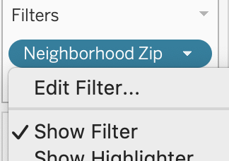
  5. Click and drag the “Neighborhood zip” pill under “Dimension” to the Filter box. Select all and click ok. Click on the upside down triangle that appears when you hover on the right side of the blue pill in the Filter box and select “Show Filter.”

### Create a map of airbnb properties in Asheville and distinguish between properties listed by single property ‘managers’ and multiple property ‘managers/owners’.

* 1. Create a new sheet named “Map”
  2. Click and drag the “Longitude” pill under “Measures” to ‘Columns’
  3. Click and drag the “Latitude” pill under “Measures” to ‘Rows’
  4. If you have a single point on your map: Select Analysis at the top ribbon, and de-select “Aggregate Measures”

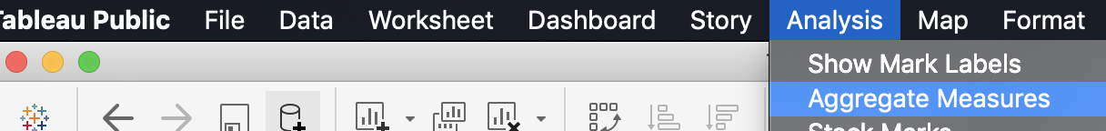

* 1. Click and drag “PropertyNum” under “Dimensions” to the “Color” box.
  2. Click and drag “Host ID” under “Dimensions” to the “Tooltip” box.
  3. Select Map > Map Layers at the top. Add detail to the basemap: Check the following layers: Streets and Highways, Zip Code Boundaries, Zip Code Labels, & Points of interest

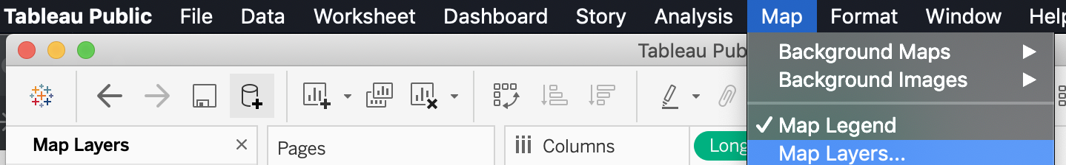

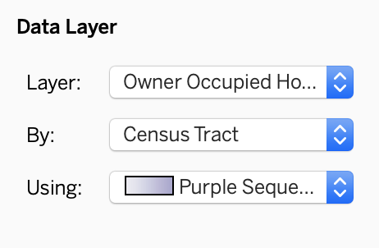

* 1. Add a data layer from US Census by selecting the drop down option for Layer, select: Owner Occupied Housing Value (median), By: Census Tract, and change the color to a different color scheme (Purple Sequential)

## Create an interactive dashboard

### Setup the dashboard

* 1. Click the ‘New Dashboard’ button to create a new dashboard, ‘Dashboard 1’. 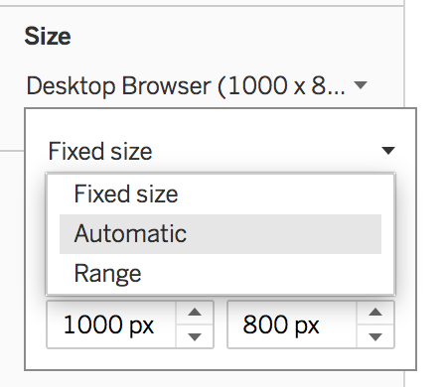
  2. In the ‘Dashboard 1’ view under ‘Size’ open the dropdown menu and then open the dropdown menu next to ‘Fixed size’ and select ‘Automatic’.
  3. Drag and drop sheets to the dashboard to position them where you like.

### Arrange the legends

* 1. Click somewhere within the ‘Groups’ legend, open the dropdown menu, and select ‘Floating’ to set the position of this graphical object to floating.
  2. Click and drag the floating ‘Measure Names’ legend and place it thoughtfully on the map.

### Connect graphics through interaction

* 1. Back in the ‘Dashboard 1’ view open the ‘Dashboard’ menu at the top of the screen and select ‘Actions…’.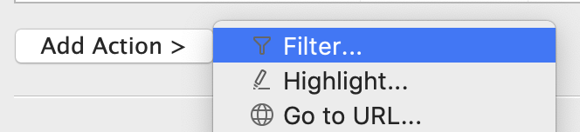
  2. In the ‘Actions’ popup menu click ‘Add Action >’ and select Filter...’.
  3. In the ‘Add Filter Action’ popup menu under ‘Source Sheets’ ensure sheets 1, 2, and 3 are checked and set ‘Run action on:’ to ‘Select’.
  4. Ensure sheets 1, 2, and 3 are checked under ‘Target Sheets’.
  5. Click OK to save.