
ATM APPLICATION
Group
CE140589 Nguyen Cao Thong
CE140024 Nguyen Pham Dinh Phuc
CE140451 Nguyen An Khoa
CE130379 Pham Le Anh Khoa

Instructor: HuongLH
TABLE OF CONTENTS
I. Problem Definition...…………………………………………………………………………………... 3
II. Project Details.……………………………..…………………………………………………………….. 4
III. User Requirements…………………………………………………………………………………….. 5
IV. Hardware and Software Requirements……………..………...……….……….………….... 6
V. Schedule……………….………………………………………………………………………………….… 7
VI. Structure of Data Files………………………………………..…………………………………….. 10
VII. Class Diagram…….……..…..…………...…………………………………………………………….. 12
VIII. Algorithm ……………………………………………………………………………………………. 14
IX. Checklist………………...………………………...…………………….…………………………………. 20

Problem Definition
An automated teller machine (ATM), also known as a Cash Machine and by several other names is a computerized device that provides the clients the financial institution without the need for the cashier .The client is identified by inserting unique card number and some security information.A user can assess the ATM(Automatic Teller Machine) system / screen only after entering the correct user name and the password on the very first screen which is installed on the the ATM room. The user name should be the unique card number provided to the user and the password can be any numeric number of four digits which is called as PIN (Personal Identification number)

PROJECT DETAILS
1. About the client
- Name of client: Luong Hoang Huong
- Address:
- E-mail address:
- Contact number:
2. About the group
- Name of group: Group
+ Leader: Nguyen Cao Thong
+ Member: Nguyen Pham Dinh Phuc
+ Member: Nguyen An Khoa
+ Member: Pham Le Anh Khoa
- Address: FPT University, Nguyen Van Cu Street, An Binh Ward, Ninh Kieu District, Can Tho
- Email address:
+ KhoaPLACE130379@fpt.edu.vn
+ ThongNCCE140589@fpt.edu.vn
+ PhucNPDCE140024@fpt.edu.vn
+KhoaNACE140451@fpt.edu.vn
- Contact number: 098-163-5471 (Thong)

Customer Requirement Specification
Each time the user tries to enter the ATM need to use the same password which is entered at the very first transaction (unless the user changes the password with the option of the ATM system). Once the user name and the password are verified the ATM screen would appear. Each time a new user enters the ATM room are suppose to provide their authentication details.
The initial screen of the ATM system should appear “Enter your card number” button along with the keypad. Once the card number is entered and button is clicked it should check its availability in the database and if it is not available then the error message should be generated stating the user is invalid else the password field would appear, user needs to enter the password. Once the password is verified, the screen appears with following menu: (main menu):
- Deposit
- Withdrawal
- Balance Enquiry
- Change Password
- Transfer money

HARDWARE AND SOFTWARE REQUIREMENTS
- Hardware requirements
2. Software requirements
- Windows 7 or higher
- JRE 1.7 or higher
- Additional file: joda-time-2.4.jar (downloadable here)
SCHEDULE
Start of project: November 15, 2019
End of project: December 8, 2019
Task No. | Task Description | Expected Completion Date | Expected Time Needed (hrs) | Members in charge
1 | Document writing 1:  - Table of Contents  - Problem definition  - Schedule  - Project details | 20-Nov-2019 | 3 | KhoaPLA  ThongNC
2 | Design & Document review 1 | 21-Nov-2019 | 1 | KhoaPLA  ThongNC  PhucNPD  KhoaNA
3 | Document writing 2:  - User requirements  - Hardware, software requirements | 22-Nov-2019 | 1.5 | KhoaPLA  ThongNC
4 | Coding 1: Admin & AdminManagement Class | 26-Nov-2019 | 3 | KhoaNA
5 | Coding 2: Main class | 6-Dec-2019 | 4 | ThongNC
6 | Coding 3: Complete all functions of admin menu without transaction detail | 30-Nov-2019 | 2 | KhoaNA
7 | Coding 4: User & UserManagement class | 2-Dec-2019 | 4 | PhucNPD  KhoaPLA
8 | Coding 5: Complete all functions of user menu without transaction detail | 4-Dec-2019 | 3 | PhucNPD  KhoaPLA
9 | Coding 6: TransactionManagement & complete code | 6-Dec-2019 | 3 | KhoaPLA  ThongNC  PhucNPD  KhoaNA
10 | Overview project code | 7-Dec-2019 | 1.5 | KhoaPLA  ThongNC  PhucNPD  KhoaNA
11 | Document writing 3:  - Class diagram  - User interface | 8-Dec-2019 | 3.5 | KhoaPLA  ThongNC
12 | Review, testing code and completion | 8-Dec-2019 | 2 | KhoaPLA  ThongNC  PhucNPD  KhoaNA

Class diagram

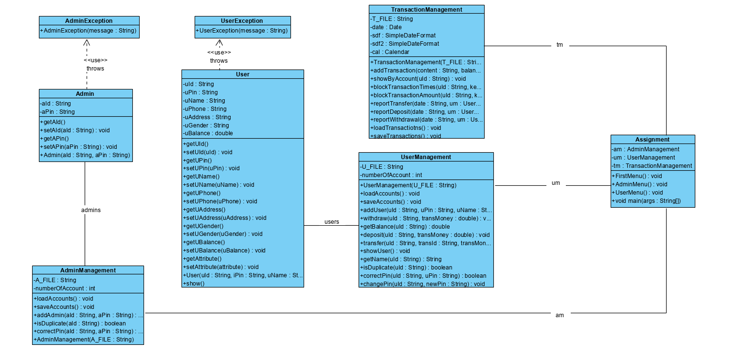

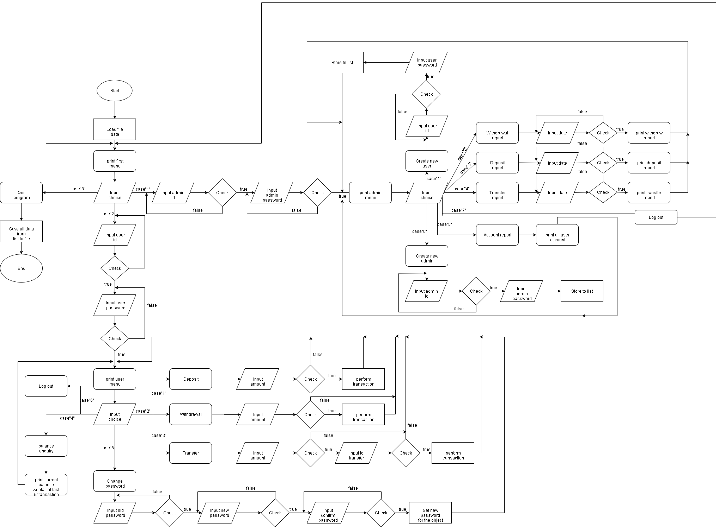

CHECKLIST

Task No. | Task Description | Expected Completion Date | Expected Time Needed (hrs) | Actual Completion Date | Actual Time Needed (hrs) | Members in charge | Progress check
1 | Document writing 1:  - Table of Contents  - Problem definition  - Schedule  - Project details | 20-Nov-2019 | 3 | 20-Nov-2019 | 2 | KhoaPLA  ThongNC | On time
2 | Design & Document review 1 | 21-Nov-2019 | 1 | 21-Nov-2019 | 1 | KhoaPLA  ThongNC  PhucNPD  KhoaNA | On time
3 | Document writing 2:  - User requirements  - Hardware, software requirements | 22-Nov-2019 | 1.5 | 22-Nov-2019 | 1 | KhoaPLA  ThongNC | On time
4 | Coding 1: Admin & AdminManagement Class | 26-Nov-2019 | 3 | 26-Nov-2019 | 3 | KhoaNA | On time
5 | Coding 2: Main class | 28-Nov-2019 | 3.5 | 28-Nov-2019 | 3 | ThongNC | On time
6 | Coding 3: Complete all function of admin menu | 30-Nov-2019 | 2 | 30-Nov-2019 | 2.5 | KhoaPLA  ThongNC  PhucNPD  KhoaNA | On time
7 | Coding 4: User & UserManagement class | 2-Dec-2019 | 4 | 2-Dec-2019 | 4 | PhucNPD  KhoaPLA | On time
8 | Coding 5: Complete all function of user menu without transaction detail | 4-Dec-2019 | 3 | 4-Dec-2019 | 2.5 | PhucNPD  KhoaPLA | On time
9 | Coding 6: TransactionManagement & complete code | 6-Dec-2019 | 3 | 6-Dec-2019 | 4 | KhoaPLA  ThongNC  PhucNPD  KhoaNA | On time
10 | Overview project code | 7-Dec-2019 | 1.5 | 7-Dec-2019 | 1 | KhoaPLA  ThongNC  PhucNPD  KhoaNA | On time
11 | Document writing 3:  - Class diagram  - User interface | 8-Dec-2019 | 3.5 | 8-Dec-2019 | 3 | KhoaPLA  ThongNC | On time
12 | Review, testing code and completion | 8-Dec-2019 | 2 | 8-Dec-2019 | 2 | KhoaPLA  ThongNC  PhucNPD  KhoaNA | On time

