**User Guide**

1. Home Page

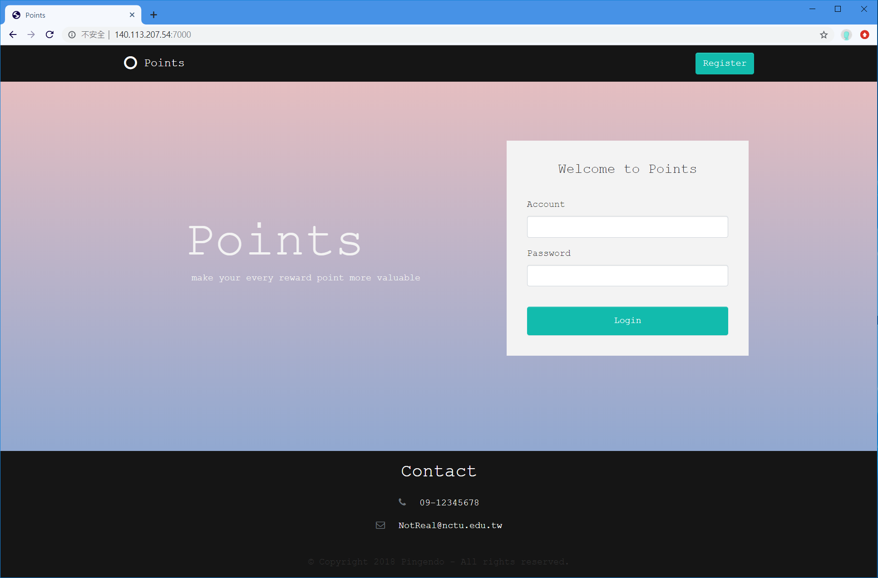

Figure 1

Figure 1 shows the home page of the reward point platform. We name the reward points circulated in this system “Points”, so the title of the website is also “Points”. In the middle of the page are the slogan and the login form. The bottom of the home page is designed for displaying the contact information of the developers.

1. Registration

Every beginner needs to register an account first. Click the “Register” button at the top right corner of the home page, and the website will redirect to the registration page. Figure 2 shows the registration page. Fill out the profile and click the “Register” button to complete the registration. After registering, the website will redirect to the corresponding page depends on the identity of the user, and the user will log in spontaneously.

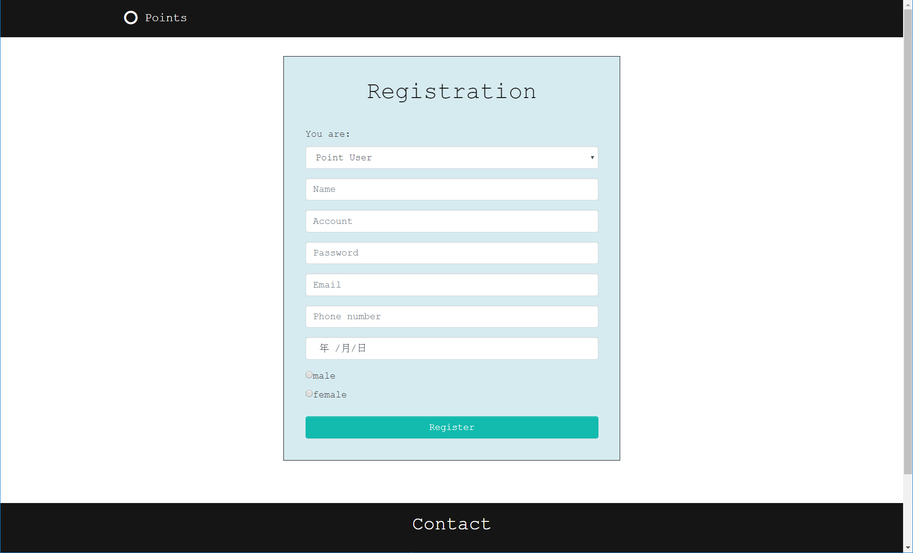

Figure 2

1. Login

Registered users have to log in to start enjoying our service. The login form is on the home page as shown in Figure 1. Fill out the account and the password and click “Login” button to log in. If there is no error, the website will redirect to the corresponding page depends on your identity.

1. Point User Page

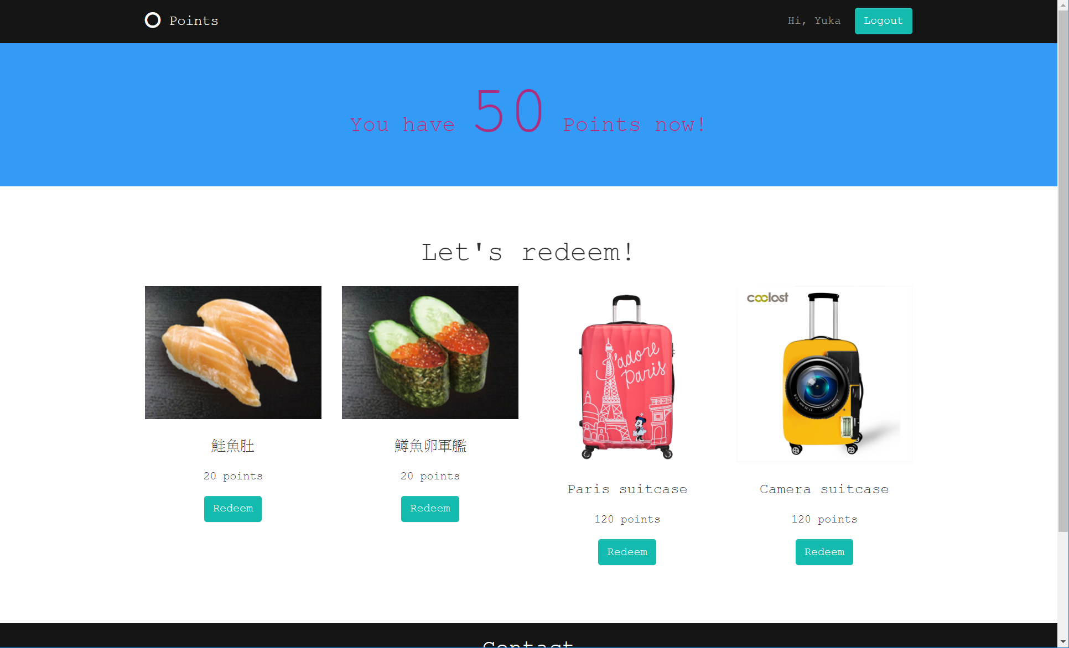

Figure 3

Figure 3 shows the point user page. The website redirects to point user page after a point user login. At the top of the page, there are greetings to the users and the “Logout” button. The point balance of the user is also displayed on the web page. Moreover, All the goods on the reward point platform for redeeming are listed. Point users could redeem the goods by click the “Redeem” buttons which are under the picture of goods.

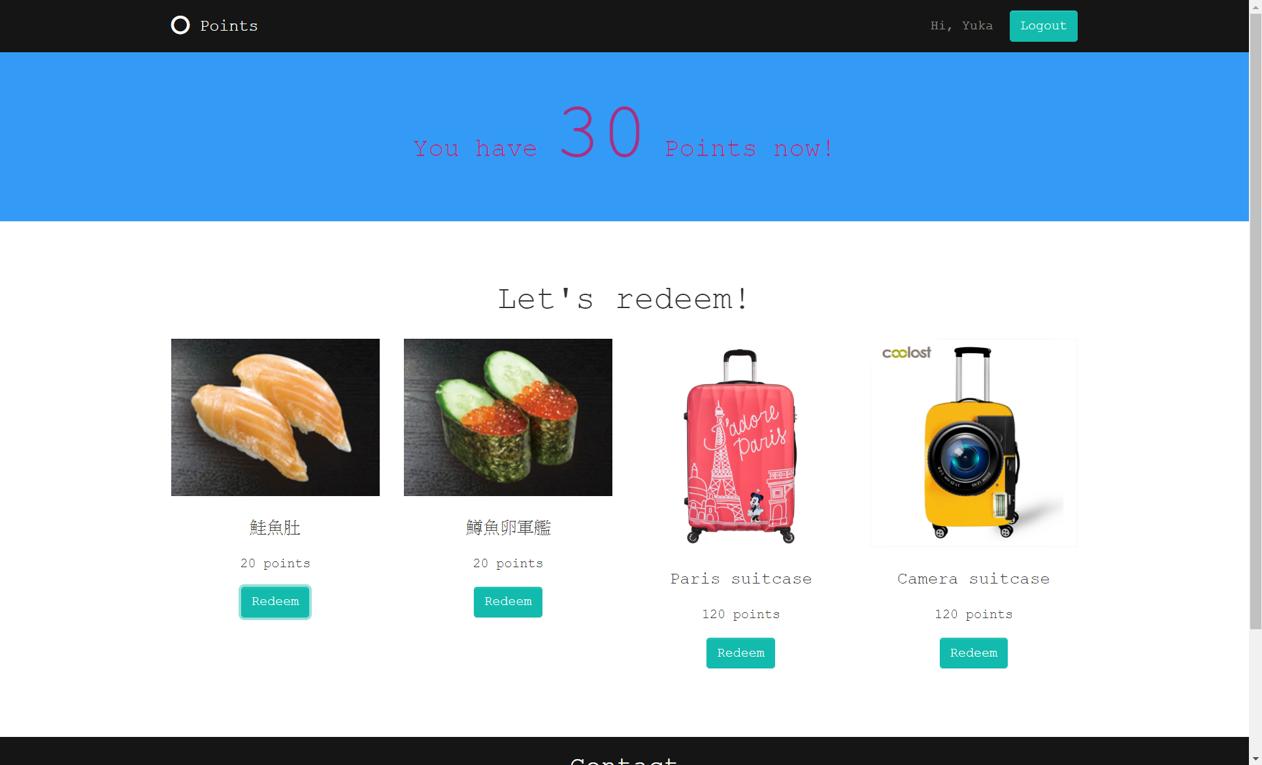

Figure 4

As shown in Figure 4, the point balance becomes 30 after the user redeems 20 points for the goods. Then, these 20 points go to the owner of the goods.

1. Point Provider Page

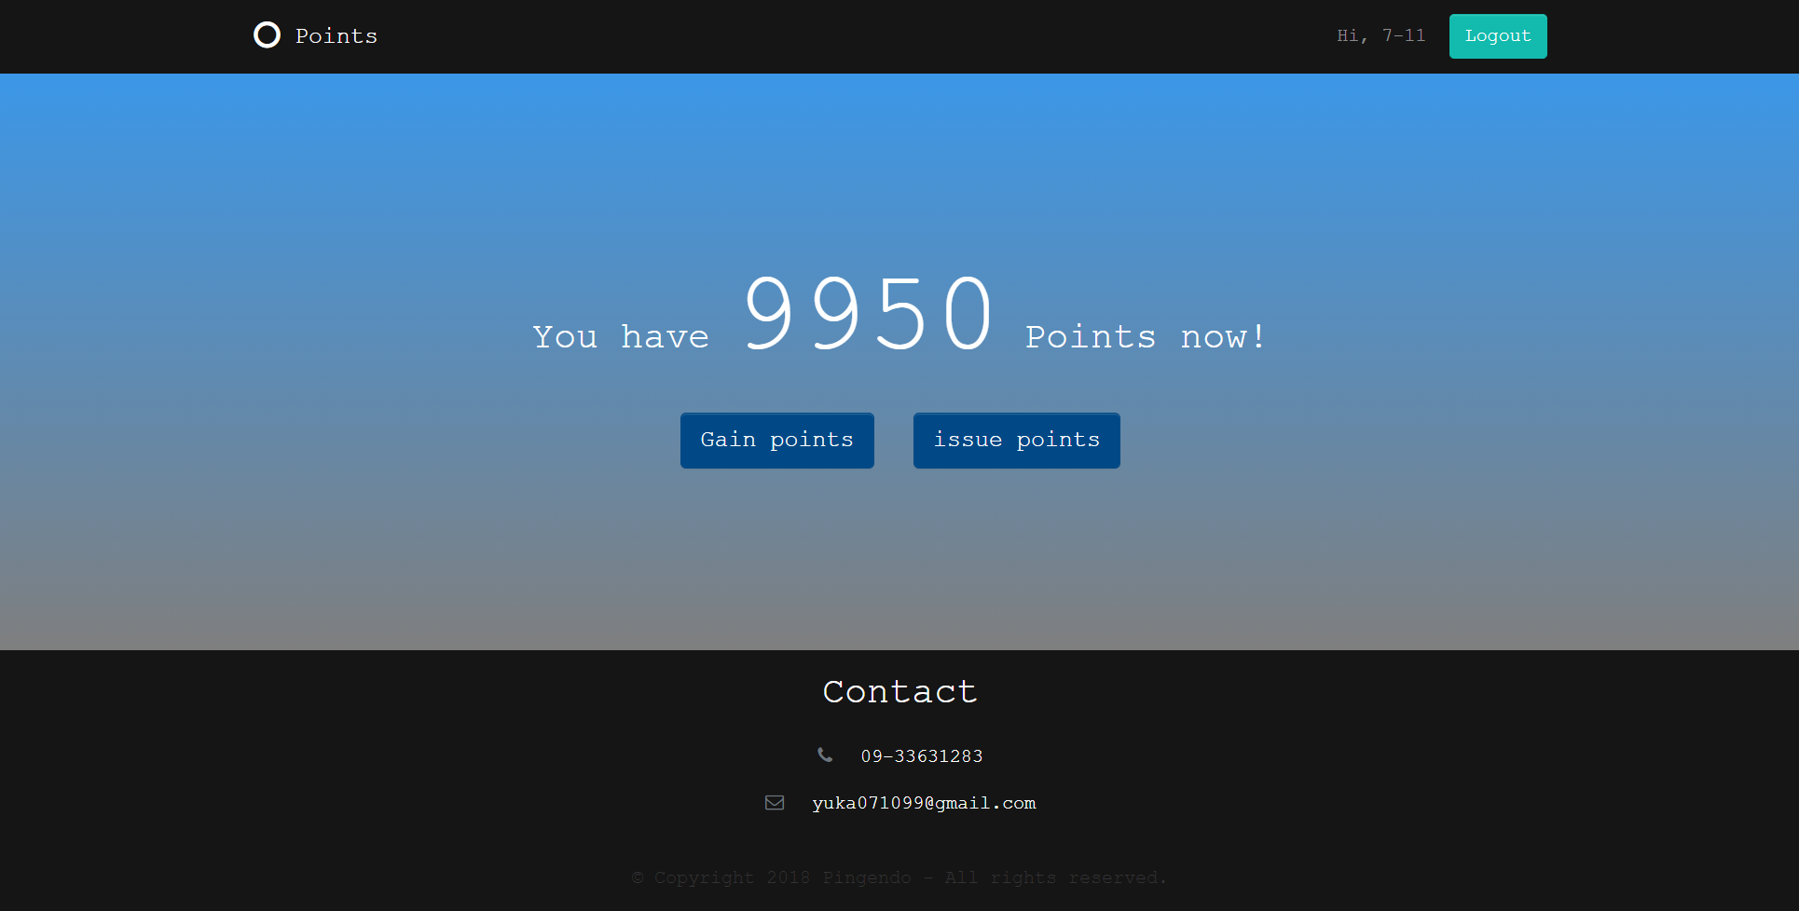

Figure 5

Figure 5 shows the point provider page. Point provider page is for point providers. Similarly, it also has the greetings, “Logout” button and the point balance of point providers. There are two more services only for point providers. First one is obtaining mint reward points. The process of gaining points is as shown in Figure 6. After the point provider clicks the “Gain points” button, a modal window pops up to ask how many reward points point providers want. Click “Confirm” button to complete the process. Then, the point balance will be updated.

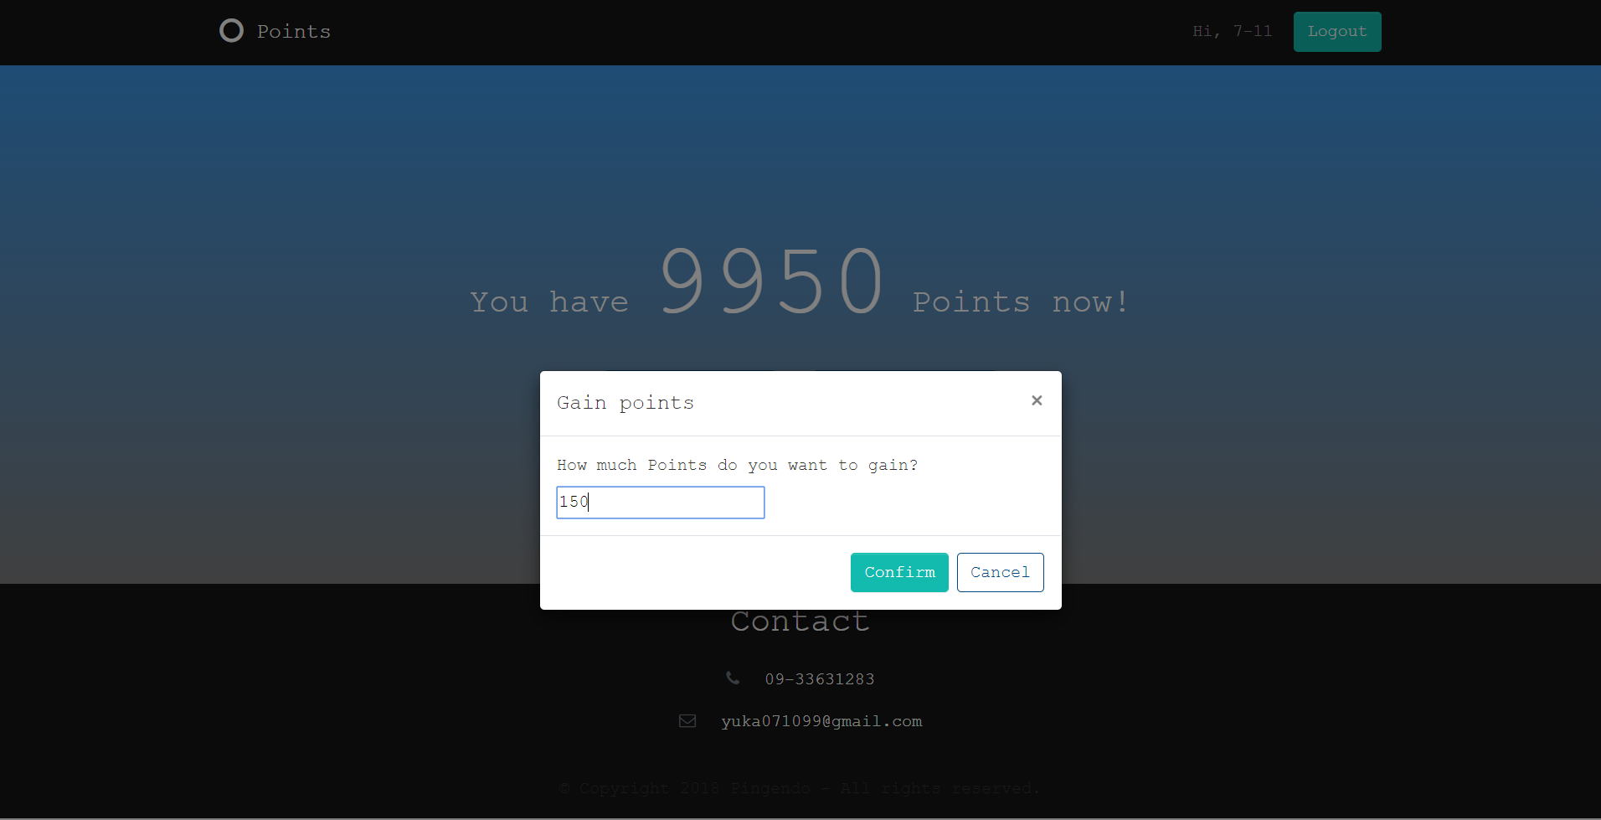 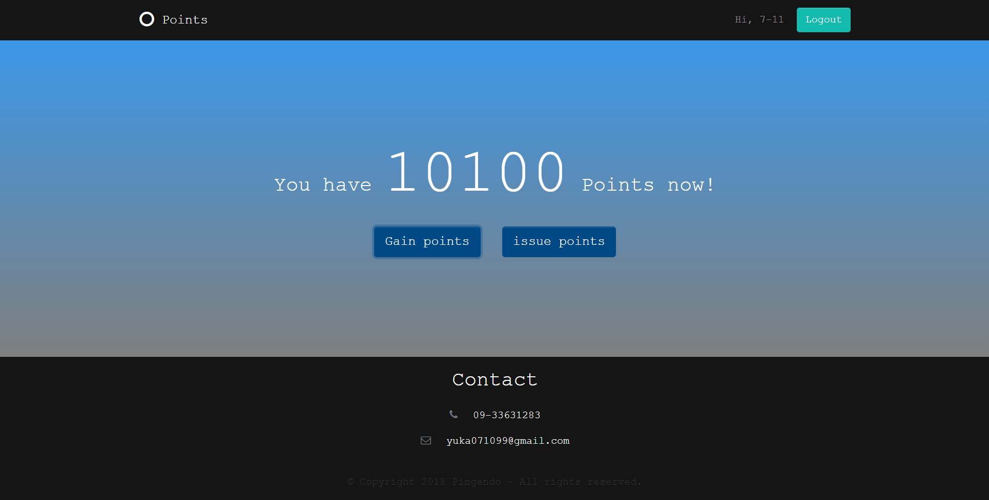

Figure 6

The second service is issuing points to point users. Figure 7 depicts the process of issuing points. A modal window pops up after the “issue points” button is clicked. Point providers have to input the receiver and the amount of points. Click the “Confirm” button to finish the process. Then, the page will show the updated point balance.

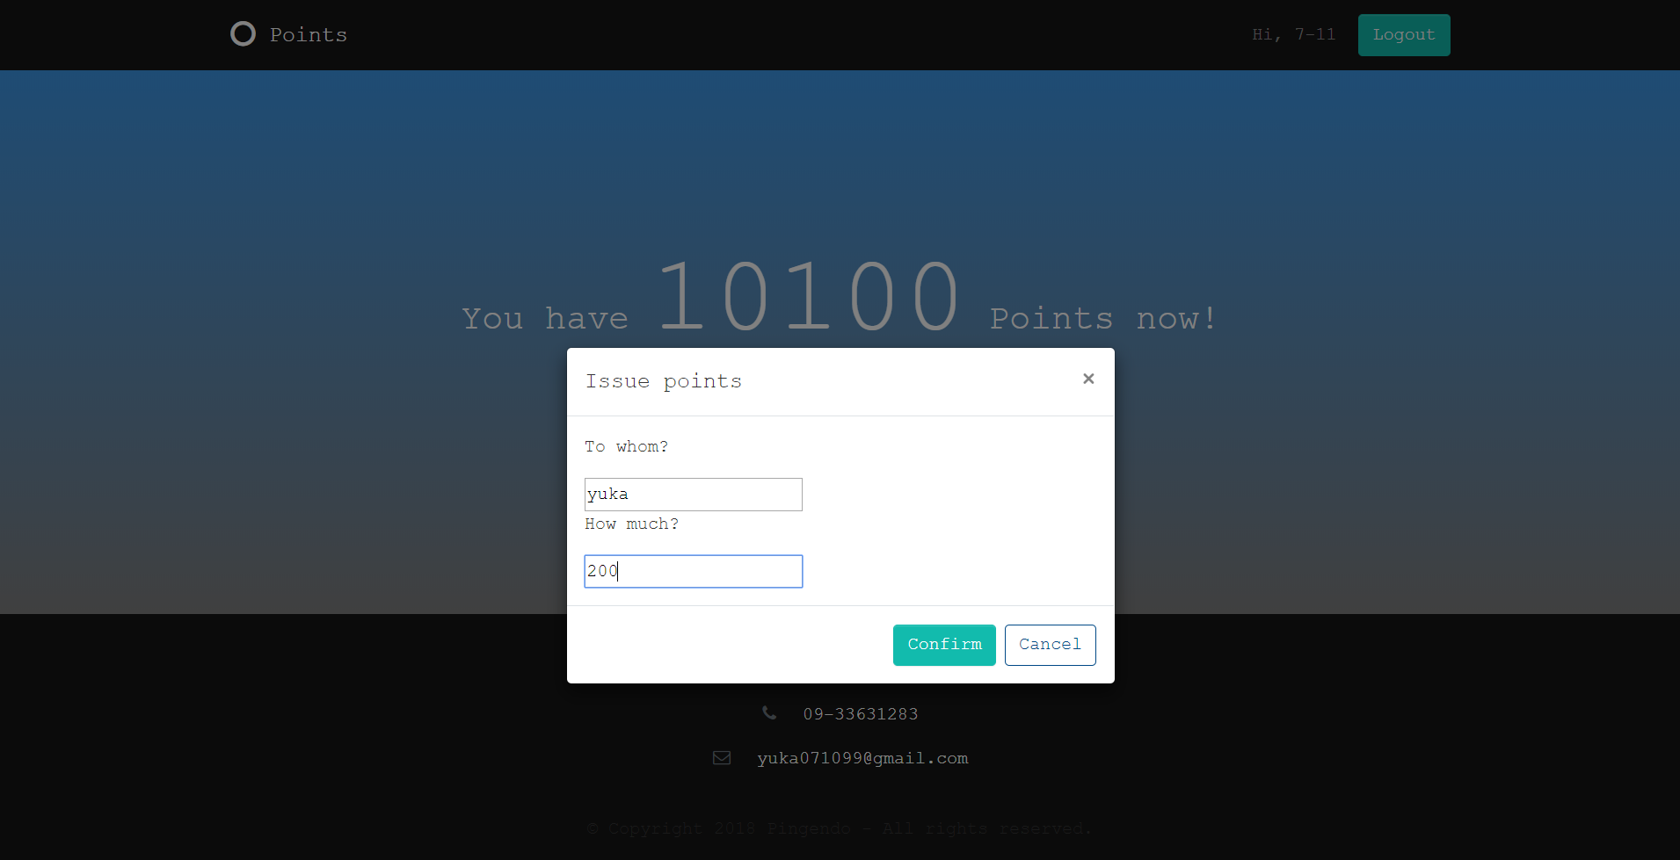 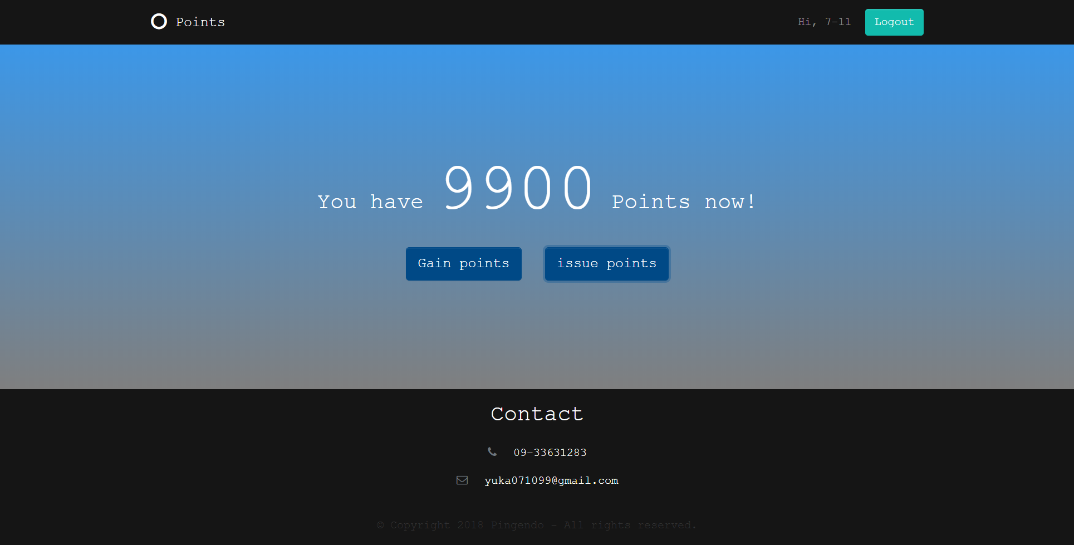

Figure 7

1. Goods Provider Page

Figure 8 illustrates the goods provider page. The greetings and the “Logout” button are in the upper right corner, and the point balance of the goods provider is shown on the web page. There are two more buttons on the page. One is “Sell points” button, and the other is “Increase goods” button. Furthermore, all the goods provided by the goods provider are listed below.

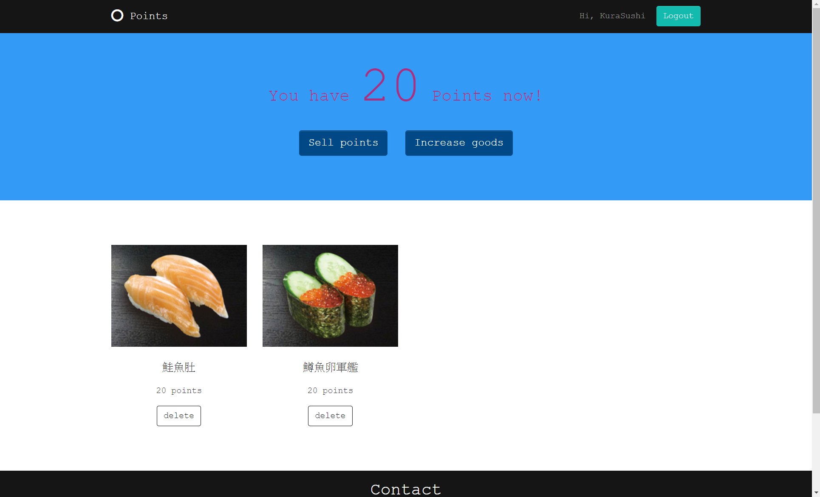

Figure 8

Figure 9 explains the process of selling points. A modal window shows up after the “Sell points” button is clicked. Enter the receiver and the amount of points. The process is accomplished when the goods provider clicks the “Confirm” button. Then, the point balance is updated.

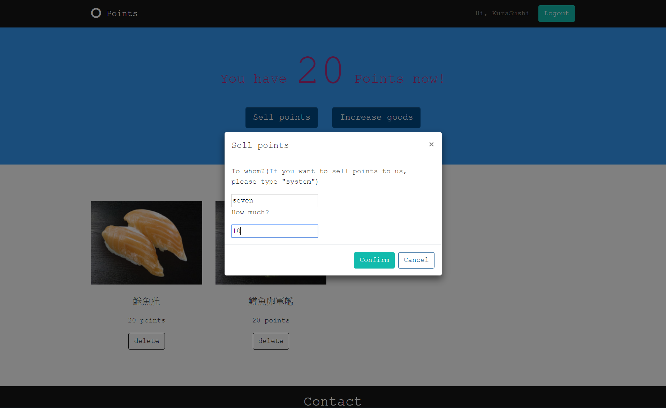 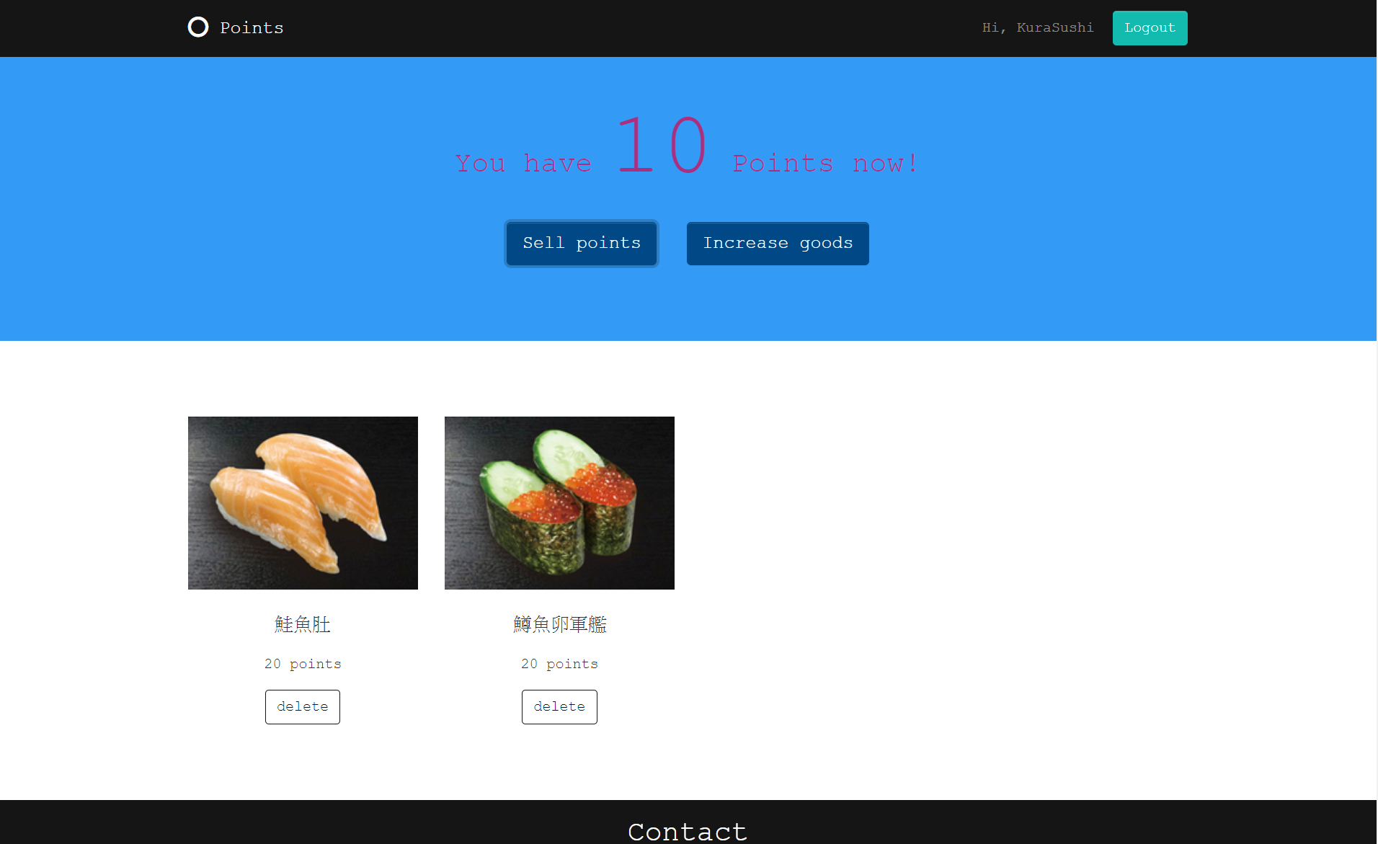

Figure 9

Figure 10 portrays the process of increasing goods. Click the “Increase goods” button, and a modal window pops up. Goods providers should enter the name of goods and the price of goods. Then, choose a picture of the goods. The preview of the picture appears on the modal window. After goods providers click the “Confirm” button, the record of new goods shows on the web page.

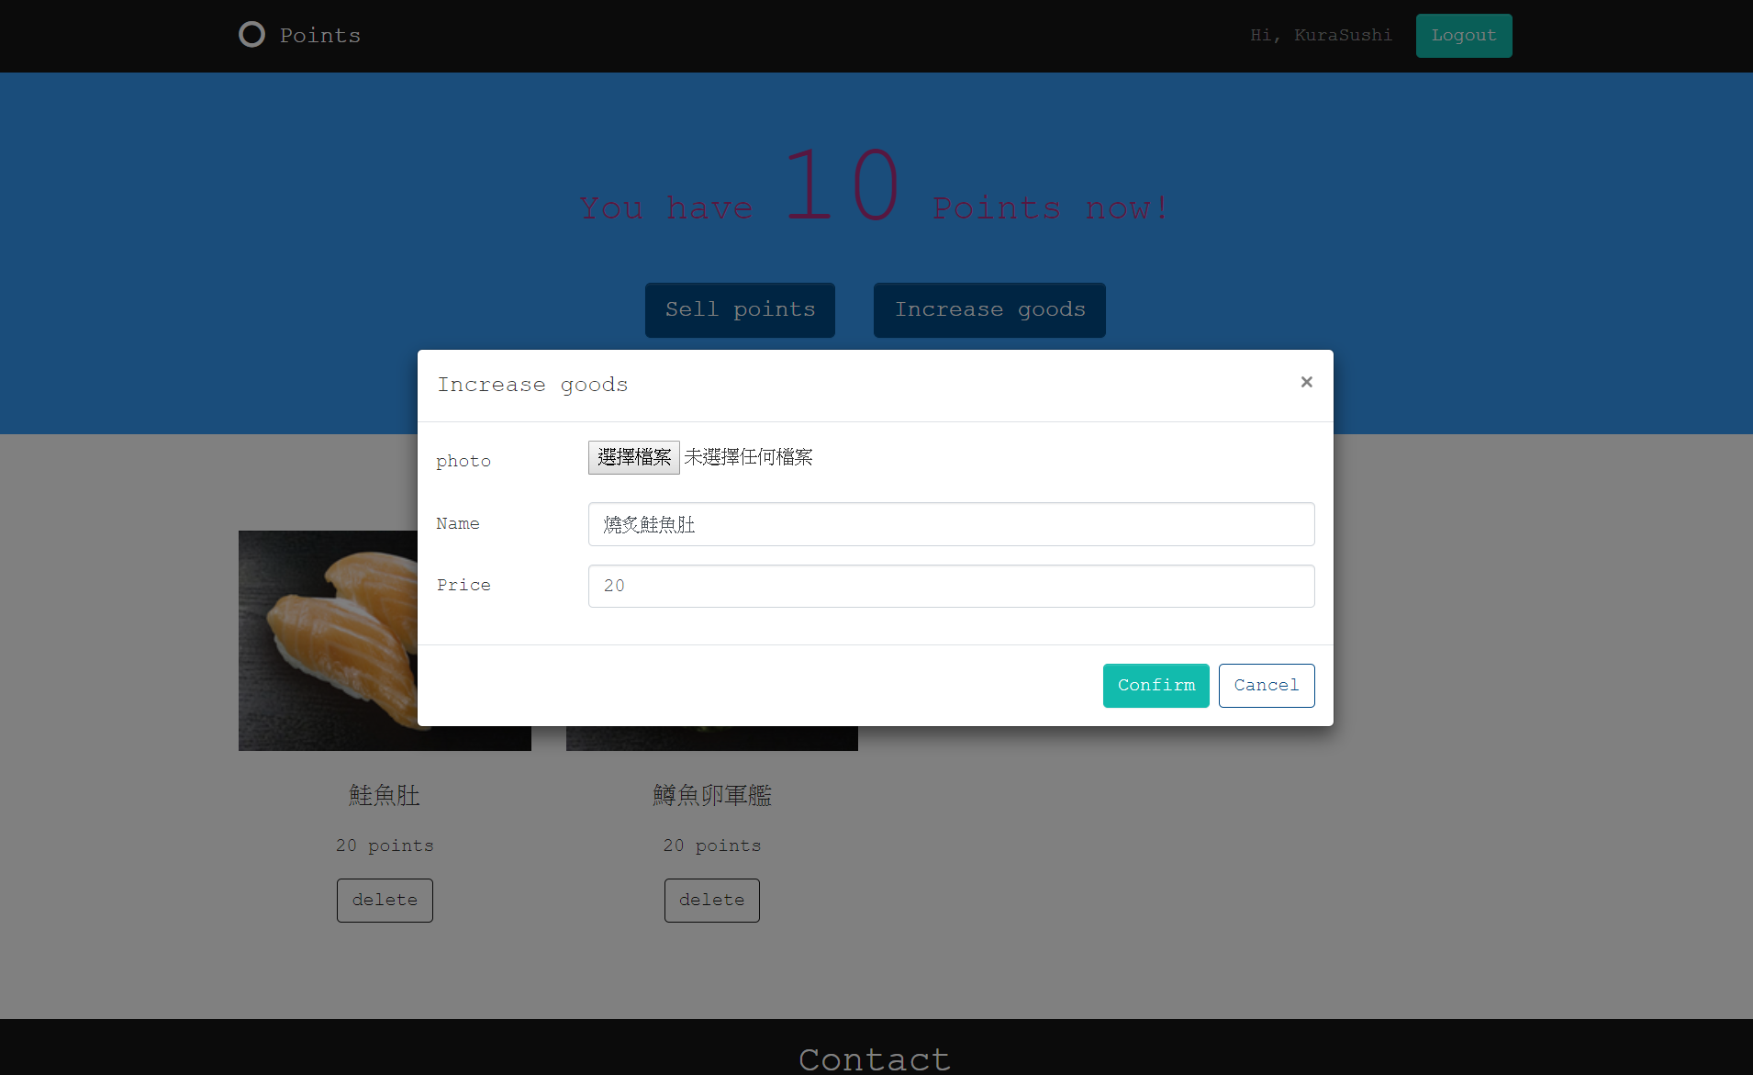 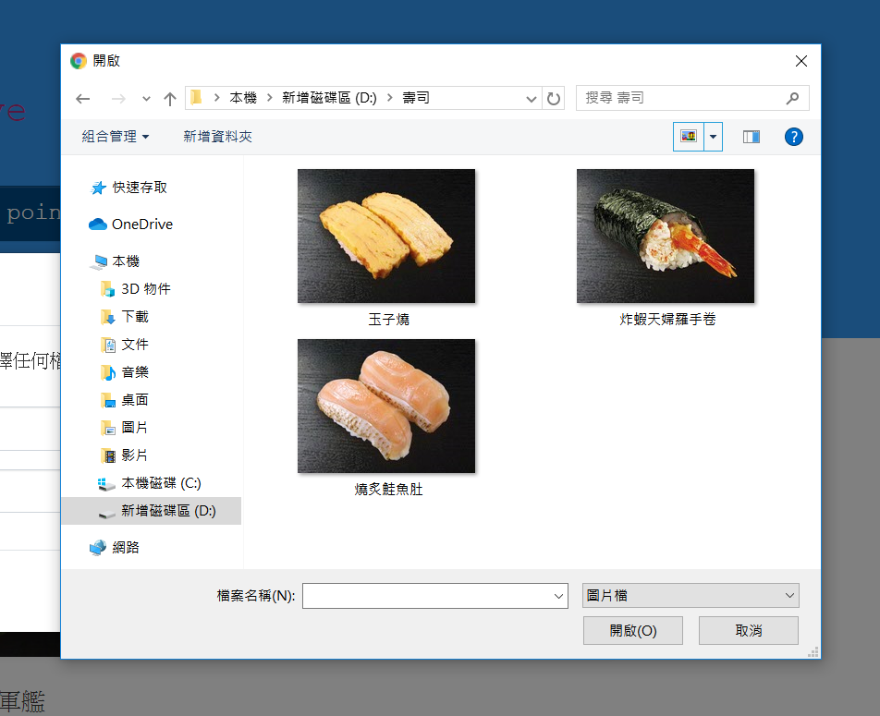

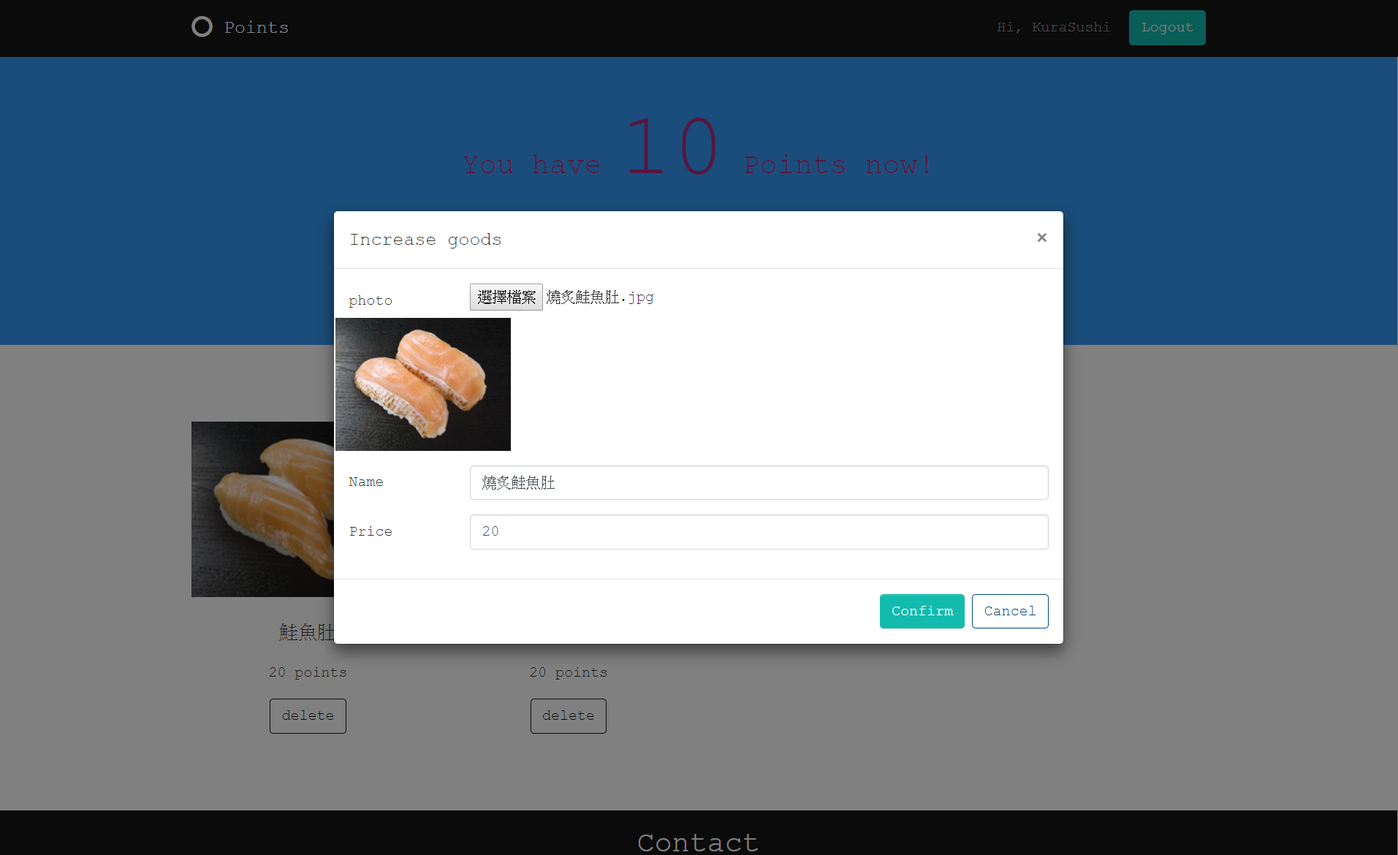

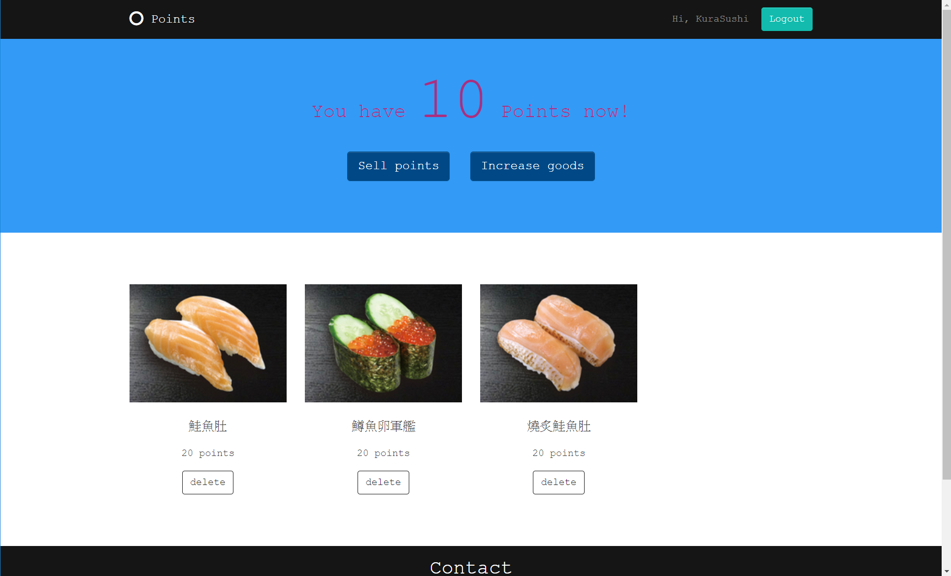

Figure 10

The platform also allows goods providers to delete the goods they do not provide anymore. For example, if the goods provider clicks the “delete” button under the first item in Figure 10, this selected item will disappear. Figure 11 and Figure 12 show the result of deleting the first item on goods provider page and point user page respectively.

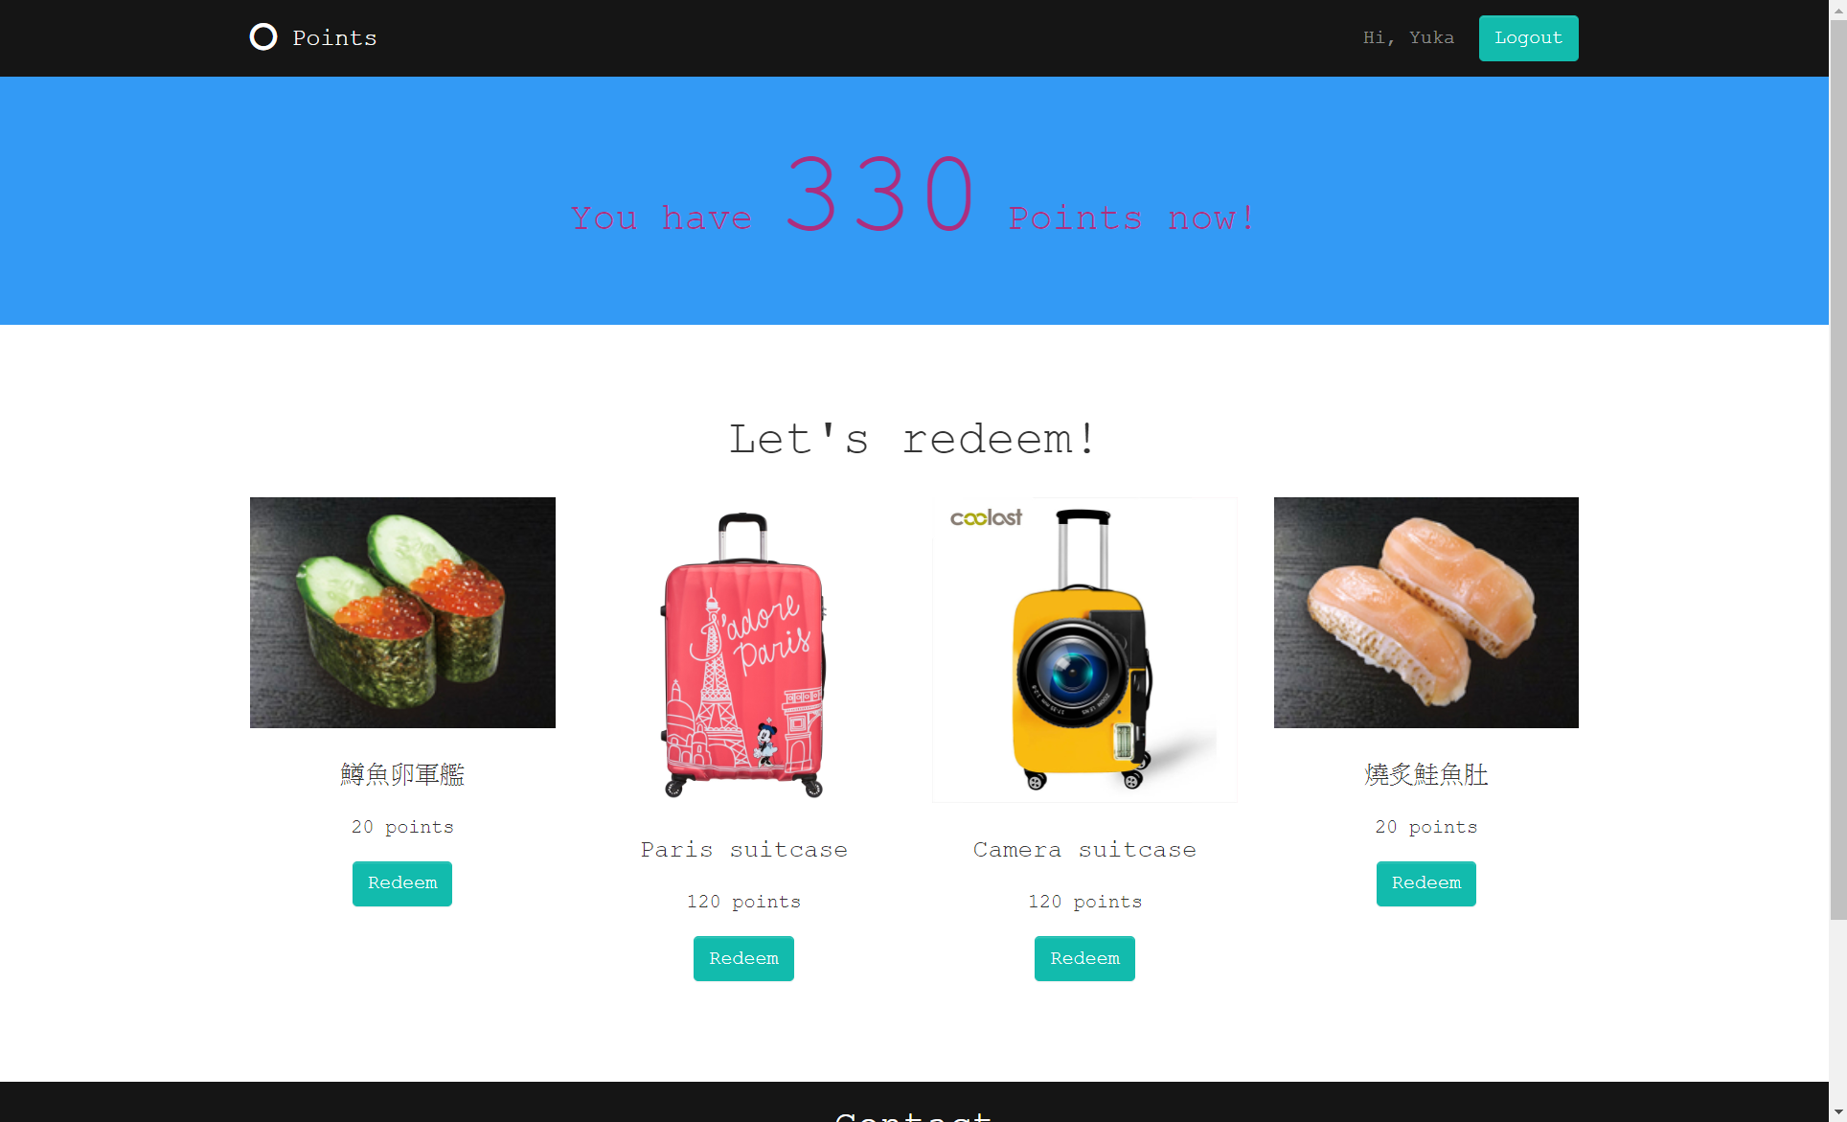

Figure 11

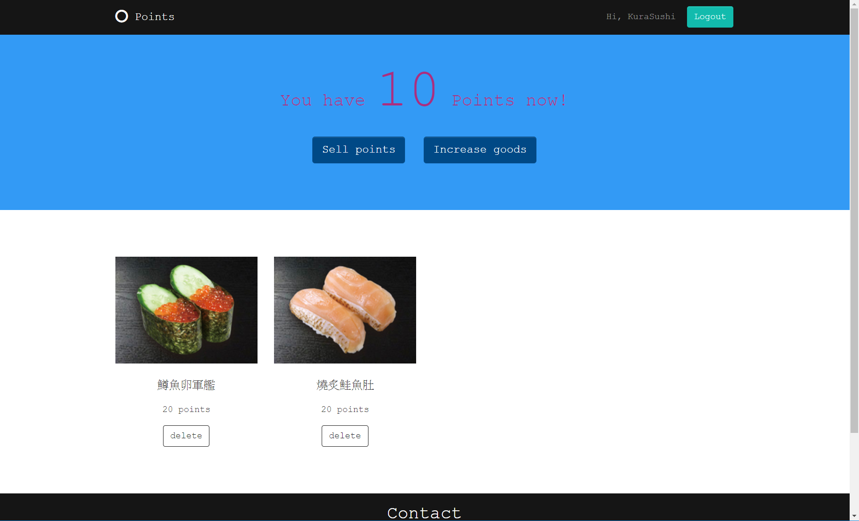

Figure 12

1. Logout

If any user wants to log out, just click the “Logout” button in the upper left corner of the web page. All the cookies stored in the web browser will be eliminated. Then, the website is redirected to the home page.

Photo Source:

* https://www.kurasushi.tw/products
* https://www.luggagesuperstore.co.uk/american-tourister-disney-legends-4-wheel-spinner-case-75cm
* https://www.aliexpress.com/item/Camera-pattern-Print-Luggage-Protective-Covers-Travel-Accessories-Elastic-anti-dust-suitcase-cover-trolley-case-covers/32853869181.html