**Fullname: Nguyễn Chơn Uy – ID: 19IT060**

**Lab: OOP1**

**Link github:** <https://github.com/ncuy0110/lab_c_sharp>

**Exercise 1:**

* **Class Dice:**

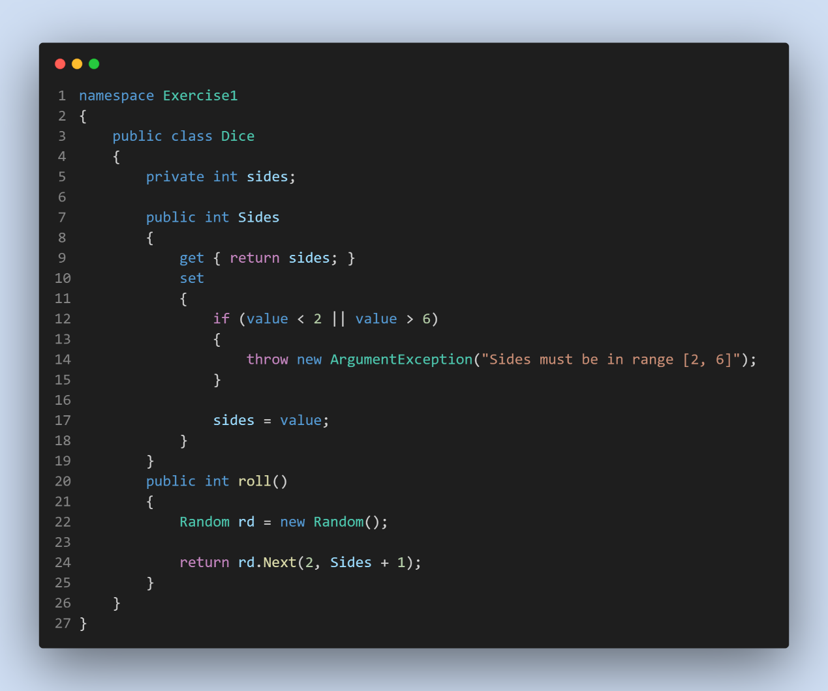

**Class Program:**

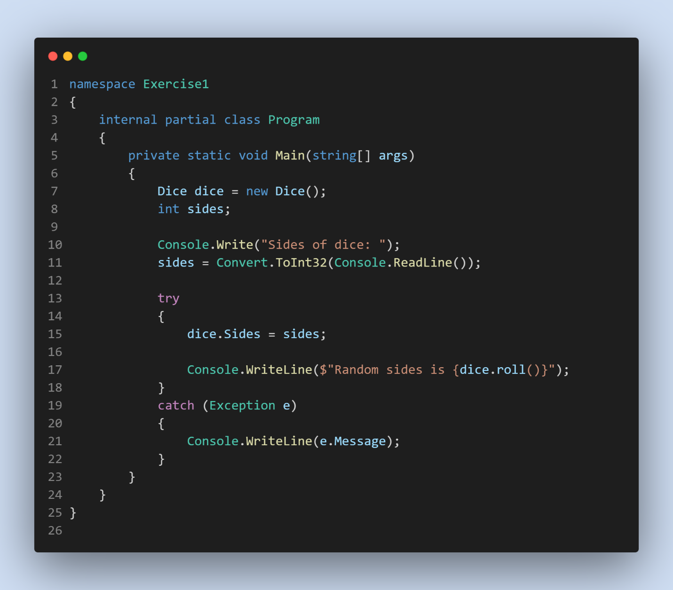

**Exercise 2:**

**Class Person:**

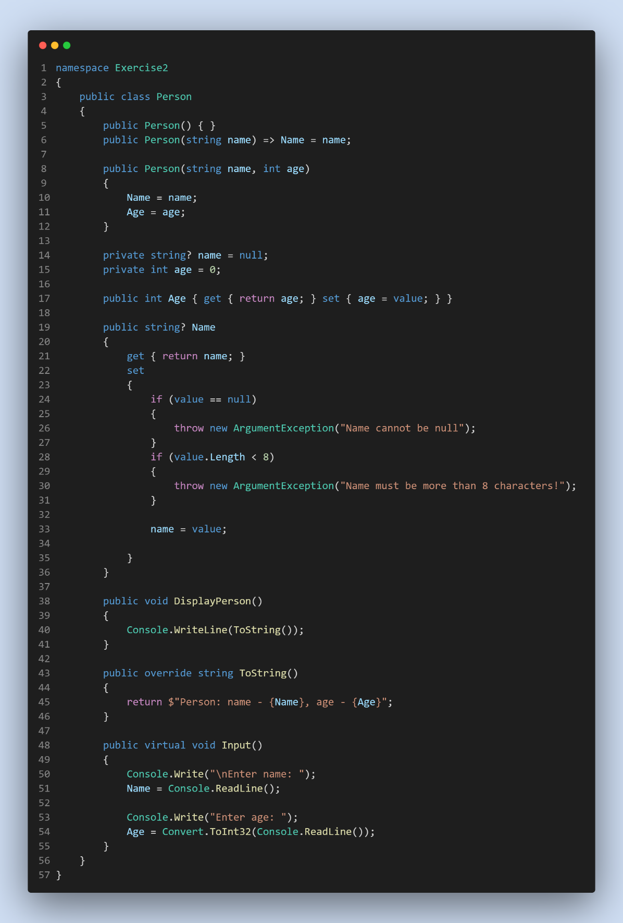

**Class Student:**

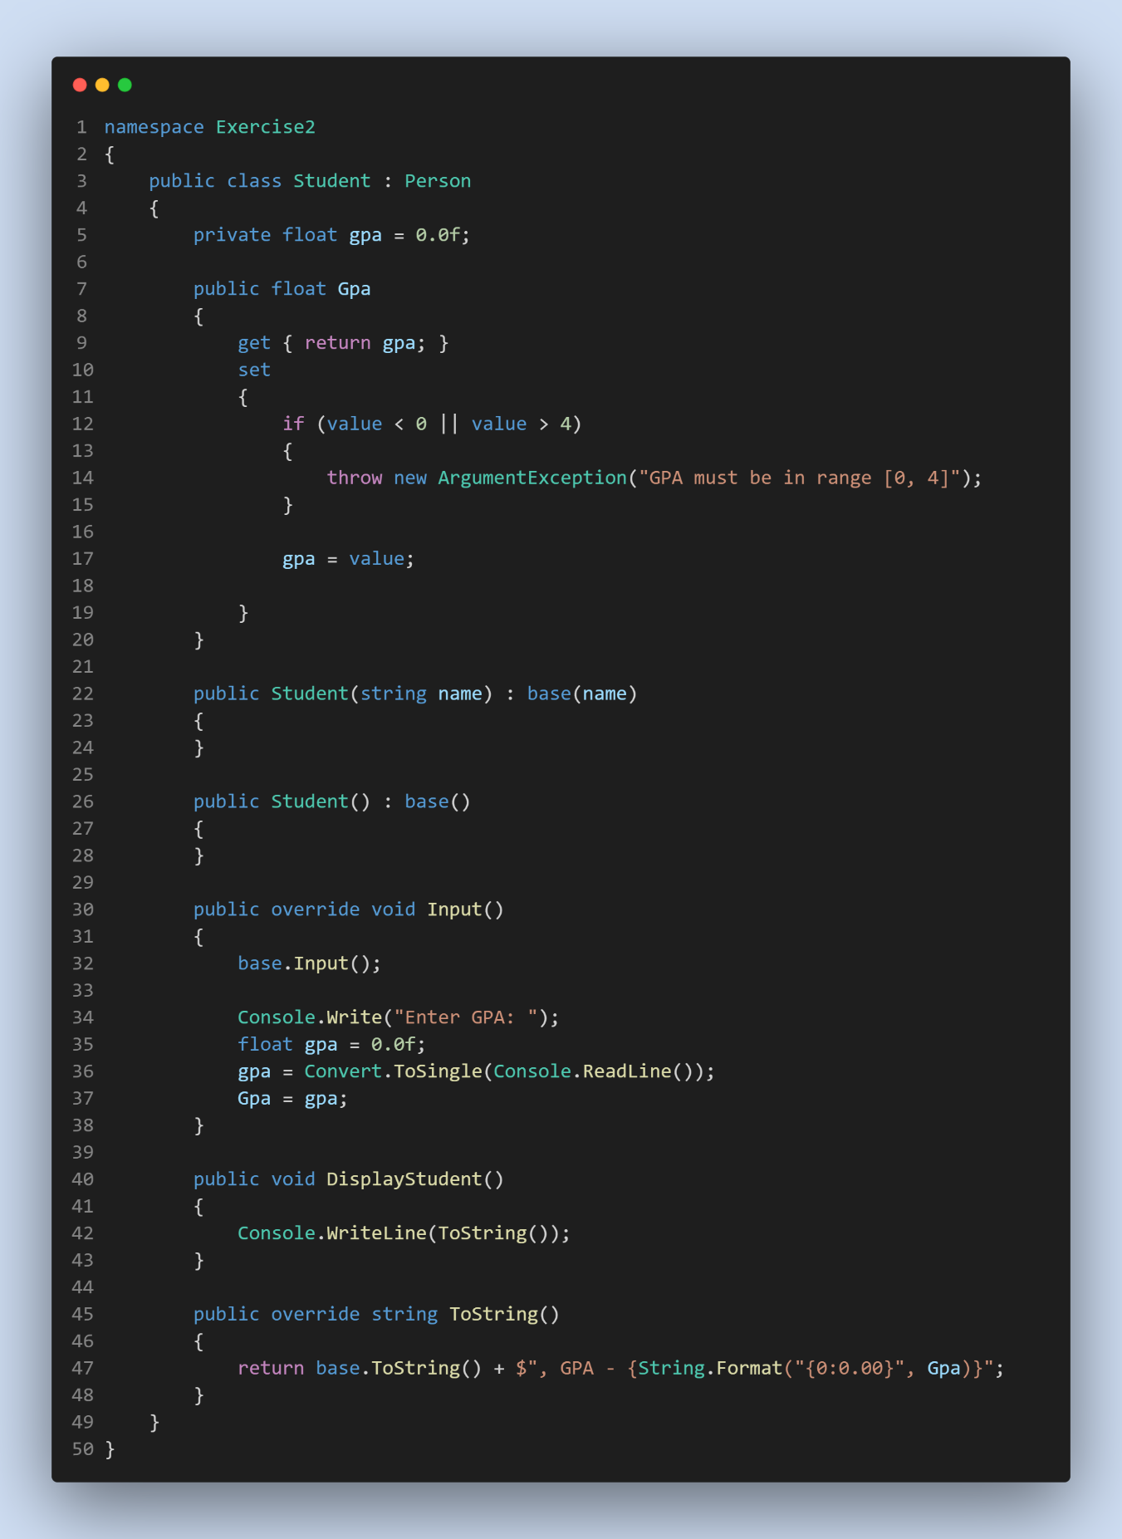

**Class Program:**

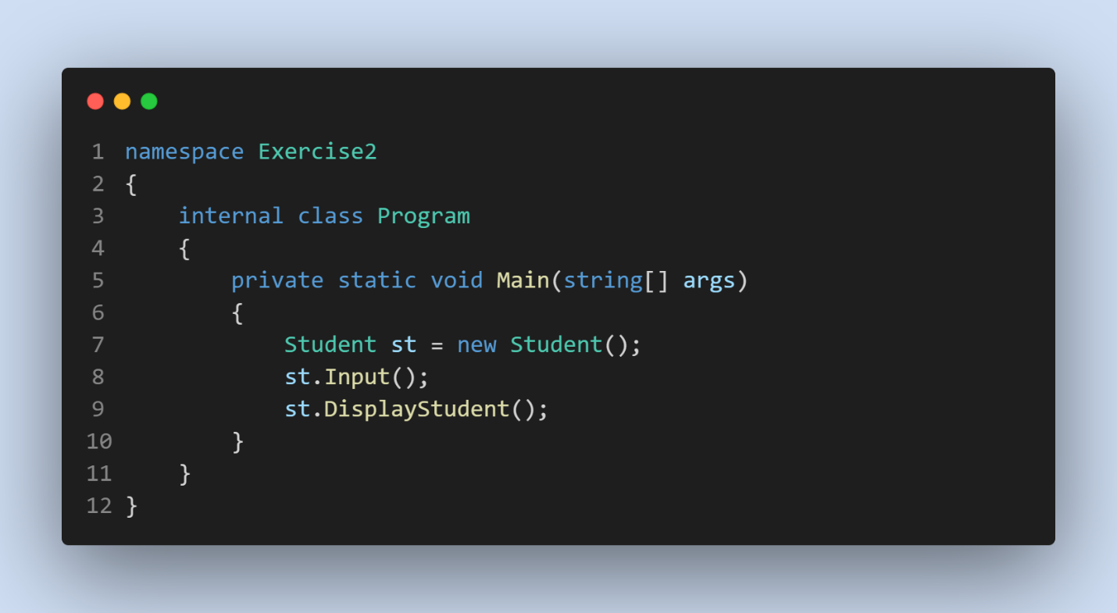

**Exercise 3: Class Song**

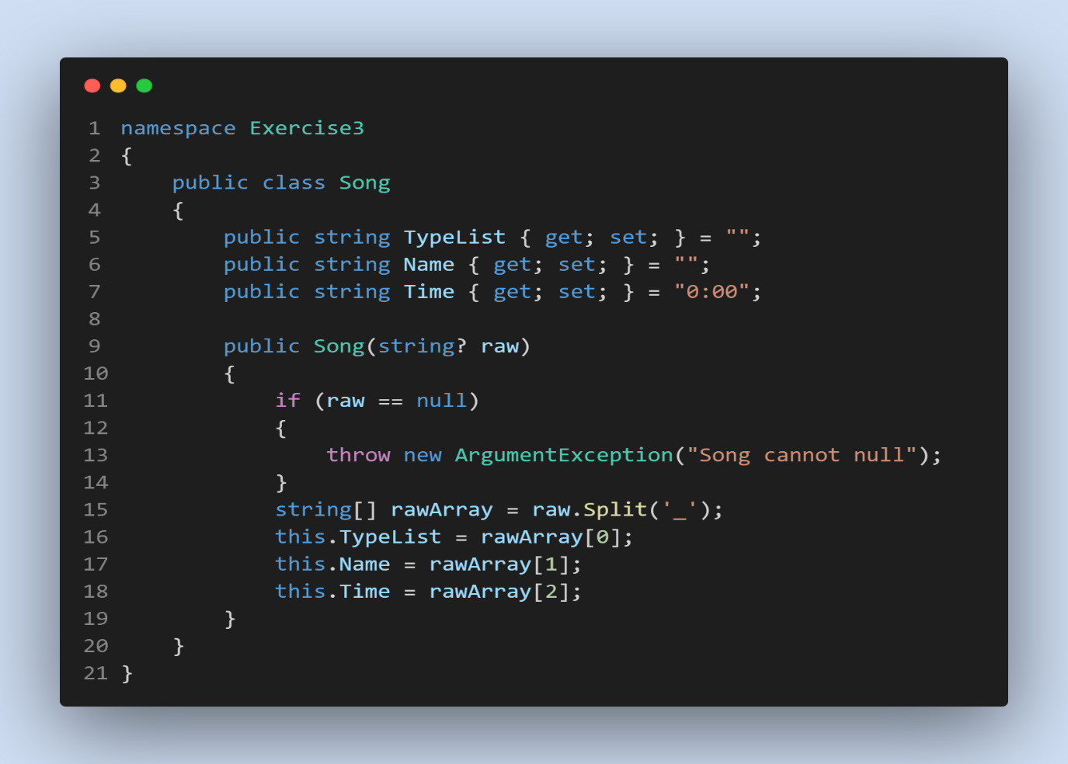

**Class Program:**

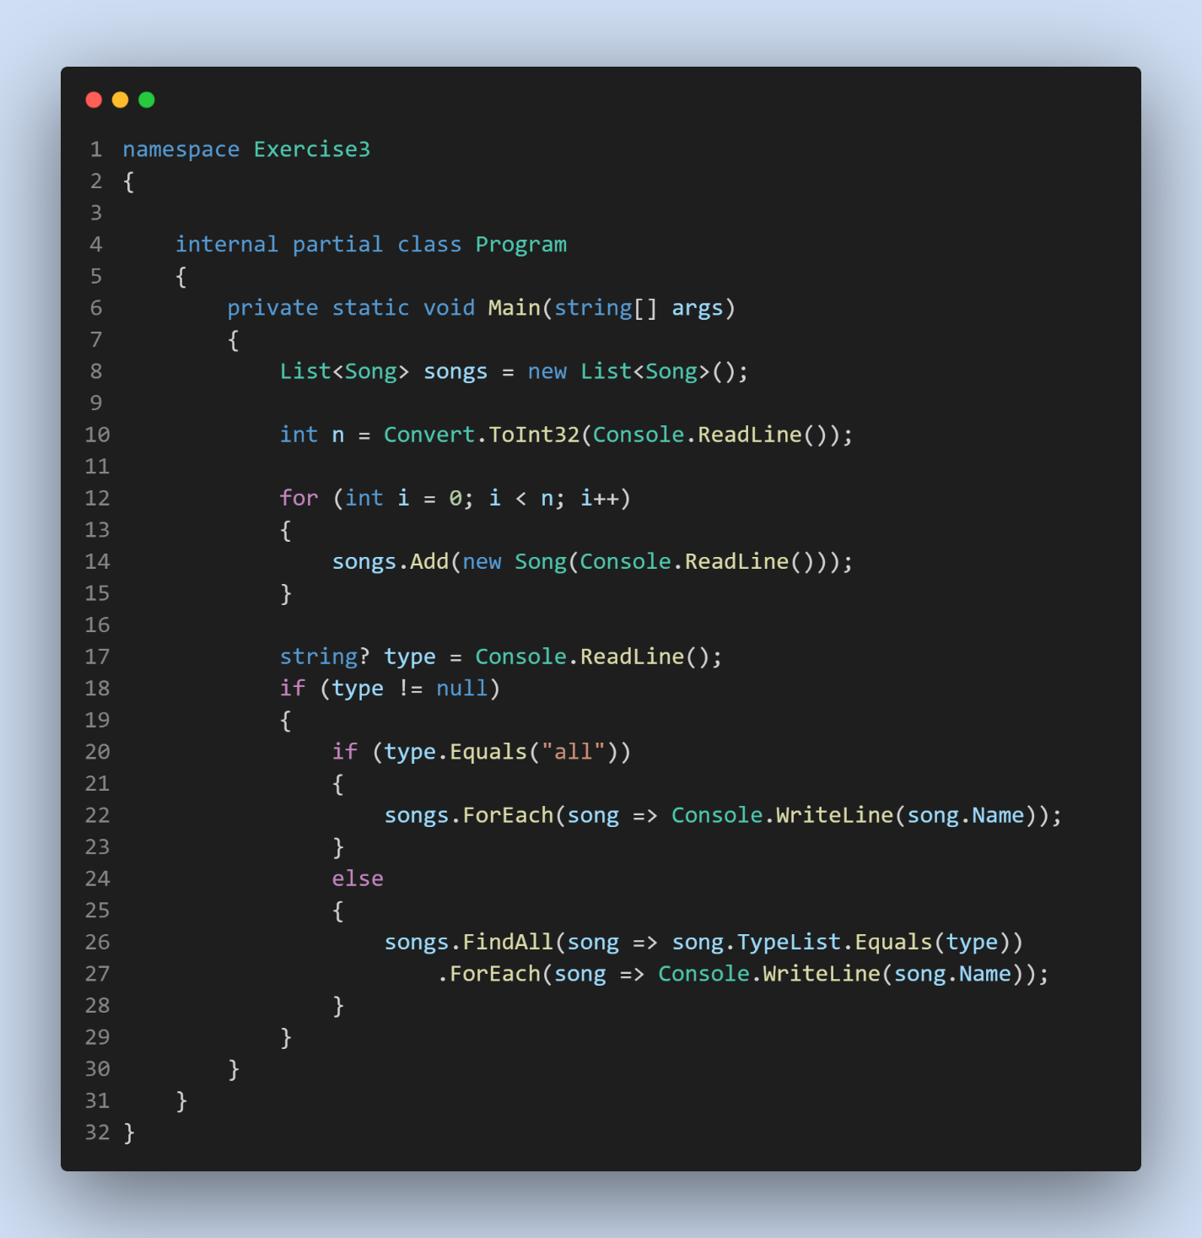

**Exercise 4:**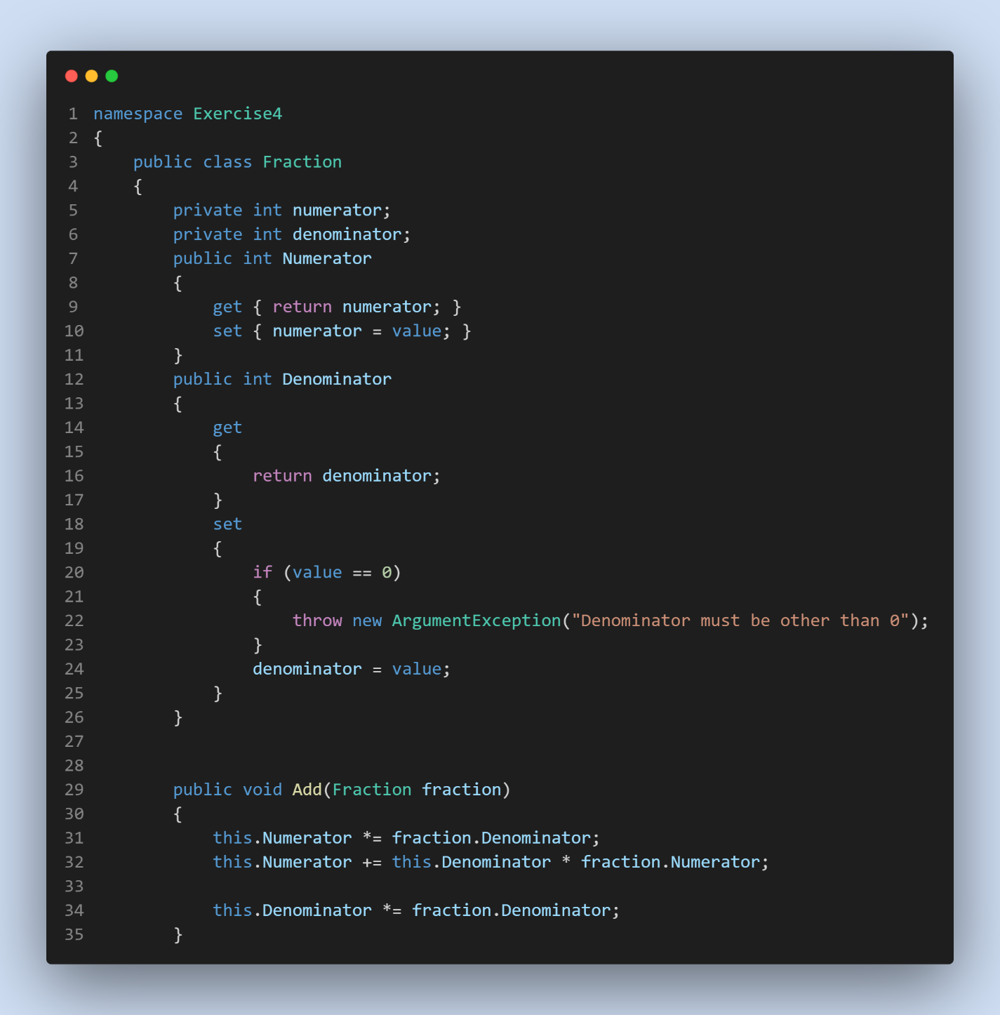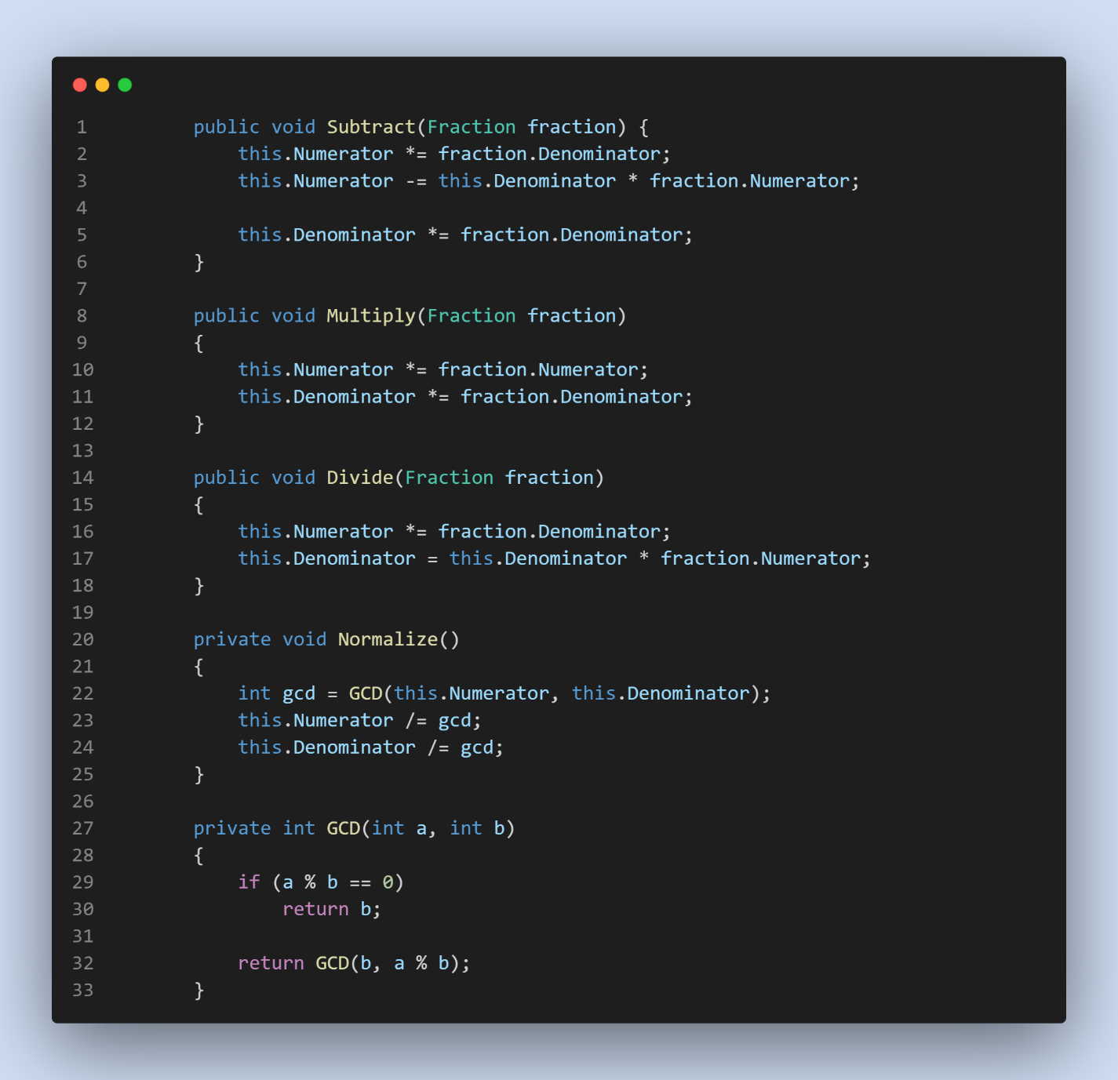

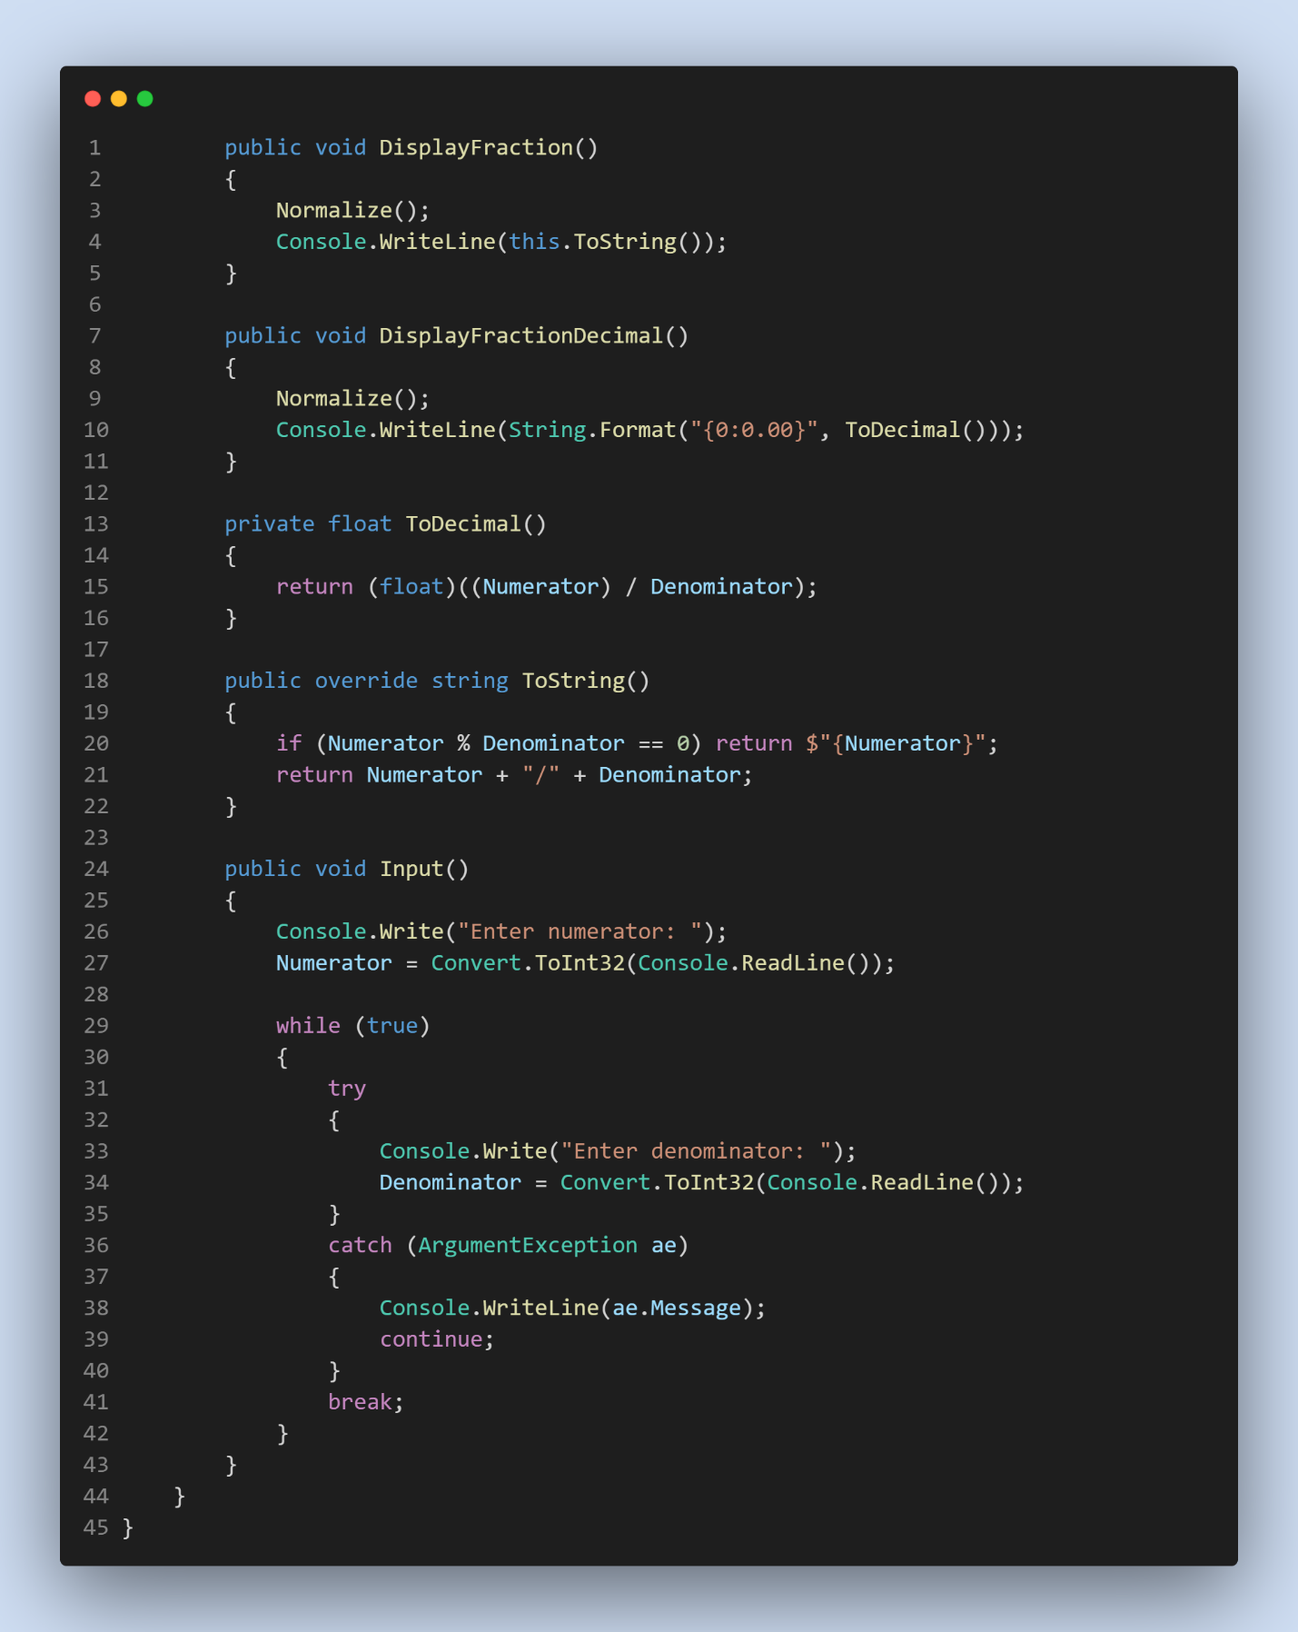

**Class Program:**

