Document

Of

Purchase Order Flow

***by***





Purchase order flow

Table of Contents

1. Introduction 3

2. Registration 4

3. Approved Request 5

4. Submit and Manage Purchase Order 5

5. Approval Process of Purchase order 8

6. Order with Purchase Order 8

7. Order Invoice of Purchase Order 9

8. Sales Quotation 10

# Introduction

This is test

MJSTraders is an eCommerce platform which is selleing safety and protection related items.

# Registration

For be part of Purchase order customer at MJSTRaders, every customer must need to be need to register first at MJSTRaders.com.

For registration, go to [MJSTraders](https://www.mjstraders.com/) site. Here click on register menu on top right corner or direct go to registration page by click [here](https://www.mjstraders.com/en/register).

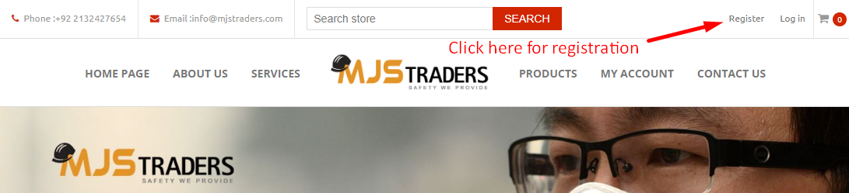

This will redirect customer to registration page. Customer must have to fill all details which are asking in form and click on registration button.

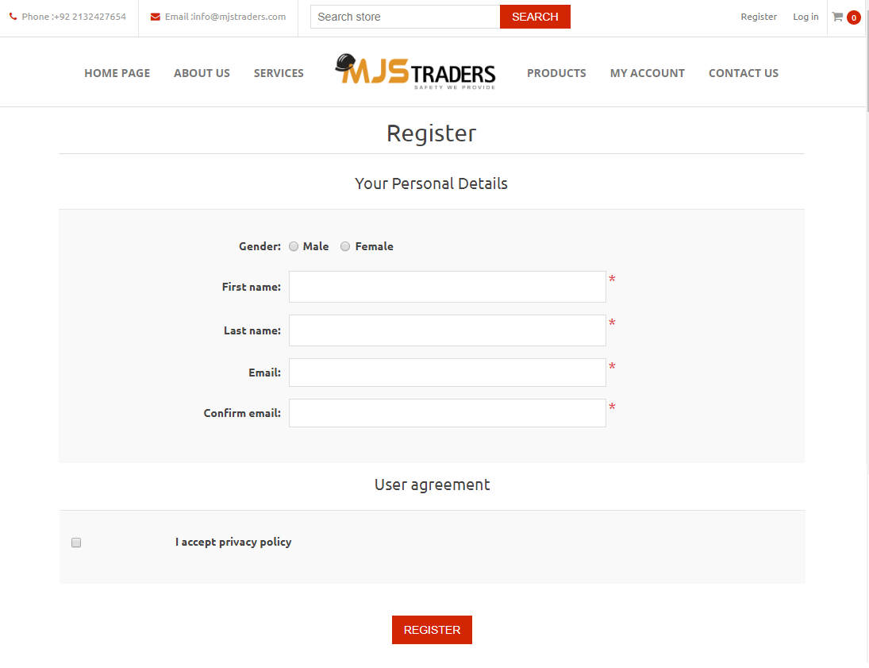

Here customer need to fill his/her personal details, email address, company name, address, phone number, password.

This email and phone number will be use for contact to customer whenever it required.

Customer must need to remember entered email address and password because he/she can login by only this email address and password.

If customer forget password then he/she can reset by click on [forget password](https://www.mjstraders.com/en/passwordrecovery) menu on [login](https://www.mjstraders.com/en/login) page. Here after fill email address click on recovery button, user will receive reset password link by email. By this link user can reset password.

# Approved Request

After complete registration, admin will review customer’s account and if everything seems fine then admin will give purchase order access to the registered customer.

Admin also can ask more details by email/call for verification.

# Submit and Manage Purchase Order

For submit purchase order, customer have to go to Purchase order page under my account section. For this customer must have to login with his/her credentials.

For go to Purchase Orders page, customer have to click on My Account option at top right corner, this will redirect user to [Customer info](https://www.mjstraders.com/en/customer/info) page.

Here, customer can see new menu Purchase Orders in left menu. This menu available only after customer’s account is approved as Purchase Order customer.

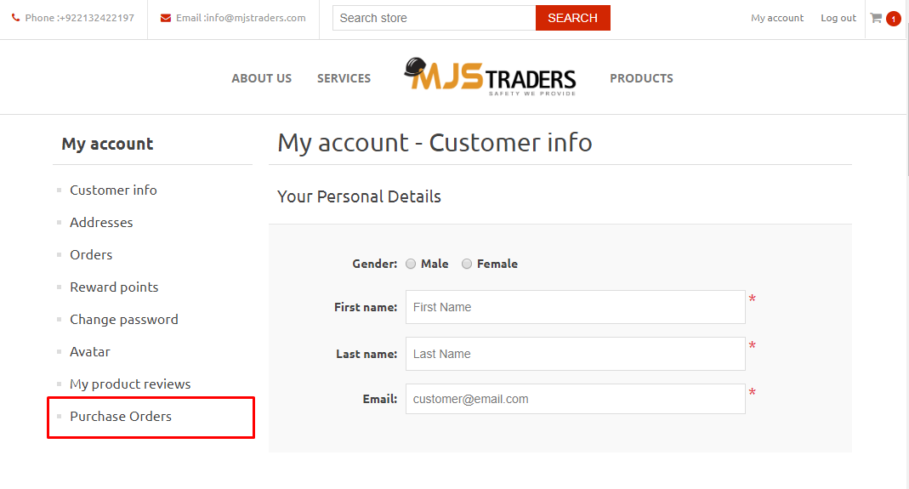

This will redirect customer to submit purchase orders page.

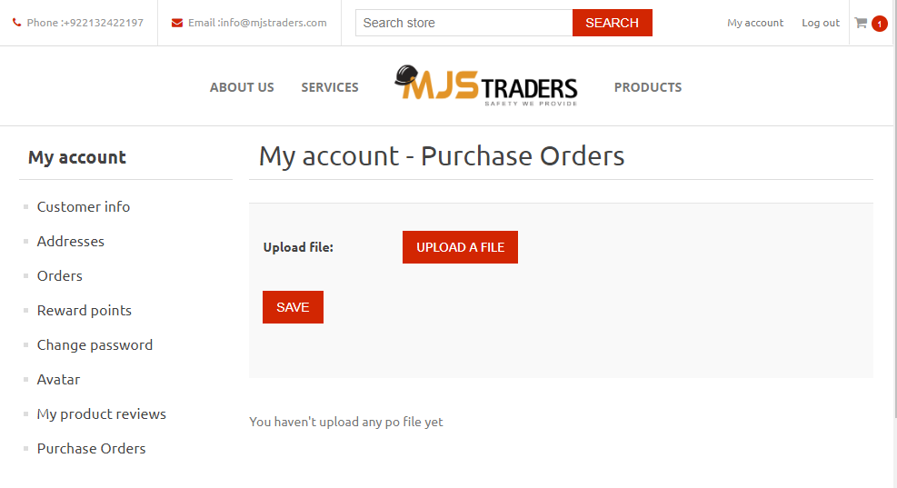

For upload purchase order, click on upload file button and select purchase order file.

Make sure your purchase order file’s name is same as purchase order number and it should contain only numbers.

After upload purchase order, it should display like this.

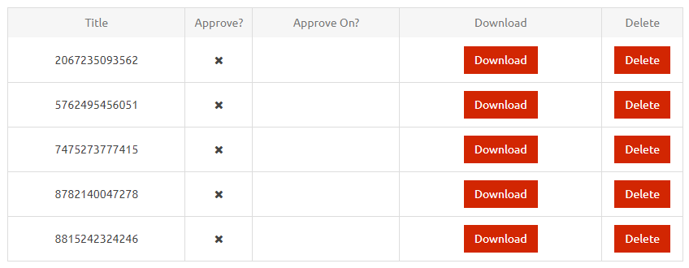

Here

* **Title:** Purchase order number which took from uploaded file name
* **Approve?** : This will display approval status of Purchase order
* **Approve On?:** This will display approval date of purchase order. If Purchase order is not approved then this will be blank.
* **Download:** Download button will allow customer to download uploaded purchase order.
* **Delete:** Deletebutton allow customer to delete uploaded purchase order. Once delete purchase order then it will not recoverable. This will remove file from server. Also delete button available till purchase order is not approved. Once this approved then delete button will no longer available.

# Approval Process of Purchase order

Every purchase order need to approve by admin before place order with uploaded purchase order. Admin will receive an email notification on every purchase order submit.

Admin will review purchase order and verify every details. If there is anything wrong with purchase order then admin can delete purchase order. Deleted purchase order will no longer available from customer account.

For approve, admin can contact customer by email or call for validate his/her request

If everything seems fine with uploaded purchase order then admin will approve purchase order.

Once purchase order approved then it customer can see approval date and status at [Purchase Orders](https://www.mjstraders.com/en/customer/ponumbers) page.

Also Delete button will no longer available with approved purchase order.

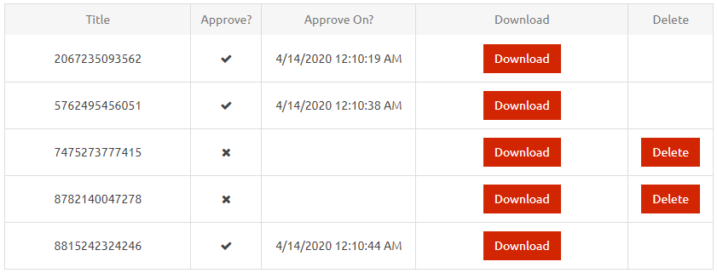

# Order with Purchase Order

After approved purchaser order, need to place order in system with of that purchase order.

For this admin will place order in behalf of customer. Please note that customer not need to place order after upload submit order. During place order, admin will map related purchase order with order which customer can see and download in order detail page.

In order detail page, you can see Purchase Order Documents section after address and before products section.

Customer can also download purchase order document from here. If admin uploaded more document with this order, then that will also display here.

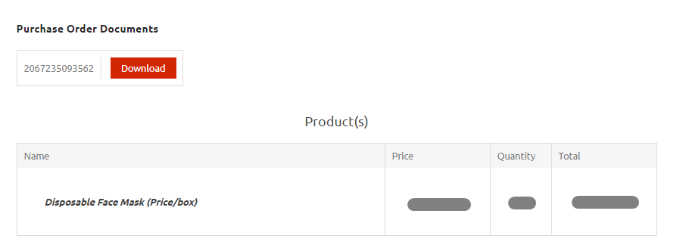

# Order Invoice of Purchase Order

If order is placed with purchase order, then purchase order number will be mentioned on invoice.

See in below invoice image.

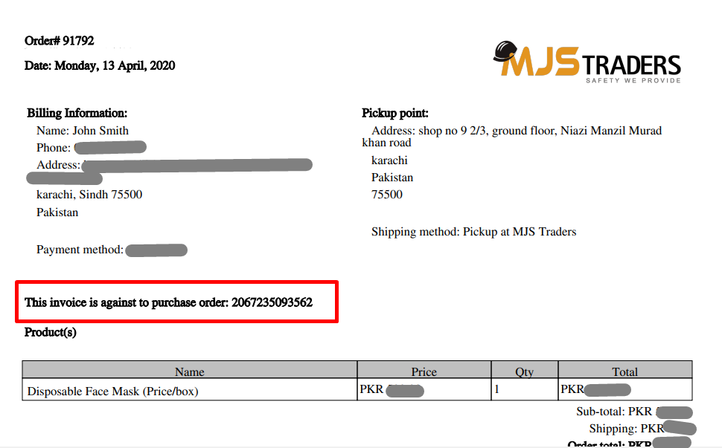

# Sales Quotation

Sales Quotation is an pdf slip which shows product, description and price.

Sales Quotation will generate by admin and send customer to via email.

Customer will receive an email from MJSTRaders with sales quotation file attached.

Thank You … !!!