**Nikhil Rajendra Danapgol**

**HPC Assignment 1**

**2019BTECCS00036**

**Q1. Program in OpenMP to print “Hello World”.**

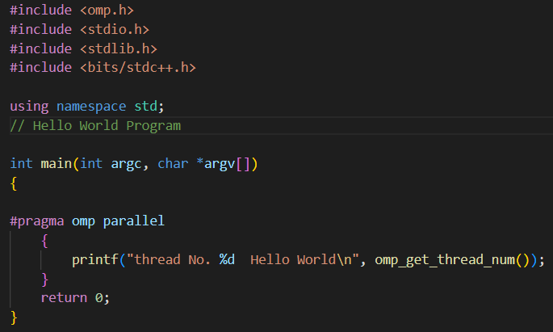

**Output:**

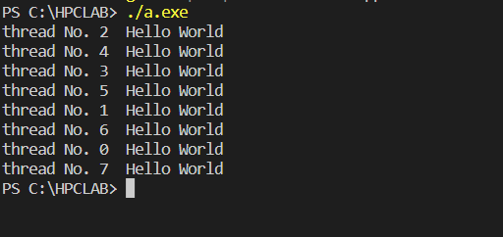

**Q2. Find the squares of first 100 numbers followed by their sum. Compare the speed in sequential and parallel algorithm.**

**Parallel Approach:**

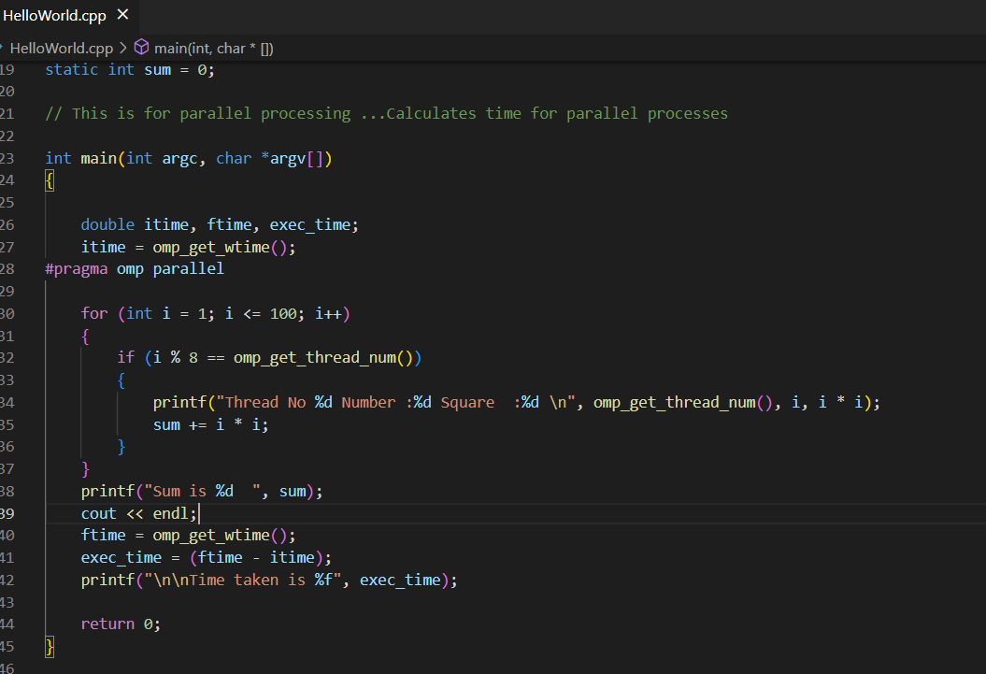

**Output:**

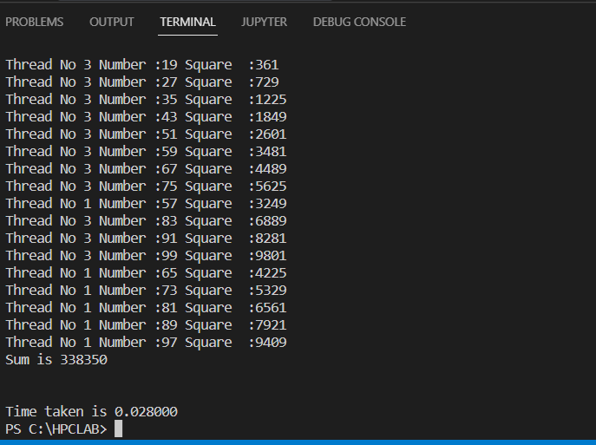

**Sequential Approach:**

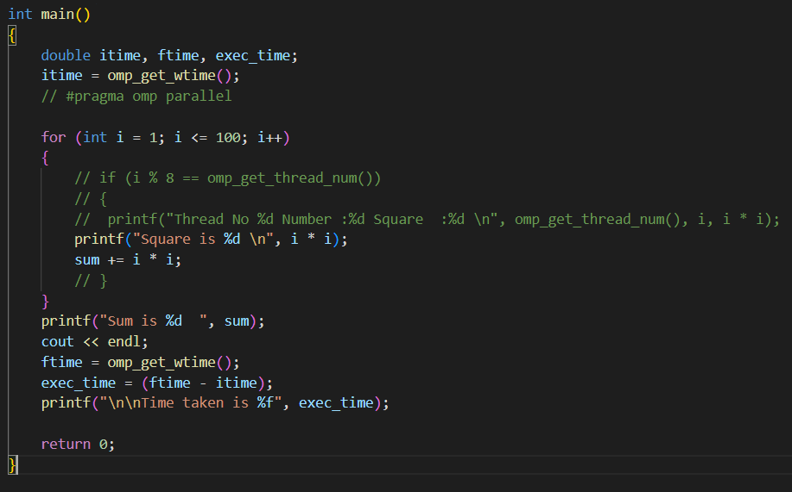

**Output:**

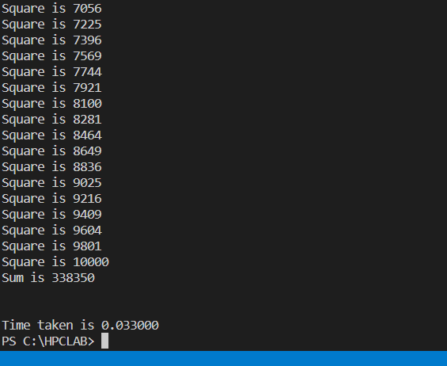

**Github Link:**

[**https://github.com/nd22052000/HPC**](https://github.com/nd22052000/HPC)