**Nikhil Rajendra Danapgol**

**HPC Assignment 2**

**2019BTECCS00036**

**Program for Vector to Vector Addition**

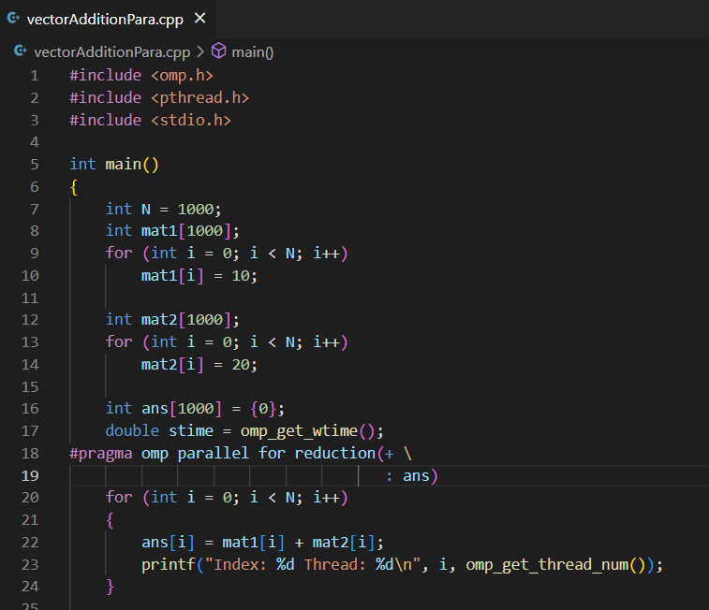

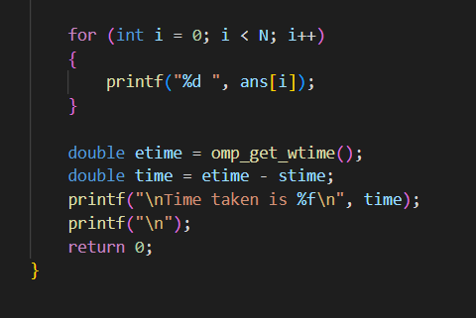

Output:

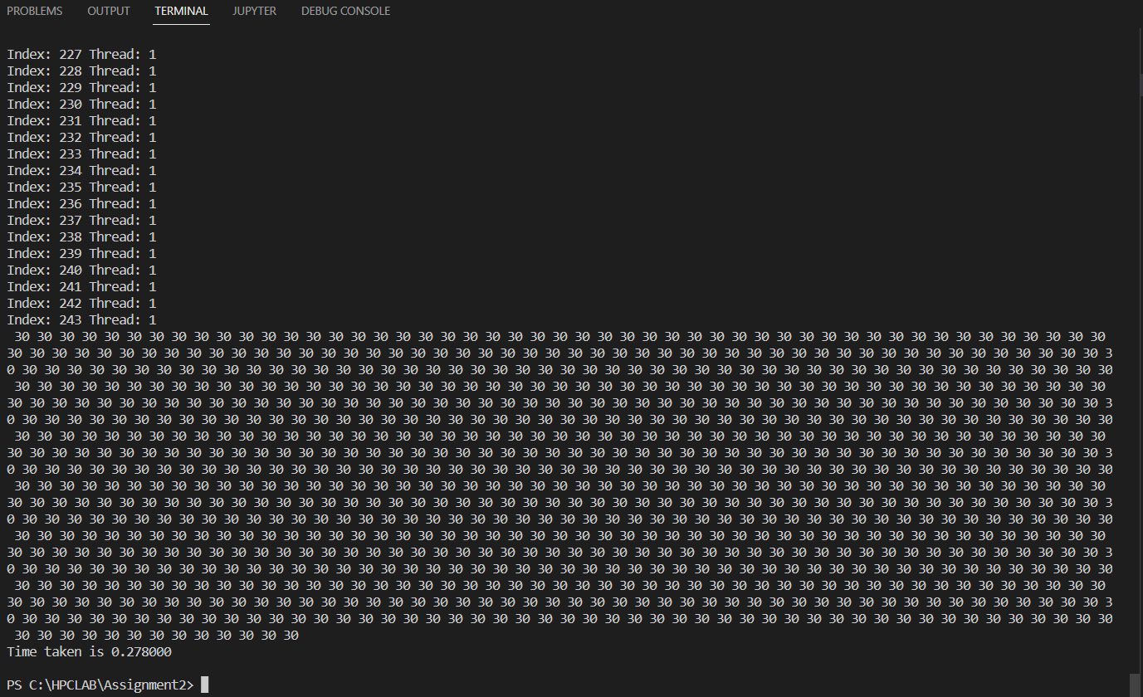

Sequential Algorithm:

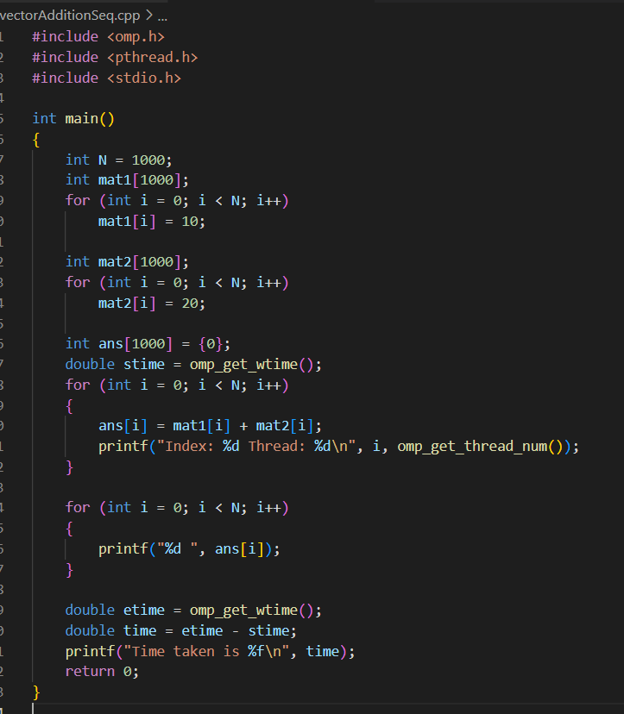

Output:

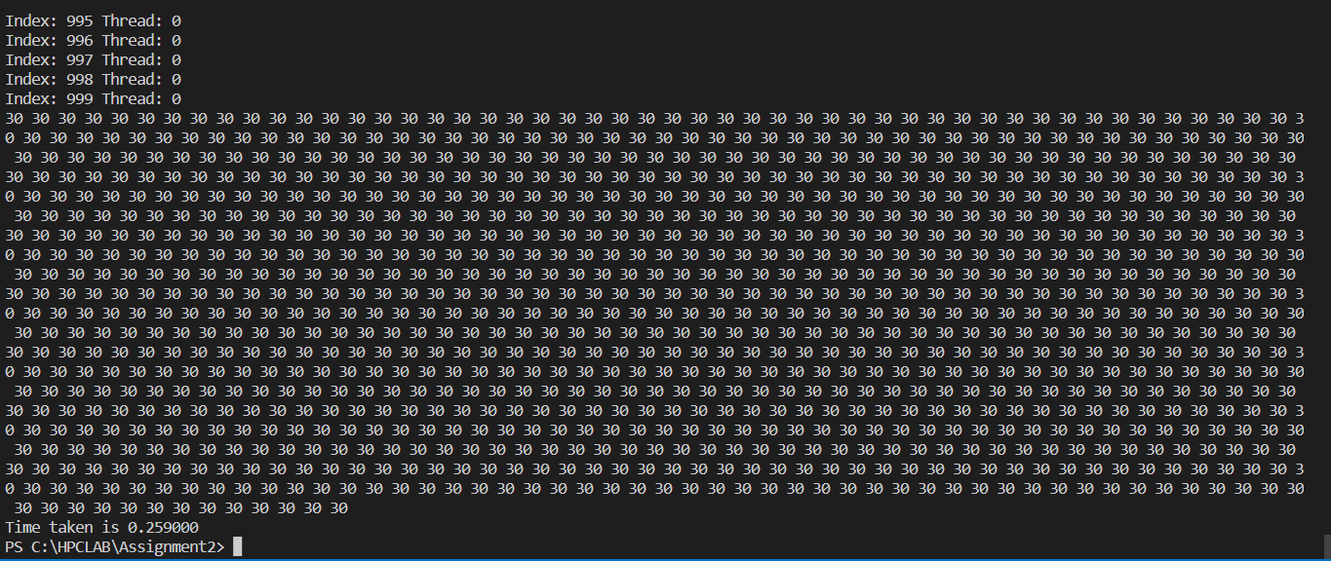

Program for Vector-Scalar Multiplication:

Sequential:

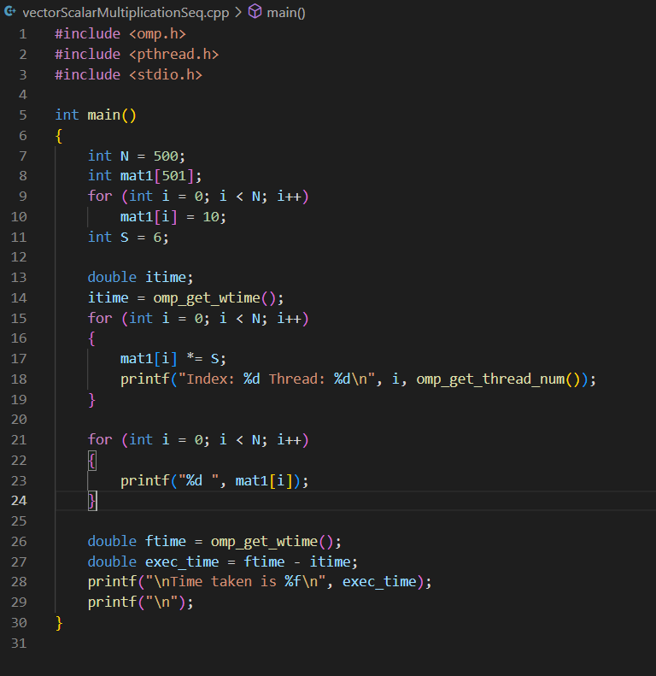

Output:

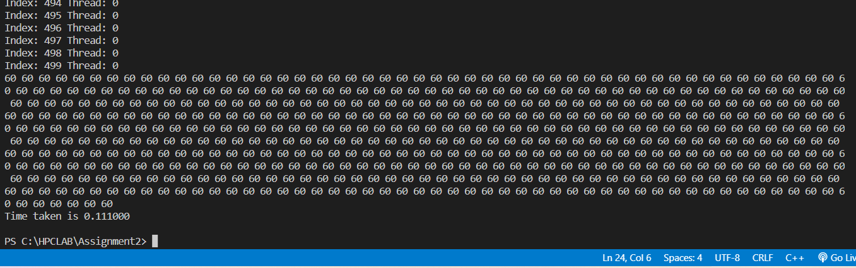

Parallel :

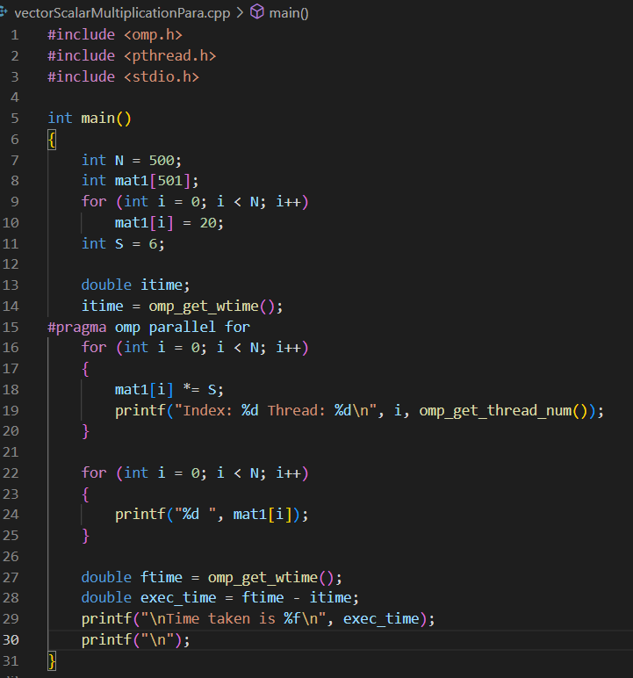

**Output:**

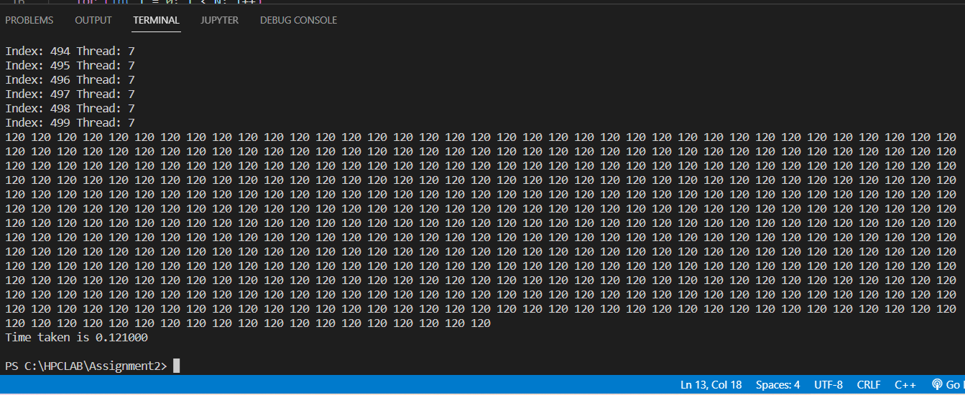

**Github Link:**

[**https://github.com/nd22052000/HPC**](https://github.com/nd22052000/HPC)