**Final Year B. Tech., Sem VII 2022-23**

**High Performance Computing Lab**

**PRN: 2019BTECS00036**

**Full Name: Nikhil Danapgol**

**Batch: B2**

**Assignment No. 4**

**Q1: Analyze and implement a Parallel code for below program using OpenMP**

**Sequential:**

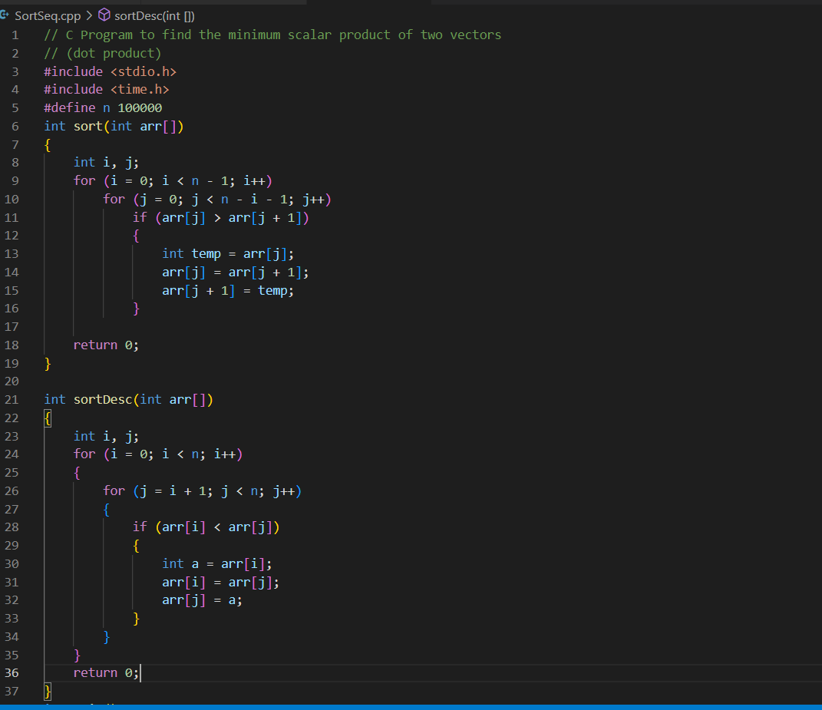

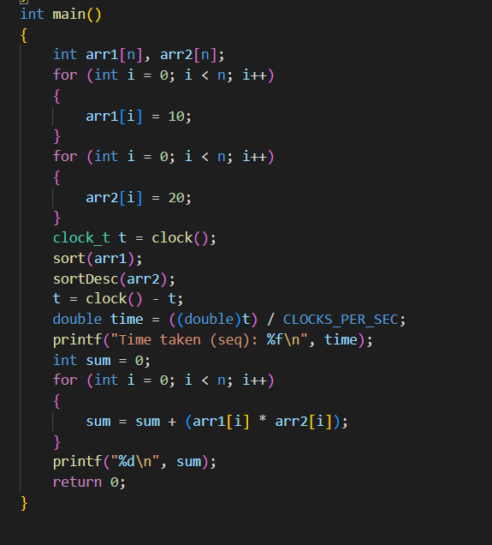

**Output:**

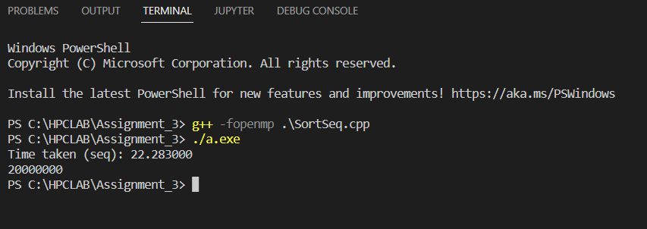

**Parallel:**

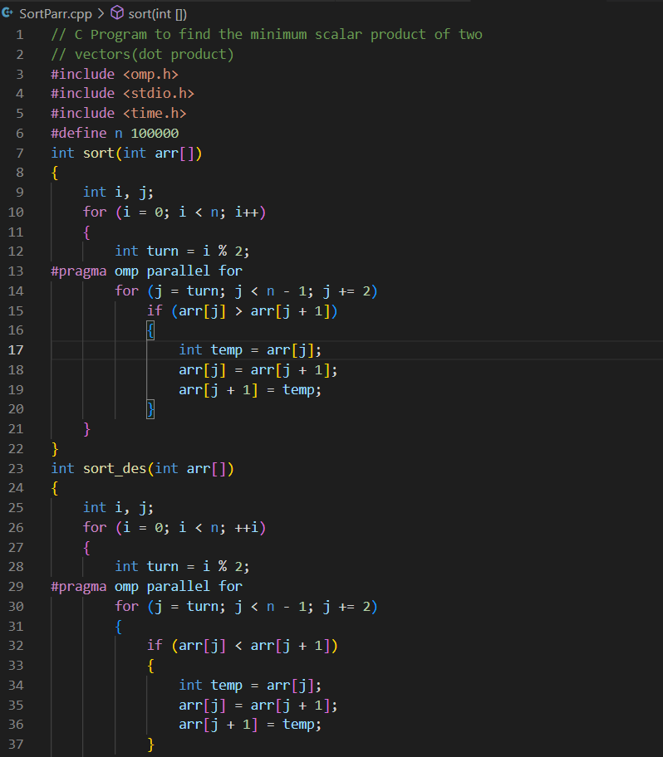

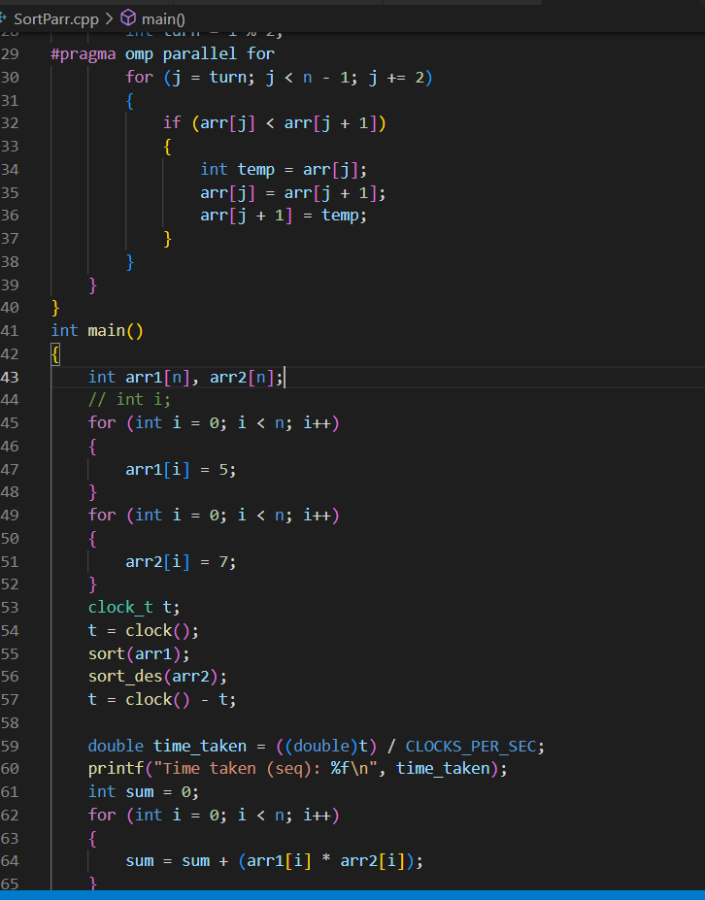

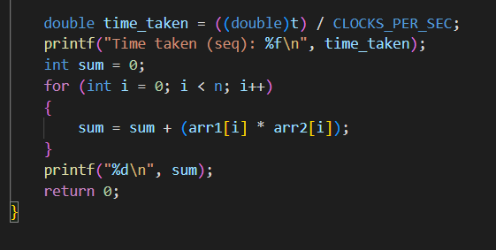

**Output:**

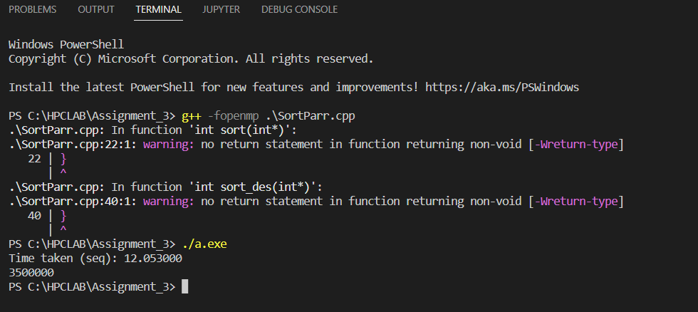

**Q2: Write OpenMP code for two 2D Matrix addition, vary the size of your matrices from 250, 500, 750, 1000, and 2000 and measure the runtime with one thread (Use functions in C in calculating the execution time or use GPROF)**

**Parallel:**

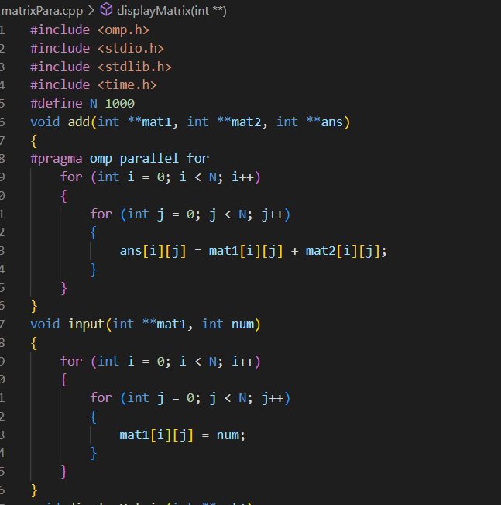

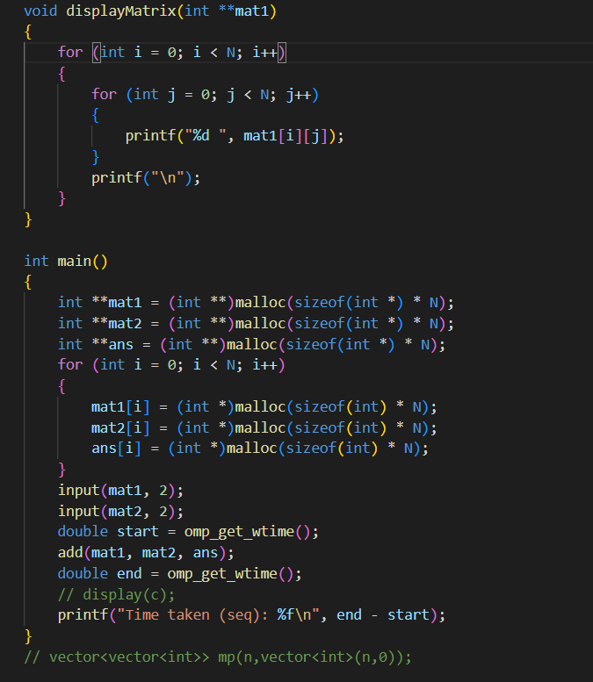

**Output:**

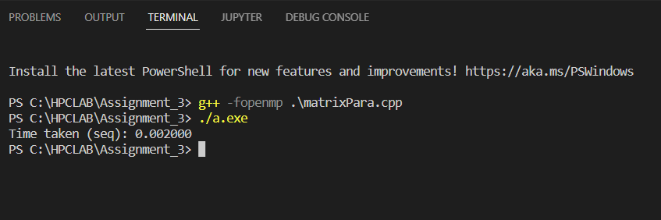

**Threads/N: 250 500 750 1000 2000**

**2 0.001000 0.001000 0.002000 0.004000 0.015000**

**4 0.001000 0.001000 0.002000 0.003000 0.007000**

**6 0.001000 0.002000 0.002000 0.003000 0.010000**

**8 0.001000 0.002000 0.003000 0.003000 0.009000**

**Sequential:**

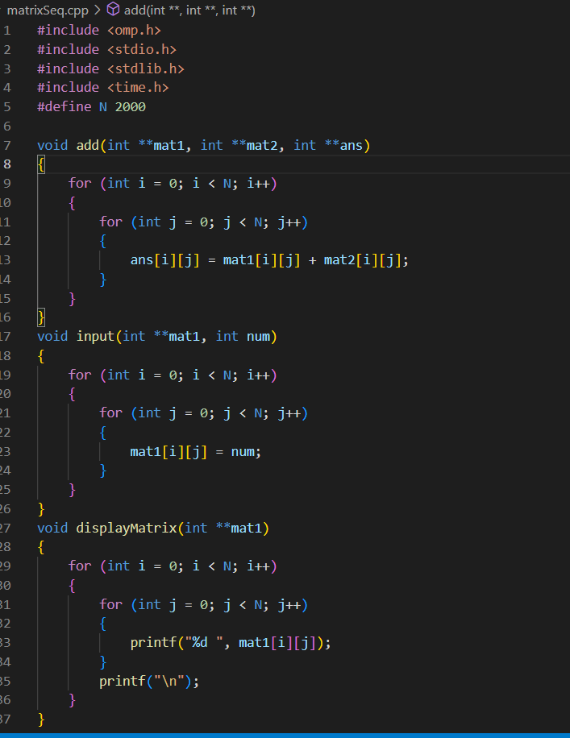

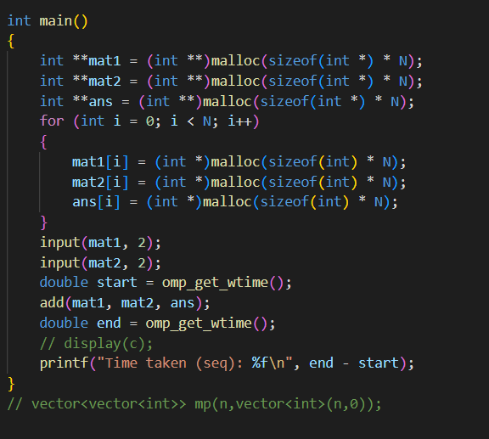

**Output:**

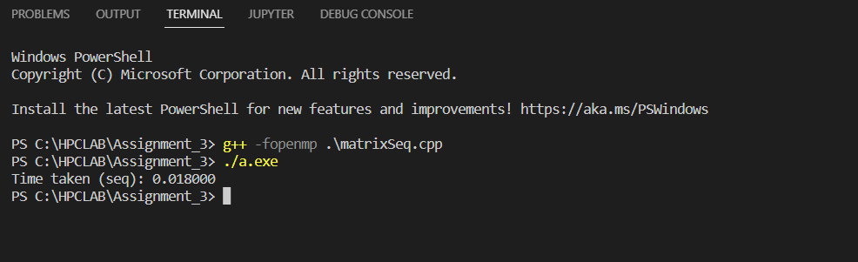

**N 250 500 750 1000 2000**

**Time 0.000000 0.002000 0.002000 0.003000 0.020000**

**Q3. For 1D Vector (size=200) and scalar addition, Write a OpenMP code with the following:**

**i. Use the STATIC schedule and set the loop iteration chunk size to various sizes when changing the size of your matrix. Analyze the speedup.**

**ii. Use the DYNAMIC schedule and set the loop iteration chunk size to various sizes when changing the size of your matrix. Analyze the speedup.**

**iii. Demonstrate the use of nowait clause.**

**1.Static Schedule:**

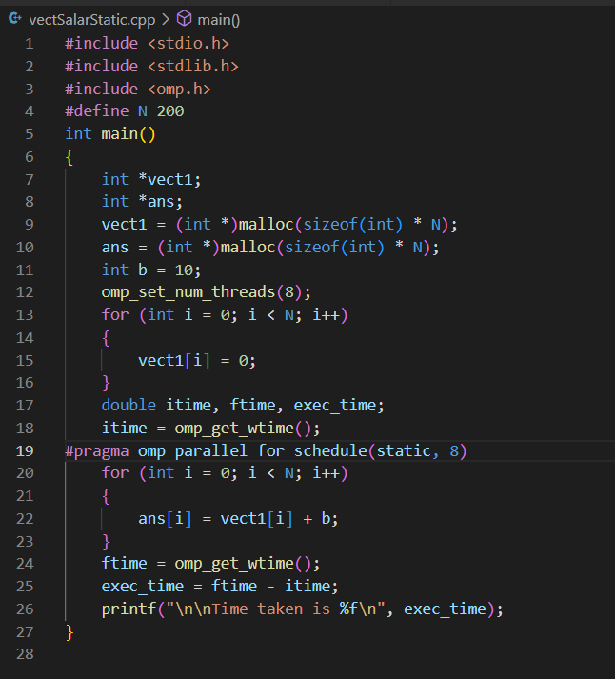

**Chunk Size: 2 4 6 8**

**Time: 0.001000 0.001000 0.001000 0.001000**

**2.Dynamic Schedule:**

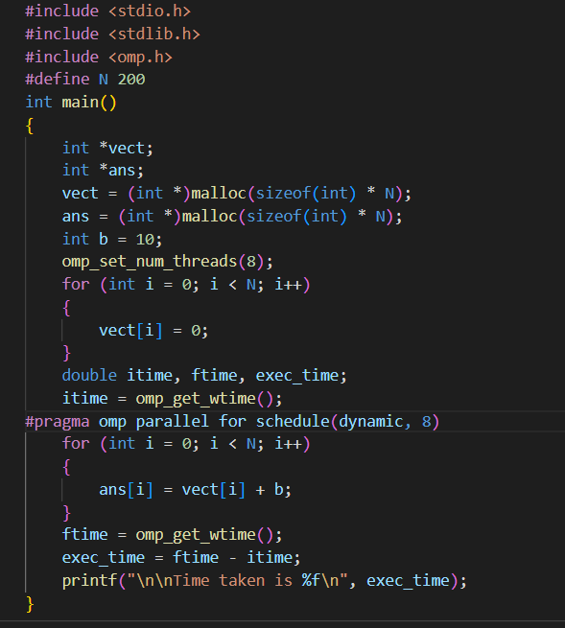

**Chunk Size: 2 4 6 8**

**Time: 0.002000 0.001000 0.001000 0.001000**

**Pros: The dynamic scheduling type is appropriate when the iterations require different computational costs. This means that the iterations are not as balance as static methods between each other.**

**Cons: The dynamic scheduling type has higher overhead then the static scheduling type because it dynamically distributes the iterations during the runtime.**

**3.Nowait Clause:**

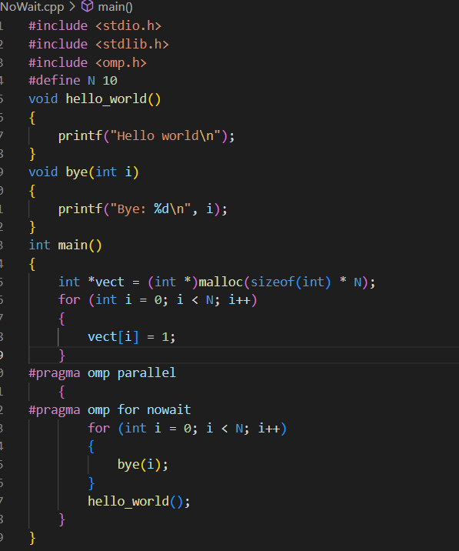

**Output:**

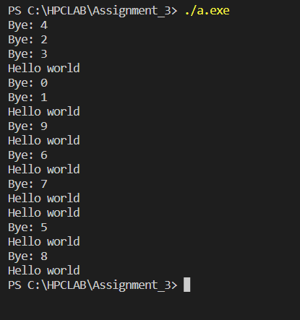

**Without NoWait Clause:**

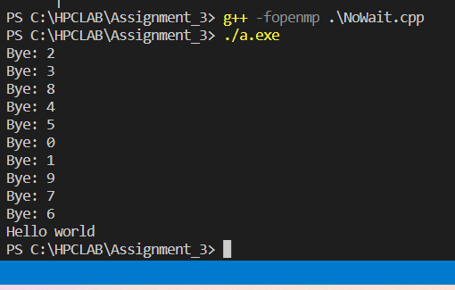

**GitHub:**

[**https://github.com/nd22052000/HPC**](https://github.com/nd22052000/HPC)