SUMMARY :-

As we know, we face some issues while buying tickets in traditional way as it becomes hectic and time taking procedure, we have come up with a solution to this problem. The solution to this problem is a **CHATBOT**, the chatbot is made to take inputs like the customer’s name , state, city, nationality and many more. For a brief introduction it asks the user firstly the name, then chatbot asks for the particular state’s museum the user wants to visit. Not only this but also it gives the user to opt different city’s museums. After all this primary details, it asks for the nationality i.e. whether the user is Indian or Foreigner (it calculates the fare accordingly) . Finally it gives the user the options to select the total number of persons. All this details will then finally lead to the payment gateway and then the QR will be generated with rules and regulations.

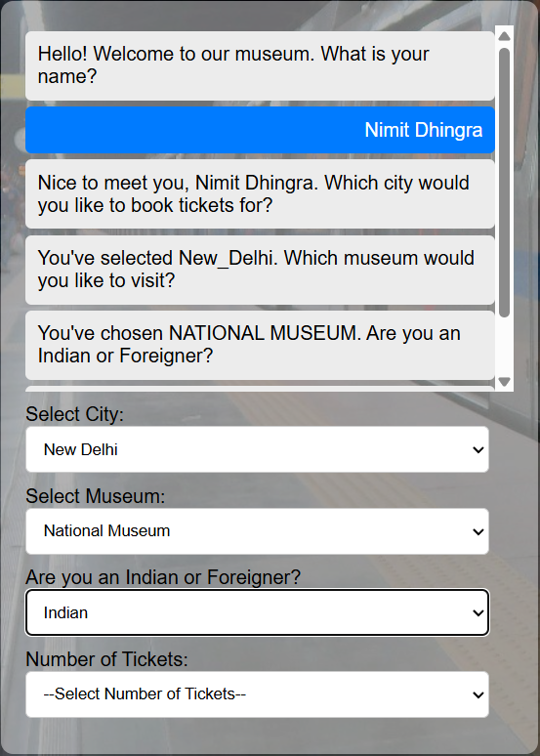

The website is multilingual, providing users to book tickets easily and complete all booking process efficiently. For multilingual it uses Google Translator, not only the chatbot but also it translates the language of all the pages as per the needs of the user.

The web page has LOGIN and EMERGENCY buttons. The login butto provides the user to save their details and the emergency button helps the user to have a contact in case of an urgency.

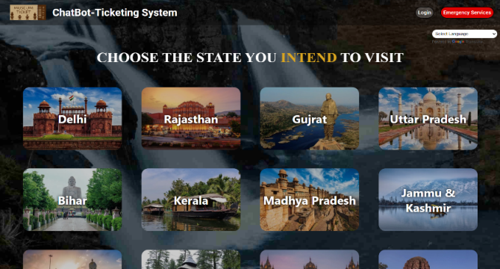

**HOME PAGE**

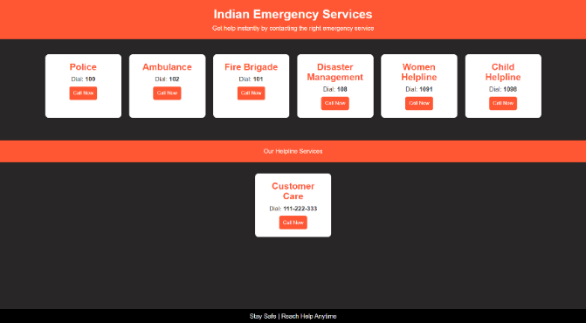

**EMERGENCY SERVICES**

This website provides with 29 States option to the user and each state has information of different museums of different city in that particular state.

The information also consist of the directions of each museum with the contact number of each museum with the images.

So with all the essential details and a catchy web page this website is a solution to the problem. This website is not only for particular states of some Government related museums, instead of this it is for 29 States and mostly all the museums one would love to visit.

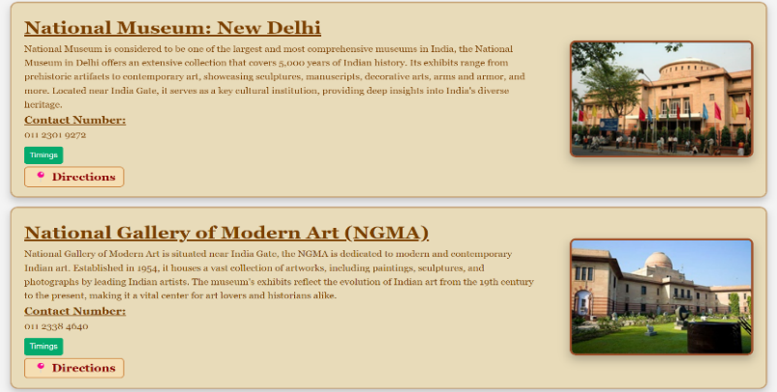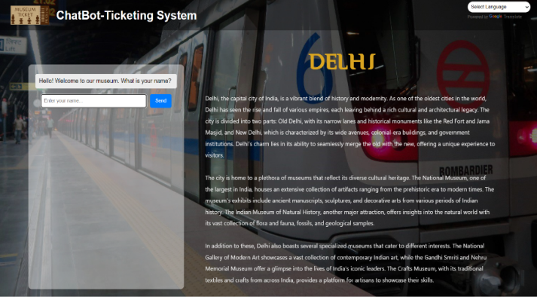

Above images shows how the information of each museum in brief is given with the days i.e. real-time update of that particular museum is also given. Multilingual is provided in each web page for efficiency.

This website serves the solution to the problem and also looks forward toward substantial increase in revenue & profit from this.