**PROJECT**

**Desktop Design**

1. This is landing page. This is the first webpage user should see, when it is opened in the browser.

Create header, footer as separate components, so that they can be used in all the webpages.

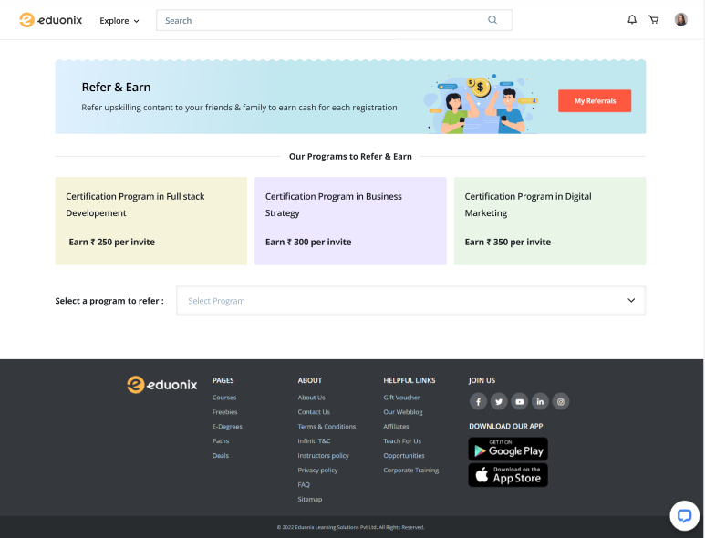

1. This is the next page selected when user selects from the dropdown. User should be able to add data when user click on Add button. Add validation.



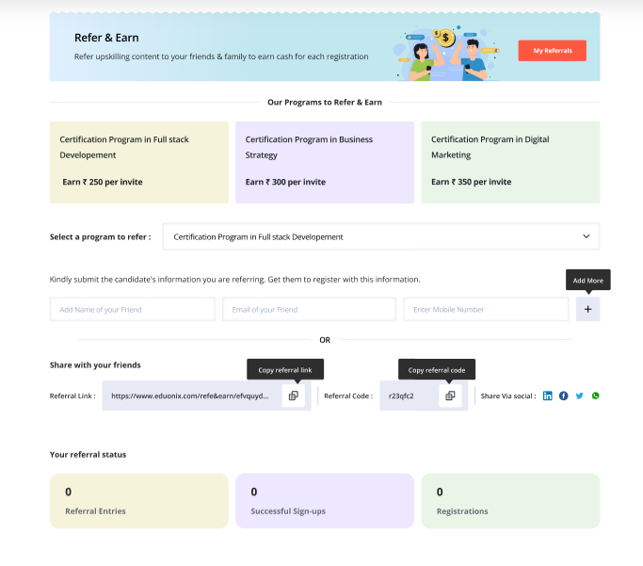



1. Create a hover on My referrals button as shown below.

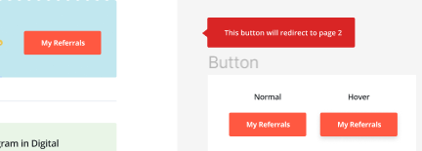

1. Data should be displayed in same place and new input should come for user to add the data. There is delete button, if user click on delete that record should be deleted. User should be able to copy the code and referral code. Style the submit button as mentioned in card below.

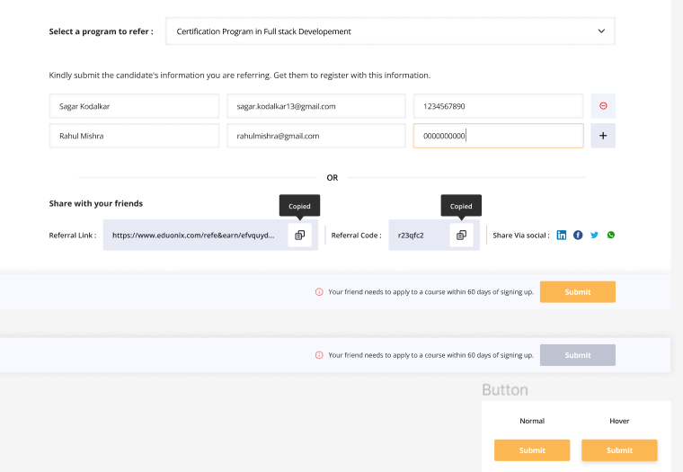

1. This is how dropdown looks.

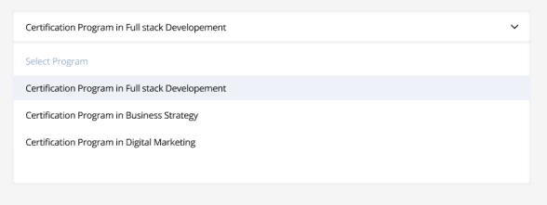

1. This is second webpage.If user has already logged in through referral, then data should here. This page will open if my referrals button is clicked.

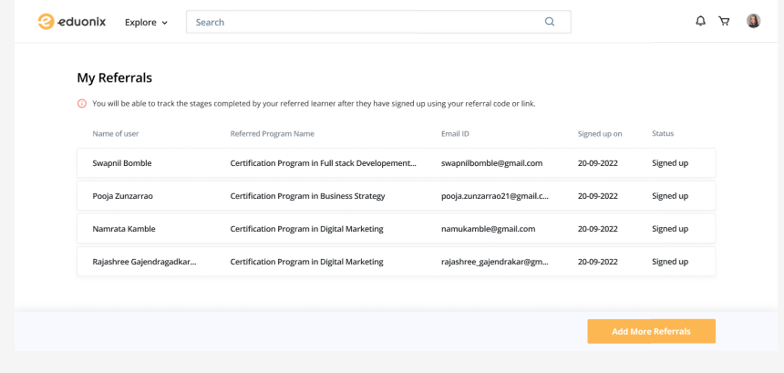

**Mobile Design**

1. This is how referral page will look.

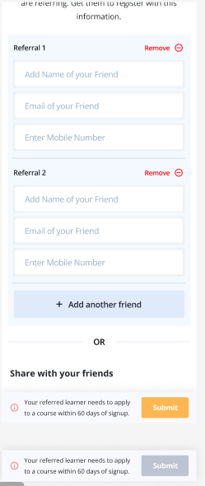

1. From dropdown, select course.



1. This should after user has selected the course.



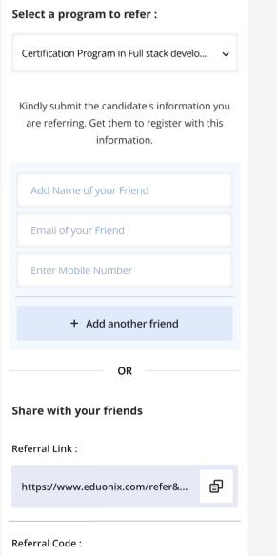

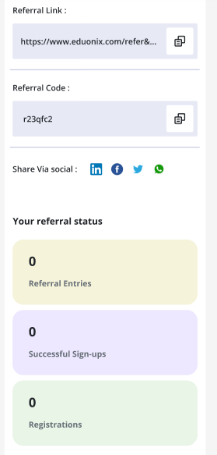

1. This is second webpage. If user has already logged in through referral, then data should here. This page will open if my referrals button is clicked.

