***Smart Home***

***Energy Monitoring and Management***

Prepared under the course

Power Electronics (EED306)



|  |  |  |  |  |
| --- | --- | --- | --- | --- |
| ***Sr. No.*** | ***Name*** | ***SNU ID*** | ***Contribution*** | ***Signature*** |
| *1.* | Arnab K Nayak | 14101100xx |  |  |
| *2.* | Ayush Kapoor | 1410110088 |  |  |
| *3.* | Niladri Dutta | 1410110264 |  |  |
| *4.* | Pranshu Srivastava | 1410110397 |  |  |

Electrical Engineering Department

Shiv Nadar University

Greater Noida, India

**TABLE OF CONTENTS**

**Abstract** 3

**Introduction** 3

**Litrature Review** 3

A. Triac 3

B. Principle of Operation of Triac 3

C. Microcontroller 3

D. Single Phase Rectifier 4

**Methodology** 5

Problem Statement 5

Simulation Circuit Diagram 6

**Results** 8

**How this topic is different from existing literature ?** 9

**References** 10

# **Abstract**

This project is a….

# **Introduction**

To control.

# **Litrature Review**

## Triac

A triac is …

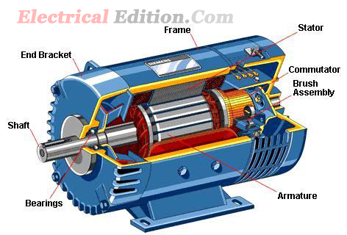

Figure 1: Parts of a DC Machine

## Principle of Operation of Triac

A microcontroller…….

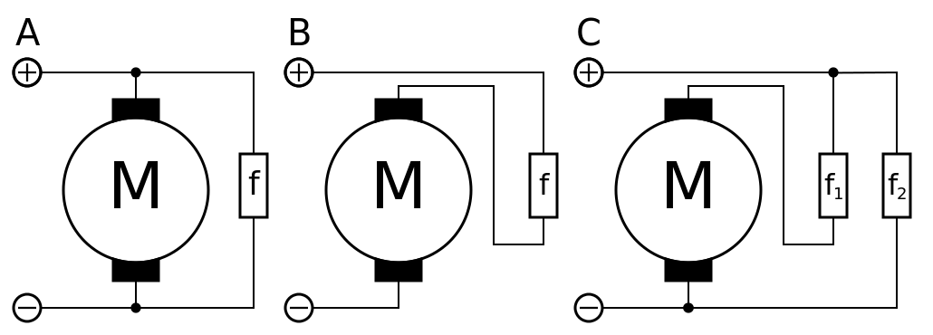

Figure 2: Wound type DC Motors: (A) DC Shunt Motor, (B) DC Series Motor and (C) DC Compound Motor

## Microcontroller

A microcontroller…….

## Single Phase Rectifier

A single phase rectifier:

# **Methodology**

There is difficulty when using the traditional or conventional method because those methods cannot deal with any application that using complex mathematical model. However, a working knowledge of…….

## Problem Statement

Let the machine is at standstill. It has not started. Suppose the operator give a high speed command. Let us say motor has to go to full speed. Because of electromechanical time constant it will take its own time to speed up. But the controller is very fast. Speed feedback is zero initially. So this will result in full controller output Ec. Converter gives the maximum voltage. But during starting back emf Eb is zero. So very large current flows which sometime exceed the motor rated current limit and it can damage the machine.

So, here the problem is current is not controlled. We are only looking at the speed and the voltage. For a machine there is not only the voltage rating but the current rating is also there. So any speed control must have a current control. So, before going to the machine one current control loop is there. That is, the applied voltage Va is now not dependent on the speed error but is on the current error. We must ensure that Va is applied in such a way that machine during positive and negative torque should not draw more than the rated current. So, an inner current loop is required.



Figure 8: Block representation of control system model.

## Controller Circuit Diagram

The following model was created in Simulink:

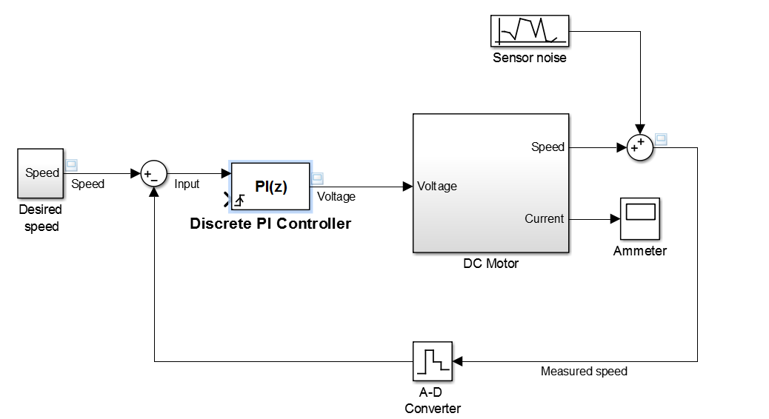

Figure 9: Controller and Plant model diagram (from Simulink)

The DC Motor block is expanded and shown below:

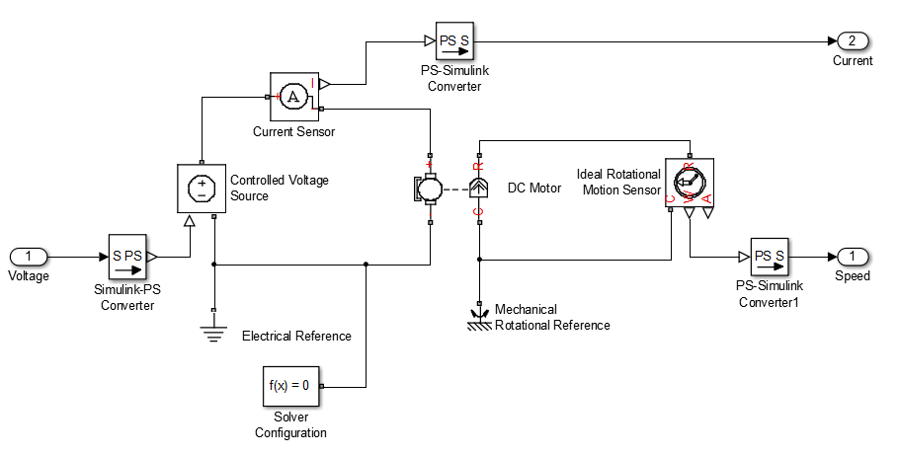

Figure 10: DC Motor Plant Model Diagram (from Simulink)

Now using the PID tuner the PI controller is tuned to set the proportional and integral constant according to the DC motor’s response. The following GUI is used to achieve the tuning:

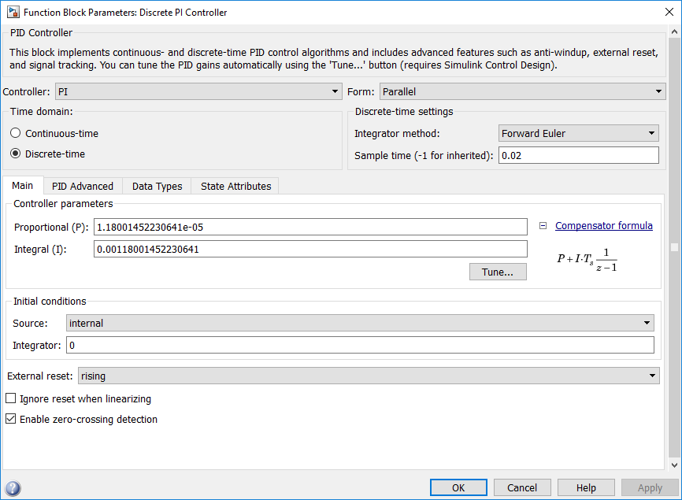

Figure 11: Block Parameters for PI Controller

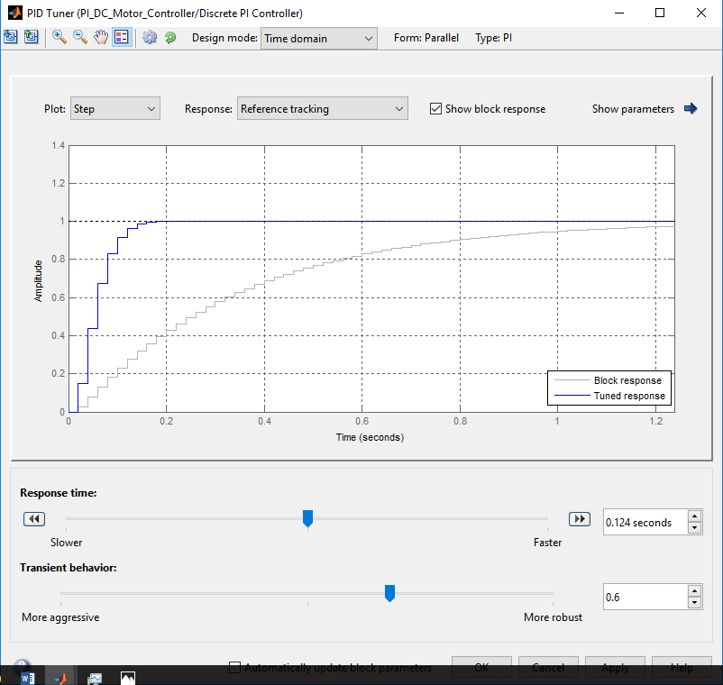

Figure 12: PID Tuner GUI: Transient response of Motor

# **Results**

In the figure the blue line plot represents the desired output speed. The red plot represents the measured output speed. When a PI controller is implemented in order to control the DC Motor speed, the measured output speed takes a delay to achieve the required speed. This delay appears as a transient with a gradual increase of output speed to the required speed, as shown in *Figure 13.*

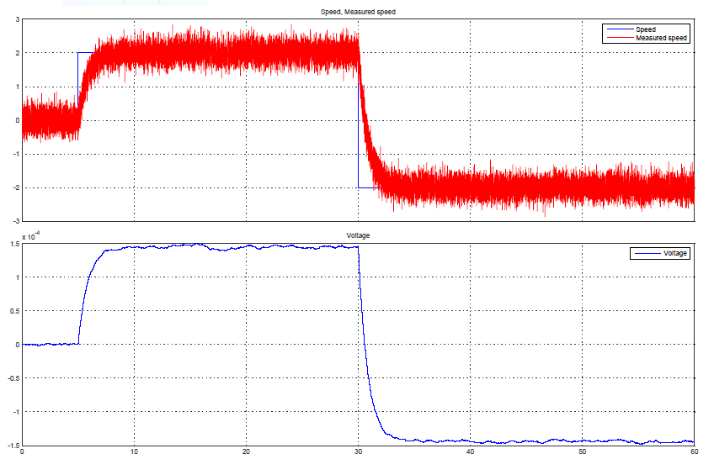

Figure 13: Speed and Voltage Output without tuning the PI Controller

Now once the PI controller has been tuned to the plant model response, the following result is obtained. The delay to change the speed has decreased and the measured speed achieves the desired speed almost instantly, as seen in *Figure 14.*

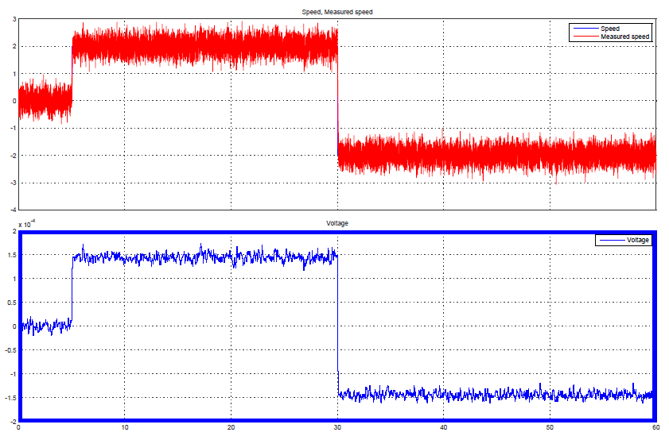

Figure 14: Speed and Voltage Output after tuning the PI Controller

# **How this topic is different from existing literature ?**

The PI controller based implementation is one of the oldest industrial automation techniques. It has been implemented in various electrical and mechanical physical systems to improve the desired performance of the machine. In this project we apply the same PI controller to closed loop controller logic to control the speed of a DC Motor. The application of the feedback based approach to control the dc machine’s makes the results of this project useful for various applications.

The results of this project can be used to implement the speed control of DC Motors by PI controllers in realtime. The following is a suggested model for realtime application [1]:

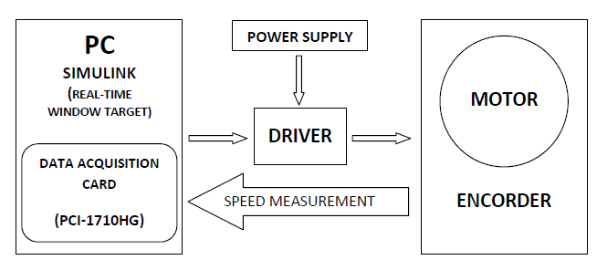

Figure 15: Block Diagram of System [1]

# **References**

|  |  |
| --- | --- |
| [1] | M. F. B. M. FARUQ, "PID CONTROLLER DESIGN FOR CONTROLLING DC MOTOR," 2008. |
| [2] | P. G. S. R. P. P. S. R. Prof. Krishna Vasudevan, "NPTEL," [Online]. Available: nptel.ac.in/. |
| [3] | K. a. Praveen Kumar Singh, "CONTROL AND DESIGNING OF THE DC MOTOR DRIVE USING P-I". |
| [4] | UMICH, "SimulinkModeling," [Online]. Available: • http://ctms.engin.umich.edu/CTMS/index.php?example=MotorPosition&section=SimulinkModeling . |
| [5] | Wikipedia, "PID Controller," [Online]. Available: https://en.wikipedia.org/wiki/PID_controller. |
| [6] | Mathworks, "PID Controller Design for a DC Motor," [Online]. Available: http://in.mathworks.com/videos/pid-controller-design-for-a-dc-motor-68881.html. |