**MultilingProfiler Training**

Materials drafted by Laurence Anthony

Version 1.00 (2023-05-27)

1. **Getting ready**

Install Python for creating JSON files from raw text files (as used in the Word Families page of MultilingProfiler).

1. Install Miniconda (a Python package manager).
   1. https://docs.conda.io/en/latest/miniconda.html
2. Launch Miniconda (from the Start Menu) and create an 'mlp' project environment.
   1. >conda create --name mlp python=3.10
3. Activate the 'mlp' environment.
   1. >conda activate mlp
4. Install the required 'regex' package into the 'mlp' environment
   1. >pip install regex

Install the Microsoft Visual Studio Code (VSCode) as a useful IDE (Integrated Development Environment) for viewing and editing text files, and Python running code.

* https://code.visualstudio.com/download
* Click on the "Extensions" button in the left sidebar, and add the "Live Server" extension by clicking and following the instructions. This is used to preview MLP before it goes live.

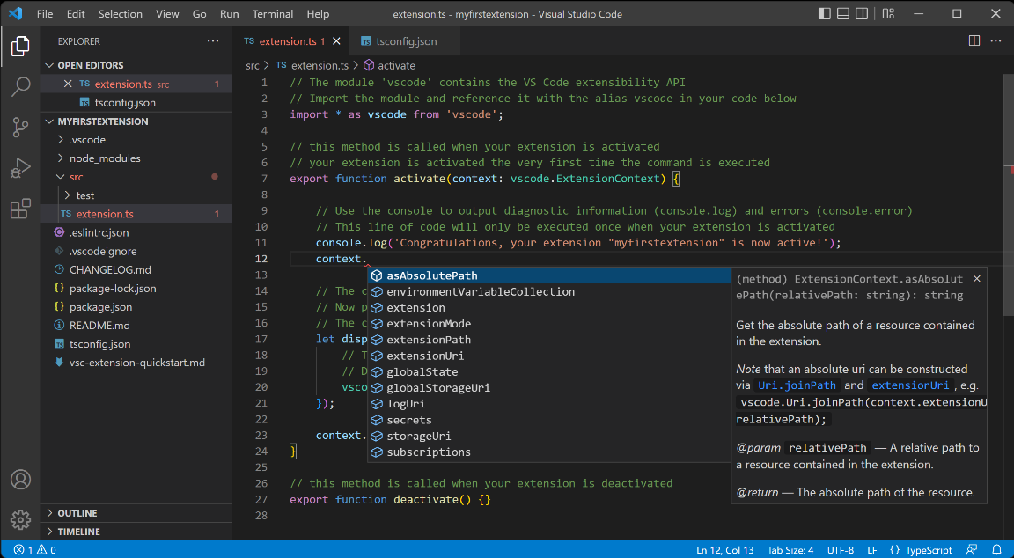

Figure 1. Visual Studio Code (VSCode)

Create a VSCode workspace for MLP work

* 1. Launch VSCode.
  2. Use File->Open Folder to navigate to the MLP folder.
  3. Use File->Save As Workspace and save the workspace file in the MLP folder with the default name.
  4. Load the workspace by double clicking on the workspace folder.

**Creating JSON files for the main list inventory and word family list tool**

1. Open the MLP workspace in VSCode.
2. Open the “add_json_files_to_data.py” script in the project folder.
3. Access the instruction to install the Python extension (which offers usually functions for debugging and highlighting the code)
4. Click on the Python version shown in the bottom right of the VSCode IDE.
5. Follow the instructions to set the Python environment to ‘MLP’.
6. Restart VSCode to ensure the changes are made (only necessary if the changes are not immediately shown)
7. Run the “add_json_files_to_data.py” script by clicking the "RUN" button in the top right of the IDE (or using "Run without debugging" from the "Run" menu.

**Editing MLP files through VSCode**

1. Open the MLP workspace in VSCode.
2. Open the "index.html" files and click the "Go Live" button at the bottom right of the VSCode IDE to see a preview of the MLP site in your default browser (e.g. Chrome)
3. In VSCode, navigate to the template file that you want to edit and double click to view the file. You can also drag the file to the top of the viewing window to see the file contents.
4. Edit the file in VSCode and see the preview site automatically update to reflect the changes.

Figure 2. Example of template file (Contact.html)

**Uploading local changes to MLP to the MLP live site**

**Option 1 (via a zip file)**

1. In File Explorer/Finder, navigate to the webapp folder.
2. Right-click on the folder name and choose to compress the folder to a zip file).
3. Send the file to the relevant IT staff member.

**Option 2 (via an FTP file update tool)**

1. Launch an FTP file manager (e.g., FileZilla).
2. Connect to the MLP server.
3. Navigate to the local MLP folder (in the left window).
4. Select the files and folders you want to upload to the server.
5. Right click in the left window and choose 'Upload'.
6. Wait for the upload to finish.
7. Confirm the changes in the live site.

Figure 3. FileZilla upload to server