22712781_NguyenDucAnh_Tuan1
producer.js
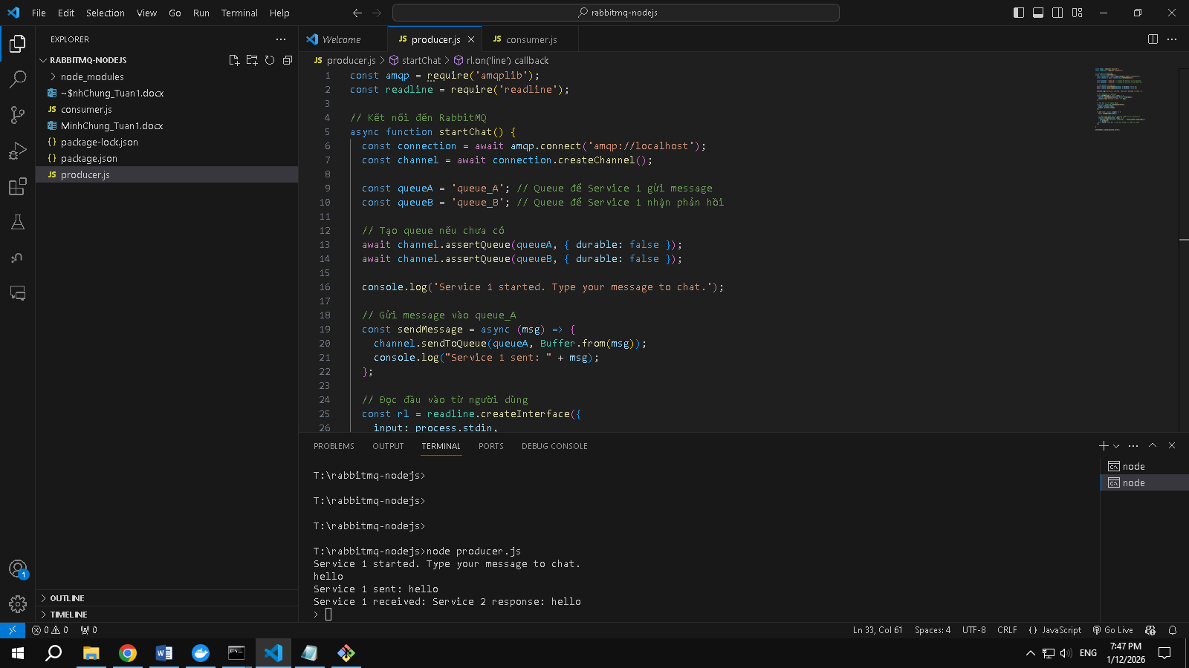

consumer.js
