**PROJECT Title:** SMART GATE

**GitHub LINK :** <https://github.com/ndabahriye/Smart-Gate>

TEAM MEMBERS

NDABAHARIYE Jean Aime Reg No 220014212

MUSABYEMARIYA Cécile Reg No 220002861

**Supervisor:** Prof KAYALVIZHI Javavel

1. **Objective / Aim:**

This project named “**Smart Gate**” is to study how to use Ultrasonic Sensor and Servo motor as actuator under one board of Arduino. This project is referring of the existing one, but this study is focusing its operations from scrash. This project is tending to be familiar with Arduino IDE and its different features.

1. **Requirements**
2. **Hardware:**
3. Ultrasonic sensor x 1
4. Arduino UNO x 1
5. LEDs x 5
6. Buzzer x 1
7. DC motor x 1 (instead of Servo motor)
8. Cord x 1
9. Breadboard x 1
10. Jumpers x 18
11. Straws x 2
12. Box x 1
13. Computer x 1
14. **Software:**
15. Arduino IDE
16. Microsoft Word
17. **Methodology**

This project is based on observation of current and working gates and there are steps that are used to reach to my objective.

**Steps:**

**Connection of components**

Buzzer

Arduino UNO Board

Breadboard



Straw

Cord

Vcc

Gnd

Echo

Trigger

Ultrasonic sensor

DC Motor

LEDs

Pin 12

Pin 11

5v

Gnd

Pin 5

Pin 6

Pin 7

Pin 7

Pin 6

Gnd

Pin 6

**How it work?**

This **smart gate** is connecting, when an obstacle object approaches to an ultrasonic sensor at the distance of less or equal to 20 cm as the codes follow explain, then buzzer, red LED and DC motor are switched **ON** otherwise are **OFF** and green, blue are switched **ON. DC** motor is rotating at clockwise with its attached cord, and then that cord pulls a straw goes back.

**Codes:**

/*==============================

Project: SMART GATE

Designed: 220014212 NDABAHARIYE Jean Aime

Date: 3/2/2020 12:48:02 PM

===============================*/

#define blue 7 //Declaration and initialization of blue LED

#define red 6 //Declaration and initialization of red LED

#define buzzer 6 //Declaration and initialization of buzzer

#define dc 6 //Declaration and initialization of DC motor

#define green 7 //Declaration and initialization of green LED

int trigPin = 11; //Declaration and initialization of TRIGGER

int echoPin = 12; //Declaration and initialization of ECHO

long duration, distance; //Declaration and initialization of duration and distance

void setup() {

Serial.begin (9600); //Rate bound

pinMode(trigPin, OUTPUT);

pinMode(echoPin, INPUT);

pinMode(green, OUTPUT);

pinMode(blue, OUTPUT);

pinMode(red, OUTPUT);

pinMode(buzzer, OUTPUT);

pinMode(dc, OUTPUT);

}

void loop()

{

digitalWrite(trigPin, LOW);

delayMicroseconds(5);

digitalWrite(trigPin, HIGH);

delayMicroseconds(10);

digitalWrite(trigPin, LOW);

pinMode(echoPin, INPUT);

duration = pulseIn(echoPin, HIGH);

distance = (duration/2) / 29.1; //Formula to calculate distance

Serial.print(distance); //Method used to printout the value of gained distance

Serial.print(" cm"); //Measure in centimeter

Serial.println();

if(distance <= 50) //Condition if distance is less than or equal to 50 cm

{

digitalWrite(dc, HIGH); //DC motor is ON

delay(2000); //Delay of 2 seconds

digitalWrite(green, LOW); //Green LED is ON

digitalWrite(blue, LOW); //Blue LED is ON

tone(buzzer,20000); //BUZZER is ON

digitalWrite(red, HIGH); //Red LED is ON

delay(100);

}

else

{

digitalWrite(green, HIGH);

delay(100);

digitalWrite(green, LOW);

delay(0);

digitalWrite(blue, HIGH);

delay(100);

digitalWrite(blue, LOW);

digitalWrite(red, LOW);

digitalWrite(dc, LOW); //DC motor is OFF

noTone(buzzer); //BUZZER is OFF

delay(0);

}

delay(0);

}

**Snapshot screen**

Arduino IDE

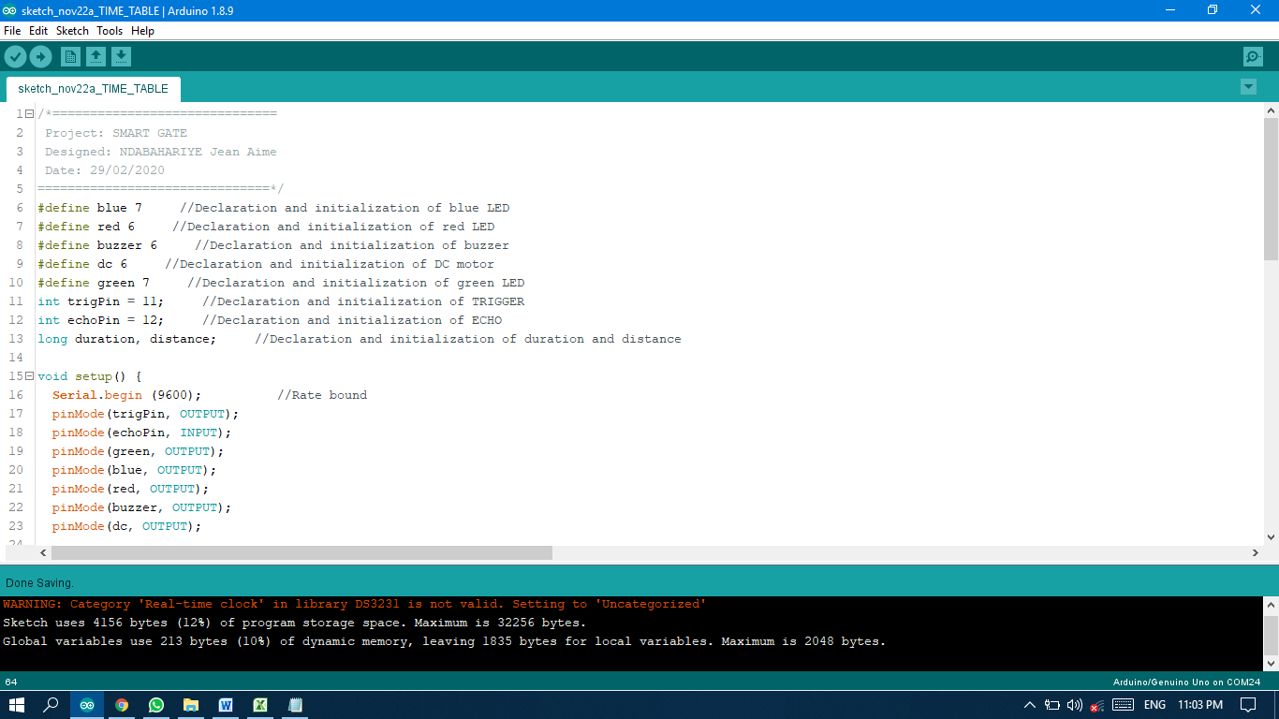

Result after running

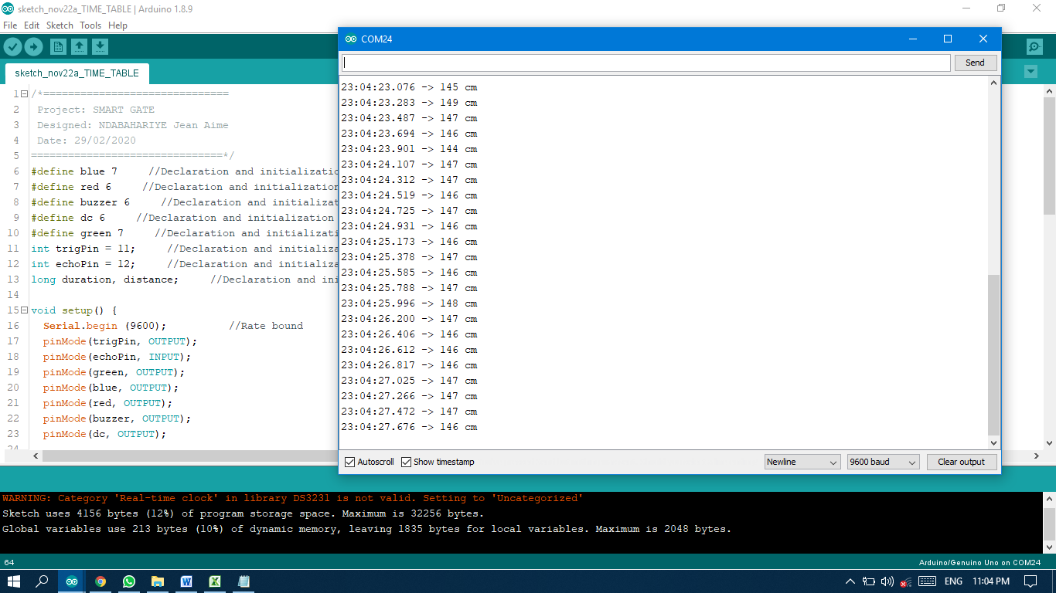

**References**

1. Lecture’s notes (Module of Sensors and actuators)
2. Links:
   1. https://create.arduino.cc/projecthub/abdularbi17/ultrasonic-sensor-hc-sr04-with-arduino-tutorial-327ff6
   2. https://howtomechatronics.com/tutorials/arduino/ultrasonic-sensor-hc-sr04/