    - Formula for firing rate:

Threshold Current:

Half-max Current:

Asymptotic Firing Rate:

Tfire:

(See attached plot, the analytical solution is the blue line)
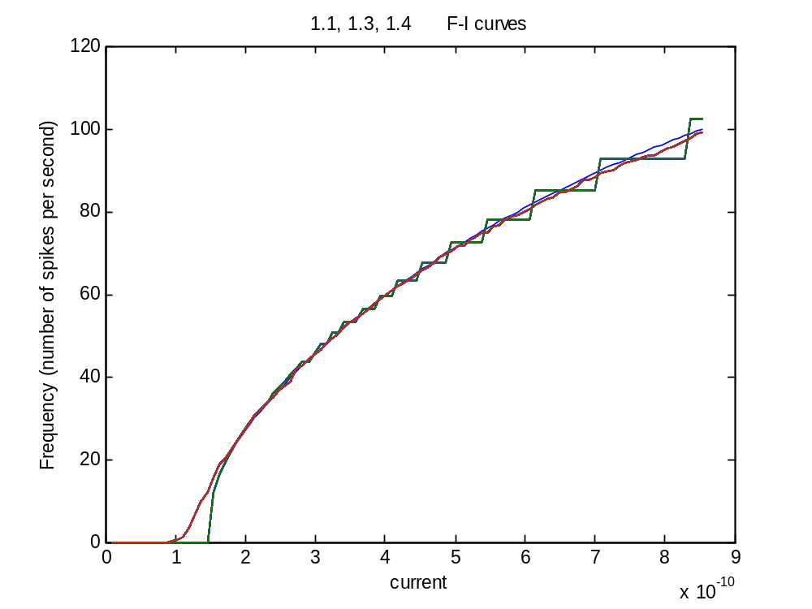

    - (No Need to Hand Anything In)

    - (See attached plot, the simulation curve is the green line) The difference between the two plots is that the simulation curve looks step like, whereas the analytical solution is a smooth curve. The reason for these step-like jumps in frequency is related to the total time over which we are integrating. Because we are only integrating over 1 second of time, we get an apparent frequency due to the current that looks the same over a narrow range of current. If we were integrating over a longer period of time slight differences in frequency would be more apparent, and the curve would be smoother. The steps grow in size with increased current because of loss of current due to this phenomenon.

    - (See attached plot, the noisy simulation curve is the red line). Noise smooths out the curve because it pushes the voltages of the units on the verge of firing over the artificial hump created by the integration time.

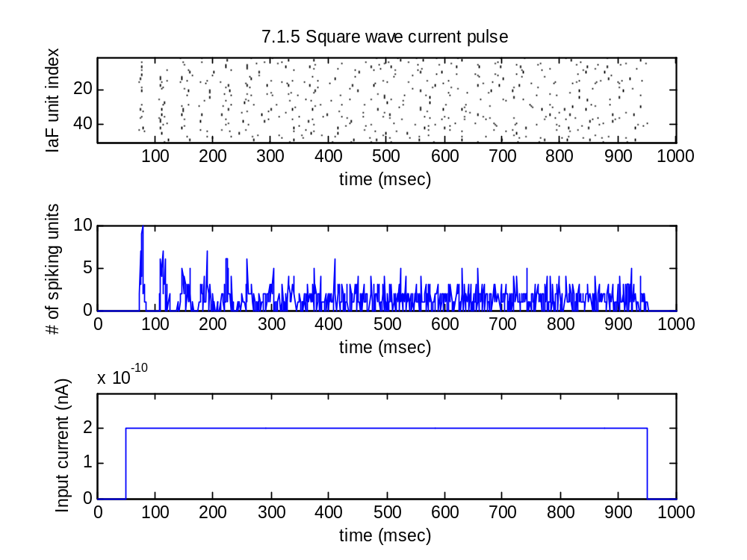
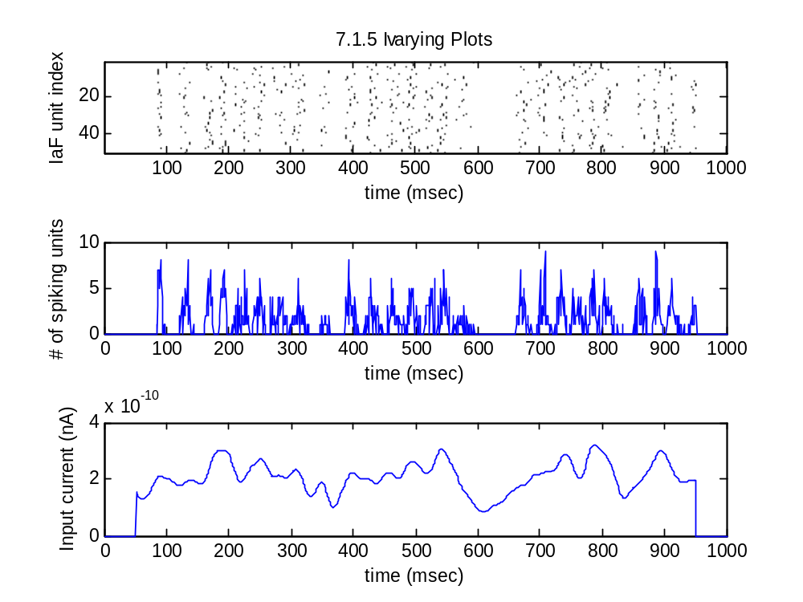

7.1.5 (cont.) The above figures plot independent units against the same current pulses. The graphs indicate how many fire at the same point when responding to the current. These results seem to point to a question of reproducibility of information across trials. When given a constant pulse, the units initially correlate with their first fire and then decorrelate over time. When Given a varying current it appears that with the initial bursts above threshold, the units fire at the same time then decorrelate until the current goes below threshold at which point, with a burst above threshold they correlate again. A simple experiment to test this behavior is applying an oscillatory current to the units. When I did this, the units always fire at the same time (See attached graph, please not crappy display on matlab – when you zoom in and count spikes the histogram and raster plot are matched up properly), when the current bursts.

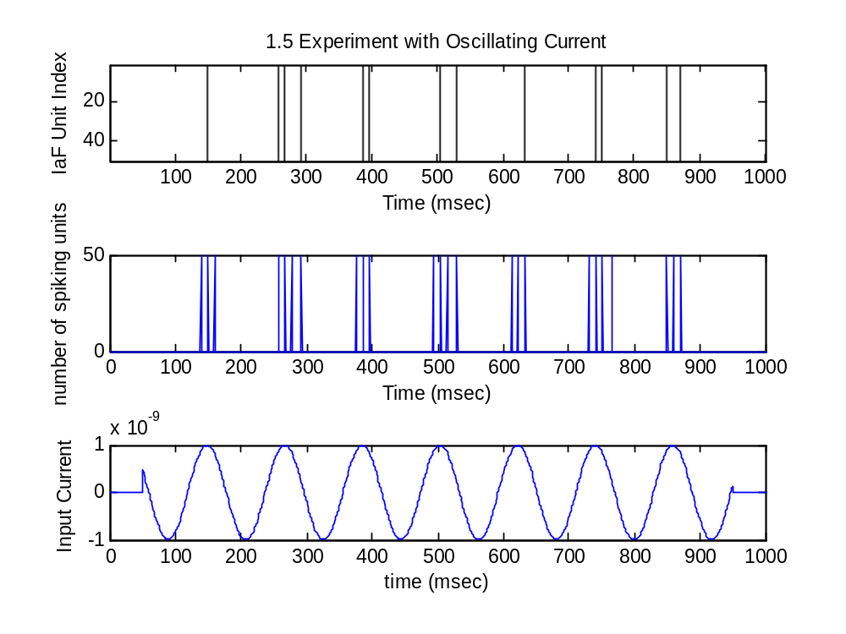

7.2.1 In order to derive the equation, I made an assumption based on a passage on RC Circuits by Christof Koch (“Biophysics of Computation”, 1999, p.12).
Essentially we can transform the complex differential equation of the mean firing rate into fourier space where the curve represented by a sin wave is shifted. Because we only care about the mean rates, the shift doesn’t matter if we take our integral over the period of the wave and then average over it.
The analytically derived mean firing rate is:

And plotted analogously to the figures provided :
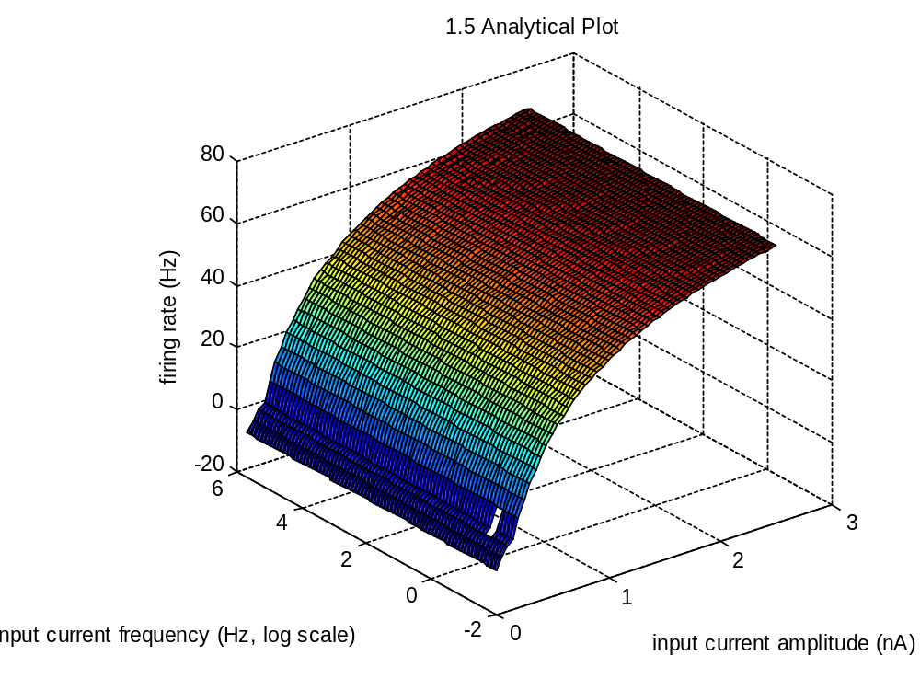
7.2.2 The discrepancy between the “instantaneous firing rate” predictions and the simulations done by the student are as follows: The predicted results suggest that frequency has no bearing on firing rate, which only varies with amplitude of input. But this assumption, (the very assumption of an “instantaneous firing rate”) is missing the information contained in the history of the circuits. Moreover, the way the analytical result is calculated (by averaging over each period), makes the frequency of the sin wave irrelevant. That is why the analytical plot lacks the wings and ripples of the student’s simulated plot. So the predicted results do not accurately depict the way integrate and fire circuits work.
By the same token there is an error in the simulation code. The bug in the student’s code is that he does not integrate over the full period of the sin wave. When the bug is corrected I get the plot on the next page (which looks like the original result but without a wing on the right side. The wing on the right side of the student’s simulation is an artifact of the bug in his code (because he does not integrate over the whole period for low frequencies, his mean firing rates for the low frequency input are heavily skewed toward the positive side of the input (so they are higher than they should be). The wing on the left side however is real, and it occurs at exactly the point where the frequency of the sin wave best lines up with I-V curve of the neuron (so that the current is negative when the neuron is in its refractory period, and positive when it can fire). The ripples in the simulation are over-portrayed due to the time used in the integration, and they smooth out as the time goes to infinity. (The ripples on the right side are an artifact, while some of the ones on the left side are real). Ripples occur when the frequency negatively interferes the refractory period. The boundary between firing and nonfiring regimes is explained by the neuron being a low-pass filter. In the student’s simulation, it takes a greater amplitude to get spikes with increasing frequency. In the correct plot of the student’s simulation, there is a much more clearly defined boundary between firing and nonfiring regimes. (Beyond a certain frequency the low pass filter will not process the input). So the boundary is real and is caused by the capacitance of the neuron (which can act as a low pass filter).

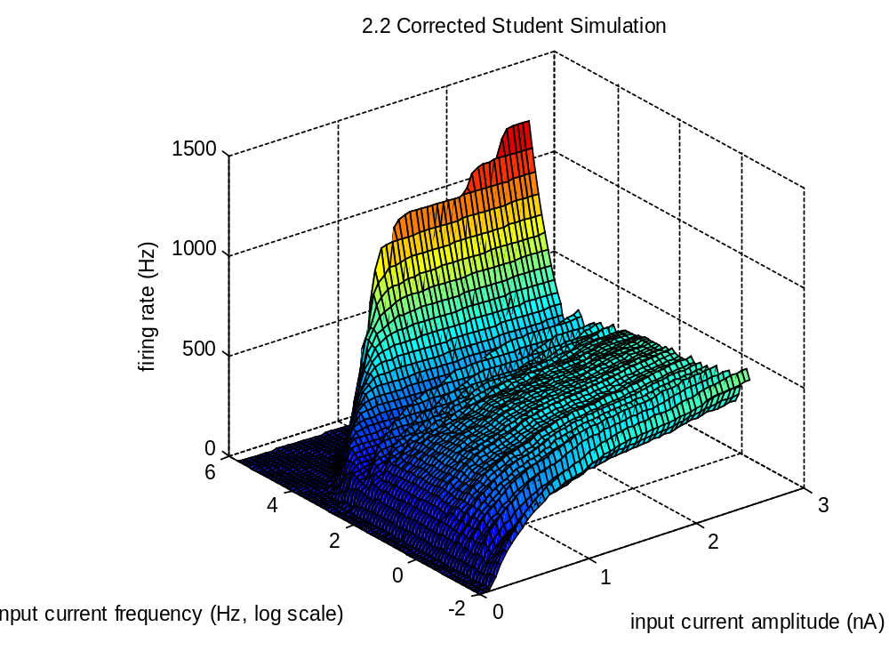

    - The minimum synaptic weight of sufficient for a single initial spike to produce continuing activity reverberating through the neuron is w = 0.00046.
When noise is present at the level 0.000001, the neuron doesn’t fire.

    - The following are the plots of the neurons with the specified parameters:
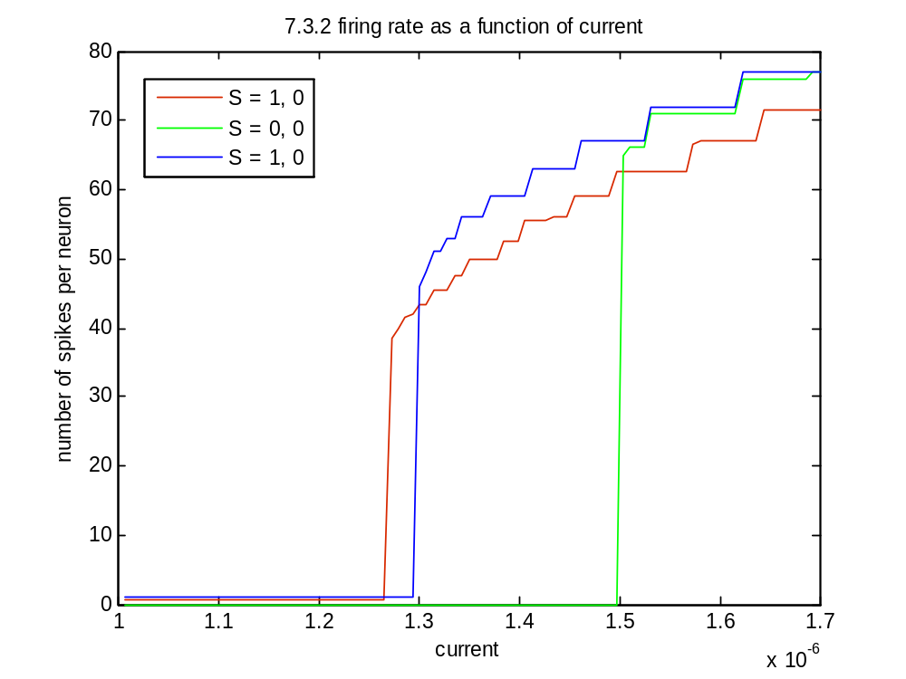
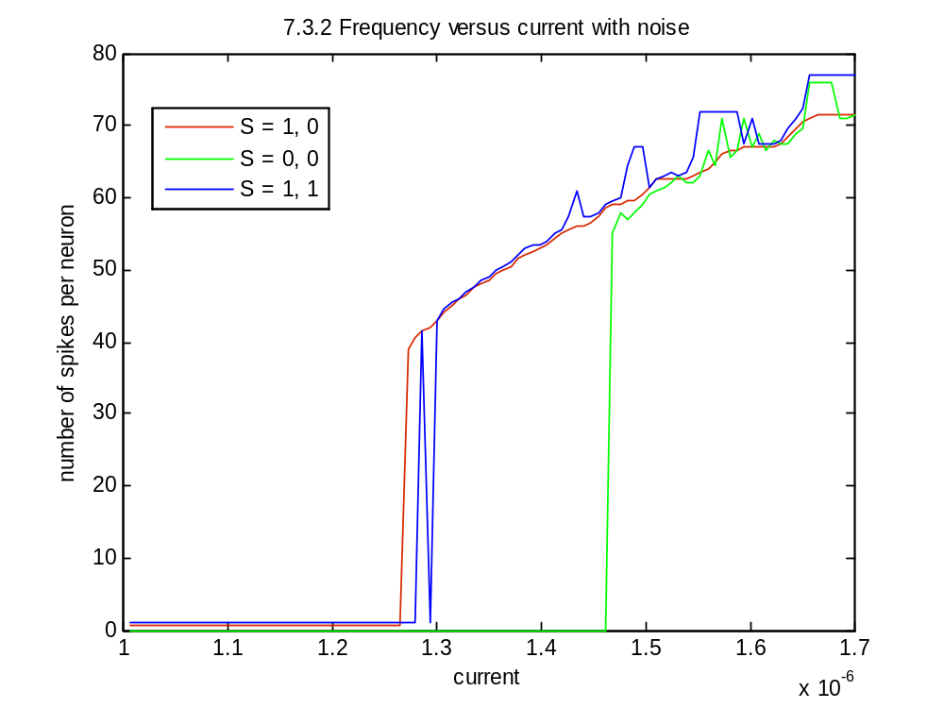

7.2.2 The noisy plot is smoother than the non-noisy plot, it also has some weird peaks. In order to investigate what was going on I did some plots comparing the synchronization of the neurons. Below I have plotted the voltage of two neurons which both initially spike –in the beginning of the graph the two neurons are perfectly synchronized, then they move out of phase with noise. So the noisy plot above is smoother and has weird peaks, because noise desynchronizes the firing of the neurons.

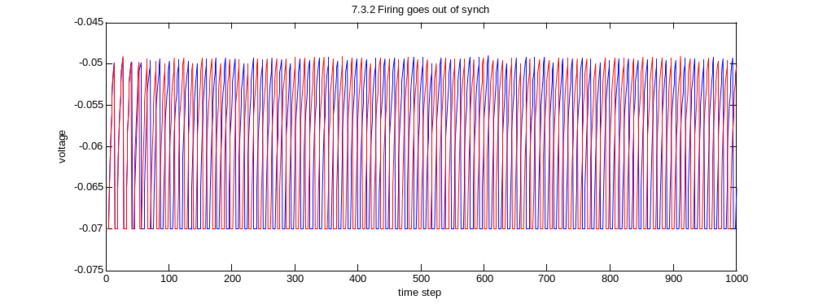

    - This network has the interesting property of hysterises. If you start with a low potential it takes more energy to fire the network, but once it is firing, it takes a big decrease in energy to stop the firing. So in the curves, if either one or both neurons are initially firing, the network requires a smaller input current to trigger reverberation, but if neither neuron is firing, the network requires 0.2 nA (or about 10-15%) more current, to get the network going. But If you follow the curve in the opposite direction, starting with a firing network and a high current, in order to halt the network you would need to lower the current to below the level that triggers firing in the initially spiking networks. This results in two stable threshold points to regulate fluctuating input.
A good use for this network would be to operate an air conditioner: The air conditioner shouldn’t turn on until the temperature is 90 degrees, but then we don’t want it to shut off right when the temperature is 89 degrees because that would result in constant on-off switching which is energey consuming and inefficient. Instead, using a network like this one the air conditioner would go off after cooling the air to 80 degrees.

