Question: Is there a significant difference in the hourly temperature between NY and PHI?

Hypothesis Test: Paired t-test

Hypothesis:

H0 : 𝜇D = 0

“There is no difference in the mean hourly temperature between NY and PHI for 2015”

HA: 𝜇D ≠ 0

“There is a difference in the mean hourly temperature between NY and PHI for 2015”

Confidence level:

α = .05

“5% is an acceptable probability of Type I Error (reject H0 when in fact H0 is true)

Summary of statistical output:

t = t-statistic = 17.44

T\* = t-critical = 1.96

p-value = 5.81 x 10-67 ~̴ 0

Since p-value = 5.81 x 10-67 < α/2 = .025, we Reject H0.

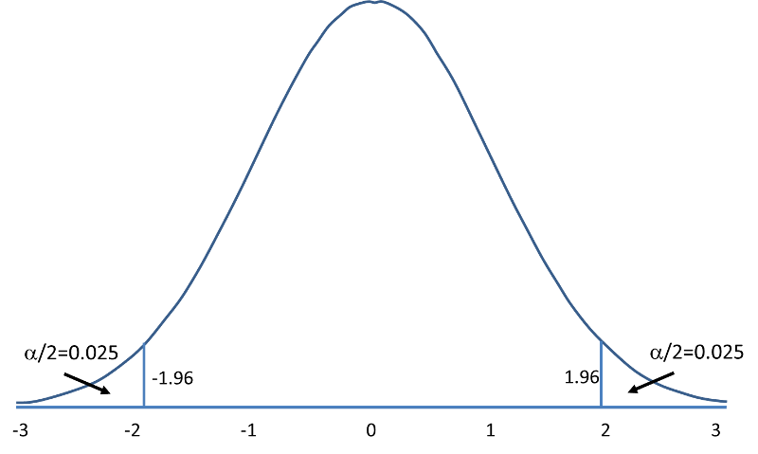

p-value = 5.81 x 10-67

Conclusion:

There is a significant difference in the mean hourly temperature between NY and PHI for 2015.