Data Check 1 — Cohort survival analysis
  - Evaluating and Setting English Learner Exit Thresholds
Sample
The K-2015 entry cohort: 2,373 students who entered EL status in kindergarten in 2015, followed through 2025 (11 years). The most complete of the five usable K cohorts — the longest follow-up.

Data fields used
Field | Used for
STUDENT_ID | Follows one student across years, and counts the cohort once per student.
YEAR | Places each row in the panel: sets the follow-up window, and each student's year in status.
GRADE | Fixes the entry grade that defines the cohort, and labels each life-table row.
EL_STATUS | The current / former transitions that date entry, exit and censoring.
LEFT_TRUNCATED | Excludes students already in EL status when the panel opened, whose time in status cannot be measured. (optional)
COMPONENT | Picks out the Overall Composite: the counts and bands on this page are built on it. (optional)
ACHIEVEMENT_LEVEL | The Overall Composite level at the student's first year in status, banded into the initial ELP band. (optional)
ELP_FORM | Keeps the annual assessment only: alternate-form levels are on a different scale and never enter a band. (optional)
SCALE_SCORE (base) | The Overall Composite scale score at the student's FIRST year in status: where they started, which the fitted models use as a covariate. The current year's score is deliberately not used -- the exit rule is applied to it. (optional)
SUBJECT | Selects the content subject whose prior-year score enters Model 2. (optional)
SCALE_SCORE (academic) | The prior-year content score: the covariate that tests for skimming, lagged so it cannot be an effect of exiting. (optional)
Derived by the package, not read from the delivery: COHORT_LABEL, YEAR_IN_STATUS, EXIT_YEAR, CENSOR_TYPE, ELP_BAND, PERSON_PERIOD and the life table’s A–F. These are recomputed from EL_STATUS transitions every run, so a delivered column of the same name is not used.

Life table
Confirm the selected cohort is large and stable enough to support a trustworthy survival curve, and not distorted by an enrollment anomaly such as a pandemic-era dip. The candidates are below: the selected cohort is the one with the longest observed follow-up that clears the minimum cell size of 10.
Table 1: Candidate entry cohorts
Cohort | Students at entry | Years of follow-up
K-2015 | 2,373 | 11 | Selected
K-2016 | 2,360 | 10
K-2017 | 2,411 | 9
K-2018 | 2,403 | 8
K-2019 | 2,374 | 7
The life table below reads one row per year in status. Column A is the number of students still classified at the start of that year; B those observed to exit at its end; C those who disappear from the data at its end. D and E are those two as rates of the students actually at risk that year, and F accumulates exits against the original cohort.
Table 2: Life table, K-2015 cohort
Grade (year in status) | A  Enrolled at year's beginning | B  Exited at year's end | C  Disappeared at year's end | D  Annual exit rate (B/A) | E  Annual censor rate (C/A) | F  Cumulative exit rate (ΣB/A₁)
K (Y1) | 2,373 | 0 | 0 | 0.00 | 0.00 | 0.00
G1 (Y2) | 2,373 | 37 | 0 | 0.02 | 0.00 | 0.02
G2 (Y3) | 2,336 | 371 | 0 | 0.16 | 0.00 | 0.17
G3 (Y4) | 1,965 | 570 | 0 | 0.29 | 0.00 | 0.41
G4 (Y5) | 1,395 | 440 | 0 | 0.32 | 0.00 | 0.60
G5 (Y6) | 955 | 234 | 0 | 0.25 | 0.00 | 0.70
G6 (Y7) | 721 | 128 | 0 | 0.18 | 0.00 | 0.75
G7 (Y8) | 593 | 94 | 0 | 0.16 | 0.00 | 0.79
G8 (Y9) | 499 | 36 | 0 | 0.07 | 0.00 | 0.80
G9 (Y10) | 463 | 31 | 0 | 0.07 | 0.00 | 0.82
G10 (Y11) | 432 | — | 432 | 0.00 | 1.00 | —

Exit curves
Column F as a picture: the share of the entry cohort observed to have exited by each year in status. The dashed line marks the state’s maximum timeline, which is where “exited within the timeline” is read off. The grey line is the at-risk estimate described in the next section, with its confidence interval; where the two run together, nobody had left the data yet.
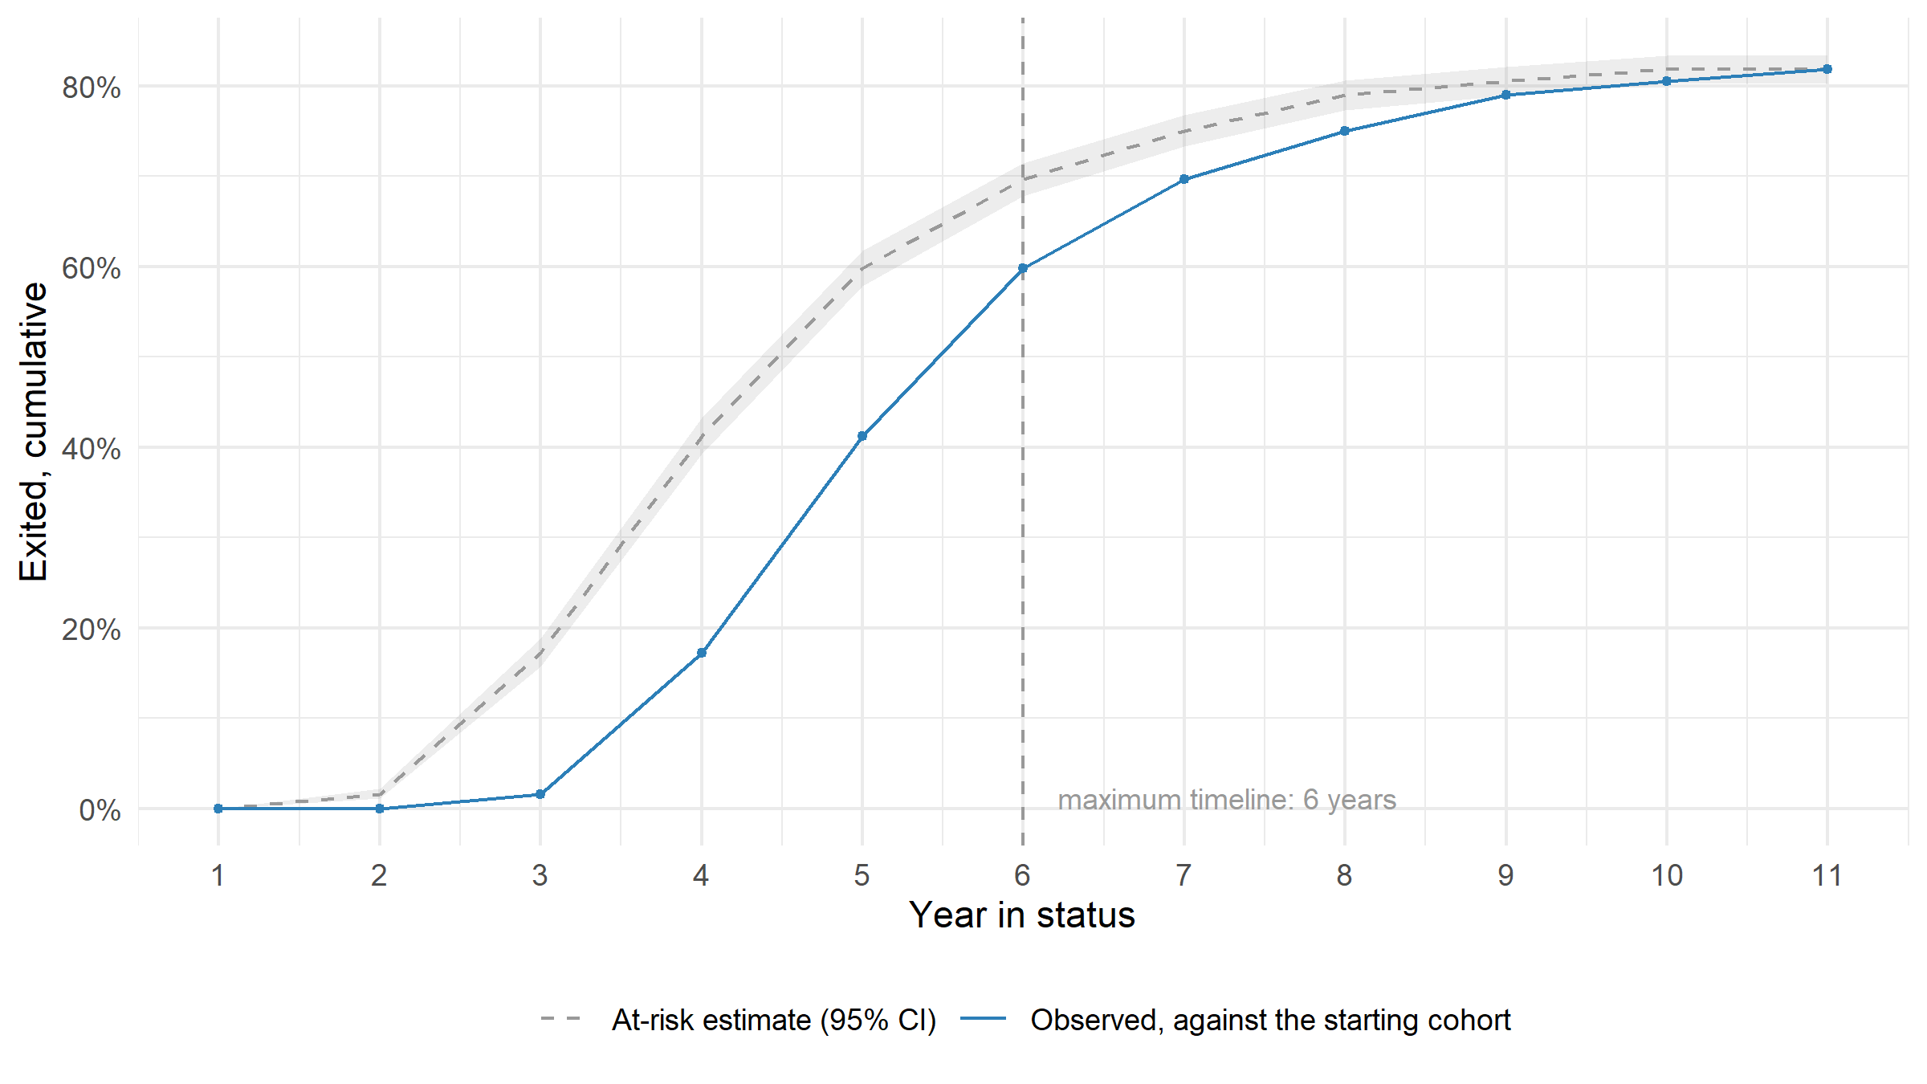
Figure 1: Cumulative exit rate, K-2015 cohort. Censored students are not exiters, so the observed line is a lower bound. The interval covers sampling variability in this cohort’s exit rates; it says nothing about whether this cohort stands for any other.
Splitting the same curve by the band a student started in asks whether exit timing is already set at entry. Everything counted on this page is built on the Overall Composite — the score this state reports as a student’s overall English language proficiency result — and a student’s band is their level on it in the first year they sat the annual assessment. That band is derived here from the score itself, not read from a delivered column.
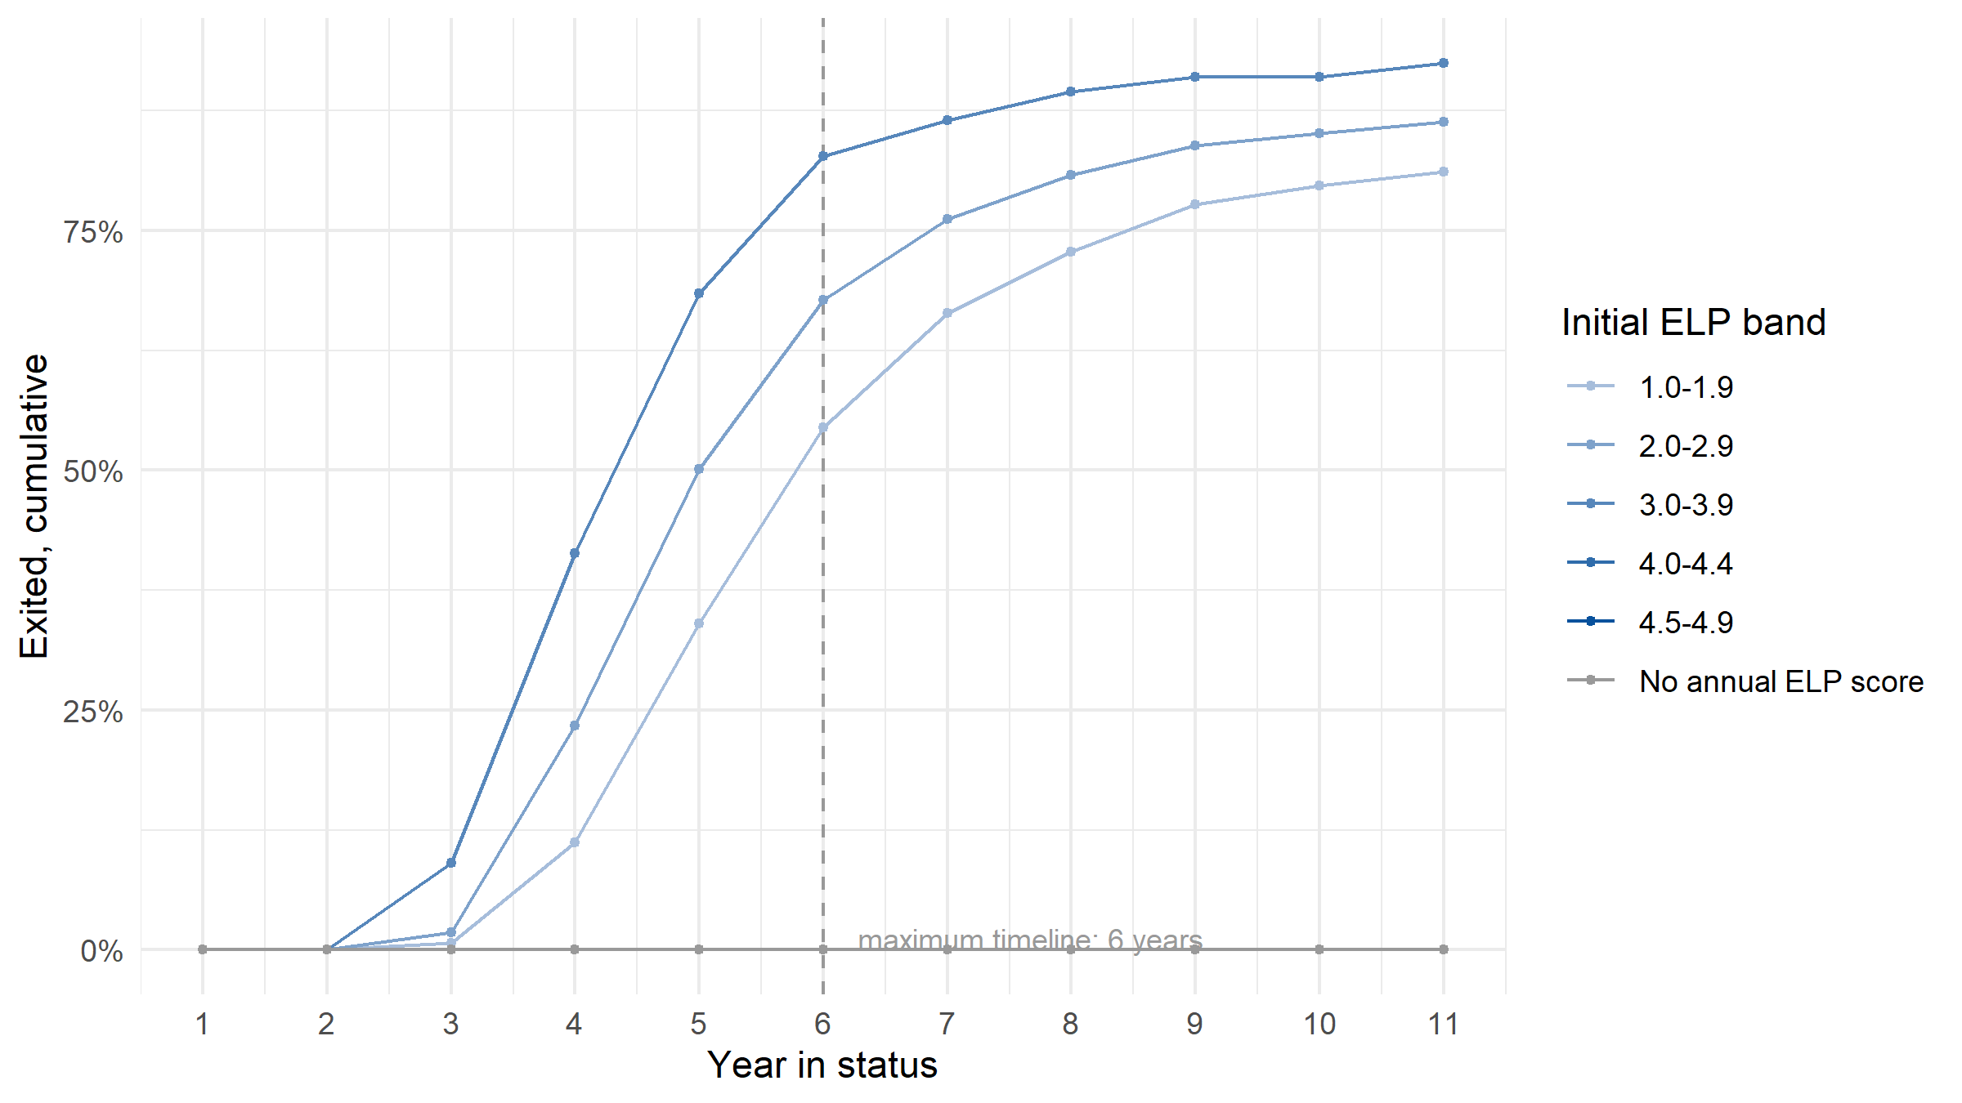
Figure 2: Cumulative exit rate by initial ELP band, from each student’s first annual Overall Composite level. Bands below the minimum cell size are suppressed and not drawn. Students with no annual score – alternate-form takers, whose levels are on a different scale – are shown separately rather than folded into a band.

How long, and how many
Column F answers “how many have exited by now” against the cohort as it started, so every student lost along the way holds it down: it is a lower bound. Beside it sits the standard discrete-time estimate, which compounds each year’s at-risk rate to ask what share would have exited had nobody been lost. Neither is the right number alone, so both are shown.
Only the estimate carries a confidence interval, and only the estimate should. The observed column is not an estimate of anything — it is a count against a denominator that quietly includes students nobody is following any more — and putting an interval around it would advertise precision about the wrong quantity. The interval covers sampling variability in this cohort’s own exit rates. It is not a claim that this cohort speaks for the next one.
Table 3: Exit rates by year in status. The observed share counts against the cohort as it started; the estimate allows for students no longer being observed, and is the only column an interval belongs to.
Year in status | At risk at year's start | Exit rate that year (D) | Exited, against the starting cohort (F) | Exited, at-risk estimate | 95% CI on the estimate
Y1 | 2,373 | 0.00 | 0.00 | 0.00 | 0.00–0.00
Y2 | 2,373 | 0.02 | 0.02 | 0.02 | 0.01–0.02
Y3 | 2,336 | 0.16 | 0.17 | 0.17 | 0.16–0.19
Y4 | 1,965 | 0.29 | 0.41 | 0.41 | 0.39–0.43
Y5 | 1,395 | 0.32 | 0.60 | 0.60 | 0.58–0.62
Y6 | 955 | 0.25 | 0.70 | 0.70 | 0.68–0.71
Y7 | 721 | 0.18 | 0.75 | 0.75 | 0.73–0.77
Y8 | 593 | 0.16 | 0.79 | 0.79 | 0.77–0.81
Y9 | 499 | 0.07 | 0.80 | 0.80 | 0.79–0.82
Y10 | 463 | 0.07 | 0.82 | 0.82 | 0.80–0.83
Y11 | 432 | 0.00 | — | 0.82 | 0.80–0.83
The two columns agree exactly here, which they do only when nobody leaves the data before the window’s edge. On a real delivery they will separate, and the gap is the price of censoring.
- Observed exits, against the cohort as it started: half the cohort has exited by year 6 in status.
- At-risk estimate, allowing for censoring: half the cohort has exited by year 6 in status.
Where the cohort stood when the window closed:
Table 4: Outcomes against the timelines. The first three rows are nested, each a subset of the one below; the last three – exited, still classified, disappeared – account for every student once.
Outcome by the window's end | Students | Share of cohort
Exited within the ESSA timeline (5 years) | 978 | 0.412
Exited within the maximum timeline (6 years) | 1,418 | 0.598
Exited at any point observed | 1,941 | 0.818
Still classified at the window's edge | 432 | 0.182
Disappeared from the data | 0 | 0.000

Model 1 — the fitted baseline
Everything above this line is descriptive: counts, and arithmetic on counts. Where the curve was split by initial band, that was a way of grouping students, not a variable in a model.
Model 1’s other half fits the same thing, so that Model 2 has something to be measured against. It runs in two steps.
Unconditional — no covariate at all. The odds of exiting in each year in status, and nothing else. This is the life table written as a model, and it should agree with the life table exactly: the fitted annual hazards are column D. Nothing new is learned here; what it provides is the baseline every later term is added to.
Fitted on 2,373 students, one row per year at risk (11,300 rows), carrying 1,941 exits. Intervals are clustered on the student, so they count students rather than rows. No covariate: one term per year in status and nothing else. The fitted hazards are the life table’s annual exit rates, which is the point – this is the descriptive half written as a model, and the baseline the others are measured against.
Adding where the student started. The same model with the student’s first Overall Composite score — the one they entered on, fixed for their whole run — as a single covariate. It asks whether entry proficiency already sets exit timing.
It is deliberately not the current year’s score. The exit rule is applied to that year’s result, so a model of exit on it would restate the rule rather than test anything, and every other covariate beside it would be conditioned on the outcome’s own cause.
Table 5: Discrete-time hazard model with the entry score as the only covariate. The ratio is per standard deviation of entry score; each year in status carries its own term.
Covariate (standardised) | Ratio | 95% CI, low | 95% CI, high | p
ELP score at entry | 1.296 | 1.229 | 1.366 | 0.000
Fitted on 2,373 students, one row per year at risk (10,805 rows), carrying 1,941 exits. Intervals are clustered on the student, so they count students rather than rows. The score is the student’s first annual result, standardised, so the ratio is per standard deviation of where students started. It is fixed for a student across their whole run: the current year’s score is what the exit rule is applied to, and regressing exit on it would restate the rule rather than test anything. Rows with a missing score are dropped, never imputed.
Table 6: Rows the model could not use. Nothing here is imputed.
Rows not used, and why | Person-years
No first annual ELP score (the student was never tested) | 605
Year in status with no exits (no baseline term to identify) | 2,695

Model 2 — does achievement predict who exits?
Model 1 describes when students exit. Model 2 asks a different question: once you already know where a student started in English, does knowing last year’s content score tell you anything more about whether they exit this year? If it does, something other than the language test is shaping who leaves EL status — the selection effect this stage exists to catch at the source.
The number to read is the ratio on prior-year achievement. At 1 it adds nothing. Away from 1 in either direction, it adds something it should not.
Both covariates are measured before the decision they are used to predict: the language score at entry, the content score a year back. That is what makes the question answerable. Put the current year’s language score in instead and the model would be conditioning on the exit rule itself, and this ratio would be driven to 1 no matter what was true.
Table 7: Discrete-time hazard model on the person-period frame. Ratios are per standard deviation.
Covariate (standardised) | Ratio | 95% CI, low | 95% CI, high | p
ELP score at entry | 1.032 | 0.952 | 1.119 | 0.447
Prior-year ELA score | 1.363 | 1.251 | 1.485 | 0.000
Fitted on 2,373 students, one row per year at risk (3,359 rows), carrying 788 exits. Intervals are clustered on the student, so they count students rather than rows. Both covariates are standardised, so each ratio is per standard deviation. Rows with a missing score are dropped, never imputed.
Table 8: Person-years the model could not use. Nothing here is imputed.
Rows not used, and why | Person-years
No first annual ELP score (the student was never tested) | 605
No prior-year ELA score: content testing does not reach that grade, or the student was untested | 9,105
No prior-year ELA score because 2020 has no assessment anywhere (every 2021 row) | 666
Year in status with no exits (no baseline term to identify) | 370
Against the baseline. The entry-score ratio is 1.30 on its own and 1.03 once prior achievement joins it. The two fits do not use the same rows: Model 2 keeps only the 3,359 rows that carry a prior-year score, against 10,805. Read the movement as a direction, not a measurement.
What this model can and cannot say here
On simulated data this is machinery, not a finding — and that holds whichever way the ratio comes out. Exit in this simulation is a rule applied to the language score, and how closely content achievement tracks that score is a parameter of the generator. Whatever this table reports, it is reporting the generator’s own design back. It is not evidence that any state’s exit process is or is not selecting on achievement. Run against a real delivery, the same table is a genuine test.
Read it as evidence about selection, not about students: a ratio away from 1 says the exit process is responding to something beyond the language test, which is a fact about the policy as implemented.

The weighting index (experimental)
Not an established statistic
What follows is a candidate the Process Overview sketches, not a validated method: retention share as a hard floor, selection strength as a continuous downweight above it. It has not been tested against real data, nothing in this package uses it, and no decision should rest on it until it has been checked against the Indiana pipeline.
Table 9: Candidate grade weights. Experimental: shown to be pressure-tested, not used.
Year in status | Retention share (still at risk) | Candidate weight (EXPERIMENTAL)
Y1 | 1.00 | 0.73
Y2 | 1.00 | 0.73
Y3 | 0.98 | 0.73
Y4 | 0.83 | 0.73
Y5 | 0.59 | 0.73
Y6 | 0.40 | 0.73
Y7 | 0.30 | 0.73
Y8 | 0.25 | 0.73
Y9 | 0.21 | 0.73
Y10 | 0.20 | 0.73
Y11 | 0.18 | 0.73
Selection strength is 0.363, computed as |ratio on lagged ELA - 1|. It is a single number for the whole cohort here; a per-grade version needs an interaction or a refit at each grade and is not built.

Looking at
Discrete-time survival analysis applied to one entry cohort: students who entered EL status in the same grade, in the same year, tracked forward across subsequent grades. Two models are named here because the rest of the process refers back to them.
Model 1 — the unconditional survival model. How long students stay in EL status, with nothing held constant. It comes in two parts, and they answer the same question in different registers. The descriptive part is the life table, the curves and the at-risk estimate: no predictor at all, only counts of who was at risk, who exited and who was lost, with the split by initial band a way of grouping students rather than a variable in a model. The fitted part runs in two steps: first the odds of exiting in each year in status with no covariate at all, which is the life table written as a model; then the same thing with the student’s entry score added. Neither involves achievement data.
Model 2 — the ELA-augmented survival model. The second of those with lagged content achievement added, to test whether academic performance is doing selection work that is supposed to belong to the language test alone. Model 1 is what it is compared against, which is why all three are fitted.
Every covariate in these models is measured before the exit decision it is used to predict — fixed at entry, or lagged a year. The current year’s language score is what the exit rule is applied to, so including it would restate the rule rather than test anything, and would strip Model 2 of its ability to answer the question it exists for.

Looking for
From Model 1: the shape of the time-to-exit distribution — the typical number of years students take to exit, what share of the cohort exits within the state’s ESSA-expected timeline, and what share appears never to exit, still EL-classified many grades later.

Interpreting it
Model 1 tells you the descriptive shape of your state’s exit patterns — when, whether, and after how long students are likely to exit under current policy and practice. That is useful in its own right, independent of whether the current threshold sits at the right level: it sets realistic expectations and gives you plain-language material for talking with stakeholders about what a typical EL trajectory looks like in your state.
Two cautions carry the weight here.
Column F, and the curve drawn from it, are a lower bound — not a completion rate. Students who disappear from the data are censored, not non-exiters: we stop being able to observe them, which is not evidence that they stayed in status. The final row is the window’s edge — there is no following year in which an exit could be observed, so B is empty and everyone still classified is censored there.
Read the band split as a description, not a prediction. A cohort that starts higher exiting sooner is what the exit rule is built to produce; it says nothing on its own about whether the threshold sits at the right level. The bands near the exit threshold hold very few K entrants — a student screening at the threshold would not have been identified — so those bands suppress, and that is the design working, not a gap in the data.
No average time in status appears anywhere in this document, because on censored data it is not defined. The honest summaries are the median years to exit and the share exiting within the timeline, both of which arrive in a later pass.
Caution: remember your data structure
This cohort is students who started in K. The total exit numbers and percentages across all students who exit after each grade will be different, because later entrants — including newcomers arriving in the upper grades — are not in this table at all. Read it as the trajectory of one entry cohort, never as the state’s overall exit rate.

What is not here
Check 1 is complete: the life table, the exit curves, the survival estimate and its median, the timeline outcomes, both fitted models and the experimental index all render above. Four things are deliberately absent.
A confidence interval on anything but the estimate. The life table’s own columns are counts, and the observed cumulative share is a count against a denominator that includes students nobody is following any more. Only the at-risk estimate is an estimator, and only it is banded.
A per-grade selection strength. The index uses one ratio for the whole cohort. The Process Overview asks for it at each grade, which needs either an interaction term or a refit through each grade; neither is built, and the single number should not be read as if it were per grade.
Any mechanical use of the index. It is rendered to be pressure-tested against real data, starting with the Indiana pipeline. Nothing downstream consumes it.
Later start grades. This is one K cohort. Students entering in grade 4, or in grade 9 as newcomers, have different trajectories, and the deck’s own next step is to repeat the analysis for them one starting grade at a time.
Decide before moving on
How much weight later grade-level findings can carry, based on Model 1 and Model 2 together.
The Process Overview sketches a candidate two-part index for making that call: retention share — at each grade, what fraction of the original entry cohort is still EL-classified, and so still at risk — as a hard floor, following the same logic as the minimum-N suppression thresholds already used in this pipeline; and selection strength — how far Model 2’s lagged-ELA hazard ratio sits from 1 — as a continuous downweight above that floor. A grade can fail on either count independently: thin-but-unselected data, or well-populated-but-heavily-selected data.
That index is an untested proposal, not an established statistic. It is flagged here as something to build and pressure-test against real data before it is presented to an SEA audience as anything more than a candidate idea, and nothing in this package uses it mechanically.
Spec: SIM. Simulated data, contract 0.4.0. stateELP 0.0.0.9000, run 2026-10-09.
These figures describe a synthetic fixture. No number here describes any real state.

