Data Check 2 — Characteristics of on-time vs. prolonged exiters
  - Evaluating and Setting English Learner Exit Thresholds
Table of contents

Sample
The K-2015 entry cohort — the same cohort Data Check 1 analyzes: 2,373 students who entered EL status in kindergarten in 2015, followed through 2025. They are split into on-time exiters (exited within 5 years [DERIVED — VERIFY]) and prolonged cases (exited later, or still classified when the window closes). Students who disappeared from the data are shown separately, in neither group.

Looking at
A comparison of two groups from the Data Check 1 cohort — students who exited on time, and students whose EL classification was prolonged — across demographic and program characteristics: home language, district size, sex, socioeconomic status, disability status, the type of EL services received, and the ELP band a student started in. Alongside it, a descriptive summary of academic achievement at comparable points in each group’s trajectory, and the ELP levels each group posted on the way there.
The groups are defined against the years actually observed, and all three exit indicators are relative to that window:
- On time (Exit_OnTime) — first observed as a former EL within 5 years of entering status, which is this state’s ESSA-expected timeline [DERIVED — VERIFY]
- Prolonged — everyone still in view who did not exit on time: students who exited after that timeline, and students never observed to exit (No_Exit).
- Disappeared — last seen before the window closed, with no exit observed. Their outcome is unknown, so they are a column of their own and are never counted as on time or as prolonged.
Exit_Ever, Exit_Max and Exit_OnTime are nested — every on-time exiter is also a maximum-timeline exiter and an ever-exiter — so those three columns do not add up. What adds up is Exit_Ever + No_Exit + Disappeared = All.

Looking for
Two things.
- Whether prolonged classification goes with specific, identifiable characteristics. Disability status, mobility, home language, particular districts or programs. A characteristic that is over-represented among prolonged students is a candidate explanation for why they are still classified; one that is spread evenly across both groups is not.
- Whether the on-time group already looks academically stronger, even at similar ELP levels. If it does, something other than English proficiency may be separating the two groups. This is the descriptive companion to the formal test in Data Check 1.

The cohort, split by exit outcome
Table 1: Exit outcomes and the characteristics of each group, K-2015 cohort, observed through 2025. Every indicator is relative to the years observed, so No_Exit means not observed exiting by 2025, not never exiting. Blocks below the first two rows are column percentages. Cells under 10 are suppressed.
 | All EL students | Exit_Ever  Exited in the years observed | Exit_Max  Exited within the maximum timeline | Exit_OnTime  Exited within the on-time timeline | No_Exit  Not observed exiting by the window's end | Disappeared  Left the data before the window closed
Total students | 2,373 | 1,941 | 1,418 | 978 | 432 | 0
% of all EL students | 100% | 82% | 60% | 41% | 18% | 0%
Primary language
Spanish | 55% | 54% | 54% | 55% | 56% | —
Arabic | 8% | 8% | 8% | 8% | 9% | —
Portuguese | 8% | 8% | 7% | 7% | 7% | —
Mandarin | 5% | 5% | 5% | 6% | 5% | —
Haitian Creole | 5% | 5% | 5% | 5% | 5% | —
Gujarati | 5% | 5% | 5% | 5% | 6% | —
Other | 4% | 4% | 4% | 4% | 5% | —
Korean | 4% | 4% | 4% | 5% | — | —
Urdu | 4% | 4% | 4% | 3% | 4% | —
Tagalog | 3% | 3% | 3% | 3% | — | —
District size
101-999 | 30% | 30% | 30% | 31% | 31% | —
1,000+ | 70% | 70% | 70% | 69% | 69% | —
Other demographics
Male | 50% | 50% | 50% | 51% | 50% | —
Low SES | 74% | 73% | 74% | 73% | 75% | —
Special education | 15% | 11% | 11% | 10% | 36% | —
Type of EL services
ESL, pull-out | 30% | 31% | 31% | 32% | 27% | —
ESL, push-in | 22% | 21% | 21% | 22% | 25% | —
Transitional bilingual | 12% | 12% | 13% | 12% | 10% | —
Sheltered content instruction | 11% | 11% | 11% | 11% | 12% | —
Dual language / two-way bilingual | 10% | 10% | 9% | 9% | 10% | —
Newcomer program | 9% | 9% | 8% | 8% | 10% | —
Services refused | 6% | 6% | 6% | 6% | 7% | —
Initial ELP
1.0-1.9 | 55% | 55% | 51% | 46% | 58% | —
2.0-2.9 | 36% | 38% | 41% | 44% | 27% | —
3.0-3.9 | 6% | 6% | 8% | 9% | 2% | —
4.0-4.4 | — | — | — | — | 0% | —
4.5-4.9 | — | — | — | — | 0% | —
(not reported) | 2% | 0% | 0% | 0% | 13% | —
The first two rows are the balance of the cohort across exit outcomes. Every block below them is a set of column percentages: read down a block within one column to see what that group is made of, and across a row to see how the groups differ.
The first two blocks are read differently from the third. Home language, district size, service type and initial ELP band partition each column, so their percentages sum to 100% — a category for students whose value was not reported keeps that true, rather than quietly shrinking the denominator. The “other demographics” rows are independent shares of each column and sum to nothing: a student can be counted in all three or none. Where a value is not reported, that student leaves the row’s denominator instead of being counted as a “no”. An exit outcome that no student in this cohort landed in has nobody to describe, so its block cells are blank rather than zero — its count in the first row is what tells you the column is empty.
Characteristics are read at entry — the cohort’s own start year, the one year every member is current by construction — so a block describes who these students were when they entered, not something that moved with them. Two are derived rather than delivered: district size is the entry-year district banded by that district’s own EL count, and the initial ELP band is the first annual Overall Composite level, taken from the same derivation Data Check 1’s band-split curve uses so the two stages cannot disagree.

Academic achievement at comparable points
Subject: ELA. Proficiency is level 4 or above on the state’s own scale. Rows run from year in status 4 to 11: the content assessment does not reach this cohort’s earlier grades, so those years have no rows at all, and year 6 is absent because no assessment was administered that year. A group with no students left to measure shows a count of zero, not a suppressed cell.
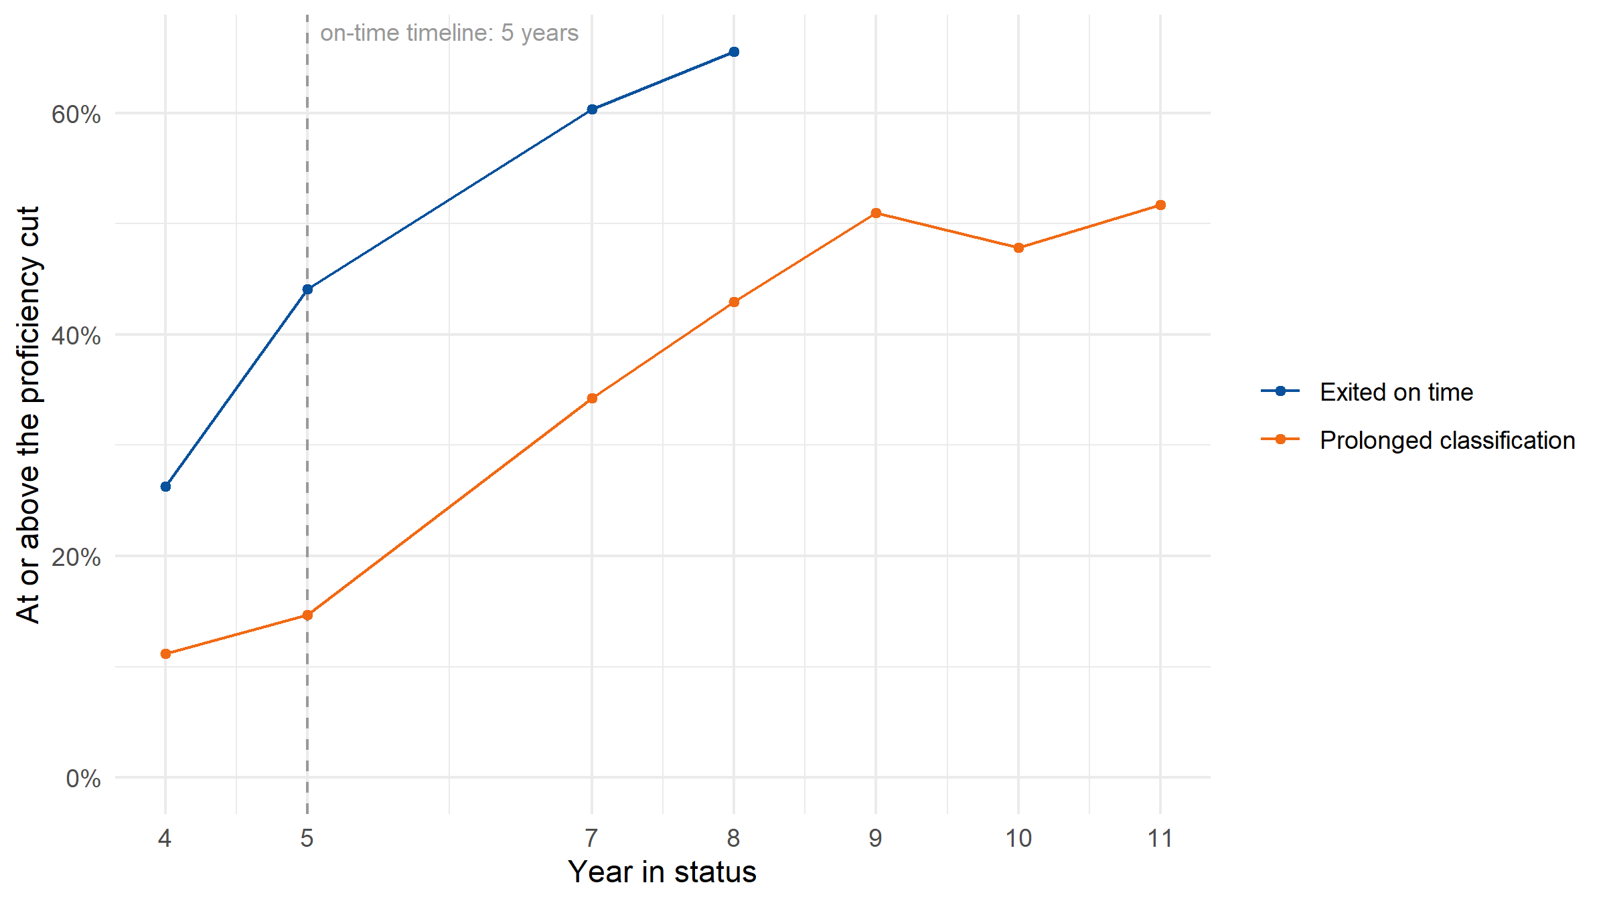
Figure 1: Share at or above the ELA proficiency cut, by exit group and year in status. A group with nobody left to measure has no point rather than a zero.
Table 2: ELA achievement by exit group at the same year in status, K-2015 cohort. The grade beside each year is the modal grade of the students in it.
Year in status | Exit group | Students scored | At or above the proficiency cut | Median scale score
Y4 (grade 3) | Exited on time | 939 | 26% | 727
Y4 (grade 3) | Prolonged classification | 1,341 | 11% | 705
Y5 (grade 4) | Exited on time | 943 | 44% | 744
Y5 (grade 4) | Prolonged classification | 1,338 | 15% | 712
Y7 (grade 6) | Exited on time | 713 | 60% | 757
Y7 (grade 6) | Prolonged classification | 987 | 34% | 734
Y8 (grade 7) | Exited on time | 537 | 66% | 761
Y8 (grade 7) | Prolonged classification | 1,294 | 43% | 743
Y9 (grade 8) | Exited on time | 0 | — | —
Y9 (grade 8) | Prolonged classification | 1,326 | 51% | 750
Y10 (grade 9) | Exited on time | 0 | — | —
Y10 (grade 9) | Prolonged classification | 911 | 48% | 748
Y11 (grade 10) | Exited on time | 0 | — | —
Y11 (grade 10) | Prolonged classification | 681 | 52% | 751
Comparing the groups at the same year in status rather than in the same calendar year is what makes this readable: two students four years into EL status are at the same point in their own trajectories, whoever they are. For a cohort that all entered in the same grade, each year in status is mostly a single grade, which is why the proficiency rate can be read down the column at all; the modal grade is printed beside each year so that assumption stays visible rather than implied.

ELP trajectories, by exit group
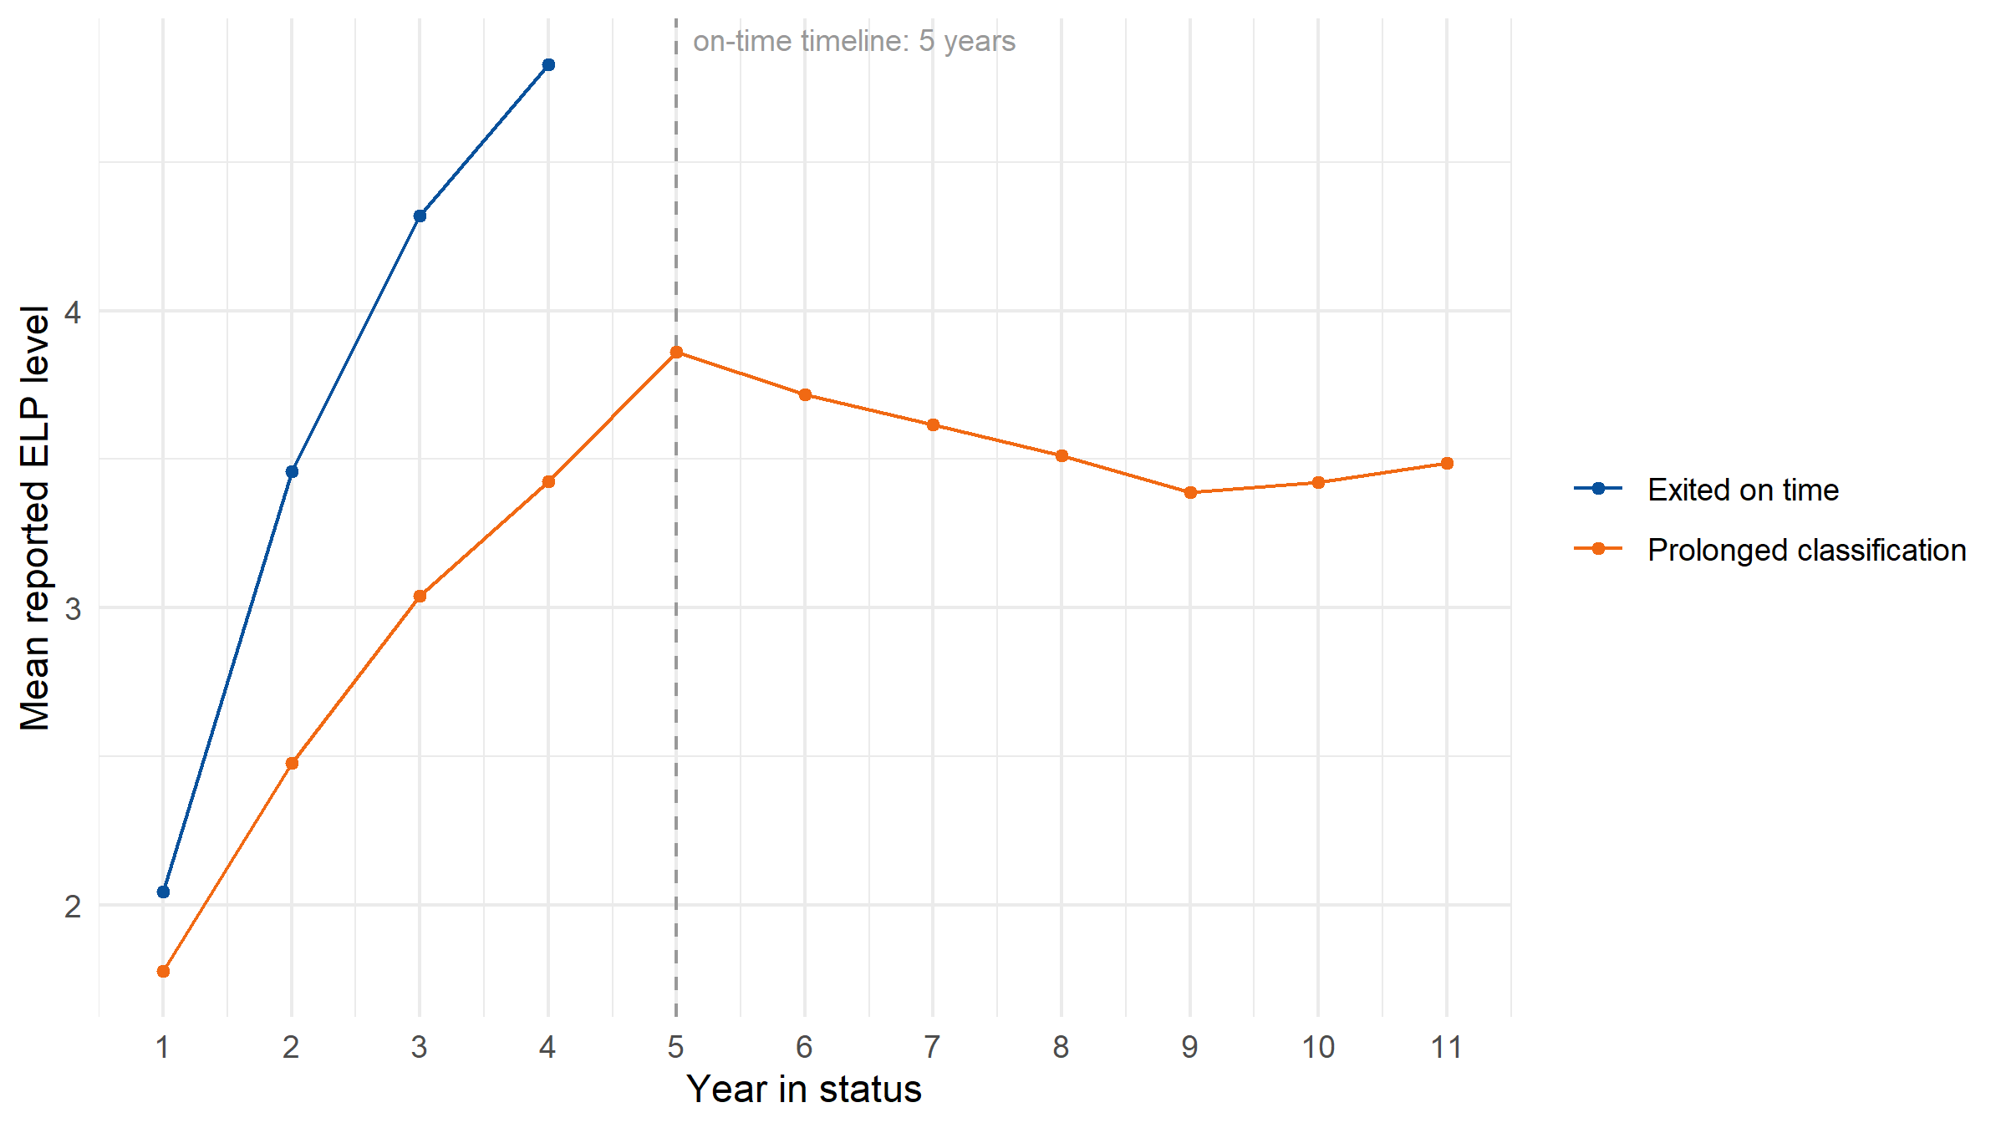
Figure 2: Mean Overall Composite level by year in status, drawn separately for each exit group. There is deliberately no pooled cohort line: see the caution below. Lines stop where a group no longer has students being assessed.
Caution: do not mistake group change for achievement trajectories
It is not necessarily that the same students are growing less over time. It is also that the slowest growers are the ones who stay.
A single cohort-average ELP line over time falls for both reasons at once and cannot separate them, so this document does not draw one. The table below is the mechanism: it shows who is still being assessed each year. As the on-time group exits it stops contributing scores, and the average of whoever is left drifts down without any individual student having slowed.
Table 3: Share of the students still being assessed each year in status, by exit group. This is why a pooled cohort average would mislead.
Exit group | Y1 | Y2 | Y3 | Y4 | Y5 | Y6 | Y7 | Y8 | Y9 | Y10 | Y11
Exited on time | 42% | 42% | 42% | 31% | 0% | 0% | 0% | 0% | 0% | 0% | 0%
Prolonged classification | 58% | 58% | 58% | 69% | 100% | 100% | 100% | 100% | 100% | 100% | 100%

Interpreting it
This is the descriptive companion to Data Check 1’s formal test. Data Check 1 asks whether exit timing is being driven by English proficiency as intended; this check puts a human face on who the “stuck” population is. That matters for what an eventual recommendation should include. If disability status is a major driver of prolonged classification, for example, a threshold change alone will not address the underlying issue: it would move some students, and leave the students held back by something other than their English exactly where they were.
Reminder: this is not automatically about the cut score
The first two data views are about the interactions between policies, programs, population, and exit criteria. The response to findings here is not necessarily to change your cut score.
Three more cautions carry the weight here.
Read a difference between the groups as a description, not a cause. A characteristic that is more common among prolonged students says who the stuck population is. It does not say why they are stuck, and two characteristics that travel together (district size and type of instructional model, say) cannot be told apart in a crosstab. Separating them needs a model that holds the others constant, which is a later addition and not in this document.
Some of the academic gap is definitional. On-time exiters left because they cleared an English proficiency bar, and the content assessment is taken in English, so finding them academically stronger is partly built into how the two groups were defined. The question worth asking of the table above is whether the gap is larger than that explains, and whether it is still there at similar ELP levels — which is what the trajectory figure lets you check.
No_Exit is “not observed exiting”, and the window is finite. The K-2015 cohort is followed through 2025. A student counted as No_Exit was still classified at the window’s edge; nothing here says they will never exit. Likewise, Exit_OnTime and Exit_Max are counted against the years available, and a caption has to say so.
Caution: remember your data structure
This cohort is students who started in K. It is the best case for exit: later entrants, including newcomers arriving in the upper grades, are not in this table at all. Read it as the make-up of one entry cohort, never as the state’s overall exit picture.

Additional check — Types 2–6: blocked by one criterion only
The exit rule is declared as Type 1 (a single overall composite), so there are no blocked-by-one-criterion groups to compare and this check does not apply. Declare the additional criteria in spec$policy$exit$pathways and set types to activate it.
When it applies, the groups Prep Step 2 identified as blocked by one criterion only are added as further comparison groups alongside the on-time and prolonged exiters. A group that looks systematically different — demographically, academically, in program experience — means that criterion is screening on something other than what the main score screens on.

Still to come
The deck’s further views for this data check are recorded and not built: repeating the analysis for students who start in later grades, and adding starting grade as its own set of crosstab rows, to see whether entry grade predicts which group a student lands in; and a statistical model — logistic regression — to control for the correlations among characteristics that the crosstab can only show one at a time. Each is a later addition.
This document reports ELA. The spec also declares Math, which run_check2(subject = ...) will report instead.
Decide before moving on
- Do specific subgroups warrant separate treatment in Data Checks 3–4? A group that is heavily over-represented among prolonged students may need its own analysis there, rather than being averaged into the whole.
- What equity considerations does the final recommendation need to address explicitly? In particular, whether any characteristic that separates the prolonged group is one a change to the threshold would leave untouched.
Spec: SIM. Simulated data, contract 0.4.0. stateELP 0.0.0.9000, run 2026-10-09.
These figures describe a synthetic fixture. No number here describes any real state. The gap between the exit groups on the content assessment, and any difference between them in who is over-represented, are parameters of the generator rather than findings.

