Data Check 3 — Academic patterns
  - Evaluating and Setting English Learner Exit Thresholds
Sample
Cross-sectional, and different from Data Checks 1 and 2: every grade-3 EL with a 2025 ELA score – not the entry cohort those stages follow – with former ELs and an English-only group beside them for reference. A student enters on having sat the content test, so the universe is the ELA table joined to roster status, not the other way round. Each grade is a panel of its own and grades are never pooled; this pass renders grade 3, the first grade the spec declares ELA tested in.

Looking at
Where academic performance sits relative to English language proficiency, at one point in time. Each ELP band is a column; beside them sit two reference groups the bands are read against — students who have already exited EL status, and students who were never classified.
The question the figure exists for: at what level of English proficiency does language stop being the dominant constraint on content performance? If the distribution in a band clears the proficiency cut, students at that level of English are performing on the content test the way the state expects of anyone. If it does not, the exit threshold is letting students out — or holding them in — at a level where the content test is still measuring their English as much as their subject knowledge.

The panel
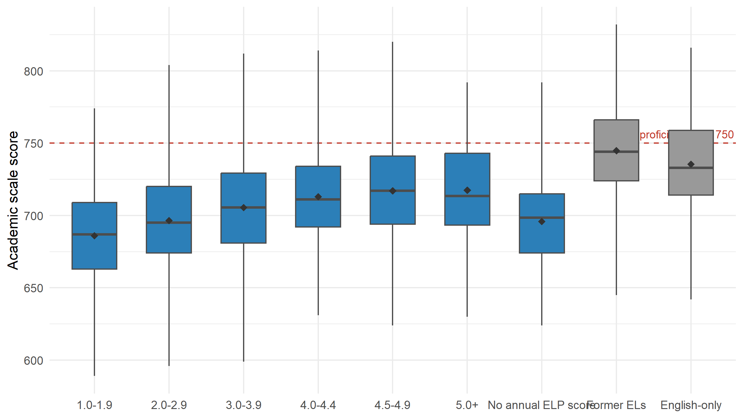
Figure 1: ELA scale score by Overall Composite band, grade 3, 2025. Former ELs and the English-only group are references, not bands. The diamond is the mean; the red line is the proficiency cut. Groups with fewer than 10 scores are suppressed and not drawn.
Scores are paired within the school year, not to the day: the Overall Composite is administered Jan-Mar and the content test later in the year. A student’s language score therefore precedes their content score, which is the right order for this question but is not a controlled interval.
Reading the band axis
The band axis is not a proficiency gradient across a stable population. Its top end is constituted by the exit rule (Overall composite proficiency level >= 4.5): a student observed as a current EL at or above the exit threshold is, in most states, in their final year – so the highest bands hold students on their way out rather than a cross-section of highly proficient ELs. Where a state’s rule carries a second criterion, the same cells instead hold students that criterion is blocking, which is a different population again. Read the top of this axis with that in mind, and read the Former ELs column beside it.
Table 1: The same panel as numbers: ELA, grade 3, 2025. n counts everyone in the group; n scored is how many scores the statistics rest on.
Group | n | n scored | Min | 25th | Median | Mean | 75th | Max | IQR | At/above cut
1.0-1.9 | 253 | 253 | 589 | 663 | 687 | 686 | 709 | 774 | 46 | 3%
2.0-2.9 | 481 | 481 | 596 | 674 | 695 | 696 | 720 | 804 | 46 | 6%
3.0-3.9 | 744 | 744 | 599 | 681 | 706 | 705 | 729 | 812 | 48 | 11%
4.0-4.4 | 529 | 529 | 631 | 692 | 711 | 713 | 734 | 814 | 42 | 13%
4.5-4.9 | 415 | 415 | 624 | 694 | 717 | 717 | 741 | 820 | 47 | 19%
5.0+ | 174 | 174 | 630 | 693 | 714 | 718 | 743 | 792 | 50 | 21%
No annual ELP score | 148 | 138 | 624 | 674 | 698 | 696 | 715 | 792 | 41 | 4%
Former ELs | 383 | 383 | 645 | 724 | 744 | 745 | 766 | 832 | 42 | 43%
English-only | 426 | 426 | 642 | 714 | 733 | 735 | 759 | 816 | 45 | 35%

Where each grade lands
Two readings of the same question. The band column is the first ELP band whose students reach the cut at least half the time — equivalently, the first band whose median clears it. The crossing is the ELP scale score at which a fitted logistic passes 50%. Agreement between them is the evidence; disagreement says the answer depends on how you ask, and has to be read against Prep 2’s composition findings and Data Check 1’s attrition.
Table 2: Where each grade lands. A dash means no band reached half; the next column says how far the highest band got. Bold marks a landing at or above the band the exit threshold falls in.
Subject | Grade | First band at/above the cut for half its students | Highest band's share | Logistic 50% crossing | 95% CI | Crossing within observed scores
ELA | 3 | — | 21% | 531 | 489—574 | no
ELA | 4 | — | 23% | 556 | 498—614 | no
ELA | 5 | — | 23% | 526 | 483—570 | no
ELA | 6 | — | 28% | 511 | 472—549 | no
ELA | 7 | — | 39% | 475 | 453—497 | no
ELA | 8 | — | 37% | 491 | 462—521 | no
ELA | 9 | — | 40% | 481 | 453—509 | yes
ELA | 10 | — | 45% | 483 | 448—518 | yes
ELA | 11 | 4.5-4.9 | 50% | 457 | 441—472 | yes
Math | 3 | — | 24% | 530 | 487—573 | no
Math | 4 | — | 29% | 522 | 482—562 | no
Math | 5 | — | 36% | 494 | 464—525 | no
Math | 6 | — | 39% | 493 | 461—524 | no
Math | 7 | — | 41% | 490 | 458—521 | no
Math | 8 | 5.0+ | 52% | 470 | 447—494 | yes
Math | 9 | — | 37% | 514 | 456—572 | no
Math | 10 | 4.5-4.9 | 55% | 476 | 448—505 | yes
Math | 11 | 4.5-4.9 | 68% | 442 | 427—457 | yes
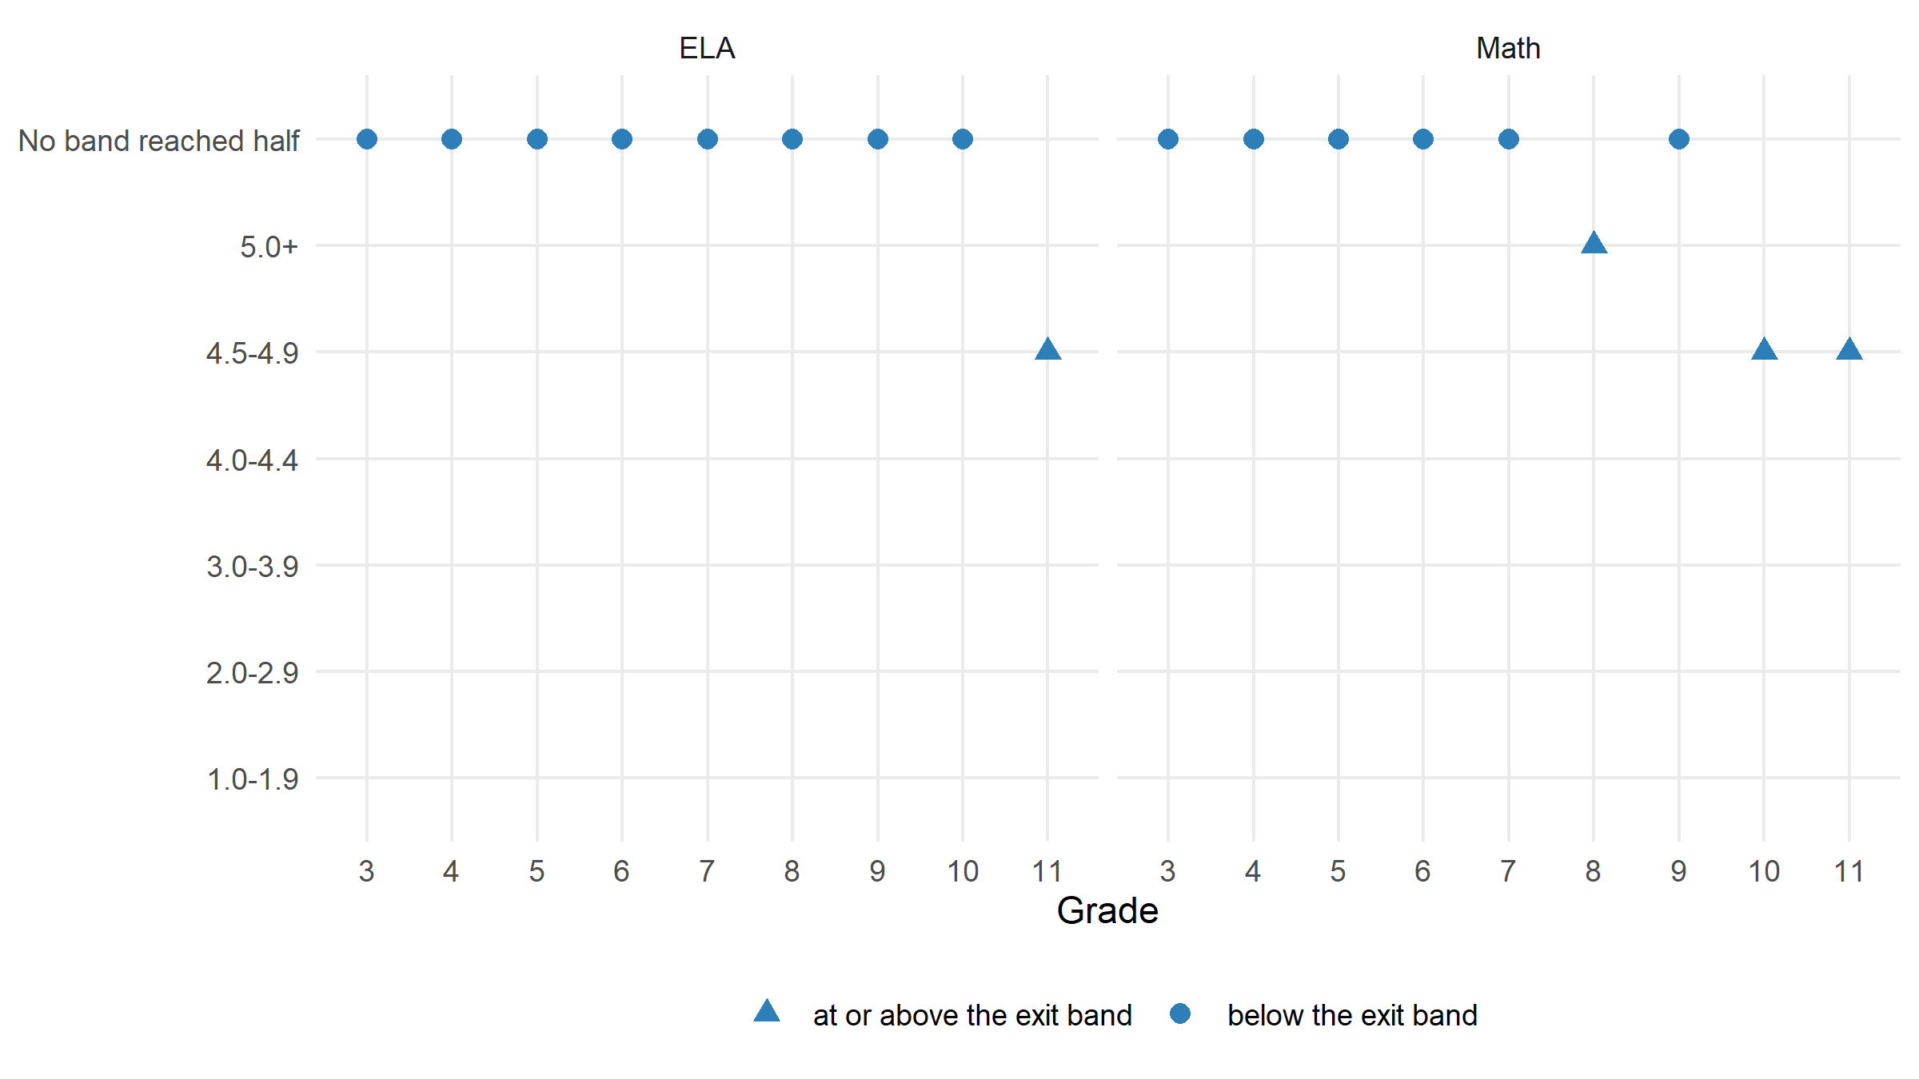
Figure 2: The same, read across grades. Triangles mark landings at or above the exit band.
Of 18 grade-and-subject panels, 4 have a band where at least half the students reach the cut; in 14 no band does. Every panel that lands, lands at or above the band the exit threshold falls in. Those bands hold students the exit rule is about to remove, so the landing statistic there is describing a population the rule itself constitutes rather than a level students sit at and stay. The logistic crossing falls outside the ELP scores actually observed in 12 of 18 panels: there the curve is being read past its data, and the number is an extrapolation rather than a level anyone was seen at.

The fairness check
Is the bar being asked of English learners one that English-speaking peers themselves clear? Two ways of asking, both of which change something the main analysis holds fixed.
(a) A comparable reference group. The English-only column above is every English-only student in the grade. Restricting it to economically disadvantaged students narrows a comparison that otherwise confounds language with poverty. The filter is crude — this delivery carries one free-and-reduced-lunch flag and no parental education — and a matched version is a later addition.
Table 3: The same panel with the English-only group restricted to economically disadvantaged students. A crude filter, not a match.
Group | n | n scored | Min | 25th | Median | Mean | 75th | Max | IQR | At/above cut
1.0-1.9 | 253 | 253 | 589 | 663 | 687 | 686 | 709 | 774 | 46 | 3%
2.0-2.9 | 481 | 481 | 596 | 674 | 695 | 696 | 720 | 804 | 46 | 6%
3.0-3.9 | 744 | 744 | 599 | 681 | 706 | 705 | 729 | 812 | 48 | 11%
4.0-4.4 | 529 | 529 | 631 | 692 | 711 | 713 | 734 | 814 | 42 | 13%
4.5-4.9 | 415 | 415 | 624 | 694 | 717 | 717 | 741 | 820 | 47 | 19%
5.0+ | 174 | 174 | 630 | 693 | 714 | 718 | 743 | 792 | 50 | 21%
No annual ELP score | 148 | 138 | 624 | 674 | 698 | 696 | 715 | 792 | 41 | 4%
Former ELs | 383 | 383 | 645 | 724 | 744 | 745 | 766 | 832 | 42 | 43%
English-only | 167 | 167 | 658 | 714 | 736 | 735 | 758 | 810 | 44 | 35%
(b) A different bar. The identical logistic, with the outcome swapped from “reached the state’s cut” to “reached the English-only group’s own average”. If the ELP level implied by that bar sits below the one implied by the state’s cut, the state is asking of ELs something the average English-speaking peer does not manage.
Table 4: The state’s cut against the English-only average, and the ELP crossing each implies.
Subject | Grade | State cut | English-only average | ELP crossing, state cut | ELP crossing, English-only bar | Difference
ELA | 3 | 750 | 735 | 531 | 480 | 51
ELA | 4 | 750 | 739 | 556 | 498 | 57
ELA | 5 | 750 | 743 | 526 | 500 | 26
ELA | 6 | 750 | 746 | 511 | 501 | 9
ELA | 7 | 750 | 753 | 475 | 481 | -7
ELA | 8 | 750 | 756 | 491 | 532 | -41
ELA | 9 | 750 | 761 | 481 | 515 | -34
ELA | 10 | 750 | 763 | 483 | 567 | -84
ELA | 11 | 750 | 769 | 457 | 523 | -66
Math | 3 | 750 | 737 | 530 | 474 | 56
Math | 4 | 750 | 744 | 522 | 514 | 8
Math | 5 | 750 | 745 | 494 | 481 | 13
Math | 6 | 750 | 751 | 493 | 501 | -8
Math | 7 | 750 | 755 | 490 | 500 | -10
Math | 8 | 750 | 761 | 470 | 491 | -21
Math | 9 | 750 | 762 | 514 | 569 | -55
Math | 10 | 750 | 767 | 476 | 561 | -85
Math | 11 | 750 | 773 | 442 | 556 | -114
In 7 of 18 panels the English-only group’s own average score sits BELOW the state’s proficiency cut – the bar being asked of English learners is one the average English-speaking peer does not clear. Swapping the bar moves the implied ELP crossing by a median of -9 scale points. A persistent gap is a construct-validity signal, not a threshold recommendation: an ELP test measures English proficiency, and a content cut is not automatically a language-access cut. It goes to the Decision stage rather than being settled here.

Looking for
Three things, read together rather than one at a time.
- Where the boxes cross the cut. The band whose distribution first reaches the proficiency line is the empirical answer to “how much English is enough for this content test” — at this grade, in this year.
- How that compares to the exit threshold. A gap in either direction is the finding. Exiting students below the crossing means they leave while the content test is still partly a language test; exiting well above it means the state is holding students longer than its own content standard requires.
- Whether the English-only column clears the cut itself. If it does not, the bar being asked of ELs is one that English-speaking peers do not meet, which is a construct-validity problem rather than a threshold one. That is what the fairness check above tests directly.

Interpreting it
This is a cross-section, not growth. A band’s distribution describes the students in it this year, not a path any student took. Students move between bands year to year, and the students in the top band this year are not last year’s top band plus progress.
The reference columns carry most of the interpretive weight. Former ELs are the group the exit rule has already acted on; the English-only group is the standard the content test was built around. A band’s position between those two is more informative than its position against the cut alone.

What is not here
All 18 grade-and-subject panels are computed; the figure draws one of them and the tables carry them all. Four things are still absent.
A matched English-only group. The fairness check filters on a single free-and-reduced-lunch flag. Propensity matching — and, where a delivery carries it, parental education — would make the comparison a comparison rather than a narrowing. This delivery has no parental-education field, so the crude version is the ceiling here.
The contested-zone models. Type-gated, and this spec is Type 1: with a single overall criterion there is no second criterion to disagree with it, so there is no contested zone to model. A Type 2–6 state would get box plots split by the second criterion within band, and one logistic with an interaction presented as two predicted curves.
Confidence around the crossings. The logistic reports a point. A delivery-quality answer wants an interval around it, and the intervals would be wide wherever the crossing is already an extrapolation.
A year dimension. Each panel takes the most recent year the pairing is available. Whether the landing moves year to year is a question this stage could answer and does not yet ask.
What this panel can and cannot say here
On simulated data this is machinery, not a finding. Every gap between EL and English-only students in this simulation is a parameter of the generator, not a measurement of anything. The figure demonstrates that the panel builds, suppresses and renders correctly; it is not evidence about any state’s students. Run against a real delivery, the same figure is the stage’s substantive output.

Decide before moving on
- Whether the crossing point, once the later passes report it across every grade, is stable enough to inform a threshold — or whether it moves by grade in ways Prep 2 and Data Check 1 explain.
- Whether the English-only comparison should be economically matched or taken whole, and on which variable, given what this delivery carries.
- Which grades carry enough students, after suppression, to be read at all.

