Prep Step 2 — Population analysis
  - Evaluating and Setting English Learner Exit Thresholds
Table of contents

Sample
Full statewide EL population: every student identified as an English learner (current and former, within the monitoring window), observed across 11 years (2015–2025). Not a single cohort. Never-EL students enter only as the enrollment denominator.

Looking at
Trends over time, grade-level distribution, district variation, entry-grade patterns, and demographic profiles (home language, disability status, alternate-assessment participation, and newcomer vs. long-term EL indicators where the delivery carries them).

Looking for
Two things, not one.
- The shape of the EL population in its own right. Where EL students concentrate by grade and district, how large the long-term-EL share is, and how uneven entry patterns are. A reclassification policy technically applies to everyone but lands unevenly: some grades and districts will feel a threshold change far more than others, simply because that is where the EL students are.
- The compositional facts that shape the later stages. Heavily K/1 entry, cumulative attrition by grade, and a concentrated long-term-EL presence are what will later justify weighting certain grades’ evidence more cautiously, and analyzing newly arrived and long-term ELs as separate groups rather than one pooled population.

Data coverage
Counts come from the roster only (the base table has rows only where a test happened; the roster is the counting frame). Everything counted here is built on the Overall Composite — the score this state reports as a student’s overall English language proficiency result. The “Annual Overall Composite” column counts student-years with an annual-form result; alternate-form takers are reported as a group and never banded, because their levels are on a different scale.
Table 1: Roster coverage by year. Cells under 10 are suppressed.
Year | Current ELs | Annual Overall Composite | Alternate form | No annual score | Former ELs
2015 | 16,176 | 15,216 | 66 | 894 | 3,281
2016 | 18,492 | 17,385 | 80 | 1,027 | 4,736
2017 | 20,176 | 18,894 | 101 | 1,181 | 6,410
2018 | 21,537 | 20,126 | 106 | 1,305 | 7,893
2019 | 22,510 | 21,014 | 119 | 1,377 | 9,327
2020 | 23,334 | 20,860 | 130 | 2,344 | 10,493
2021 | 24,058 | 18,443 | 139 | 5,476 | 11,131
2022 | 24,915 | 23,195 | 144 | 1,576 | 11,226
2023 | 24,762 | 22,938 | 156 | 1,668 | 11,995
2024 | 24,830 | 22,963 | 161 | 1,706 | 12,341
2025 | 24,938 | 23,037 | 169 | 1,732 | 12,515

1. EL counts over time
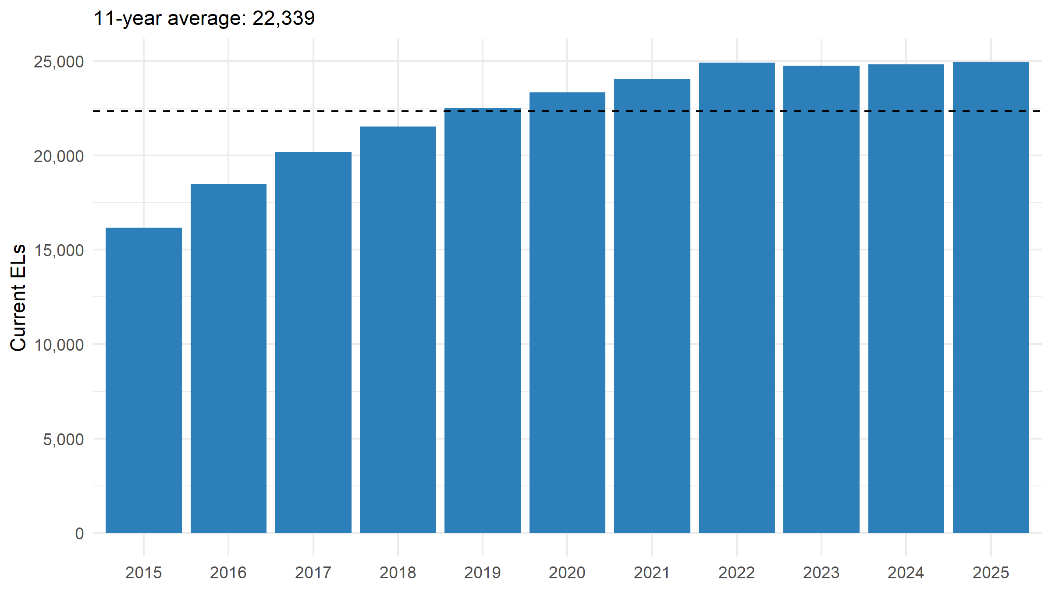
Figure 1: Current English learners by year. Dashed line: average across the panel.
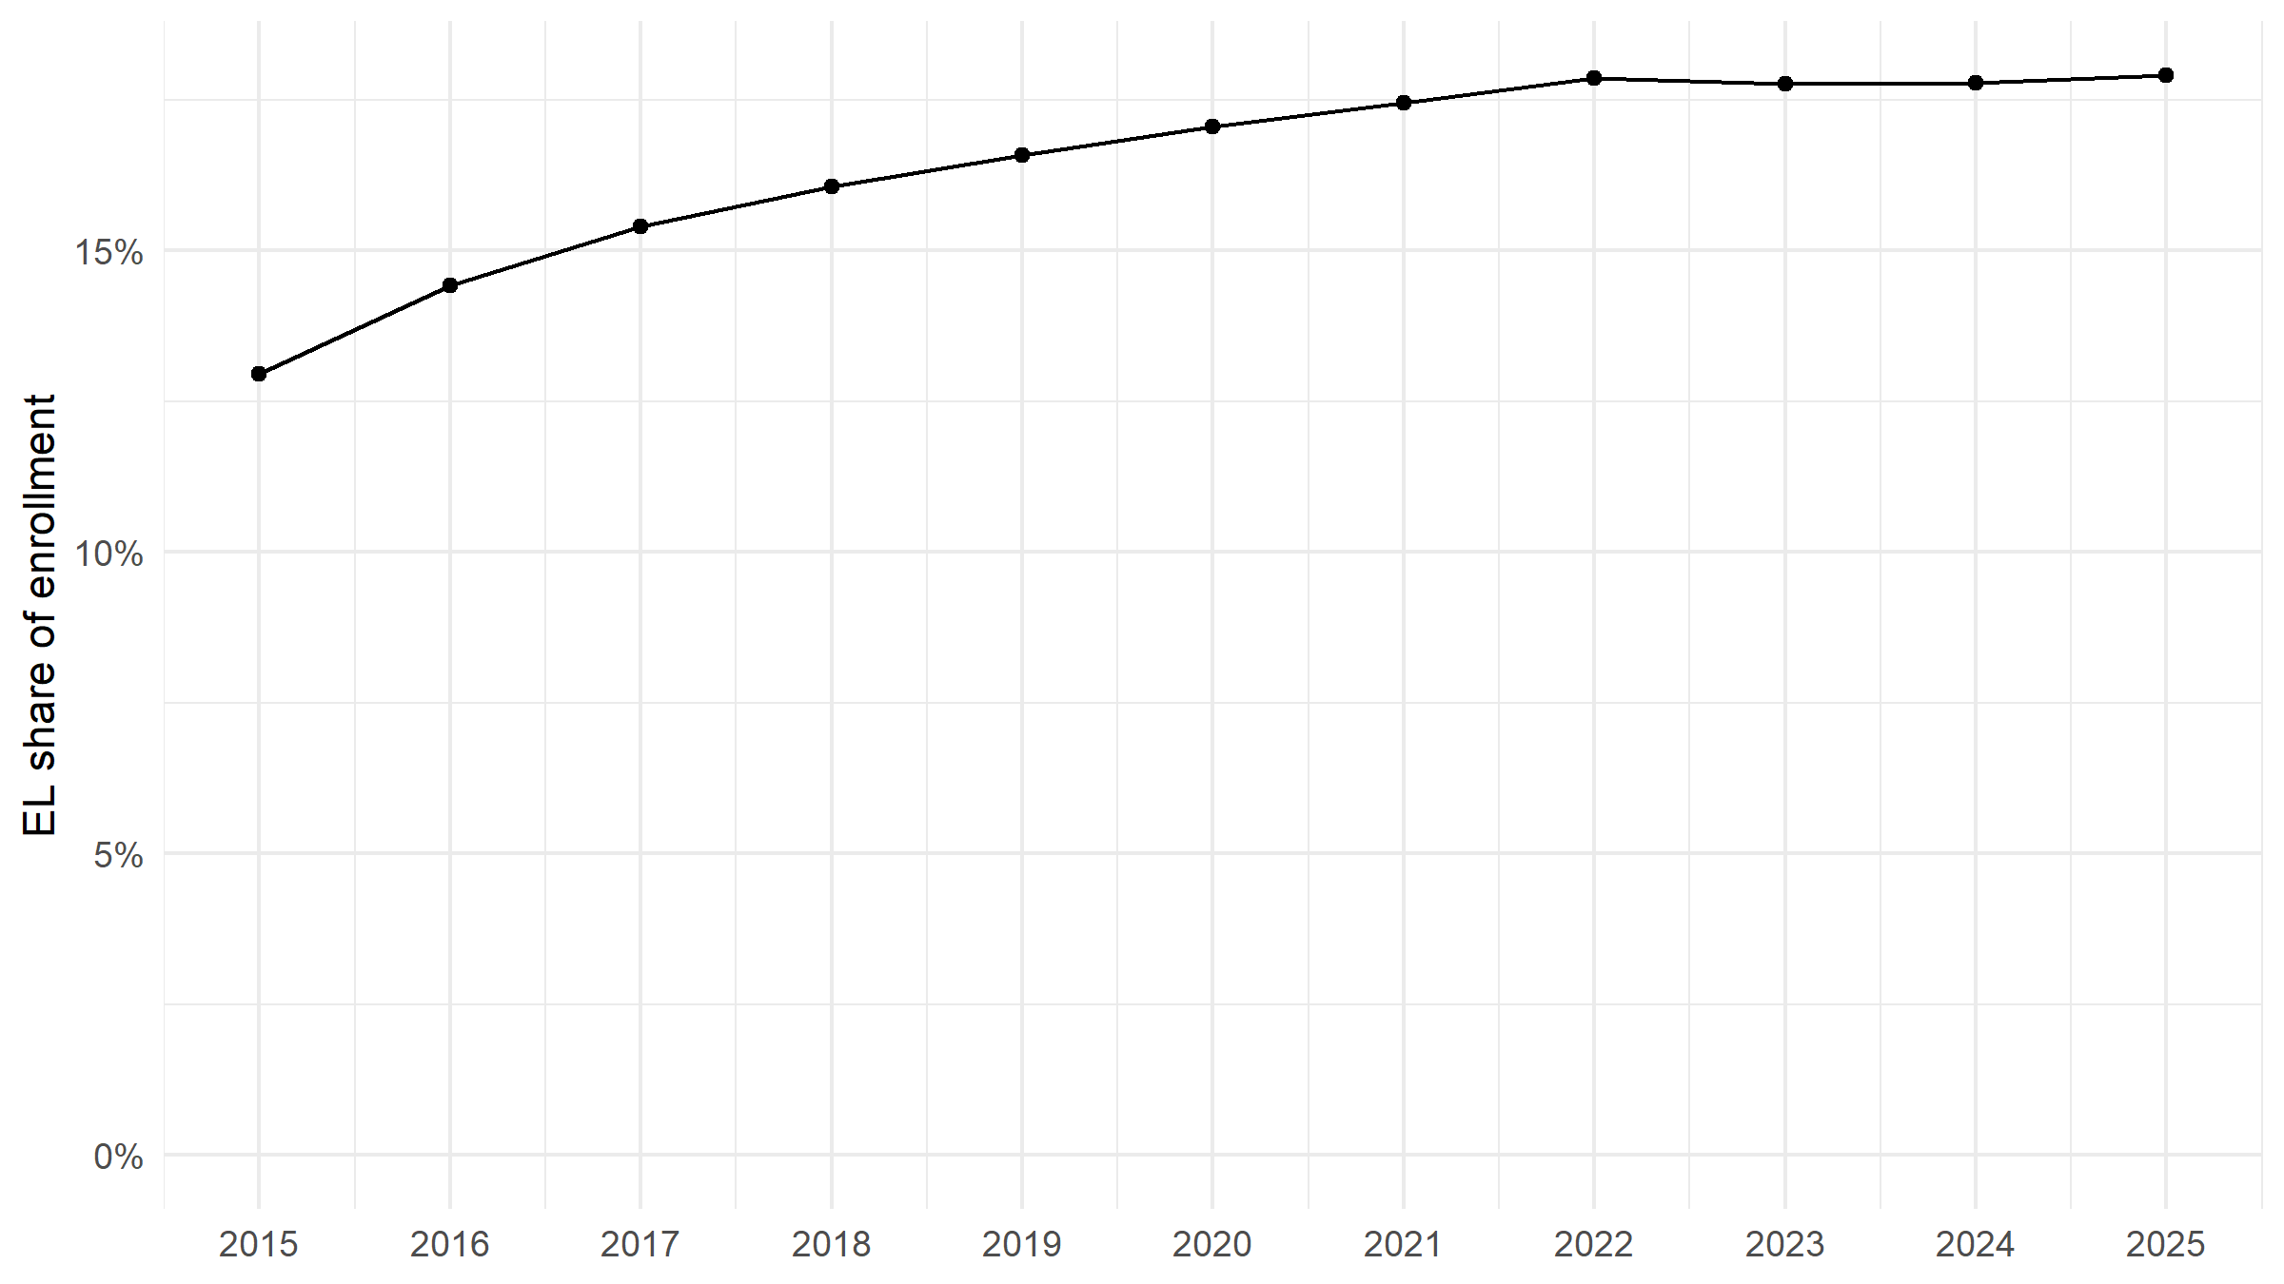
Figure 2: Current ELs as a share of total enrollment (weighted by SAMPLE_WEIGHT).
Table 2: Total enrollment and the EL share, weighted by SAMPLE_WEIGHT.
Year | Enrollment (weighted) | Current ELs | EL share
2015 | 124,867 | 16,176 | 13.0%
2016 | 128,288 | 18,492 | 14.4%
2017 | 131,096 | 20,176 | 15.4%
2018 | 134,070 | 21,537 | 16.1%
2019 | 135,827 | 22,510 | 16.6%
2020 | 136,787 | 23,334 | 17.1%
2021 | 137,909 | 24,058 | 17.4%
2022 | 139,481 | 24,915 | 17.9%
2023 | 139,407 | 24,762 | 17.8%
2024 | 139,691 | 24,830 | 17.8%
2025 | 139,293 | 24,938 | 17.9%

2. Grade-level distribution
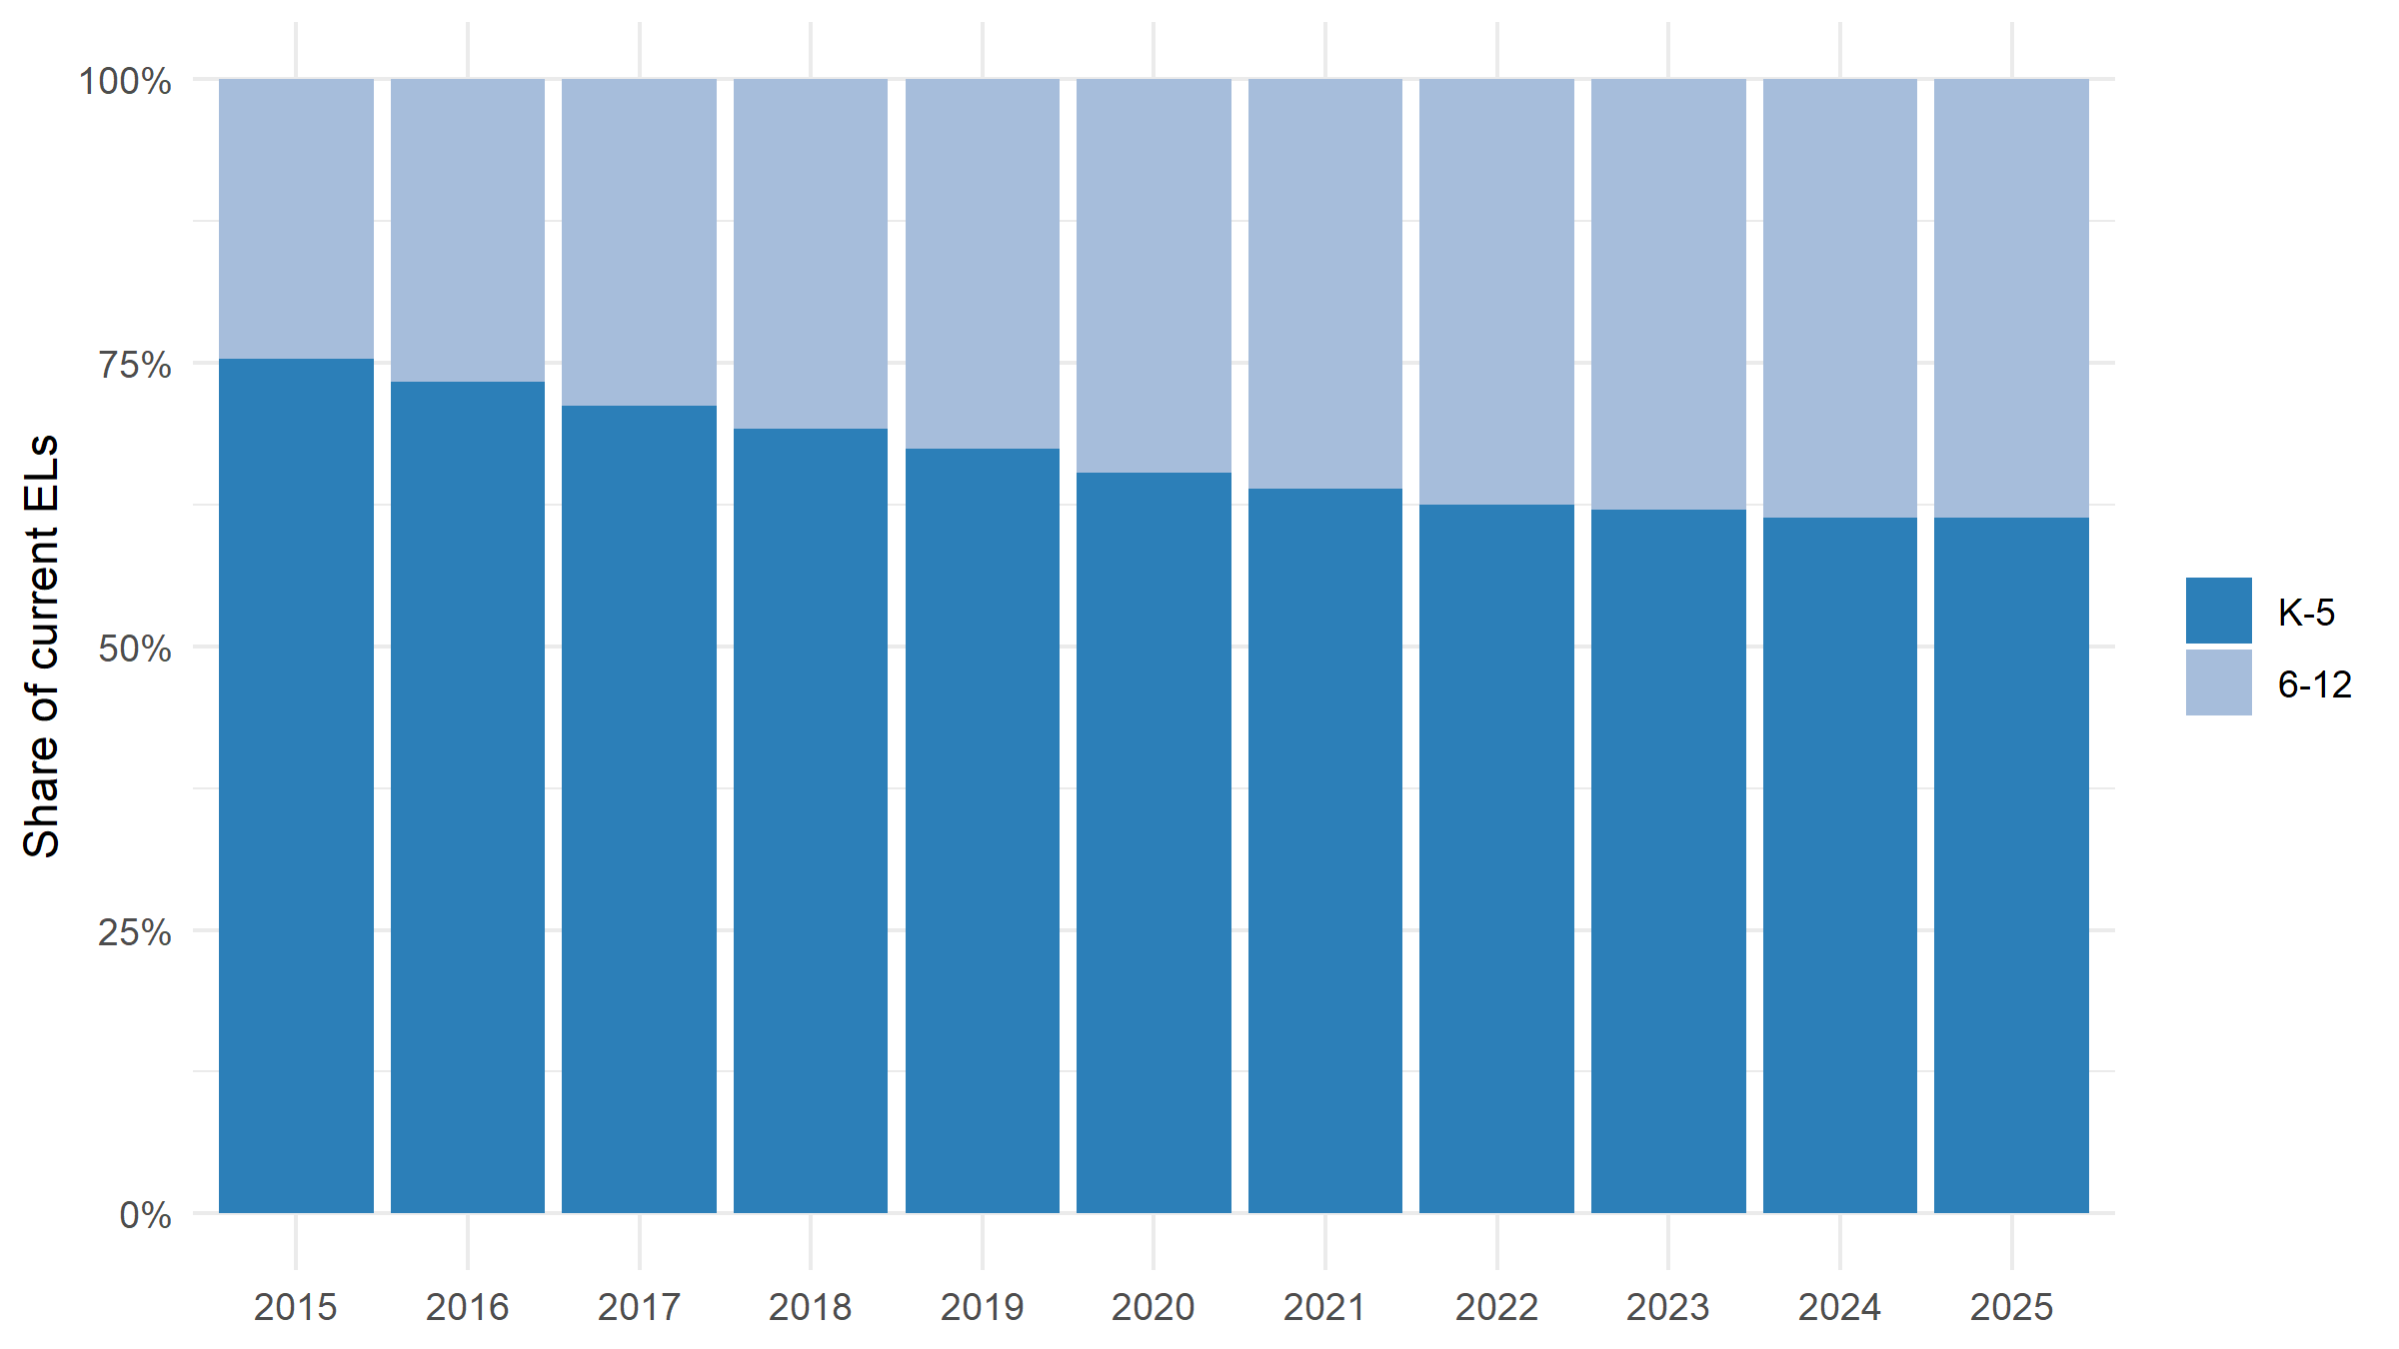
Figure 3: Current ELs by grade span and year (100% stacked).
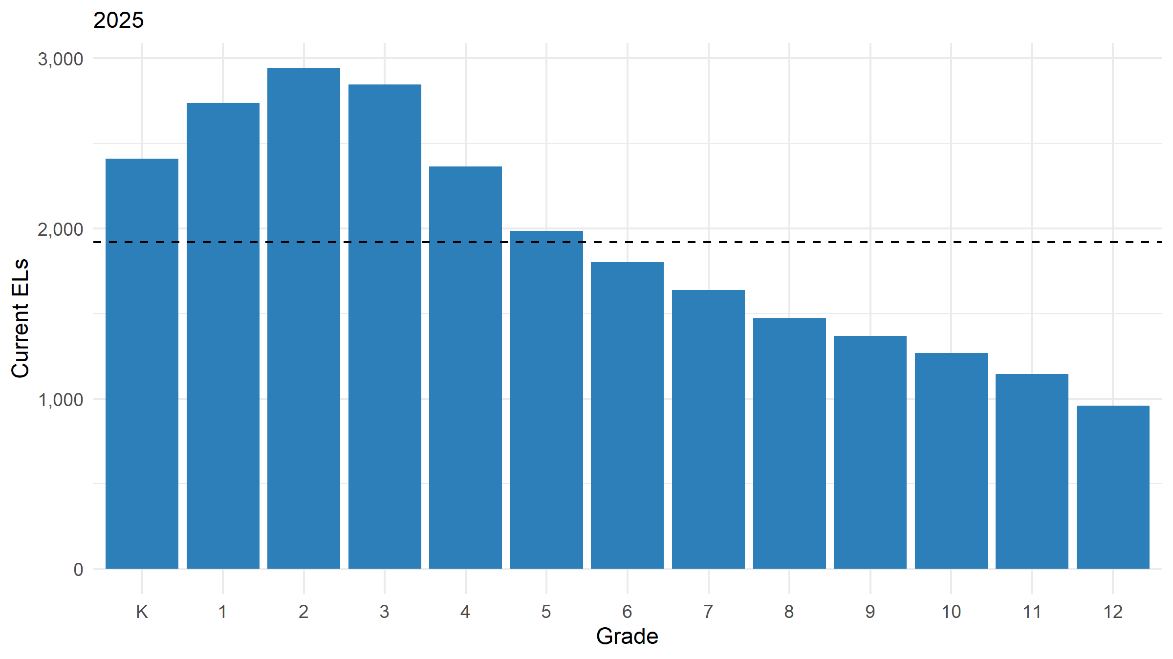
Figure 4: Current ELs by grade, 2025. The dashed line is the average across grades.
Table 3: Share of current ELs in each grade, by year (column percentages). Read down a column for concentration; read across a row for drift.
Grade | 2015 | 2016 | 2017 | 2018 | 2019 | 2020 | 2021 | 2022 | 2023 | 2024 | 2025
K | 14.7% | 12.8% | 11.9% | 11.2% | 10.5% | 10.3% | 9.8% | 9.5% | 9.7% | 9.7% | 9.7%
1 | 15.7% | 14.5% | 13.2% | 12.8% | 12.2% | 11.5% | 11.2% | 10.8% | 11.0% | 10.8% | 11.0%
2 | 15.3% | 14.9% | 14.2% | 13.4% | 13.1% | 12.7% | 12.1% | 11.8% | 11.7% | 12.1% | 11.8%
3 | 12.5% | 12.9% | 13.2% | 12.6% | 12.2% | 12.1% | 11.8% | 11.4% | 11.2% | 11.0% | 11.4%
4 | 9.7% | 10.3% | 10.4% | 11.0% | 10.4% | 10.4% | 10.5% | 10.3% | 9.9% | 9.7% | 9.5%
5 | 7.4% | 7.9% | 8.3% | 8.2% | 8.9% | 8.3% | 8.5% | 8.6% | 8.5% | 8.0% | 8.0%
6 | 6.4% | 6.6% | 7.1% | 7.3% | 7.3% | 7.9% | 7.4% | 7.7% | 7.3% | 7.5% | 7.2%
7 | 4.3% | 5.5% | 5.5% | 6.0% | 6.3% | 6.4% | 6.7% | 6.4% | 6.6% | 6.3% | 6.6%
8 | 4.0% | 4.1% | 5.0% | 5.0% | 5.5% | 5.7% | 5.9% | 6.2% | 5.9% | 6.0% | 5.9%
9 | 3.4% | 3.7% | 3.9% | 4.5% | 4.5% | 5.0% | 5.3% | 5.5% | 5.6% | 5.6% | 5.5%
10 | 2.9% | 2.9% | 3.1% | 3.3% | 3.9% | 4.0% | 4.4% | 4.8% | 5.0% | 5.1% | 5.1%
11 | 2.2% | 2.4% | 2.4% | 2.7% | 2.9% | 3.4% | 3.5% | 4.0% | 4.3% | 4.5% | 4.6%
12 | 1.4% | 1.5% | 1.8% | 1.9% | 2.1% | 2.2% | 2.8% | 2.9% | 3.3% | 3.7% | 3.8%

3. District variation
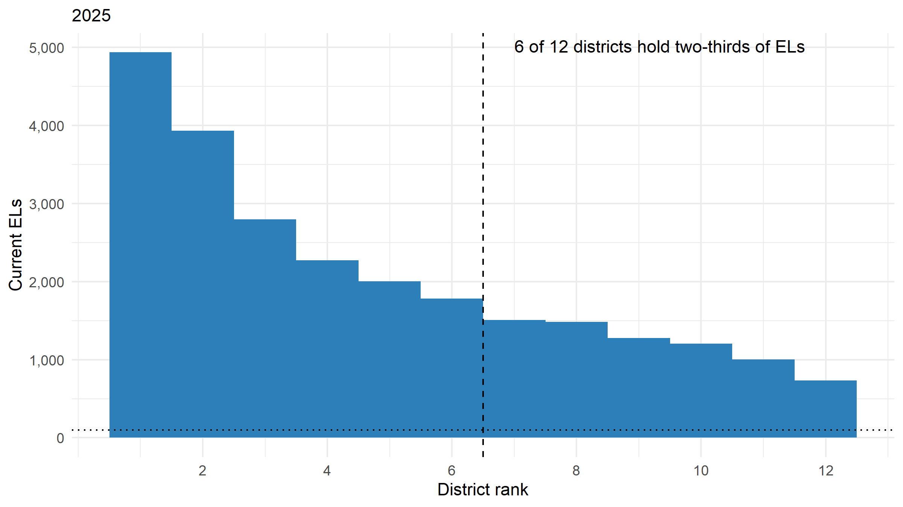
Figure 5: Current ELs by district, ranked (districts are ranked, not named). The dotted line is at 100 ELs. The districts to the left of the dashed line hold two-thirds of all current ELs.
Table 4: Districts by EL enrollment band, 2025. Band edges [PROPOSED – CONFIRM].
District EL count | Districts | Current ELs | Share of ELs
<100 | 0 | 0 | 0.0%
101-999 | 1 | 734 | 2.9%
1,000+ | 11 | 24,204 | 97.1%
Table 5: Districts that together hold two-thirds of current ELs. These are where a threshold change lands hardest.
Rank | District | Current ELs | Cumulative share
1 | D01 | 4,937 | 19.8%
2 | D02 | 3,933 | 35.6%
3 | D03 | 2,797 | 46.8%
4 | D04 | 2,271 | 55.9%
5 | D05 | 2,005 | 63.9%
6 | D06 | 1,782 | 71.1%

4. Entry-grade patterns and candidate cohorts
Each student’s entry into EL status is dated from the roster, using the first of the fields in spec$data$entry_sources that is delivered and non-missing (by default LEP_PROGRAM_START_DATE, COHORT_START_YEAR, YEAR_IN_STATUS, then ENTRY_GRADE, which assumes one grade per year). A state’s own count of years in the program maps onto YEAR_IN_STATUS through spec$data$columns$roster; whether that count codes a student’s first year as 1 or as 0 is detected from entrants the panel observes, unless the spec says. A delivered start date reads on the academic calendar (a September date belongs to the next spring year) unless spec$data$entry_date_rule says otherwise. With none of these fields, the panel itself dates entry only when the student first turns current after the panel opens (a student in K in the panel’s first year is also taken as a K entrant that year). A student already EL in the panel’s first year with nothing delivered to date them has an unknown entry: their time in status is a lower bound, and they are excluded from the entry views and from any Check 1 cohort.
Table 6: How each ever-current student’s entry year was resolved. Rows below the delivered fields are what the panel can do on its own.
Entry year dated from | Students | Share
LEP_PROGRAM_START_DATE | 59,816 | 100.0%
On the first observed current year of in-panel entrants, YEAR_IN_STATUS is 1 for 100.0% of them, so it is read as counting the current year (first year = 1) [DERIVED - VERIFY].
Delivered entry fields cover 100.0% of ever-current students. Where the panel also observes the entry (43,640 students first current after 2015), the delivered year matches the first current year for 100.0%; 0 delivered years fell after an observed current year and were pulled back to it.
Left-truncation recomputed here agrees with the delivered LEFT_TRUNCATED flag for 100.0% of students.
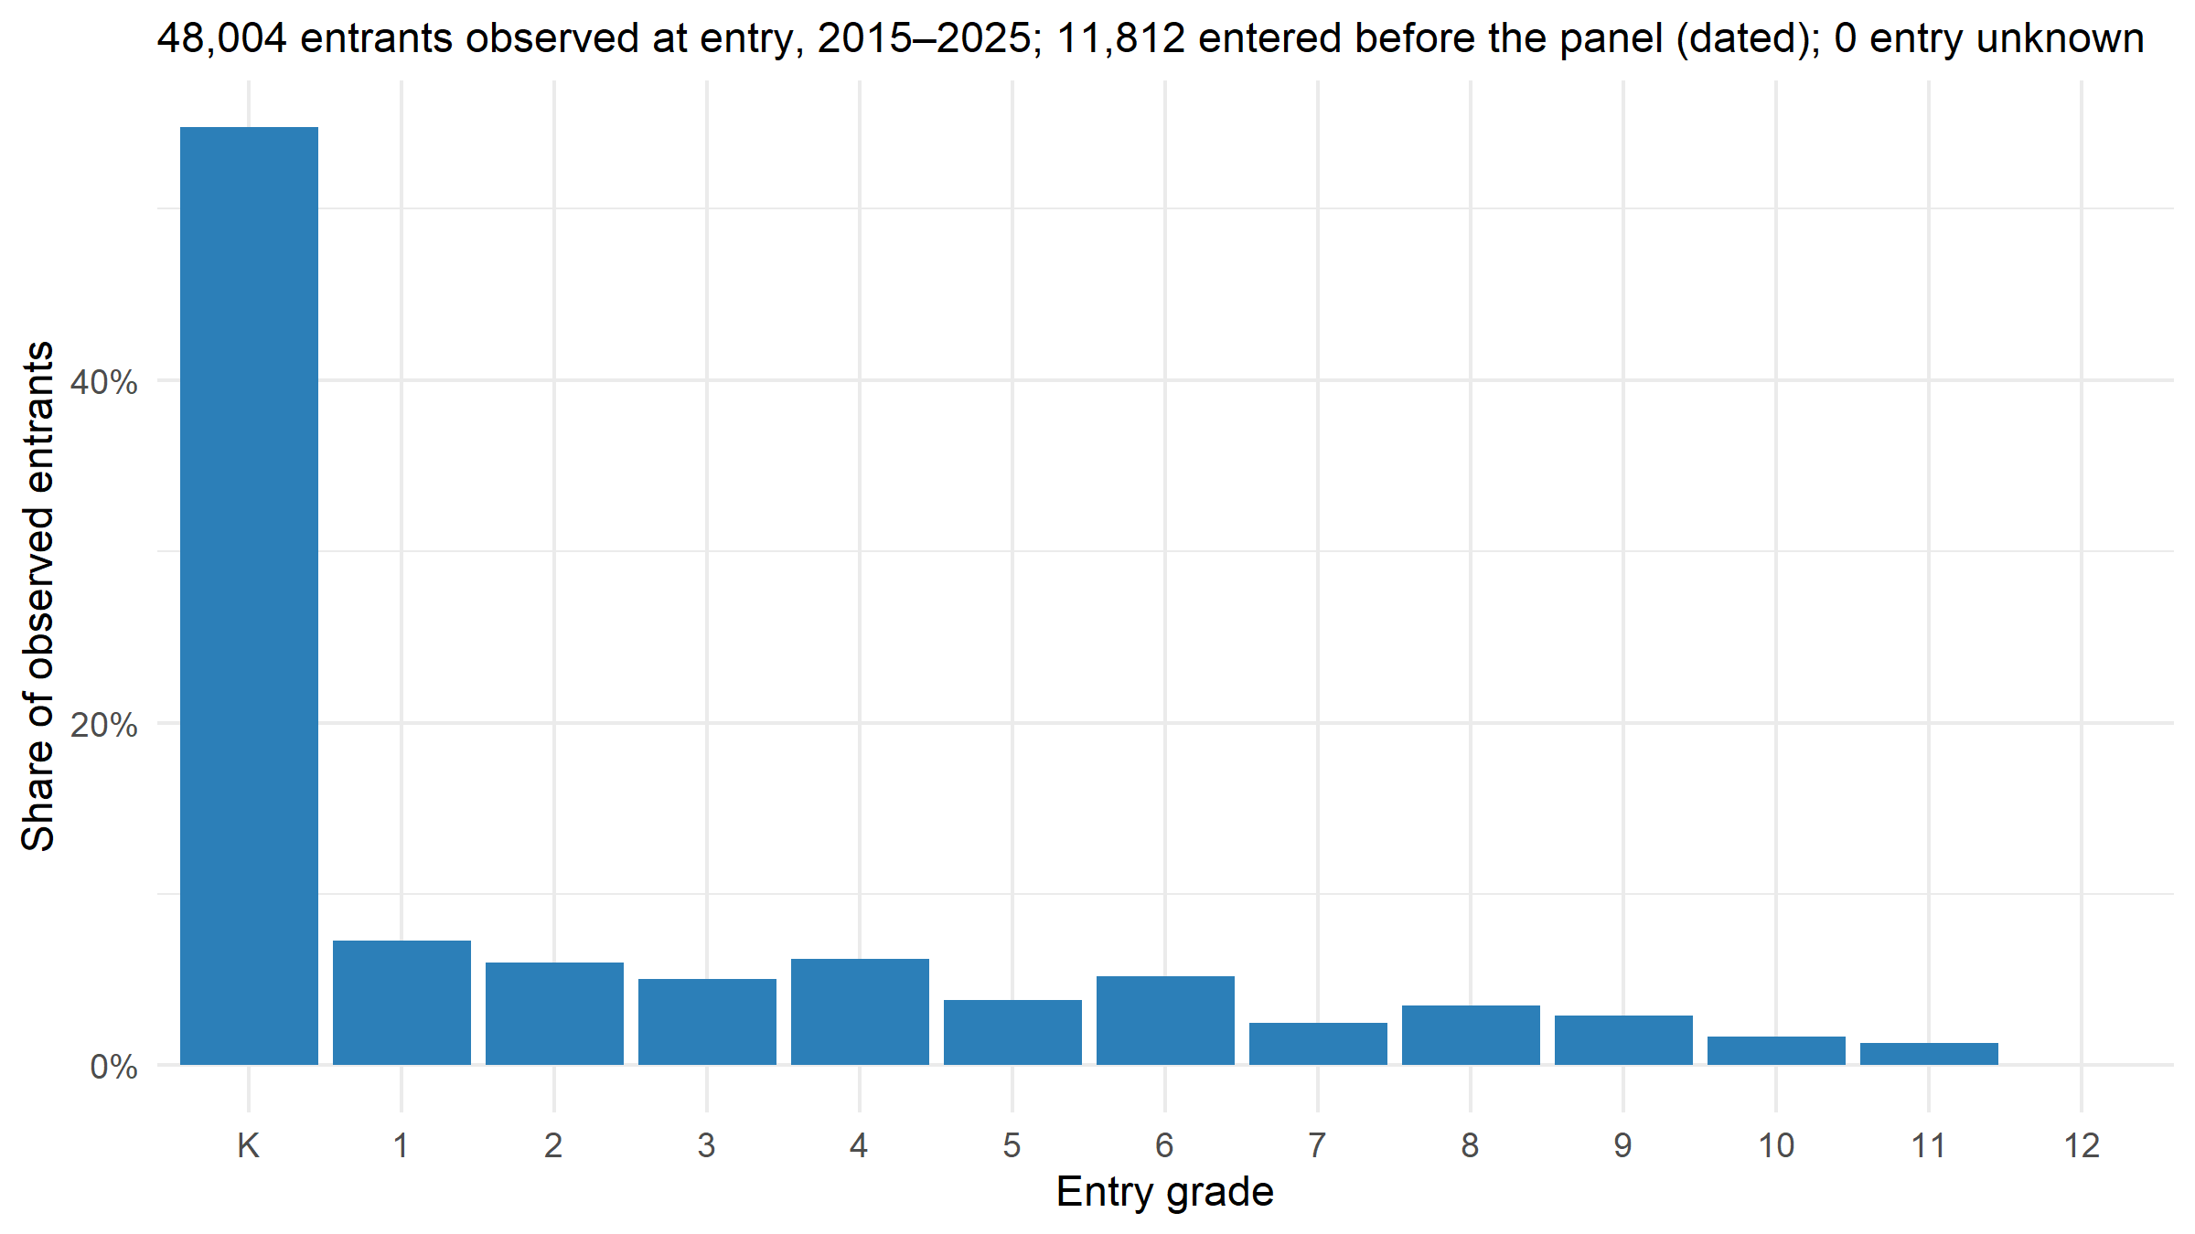
Figure 6: Grade at entry into EL status, among students whose entry falls inside the panel.
Table 7: Students entering EL status, by entry year and grade (entry observed inside the panel).
Entry year | K | 1 | 2 | 3 | 4 | 5 | 6 | 7 | 8 | 9 | 10 | 11 | 12
2015 | 2,373 | 309 | 268 | 220 | 296 | 189 | 212 | 105 | 139 | 110 | 83 | 60 | 0
2016 | 2,360 | 303 | 253 | 198 | 288 | 186 | 213 | 127 | 171 | 128 | 80 | 57 | 0
2017 | 2,411 | 299 | 228 | 242 | 251 | 159 | 239 | 99 | 160 | 142 | 72 | 62 | 0
2018 | 2,403 | 339 | 260 | 221 | 281 | 147 | 224 | 103 | 160 | 110 | 68 | 48 | 0
2019 | 2,374 | 332 | 234 | 218 | 269 | 181 | 240 | 96 | 161 | 134 | 69 | 56 | 0
2020 | 2,408 | 300 | 256 | 216 | 275 | 155 | 255 | 119 | 143 | 122 | 63 | 52 | 0
2021 | 2,350 | 295 | 273 | 235 | 289 | 174 | 222 | 115 | 151 | 129 | 72 | 59 | 0
2022 | 2,370 | 337 | 272 | 233 | 260 | 147 | 220 | 101 | 143 | 142 | 76 | 63 | 0
2023 | 2,406 | 361 | 252 | 209 | 245 | 171 | 193 | 118 | 144 | 133 | 77 | 55 | 0
2024 | 2,410 | 280 | 295 | 221 | 248 | 157 | 241 | 105 | 154 | 134 | 70 | 49 | 0
2025 | 2,410 | 328 | 278 | 212 | 273 | 152 | 228 | 96 | 142 | 111 | 68 | 66 | 0
Candidate K-start cohorts for Data Check 1 are below. They are the same cohorts Check 1 selects from: membership is the shared cohort derivation, and left-truncated students are excluded by construction.
Table 8: Candidate K-start cohorts for Data Check 1. Seeing the full exit window needs 7 observed years under first-former-year exit dating; shorter cohorts are usable but censored.
Entry year | Entrants | Years observed | Covers full exit window
2015 | 2,373 | 11 | yes
2016 | 2,360 | 10 | yes
2017 | 2,411 | 9 | yes
2018 | 2,403 | 8 | yes
2019 | 2,374 | 7 | yes
2020 | 2,408 | 6 | no
2021 | 2,350 | 5 | no
2022 | 2,370 | 4 | no
2023 | 2,406 | 3 | no
2024 | 2,410 | 2 | no
2025 | 2,410 | 1 | no

5. Time in status: new vs. long-term ELs
Years in status count from the entry year resolved in section 4, not from a student’s first appearance in the panel. A student whose entry is unknown (already EL when the panel opened, nothing delivered to date them) has only a lower bound: the years they have been observed as current. Such a student counts as long-term once observed for 6+ years, and is otherwise carried as unknown, which is why the long-term share is reported as a range (at least / at most). The two bounds meet once every student’s entry is dated.
Distributions only. Per the slide-38 guardrail, no mean or average time in status is computed anywhere in this document: a mean of durations across students who entered at different grades, and are censored at different points, describes no one.
Table 9: New and long-term ELs by year. Long-term = 6+ years in status [DERIVED – VERIFY]. “At least” counts students dated or observed current for 6+ years; “at most” adds every student whose entry is unknown and could be. First-year shares count dated entries only.
Year | Current ELs | First year in status | Long-term EL, at least | Long-term EL, at most | Entry unknown
2015 | 16,176 | 27.0% | 6.2% | 6.2% | 0.0%
2016 | 18,492 | 23.6% | 8.3% | 8.3% | 0.0%
2017 | 20,176 | 21.6% | 10.7% | 10.7% | 0.0%
2018 | 21,537 | 20.3% | 13.5% | 13.5% | 0.0%
2019 | 22,510 | 19.4% | 16.6% | 16.6% | 0.0%
2020 | 23,334 | 18.7% | 19.3% | 19.3% | 0.0%
2021 | 24,058 | 18.1% | 21.6% | 21.6% | 0.0%
2022 | 24,915 | 17.5% | 23.5% | 23.5% | 0.0%
2023 | 24,762 | 17.6% | 24.3% | 24.3% | 0.0%
2024 | 24,830 | 17.6% | 24.6% | 24.6% | 0.0%
2025 | 24,938 | 17.5% | 25.0% | 25.0% | 0.0%
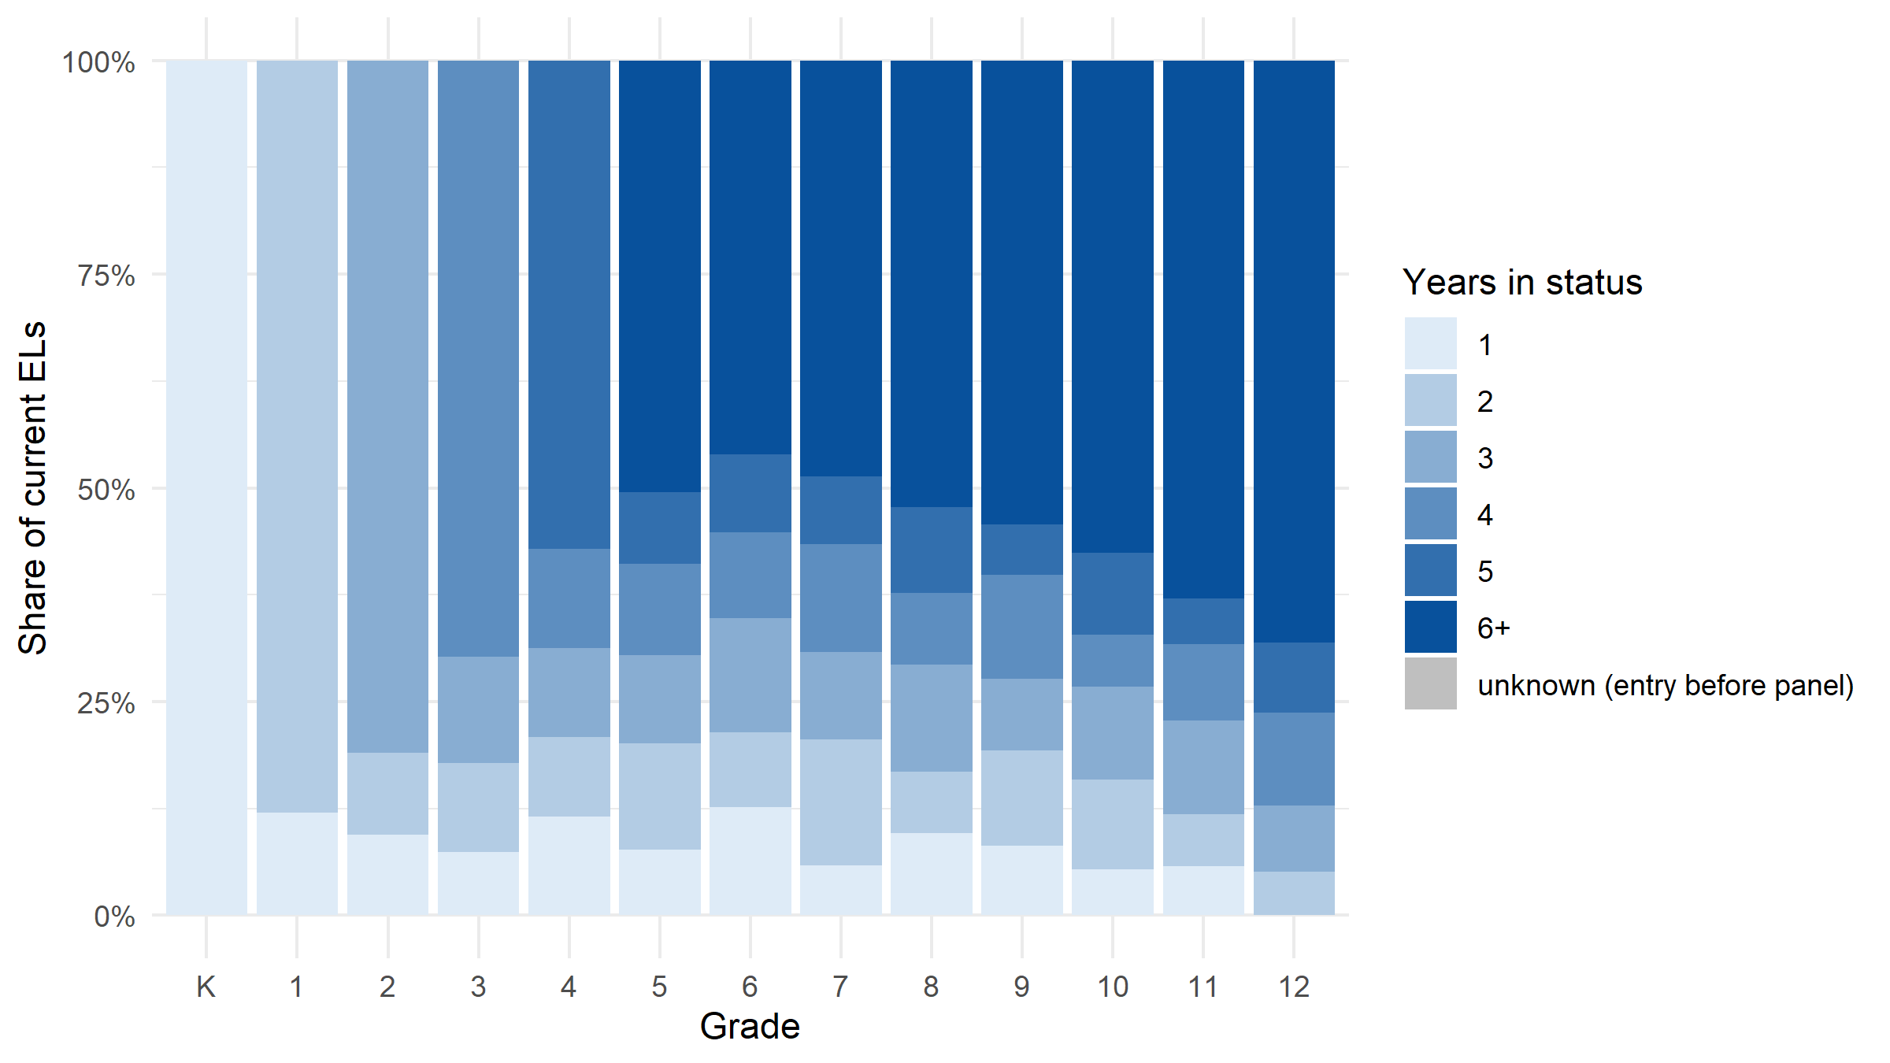
Figure 7: Years in EL status among current ELs, by grade, 2025. Grey marks unknown entry, observed for fewer years than the long-term threshold.
Table 10: New and long-term shares by grade, 2025. This is the table that tells you where a pooled all-EL analysis would mix two different populations.
Grade | Current ELs | First year in status | Long-term EL | Entry unknown
K | 2,410 | 100.0% | 0.0% | 0.0%
1 | 2,738 | 12.0% | 0.0% | 0.0%
2 | 2,942 | 9.4% | 0.0% | 0.0%
3 | 2,846 | 7.4% | 0.0% | 0.0%
4 | 2,365 | 11.5% | 0.0% | 0.0%
5 | 1,986 | 7.7% | 50.5% | 0.0%
6 | 1,801 | 12.7% | 46.1% | 0.0%
7 | 1,638 | 5.9% | 48.7% | 0.0%
8 | 1,471 | 9.7% | 52.3% | 0.0%
9 | 1,368 | 8.1% | 54.2% | 0.0%
10 | 1,269 | 5.4% | 57.6% | 0.0%
11 | 1,146 | 5.8% | 62.9% | 0.0%
12 | 958 | 0.0% | 68.1% | 0.0%

6. Initial ELP level
The Overall Composite level at entry, banded per the spec. Only students whose entry is observed inside the panel have an initial level. Alternate-form takers are counted as a group and never banded: the alternate scale is a different measurement scale.
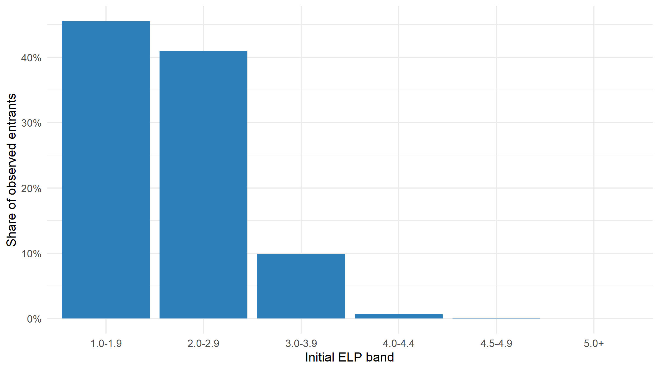
Figure 8: Initial ELP level (the banded Overall Composite level), among entrants observed at entry.
Table 11: Initial ELP at entry. Bands are the spec’s [DERIVED – VERIFY].
Initial ELP | N | Share
1.0-1.9 | 21,866 | 45.6%
2.0-2.9 | 19,671 | 41.0%
3.0-3.9 | 4,756 | 9.9%
4.0-4.4 | 307 | 0.6%
4.5-4.9 | 63 | 0.1%
5.0+ | 14 | 0.0%
alternate form (excluded from bands) | 173 | 0.4%
no annual score observed | 1,154 | 2.4%
The band recomputed here from the Overall Composite (first annual result at or after entry) agrees with the delivered INITIAL_ELP for 100.0% of the 46,677 entrants carrying both.

7. Demographic profile
Table 12: Profile of current ELs, 2025. Shares are within-EL and unweighted; cells under 10 suppressed; long value lists collapsed to the top entries. Columns not delivered are simply absent.
Variable | Value | N | Share
HOME_LANGUAGE | spa | 13,671 | 54.8%
HOME_LANGUAGE | por | 2,041 | 8.2%
HOME_LANGUAGE | ara | 1,757 | 7.0%
HOME_LANGUAGE | cmn | 1,278 | 5.1%
HOME_LANGUAGE | hat | 1,243 | 5.0%
HOME_LANGUAGE | guj | 1,236 | 5.0%
HOME_LANGUAGE | kor | 1,037 | 4.2%
HOME_LANGUAGE | oth | 1,026 | 4.1%
HOME_LANGUAGE | urd | 931 | 3.7%
HOME_LANGUAGE | tgl | 718 | 2.9%
SERVICE_MODEL | esl_pullout | 7,548 | 30.3%
SERVICE_MODEL | esl_pushin | 5,442 | 21.8%
SERVICE_MODEL | sheltered | 3,212 | 12.9%
SERVICE_MODEL | bilingual_trans | 2,701 | 10.8%
SERVICE_MODEL | bilingual_tw | 2,284 | 9.2%
SERVICE_MODEL | newcomer_program | 2,273 | 9.1%
SERVICE_MODEL | refused_services | 1,478 | 5.9%
IEP | N | 20,392 | 81.8%
IEP | Y | 4,546 | 18.2%
SPED_CLASSIFICATION | (missing) | 20,392 | 81.8%
SPED_CLASSIFICATION | SLD | 1,509 | 6.1%
SPED_CLASSIFICATION | SLI | 1,085 | 4.4%
SPED_CLASSIFICATION | OHI | 630 | 2.5%
SPED_CLASSIFICATION | AUT | 560 | 2.2%
SPED_CLASSIFICATION | MD | 431 | 1.7%
SPED_CLASSIFICATION | OTH | 331 | 1.3%
GENDER | M | 12,699 | 50.9%
GENDER | F | 12,177 | 48.8%
GENDER | X | 62 | 0.2%
FRL | Y | 18,162 | 72.8%
FRL | N | 6,776 | 27.2%
FRL_DETAIL | F | 15,425 | 61.9%
FRL_DETAIL | N | 6,776 | 27.2%
FRL_DETAIL | R | 2,737 | 11.0%
ELP_FORM | annual | 24,769 | 99.3%
ELP_FORM | alternate | 169 | 0.7%
NEWCOMER_FLAG | N | 20,095 | 80.6%
NEWCOMER_FLAG | Y | 4,843 | 19.4%
SIFE_FLAG | N | 23,412 | 93.9%
SIFE_FLAG | Y | 1,526 | 6.1%
IMMIGRANT_STATUS | Y | 12,796 | 51.3%
IMMIGRANT_STATUS | N | 12,142 | 48.7%
MIGRANT_STATUS | N | 23,935 | 96.0%
MIGRANT_STATUS | Y | 1,003 | 4.0%
TIME_IN_STATUS | 1 year (new) | 4,364 | 17.5%
TIME_IN_STATUS | 2-5 years | 14,329 | 57.5%
TIME_IN_STATUS | 6+ years (long-term) | 6,245 | 25.0%

8. Former ELs in monitoring
Table 13: Former ELs by monitoring year [PROPOSED – CONFIRM view].
Year | Monitoring year 1 | Monitoring year 2 | Monitoring year 3 | Monitoring year 4
2015 | 1,436 | 1,009 | 588 | 248
2016 | 1,815 | 1,393 | 974 | 554
2017 | 2,397 | 1,749 | 1,337 | 927
2018 | 2,641 | 2,309 | 1,672 | 1,271
2019 | 2,977 | 2,568 | 2,203 | 1,579
2020 | 3,061 | 2,879 | 2,464 | 2,089
2021 | 3,120 | 2,933 | 2,761 | 2,317
2022 | 2,837 | 2,992 | 2,791 | 2,606
2023 | 3,792 | 2,713 | 2,844 | 2,646
2024 | 3,470 | 3,621 | 2,577 | 2,673
2025 | 3,331 | 3,341 | 3,426 | 2,417

Interpreting
This step is not just a technical prerequisite for choosing analytic samples. It is the interpretive backdrop for every Data Check that follows. A grade-level finding, a district pattern, or a subgroup difference in Data Checks 1–4 has to be read through what this step shows: is that grade, district, or subgroup representative of the EL population, or an outlier shaped by unusual entry timing, thin N, or a concentrated long-term-EL presence? Skipped or skimmed, this step lets later results be taken at face value when they actually reflect population idiosyncrasy rather than anything about the exit threshold.
Resist the urge to average
Nothing above averages across groups, and nothing reports a mean time in status. Grade, district, and duration groups are shown as distributions and shares so that the concentration itself stays visible. Keep it that way in the stages that follow.

Additional check — Types 2–6: criteria crosswalk
The exit rule is declared as Type 1 (a single overall composite), so the criteria crosswalk does not apply. criteria_crosswalk, blocked_groups and contested_zone are NULL in the results object. Declare the additional criteria in spec$policy$exit$pathways and set types to activate this check.

Decide before moving on
- Panel. 11 years (2015–2025).
- Size. 24,938 current ELs in 2025 (11-year average 22,339).
- Grade concentration (2025). Grades 2, 3, 1 hold 34.2% of current ELs; K-5 holds 61.3%.
- Districts (2025). 6 of 12 districts hold two-thirds of current ELs; 0 districts serve fewer than 100.
- Entry. 62.0% of observed entrants enter in K or grade 1. K-start cohorts that cover the full exit window: 2015 (n = 2,373, 11 years observed); 2016 (n = 2,360, 10 years observed); 2017 (n = 2,411, 9 years observed); 2018 (n = 2,403, 8 years observed); 2019 (n = 2,374, 7 years observed) (plus 6 shorter cohorts, censored at the window’s edge).
- Time in status (2025). 17.5% of current ELs are in their first year; 25.0% have 6+ years (long-term); entry is unknown for 0.0% (already EL when the panel opened, no entry field delivered).
- Alternate-form ELP. 0.7% of current ELs in 2025 take the alternate form (reported as a group, never banded).
Decide
- Which cohorts and subgroups are large and stable enough to analyze reliably? Is there a clean K-start cohort for Data Check 1 (observed at entry, not pandemic-distorted, N well above the suppression floor)?
- Which grades, districts, or subgroups are most likely to be affected by any eventual policy change and warrant closer attention throughout?
- Where would a single pooled “all ELs together” analysis obscure more than it reveals? Most notably: newly arrived vs. long-term ELs, and the grades where the long-term share is concentrated.
Spec: SIM. Simulated data, contract 0.4.0. stateELP 0.0.0.9000, run 2026-10-09.
These figures describe a synthetic fixture. No number here describes any real state.

