Data Check 4 — Decision consistency and Youden’s J
  - Evaluating and Setting English Learner Exit Thresholds
Sample
Cross-sectional – the same paired cross-section as Data Check 3, not the entry cohort Data Checks 1 and 2 follow: every current grade-3 EL with both a 2025 Overall Composite level and a 2025 ELA score (n = 2,596). Former ELs and English-only students are not in it: the two classifications compared here exist only for students still classified. Each grade is a panel of its own and grades are never pooled; this pass renders one, grade 3 ELA.

Looking at
Two statistics, computed at every candidate cut on the Overall Composite level. At each cut a current EL is classified ready to exit if their level is at or above it, and that classification is set against whether the same student reached proficiency on the content test that year.
- Decision consistency is the share of students for whom the two classifications agree.
- Youden’s J is sensitivity plus specificity, minus one: how well the cut separates students who are proficient on the content test from those who are not, with the two error rates — the share of proficient students it holds back, and the share of not-proficient students it lets exit — weighted the same, however common each group is.
The Process Overview pairs these with a rank-dependence analysis — the Betebenner copula / Kendall’s-tau method — that examines where and how strongly ELP and content performance move together, including in the tails. That piece is not built yet; What is not here says what is turnkey and what is not.

The curves
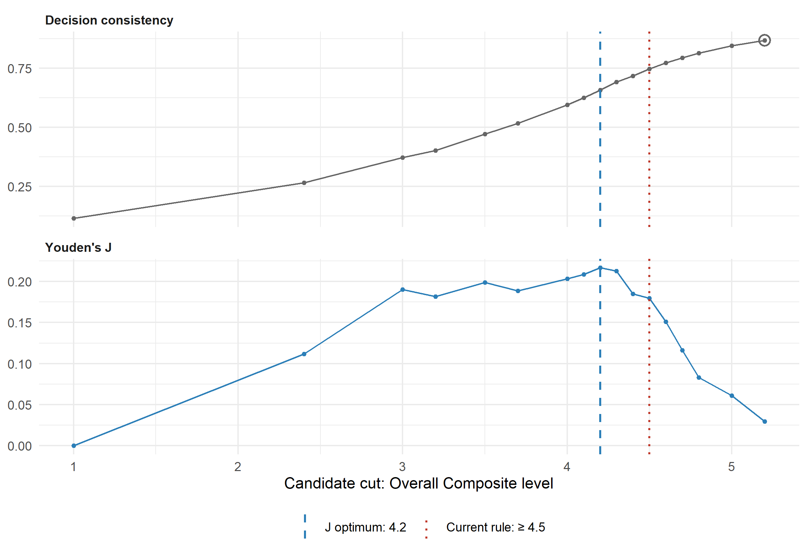
Figure 1: Decision consistency and Youden’s J at every candidate cut on the Overall Composite level, grade 3 ELA, 2025. The dashed line marks the J optimum among the cuts shown; the dotted line marks the current exit rule; the circle marks raw agreement’s highest reportable point. Suppressed cuts are not drawn: a cut is shown only if neither its own cells nor its difference from a neighbouring published count — the cut shown before it, or a band boundary Data Check 3 reports — would disclose a group of fewer than 10 students.
In grade 3 ELA, 11% of the 2,596 current ELs reached proficiency. Youden’s J is highest, among the cuts that can be shown, at 4.2 (J = 0.22). Raw agreement’s highest reportable point is elsewhere, at 5.2 (87%), no better than simply calling every student not ready, which agrees 89% of the time. That is the base-rate pull, and it is why the J optimum, not the agreement peak, is this stage’s optimal-cut statistic. Some cuts are suppressed, so agreement’s true maximum may lie among them. The current rule (≥ 4.5) sits above the J optimum, where J = 0.18.
Which error costs more
Which error costs more is still an open question: Prep 3 has not recorded an answer. Youden’s J weights the two errors equally as rates – the share of proficient students held back and the share of not-proficient students exited – however common each group is. Per student that is not an even trade: with 11% of these students proficient, the J optimum of 4.2 weighs holding back one proficient student as heavily as exiting 7.7 who are not. If stakeholders price the two errors differently from that, it is a documented reason to land the threshold deliberately above or below the J optimum – a values input, not a departure from the evidence.
Table 1: Where J peaks among the cuts that can be shown, the highest reportable agreement, and how the current rule scores, grade 3 ELA, 2025. Proficient is the share of these current ELs at or above the content test’s proficiency cut.
Subject | Grade | n | Proficient | J optimum | J there | Highest reportable  agreement | Agreement there | Current rule | J at the rule
ELA | 3 | 2,596 | 11% | 4.2 | 0.22 | 5.2 | 87% | ≥ 4.5 | 0.18
Scores are paired within the school year, not to the day: the Overall Composite is administered Jan-Mar and the content test later in the year.
Reading the right-hand end of the axis
The right-hand end of the axis is constituted by the exit rule. A student still classified as an EL at or above the current rule’s level (4.5) is, in most states, in their final year, so the cuts at and above it rest on students on their way out rather than on a cross-section of highly proficient ELs. Read both curves there with that in mind.

Looking for
Decision consistency’s peak — with a specific caution. When English learners’ academic-proficiency rate sits well below 50%, as it typically does, the peak can be distorted, or fail to appear within a realistic range at all, because the statistic is pulled toward whichever classification is more common. Calling every student not ready already agrees with the content test for every student who is not proficient, so agreement climbs as the cut rises and can keep climbing to the top of the scale.
The arithmetic is short. Raising the cut past a level moves agreement up when most students at that level are not proficient, so — where the proficiency rate rises steadily with level — agreement peaks where the rate among students at a level crosses one half. It moves J up when students at that level are proficient less often than the overall base rate, so J peaks where the rate crosses the base rate instead. With a base rate below one half, the J optimum therefore sits at or below the agreement peak, and in practice usually well below it. That gap is what the figure shows.
Youden’s J corrects for this by weighting both error rates equally, however common each kind of student is — which is why it, and not raw consistency, is this stage’s optimal-cut statistic.

Interpreting it
Prefer J over raw decision consistency as the primary optimal-cut statistic, because of the base-rate sensitivity above.
Treat convergence between Data Checks 3 and 4 as the strongest evidence, and any single method’s result on its own with more caution. Read the comparison with one fact in mind. Check 3’s two landings — the first band where half the students reach the proficiency cut, and the Overall Composite scale score (a different axis from this stage’s levels) at which a fitted logistic crosses 50% — both mark where proficiency becomes more likely than not. That is the point raw agreement aims at, not the point J aims at. With a base rate below one half they should therefore land at or above the J optimum, or not appear at all: a gap of that sign is expected, not a disagreement. The informative comparisons are Check 3’s band landing against this stage’s agreement curve, and both against J.
Read the curve’s shape, not only its peak. A J curve that is flat near its top means several cuts separate students almost equally well, and the optimum alone overstates how precisely the data locate a threshold. That is why this stage’s eventual output is a candidate region rather than a single number.
Remember Prep 3’s error-tolerance question here. Youden’s J treats a false exit and a false hold as equally costly as rates: one in ten proficient students held back counts the same as one in ten not-proficient students let go. Per student that is not an even trade — at a low base rate J weighs each held-back proficient student far more heavily than each premature exit, and the note beside the figure says by how much. Stakeholders answer Prep 3’s question per student, so if they weigh the two errors differently from J, that is a deliberate, documented reason to land the final threshold above or below the J-optimal point — a values input the statistic itself cannot supply, not a departure from the evidence.

The numbers behind the curves
Table 2: Every candidate cut, grade 3 ELA, 2025. A student counts as at/above when their Overall Composite level is at or above the cut. A dash marks a suppressed cut: one whose own cells, or whose difference from the cut shown before it or from a band boundary Data Check 3 reports, would disclose a group of fewer than 10 students.
Cut (at or above) | Proficient,  at/above | Not proficient,  at/above | Proficient,  below | Not proficient,  below | Agreement | Sensitivity | Specificity | J
1.0 | 298 | 2,298 | 0 | 0 | 11% | 1.00 | 0.00 | 0.00
1.1 | — | — | — | — | — | — | — | —
1.2 | — | — | — | — | — | — | — | —
1.3 | — | — | — | — | — | — | — | —
1.4 | — | — | — | — | — | — | — | —
1.5 | — | — | — | — | — | — | — | —
1.6 | — | — | — | — | — | — | — | —
1.7 | — | — | — | — | — | — | — | —
1.8 | — | — | — | — | — | — | — | —
1.9 | — | — | — | — | — | — | — | —
2.0 | — | — | — | — | — | — | — | —
2.1 | — | — | — | — | — | — | — | —
2.2 | — | — | — | — | — | — | — | —
2.3 | — | — | — | — | — | — | — | —
2.4 | 278 | 1,887 | 20 | 411 | 27% | 0.93 | 0.18 | 0.11
2.5 | — | — | — | — | — | — | — | —
2.6 | — | — | — | — | — | — | — | —
2.7 | — | — | — | — | — | — | — | —
2.8 | — | — | — | — | — | — | — | —
2.9 | — | — | — | — | — | — | — | —
3.0 | 264 | 1,598 | 34 | 700 | 37% | 0.89 | 0.30 | 0.19
3.1 | — | — | — | — | — | — | — | —
3.2 | 249 | 1,503 | 49 | 795 | 40% | 0.84 | 0.35 | 0.18
3.3 | — | — | — | — | — | — | — | —
3.4 | — | — | — | — | — | — | — | —
3.5 | 228 | 1,301 | 70 | 997 | 47% | 0.77 | 0.43 | 0.20
3.6 | — | — | — | — | — | — | — | —
3.7 | 207 | 1,163 | 91 | 1,135 | 52% | 0.69 | 0.49 | 0.19
3.8 | — | — | — | — | — | — | — | —
3.9 | — | — | — | — | — | — | — | —
4.0 | 182 | 936 | 116 | 1,362 | 59% | 0.61 | 0.59 | 0.20
4.1 | 172 | 847 | 126 | 1,451 | 63% | 0.58 | 0.63 | 0.21
4.2 | 162 | 751 | 136 | 1,547 | 66% | 0.54 | 0.67 | 0.22 | J optimum
4.3 | 148 | 652 | 150 | 1,646 | 69% | 0.50 | 0.72 | 0.21
4.4 | 128 | 562 | 170 | 1,736 | 72% | 0.43 | 0.76 | 0.18
4.5 | 115 | 474 | 183 | 1,824 | 75% | 0.39 | 0.79 | 0.18 | current rule
4.6 | 95 | 386 | 203 | 1,912 | 77% | 0.32 | 0.83 | 0.15
4.7 | 75 | 311 | 223 | 1,987 | 79% | 0.25 | 0.86 | 0.12
4.8 | 56 | 241 | 242 | 2,057 | 81% | 0.19 | 0.90 | 0.08
4.9 | — | — | — | — | — | — | — | —
5.0 | 36 | 138 | 262 | 2,160 | 85% | 0.12 | 0.94 | 0.06
5.1 | — | — | — | — | — | — | — | —
5.2 | 17 | 63 | 281 | 2,235 | 87% | 0.06 | 0.97 | 0.03 | highest reportable agreement
5.3 | — | — | — | — | — | — | — | —
5.4 | — | — | — | — | — | — | — | —
5.5 | — | — | — | — | — | — | — | —
5.6 | — | — | — | — | — | — | — | —
5.7 | — | — | — | — | — | — | — | —
5.8 | — | — | — | — | — | — | — | —

Checkpoint
Confirm the analysis is computing Youden’s J, not raw decision consistency relabeled, before relying on it as the primary threshold statistic. This is a demonstrated gap between the two methods, not a theoretical concern: where the two curves above peak at different cuts, the J optimum is the one this stage reports. The package holds a small test fixture whose proficiency rate is well below one half, where the consistency peak and the J optimum diverge by construction, and the stage must return the J optimum there.

Additional check — Types 2–6: the policy as a whole
Does not apply. This spec’s exit rule is Type 1, a single overall criterion, so the policy’s own pass/fail outcome is one point on the curves above – the current rule’s cut – and there is nothing further to compute.

What is not here
The candidate region. The stage’s eventual answer is a region, not a single number, read across every tested grade and annotated with which grades and years carry the most and least reliable evidence per Data Check 1. This pass computes one grade and subject; the region across grades is a later pass.
The rank-dependence analysis. What is turnkey and what is custom: decision consistency and Youden’s J — the Cook et al. methods — are built here and run on any delivery. The copula / Kendall’s-tau dependence analysis, which asks where and how strongly ELP and content performance move together and whether they couple differently at the low end (expected: independence, noise) than at the high end (expected: real signal), is custom. It has no package support yet, and its slot stays empty until it does.
What these curves can and cannot say here
On simulated data the J-optimal point is machinery, not a finding. Where it lands is set by the generator’s parameters — how far EL content scores sit below the cut, how steeply they rise with ELP level, how much they vary — and by how the simulated exit rule thins the top of the level scale. The figure demonstrates that the curves build, suppress and render correctly, and that the two statistics part ways at a low base rate as the method says they should; it is not evidence about where any state’s threshold belongs. Run against a real delivery, the same figure is the stage’s substantive output.

Decide before moving on
- A candidate region — not necessarily a single number — supported by the balance of evidence across Data Checks 3–4, noting explicitly which grades and years carry the most and least reliable evidence per Data Check 1’s findings.
- Record Prep 3’s error-tolerance answer beside the region — or that the question is still open — as an input to the Decision stage, which chooses where in the region to land.
Spec: SIM. Simulated data, contract 0.4.0. stateELP 0.0.0.9000, run 2026-10-09.
These figures describe a synthetic fixture. No number here describes any real state. Where the J optimum and the highest agreement land, and the gap between them, are consequences of the generator’s parameters rather than findings.

