|  |
| --- |
| Database Query using SQL |

***No:*** *1*

***Date:*** *12/09/2022*

***Program:***

|  |  |  |  |  |  |  |
| --- | --- | --- | --- | --- | --- | --- |
| **S.NO.** | **NAME** | **STIPEND** | **STREAM** | **AVG MARKS** | **GRADE** | **CLASS** |
| 1 | Karan | 400 | Medical | 78.5 | B | 12 A |
| 2 | Divakar | 450 | Commerce | 89.2 | A | 12 B |
| 3 | Divya | 300 | Commerce | 68.6 | C | 12 B |
| 4 | Arun | 350 | Humanities | 73.1 | B | 12 B |
| 5 | Sabina | 300 | Non-medical | 90.6 | A | 12 B |
| 6 | John | 400 | Medical | 75.4 | B | 12 A |
| 7 | Robert | 250 | Humanities | 64.4 | C | 12 B |
| 8 | Rubina | 450 | Non-medical | 88.5 | A | 12 B |
| 9 | Vikas | 500 | Non-medical | 92 | A | 12 B |
| 10 | Mohan | 300 | Commerce | 67.5 | C | 12 B |

**Write the SQL command to create a table ‘Student’.**

1. Create table ‘Students’ with structure (no int primary key, name varchar(25), stipend int(50), stream varchar (25), avg_mark int(5), grade char(5), class char(5));
2. Insert 10 records.
3. List all the names of students who are in class XII B sorted by stipend.
4. List all students sorted by average marks in descending order.
5. To count the number of students with grade ‘A’.
6. To insert a new student in the table and fill the columns with some values.
7. To count values of students in Commerce stream.
8. Display the details of students whose names start with ‘D’ and end with ‘r’.
9. Display the names of students having a lower stipend.
10. Display the student details in the descending order of average marks and ascending order of stipends.
11. Display the minimum, max, average, and sum of the stipends.
12. Display the number of students in each stream.
13. Display the count of students who are studying in medical.
14. Display the details of students of 12th A.
15. Display the details of students with avg marks greater than 80%.

***Source Code and Output***

*a)*

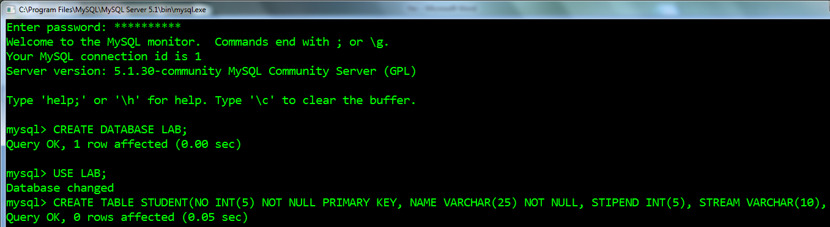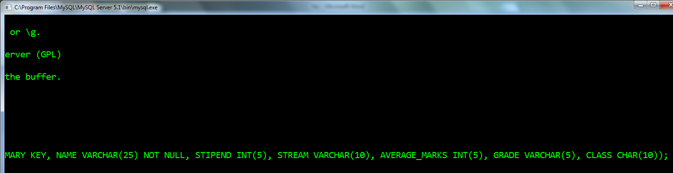

b)  
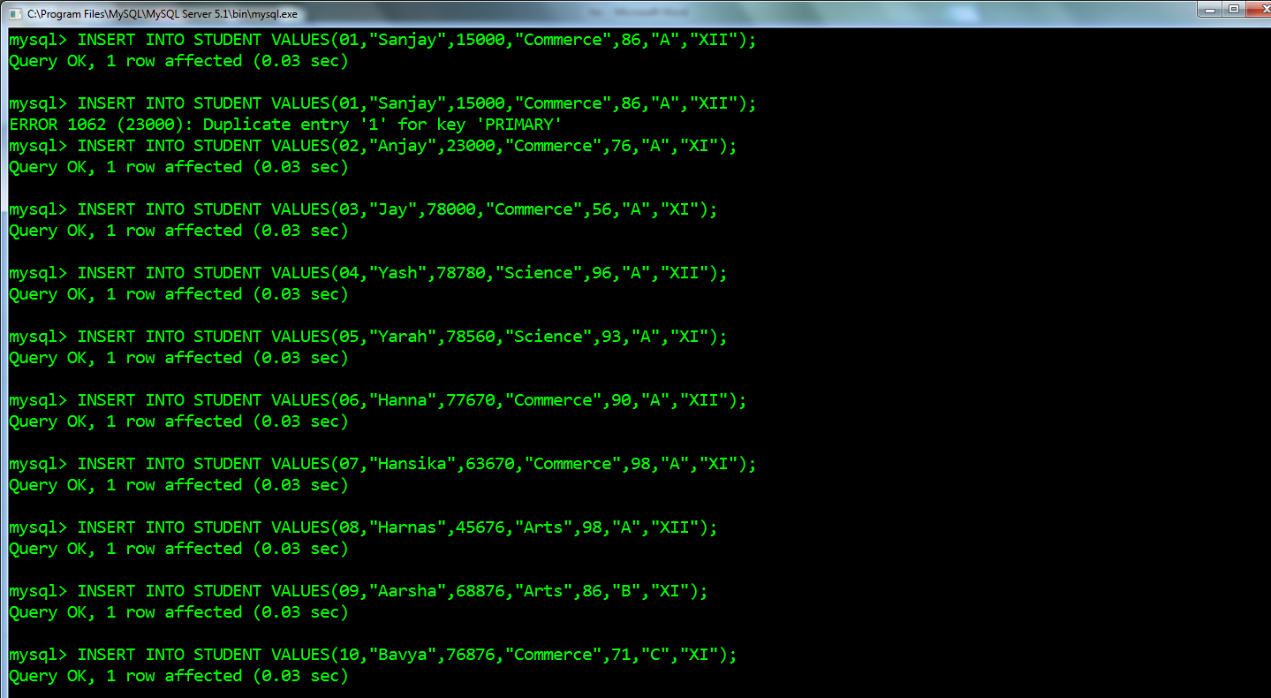

c)

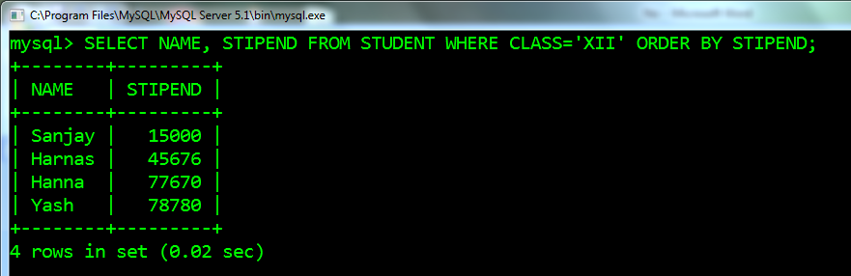

d)

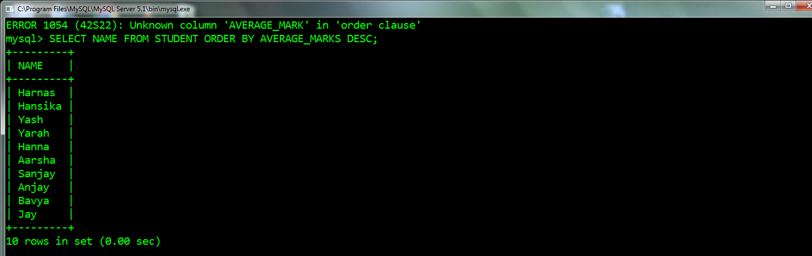

e)

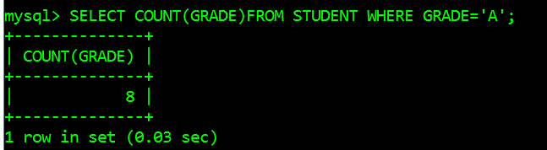

f)

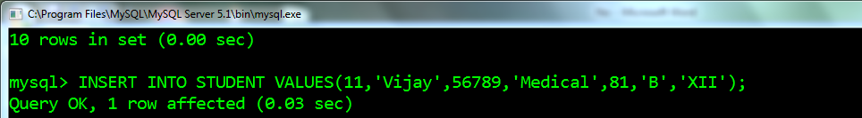

g)

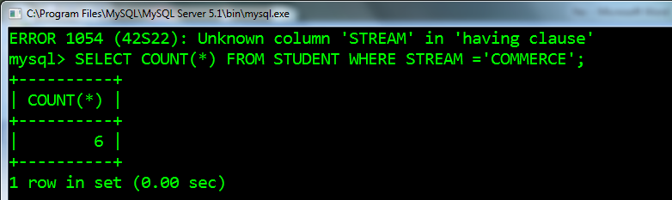

h)

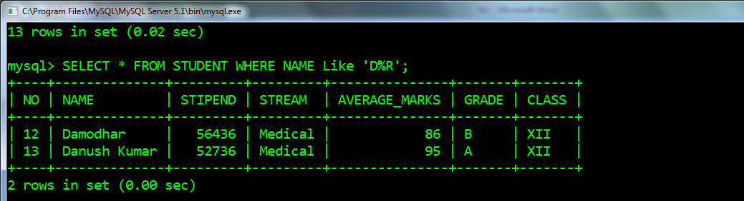

i)

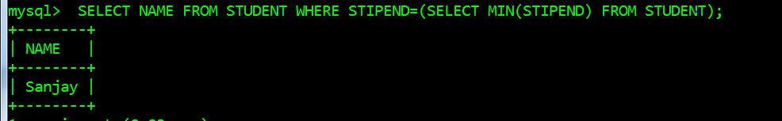

j)

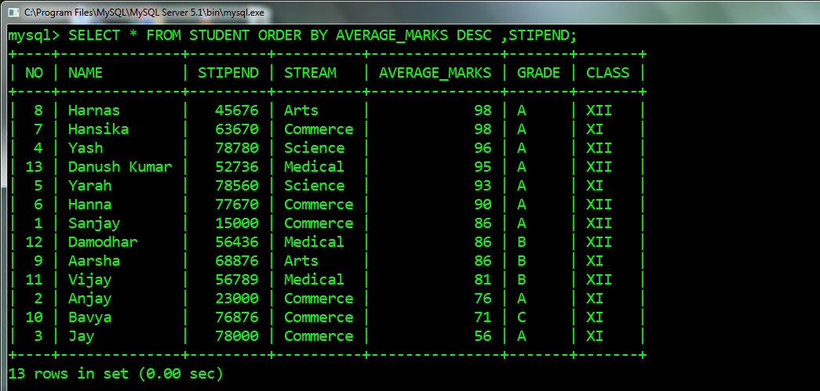

k)

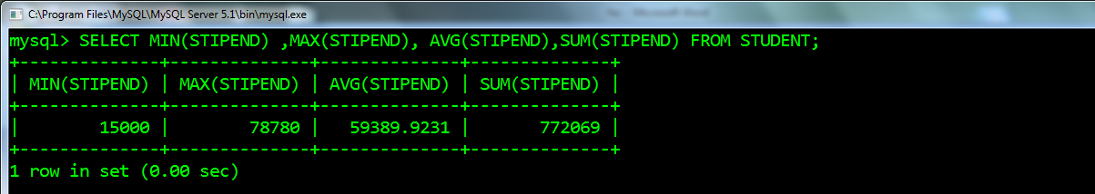

l)

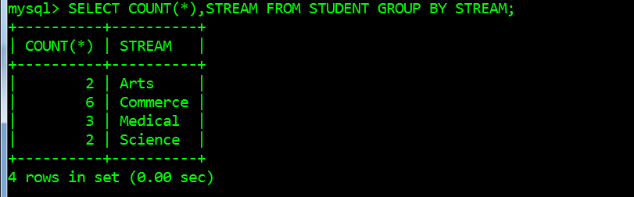

m)

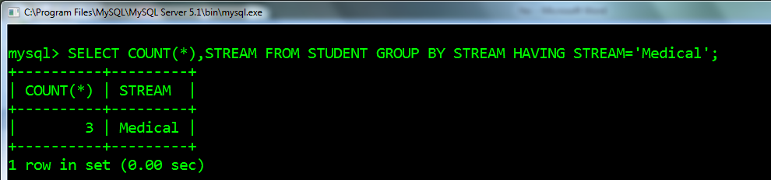

n)

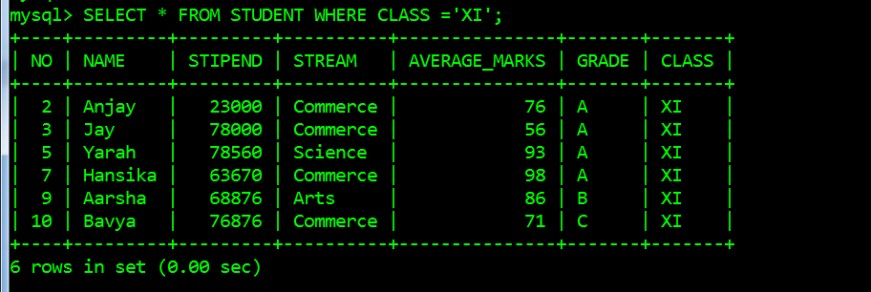

o)

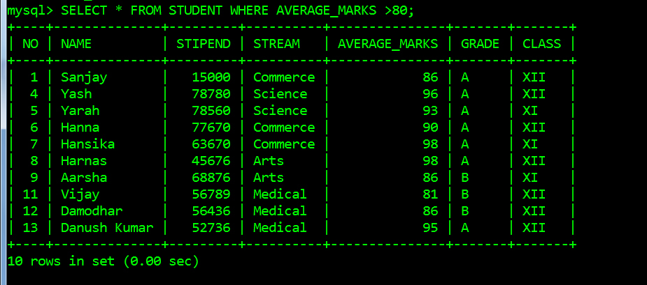

***No****: 2*

***Date****:26/10 /2022*

***Program:***

**Consider the table below and answer the questions:**

|  |  |  |  |  |  |  |
| --- | --- | --- | --- | --- | --- | --- |
| S.NO | TITLE | AUTHOR | TYPE | PUB | QTY | PRICE |
| 1 | Data Structure | Lipshutz | DS | Mcgraw | 4 | 217 |
| 2 | Computer Studies | French | FND | Galgotia | 2 | 75 |
| 3 | Advanced Pascal | Schildt | PROG | Mcgraw | 4 | 350 |
| 4 | D Base Dummies | Palmer | DBMS | PustakM | 5 | 130 |
| 5 | Mastering C++ | Guerewish | PROG | BPB | 3 | 295 |
| 6 | Guide Network | Freed | NET | Zpress | 3 | 200 |
| 7 | Mastering Fox Pro | Seigal | DBMS | BPB | 2 | 135 |
| 8 | DOS Guide | Norton | OS | PHI | 3 | 175 |
| 9 | Basics of Beginners | Norton | PROG | BPB | 3 | 40 |
| 10 | Mastering Windows | Cowart | OS | BPB | 1 | 225 |

1. Select all the PROG type published by BPB from the table.
2. Display a list of all books with price more than 130 and sorted by Qty.
3. Display all books sorted by price in ascending order.
4. Display report, listing book title, current value and misplacement charges for each book.
5. Count the number of books in the table.
6. Insert a new book in the table. Fill all the columns with values.
7. Give the output of the SQL commands:-
8. SELECT MIN(PRICE) FROM LIBRARY WHERE PRICE<150;
9. SELECT AVG(PRICE) FROM LIBRARY WHERE QTY<3;
10. SELECT COUNT(DISTINCT PUB) FROM LIBRARY;

***Source Code and Output***

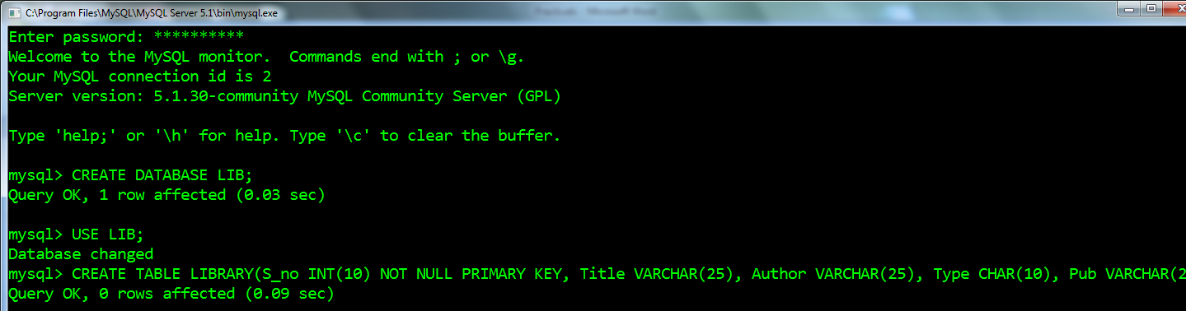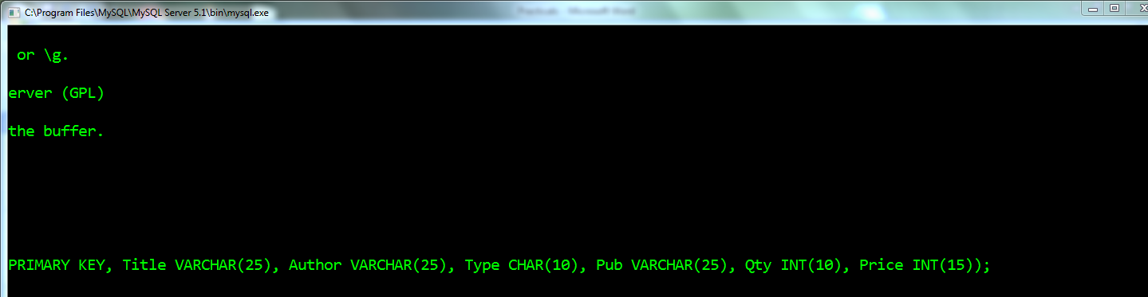

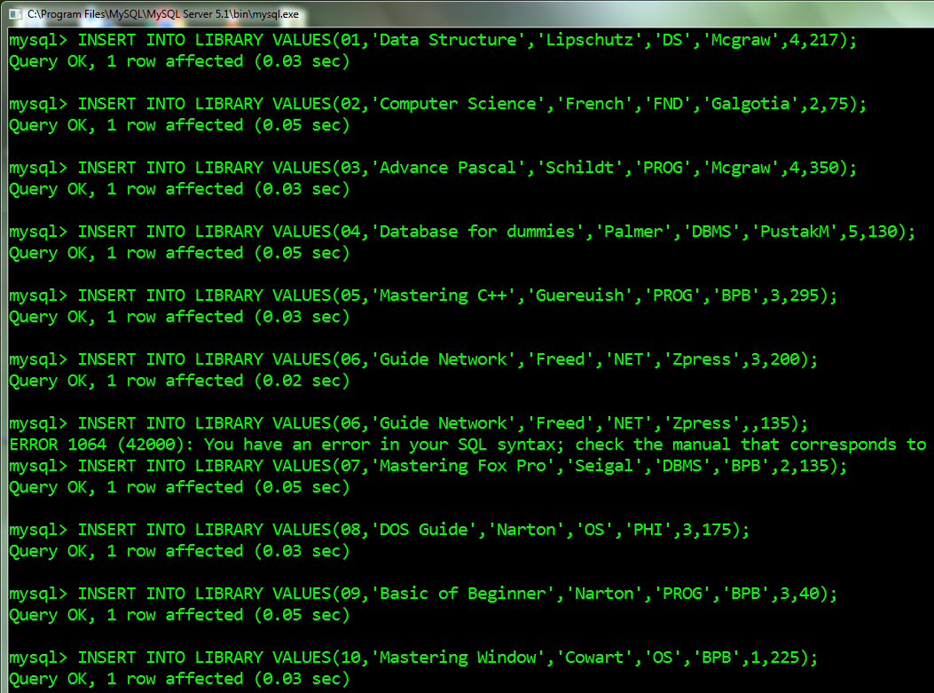

a)

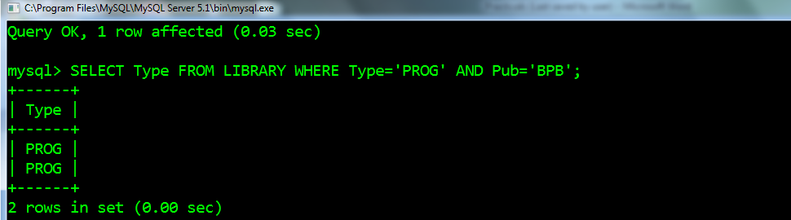

b)

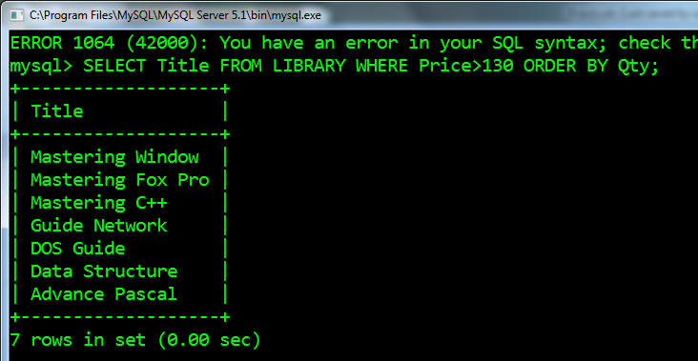

c)

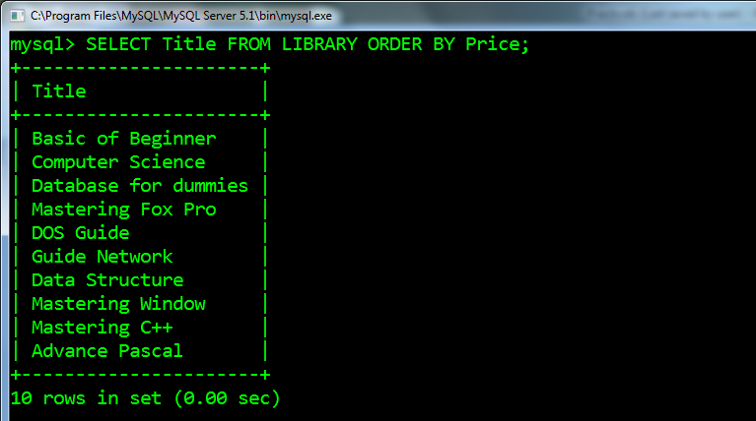

d)

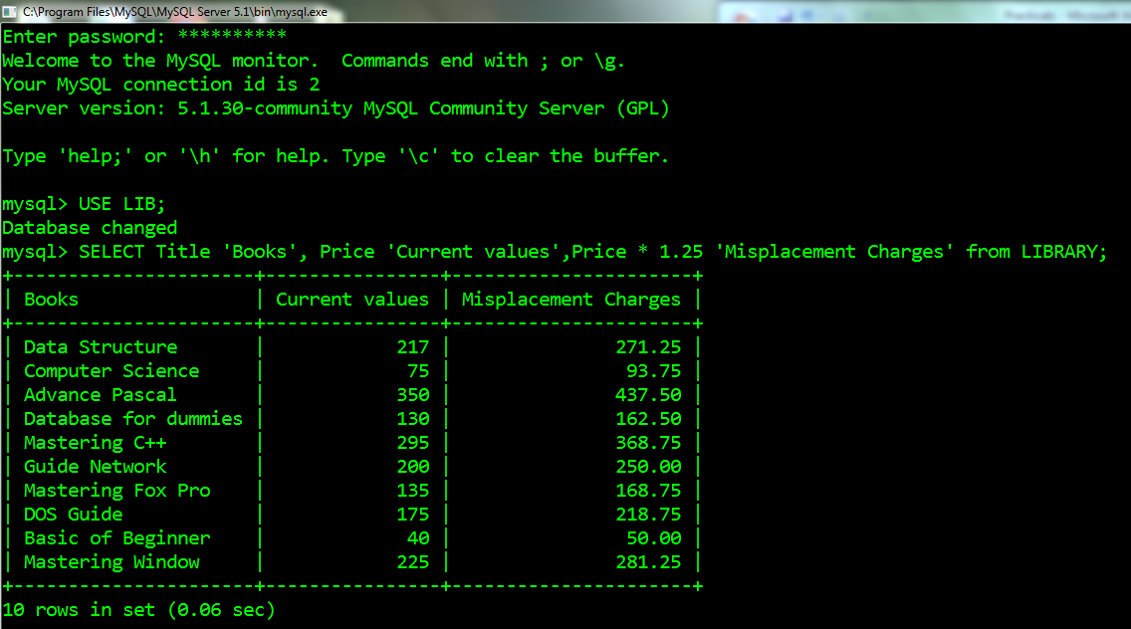

e)

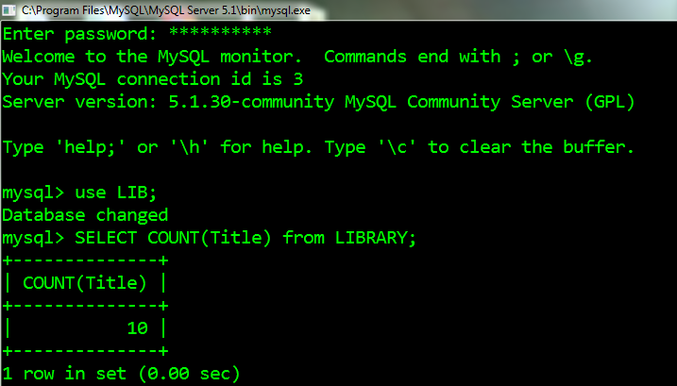

f)

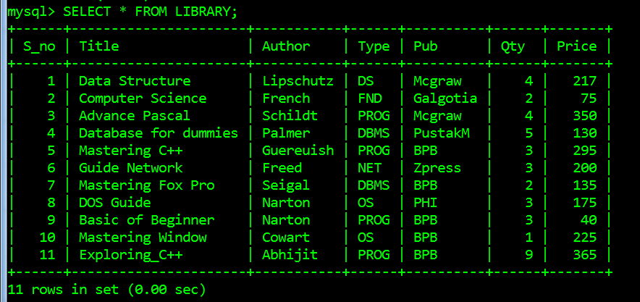

g)

i)

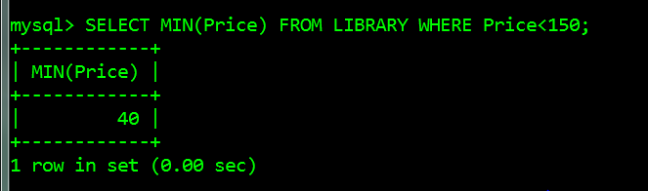

ii)

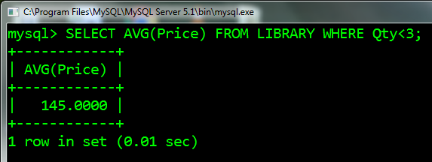

iii)

