**The Use of Technology to Treat Agoraphobia**

COMM1130 Section 16S

Prepared By: Nicole Dahlquist - 6817019

Prepared For: Tom Leslie

Date: July 31, 2016

**Abstract**

The following is a feasibility report on the use of technology as a treatment for agoraphobia. This report looks at agoraphobia and the necessity of its treatment. The intended audience for this report is primarily psychologists, however, it may also appeal to people with agoraphobia, and virtual reality engineers. The positive relationships between agoraphobia and technology will be assessed, and include technology as an aid and as a treatment. The negative relationships will also be examined; they include technology as a trigger and as an enabler. The feasibility of the use of technology as an entire treatment is not assessed, but it is definitely feasible as a tool to be used in traditional treatments.

**Table of Contents**

Introduction……………………………………………………………………………………………………………………………p.1

History……………………………………………………………………………………………………………………..…p.1

Background…………………………………………………………………………………………………………………p.1

Discussion……………………………………………………………………………………………………………………………….p.2

Technology as an Agoraphobia Trigger……..……………………………………………….……………….p.2

Availability Heuristic…………………………………….………………………………………………….p.2

Technology as a Cause of Stress…………………………………..………………………………….p.3

Technology Aids and Enables People with Agoraphobia…………………………………………..…p.4

Technology as an Aid…………………………………………………………………….……………..…p.4

Technology as an Enabler………………………………………………………………………………..p.5

Technology as a Treatment for Agoraphobia………………………………………………………………p.6

Traditional (Non-Technological) Treatments……………………………………………………p.6

GPS as a Monitoring Device…………………………………………………………………………….p.7

Virtual Reality and Skype Treatments…………………………………………………….……….p.7

Conclusion……………………………………………………………………………………………………………………………..p.9

References…………………………………………………………………………………………………………………………..p.10

**Table of Illustrations**

Acute Stress Symptom Figure 1……………………………………………………………………………………………...p.3

Virtual Reality Scenarios Figure 2…………………………………………………………………………………………...p.9

**The Use of Technology to Treat Agoraphobia**

**Introduction**

Agoraphobia is a debilitating mental illness that causes its sufferers to live trapped within their own homes. Agoraphobia and technology have a multi-faceted, agathokakological relationship. This paper examines the feasibility of using technology to treat agoraphobia. A brief history and background on agoraphobia will be presented to give context. Next several aspects of the relationship between technology and agoraphobia will be discussed, including: technology as a trigger, technology as an aid and enabler, and possibilities for technology-driven treatment.

**History**

Agoraphobia is a mental illness; it is categorized as an “anxiety disorder in which you fear and often avoid places or situations that might cause you to panic and make you feel trapped, helpless or embarrassed” [1]. “The fears can be so overwhelming that you may feel unable to leave your home” [1]. The Mayo Clinic Staff [1] explains that “people with agoraphobia often have a hard time feeling safe in any public place, especially where crowds gather” and that they “may feel that [they] need a companion, such as a relative or friend, to go with [them] to public places”. People with agoraphobia face many challenges in their day to day lives.

**Background**

The challenges that people with agoraphobia face are the reasons why intervention is necessary. “Agoraphobia can severely limit your ability to socialize, work, attend important events and even manage the details of daily life, such as running errands” [1]. Being unable to function normally can take a toll on one’s mental health and can “…lead to or be associated with: depression, other mental disorders, including other phobias and other anxiety disorders, alcohol or drug misuse to try to cope with the fear, guilt, hopelessness, isolation and loneliness” [1]. The issues that can arise when suffering from agoraphobia make treatment important.

The main psychotherapy treatments for agoraphobia are based around the sufferer having to face his/her fears. Frequent exposure to his/her fears can help “…change unwanted or unhealthy behaviors through desensitization, also called exposure therapy…” [1]. During exposure therapy a patient with agoraphobia should find that his/her “… anxiety gradually decreases if [he/she] remain[s] in public and [he/she] can manage those symptoms” [1]. Psychologists, people with agoraphobia and virtual reality engineers should be interested in upcoming technologies that allow people with agoraphobia to face their fears in a safe environment. The relationship between agoraphobia and technology is much more complex than the single-facet of being able to treat agoraphobia with technology.

**Discussion**

People interact with technology every day. It is no wonder then that technology can have an effect on them. Like most things, there is good and bad in the relationship between technology and agoraphobia. It is important to understand how agoraphobia can be triggered, in order to fully appreciate this illness.

**Technology as an Agoraphobia Trigger**

Agoraphobia can be triggered by any variety of things. A trigger for one person may not be a trigger for another. The one thing all agoraphobia triggers have in common is that they cause fear. The reason that agoraphobia gets triggered in a person can be related to his/her use of the availability heuristic.

**Availability Heuristic**

A heuristic is a technique for quick estimation based on previous knowledge that we have gained. Extending a basic heuristic, “a person is said to employ the availability heuristic whenever he estimates frequency or probability by the ease with which instances or associations could be brought to mind” [2]. It has been found that “…frequent events are easier to recall or imagine than infrequent ones” [2]. If a person becomes preoccupied with an event, then the event becomes easier to recall. The person may then, in effect, subconsciously convince themselves that the event on which they have been thinking has a higher likelihood of occurring than it actually does [2]. Technology can skew our use of the availability heuristic.

As technology improves our world becomes smaller. Television and internet can bring information from all over the world into our homes. Silver, et al. [3] suggest that “widespread media coverage extends the boundaries of local disasters, transmitting their impact far beyond the directly exposed population and turning them into collective traumas with potentially detrimental health effects”. Due to our reliance on the availability heuristic “mass media may become a conduit that spreads negative consequences of community trauma beyond directly affected communities” [3]. As such, these technologies can cause people to believe that they are likely to experience the events that they have seen or read about, even if it is entirely unlikely.

**Technology as a Cause of Stress**

Technology has increased the availability of information. When newspapers were the only source of news the general population was unlikely to hear news from very far away. Television brought news into the home once or twice a day for an hour, featuring mostly local news with highlights of the most important news from the world. The advent of the internet made news available 24/7 from all across the world, which allowed people to find as much information on a certain event as they wished. Frequent exposure to negative newscasts can cause stress because of the availability heuristic.

The news often presents negative events the most frequently, and “…repetitive showing of traumatic clips and images that are likely to be displayed on news outlets…” [4] can alter our thinking based on the availability heuristic. It was found that “…watching, reading, or listening to the news may cause people greater stress and anxiety” [4]. Furthermore, “repeatedly engaging with trauma-related media content for several hours daily shortly after collective trauma may prolong acute stress experiences and promote substantial stress-related symptomatology” [3], as illustrated in Figure 1.

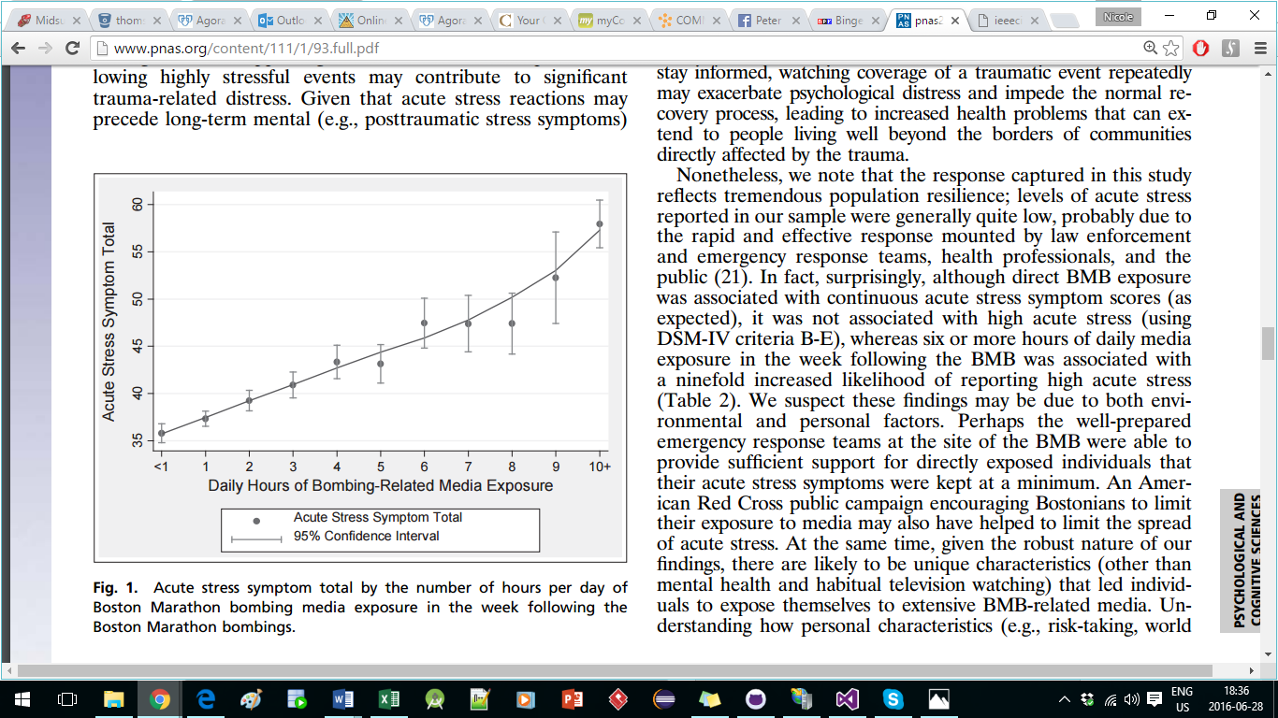

Figure 1. Acute Stress Symptom total as related to hours of news broadcast

exposure in the week following a traumatic event. [3]

Silver, et al. [3] studied stress levels after the Boston marathon bombing and found that “repeated bombing-related media exposure was associated with higher acute stress than was direct exposure” [3]. While “both live and video observation of threatening content can lead to fear conditioning” [3], those people that had previous similar experiences or became preoccupied with following the event were particularly susceptible to suffering from acute stress [3]. The stress caused by this technology-induced negativity overexposure can have serious consequences.

Agoraphobia is a fear-based anxiety disorder [1] and these fears can be triggered by a variety of activities, such as watching the news [2][3]. It has been established that “… experiencing stressful life events, may play a major role in the development of agoraphobia” [1], and as stated by Silver et al. [3], these stressful life events do not need to be witnessed live to elicit a stress response. They also indicated that “…acute stress reactions may precede long-term mental (e.g., posttraumatic stress symptoms) … health ailments…” [3], such as agoraphobia.

In essence, technology can skew our use of the availability heuristic, making us more susceptible to stressors in our environment. Technology can also cause stress, if we repeatedly expose ourselves to things like negative news programs. Stress can lead to anxiety and anxiety can lead to agoraphobia; thus, technology can trigger agoraphobia. Technology in and of itself is not blame, of course; the issue lies in how we use it. Technology can also be used to help people with agoraphobia function, but this is not without its side effects.

**Technology Aids and Enables People with Agoraphobia**

Most things either aid or enable something, not both. For example, ignoring an alcoholic’s drinking enables them to continue being an alcoholic; you would never say that this behavior is aiding the alcoholic. The same is not true about agoraphobia, where aiding a person with agoraphobia to fully function from home also enables them to remain agoraphobic.

**Technology as an Aid**

People with agoraphobia often have trouble leaving their house, or need someone to accompany them to provide support. Technology, such as the internet, provides a way for people with agoraphobia to function without leaving home [5] [6]. Many jobs are able to be done from home [5] [6] with online access and a remote desktop. Anyone can order the necessities of life online and have them delivered to your door including, but not limited to: groceries, restaurant food, books and many household items [5] [6]. Previously, people with agoraphobia would need to rely on friends or family to acquire these items, or accompany them while they shopped. Not only can the internet provide physical necessities, but it can also help people with agoraphobia socially and emotionally.

The internet has allowed for improved support for many mental illnesses, including agoraphobia. “Day or night, sufferers can now connect instantly with others like themselves in forums and social media groups all around the world, who can offer advice and emotional support” [7]. People, including those with agoraphobia, “…now have the ability to access information from health organizations, doctors and medical researchers on a global scale” [7]. In addition to improved support, mental health issues have reaped the benefits of increased awareness, brought about by the internet; “through these new media channels, mental health has become a hot topic, with charities and other organisations reaching out to the public to raise awareness and to educate” [7]. Bennet [7] notes that “it has empowered a great many people, and allowed them to take control of their health and their lives. It has connected people in a way that would otherwise have been impossible.” While these improvements have helped people with agoraphobia to cope, they do not necessarily help them to improve.

Improvements in technology has allowed the creation of “Pokémon Go”, a smartphone game in which players must walk around outside to collect cute cyber animals. Reddit user AwkwardArley [8] stated that “Pokémon Go” has given him a reason to leave the house and explore the area he has lived in for five years, but has barely seen. He continued to say that he “… was genuinely excited to be outside, even if [he] wasn't interacting with that many people” [8]. With “Pokémon Go” being a newly released game, it is possible that AwkwardArley was previously using technology to survive without leaving the house.

**Technology as an Enabler**

Advances in technology may enable people with agoraphobia to avoid their fears, by remaining indoors. Stobing [6] states that “thanks to the Internet, activities like ‘going outside’ or ‘being a productive member of the community’ are becoming increasingly optional parts of daily life.” He goes on to say that entertainment is available at home, because “…online streaming services like Netflix, Hulu Plus, and Amazon Prime have massive catalogs of movies, TV shows, and original programming” [6]. Leadbetter [5] adds that “…you can download books, and films, and music direct to your smartphone or tablet without leaving the house”, and people are “…using FaceTime or Skype to communicate with the outside world” [5]. As technology has allowed people to function more fully at home, it has enabled people with agoraphobia.

It is interesting that the very thing that helps people with agoraphobia to survive may also be the same thing keeping them from thriving. If people with agoraphobia don’t face their fears, they will never recover. It would be challenging for people with agoraphobia to give up the technology that helps them manage on a daily basis and force themselves to get treatment. Treatment of agoraphobia is not always easy, but technology has brought improvements in this area as well.

**Technology as a Treatment for Agoraphobia**

There may be no technological treatments for agoraphobia at this time that could completely replace traditional treatments. However, traditional treatments for agoraphobia have obstacles to overcome in order to be effective; they are also not all without side effects. Technology can help overcome some of the obstacles that are found in traditional treatments, allowing for easier treatments and better outcomes.

**Traditional (Non-Technological) Treatments**

Traditionally, “antidepressant and anti-anxiety medications are often used to treat agoraphobia and panic symptoms that frequently accompany agoraphobia” [1]. However, these medications “can have emotional and behavioral side-effects” [7]. I have personally experience that “both starting and ending a course of antidepressants can cause side effects that seem like a panic attack” [1]. Because of the side effects, these medications are not suitable for some people. These people may turn to natural remedies such as “…the herbal supplement called kava [which] appeared to be a promising treatment for anxiety, but reports of serious liver damage — even with short-term use — caused several European countries and Canada to pull it off the market” [1]. In conjunction with, or in place of, medications many people with agoraphobia will receive counselling.

“Also known as talk therapy or psychological counseling, psychotherapy involves working with a therapist to reduce your anxiety symptoms. Cognitive behavioral therapy is one of the most effective forms of psychotherapy for anxiety disorders, including agoraphobia” [1]. However, “If you have agoraphobia, you may be too afraid or embarrassed to go to your health care provider's office” [1]. Treatment is important and people with agoraphobia may “want to take a trusted relative or friend to your appointment who can offer comfort and help, if needed” [1].

Talk therapy is a start, but an important treatment for agoraphobia involves the facing of fears.

In addition to talk therapy, the counsellor will likely recommend that people with agoraphobia start to increase their time outside and go places that they normally feel like they cannot go; this treatment is referred to as exposure therapy [1]. Exposure therapy helps because “…practicing going to more and more places can make them less frightening and anxiety provoking” [1].This type of “agoraphobia treatment can be challenging because it usually means confronting your fears” [1]. One drawback with exposure therapy is that the experience may cause a panic attack because it is too overwhelming. Moreover, it is difficult to know how much exposure the patient is getting, if any.

**GPS as a Monitoring Device**

So far it has been shown that technology can trigger agoraphobia and enable people with agoraphobia, but it can aid them, as well. It is important to examine whether it would be feasible to treat agoraphobia with technology. Because “self-report methods can be subject to memory distortions, influenced by social desirability in all of its forms, and, like direct observational methods, highly reactive” [9], a method of tracking a patient would give a counselor reliable data to work with.

A counsellor may want to use GPS to “record the number of places a person visited over a given time” [9]. Wolf and Jacobs [9] suggested that “the use of GPS technology… increases the researcher[’s] ability to gather some forms of real-time naturalistic data unobtrusively and without the memory distortions, demand characteristics, and reactivity often introduced by self-report”. They examined GPS-monitored exposure therapy and determined that “GPS technology provides outcome measures that may relate to the outcome of interventions designed to treat psychological disorders that, for example, may leave a person homebound (e.g. Agoraphobia, PTSD, TBI)” [9]. Before a patient with agoraphobia can begin this type of therapy he/she needs to be able to see a counsellor.

**Virtual Reality and Skype Treatments**

People with agoraphobia may find it difficult to leave their house to attend a counselling session; they may find it easier using technology to communicate with their counsellor than having face-to-face meetings, especially at the beginning of treatment. Some counsellors may offer talk therapy over different technologies, including “…over the phone, through email, or using computer programs or other media” [1]. Skype is a technology that would allow counsellors and patients to communicate in a quasi-face-to-face manner, providing a realistic feel that allows for the interpretation of body language and facial expressions. Once a person with agoraphobia is able to obtain talk therapy, the counsellor can recommend steps to follow for exposure therapy.

If a patient has difficulty leaving his/her house for talk therapy, it is entirely likely that he/she will not feel able to leave his/her house for exposure therapy. Martin, et al. [10] found that “…20% to 25% of participants reject [in vivo](http://topics.sciencedirect.com/topics/page/In_vivo) exposure because they find it too aversive to confront the feared situations.” Virtual reality can provide exposure therapy to patients who are not at a stage that they feel able to face real-life fears. Martin, et al. [10] explained that “VR enacts a safe environment for the patient to explore the problem and practice using therapeutic tools in the consultation room.” These researchers found that they were able to tailor the virtual reality experience to individual patients and create a feeling similar to that of tradition exposure therapy [10]. If these virtual reality experiences are able to elicit the same response from a patient as they would feel when they are facing a fear in real-life, then they could potentially be invaluable in the treatment of agoraphobia.

Research on virtual reality treatments thus far has suggested that this type of treatment is viable. Martin, et al. [10] found that “…VR is a useful tool that allows for a high degree of control over virtual situations.” Not only were they able to simulate a specific scenario, but they could also simulate “…bodily sensations like shortness of breath, blurred vision, or palpitations while the patient is immersed in a virtual agoraphobic situation…” [10], as seen in Figure 2. Overall they found that “the results showed an important reduction in all clinical measures after treatment with virtual exposure and the patient reached the therapeutic goals established during the pretreatment assessment” [10]. These findings show that virtual reality treatments may be the most important technological advancement for the treatment of agoraphobia.

Traditional treatments fall somewhat short of the mark for treating agoraphobia, because of side effects or an inability to get the patient to follow through with the treatment. Technology can fill some of these gaps, allowing counsellors to treat patients in their homes, monitoring patients’ progress and providing a safe environment to practice facing their fears. Overall, improvements in technology are a boon to people suffering with agoraphobia.

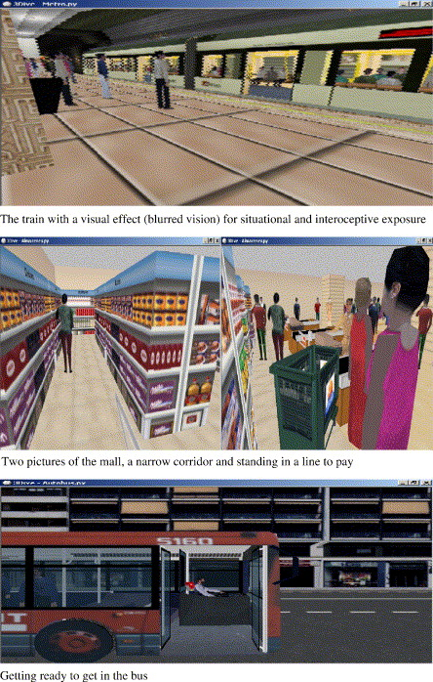

Figure 2. Virtual reality scenarios that simulate fear-inducing real-life situations

used in exposure therapy for agoraphobia [10].

**Conclusion**

Agoraphobia and technology intersect at several points. Technology that causes stress may lead to agoraphobia. Technology can help people who suffer from agoraphobia to function more easily at home. In contrast, the same technologies that help people function from home also enable those people to continue on without treatment. As this paper has shown, certain technologies can aid in the treatment of agoraphobia. It is feasible to use technology as supporting tools during traditional treatments, but not as a standalone treatment. In conclusion, understanding the relationship between agoraphobia and technology is important for the prevention, support and treatment of agoraphobia.

**References**

1. Mayo Clinic Staff, "Agoraphobia," [Online]. Available: http://www.mayoclinic.org/diseases-conditions/agoraphobia/basics/definition/con-20029996. [Accessed 25 June 2016].

2. A. Tversky and D. Kahneman, "Availability: A heuristic for judging frequency and probability," September 1973. [Online]. Available: http://people.umass.edu/biep540w/pdf/Tversky%20availability.pdf. [Accessed 03 July 2016].

3. E. Silver, D. Holman and R. Garfinb, "Media's role in broadcasting acute stress following the Boston Marathon bombings," November 2013. [Online]. Available: jttp://www.pnas.org/content/111/1/93.full.pdf. [Accessed 28 June 2016].

4. "Traumatic events in the new causes spikes in stress," July 2014. [Online]. Available: https://www.anxiety.org/news-increases-stress. [Accessed 28 June 2016].

5. R. Leadbetter, "Why you never need to leave your house again (except in a medical emergency)," June 2016. [Online]. Available: http://www.heraldscotland.com/news/14566288.Why_you_never_need_to_leave_your_house_

again__except_in_a_medical_emergency_/. [Accessed 25 June 2016].

6. C. Stobing, "How to Use the Internet to Never Leave Your House Again," June 2015. [Online]. Available: http://www.howtogeek.com/216828/how-to-use-the-internet-to-never-leave-your-house-again. [Accessed 28 June 2016].

7. J. Bennett, "A Broken Utopia? The Internet and Health Activism," April 2015. [Online]. Available: http://davidhealy.org/a-broken-utopia-the-internet-and-health-activism/. [Accessed 11 July 2016].

8. AwkwardArley, "Pokemon Go Stories," July 2016. [Online]. Available: https://www.reddit.com/r/PokemonGoStories/comments/4s6h46/a_legitimate_reason_to_leave

_my_house/. [Accessed 14 July 2016].

9. P. Wolf and J.Jacobs, "GPS Technology and Human Psychological Research: A Methodological Proposal," 2010. [Online]. Available: https://www.researchgate.net/profile/Pedro_Wolf/publication/232075531_GPS_Technology_and_

Human_Psychological_Research_A_Methodological_Proposal/links/09e4150757bbbe30f3000000.pdf. [Accessed 25 June 2016].

10. H. V. Martin, C. Botella, A. Garcia-Palacios and J. Osma, "Virtual Reality Exposure in the Treatment

of Panic Disorder With Agoraphobia: A Case Study (Vol 14)," January 2007. [Online]. Available: http://ra.ocls.ca/ra/login.aspx?inst=conestoga&url=http://search.ebscohost.com.eztest.ocls.ca/login.aspx?direct=true&db=edselp&AN=S1077722906001271&site=eds-live&scope=site. [Accessed 10 July 2016].