**Definition of a Bra**

**COMM1130 – Nicole Dahlquist**

If the average woman owning nine bras [1] seems excessive, then perhaps you are not well enough acquainted with the virtues of the bra. The modern-day brassiere, or bra, is an undergarment worn by women in order to support their breasts. In this paper, I will discuss several topics, which are important for fully appreciating the bra. In order to best define the bra, I will look at the etymology of the word and its evolution, as one must experience an item’s history to fully understand it. I will then compare and contrast items that are similar to, but are not, bras. Finally, I will label the parts of a bra pictorially and give an analysis of its parts. Through these avenues I hope that the reader will be able to come to understand the modern-day bra more fully.

The origin of the word bra and the history of the bra help to understand its existence. The word ‘bra’ is the short form of the French word brassière, which means “woman’s bodice” [2]. Bras evolved from corsets, which were worn from the 14th to 19th centuries [3] and functioned to cinch the waist and lift the breasts. In the 19th century a split corset, the corselet-gorge, was introduced; it did not cinch the waist as the previous corset had [3]. The top-half of the corselet-gorge, or the soutien-gorge as it is still called in France today, supported the breasts and was held in place by shoulder straps. This top-half was sold by itself and became known as a brassiere [3]. Physicians, feminists and the metal shortage caused by World War I are attributed with the switch from corsets to brassieres [3].

In order to define the modern-day bra it is important to distinguish it from other similar items. A bra is not a bikini top, nor a corset, nor a bodice. A bikini top is similar to a bra, in that it covers the breasts and does up at the back, however it is not fully supportive and is not worn as an undergarment. A corset covers the breasts and provides support, but also covers and cinches the waist. A bodice is similar to a bra because it covers the breasts and provides supports, but it is worn on the outside of a woman’s clothing and similar to a corset it covers the waist, but without cinching it.

There are various types of bras in existence, and while they differ in shape, fit, and functionality the main components remain the same. Common bra types include front closure, back closure, strapless, nursing and sports bras. Figure 1 demonstrates the parts of a back closure bra [4], which I will now discuss. The front of the bra is made mostly of the **cups**, which cover the breasts; the cups may or may not contain a piece of metal **underwire**, which is set in a **channel**, based on the wearer’s preference. In nursing bras, the cups clip onto the **shoulder straps** and can be unclipped and pulled down to nurse an infant. The cups are separated by a small piece of fabric called the **center front gore**, which would be replaced by clasps in a front closure bra. The **neckline** is formed by the inner edges of the cups and can vary widely in width and depth; different necklines are preferred under different styles of tops. The **apex** of each cup attaches to a shoulder strap, which runs over the shoulder to the back of the bra. The shoulder straps are adjustable using the **sliders**, which can be found at either the front or back of both straps. Strap **rings** form a joint between the front and back straps to help alleviate stress caused by differences in elasticity between the two straps. The straps provide the majority of the support; in strapless bras the straps are removed and the bra is held in place by a rubber strip that runs the inside of the bra and sticks slightly to the skin. The **wings** are strips of fabric that run from the bottom lateral edges of the cups around the ribcage where they join at the back with the straps before ending at the

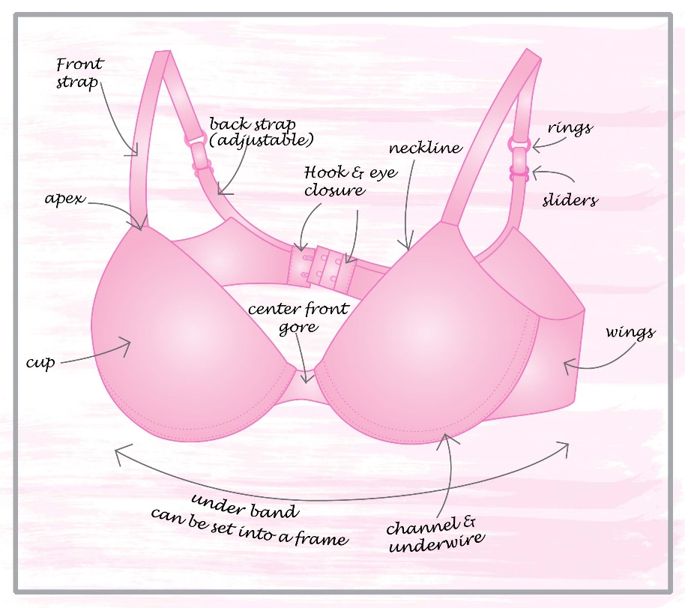

Figure 1. Labeled parts of a back closure bra.

**hook & eye closure** area. The hooks clip into the eyes to close the bra. Sports bras do not have hook and eye closures or defined cups, they are often tighter to help keep the breasts from bouncing during vigorous activity.

**Conclusion**

In conclusion, though the modern-day bra is often deemed uncomfortable and a burden, it is arguably leaps and bounds better than its predecessors. Its development has a long history that is often related to various social aspects [3]. While many women find the support it provides invaluable, others are happy to do without. It is probably safe to say that the bra will be around for a long time to come.

**References**

1. C. Lin. (2012, July 10). *SkinMag*. [Online]. Available: http://www.skinmagonline.com/sg/2012/07/intimate-secrets-10-surprising-bra-stats-you-need-to-know/. Accessed: May 31, 2016

2. "brassiere", *The Oxford Canadian Dictionary*. Oxford University Press, Don Mills, ON, p. 170, 2001.

3. *History of Bras.* [Online]. Available: https://en.wikipedia.org/wiki/History_of_bras. Accessed: May 31, 2016.

4. [Online]. Available: http://vignette2.wikia.nocookie.net/bustyresources/images/b/bb/Anatomy-of-a-bra.jpg/revision/latest?cb=20120810014622

5. *Ring, Slide and Hook.* [Online]. Available: https://en.wikipedia.org/wiki/Ring,_slide_and_hook. Accessed: June 3, 2016