**Description of the Modern-Day Back-Closure Bra**

Going bra-less or wearing improperly fitting bras can lead to numerous pains across a woman’s upper torso [1][2]. There are many styles of bras to suit the preferences of the wearer, and the multitude of shapes of the female body. The modern-day bra is the ideal device for supporting breasts. In this paper, I will describe the modern-day back-closure wireless (soft cup) bra, discuss the various parts and their functions, and illustrate how a bra operates.

**Description of the Modern-Day Back-Closure Bra and Its Component Parts**

**General Description**

The bra is a cloth undergarment that covers and supports the breasts. While the bra varies in cup-size and band width (measurement around the ribcage below the breasts), based on the wearer’s size, it is relatively small in comparison to its predecessor the corset [3]. A bra weighs less than one pound. It is often made from a blend of materials, which can include: spandex, microfiber, satin, cotton, polyester, and lace [2]. The fabric is flexible, which makes it easy to put the bra on and makes the bra less likely to suffer damage from frequent usage. Bras provide support either by encapsulation (molded cups) or compression (press the breasts against the body) [4]. The modern-day bra is made up of several small parts and sections that work together to provide support to the breasts.

**Image of Device**

Figure 1 demonstrates the parts of a soft-cup back-closure bra [5]. This image labels the most important parts of this bra. Each labeled part either has a role in allowing the bra to stay in place, or in supporting the breasts. There are no extraneous parts, which suggests that the bra is an efficiently designed device.

Figure 1. Labelled parts of a back-closure soft cup bra [5].

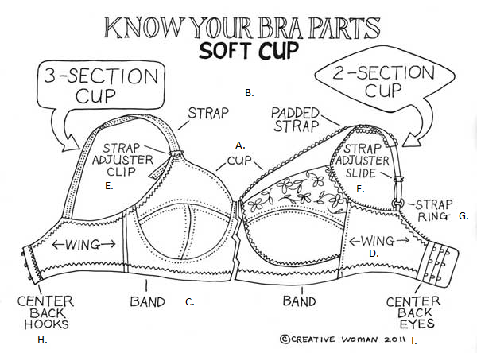

**List of major parts**

A: Cup

B: Strap/Padded Strap

C: Band

D: Wing

E: Strap Adjuster Clip

F: Strap Adjuster Slide

G: Strap Ring

H: Center Back Hooks

I: Center Back Eyes

**Description and Function of Parts**

**Cup.** Round in shape and concave, cups vary in size based on the size of the wearer’s breasts. The cups cover the breasts and provide support [2].

**Strap/Padded Strap.** Straps are fabric strips that are ~ ½ to 1” in width with an adjustable length; wider straps “distribute weight better than thin straps and provide more comfort” [6]. These straps run from the top of the cup, over the shoulder where they attach to the back of the bra below the shoulder blades. They function to help keep the bra in place and they may be padded for extra comfort.

**Band.** Starting at the hook section, the band runs all the way around the torso to the eye section. The band varies in thickness, based on the style of bra, and length (the numerical measurement on a bra size). The band, along with the cups, provide the majority of the support for the wearer’s breasts [2].

**Wing.** The wings are fabric sections that run from the bottom lateral edges of the cups around the ribcage, where they join at the back with the straps before ending at the hook & eye closure area. The wings form the bulk of the sides and back of the bra; they function to provide the length needed for the bra to encircle the wearer’s ribcage.

**Strap Adjuster Clip/Strap Adjuster Slide.** The shoulder straps are adjustable using either a) strap adjuster slides, which can be found at either the front or back on both straps, or b) a strap adjuster clips, which are located at the apex of the cups. These items can either be made of plastic or metal and their shape is shown in Figure 2 below.

**Strap Ring.** Strap rings form a joint between the front and back straps to help alleviate stress caused by differences in elasticity between the two straps [8]. Strap rings are small, round pieces of metal or plastic as shown in Figure 2 below.

**Center Back Hooks.** Most bras come with two to five hooks in the hook row, depending on the width of the wings and band. Each hook is a small piece of metal that is sewn into the fabric of the hook closure section, as shown in Figure 3 below. The hooks, together with the eyes, function to close the bra around the wearer’s torso.

**Center Back Eyes.** Most bras come with two to five eyes in each eye row, depending on the width of the wings and band. The number of eyes in each row matches the number of hooks in the center back hook closure area. There are usually two to three rows of eyes, which allows the wearer to adjust the size of the bra to fit her torso comfortably. Each eye is a small piece of metal that is sewn into the fabric of the eye closure section, as shown in Figure 3 below. The eyes, together with the hooks, function to close the bra around the wearer’s torso.

Figure 2. From top to bottom: Strap adjuster slides, strap adjuster clips, strap rings [7].

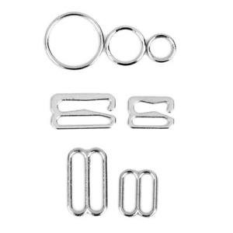

Figure 2. Center back hook closure section on the left, and center back eye closure section on the right [9].

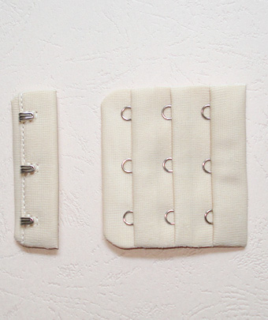

As you can see, the bra is made up of many small parts that work together to provide the proper fit and support for the wearer. Because they are worn and washed daily, bras have to be sturdy. The sturdiness of a bra is mainly provided by the materials from which it is made and the strap rings that alleviate tension in the shoulder straps. And because of this sturdiness, bras are able to be put on and taken off every day, sometimes several times a day.

**Operating Description**

1. The process begins when the bra cups are positioned on the breasts and the straps are over the shoulders.

2. The center back hooks and eyes keep the bra from coming undone during wear.

3. The band sits below the bottom of the breasts and its elasticity, in a properly sized and tightened bra, molds the bra to the ribcage to help maintain bra position and support the breasts [2].

4. The cups support the breasts either by encapsulation or compression [4] and provide relief from the pain caused by bouncing during vigorous movements.

5. The strap adjuster clips/slides need to be in the correct position so the shoulder straps are the appropriate length. The shoulder straps prevent the bra from slipping down the torso during movement. The strap rings relieve tension differences between the front and back shoulder straps when they are tight against the shoulders.

**Conclusion**

In conclusion, the bra is the ideal device for supporting women’s breasts. The bra is sturdy and flexible, which is important because of its frequent use. The bra is supportive, which alleviates the pain that women may suffer from going braless. Moreover, it is efficiently made, with no extraneous parts. Furthermore, it is built to adjust in size around the torso and along the shoulders, to allow for the most comfortable fit. Overall, the bra is a unique device that women are lucky to have.

**References**

1. L. Young. (2001, September). *The Importance of Correct Breast Support*. [Online]. Available: http://www.positivehealth.com/article/bodywork/the-importance-of-correct-breast-support. Accessed: June 7, 2016

2. *Bra*. [Online]. Available: https://en.wikipedia.org/wiki/Bra. Accessed: June 7, 2016.

3. *History of Bras*. [Online]. Available: https://en.wikipedia.org/wiki/History_of_bras. Accessed: May 31, 2016.

4. A. Casselman. (2005, November 22). *The Physics of Bras – Overcoming Newton’s second law with better bra technology.* [Online]. Available: http://discovermagazine.com/2005/nov/physics-of-bras. Accessed: June 7, 2016

5. [Online]. Available: http://www.wizardofbras.com/slideshow/parts/Bra_parts_1.jpg. Accessed: June 7, 2016

6. *How to Adjust Bra Straps*[Online]. Available: http://www.wikihow.com/Adjust-Bra-Straps. Accessed: June 7, 2016

7. [Online]. Available: http://i.ebayimg.com/images/g/R48AAOSw~gRVuYC0/s-l300.jpg. Accessed: June 7, 2016

8. *Ring, Slide and Hook*. [Online]. Available: https://en.wikipedia.org/wiki/Ring,_slide_and_hook. Accessed: June 3, 2016

9. [Online]. Available: http://www.mxinfa.com/upload/images/D003%23(1).jpg. Accessed: June 7, 2016