**Instructions for Operation**

I have personally heard men bemoan the difficulties they have in removing their partner’s bra. The key is practice, as any bra-wearing woman could tell you. The purpose of this paper is to provide step by step instructions for the operation of a soft cup back-closure bra. I will discuss the three major steps involved for wearing a bra (ie. putting on, adjusting and taking off), which are composed of three to eight steps each. No additional materials or tools are required. Each major step should take no longer than one minute.

**NOTE**

Steps are best executed when the upper torso is bereft of any clothing

**WARNING**

Wearing the incorrect size of bra can lead to upper torso pain [2][3].

**WARNING**

Wearing an improperly adjusted bra can lead to upper torso pain [2][3].

**Steps for Putting On a Soft Cup Back-Closure Bra (Hook and Spin Method) [1]**

**Step 1 Fasten around torso:**

1. Position the bra so that it is right-side out

2. Place against upper torso, below breast level

3. Wrap bra around torso, so the **hooks and eyes** (see Figure 1) are at the front of the body and the **cups** (see Figure 1) are at the back

Figure 1. Labelled parts of a back-closure soft cup bra. http://www.wizardofbras.com/slideshow/parts/Bra_parts_1.jpg

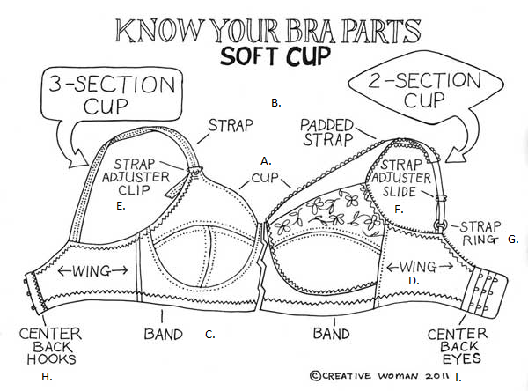

4. Pull eye and hook areas close together until bra feels snug

5. Clip hooks into nearest row of eyes, in order to maintain snug feeling (Figure 2, Picture A)

Figure 2. Putting on a back-closure bra with the hook and swivel method.

Picture A) Clip hooks into eyes, Picture B) Spin bra around until hooks and eyes are over the spine. https://img.buzzfeed.com/buzzfeed-static/static/2015-08/19/13/enhanced/webdr04/enhanced-11275-1440004295-1.jpg

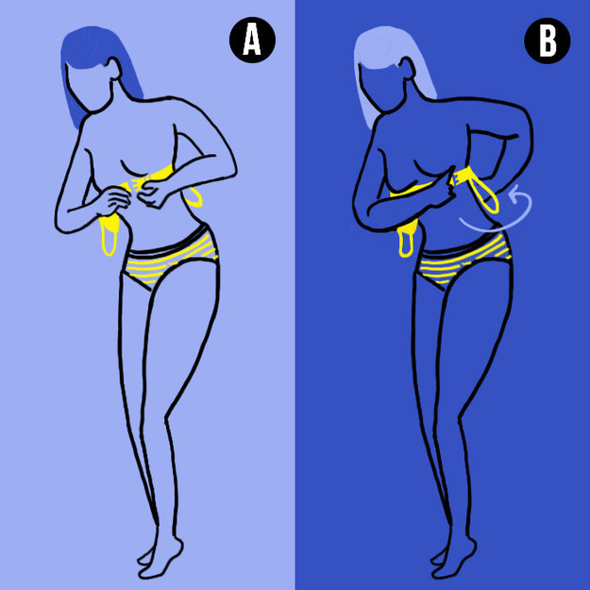

**Step 2 Position the bra:**

1. Spin bra around until the eyes and hooks that are clipped together are sitting over the spine (Figure 2, Picture B)

2. Pull bra up so the **band** (see Figure 1) is sitting just below the bottom of the breasts

3. Put arms into respective shoulder **straps** (see Figure 1)

4. Pull shoulder straps up onto shoulders

5. If they did not go into the cups during step 4, place each breast inside its respective cup

**Steps for Adjusting a Bra**

**WARNING**

Wearing an improperly adjusted bra can lead to upper torso pain [2][3].

**Step 1 Adjust placement [1]:**

1. Bend forward slightly

2. Reach beneath the cups and grab breasts

3. Lift breasts slightly to make sure they are centered in the cups (Figure 3)

Figure 3. Adjust breasts once the bra is on. http://blog.lindasonline.com/wp-content/uploads/2013/09/BPS-Bigger-adjust-insert.jpg



4. Stand up straight

5. Readjust band so that it is sitting just below the bottoms of the breasts

6. Pull down sides and back of bra to a comfortable position. The back of the bra should sit at the bottom of the shoulder blades (Figure 4)

Figure 4. Pull bra sides and back down. http://pad2.whstatic.com/images/thumb/8/8d/Adjust-Bra-Straps-Step-10.jpg/aid152409-728px-Adjust-Bra-Straps-Step-10.jpg

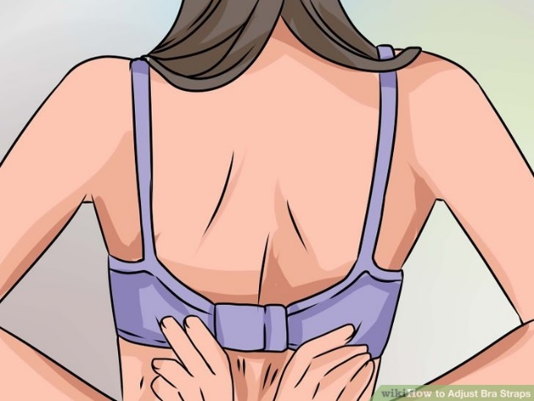

7. Feel for the tag and adjust it so it is lying flat

**WARNING**

Wearing the incorrect size of bra can lead to upper torso pain [2][3].

8. If the bra is too loose, move hooks to a row of eyes that is further in. If there is no further in row, then a smaller bra size is required.

9. If the bra is too tight, move hooks to a row of eyes that is further out. If there is no further out row, then either a larger bra size or an extender is required.

**Step 2 Adjust straps [4]:**

1. Place straps just inside of the shoulder joint

2. Use the **strap adjuster slide/clip** (see Figure 1) to tighten or loosen each strap so it sits snugly on the shoulder, without digging in to the skin (Figure 5)

Figure 5. Adjust strap length. http://blog.lindasonline.com/wp-content/uploads/2013/07/Falling-straps-step-1-adjust-the-straps.jpg



3. Pull the straps up and away from the shoulders to test the elasticity; if the straps easily reach your ears then they have lost their elasticity and should be replaced

**Steps for Taking a Bra Off**

**Step 1 Undo bra:**

1. Place one hand near the hooks and the other hand near the eyes

2. Pull the fabric of the back of the bra towards the center of the spine to relieve tension at the hook & eye clips (Figure 5)

Figure 5. Relieve tension around the hook and eye clips. http://photos.demandstudios.com/130/46/fotolia_2693839_XS.jpg



3. Unclip hooks from eyes

**Step 2 Remove bra:**

4. Remove straps from shoulders

5. Pull bra off

6. Enjoy!

**Conclusion**

In conclusion, the individual steps to operating a back-closer bra are simple. However, some steps are challenging to master and require practice to execute quickly. Several factors, including an improperly sized or improperly adjusted bra can lead to upper torso pain [1][2]. Overall, each part of the cycle of bra use contains several steps that are required for proper operation. Congratulations on successfully using a bra! If you have any questions you can call 1-800-867-5309.

**References**

1. Tomima. (2008, December). *Best Way to Put On a Bra – Actually, There Are Several.* Available: http://www.tomima.com/2008/12/13/best-way-to-put-on-a-bra-actually-there-are-several/. Accessed: June 19, 2016

2. L. Young. (2001, September). *The Importance of Correct Breast Support*. [Online]. Available: http://www.positivehealth.com/article/bodywork/the-importance-of-correct-breast-support. Accessed: June 7, 2016

3. E. Denton. (2015, April). *10 Signs You’re Wearing the Wrong Size Bra – and how to find the right one.* [Online]. Available: http://www.seventeen.com/fashion/style-advice/tips/a30030/signs-youre-wearing-the-wrong-size-bra/. Accessed: June 17, 2016

4*. How to Adjust Bra Straps*[Online]. Available: http://www.wikihow.com/Adjust-Bra-Straps. Accessed: June 7, 2016