**Memorandum**

**To: Tom Leslie**

**From: Nicole Dahlquist**

**Date: July 1, 2016**

**Subject: Proposal for Feasibility Report on The Use of Technology to Treat Agoraphobia**

I would like to present for your approval the following proposal for a report on The Use of Technology to Treat Agoraphobia. This proposal covers background on the relationship between agoraphobia and technology, a look at the available research, and a timetable for completion.

Agoraphobia is a fear-based anxiety disorder that often renders its sufferers unable to leave their home. You will find that the following proposal illustrates the importance of understanding how some technologies may affect agoraphobia, and how others could be used to cure it.

**Introduction**

This report is a feasibility analysis that looks at the relationship between technology and agoraphobia. More specifically, I will examine ways in which technology can cause or worsen agoraphobia, aid and enable agoraphobes, as well as treat their condition.

The intended audience for this report is primarily psychologists, however, it may also appeal to agoraphobes, and virtual reality engineers. The psychologists and agoraphobes will have an appreciation for the need to treat agoraphobia, while the virtual reality engineers would have the skills to create technological treatments. A look at the background of the topic will provide you with a broad overview of the relationship between agoraphobia and technology.

**Background**

Agoraphobia often leads sufferers to live their lives trapped at home; it is categorized as an anxiety disorder that is based on, sometimes unrealistic, fear [1]. These fears can be triggered by a variety of activities, such as watching the news [2][3], as seen in Figure 1 below.

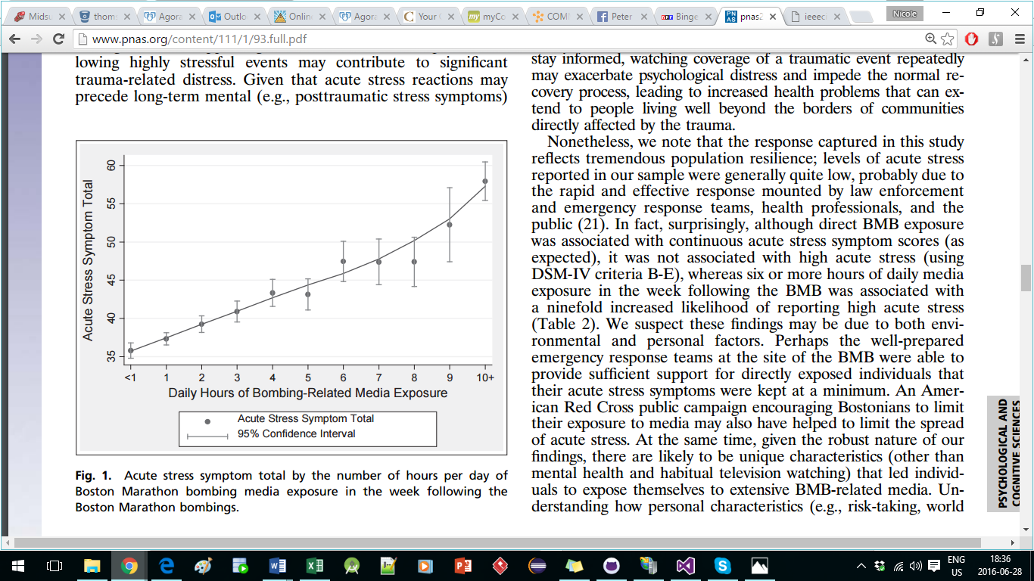

Figure 1. Acute Stress Symptom total as related to hours of news broadcast

exposure in the week following a traumatic event. [3]

Historically, agoraphobes would need to rely on the help of others to make purchases, bring groceries, and escort them when they absolutely had to go out. Now, many agoraphobes are able to function from home with the aid of the internet [4][5]; however, the internet may also enable agoraphobes and prevent them from seeking curative treatment. Some of the most modern treatments include GPS tracking [6] and virtual reality simulators [7].

**Preliminary Research**

I will use sources that discuss agoraphobia and its development, those that discuss how the internet can allow you to function without leaving the house, and those that discuss technological treatment.

* http://www.mayoclinic.org/diseases-conditions/agoraphobia/basics/definition/con-20029996 [1]
* https://www.anxiety.org/news-increases-stress [2]
* http://www.pnas.org/content/111/1/93.full.pdf [3]
* http://www.howtogeek.com/216828/how-to-use-the-internet-to-never-leave-your-house-again/ [4]
* http://www.heraldscotland.com/news/14566288.Why_you_never_need_to_leave_your_house_again__except_in_a_medical_emergency_/ [5]
* https://www.researchgate.net/profile/Pedro_Wolf/publication/232075531_GPS_Technology_and_Human_Psychological_Research_A_Methodological_Proposal/links/09e4150757bbbe30f3000000.pdf [6]
* http://www.mitpressjournals.org/doi/abs/10.1162/pres.1996.5.3.346#.V27albgrK00 [7]

You will find that the above sources span across all of my proposed areas of discussion. I feel these topics are the most important for understanding the relationship between technology and agoraphobia. By having these areas of discussion well defined, I anticipate that I will have no issues completing this report in a timely manner.

**Timetable**

Given the preliminary research that I have done, I am confident that I will be able to complete the assignment by the due date. Below is a timetable for completion of the major tasks.

|  |  |
| --- | --- |
| **Task** | **Completion Date** |
| **Complete Research** | July 1, 2016 |
| **Complete Outline** | July 8, 2016 |
| **Complete Rough Draft** | July 15, 2016 |
| **Peer Edit** | July 22, 2016 |
| **Revise/Final Draft/Finishing** | July 25, 2016 |
| **Submit Report** | July 29, 2016 |

By adhering closely to the completion dates for the tasks, I will meet the deadline for the report. I hope you will find my proposed timetable, my preliminary research and the overall topic to your liking.

**Call for Action**

If what you have read in this proposal pleases you, I would appreciate your approval to continue pursuing this topic. This report can benefit psychologists, agoraphobes and virtual reality engineers that are interested in treating agoraphobia. This report may be limited because agoraphobia does not necessarily have the same causes and triggers from patient to patient. If you have any questions I can be reached at ndahlquist-cc@conestogac.on.ca.

Please inform me of your decision at your earliest convenience.

Date: ­­­­­­­­­­­­­­­____June 30, 2016___ Signature: 

**References**

1. Mayo Clinic Staff. *Agoraphobia* [Online]. Available: http://www.mayoclinic.org/diseases-conditions/agoraphobia/basics/definition/con-20029996. Accessed June 25, 2016

2. (2014, July). *Traumatic events in the news Causes spikes in stress* [Online]. Available: https://www.anxiety.org/news-increases-stress. Accessed: June 28, 2016

3. E. Holmana, D. Garfinb , and R. Silver. (2013, November). *Media’s role in broadcasting acute stress following the Boston Marathon bombings* [Online]. Available: http://www.pnas.org/content/111/1/93.full.pdf. Accessed: June 28, 2016

4. C. Stobing. (2015, June). [*How to Use the Internet to Never Leave Your House Again*](http://www.howtogeek.com/216828/how-to-use-the-internet-to-never-leave-your-house-again/)[Online]. Available: http://www.howtogeek.com/216828/how-to-use-the-internet-to-never-leave-your-house-again/. Accessed: June 25, 2016

5. R. Leadbetter. (2016, June). *Why you never need to leave your house again (except in a medical emergency)* [Online]. Available: http://www.heraldscotland.com/news/14566288.Why_you_never_need_to_leave_your_house_again__except_in_a_medical_emergency_/. Accessed June 25, 2016

6. P.Wolf and J.Jacobs. (2010).  *GPS Technology and Human Psychological Research: A Methodological Proposal* [Online]. Available: https://www.researchgate.net/profile/Pedro_Wolf/publication/232075531_GPS_Technology_and_Human_Psychological_Research_A_Methodological_Proposal/links/09e4150757bbbe30f3000000.pdf. Accessed: June 25, 2016

7. M. North, S. North, and J. Coble. (1996, Summer). *Effectiveness of Virtual Environment Desensitization in the Treatment of Agoraphobia*  (Vol 5, No 3) [Online]. Available: http://www.mitpressjournals.org/doi/abs/10.1162/pres.1996.5.3.346#.V27albgrK00. Accessed: June 25, 2016