**Definition of a Bra**

**COMM1130 – Nicole Dahlquist**

If the average woman owning 9 bras [1] seems excessive, then perhaps you are not well enough acquainted with the virtues of the bra. The modern-day brassiere, or bra, is an undergarment worn by women in order to support their breasts. In this paper, I will discuss numerous topics pertaining to the bra that are important for fully appreciating it. In order to best define the bra, I will look at the etymology of the word and its evolution, as one must experience an item’s history to fully understand it. I will then label the parts of a bra pictorially and give an analysis of its parts. Finally, I will discuss items that are similar to, but are not, bras; by comparing and contrasting them. Through these avenues I hope that the reader will be able to come to understand the modern-day bra more fully.

The word ‘bra’ is the short form of the French word brassière, which means “woman’s bodice” [2].

Bras evolved from corsets, which were worn from the 14th to 19th centuries [3] and functioned to cinch the waist and lift the breasts. In the 19th century a split corset, the corselet-gorge, was introduced, which did not cinch the waist as the previous corset had [3]. The top-half of the corselet-gorge, or the soutien-gorge as it is still called in France today, supported the breasts and was held in place by shoulder straps; the soutien-gorge was sold by itself and became known as a brassiere [3]. Physicians, feminists and the metal shortage caused by World War I are attributed with the switch from corsets to brassieres [3].

The modern-day bra is not a bikini top, as a bikini top is not fully supportive and is not worn as an undergarment. The bra is not a corset; it only covers the breasts and a small part of the chest, whereas a corset also covers and cinches the waist. It is also not a bodice, which is similar to a corset, but worn on the outside of a woman’s clothing and does not cinch the waist.

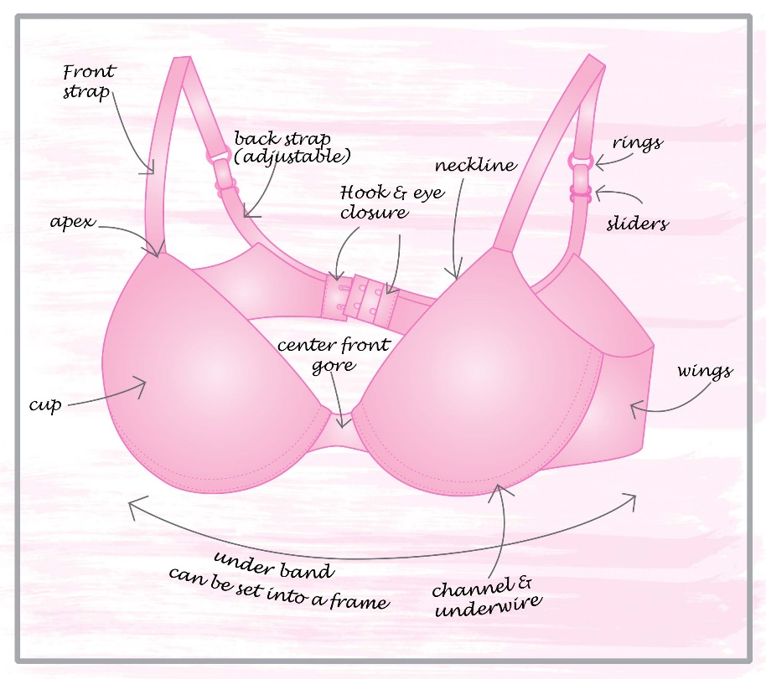

**Conclusion**

In conclusion, though the modern-day bra is often deemed uncomfortable and a burden, it is arguably leaps and bounds better than its predecessors. Its development has a long history that is often related to various social aspects [3]. While many women find the support it provides invaluable, others are happy to do without. It is probably safe to say that the bra will be around for a long time to come.

**References**

1. C. Lin. (2012, July 10). *SkinMag*. [Online]. Available: http://www.skinmagonline.com/sg/2012/07/intimate-secrets-10-surprising-bra-stats-you-need-to-know/. Accessed: May 31, 2016

2. "brassiere", *The Oxford Canadian Dictionary*. Oxford University Press, Don Mills, ON, p. 170, 2001.

3. *History of Bras.* [Online]. Available: https://en.wikipedia.org/wiki/History_of_bras. Accessed: May 31, 2016.

http://vignette2.wikia.nocookie.net/bustyresources/images/b/bb/Anatomy-of-a-bra.jpg/revision/latest?cb=20120810014622