

College of Computing Education
Bachelor of Science Information Technology

Baby Mochie Korean Manju POS System
IT6L (6682) Fundamentals of Database Systems

Submitted by:
Dalandangan, Nasrullah M

Submitted to:
Professor Jenny Espadero

April 2026
I. Project Context
A. Company Background
Baby Mochie Korean Manju is a food business that offers Korean-inspired mini pastries known as “manju.” These are soft, bite-sized cakes filled with a variety of sweet flavors such as chocolate, strawberry, and ube, along with an assorted option that includes a mix of available flavors. The products are freshly baked and are popular among customers due to their soft texture, appealing taste, and affordability.
The business is commonly operated through small kiosks or food stalls, making it accessible to students, employees, and walk-in customers. It’s simple yet attractive product concept makes it a popular snack choice, especially for customers looking for quick and affordable treats.
Currently, the business manages its daily operations manually. Orders are taken by staff, and total amounts are computed using basic calculations. Sales are recorded in notebooks, and inventory is monitored through physical counting. While this process works for small-scale operations, it becomes inefficient during peak hours and may lead to errors in computation and record-keeping.
As the business continues to grow, there is a need for a more efficient system to handle transactions and manage data. Implementing a Point of Sale (POS) system will help automate operations, improve accuracy, and enhance customer service.

Transactions of the Company
Baby Mochie Korean Manju processes daily sales transactions involving customer orders and payments. The process begins when a customer selects their preferred manju flavor and pack size. Staff then computes the total amount manually based on the pack-size pricing. After computation, the customer pays typically in cash, though the proposed system will also support GCash and the transaction is recorded in a logbook.
With the proposed POS system, this process will be fully automated. The cashier will select products and quantities in the system, totals will be computed instantly, and digital receipts will be generated. All records will be stored in a structured database for easy retrieval and reporting.

Stock Management Process
Baby Mochie monitors product and ingredient availability daily. The current manual approach involves checking remaining stock at the end of each day and estimating restocking needs — a method prone to inaccuracies, shortages, and overproduction.
The stock management process involves the following steps:
- Stock-In (Restocking): Ingredients and supplies are purchased and added to inventory. The POS system will log these entries and update stock levels automatically.
- Stock Monitoring: Staff checks available quantities regularly. The system will display real-time stock levels and flag low-stock items.
- Stock Usage: Ingredients are consumed daily during manju production. The system automatically deducts sold quantities from inventory after each transaction.
- Stock Adjustment: Damaged, expired, or excess items are recorded and adjusted. The system provides an adjustment feature to maintain accurate inventory counts.

B. Problems
- Manual computation of orders may lead to incorrect totals.
- Transactions recorded by hand risk data loss, duplication, or errors.
- Slow transaction processing during peak hours reduces customer satisfaction.
- Difficulty tracking daily sales and monitoring overall business performance.
- Inventory is not monitored in real time, leading to possible shortages or overstocking.
- No formal record of user activity, making accountability and audit trails difficult.
C. Solutions
- Develop a POS system to automate sales transactions handled by the assigned cashier.
- Implement automatic calculation of total amount and change, supporting both Cash and GCash payment methods.
- Store transaction records in a relational database (MySQL) for easy retrieval and audit.
- Generate daily and monthly sales reports accessible to the Admin.
- Include real-time inventory monitoring to track product availability and trigger low-stock alerts.
- Implement role-based access control: Admin manages users and views reports; Cashier processes sales and views inventory.
D. Document Analysis
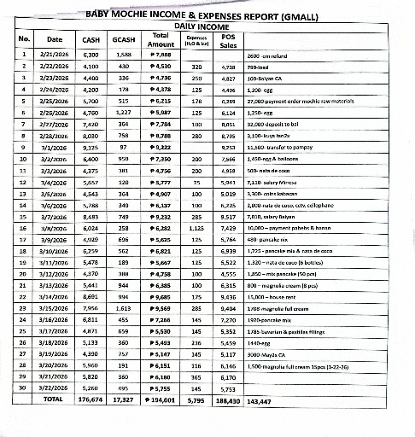
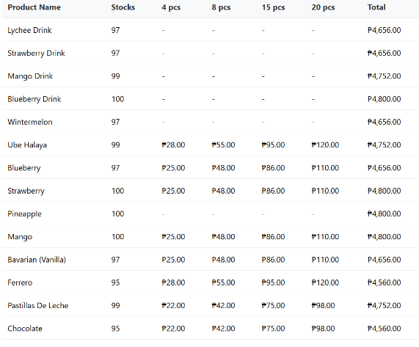
Sample Picture of transactions

Figure 1. Inventory Figure 2. Daily Sales


F. Proof of Interview /Data Gathering(Research)

Figure 3. Proof of interview / Data Gathering(Research)

II. Objectives of the Study
The main objective of this study is to develop a Point of Sale (POS) System for Baby Mochie Korean Manju to improve transaction efficiency, accuracy, and inventory management.

Specifically, it aims to:
- Automate the process of recording customer orders and payments processed by the Cashier.
- Provide accurate and real-time computation of total sales, including change calculation for Cash payments.
- Store sales and inventory data in a structured relational database (MySQL).
- Generate daily and monthly sales reports for business monitoring and decision-making by the Admin.
- Improve customer service by reducing transaction time at the point of sale.
- Enforce role-based access control to protect system integrity and establish accountability.

III. Scope and Limitation of the Study
This study focuses on the development of a Point of Sale (POS) System for Baby Mochie Korean Manju. The system will handle product selection, order processing, and automatic computation of total sales. It will also store transaction records and generate basic sales reports.
The system includes features such as adding and managing products, processing customer orders, viewing sales history, and basic inventory monitoring. It is designed to be simple, user-friendly, and suitable for small food businesses such as kiosks and food stalls.
However, the system has certain limitations. It does not include advanced features such as online ordering, mobile application integration, or multi-branch management. It also does not support advanced inventory forecasting or analytics. The system depends on manual data input, which means accuracy relies on the user. Additionally, it is intended only for small-scale operations and may not be suitable for large businesses with complex requirements.

III. Conceptual and Logical Design
a. Business Rules
- A User can be either Admin or Cashier.
- A User can process many Orders; each Order is handled by one User.
- An Order contains multiple Order Items.
- Each Order Item is linked to one Product.
- A Product belongs to one Category.
- A Category can have many Products.
- A Supplier provides stock for many Products through Stock-In.
- Each Stock-In is recorded by an Admin User.
- Each Order has exactly one Payment.
- Product stock is automatically reduced after each Order.
b. ERD
Full Blown Entity Relationship Diagram (ERD)

