Current research figures

Earlier runs spent hours checking saved routes
We saved routes from the previous, smaller problem and checked every one before restarting CG. The large part of each bar is that checking time. For example, chain 3 at k=10 spent about 283 minutes checking saved routes and 10 minutes on the remaining CG work. These completed runs show why we limited how many saved routes the new experiments check.
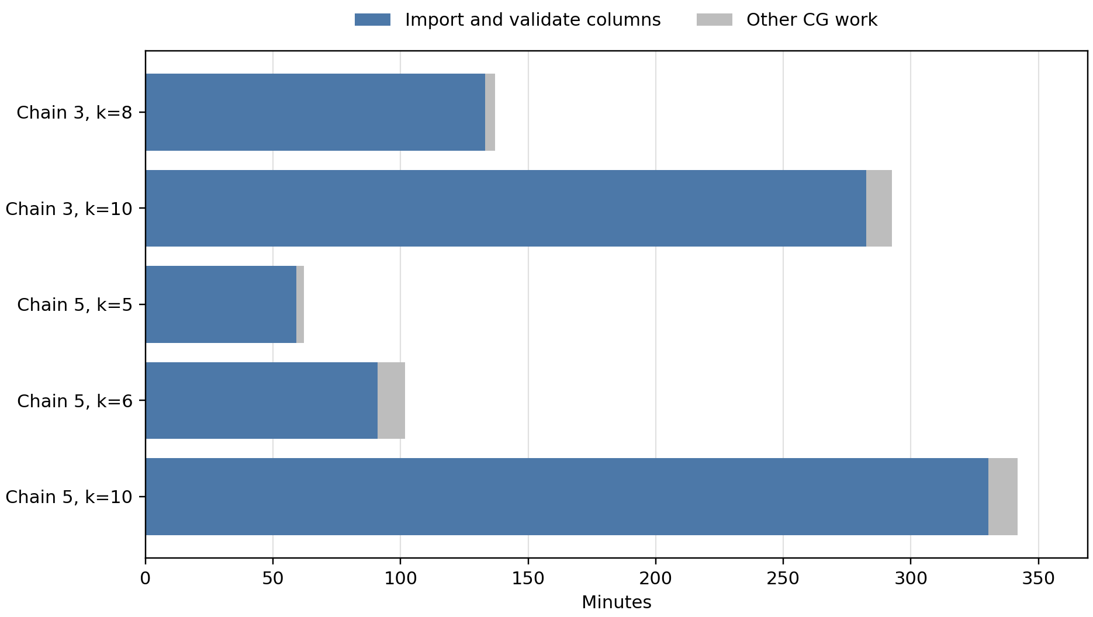
Source: completed full-pool warm runs, chains 3 and 5. “Other CG work” includes optimization and remaining overhead; final MIP time is excluded.

Charging savings with matched return energy
Five buses, 62 trips, 240 kWh batteries, 350 kW charging. Both optimized cases return at least 280.7833 kWh in total. Shared charger capacity is not imposed.
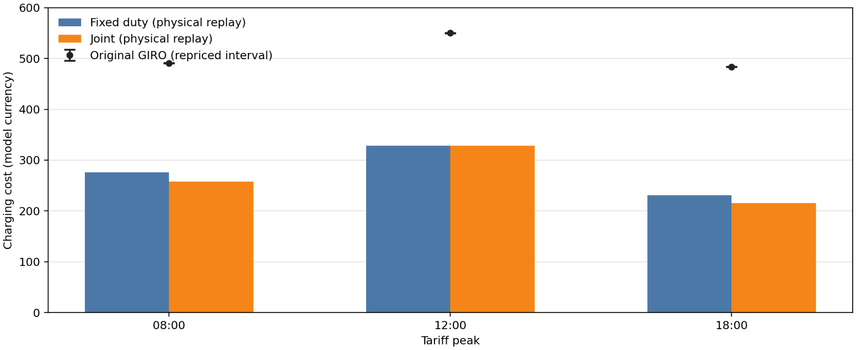

Price peak | GIRO repriced ($) | Fixed duties ($) | Joint ($)
08:00 | 490.29–490.98 | 275.87 | 257.69
12:00 | 549.59–550.60 | 328.55 | 328.36
18:00 | 483.45–483.72 | 230.78 | 215.76
Fixed duties: preserve trips on each bus and use DP to optimize charging. Joint: also change trip assignment using the saved route pool. Costs include electricity and 5 units per charging start, measured by physical replay.
The original range reflects unknown power within charging windows. At noon the discrete objectives tie; the small replay difference is not an improvement in that objective. Optimality claims apply only to the saved pool.

Geography suggests groups, but they still interact
The full GIRO input has 40 duties and 948 trips. This map shows 838 trips as straight lines between known endpoints, not road paths. PARX and 110 trips with unmapped endpoints are omitted. Coordinates: OpenStreetMap.
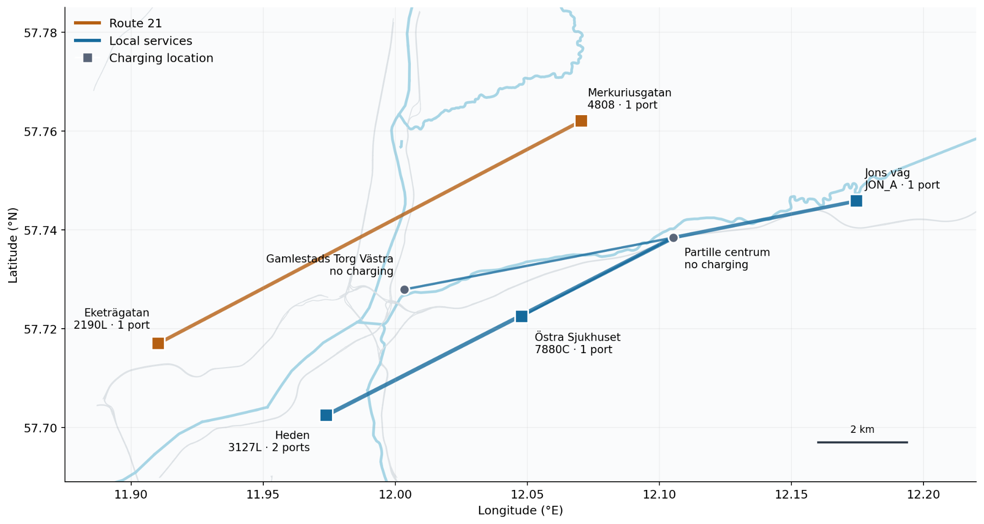
Route 21 has 14 duties / 203 trips; local services have 26 duties / 745 trips. An optimistic timetable screen finds 31.6% of connections cross the groups. It ignores battery and charging feasibility, so geography does not establish independence.
The current decomposition pilot uses a 32-duty, 750-trip subset split into four groups of eight. Shared capacity and exchanges between groups must be checked when recombining solutions.
Earlier figures and discussions: research archive · slide archive

Checking fewer saved routes lets CG get started
Each new run checked 512 saved routes in about 5–8 minutes, then continued searching for new routes. The limit is 512 routes or 15 minutes, whichever comes first. Checking a route means rebuilding and validating it for the larger trip set. The bars separate that checking from the rest of the run. All seven shown here completed CG by the 01:27 EDT snapshot on 12 September.
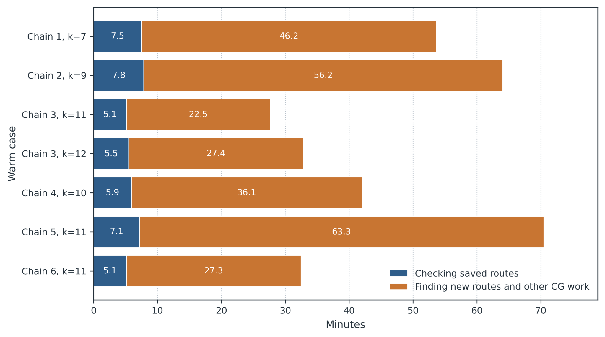
The three previously blocked cases are chain 1 at k=7, chain 2 at k=9 and chain 4 at k=10. Their new integer solutions were still pending at this snapshot. Fewer starting routes can change the integer pool, so we must check solution quality as well as runtime.

With charger limits the slow step was finding a new route
This compares two steps in the same iteration of a three-bus capacity test. Solving the LP took 0.006 seconds. Searching for a new route took about 7 hours 9 minutes. The axis is logarithmic because the times differ by several million times. The delay is inside the route search, unlike the saved-route checking in the previous figure.

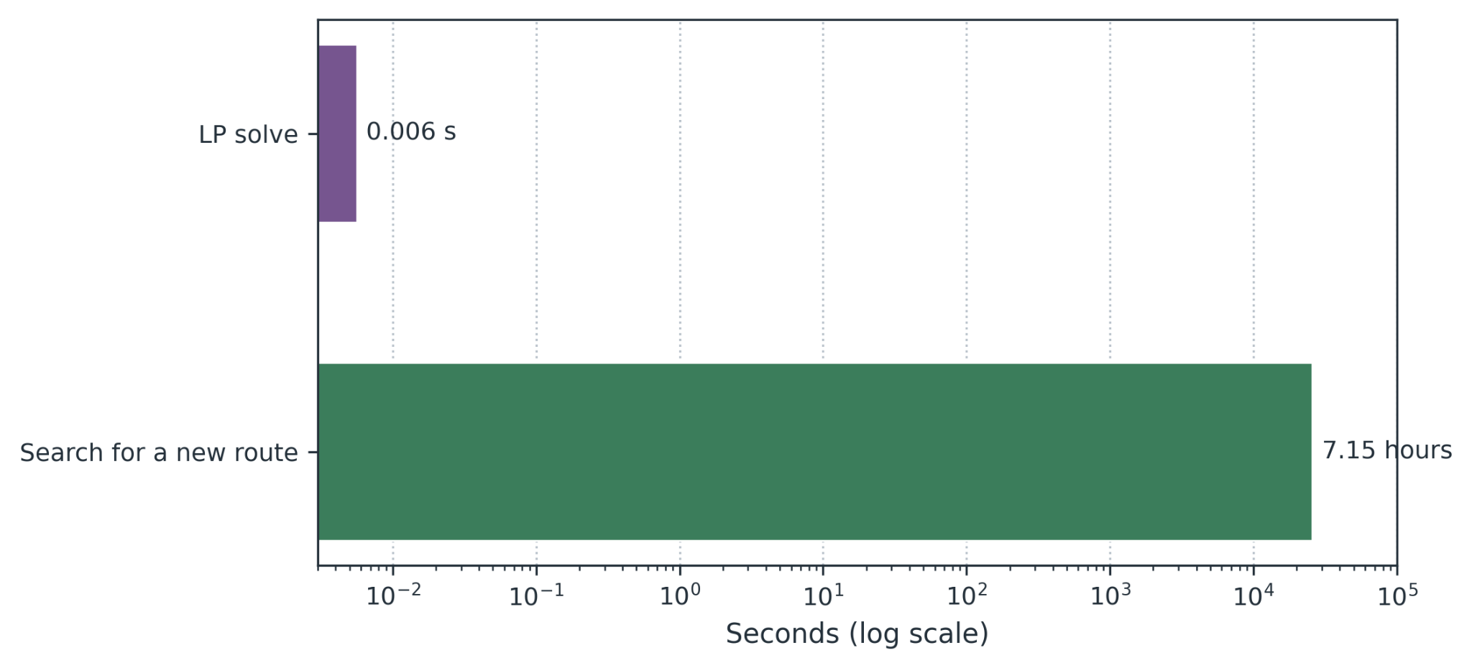The run stopped before it could prove that no improving route remained. It generated only three new routes in eight hours. The final MIP found 16 buses among the saved routes; this is not evidence that the full problem requires 16 buses.

