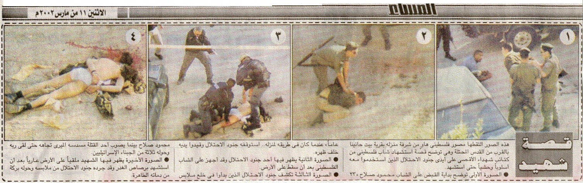

Photos taken by a Palestinian amateur showing the massacre of Mahmoud Salah. The Israeli Army claimed he was crossing into Jerusalem behind the Checkpoint carrying a belt of explosives. Please follow the photographs –from right to left- and the translation of the words in English to examine whether that was what really happened or not!!!!!!!!!!!!!

Words of an eyewitness!!

Photo 1: Mahmoud Salah, a 23 years old Palestinian youth being held by the Israeli soldiers while heading back home. His friend laying down on the ground.

Photo 2: One of the soldiers holds him to the ground while the other is getting ready to shoot.

Photo 3: After taking his cloths off, Mahmoud is shot again in the head.

Photo 4: Mahmoud is assassinated and left on the ground naked.

It is obvious that the Israeli claims are false. They claimed that they shot down a Palestinian suspect. After examination with a robot they discovered a belt of explosives around his body. This is only one of the numerous massacres committed daily by Israeli soldiers on checkpoints and elsewhere!!!!

