<http://localhost:8983/solr/books/select?q=id:0553573403&fl=id+name>

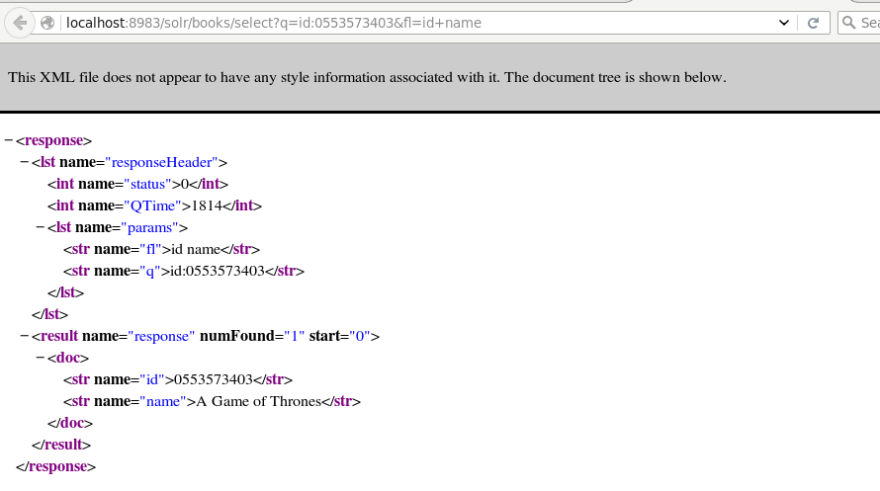

<http://localhost:8983/solr/books/select?q=author:George>

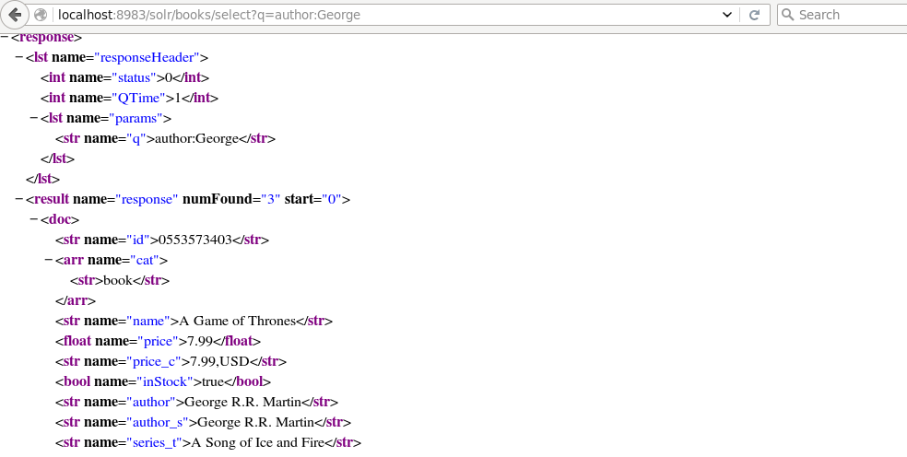

<http://localhost:8983/solr/books/select?q=price:7.99>

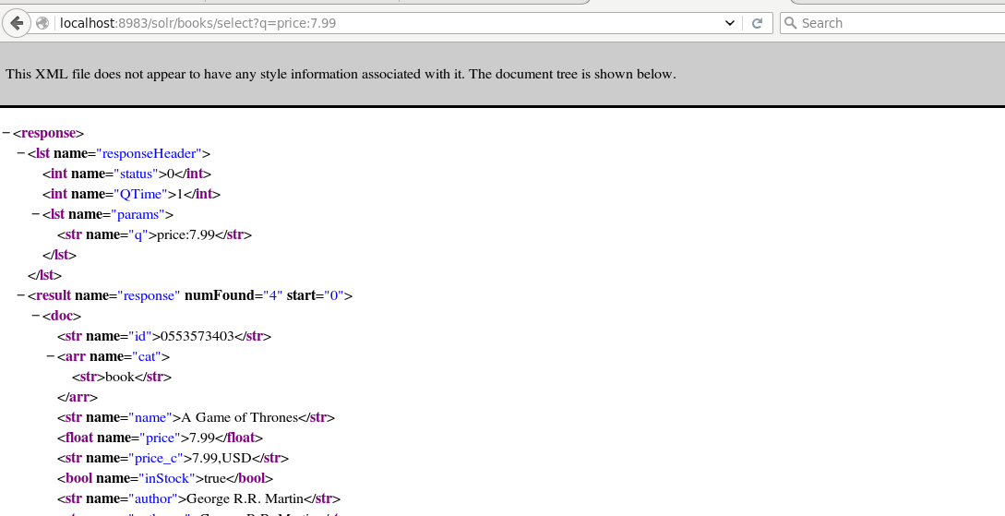

<http://localhost:8983/solr/books/select?q=inStock:false>

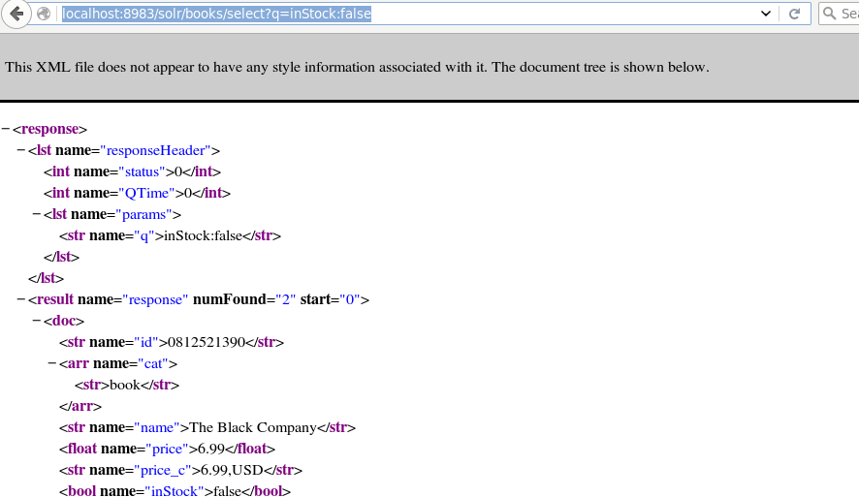

author:Martin || Glen

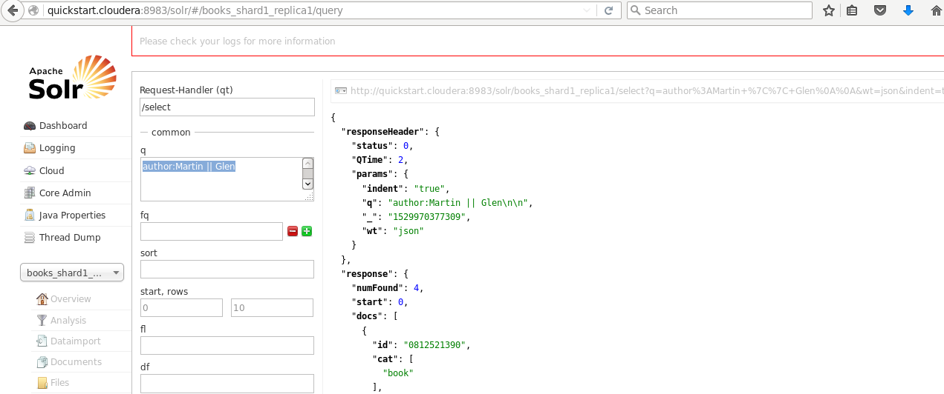

Part 2

genre:Horror

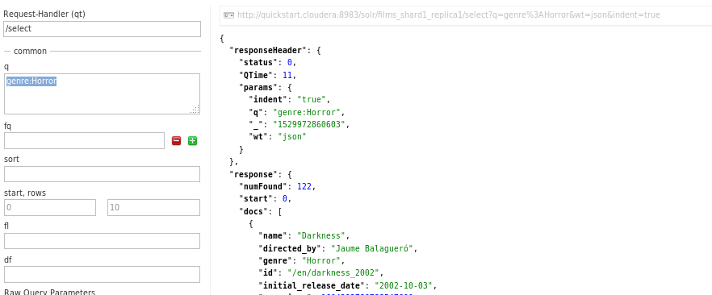

directed_by: Gary

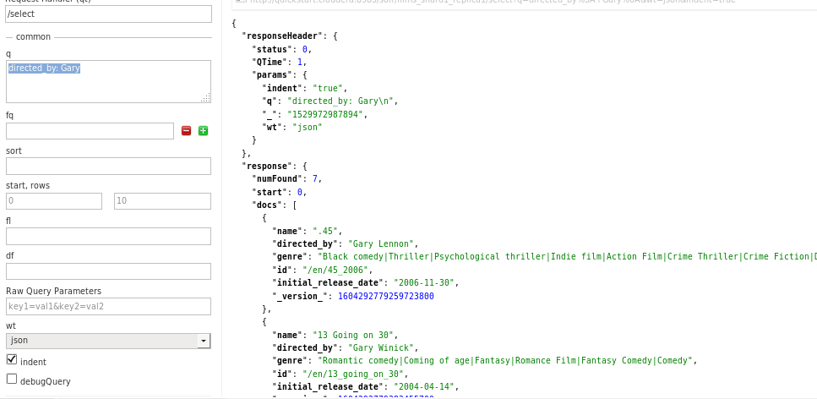

initial_release_date:2005

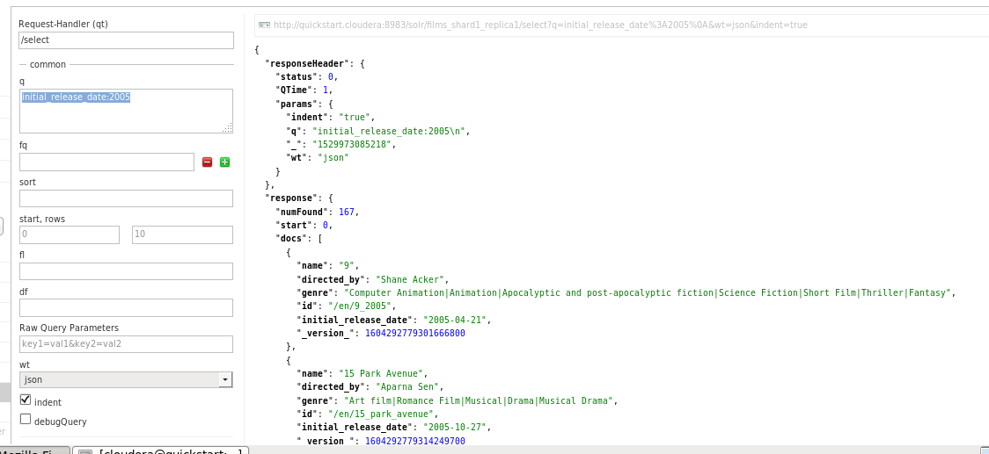

name:America~

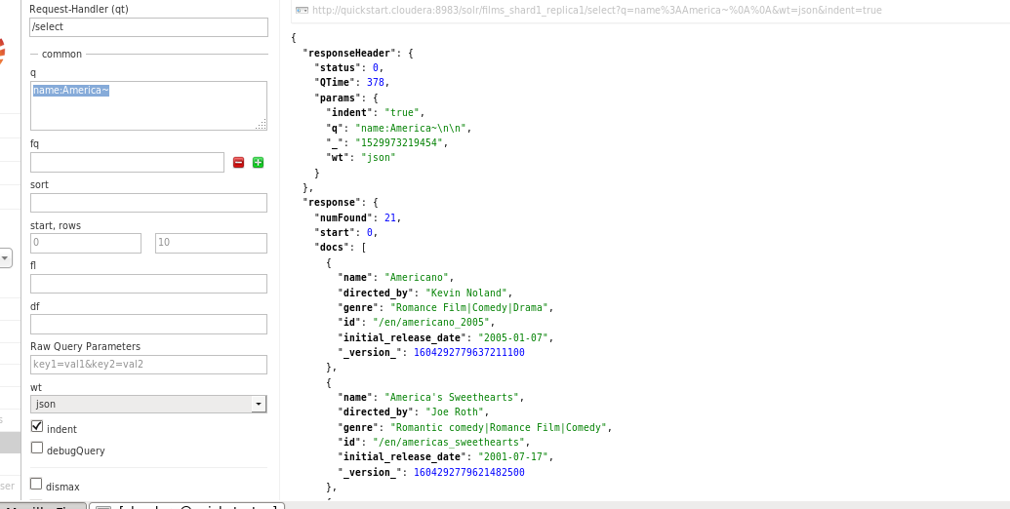

name:[0 TO 9]

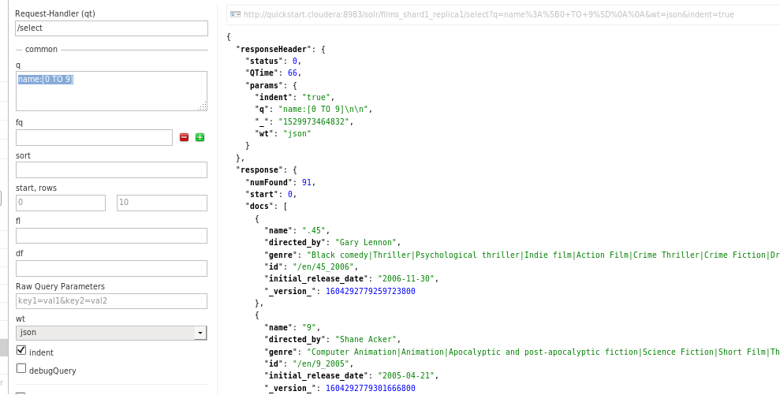

Bonus

Proximity

name:"Book three"~5

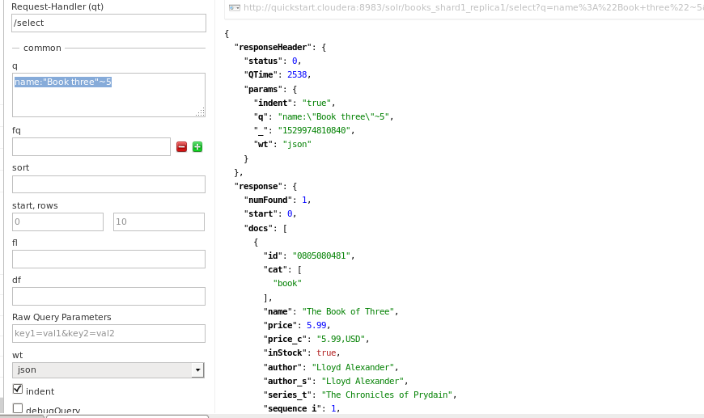

Match

name:B*K

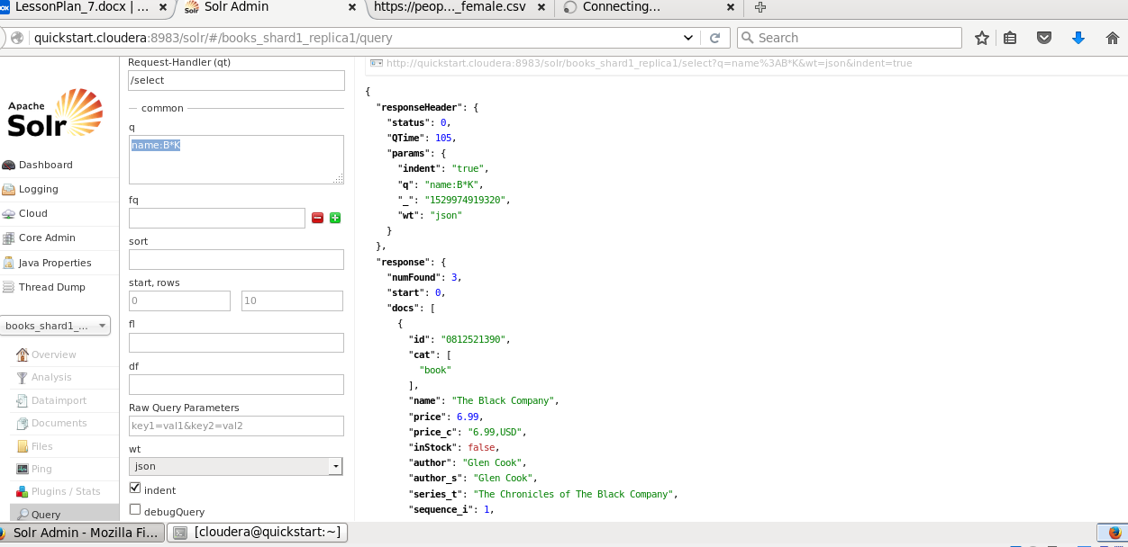

Fuzzy search

name:the~

