Part 2

2 queries on each type of HBase Command (total of 8 queries)

1. General Hbase shell commands

status ‘simple’

A close up of a logo

Description generated with very high confidence

whoami

A screenshot of a cell phone

Description generated with high confidence

2.Table Management commands

Create

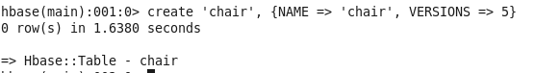

Describe

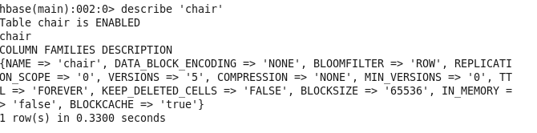

3. Data Manipulation commands

Count: Interval

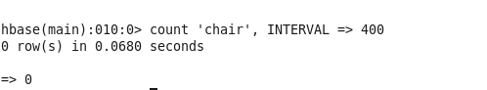

Truncate

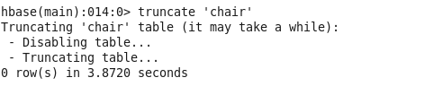

HBase surgery tool

Balancer

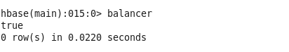

Split

A close up of a logo

Description generated with very high confidence