FORMATIVE ASSIGNMENT 1: PROJECT PROPOSAL AND SOFTWARE REQUIREMENTS SPECIFICATION
ALU SmartBus
Know Your Bus, Own Your Journey
Author: Ntwali Beni David
Organization: African Leadership University (ALU)
Mission sector: Infrastructure and Urbanisation
Version: 1.1
Date created: 29 September 2026

Table of Contents
Part A: Project Proposal
1. Description of the Mission
2. Problem Statement
3. Proposed Solution and What Makes It Unique
4. Software Development Model: Agile (Scrum)
5. Hypothesis
Part B: Software Requirements Specification (SRS)
Revision History
1. Introduction
1.1 Purpose
1.2 Document Conventions
1.3 Intended Audience and Reading Suggestions
1.4 Product Scope
1.5 References
2. Overall Description
2.1 Product Perspective and System Overview
2.2 Product Functions
2.3 User Classes and Characteristics
2.4 Operating Environment
2.5 Design and Implementation Constraints
2.6 User Documentation
2.7 Assumptions and Dependencies
3. External Interface Requirements
3.1 User Interfaces
3.2 Hardware Interfaces
3.3 Software Interfaces
3.4 Communications Interfaces
4. System Features (Functional Requirements)
5. Other Nonfunctional Requirements
5.1 Performance Requirements
5.2 Safety Requirements
5.3 Security Requirements
5.4 Software Quality Attributes
5.5 Business Rules
6. Appendix
Appendix A: Glossary
Appendix B: Analysis Models
Appendix C: Proposed Technology Stack
References22

Part A: Project Proposal
Mission, problem statement, software development model and hypothesis

1. Description of the Mission
My ALU mission revolves around Infrastructure and Urbanization. I want to help African cities move people safely, reliably and affordably. “Public transport is becoming the main way people get around Kigali and the government is investing in it. In 2025 and 2026, bus-priority traffic lights and dedicated bus lanes were introduced. The new network increased bus use by around 15% (Mwasa & Kamanzi, 2026; Ngabonziza, 2025).
Faster buses do not mean people know where the buses are. You still stand at the stop without knowing if the bus has already passed, is stuck in traffic or is already full. So people wait for a long time, or they give up and pay for a moto, which costs more and is less safe. To me this is a missing piece of infrastructure: the roads and the buses are there, but the information about them is not. This happens in many African cities, not only in Kigali, so it is a real opportunity for ALU, for Rwanda and for the continent.
I am starting with something I know well: the ALU school bus between Rebero and campus. The route is short, the stops are known and the users are my fellow students, so I can test the idea properly. If it works, the same idea could help parents who want to know where their children’s school bus is during traffic jams, and later the public buses in Kigali.

1.1 Formulating the Mission

Programmes I can take part in to learn more about the problem
Priority | Stakeholder | What I want to learn
1 | ALU students who ride the bus | What frustrates them most: waiting, missing the bus, moto costs and safety.
2 | The bus drivers | The real stops, departure times and traffic delays, and what would be easy for them to use without being distracted while driving.
3 | The school (ALU) | How the bus schedule, routes and capacity are managed today, and what information the school is missing.

Research I need to do (in order of priority)
- A short survey of ALU bus riders (Google Form) to find out how long they usually wait, how often they miss the bus, how often they take a moto instead and how much it costs them.
- Interviews with the bus drivers and the school to confirm the stops, departure times, capacity and how updates are shared today.
- Observing the route for a week and noting when the bus actually reaches key stops (Kimironko, Remera, Sonatube, Rebero), to compare with what students say.
- Reading Kigali transport reports and news, road safety studies, and research on real-time passenger information.
- Looking at how students follow the bus now through the WhatsApp groups, to see what is missing.

Problems in this domain (in order of importance)
Rank | Problem | Why it matters
1 | ALU students have no reliable way to know where the school bus is, when it will reach their stop or whether it is full. | Students wait for long periods, miss the bus and spend money on motos, which are expensive and less safe.
2 | ALU has no data on how many students use the bus at each stop and time. | Without this, it is hard to plan routes, the number of buses and capacity.
3 | Public bus passengers in Kigali cannot see where buses are, even with the new bus lanes. | Waiting at stops is still uncertain. This is where the idea could grow after the ALU pilot.

2. Problem Statement
Kigali’s buses carry around 280,000 passengers every weekday (Mwasa & Kamanzi, 2026), yet commuters on the Kimironko and Remera routes still report waiting close to an hour at peak times (Top Africa News, 2025). The ALU school bus passes through these same areas.
WHO: ALU students who take the school bus, the drivers, and the school.
WHAT: Students cannot tell where the bus is, when it will arrive or whether it is full.
WHEN: Every school day, especially during morning pickups, evening returns and heavy traffic.
WHERE: On the Rebero–ALU route in Kigali, Rwanda.
WHY: Students wait for a long time or pay for motos, which are expensive and risky: 38.7% of 609 Kigali moto drivers surveyed had been in a crash (Vissoci et al., 2020). In a short survey I ran of ALU bus riders on 29–30 September 2026 (n = 12), 9 out of 12 (75%) said they usually wait more than 10 minutes, and 8 out of 12 (67%) take a moto at least once a month because they are unsure about the bus. The school also has no data to plan buses and capacity.
HOW: Updates come mainly through WhatsApp groups, and they are often late or missing. One student described the problem as “checking the WhatsApp group and finding out that it has already left.”
In short, ALU students have no real-time information about the school bus, so they lose time and money and take unsafe motos, while the school cannot plan its transport.

3. Proposed Solution and What Makes It Unique
ALU SmartBus is a website that works in any phone browser, so nobody has to download an app. It has three views:
- Students can see which buses are available, where the bus is on a map, the next stop and arrival time. They can choose a pickup or drop-off stop, get alerts when the bus is close, and scan the bus QR code when they get on.
- Drivers choose the bus and direction and start the journey. After that the location is shared automatically, so they don’t have to touch the phone while driving.
- Admins manage the buses and their capacity, and see reports on journeys, boarding and demand at each stop.
What students use now | The problem with it | What ALU SmartBus does
WhatsApp groups | Updates are manual, often late or missing, and depend on someone posting. Nothing is recorded, and there is no way to know if the bus is full. | Shows the live bus location, the arrival time and whether the bus is full, without anyone having to post a message. QR boarding also gives the school records by stop and time.

What makes it different is that it brings live tracking, the Full status and QR boarding records together in one simple web app built around a real school route. Later it could be opened to parents who want to follow their children’s school bus, and to public buses in Kigali.

4. Software Development Model: Agile (Scrum)

4.1 Why Scrum fits this project
Scrum is an Agile way of working where the software is built in short sprints. At the end of each sprint there is a working piece to review, and a short look back at what to improve next time (Schwaber & Sutherland, 2020). I chose it for four reasons:
- Some of my requirements can only be checked on the road. I don’t know yet whether five metres is the right distance to detect that the bus has arrived at a stop, or whether three minutes is enough time to board. Sprints let me test these early and change them.
- My users are close by. Other students and the drivers can try each version and tell me what doesn’t work.
- I am building this alone in about two months. With a prioritised backlog, live tracking and arrival times get built first, so there is something useful even if time runs out.
- Waterfall would leave testing until the end. That is risky when GPS accuracy, camera permissions and mobile data in Kigali are still unknowns.

4.2 How I will apply Scrum
I will be both the Product Owner and the developer. A classmate or my supervisor will review each sprint, and ALU riders and drivers will give feedback. The build takes about eight weeks, split into four sprints of two weeks each.
Step | Scrum activity | What I will do
1 | Product backlog | List all the features.  Put the most important first.  Tracking comes first, reports last.
2 | Sprint 1 (weeks 1–2) | Build log-in and roles.  Add the buses.  Let drivers start a journey.  Drivers test it.
3 | Sprint 2 (weeks 3–4) | Share the bus location.  Show the map and stops.  Show arrival times.  I ride the bus to check them.
4 | Sprint 3 (weeks 5–6) | Let students choose a stop.  Detect when the bus arrives.  Send alerts.  Students test the alerts.
5 | Sprint 4 (weeks 7–8) | Add QR boarding.  Show when the bus is full.  Build the admin reports.  ALU transport staff check them.
6 | In every sprint | Plan the work.  Track progress daily.  Show users what I built.  Note what to improve.
7 | Pilot and release | Run a four-week pilot.  Measure the results.  Use the feedback for the next version.

5. Hypothesis
If at least 30 ALU students use ALU SmartBus on the Rebero–ALU route for four weeks, with the pilot finished by the end of January 2027, then compared with the survey I run before launch:
- the average time students say they wait at the stop will drop by at least 30%;
- at least 70% of pilot users will say they usually know when the bus will reach their stop; and
- the share of students who say they take a moto because they are unsure about the bus will drop by at least 25%.
SMART | How the hypothesis meets it
Specific | One route (Rebero–ALU), one group of users (ALU students who ride the bus) and three clear outcomes.
Measurable | Waiting time, knowing when the bus will arrive, and moto use, measured with the same survey before and after the pilot, plus journey and boarding data from the app.
Achievable | It uses phones that drivers and students already have, needs no extra hardware, and the most important features are built first.
Realistic | The targets are in line with research showing that real-time information shortens both actual and perceived waiting (Watkins et al., 2011).
Timely | Eight weeks of building (October–November 2026), then a four-week pilot finished by 31 January 2027.

Part B: Software Requirements Specification (SRS)
ALU SmartBus, version 1.1

Revision History
Name | Date | Reason for Changes | Version
Ntwali Beni David | 29 Sep 2026 | Initial SRS: consolidated requirements for the web-first ALU SmartBus prototype. | 1.0
Ntwali Beni David | 26 Oct 2026 | Added UML diagrams (use case, class, sequence and component) with explanations in Appendix B. | 1.1

1. Introduction

1.1 Purpose
This document describes the software requirements for ALU SmartBus version 1.0, a web app that helps ALU students keep track of the school bus. With it, students can see where the bus is, when it will reach their stop and whether it is full. Drivers share the bus location during a trip, and admins manage the buses and look at reports on journeys and demand.
It covers the whole first prototype: log-in and roles, journeys, live tracking and arrival times, choosing a stop, pickup requests, QR boarding, notifications, bus availability and capacity, and admin reports. Payments, GPS hardware, parent access and Kigali public buses are not part of this version; they can be added in later versions. I will use this document as the reference when designing, building and testing the system, and when evaluating the pilot.

1.2 Document Conventions
“Shall” is used for something the system must do and “should” for something that is desirable. FR stands for functional requirement and NFR for non-functional requirement, and each one has its own number. Every feature in Section 4 has a priority (High, Medium or Low), and the requirements under it take the same priority. Terms are explained in the glossary (Appendix A).

1.3 Intended Audience and Reading Suggestions
The intended audience includes the student developer, ALU student users, drivers, transport administrators, project supervisors, and testers. Read Sections 1–2 for context, Section 3 for interfaces, Section 4 for functional requirements, and Section 5 for quality and operational requirements. Developers and testers will mostly need Sections 4 and 5, while supervisors and ALU transport staff may find Sections 1, 2 and Appendix B more useful.

1.4 Product Scope
ALU SmartBus will centralize transportation information for ALU student buses operating between Rebero and the ALU campus. The initial web application will provide live journey visibility, estimated arrival information, stop selection, QR-based boarding records, bus availability, and administrative reporting. It is intended to reduce uncertainty and fragmented communication and to provide transport-demand data. General public transport, payments, and dedicated GPS hardware are outside the initial prototype.
The main goals are to cut the time students spend waiting at stops without knowing anything, to reduce the moto trips students take because they are unsure about the bus, and to give ALU real numbers on how the bus is used at each stop and time.

1.5 References
All the sources used in this document are listed in the References section at the end of the document.

2. Overall Description

2.1 Product Perspective and System Overview
ALU SmartBus is a new system. It is meant to replace the WhatsApp group messages students use today to find out where the bus is. It is not part of an existing product, and version 1.0 does not connect to ALU’s student systems.
System overview. The system has four parts: a web app that students and drivers open in their phone browser, a web dashboard for admins, a backend that handles log-in, journeys, tracking, arrival times, boarding and reports, and a database. When a journey starts, the driver’s phone sends its location to the backend. The backend saves it, checks how close the bus is to each stop, works out the arrival times and sends updates to students. When students get on the bus they scan the QR code, which records that they boarded and updates the passenger count. Nothing needs to be installed from an app store.
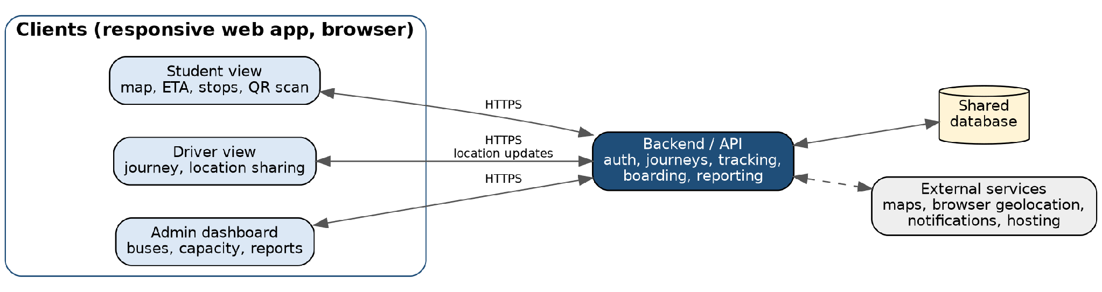
Figure 2.1. ALU SmartBus system overview.

2.2 Product Functions
- Authenticate users and provide role-specific functionality.
- Display bus availability, active journeys, route stops, live bus location, next stop, and estimated arrival times.
- Allow students to select designated pickup or drop-off stops for an active route.
- Allow drivers to start and manage journeys and share device location during active journeys.
- Record boarding through a permanent bus QR code scanned when entering.
- Provide arrival and missed-pickup notifications where the browser supports them.
- Allow administrators to manage bus records, capacity, availability, and view reports.

2.3 User Classes and Characteristics
User class | Characteristics | Importance
Students | View journeys, choose stops, scan bus QR codes, and receive transport updates. Daily users on smartphones; varied technical skill; may have limited mobile data. | Primary
Drivers | Use the web interface to select a bus and direction, start journeys, update availability, and view pickup requests. Driver interaction while driving must be minimized. | Primary
Administrator | Manage buses, capacity, availability, and access journey and demand reports. Administrator access is restricted to authorized accounts; mainly desktop use. | Secondary

2.4 Operating Environment
The system shall be a responsive web application accessible through current versions of modern browsers on Android and iOS smartphones and on computers. Students and drivers use the same web application with role-based interfaces; administrators use a web dashboard. Live tracking, synchronization, and centralized services require internet connectivity. Driver location uses browser-supported geolocation while the journey is active and the necessary permissions are granted.

2.5 Design and Implementation Constraints
- The initial prototype is built by a solo developer over approximately two months using Agile (Scrum) sprints.
- The pilot is limited to ALU student transportation on the Rebero–ALU route.
- The system must work within browser GPS and camera permission limits and variable mobile connectivity in Kigali.
- Student personal data must be handled in line with Rwanda’s personal data protection law (Republic of Rwanda, 2021) and ALU policies.
- Specific frameworks, database products, and hosting providers are design decisions; the proposed stack is listed in Appendix C.

2.6 User Documentation
There will be short help pages inside the app and a one-page quick-start guide (PDF) for each type of user:
- Students: accessing the website, selecting stops, scanning the bus QR code, and understanding bus status.
- Drivers: starting journeys, enabling location, and updating availability.
- Administrators: managing buses and capacity, and reviewing reports.

2.7 Assumptions and Dependencies
- Users have a compatible smartphone or computer and internet access for live features.
- Drivers carry a phone with location services and browser geolocation enabled during an active journey.
- Bus route stops and coordinates are provided and confirmed by ALU transport staff.
- A permanent, unique QR code is displayed on each registered bus.
- Map tiles, geolocation, notifications, hosting, and authentication depend on third-party services and browser/device support.
- The initial route runs between Rebero and ALU campus, with designated stops: ALU Campus, Zindiro, Kimironko Kwa Mushimire, Kimironko Gare, Remera Gare, Sonatube, Rwandex, SEGEM, MEREZ 1, MEREZ 2, RUJUGIRO, and REBERO.

3. External Interface Requirements

3.1 User Interfaces
The responsive web interface shall provide role-specific student, driver, and administrator views. Layouts must be usable on mobile screens and desktop browsers, use consistent navigation, and show errors in plain language near the related action.
View | Main screens and elements
Student | Bus list with availability; route map with live bus and stops; next stop and ETA; stop selection; QR scanner; notifications.
Driver | Bus and direction selection; large Start/End Journey buttons; journey status; availability toggle; pickup request list.
Administrator | Bus management (add/edit, capacity, availability); active and completed journeys; boarding and demand reports by stop and period.

3.2 Hardware Interfaces
The system interfaces with a smartphone or computer display, the camera for QR scanning, and the driver device’s location/GPS capability through the browser. The QR code is a printed, persistent identifier attached to each bus. Dedicated GPS trackers and NFC/RFID hardware are future possibilities, not initial requirements.

3.3 Software Interfaces
Component | Purpose and data exchanged
Web browser APIs | Geolocation API (driver latitude/longitude and timestamp); camera access for QR scanning; Notifications API for arrival alerts.
Backend / API | Receives location updates, journeys, pickup requests and scans; returns bus status, ETA and reports.
Database | Stores users, buses, stops, journeys, location updates, pickup requests and boarding records (see class diagram, Appendix B).
Mapping service | Map tiles and display of route, stops and live bus position.
Authentication service | User sign-in, sessions and role information.

3.4 Communications Interfaces
Client and backend communications will be made over the internet connectivity and encrypted HTTPS connections. The system shall transmit location and journey updates to authorized clients via REST API calls and a real-time channel (e.g. WebSockets). Data needs to be sent in a JSON format. When connectivity is lost, the interface shall clearly show that the data is not live and shall resynchronize automatically when the connection returns.

4. System Features (Functional Requirements)
The requirements are grouped by feature. Each feature has a short description and a priority.

4.1 Authentication and Roles
Description and priority: Users sign in and see only the functions for their role (student, driver or administrator). Priority: High.
Req ID | Requirement
FR-01 | The system shall allow registered users to authenticate.
FR-02 | The system shall display functionality according to the authenticated user’s role.
FR-03 | The system shall restrict administrator functions to authenticated, authorized administrator accounts.
FR-04 | The system shall allow users to log out.

4.2 Student and Stop Management
Description and priority: Students view buses and route stops and choose a valid pickup or drop-off stop. Priority: High.
Req ID | Requirement
FR-05 | The system shall provide students access to the student interface after authentication.
FR-06 | The system shall display registered buses and their current availability status.
FR-07 | The system shall allow a student to select an available bus for a relevant journey.
FR-08 | If a student attempts to select an unavailable bus, the system shall display an unavailable message.
FR-09 | The system shall display designated route stops.
FR-10 | The system shall allow students to select a designated pickup or drop-off stop applicable to the active journey direction.
FR-11 | The system shall display the student’s selected stop.
FR-12 | The system shall prevent selection of a stop already passed by the bus or not applicable to the journey direction.

4.3 Bus and Journey Management
Description and priority: Drivers select a bus and direction and start a journey, which is recorded for reporting. Priority: High.
Req ID | Requirement
FR-13 | The system shall allow a driver to select the bus assigned to the journey.
FR-14 | The system shall allow the driver to select Rebero-to-ALU or ALU-to-Rebero direction.
FR-15 | The system shall allow the driver to start a journey.
FR-16 | When a journey starts, the system shall create a journey record containing bus, driver, direction, start time, and status.
FR-17 | The system shall display active journey status to authorized drivers and administrators.
FR-18 | The system shall mark a journey completed when the bus reaches the designated terminal stop, subject to location detection being available.
FR-19 | The system shall retain completed journey records for reporting.

4.4 Location Tracking and ETA
Description and priority: The driver’s device location is shared during a journey so students can see the live bus, next stop and ETA. Priority: High.
Req ID | Requirement
FR-20 | During an active journey, the system shall obtain bus location from the driver device using browser geolocation.
FR-21 | The system shall transmit available location updates to the backend.
FR-22 | The system shall display the active bus location on a map to students.
FR-23 | The system shall display the route and designated stops.
FR-24 | The system shall calculate and display an estimated arrival time for relevant stops.
FR-25 | The system shall update the displayed location and ETA when new location data is received.
FR-26 | The system shall indicate when bus location is unavailable or stale.
FR-27 | The system shall display the next stop and its estimated arrival time.

4.5 Stop Arrival and Pickup Requests
Description and priority: The system detects arrival at stops, manages the boarding window and informs the driver of pickups. Priority: Medium.
Req ID | Requirement
FR-28 | The system shall compare received bus location with designated stop coordinates.
FR-29 | The system shall detect arrival when the bus is within a configurable proximity threshold of a stop (default: five metres, adjustable by the administrator).
FR-30 | The system shall update the arrival status of a stop when arrival is detected.
FR-31 | The system shall identify students who selected a pickup stop on the active journey.
FR-32 | The system shall provide a three-minute boarding window after the bus arrives at a requested pickup stop.
FR-33 | The system shall mark a pickup as missed if the student has not boarded within the boarding window.
FR-34 | The system shall distinguish a missed pickup from a stop not yet reached or skipped.
FR-35 | The system shall display pickup requests and expected passenger information to the driver.

4.6 QR Boarding Records
Description and priority: Students scan a permanent bus QR code on entry to create a verified boarding record. Priority: High.
Req ID | Requirement
FR-36 | The system shall assign each registered bus a unique identifier.
FR-37 | The system shall associate a permanent QR code with each bus.
FR-38 | The system shall allow an authenticated student to scan the bus QR code when entering the bus. No exit scan is required.
FR-39 | After a valid scan, the system shall record the student, bus, active journey, and boarding time.
FR-40 | The system shall verify that the scanned QR code belongs to the bus operating the active journey.
FR-41 | The system shall not create a boarding record for a bus without an active journey.
FR-42 | The system shall prevent duplicate boarding records for the same student on the same journey.
FR-43 | The system shall update boarding records after a successful scan.

4.7 Notifications
Description and priority: Students receive alerts before and at bus arrival and when a pickup is missed. Priority: Medium.
Req ID | Requirement
FR-44 | The system shall notify a student approximately ten minutes before the bus is estimated to reach the selected pickup stop, where notification services and permissions are available.
FR-45 | The system shall notify a student approximately five minutes before estimated arrival, where supported.
FR-46 | The system shall notify a student when the bus arrives at the selected stop, where supported.
FR-47 | The system shall notify a student when their pickup is marked missed, where supported.
FR-48 | The system shall display an unavailable message only when the student attempts to select an unavailable bus; it shall not send unsolicited unavailable-bus notifications.

4.8 Availability and Capacity
Description and priority: Buses can be marked Available/Unavailable, and occupancy is tracked to show a Full status. Priority: Medium.
Req ID | Requirement
FR-49 | An administrator or authorized driver shall be able to mark a bus Available or Unavailable.
FR-50 | The system shall allow a reason to be entered when marking a bus Unavailable.
FR-51 | The system shall display bus availability in the student bus list.
FR-52 | The administrator shall be able to configure the passenger capacity of each bus.
FR-53 | During pickup journeys, the system shall calculate boarding count from successful QR scans and display Full when the configured capacity is reached.
FR-54 | When a bus is marked Full, the system shall display that status and leave the decision to accept additional passengers to the driver.

4.9 Administration and Reports
Description and priority: Administrators monitor journeys and buses and view journey, boarding and demand reports. Priority: Medium.
Req ID | Requirement
FR-55 | The administrator shall be able to view active and completed journeys.
FR-56 | The administrator shall be able to view registered buses and availability.
FR-57 | The system shall provide reports of completed journeys for a selected period.
FR-58 | The system shall provide boarding totals and demand summaries by stop.
FR-59 | The system shall allow authorized administrators to access relevant student transportation records.

5. Other Nonfunctional Requirements

5.1 Performance Requirements
Type | Req ID | Description
Performance | NFR-01 | Under normal network conditions, the displayed bus location should update within 10 seconds of a new location update being received.
Performance | NFR-02 | Standard screens and user actions should respond within three seconds, excluding external-service delays.
Performance | NFR-03 | A successful QR scan and corresponding boarding-count update should complete within three seconds under normal connectivity.
Performance | NFR-04 | ETA should update automatically when new location data is received.

5.2 Safety Requirements
The biggest safety risk is the driver getting distracted by the phone, so the driver should have to touch it as little as possible while the bus is moving.
Type | Req ID | Description
Safety | NFR-24 | Driver screens and workflows shall minimize visual and manual interaction while the vehicle is moving.
Safety | NFR-25 | The system shall not require drivers to manually enter passenger details while driving.

5.3 Security Requirements
The system stores student names, accounts, locations and boarding times, so it has to follow Rwanda’s Law No. 058/2021 on the protection of personal data and privacy (Republic of Rwanda, 2021) and ALU’s data policies.
Type | Req ID | Description
Security and Privacy | NFR-09 | Authentication and sensitive transportation data shall be transmitted over encrypted HTTPS connections.
Security and Privacy | NFR-10 | The system shall enforce role-based access control.
Security and Privacy | NFR-11 | Student personal and boarding records shall not be accessible to unauthorized users.
Security and Privacy | NFR-12 | Students shall not be able to view other students’ private transportation records.
Security and Privacy | NFR-13 | Unauthorized users shall not be able to modify administrator-controlled data.

5.4 Software Quality Attributes
Type | Req ID | Description
Reliability | NFR-05 | The system shall clearly indicate stale or unavailable location data and shall not present it as live.
Reliability | NFR-06 | Journey and boarding records shall persist after the user closes or reloads the browser.
Reliability | NFR-07 | Retrying a request after a network interruption shall not create duplicate boarding records.
Reliability | NFR-08 | The system shall restore current journey information when connectivity and backend services become available.
Usability | NFR-14 | Students shall be able to view an active journey without scanning a QR code or boarding.
Usability | NFR-15 | Driver interaction shall be minimized, particularly while a vehicle is moving.
Usability | NFR-16 | The interface shall use readable text and consistent navigation on mobile and desktop screens.
Usability | NFR-17 | The interface shall communicate bus status, arrival, and errors clearly.
Compatibility | NFR-18 | The web application shall support current versions of Google Chrome, Safari and Firefox on Android and iOS smartphones.
Compatibility | NFR-19 | The administrator dashboard shall support current versions of Google Chrome and Microsoft Edge.
Maintainability | NFR-20 | The system architecture should allow future mobile applications to use the same backend without redesigning core services.
Maintainability | NFR-21 | The system should separate authentication, journey management, tracking, boarding, and reporting logic.
Scalability | NFR-22 | The system should allow additional buses and stops to be configured without fundamental redesign.
Extensibility | NFR-23 | The architecture should allow future integration of dedicated GPS hardware or contactless boarding technology.

5.5 Business Rules
- Only authorized users may access functions associated with their role.
- Only registered ALU student transportation buses and designated route stops are in the initial scope.
- QR boarding scans are required only when entering the bus; no exit scan is required.
- Passenger occupancy is calculated for pickup journeys from successful boarding scans; return-trip drop-offs are not tracked in the initial version.
- A Full status informs the driver; the system does not automatically authorize or prevent additional boarding.
- Students can select only designated stops applicable to the journey direction and not already passed.
- Only administrators can create buses, set capacity, and create driver accounts.

6. Appendix

Appendix A: Glossary
Term | Definition
Active journey | A bus journey that has started and has not been completed.
Boarding window | The three-minute period after the bus arrives at a requested pickup stop during which the student can board.
Drop-off stop | A designated stop where a student expects to leave the bus; no exit scan is required.
ETA | Estimated time of arrival.
Pickup stop | A designated stop where a student expects to board.
QR code | A machine-readable code associated with a specific bus.
Stale location | A location update that is too old to be reliably represented as current.
SRS | Software Requirements Specification.
FR / NFR | Functional requirement / non-functional requirement.

Appendix B: Analysis Models
These UML diagrams show how ALU SmartBus is designed and use the same roles, terms and requirement numbers as Sections 2 to 5. I used four types: two structural (class and component) and two behavioural (use case and sequence).
Section | Diagram type | UML category | What it shows
B.1 | Use case diagram | Behavioural | Who uses the system and what each user can do.
B.2 | Class diagram | Structural | The main classes, their data and methods, and how they are related.
B.3 | Sequence diagrams (2) | Behavioural | The messages exchanged between the parts of the system, in time order.
B.4 | Component diagram | Structural | The main software parts, the interfaces they provide and need, and their dependencies.

B.1 Use Case Diagram
What it is. A use case diagram shows the system from the outside: who uses ALU SmartBus (actors) and what they can do with it (use cases).
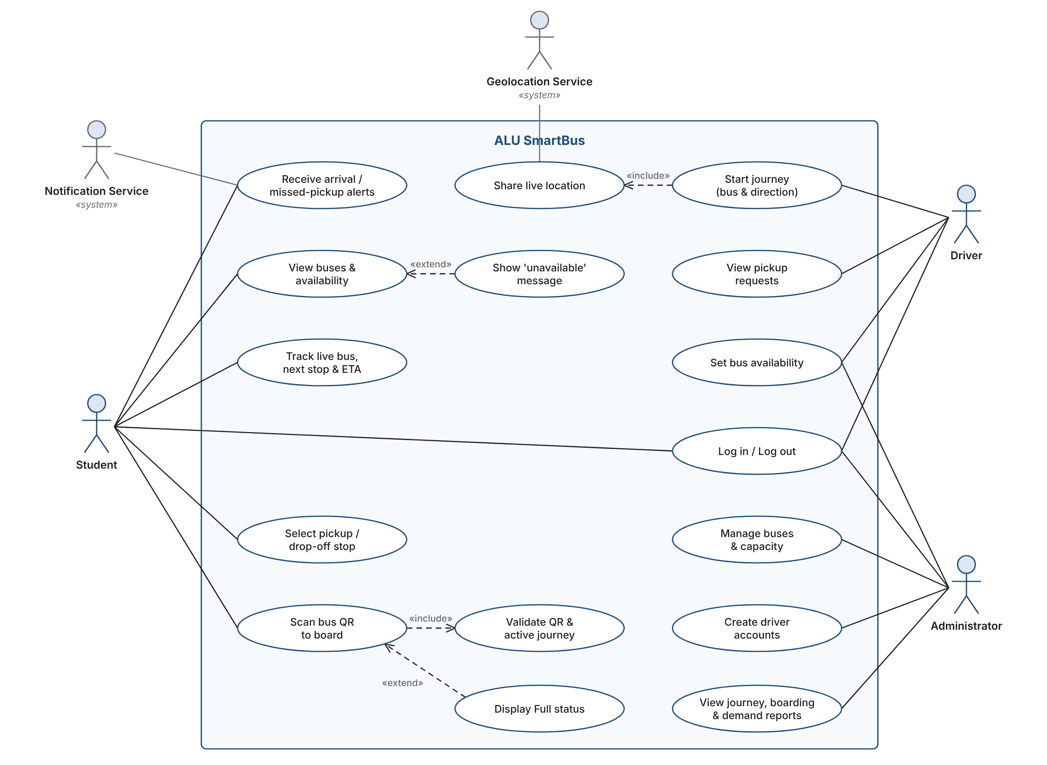
Figure B.1. ALU SmartBus use case diagram.
- System boundary: the rectangle “ALU SmartBus”. Use cases are inside it; actors are outside.
- Actors: Student, Driver and Administrator are primary actors because they start the use cases. Geolocation Service and Notification Service, marked «system», are secondary actors: outside services the system calls on.
- Use cases and associations: each oval is one goal; a solid line shows which actor takes part in it.
- «include»: the base use case always uses the included one. Starting a journey always includes sharing the live location, and scanning the QR always includes validating it (FR-40, FR-41).
- «extend»: the extending use case happens only under a condition. “Show ‘unavailable’ message” happens only when a student picks an unavailable bus (FR-08), and “Display Full status” only when capacity is reached (FR-53).
Actor | Input | Output
Student | Login, chosen bus and stop, QR scan | Live map, next stop, ETA, boarding confirmation, alerts
Driver | Bus, direction, Start tap, availability | Active journey, pickup list, Full badge
Administrator | Bus details, capacity, driver accounts, report period | Bus list, journey, boarding and demand reports
Geolocation / Notification Service | Request from the system | GPS position / alert on the student’s phone

B.2 Class Diagram
What it is. A class diagram shows the building blocks of the software: the classes, their attributes and operations, and how they are related. It is also the base for the database tables in Section 3.3.
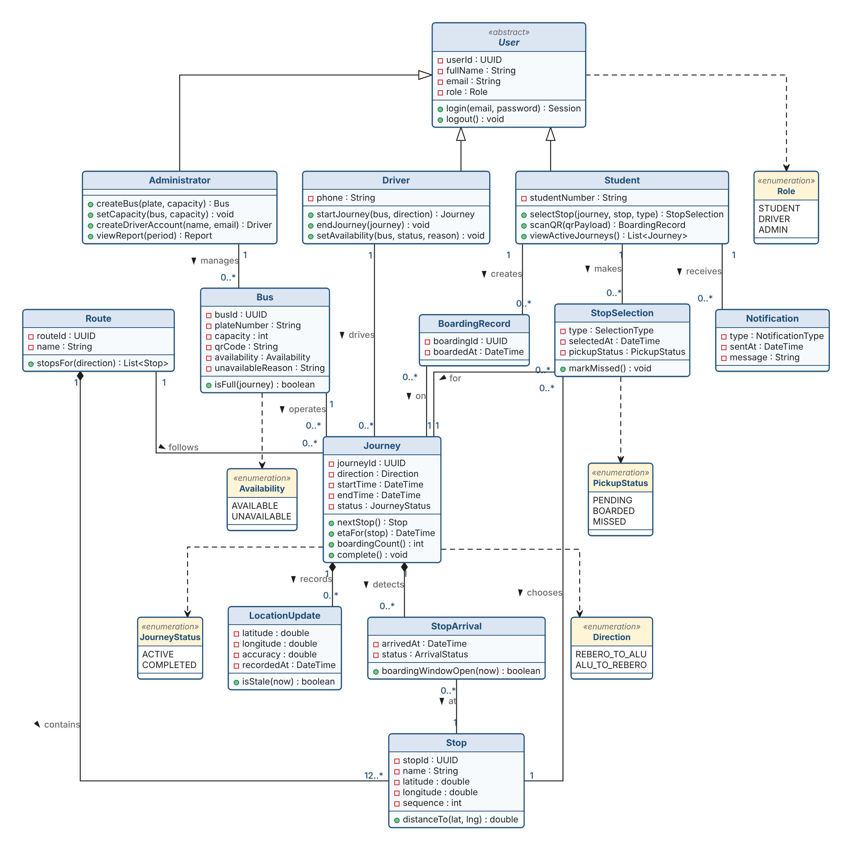
Figure B.2. ALU SmartBus class diagram.
- Class box: name at the top, attributes in the middle, operations at the bottom. A red square means private and a green circle means public.
- Main classes: User is abstract and is specialised into Student, Driver and Administrator, so each role only gets its own operations (FR-02, NFR-10). Journey is the centre of the design: it links a bus, a driver and a route, and holds the location updates, stop arrivals and boardings for one trip.
- «enumeration» boxes list the only values allowed, for example a Journey is ACTIVE or COMPLETED.
- Multiplicities at the line ends: “1” means exactly one, “0..*” zero or more, “12..*” at least twelve.
Relationship | UML symbol | Meaning
Student, Driver, Administrator → User | Generalisation (hollow triangle) | Each role is a kind of User and inherits login/logout.
Route ◆— Stop; Journey ◆— LocationUpdate, StopArrival | Composition (filled diamond) | The parts belong to the whole and do not exist without it.
Driver, Bus, Route — Journey (1 to 0..*) | Association | One driver, bus or route has many journeys over time.
Student — StopSelection, BoardingRecord, Notification | Association | A student makes selections, boards journeys (once each, FR-42) and receives alerts.
Classes → enumerations | Dependency (dashed arrow) | The class uses the enumeration for an attribute.

B.3 Sequence Diagrams
What it is. A sequence diagram shows how the parts of the system exchange messages over time for one scenario, from top to bottom. Each part has a dashed lifeline; solid arrows are requests, dashed arrows are replies, and an arrow back to the same lifeline is internal work. Frames show “loop” (repeat), “alt” (choose one path) and “opt” (only if the condition in brackets is true). Messages are numbered in order.

B.3.1 Start journey and live tracking
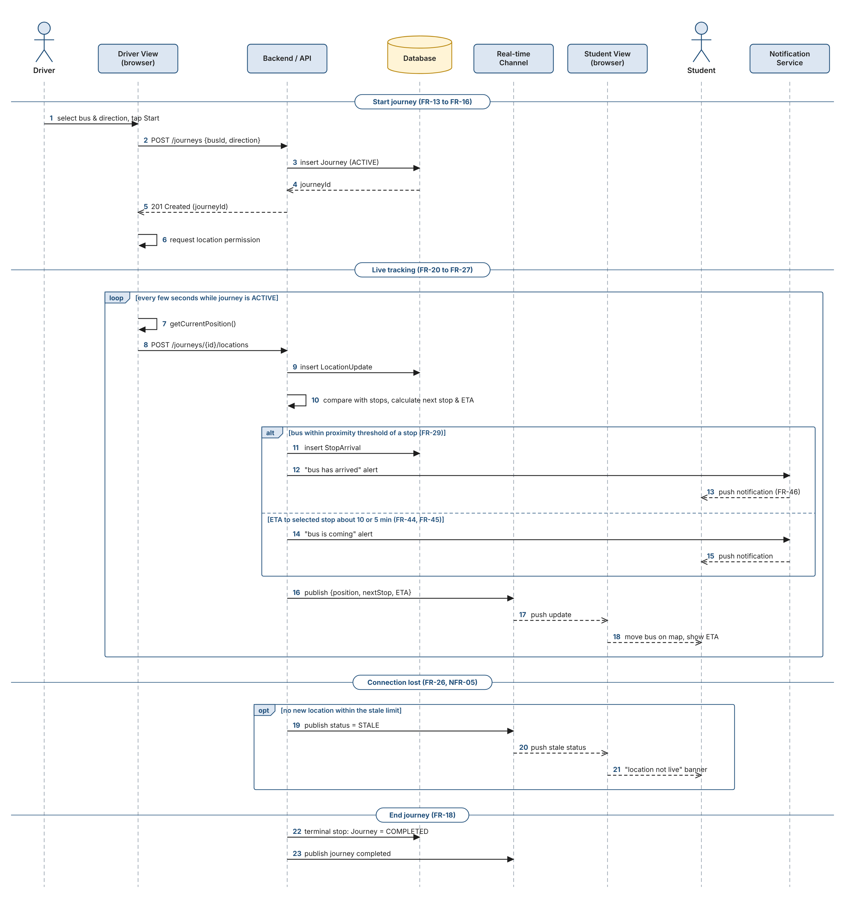
Figure B.3.1. Sequence diagram: start journey, live tracking, ETA and alerts.
- 1–6: the driver starts the journey; the backend saves it as ACTIVE.
- 7–18 (loop): the driver’s phone sends its position every few seconds; the backend saves it, works out the next stop and ETA, sends “arrived” or “coming” alerts (alt), and pushes the update to the Student View.
- 19–23: if updates stop, students see “location not live” (NFR-05); at the terminal stop the journey is marked COMPLETED.
Input: bus, direction and GPS positions. Output: live position, next stop, ETA, alerts and a saved journey.

B.3.2 QR boarding
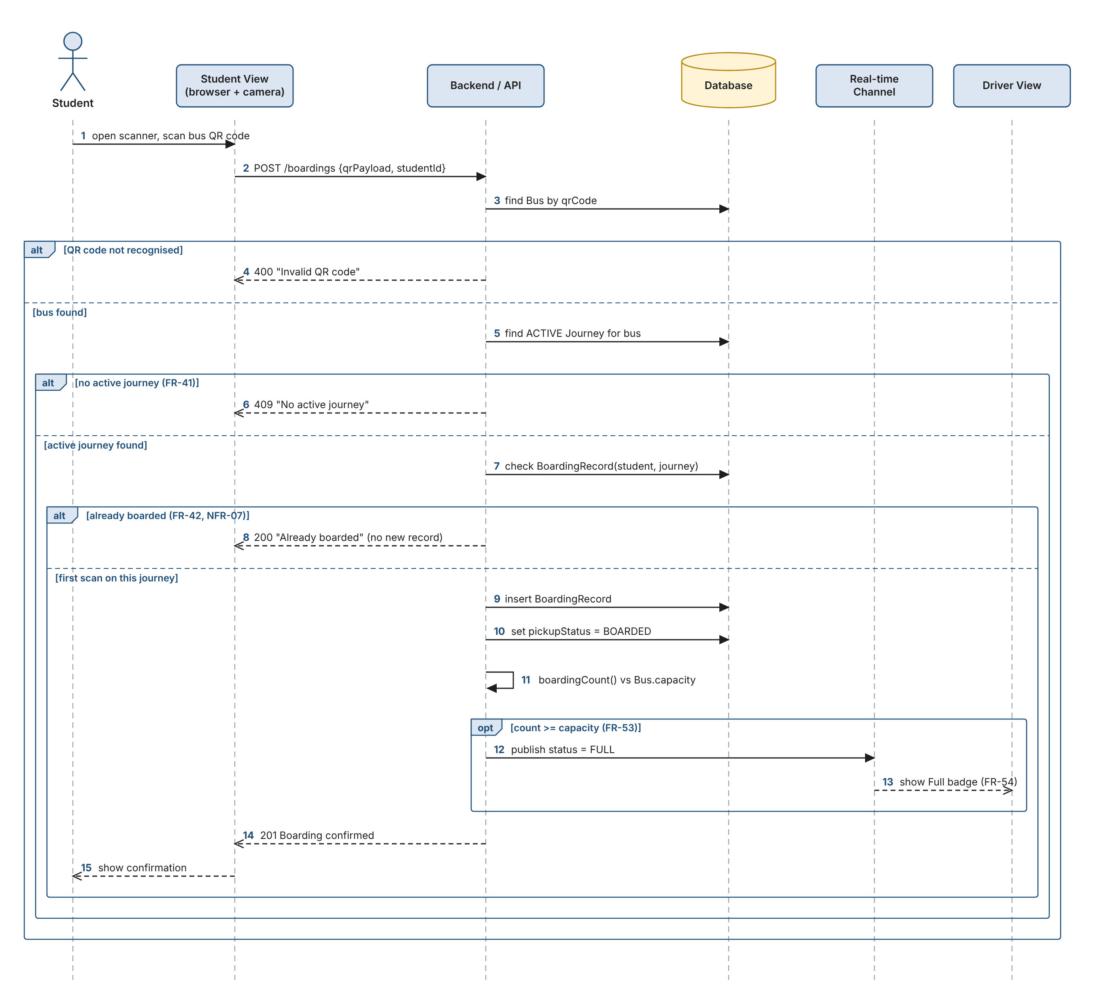
Figure B.3.2. Sequence diagram: QR boarding and Full status.
- 1–8 (nested alt): the scan is rejected if the QR code is unknown, the bus has no active journey (FR-41), or the student already boarded (FR-42).
- 9–15: otherwise the backend saves the boarding, marks the pickup BOARDED and, if capacity is reached, shows the driver a Full badge (opt, FR-53, FR-54).
Input: QR code and the logged-in student. Output: a boarding record or an error message, and a Full status when capacity is reached.

B.4 Component Diagram
What it is. A component diagram breaks the system into its main software parts and shows the interfaces they provide or need and how they depend on each other.
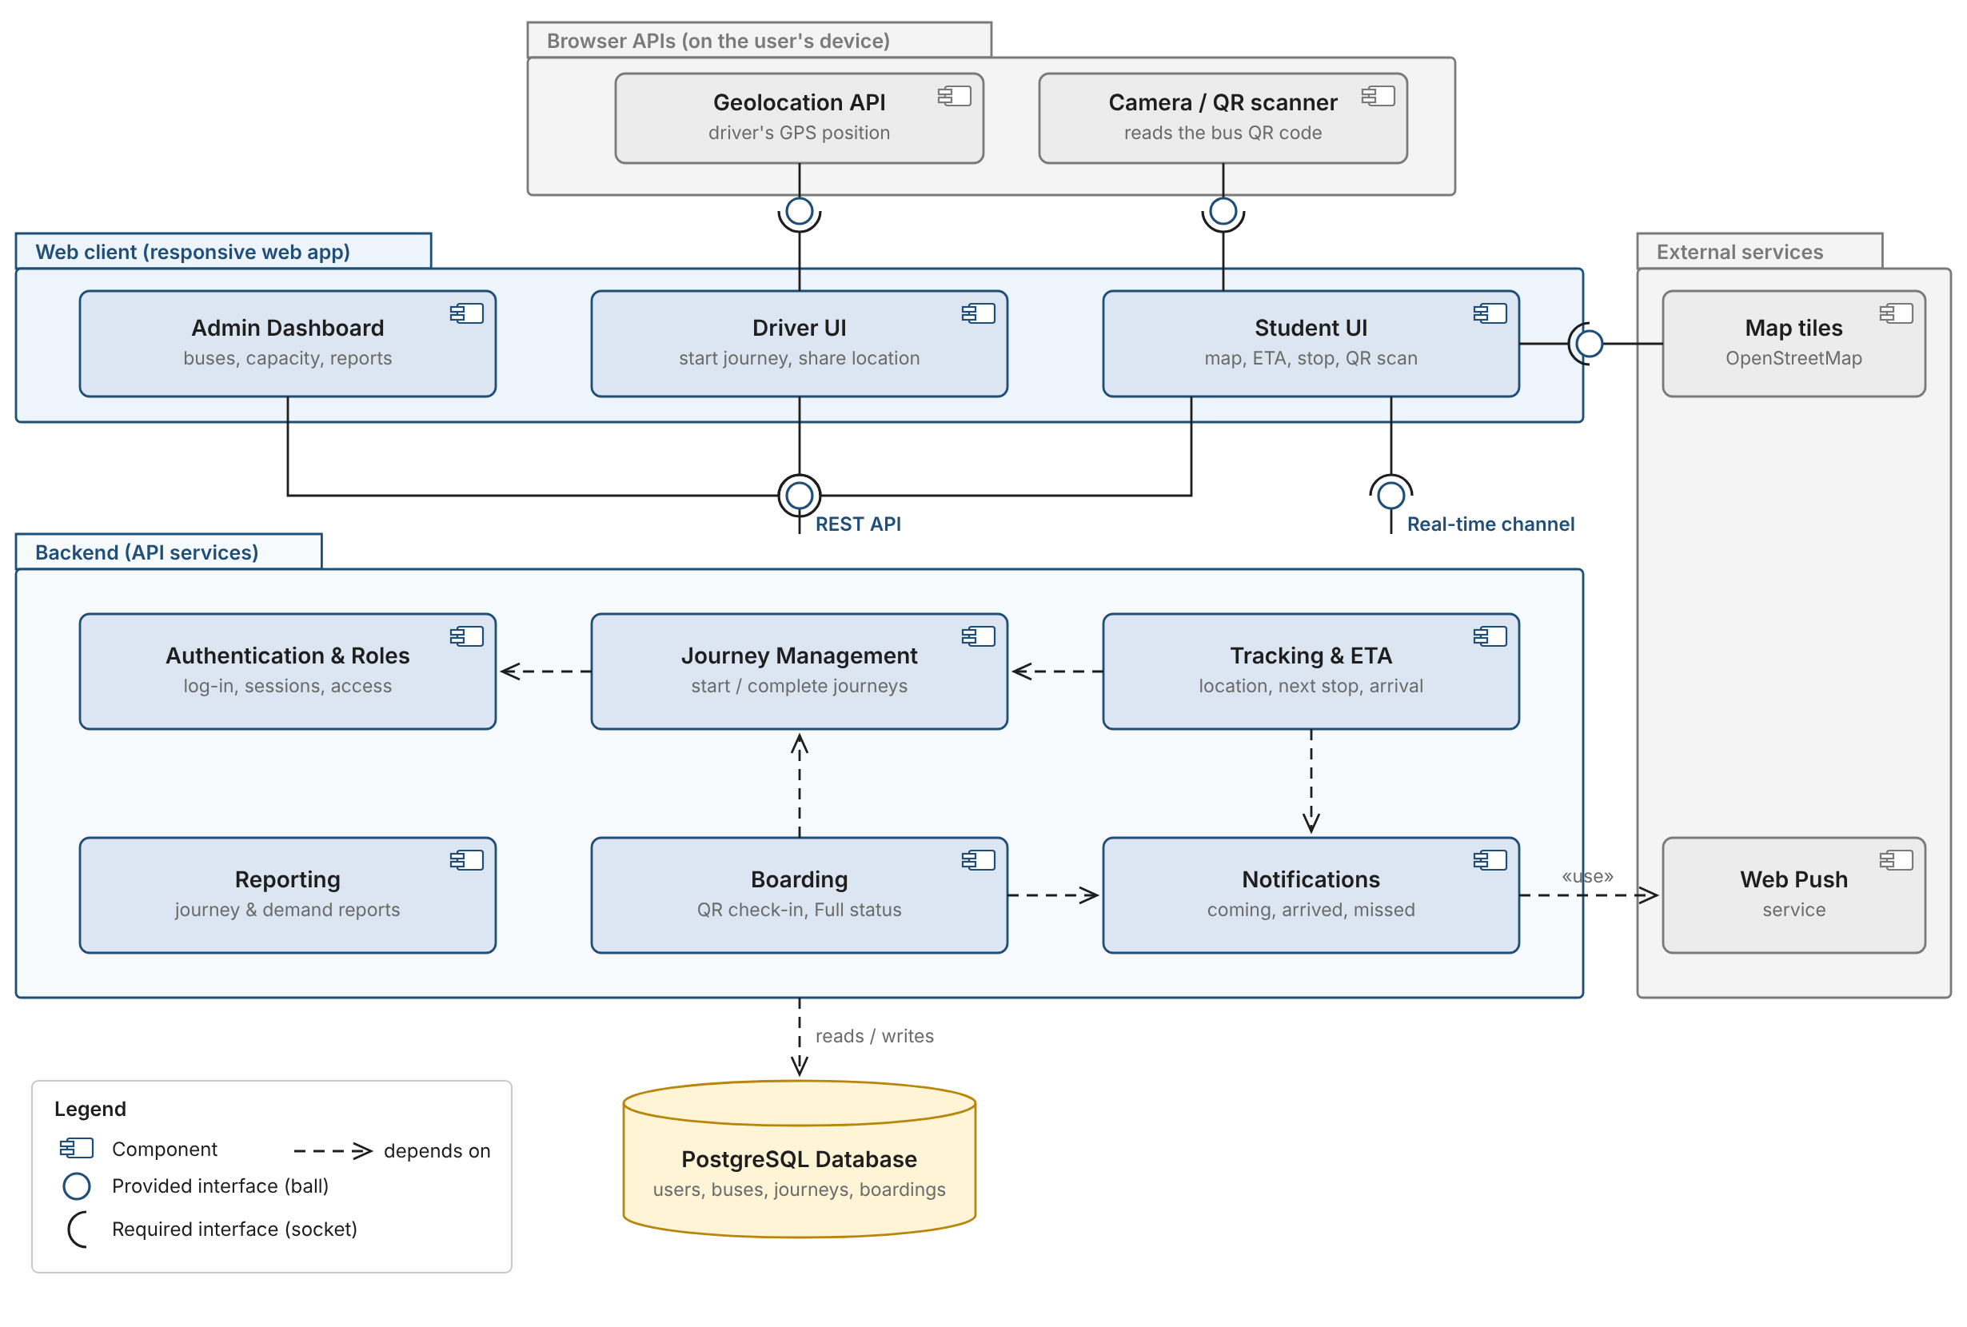
Figure B.4. ALU SmartBus component diagram.
- Components and packages: each box with the two-tab icon is one part of the software, grouped by where it runs: web client, backend, browser APIs and external services.
- Interfaces: a ball is a service a component provides; a socket is a service it needs. The backend provides the REST API (used by all three UIs) and the real-time channel (used by the Student UI). The Driver UI needs the Geolocation API, and the Student UI needs the camera and map tiles.
- Dependencies (dashed arrows): Tracking & ETA and Boarding depend on Journey Management, because both only work during an active journey (FR-20, FR-41), and both trigger Notifications. Journey Management depends on Authentication & Roles, and the whole backend reads and writes the database.
Each backend component matches one feature group in Section 4, which keeps the logic separate (NFR-21) and lets a future mobile app reuse the same backend (NFR-20).

Appendix C: Proposed Technology Stack
Layer | Proposed choice
Frontend | Responsive web app using HTML, CSS, TypeScript and React
Backend, database and authentication | Supabase services with PostgreSQL
Hosting | Vercel
Maps | Leaflet with OpenStreetMap
Device features | Browser Geolocation API and a JavaScript QR-scanning library
I will confirm these choices in Sprint 1 after checking the costs, free-tier limits, browser support and security settings.

References
Mwasa, F., & Kamanzi, S. (2026, June 8). Public bus usage rises 15% after rapid transit network became operational. KT Press. https://www.ktpress.rw/2026/06/public-bus-usage-rises-15-after-rapid-transit-network-became-operational/
Ngabonziza, D. (2025, December 3). Kigali’s new bus lane and the stubborn motos. KT Press. https://www.ktpress.rw/2025/12/kigalis-new-bus-lane-and-the-stubborn-motos/
Republic of Rwanda. (2021). Law No. 058/2021 of 13/10/2021 relating to the protection of personal data and privacy. Official Gazette of the Republic of Rwanda.
Schwaber, K., & Sutherland, J. (2020). The Scrum guide. https://scrumguides.org/scrum-guide.html
Top Africa News. (2025, December 2). Kigali commuters decry long waiting hours for public buses as MININFRA unveils a new system to cut waiting time to 10 minutes. Top Africa News. https://www.topafricanews.com/2025/12/02/kigali-commuters-decry-long-waiting-hours-for-public-buses-as-mininfra-unveils-a-new-system-to-cut-waiting-time-to-10-minutes/
Vissoci, J. R. N., Krebs, E., Meier, B., Vieira, I. F., de Andrade, L., Byiringiro, F., Rulisa, S., & Staton, C. (2020). Road traffic crash experience among commercial motorcyclists in Kigali, Rwanda. International Journal of Injury Control and Safety Promotion, 27(2), 181–187. https://doi.org/10.1080/17457300.2020.1724158
Watkins, K. E., Ferris, B., Borning, A., Rutherford, G. S., & Layton, D. (2011). Where is my bus? Impact of mobile real-time information on the perceived and actual wait time of transit riders. Transportation Research Part A: Policy and Practice, 45(8), 839–848. https://doi.org/10.1016/j.tra.2011.06.010

