Post-PC final project:

**BeepMe!**

Teacher: Dr. Amnon Dekel

Students:

Nili Davidor, [nili.davidor@mail.huji.ac.il](mailto:nili.davidor@mail.huji.ac.il), ID 300641834

Ofir Marcus, [ofir.marcus@mail.huji.ac.il](mailto:ofir.marcus@mail.huji.ac.il), ID 201618469

[**https://github.com/ndavidor/BeepMe**](https://github.com/ndavidor/BeepMe)**,** 30/09/13

**Prologue – a real life dilemma!**

… You are waiting for your Dentist appointment [located at the Mall].

It is scheduled for 13:30 PM, and unfortunately you have skipped lunch.

The time is 13:20, and there are 2 patients pending before you.

Your mouth will be numbed after the appointment so you will not be able to eat for at least three more hours…

**Do you have enough time to grab a quick lunch???**

**BeepMe! - Concept**

BeepMe! consists of two applications: Business application and Client application.

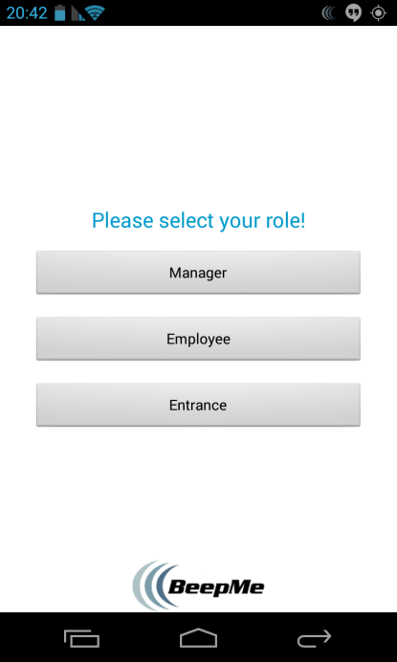BeepMe! [Business] application will allow multi-queues maintenance and care for businesses [Kupat Holim, Pelephone, etc].

Business model: purchasable.

The BeepMe! for business application consists of three flows:

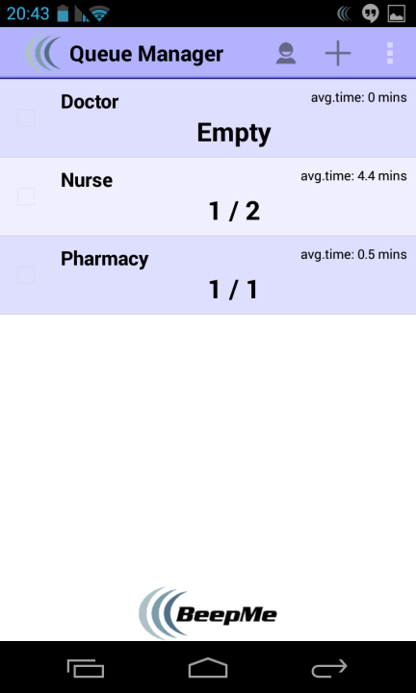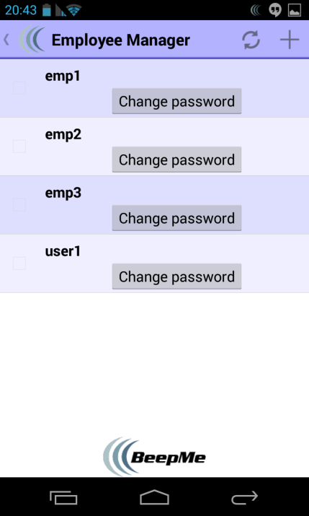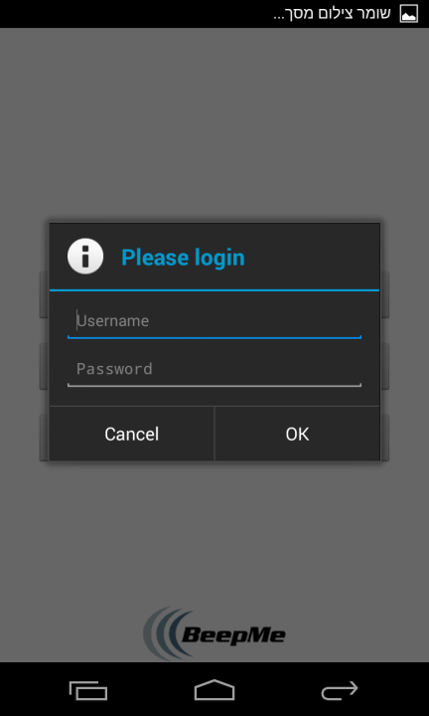Manager (administrator, secured access) can maintain the queues list, and his employees.

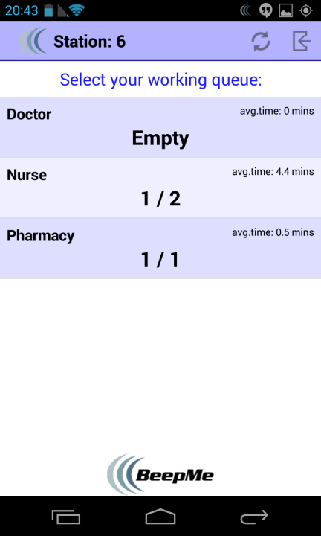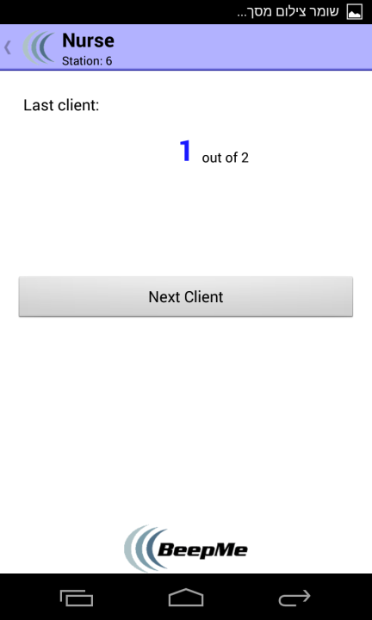An Employee (secure access) can process a single queue and call for the next pending customer.

The entrance screen is the main interaction with the customers. It is a one-click & one-scan flow, in which the customer registers himself to the desired queue.

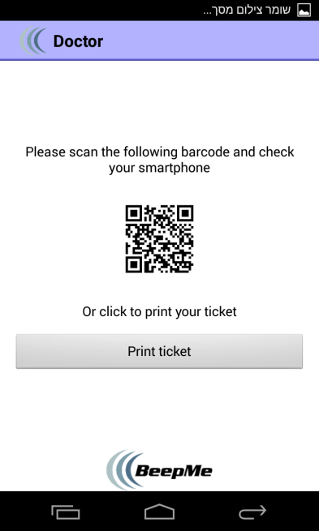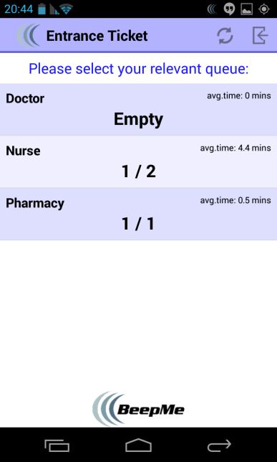

Backward compatibility: users without Android devices will have to print their ticket and use the old-fashioned way of electronic signs or rotating numbers…

Using BeepMe! [Client], one could queue without physically stand in line and get constant status updates.

BeepMe! [Client] serves like a beeper at money time: Beeps when turn is about to arrive, when user is too far [location], etc.

Business Model: downloadable, free of charge. One screen to rule them all!

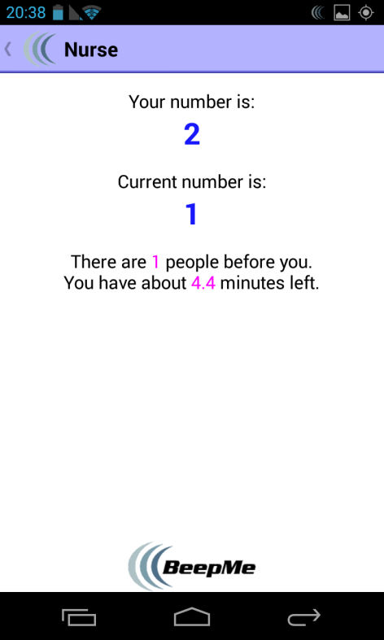Our client will enable the users to scan their desired queue, and from that moment on, their mobile device will serve them as a beeper. It will beep whenever their turn is near, whenever they are too far, and will keep a visual indication of the queue at all times.

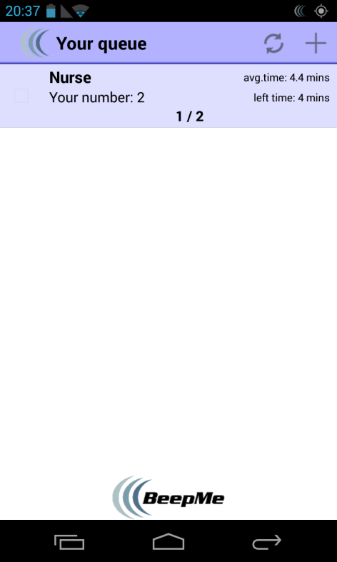

Architecture: Business

DAL: Parse entities & DB wrapper

BLL: ParseBroadcastReceiver, Printer (Google Cloud Print), Update services (queues & employees), activities

UI: All UI seen in Concept page

External Libraries:

* ActionBar (common with Customer)
* ZXing

You can view our design using the following UMLs (original images with better resolution in our github repository):

* DB UML <https://github.com/ndavidor/BeepMe/blob/master/BeepMeBussiness/BeepMeBusinessDB.png>
* Model UML <https://github.com/ndavidor/BeepMe/blob/master/BeepMeBussiness/BeepMeBusinessModel.png>
* UI UML <https://github.com/ndavidor/BeepMe/blob/master/BeepMeBussiness/BeepMeBusinessUI.png>

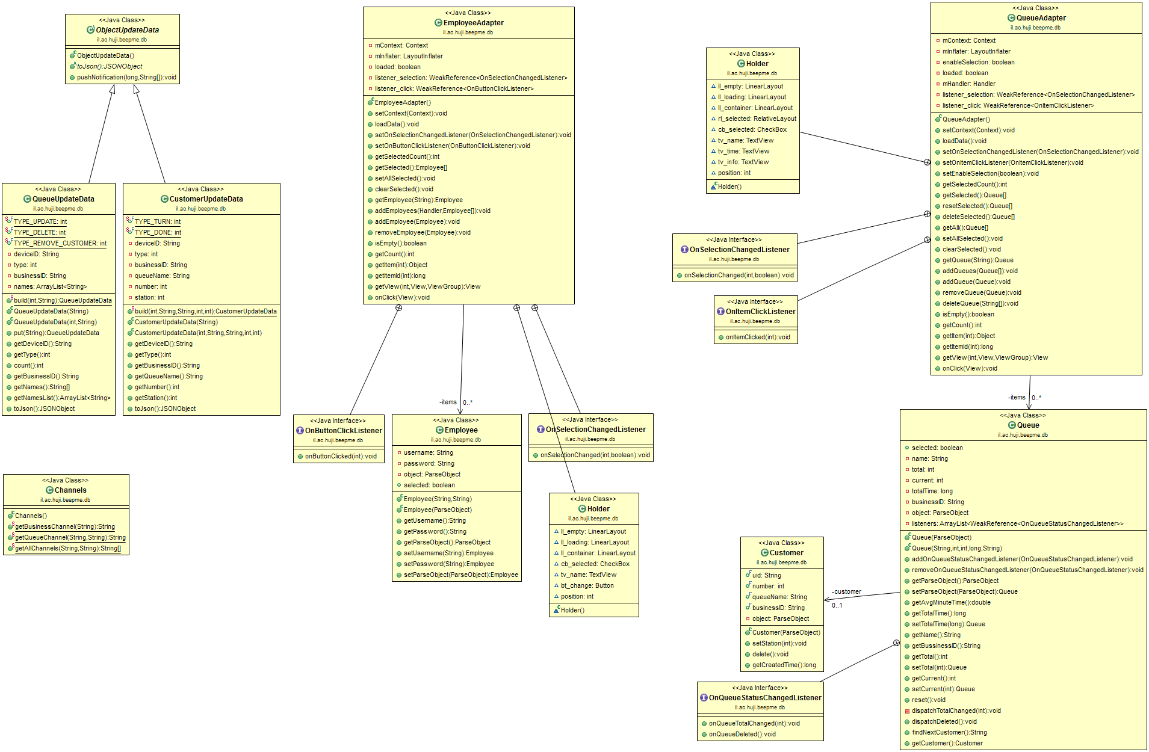

**DB UML**

**Model UML**

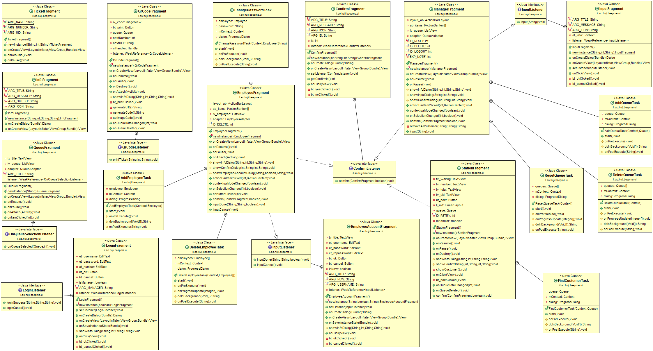

**UI UML**

Architecture: Client

DAL: Parse entities & DB wrapper

BLL: ParseBroadcastReceiver, LocationWatcher, Update services (queues & customer), activities

UI: All UI seen in Concept page.

External Libraries:

* ActionBar (common with Customer)

You can view our design using the following UMLs (link to our github repository with better resolution):

* DB UML <https://github.com/ndavidor/BeepMe/blob/master/BeepMeCustomer/BeepMeCustomerDB.png>
* Model UML <https://github.com/ndavidor/BeepMe/blob/master/BeepMeCustomer/BeepMeCustomerModel.png>
* UI UML <https://github.com/ndavidor/BeepMe/blob/master/BeepMeCustomer/BeepMeCustomerUI.png>

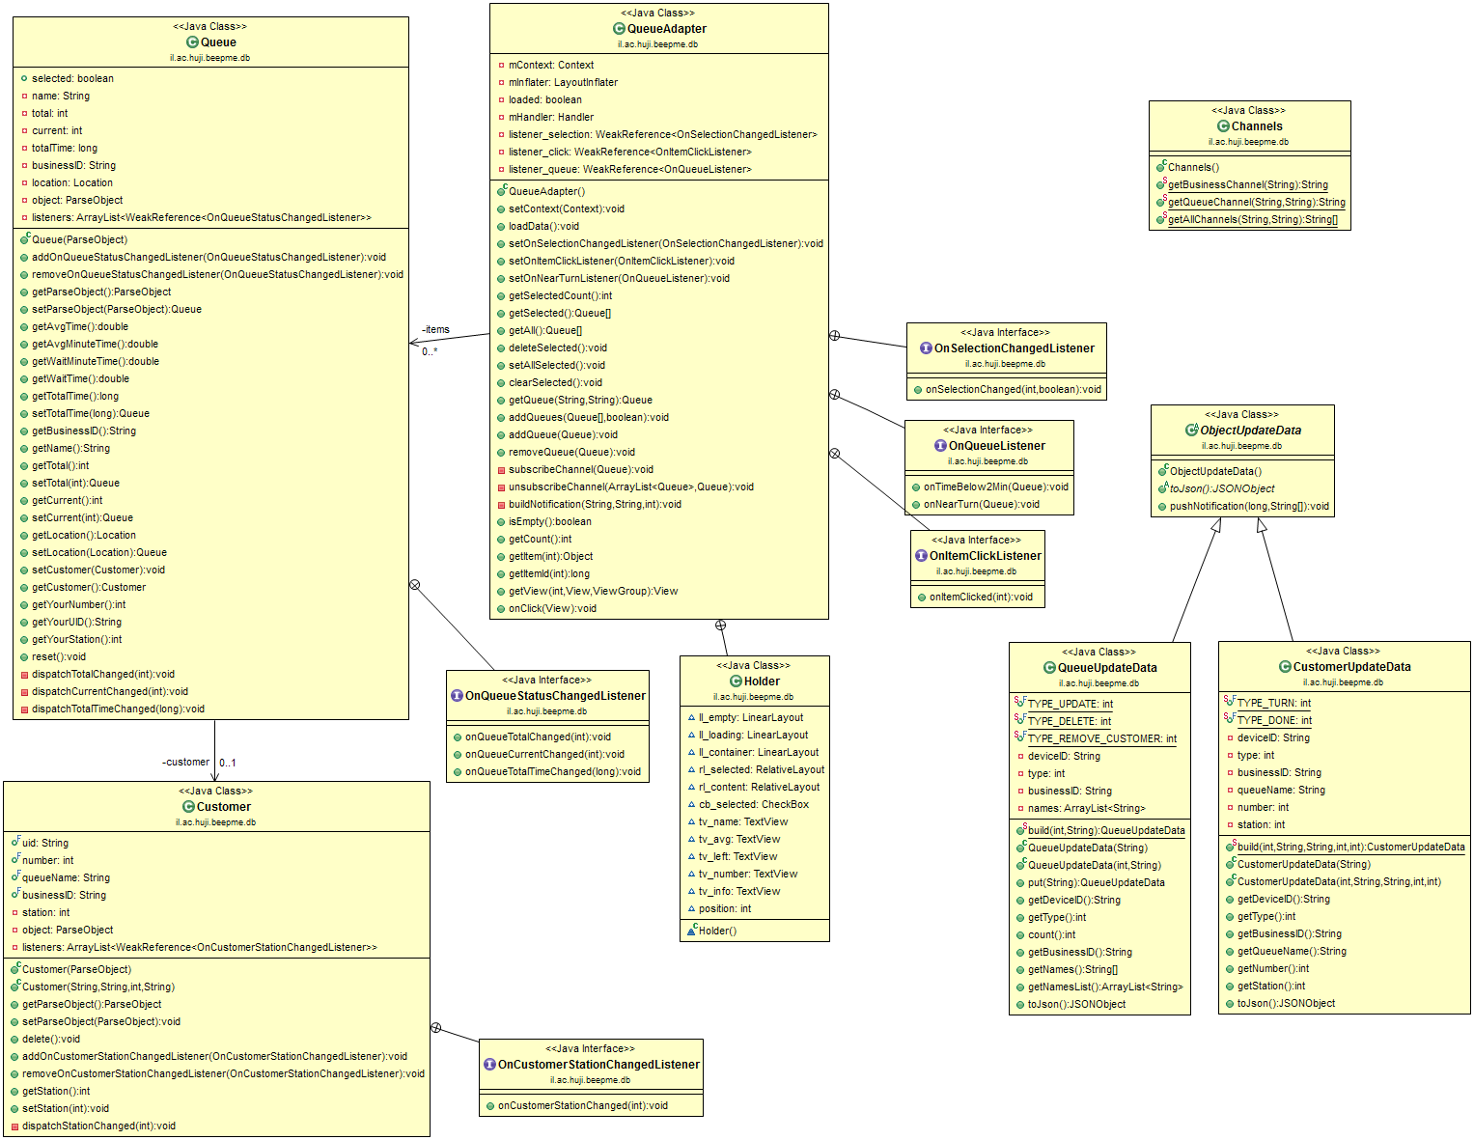

**DB UML**

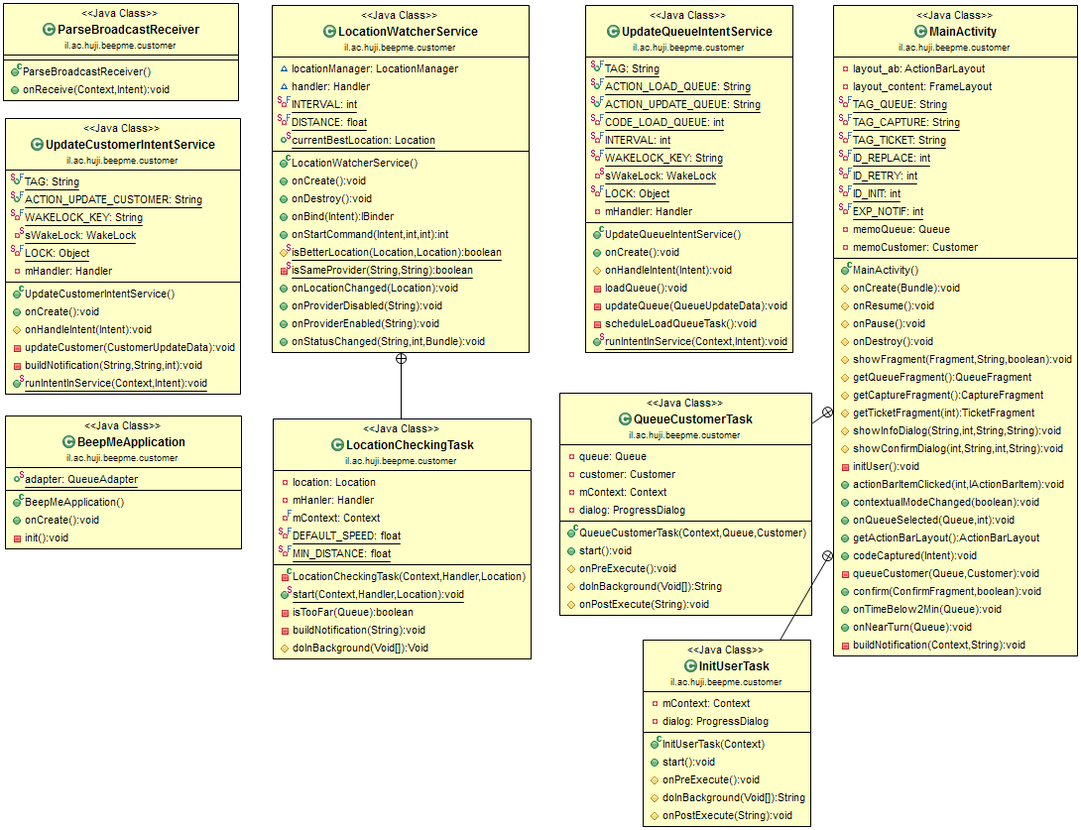

**Model UML**

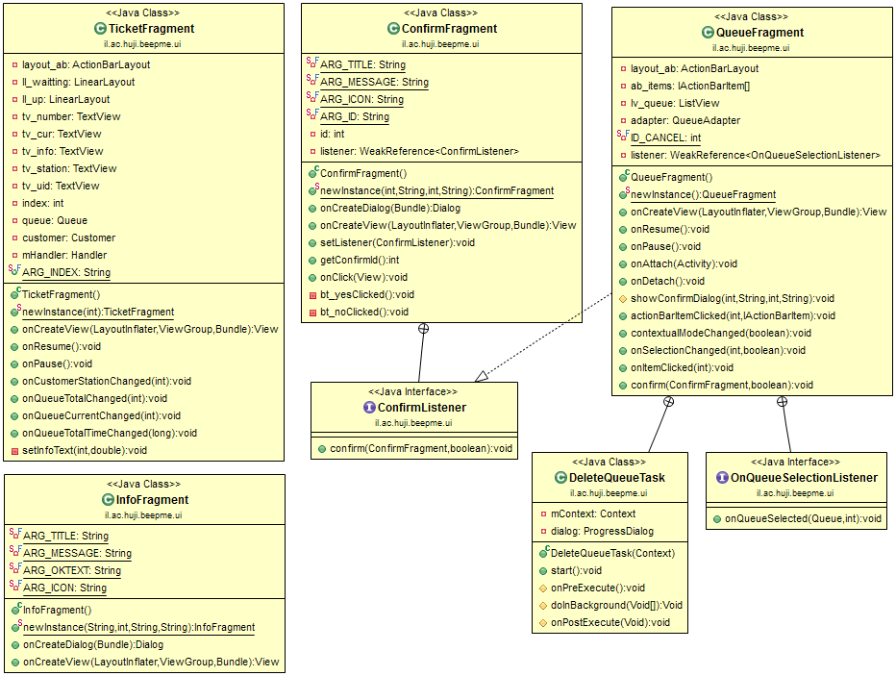

**UI UML**

**To sum it up…**

Thank you for allowing us to explore the wonderful world of Android and post-PC. We have learned a new technology that is integrated in our lives so deeply!

We enjoyed creating BeepMe! and hope you will one day run into it while queuing in a business near you…