CS 6378 Project 2

Nicholas Baker - ndb180002

Jaden Dick - jrd180002

# Varying Inter-Request Delay

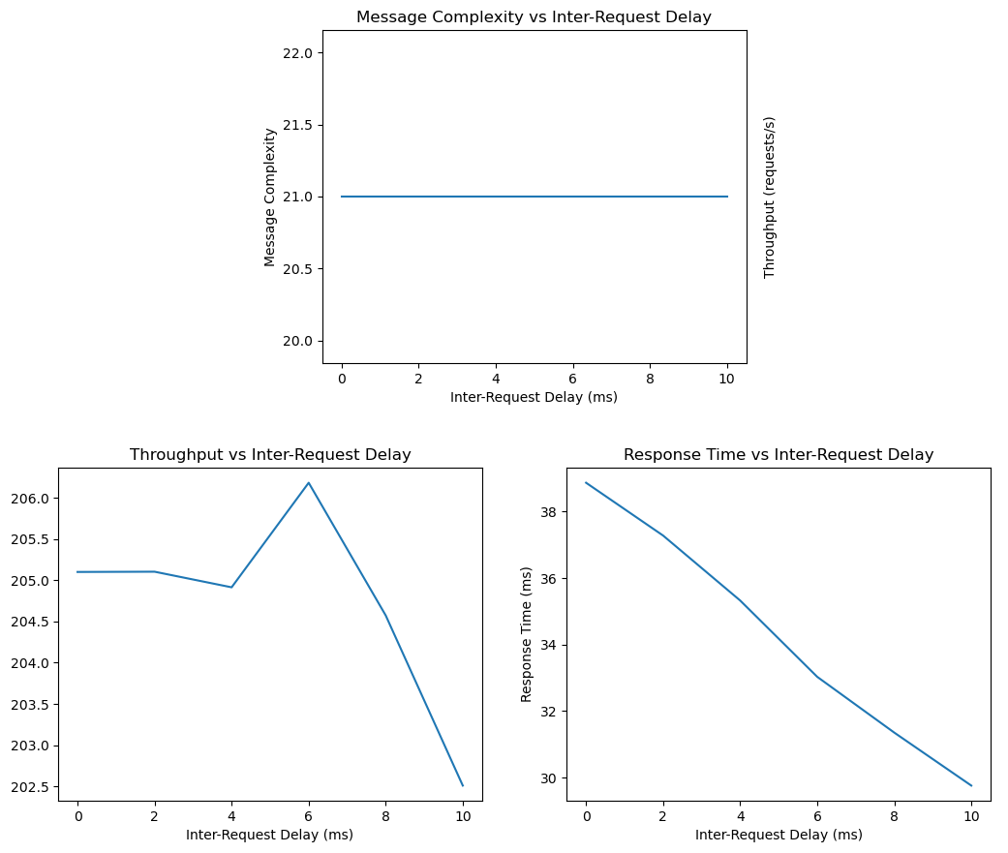

# Varying Critical Section Execution Time

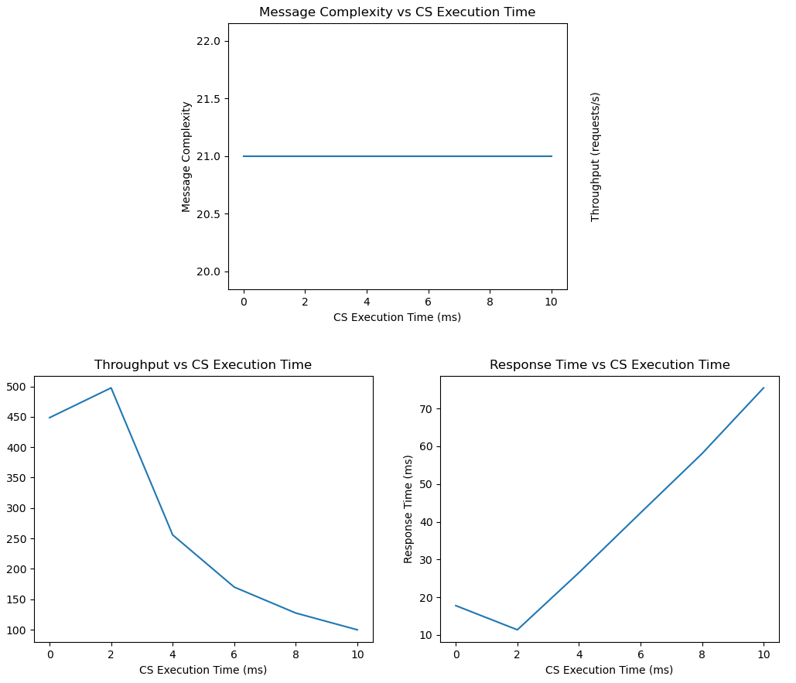

# Results

Message complexity is constant as there are no optimizations to the Lamport algorithm. With 8 nodes, there are 7 neighbors. For each CS request, a node will send a request to each neighbor, a release to each neighbor, and a reply to each neighbor that generated their own CS request. This gives 21 messages total.

Throughput decreases in both case since we are introducing more delay into the system. Throughput is based on the total run time so increased delay means a higher run time while still processing the same number of requests.

Response time decreases with increased inter-request delay due to the reduction in competition. Since nodes spend more time waiting to generate a request, it is easier for other nodes to reach the front of their queue and begin their CS.

Response time increased with increased critical section execution time since the two are directly related. Response time includes the time to execute the critical section so obviously increasing one increases the other.