**README**

The code is written in Python 2.7, to run the server make sure you enable the floodlight per the manual:

* cd floodlight
* ant
* java -jar target/floodlight.jar

then from the ~ directory, you should be able to run

* sudo python2.7 Homework3.py

There will be places to press Enter to get the machine to continue through a Parts 1 and 2.

**Part A**

**Step 1.1 What are the Type/Code values for an ICMP echo request and echo reply packet,  
respectively? Is there any difference between the two packet captures (if so, what)?**

The Type and Code for the request is 8 and 0 respectively. The Type/Code for the reply are both 0’s for the request. The Type is different for the request and the reply.



**Step 1.2: How do the Identifier and Sequence Number compare for an echo request and the  
corresponding echo reply? Is there any difference between the two packet captures (if so, what)?**

The Identifier has two positions BE and LE, which are 15798 and 46653 respectively. The Sequence Number has two positions BE and LE, which are 1 and 256 respectively. The Identifier and Sequence number is the same for both request and reply even across h1→h2 and h1→h5.

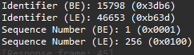

**Step 1.3: Is the data in the echo reply the same as in the echo request or different? Is there any  
difference between the two packet captures (if so, what)?**

The reply and the request both have the same data being sent to one another, even across both pings. The only difference is the Type, the request is an 8 and the reply is a 0, otherwise they are the same packet.

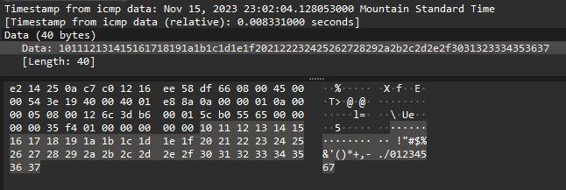

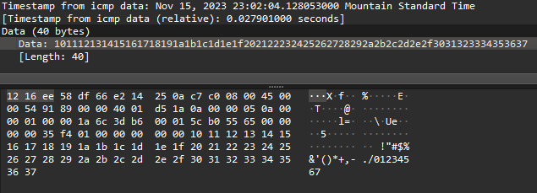

**Step 2.1: What is the rough data rate in the download direction (H1 -> H2 and H1 -> H5) in  
packets/second and bits/second once the TCP connection is running well? Is there any difference  
between the two packet captures (if so, what)?**

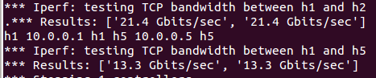

For h1→h2 the download speed is [21.4 Gbits/sec, 21.4 Gbits/sec] and h1→h5 is [13.3 Gbits/sec, 13.3 Gbits/sec]. Where the left number is the speed from h1 and the right number is the reply (h2 and h5 to h1). I also noticed that while wireshark was running the speed was considerably slower at [3.30 Gbits/sec, 3.31Gbits/sec] and [2.21Gbits/sec, 2.21Gbits/sec] respectively. In comparing the [FIN, ACK] portion of the communication, I have determined that the raw acknowledgment number and the raw sequence number are different between the two types of host connections. In addition the Stream Index is different between the two as well as the source port (which is pretty obvious).

**Step 2.2: If the most recently received TCP segment from the server has a sequence number of X,  
then what ACK number does the next transmitted TCP segment carry? Is there any difference between the two packet captures (if so, what)?**

The ACK number depends on what part in the handshake the system’s are with eachother. If it was one of the first few packets, the ACK number for the next packet would have most likely been 1. When establishing connection, there are no payloads sent which means no data, in this case the ACK would be X + 0, where X is presumably 1. If the segment is carrying data the ACK number would increase based on the number of bytes of data the server has received plus the previous amount of bytes received. My lab had a tough time establishing a connection, so the best evidence I could get was this:

