AXI-Lite Wrapper for ARINC 717 Protocol IP
Complete Design Specification
Single RX (HBP/BPRZ selectable) · Dual TX (HBP + BPRZ) · 128-word Async FIFOs (FIFO_DEPTH parameter) · CDC-safe config/status · TX/RX path operation · Full registers · FIFO & IRQ modes · Sync detection
Revision History
Table 1 lists the revisions of this document.
Table 1: Revision History
Date | Rev | Change
2026-10-15 | 1.0–1.23 | First full specification: memory map, registers, FIFOs, interrupts, reset, TX Timing Generator, HBP / BPRZ encoders and decoders, sync detection, pseudo-code and diagrams. RX path in detail (sample_tick, level classification, decoder examples). Word rates 64 ... 8192 words/s; FIFO_DEPTH as a synthesis parameter (default 128).
2026-10-19 | 1.24–1.48 | Receive path regrouped (3.2.1 bit front-end, 3.2.2 sync detection, 3.2.3 word framing). Timing base core_clk = 48 MHz with 16 samples per bit cell (sample rate = W x 192, 4-sample dwell, HBP windows 0..7 / 8..13, tolerance -2 / +4 samples); all formulas, tables, pseudo-code, examples, figures, tests and the reference model rescaled; 8192 words/s optional. Data ports TX_WR_EN / TX_WR_ADDR / RX_RD_EN / RX_RD_ADDR (Section 7.7); FIFO level / room registers removed; built-in pattern injector with INJ_CTRL / INJ_STATUS (Section 12.14); test points, test patterns, test plan, board self-test and per-rate test vectors (Sections 12.10 - 12.13); ST_UNDERRUN interrupt; hardware reset with reset synchronizers and reset-done flags; Section 4.2.5 (clock frequencies, synchronizers, constraints, FIFO memory); parameter INCLUDE_INJECTOR; table of fixed design constants; the term bit cell.
2026-10-22 | 1.49–1.52 | HBP decoder: two new framing-error checks in tracking mode (minimum edge distance of 6 samples; no two mid-cell edges in a row). BPRZ decoder: timeout reduced from 24 to 16 samples so that a lost pulse is detected; new check for two bits less than 10 samples apart. New requirements REQ-RX-06 to REQ-RX-08, tests ER-04 to ER-08, reference model and vectors updated.
2026-10-26 | 1.53–1.62 | Bit errors after lock (Section 3.2.4): every bit has bit_err, the word error flag is bit 12 of the 13-bit RX FIFO entry, the receiver keeps INSYNC after an error (HBP re-synchronization window, BPRZ placeholder bit, one-bit hold) and RX_ERR_LIMIT consecutive bad bits end INSYNC. New registers RX_ERR_LIMIT, RX_ERR_CLEAR, RX_BIT_ERR_CNT, RX_WORD_ERR_CNT, RX_BIT_ERR_POS, RX_BIT_ERR_POS0, RX_BIT_ERR_CAUSE and RX_ERR_CTRL (ERRCHK_ENB, reset 0: the check is optional); interrupt ST_BIT_ERR; a sync word with a wrong code ends INSYNC, with the right code it is accepted. REQ-RX-09 to REQ-RX-14, tests ER-09 to ER-23. Bit Error Check block and its connections (Section 3.2.4.9).
2026-10-28 | 1.63–1.74 | Consistency review of Section 3.2.4 and the port tables; both FIFOs 16 bits wide. Counters, positions and cause live on s_axi_clk and are loaded from core events; they are cleared by RX_ERR_CLEAR, by SOFT_RESET and when GLOBAL_EN AND RX_EN rises. New read-only register RX_BIT_POS_NOW (RX base + 0x60, address 0x00C0): bit, word, subframe and frame of the receiver, valid while INSYNC = 1 with ERRCHK_ENB = 0 or 1, REQ-RX-15, tests ER-24 to ER-26. The frame counter is independent of ERRCHK_ENB; in NOSYNC mode the word, subframe and frame fields are 0.
2026-11-02 | 1.75–1.81 | Final review: register access rules of the bit-error registers; Bit Error Check added to the RX PATH list (Section 2.1); MATCH in the RX_STATUS description; per-rate vector table lists the 9 output edges; requirement index and test plan sorted; with ERRCHK_ENB = 0 a BPRZ line that stops for good leaves INSYNC = 1 (Section 3.2.4.8, test ER-20); wording and cross-reference fixes; references to other cores and external sources removed.
2026-11-04 | 1.82 | Sync watchdog (Section 3.2.3.1): while INSYNC = 1, if no sync word is accepted within 1.5 subframes (288 x W RX sample_ticks) INSYNC falls and ST_INSYNC_LOST is raised, like after a wrong word 0. It also ends the lock on a BPRZ line that stops with ERRCHK_ENB = 0. New REQ-SYNC-06, test SY-08, constant in the table of fixed design constants, rx_sync_detect input sample_tick; reference model updated.
2026-11-06 | 1.83 | The time limit of the sync watchdog is programmable: new register RX_SYNC_WD (RX base + 0x64, address 0x00C4, MARGIN[7:0], limit = (16 + MARGIN) x 12 x W RX sample_ticks, reset 8 = 1.5 subframes, 0 = off; at least 3 for the longest legal bit cell). Register tables, configuration bundle, access rules, port table, REQ-SYNC-06, test SY-08 and the reference model updated. New field RX_STATUS.LOST_CAUSE[1:0] (bits [9:8]) gives the reason of the last loss of INSYNC (REQ-SYNC-07, test SY-09). Redundant heading Hardware reset removed from Section 5.2.
2026-11-11 | 1.84 | Writing conventions applied to the whole document: American English, ISO dates, "shall" for every mandatory rule, italic signal and register names, blue keywords in code, captions in the form "Table x:" and "Figure x:", bold table headers on a light fill, A4 page with the new margins, Arial 11 pt text. Every table and figure is now referred to in the text. Clarified which registers RX_ERR_CLEAR clears (Section 2.4), the rate sentence of Section 3.1.3 and the section reference in Section 12.11.2.
2026-11-16 | 1.85 | HBP decoder (Section 3.2.1.2): new framing-error check for the maximum distance between edges (HBP_MAX_GAP = 14): a mid-cell edge, or a boundary edge that follows a mid-cell edge, arriving 14 samples or more after the previous edge is a framing error. It closes the case of a short glitch (2 to 3 samples) right after a boundary edge, which delayed the edge into the mid-cell window and turned a bit 0 into a bit 1 without any error. New explanation and figure; HBP tables, pseudo-code, flowchart, Table 12, cause EDGE_DIST and the figures for undetected glitches updated (about 3 % instead of 20 to 30 %). New requirement REQ-RX-16 and test ER-27; reference model updated (147 checks, all pass). New read-only register IRQ_SOURCE (0x000C, Section 8.3): sticky AND enable of every interrupt source in one read (TX bits [3:0], RX bits [22:16]), with the table of all interrupt sources, REQ-IRQ-05 and test IR-07. The built-in pattern injector (Section 12.14) is shared by TX and RX: new bit GLOBAL_CTRL.INJ_DST (bit 5; 0 = TX pins, 1 = RX input; reset 0) selects where the ROM sequence goes; with INJ_DST = 0 the ROM drives the four TX pins instead of the encoders. New requirements REQ-INJ-01 to REQ-INJ-03 and tests IN-07 to IN-09; Figure 3 (Internal Pattern blocks), the test point figure and the injector figure updated. Decoder tolerance narrowed from -2 / +4 to -2 / +2 samples per bit cell (cell 14 to 18; lock range 14..18; new maximum cell length check, test ER-28; BPRZ and watchdog test ranges follow). Status and interrupts reorganized by clock domain: each FIFO flag and sticky bit lives in the domain of the FIFO side or core block that produces it (TX write side and RX read side in s_axi_clk, TX read side, RX write side and core events in core_clk); the core_clk part crosses to s_axi_clk as a coherent status snapshot, W1C clears of it cross back as a clear request with read-after-clear masking (new Section 8.5, REQ-IRQ-04, test IR-06, interrupt figure redrawn); the IRQ aggregation is done in s_axi_clk. New TX counters TX_WORD_CNT, TX_BIT_CNT and TX_CNT_CLEAR (TX base + 0x30 to 0x38, Section 7.3, REQ-TX-07, test TX-06). New requirement REQ-RX-17 for the maximum cell length. Register addresses: the tables list the offset block_base + Off from the base address base_addr of the core, which the SoC defines; the fixed 0x0001_0000 of earlier revisions is removed (Section 7.1).

Confidentiality Status
This is a confidential document.
Table of Contents
Preface 6
About this Document 6
Intended Audience 6
1. Introduction 6
1.1 Scope and Overview 6
1.2 Key Features 6
1.3 Core Version 7
1.4 External Components 7
1.5 ARINC 717 Protocol Overview 7
1.6 ARINC 717 Message and Bit Ordering 8
2. System Architecture 9
2.1 Top-Level Block Diagram 9
2.2 Detailed Design Block Diagram 10
2.3 Clock-domain summary 12
2.4 Enable, Active and Idle Behavior 13
3. TX PATH and RX PATH Operation 14
3.1 Transmit Path 14
3.2 Receive Path 23
3.3 Bit Rate and Clock Requirements 64
3.4 Digital Loopback 64
4. AXI4-Lite Protocol & Clock-Domain Crossing 65
4.1 AXI4-Lite Protocol 65
4.2 Clock-Domain Crossing 68
5. Reset & FIFO Clear 73
5.1 Hardware Reset 73
5.2 Soft Reset & FIFO Clear 73
6. FIFO Behavior 75
7. Memory Map & Register Reference 75
7.1 Memory Map Organization 75
7.2 Global Registers (block_base 0x0000) 76
7.3 Transmit – Control / Status (block_base 0x0020) 77
7.4 Receive – Control / Status (block_base 0x0060) 79
7.5 TX Data Port (block_base 0x0100) 83
7.6 RX Data Port (block_base 0x0140) 83
7.7 From register accesses to FIFO signals 84
8. Interrupt System 86
8.1 TX_IRQ_ENABLE / TX_IRQ_STATUS 86
8.2 RX_IRQ_ENABLE / RX_IRQ_STATUS 86
8.3 Aggregation 86
8.4 Sticky Edge Rules (frozen) 87
8.5 Status snapshot and clear request 89
9. AXI Error Handling 90
10. Interface Description 90
10.1 Configuration Parameters (synthesis-time) 90
10.2 I/O Signal Descriptions 92
10.3 FIFO Micro-Architecture 93
10.4 Subframe Index Mapping 94
10.5 Module Port Tables 94
11. Frozen Decisions (Summary) 96
12. Operational Flows 97
12.1 Reset Flow 97
12.2 Initialization Sequence 97
12.3 FIFO_CLEAR versus SOFT_RESET 97
12.4 TX FSM States 97
12.5 Sync Acquisition (tracker model) 98
12.6 RX Sample Phase 98
12.7 Worked Example – 64 wps, three words (SYNC_INS_MODE=0) 98
12.8 Verification Minimum Checklist 99
12.9 Requirement Index 100
12.10 Reference Model and Test Vectors 103
12.11 Test Patterns and Test Points 109
12.12 Test Plan 113
12.13 Board Self-Test 122
12.14 Built-in Pattern Injector 123
13. Glossary 128
14. Open Issues 129

Preface

About this Document
This document is the design specification of the AXI-Lite Wrapper for ARINC 717 Protocol IP (Core717). It describes the operating principles of the TX PATH and RX PATH, the CPU TOP IF (AXI4-Lite slave, address decoding, register blocks and clock-domain-crossing rules), the memory map and every register, the FIFO, interrupt, reset and error behavior, the interface of the core, and how to use them.

Intended Audience
FPGA/ASIC hardware designers integrating the core into a system, and software engineers programming it through the AXI4-Lite register interface.

1. Introduction

1.1 Scope and Overview
This document is the authoritative design specification for an AXI4-Lite wrapper connecting a host (ARM) to an ARINC 717 protocol engine (Core717). It defines the CPU TOP IF module split, complete memory map, every register bit field, Tx/Rx flows, CDC rules, Async FIFO behavior (EMPTY/HALF/FULL), interrupt model, reset including async FIFO flush, and AXI error responses.
The IP implements the digital behavior of the HI-3717 (Holt Integrated Circuits). All analog functions (line receivers, line drivers, DC-DC converters, physical slew-rate control) are omitted; the core operates exclusively on digital bit-streams.
Core717 provides one selectable receive channel (Harvard Bi-Phase or Bi-Polar Return-to-Zero) and simultaneous Harvard Bi-Phase and Bi-Polar Return-to-Zero transmit channels. Each path contains a dual-clock asynchronous FIFO of FIFO_DEPTH words (synthesis parameter, default 128; 16 bits per entry in both FIFOs; TX uses 12 bits, RX uses 13: 12 data bits and the error flag of the word in bit 12, Section 3.2.4; the unused bits are 0). Configuration, status and data movement are performed through a 32-bit AXI4-Lite register interface with deterministic OKAY/SLVERR responses. Data-path clock crossing uses dual-clock asynchronous FIFOs; control and status use coherent multi-bit CDC or 2FF synchronizers.

1.2 Key Features
- Targets the ARINC 717 digital protocol (latest public revision found: 717-15, 2011) and follows the published device data for data rates, sync words and decoder tolerance. See the conformance notes in Section 1.5.
- One RX channel selectable as HBP or BPRZ; simultaneous HBP and BPRZ TX channels.
- Dual-clock asynchronous FIFOs for TX and RX, FIFO_DEPTH words each (synthesis parameter, default 128): 16 bits per entry in both: TX uses 12 bits (data [11:0]); RX uses 13 bits (12 data bits [11:0] and the error flag of the word in bit 12, which is 0 unless RX_ERR_CTRL.ERRCHK_ENB = 1).
- Programmable word rate for TX and RX: 64, 128, 256, 512, 1024, 2048, 4096 and 8192 words/s, set by a 4-bit rate code (Table 5). The highest rate (8192 words/s) is optional in this version: it is still designed, but it will not be tested.
- Enhanced subframe sync detection: 4-sync-word mode (lock after 5 ordered marks), 2-sync-word mode (lock after 3 marks) or no-sync mode, with tolerance of up to three false sync marks inside the data; a programmable sync watchdog (RX_SYNC_WD, default 1.5 subframes) drops the lock when no sync word arrives in time; RX_STATUS.LOST_CAUSE tells why the lock was lost.
- Optional bit-error check after lock (RX_ERR_CTRL.ERRCHK_ENB, off after reset): error flag for each received word, counters of bad bits and bad words, position and cause of the bad bits, limit of consecutive bad bits.
- AXI4-Lite 32-bit slave interface (one outstanding transaction) with coherent multi-bit CDC for control/status.
- Global soft-reset, version register, MATCH interrupt on programmed word-count/subframe.
- TX word and bit counters (TX_WORD_CNT, TX_BIT_CNT: 32-bit, read-only, saturating, cleared by TX_CNT_CLEAR).
- Digital loopback mode for self-test.
- Sticky interrupt sources with write-1-to-clear semantics.

1.3 Core Version
This document is revision 1.85 of the Core717 (AXI-Lite Wrapper for ARINC 717 Protocol IP) specification (see Revision History). The document revision is independent of the RTL version in the CORE_VERSION register. CORE_VERSION resets to 0x0001_0000 (major = 1, minor = 0); it reports the version of the RTL, a constant that changes only when the RTL behavior or the register map changes, never when only this document changes.

1.4 External Components
The core expects digital bit-streams at its RX input and produces digital bit-streams at its TX outputs. External ARINC 717 line receivers and line drivers (or FPGA SERDES / isolators) shall be provided by the system. The AXI4-Lite master (typically an ARM or soft-CPU) is external to the core.

1.5 ARINC 717 Protocol Overview
ARINC 717 defines continuous transmission of 12-bit words organized into 4-second frames that are subdivided into four 1-second subframes. The number of words per subframe is determined by the selected data rate (Table 5). The first word of each subframe is a unique Barker-code synchronization mark:
Table 2: ARINC 717 subframe synchronization codes
Subframe | Octal | Binary (12-bit) | Name
1 | 1107 | 001001000111 | SYNC1
2 | 2670 | 010110111000 | SYNC2
3 | 5107 | 101001000111 | SYNC3
4 | 6670 | 110110111000 | SYNC4

Bits are transmitted LSB-first on the ARINC bus. Encoding may be Harvard Bi-Phase (HBP – main DFDR bus) or Bi-Polar Return-to-Zero (BPRZ – auxiliary AIDS bus).

Conformance notes
- Word rates: the supported rates are listed once, in Table 5 (rate-code encoding), and every other section refers to that table. ARINC 717-15 itself expanded the bus to 1024 wps, so the rates above 1024 wps are HI-3717 extensions (the legacy ARINC 573 rate is the lowest rate of Table 5). In this version every rate of Table 5 is required except the highest one, which is optional.
- Sync words 1107 / 2670 / 5107 / 6670 octal (0x247 / 0x5B8 / 0xA47 / 0xDB8), 12-bit words sent LSB first, 4-second frame of four 1-second subframes: consistent with the published device data.
- Harvard Bi-Phase: a transition at every bit cell boundary and an additional mid-cell transition for logic 1 only (decoder output 1 if a transition is present in the bit cell, otherwise 0). BPRZ: One/Zero pulse followed by Null.
- Not defined by the public sources: the HBP level at the start of a cell and the idle level of the digital outputs. This core drives P = 0 after reset (Section 2.4), a design choice; the decoder is polarity-insensitive because it only looks at transitions.

1.6 ARINC 717 Message and Bit Ordering
This section summarizes how an ARINC 717 message is organized on the bus. It is the reference for the word, subframe and frame terms used in the rest of this document.
- Frame: an ARINC 717 message is a continuous stream of 12-bit words sent in a 4-second frame that is divided into four 1-second subframes (Figure 1).
- Subframe size: a subframe consists of W words, where W is the word rate of Table 5 selected for the target system (the lowest rate is the legacy basic rate); because a subframe lasts 1 second, the number of words per subframe equals the word rate in words/s.
- Synchronization word: the first 12-bit word of every subframe is a unique Barker-code synchronization pattern that identifies the subframe. The octal codes for subframes 1 to 4 are 1107, 2670, 5107 and 6670 (Table 2).
- Data words: the sync word is followed immediately by up to 8191 12-bit data words, all within 1 second from the start of the synchronization code. The next three subframes follow immediately, each starting with its own sync word and carrying the same number of data words as the first subframe.
- Bit ordering: every word, the sync word included, is sent LSB first: bit 0 first, bit 11 last. The sync word 1107 octal (0x247) therefore appears on the bus as 1, 1, 1, 0, 0, 0, 1, 0, 0, 1, 0, 0.
- Continuity: words follow each other back-to-back with no gap; the bit stream is continuous across word and subframe boundaries.
Mapping to Core717: the host writes and reads each word as a 12-bit value in bits [11:0] of TX_DATA and RX_RD_DATA (Section 7); RX_RD_DATA also returns the error flag of the word in bit 12 (Section 3.2.4). TX shifts bit 0 out first. RX assembles the received bits so that the first received bit lands in bit 0 (Section 3.2.2.1). The line coding of each bit (Harvard Bi-Phase or Bi-Polar Return-to-Zero) is described in Sections 3.1.3 and 3.1.4.
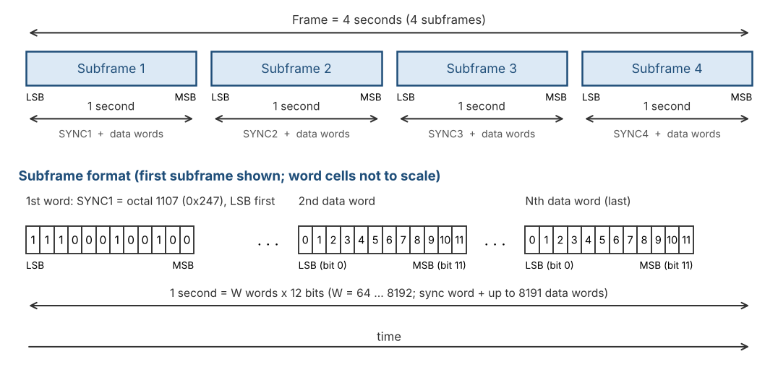
Figure 1: ARINC 717 message: frame, subframes and word bit ordering

2. System Architecture
The core is partitioned into two asynchronous clock domains:
- core_clk (48 MHz ±0.1 %) – entire TX path, RX path (sampler, decoder, sync FSM, word-count), read side of TX FIFO, write side of RX FIFO. This is the ARINC timing reference; all bit cell and sample-period calculations are performed from this clock.
- s_axi_clk – AXI4-Lite slave, register file, write side of TX FIFO, read side of RX FIFO. Frequency and phase are independent of core_clk.
Data-path clock crossing is performed exclusively by dual-clock asynchronous FIFOs. Configuration and status words use coherent multi-bit CDC (Req/Ack or toggle-strobe). Enables travel inside the atomic configuration bundle (Section 4.2.1); the interrupt enables stay in s_axi_clk. Every flag and sticky bit lives in the clock domain of the FIFO side or of the core block that produces it; the core_clk part crosses to s_axi_clk as one coherent status snapshot, and the W1C clears of those bits and of the TX counters cross back as one clear request (Section 8.5); single-bit levels use 2FF synchronizers.

2.1 Top-Level Block Diagram
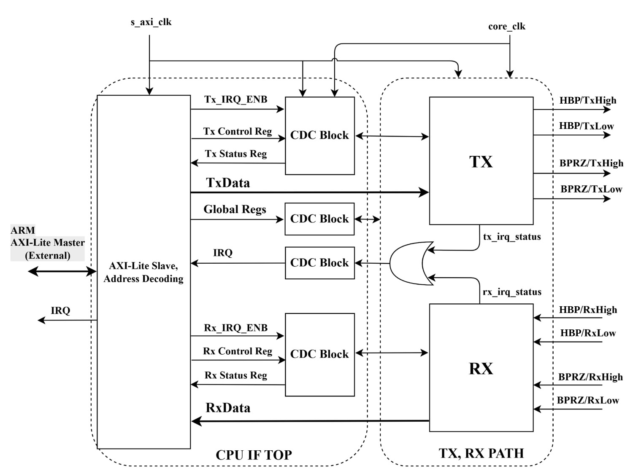
Figure 2: Top-level architecture (CPU IF TOP and TX/RX PATH)
Figure 2 shows the two major partitions of the IP core and the external ARM AXI-Lite master.

CPU IF TOP (s_axi_clk domain)
- AXI-Lite Slave, Address Decoding – decodes the 16-bit AXI address window 0x0000-0x014F (Section 7.1), accepts one outstanding transaction, and routes register / data-port accesses.
- Tx_IRQ_ENB / Tx Control Reg / Tx Status Reg – TX-side control, interrupt enable and status registers on the s_axi_clk side of the CDC; the status registers also hold the copy of the core_clk part of the TX status (EMPTY, UNDERRUN, counters).
- TxData – write port that pushes 12-bit words into the TX asynchronous FIFO.
- Global Regs – VERSION, SOFT_RESET, GLOBAL_EN, TX_EN / RX_EN, INJ_DST (destination of the built-in pattern injector), the read-only IRQ_SOURCE (which sources raised the interrupt) and aggregate IRQ enables.
- Rx_IRQ_ENB / Rx Control Reg / Rx Status Reg – RX-side control, interrupt enable and status registers on the s_axi_clk side of the CDC; the status registers also hold the copy of the core_clk part of the RX status (FULL, OVERFLOW, MATCH, INSYNC_LOST, BIT_ERR).
- RxData – read port that pops 12-bit words and their error flag from the RX asynchronous FIFO.
- IRQ – combined interrupt output to the external ARM: sticky AND enable of the s_axi_clk bits and of the snapshot of the core_clk bits, then AND IRQ_ENABLE, aggregated in s_axi_clk.

CDC Blocks
- Each CDC Block crosses multi-bit control/status words between s_axi_clk and core_clk using coherent handshaking or 2FF synchronizers. Data-path words cross only through the async FIFOs (not shown explicitly in Figure 2; see Figure 3).

TX PATH (core_clk domain)
- TX – complete transmit path: Timing Generator, FSM, Sync Insertion, Shift Register, HBP Encoder and BPRZ Encoder.
- Outputs: HBP/TxHigh, HBP/TxLow, BPRZ/TxHigh, BPRZ/TxLow (digital line levels for external drivers).
- tx_irq_status (core part) – sticky TX bits of the read side (EMPTY, UNDERRUN), kept in the TX path (core_clk); they cross to the CPU IF in the status snapshot and are cleared through the clear request.

RX PATH (core_clk domain)
- RX – complete receive path: Sample & Hold, HBP/BPRZ Clock Recovery, Shift Register, SYNC Detection FSM, Timing Generator.
- Bit Error Check – optional block inside the RX path (RX_ERR_CTRL.ERRCHK_ENB = 1, reset 0): checks every bit after lock, flags the words that contain a bad bit (bit 12 of the RX FIFO entry), counts bad bits and words, records position and cause, and can end INSYNC after RX_ERR_LIMIT bad bits in a row. Details in Section 3.2.4.
- Inputs: HBP/RxHigh, HBP/RxLow, BPRZ/RxHigh, BPRZ/RxLow.
- rx_irq_status (core part) – sticky RX bits of the core side (FULL, OVERFLOW, MATCH, INSYNC_LOST, BIT_ERR), kept in the RX path (core_clk); they cross to the CPU IF in the status snapshot and are cleared through the clear request.
- INSYNC – digital status pin indicating subframe lock.

2.2 Detailed Design Block Diagram
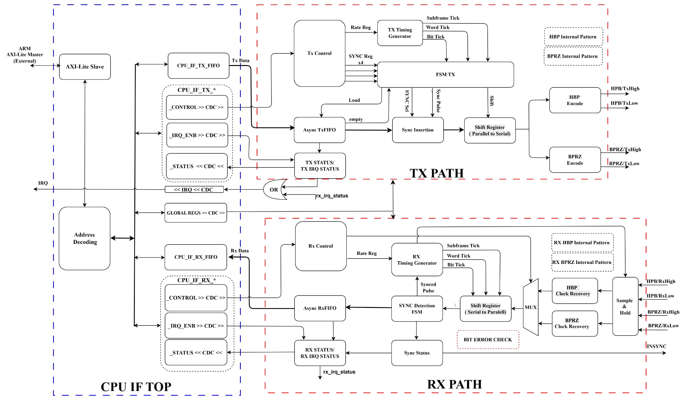
Figure 3: Detailed TX PATH and RX PATH design
Figure 3 expands every major functional block inside the TX and RX paths and shows the exact data-flow and control connections.

CPU IF TOP blocks (left, blue boundary)
- AXI-Lite Slave – protocol engine (AW/W/B and AR/R channels).
- Address Decoding – maps base offsets to Global, TX, RX register banks and the two data ports.
- CPU_IF_TX_FIFO / CPU_IF_RX_FIFO – s_axi_clk-side views of the dual-clock FIFOs (write side of TX FIFO, read side of RX FIFO).
- CPU_IF_TX_* / CPU_IF_RX_* – register shadows (CONTROL, STATUS; the IRQ_ENB registers stay in s_axi_clk) that are CDC’d into / out of the core_clk domain.
- GLOBAL REGS >> CDC >> – global enable, soft-reset, version and injector-destination (INJ_DST) bits crossed into core_clk.
- OR / IRQ << CDC << – the interrupt bits of the core_clk side cross to s_axi_clk in the status snapshot; there each bit is masked with its enable, OR-ed with the s_axi_clk bits and with IRQ_ENABLE, and the result drives the IRQ pin.

TX PATH blocks (upper red boundary)
- Tx Control – holds TX_RATE[3:0], SYNC_INS_MODE and the four TX_SYNCx codes after CDC.
- TX Timing Generator – produces Bit Tick, Word Tick and Subframe Tick from core_clk according to the programmed rate; starts only when enables are set and the TX FIFO is not empty (except for an injector run with INJ_DST = 0, Section 12.14.1) (see Section 3.1.2b).
- Async TxFIFO – dual-clock FIFO (wr = s_axi_clk, rd = core_clk); supplies payload words and the empty flag to the FSM.
- Sync Insertion – selects either the FIFO data word or the appropriate TX_SYNCx word when SYNC_INS_MODE = 1 and subframe_start is asserted.
- FSM TX – sequences Load, Shift and sync-insert decisions under control of the timing ticks.
- Shift Register (Parallel to Serial) – 12-bit parallel-load, serial-out LSB-first register clocked by Bit Tick.
- HBP Encode / BPRZ Encode – dual digital encoders driven from the same shift-register bit stream; produce HBP/TxHigh·TxLow and BPRZ/TxHigh·TxLow.
- HBP Internal Pattern / BPRZ Internal Pattern – the ROM of the built-in pattern injector (Section 12.14, synthesized only when INCLUDE_INJECTOR = 1). It is one ROM for both paths, drawn next to each path in the block diagram: it holds the pre-encoded line sequence in the HBP format and in the BPRZ format. GLOBAL_CTRL.INJ_DST selects the destination: 0 = the TX pins (tx_hbp_high/low and tx_bprz_high/low are driven by the ROM instead of the encoders), 1 = the RX input (see the RX PATH blocks).
- TX STATUS / TX IRQ STATUS – flags and sticky bits on both sides of the TX FIFO. The write side (FULL, HALF, ST_LOW, ST_FULL) stays in s_axi_clk, computed from the write pointer. The read side (EMPTY, ST_EMPTY, ST_UNDERRUN) and the TX word and bit counters are computed in core_clk and cross to the CPU IF in the status snapshot.

RX PATH blocks (lower red boundary)
- Sample & Hold – 16× oversampling front-end that classifies the incoming digital levels into ONES / ZEROS / NULL windows (see Section 3.2.1.1).
- HBP Clock Recovery / BPRZ Clock Recovery – edge-based and pulse-based bit-clock recovery for the two encodings.
- MUX – selects the recovered bit stream according to RX_CTRL.RXSEL.
- Shift Register (Serial to Parallel) – assembles 12 recovered bits into a parallel word.
- SYNC Detection FSM – tracker-based acquisition (see Section 3.2.2.2) and word-0 maintenance (Section 3.2.3.1).
- Bit Error Check – optional block (RX_ERR_CTRL.ERRCHK_ENB = 1, reset 0) that checks every bit after lock. Inputs: bit_err and cause of each bit from HBP Clock Recovery and BPRZ Clock Recovery (through the MUX); ERRCHK_ENB and RX_ERR_LIMIT from Rx Control; Bit Tick, Word Tick and Subframe Tick from RX Timing Generator; INSYNC and the lock event from SYNC Detection FSM. Outputs: the word error flag to Async RxFIFO (bit 12 of the entry); the "RX_ERR_LIMIT bad bits in a row" event to SYNC Detection FSM, which ends INSYNC; the counters, POS, POS0, CAUSE, the receiver position for RX_BIT_POS_NOW and the ST_BIT_ERR event to RX STATUS / RX IRQ STATUS. RX_ERR_CLEAR is not an input of the block: it clears those registers directly on the s_axi_clk side. Details in Section 3.2.4.9.
- RX Timing Generator – produces Bit Tick, Word Tick and Subframe Tick locked to the recovered bit rate once INSYNC is asserted; receives the Synced Pulse from the detection FSM.
- RX HBP Internal Pattern / RX BPRZ Internal Pattern – the same ROM when INJ_DST = 1. It replaces the loopback tap or the synchronized pins at the input of Sample & Hold (test point TP5); RX_CTRL.RXSEL selects the HBP or the BPRZ pair.
- Async RxFIFO – dual-clock FIFO (wr = core_clk, rd = s_axi_clk); stores recovered words for the host.
- Sync Status / RX STATUS / RX IRQ STATUS – INSYNC, SYNC[1:0], LOST_CAUSE and the core-side flags and sticky bits (FULL, OVERFLOW, MATCH, INSYNC_LOST, BIT_ERR) are computed in core_clk; the read-side flags and sticky bits (EMPTY, HALF) stay in s_axi_clk.
- INSYNC – external status pin reflecting subframe lock.

2.3 Clock-domain summary
- 1 × Async FIFO TX (FIFO_DEPTH × 16-bit (12 bits used), default 128, wr_clk = s_axi_clk, rd_clk = core_clk).
- 1 × Async FIFO RX (FIFO_DEPTH × 16-bit (13 bits used: 12 data bits and the error flag), default 128, wr_clk = core_clk, rd_clk = s_axi_clk).
- All multi-bit control/status crossings use dedicated CDC blocks (Figure 2).
- IRQ is the aggregation (sticky AND enable, then AND GLOBAL_CTRL.IRQ_ENABLE) of the TX and RX interrupt bits; it is computed in s_axi_clk (Section 8.3). The core_clk bits reach it through the status snapshot. IRQ_SOURCE gives the same AND per source, readable by software (Section 8.3).

2.4 Enable, Active and Idle Behavior
This section is the single definition of when each path runs, what is cleared when it stops, and which configuration fields may change while it runs. Other sections refer to it.

Active flags (core_clk domain)
- tx_active = GLOBAL_EN AND TX_EN AND core_ready AND NOT srst_core. rx_active = GLOBAL_EN AND RX_EN AND core_ready AND NOT srst_core (core_ready: Section 5.1). The enables come from the applied configuration bundle (Section 4.2.1); srst_core is the soft-reset signal of Section 5.2.

TX path when tx_active = 0
- The TX Timing Generator is in GEN_OFF and the TX FSM in IDLE; acc, phase, bit_cnt, word_in_subframe, subframe_index, frame_count, shreg and tx_bit are cleared. The TX word and bit counters (Section 7.3) are the exception: they keep their values when tx_active falls and are cleared when it rises, by SOFT_RESET and by TX_CNT_CLEAR.
- Outputs go to their idle levels on the next core_clk edge, even in the middle of a word (the word is aborted): HBP polarity P = 0, i.e. tx_hbp_high = 0 and tx_hbp_low = 1; BPRZ = Null, i.e. tx_bprz_high = 0 and tx_bprz_low = 0. The same levels are driven after hardware reset.
- During an underrun (GEN_FROZEN, tx_active = 1) the outputs hold: HBP keeps its last polarity, BPRZ is Null.

RX path when rx_active = 0
- The RX sample generator (accumulator and phase counter), the ONES/ZEROS/NULL registers, the HBP and BPRZ decoders, the 12-bit window, bit_index, the trackers, the sync watchdog counter, word_in_subframe, subframe_index, INSYNC, SYNC[1:0], MATCH and the state of the bit-error check (hold register, consecutive-bad-bit counter, resync flag, bit_slot) and the frame counter are held cleared. Nothing is written to the RX FIFO.
- The bad-bit counters, the two positions, the cause, RX_BIT_POS_NOW (Section 3.2.4.5) and RX_STATUS.LOST_CAUSE (Section 3.2.3.1) are not cleared when rx_active falls, so software can read them after it has stopped the receiver; they are cleared on the s_axi_clk side when GLOBAL_EN AND RX_EN rises (the start of a reception) and by SOFT_RESET; RX_ERR_CLEAR clears only the counters, the two positions and the cause, not RX_BIT_POS_NOW and not LOST_CAUSE. Words already in the RX FIFO are kept; only SOFT_RESET or RX_FIFO_CLEAR flush it.
- When rx_active rises the sample accumulator starts at 0 and the decoder starts unlocked (acquisition).

Configuration fields that change while a path runs
- TX_RATE (TX_CTRL[11:8]) is applied in the core (level-sensitive latch) only while tx_active = 0; RX_RATE (RX_CTRL[11:8]) only while rx_active = 0. The two paths are independent: they may run at different rates. A rate change made while its own path runs stays pending and is applied as soon as that path is inactive.
- SYNC_INS_MODE is applied only while tx_active = 0. RXSEL (together with the synchronized rsel pin), NOSYNC, SFTSYNC, TEST and RX_ERR_CTRL.ERRCHK_ENB are applied only while rx_active = 0. TEST = 1 routes the TX encoders into the RX decoder, so TX_RATE and RX_RATE shall then hold the same code (Section 3.4). INJ_EN is applied only while the path that the injector drives is inactive (tx_active = 0 for INJ_DST = 0, rx_active = 0 for INJ_DST = 1) and GLOBAL_CTRL.INJ_DST is applied only while INJ_EN = 0 (Section 12.14.5).
- TX_SYNCx, RX_SYNCx, WRDCNT, RX_ERR_LIMIT and RX_SYNC_WD are applied immediately and take effect at their next use.
- Rate-change procedure (per path, TX shown; RX is identical with RX_EN and RX_RATE): (1) clear TX_EN (or GLOBAL_EN) in GLOBAL_CTRL; (2) write the new TX_RATE in TX_CTRL; (3) wait at least the latency bound of Section 4.2.1; (4) set TX_EN again. Steps (1) and (2) may be in either order because the latch only applies the rate while the path is inactive; the enable shall come last. SOFT_RESET is optional and only needed when the FIFOs and sticky IRQ bits should also be flushed.

3. TX PATH and RX PATH Operation

3.1 Transmit Path
The TX path reads 12-bit words from the TX FIFO and encodes them simultaneously into Harvard Bi-Phase (HBP) and Bi-Polar Return-to-Zero (BPRZ) digital streams at the programmed rate. ARINC 717 transmits words back-to-back with no inter-word gap: as soon as the last bit of one word is sent, the first bit of the next word follows immediately. Transmission begins when the first word is present in the FIFO and GLOBAL_EN & TX_EN are set. The host is responsible for placing the correct subframe sync mark as the first word of each subframe and for keeping the FIFO non-empty so that the continuous stream is not interrupted.
Terminology. This document uses one term, bit cell (or just cell), for the time of one data bit, on the transmit side and on the receive side. Other ARINC texts call it bit period or bit time. A bit cell is 16 sample_ticks long; its two halves (8 sample_ticks each) are the first half cell and the second half cell. The TX Timing Generator starts a cell with bit_tick, marks its middle with half_bit_tick and counts 12 cells per word with bit_cnt; the RX decoders recover one bit per cell and count 16 samples per cell with their phase counter.

3.1.1 TX Path block overview
- Async FIFO TX (write side s_axi_clk, read side core_clk) – holds up to FIFO_DEPTH words of 12 bits (default 128).
- TX Timing Generator – independent block that produces bit_tick, word_tick, subframe_index (0…3) and frame_count; it is not part of the TX FSM but supplies timing strobes and indices to the FSM (see Section 3.1.2b).
- TX FSM – consumes timing strobes from the Timing Generator, reads the FIFO (or auto-inserts a sync word), and drives the shift register.
- Parallel-load shift register – loads a complete 12-bit word when the TX FSM pulses Load.
- HBP Encoder – produces the Harvard Bi-Phase digital bit stream.
- BPRZ Encoder – produces the Bi-Polar Return-to-Zero digital bit stream.
- Both encoders run in parallel from the same shift-register data and the same bit-clock; their outputs appear on tx_hbp_high/low and tx_bprz_high/low.

3.1.2 TX FSM operation
Whenever GLOBAL_EN = 1, TX_EN = 1 and the TX FIFO is not empty, the TX FSM:
- Pulses Load – the next 12-bit word is read from the FIFO and captured in the parallel-load shift register.
- Shifts the word out LSB-first, one bit per bit cell (the length defined in Section 3.3).
- Immediately after the 12th bit, if the FIFO still contains data, the FSM loads the next word and continues shifting without any idle interval – producing a continuous, gap-free bit stream.
If the FIFO becomes empty the FSM stops after the current word; the line remains at the last HBP polarity (or BPRZ Null) until new data arrives and transmission resumes automatically.

3.1.2a Sync-word insertion mechanism
Each subframe shall begin with the appropriate Barker sync mark (SYNC1…SYNC4). The selection between host-driven and hardware auto-insert is controlled by TX_CTRL.SYNC_INS_MODE (bit 0):
- SYNC_INS_MODE = 0 – Software mode (default). The host is responsible for writing the sync word as the first FIFO entry of every subframe. The TX FSM always reads from the FIFO; it never injects TX_SYNCx.
- SYNC_INS_MODE = 1 – Hardware auto-insert mode. At the start of each subframe (word_in_subframe = 0, indicated by the TX Timing Generator) the TX FSM loads the corresponding TX_SYNCx register instead of popping the FIFO. After that word is shifted out, all remaining words of the subframe are taken from the FIFO.

Software mode (SYNC_INS_MODE = 0)
The host writes the 12-bit sync code (or any other value it chooses) as the first word of every subframe into the TX FIFO, followed by the payload words. The four TX_SYNCx registers are ignored by the TX path in this mode. This mode gives the host complete control over the first word of each subframe.

Hardware auto-insert mode (SYNC_INS_MODE = 1)
- When the TX Timing Generator asserts subframe_start and the TX FIFO is not empty, the TX FSM parallel-loads:
- subframe_index 0 → TX_SYNC1, 1 → TX_SYNC2, 2 → TX_SYNC3, 3 → TX_SYNC4.
- If the FIFO is empty at subframe_start, no sync is inserted and the Timing Generator freezes (see Section 3.1.2b) until data arrives.
- After a sync word is shifted out, subsequent words of the subframe are popped from the TX FIFO.
- The host shall therefore keep the FIFO non-empty and supply exactly (N − 1) payload words per subframe, where N is the programmed number of words per second.
- TX_SYNCx registers power-up to the standard ARINC 717 codes (octal 1107 / 2670 / 5107 / 6670) and may be overwritten at any time.
If the host also places a sync word in the FIFO while auto-insert is enabled, two consecutive sync marks will appear; this is a software error and is not blocked by hardware.
In both modes the stream remains continuous and gap-free while data is available: the bit that follows the last bit of a sync word is the first bit of the next data word.

3.1.2b TX Timing Generator
The TX Timing Generator is a standalone block in the core_clk domain. It is not embedded inside the TX FSM; it only produces timing outputs that the FSM (and optionally status logic) consumes.

Outputs of the Timing Generator
- bit_tick – pulse at the start of every bit cell (phase accumulator, Section 3.2.1.1).
- half_bit_tick – pulse at the midpoint of every bit cell (HBP mid-edge, BPRZ return-to-Null).
- word_tick – pulse at the start of the first bit cell of every word (every 12th bit_tick, counted by bit_cnt).
- bit_cnt[3:0] – index 0..11 of the bit cell that starts at bit_tick; owned by the Timing Generator (the TX FSM has no bit counter of its own). bit_cnt advances (11 wraps to 0) at the sample_tick where phase = 15.
- word_in_subframe[12:0] – index (0…W-1) of the word that will be loaded at the next word_tick; incremented only when a word is actually loaded, wraps to 0 at W (W = words per subframe).
- subframe_index[1:0] – 0…3, advances each time word_in_subframe wraps.
- frame_count[31:0] – increments each time subframe_index wraps from 3 to 0 (one 4-second frame). Internal only: no register reads it, so it may be omitted in RTL.
- subframe_start – registered flag: set when word_in_subframe will be 0 for the upcoming word. Timing: on word_tick N the FSM sees subframe_start and word_in_subframe for the word about to be loaded; after LOAD completes, word_in_subframe increments (or wraps). First word after generator release: word_in_subframe=0, subframe_start=1.

When the Timing Generator starts running
The Timing Generator is in GEN_OFF until tx_active = 1 (Section 2.4) and the TX FIFO is not empty (at least one 12-bit word is waiting on the core_clk read side); it then enters GEN_RUN (see "Timing Generator states" below). TX_RATE shall hold a legal code (reserved codes behave as code 0000, 64 wps).
The FIFO condition is essential: without data in the FIFO the generator shall not free-run. Otherwise, in hardware auto-insert mode, the TX FSM would keep injecting TX_SYNCx at every subframe boundary while producing no payload, resulting in a stream of sync marks only.
On entry INC(TX_RATE) from Table 5 is used. word_in_subframe, subframe_index and frame_count start at 0, so the first word is the first word of subframe 0 (SYNC1).

Behavior when the FIFO later becomes empty
- After the word currently being shifted has finished, the TX FSM stops issuing Load and the line holds the last HBP polarity (or BPRZ Null).
- The Timing Generator freezes (GEN_FROZEN): it stops emitting bit_tick / word_tick, holds word_in_subframe, subframe_index and frame_count at their current values (it does not clear them) and clears acc, phase and bit_cnt so that the resume latency is deterministic.
- When the host later pushes new data into the FIFO, the Timing Generator resumes from the frozen count (mid-subframe or mid-frame) and the FSM continues transmission without forcing a return to subframe 0.
- If software prefers to restart from a clean subframe boundary after an underrun, it shall clear TX_EN (or assert SOFT_RESET) before re-filling the FIFO; that forces the generator to clear its counters back to 0.

Stop / reset conditions
If tx_active = 0 the Timing Generator clears all counters to 0 and stops emitting ticks (GEN_OFF). Rate changes follow the procedure of Section 2.4: TX_RATE is only latched while tx_active = 0.

Timing Generator states
The Timing Generator is a small state machine in core_clk. It (not the TX FSM) owns the sample accumulator, the phase counter (0..15), the bit counter bit_cnt (0..11) and the word/subframe counters.
- GEN_OFF – tx_active = 0 (tx_active is defined in Section 2.4). acc, phase, bit_cnt, word_in_subframe, subframe_index and frame_count are cleared to 0. No strobes.
- GEN_RUN – strobes are generated. Entered from GEN_OFF or GEN_FROZEN when tx_active = 1 and fifo_empty = 0. On entry acc = 0, phase = 0, bit_cnt = 0, so the first sample_tick (and with it the first bit_tick and word_tick, which coincide) arrives exactly one sample period after entry. This latency is deterministic after every start and every resume.
- GEN_FROZEN – entered from GEN_RUN at a word_tick where fifo_empty = 1 (underrun). word_in_subframe, subframe_index and frame_count hold their values; acc, phase and bit_cnt are cleared; no strobes. Returns to GEN_RUN when tx_active = 1 and fifo_empty = 0; goes to GEN_OFF when tx_active = 0.

Strobes and indices (Generator to FSM and encoders)
- sample_tick – phase-accumulator output (Section 3.2.1.1). phase counts sample_ticks 0..15 inside a bit cell.
- bit_tick = sample_tick when phase = 0 (phase is the value held before the update that this sample_tick causes; phase and bit_cnt are updated at the end of that clock, see Figure 4). It starts a bit cell; bit_cnt is the index of that cell.
- half_bit_tick = sample_tick when phase = 8 (mid-cell).
- word_tick = bit_tick when bit_cnt = 0, i.e. the start of the first cell of a word. At word_tick the previous word, if any, has just finished its 12th cell.
- word_in_subframe and subframe_index are registered and describe the word that will be loaded at the next word_tick. subframe_start = (word_in_subframe = 0) is a registered flag, so the FSM reads it on the same clock edge as word_tick without any ordering problem.

Load decision (one rule, evaluated at every word_tick)
At word_tick the FSM and the Generator sample the same registered fifo_empty flag in the same clock cycle, so no extra handshake signal is needed (there is no tx_run or load_pulse).
- fifo_empty = 0: LOAD. The FSM selects the source (below). On the same clock edge word_in_subframe increments (at W it wraps to 0 and subframe_index increments) and the first bit cell starts.
- fifo_empty = 1: underrun. The FSM goes to IDLE, the Generator goes to GEN_FROZEN and no cell starts. The line holds: HBP keeps its last level; BPRZ is Null (the previous cell already ended in its Null half).
Source selection at LOAD: if SYNC_INS_MODE = 1 and subframe_start = 1, load TX_SYNC[subframe_index] and do not pop the FIFO; otherwise load the FIFO head and pop it. fifo_empty shall be 0 in both cases, so a stream of sync words without payload is never produced.

Shift register and encoder timing
Define cell_start = bit_tick AND NOT (word_tick AND fifo_empty). The encoders act only on cell_start and half_bit_tick, so an underrun never creates a spurious boundary edge. The bit being transmitted is held in the registered flag tx_bit, stable for the whole cell:
- cell_start with word_tick = 1 (LOAD): tx_bit <= word[0]; shreg <= {1'b0, word[11:1]}.
- cell_start with word_tick = 0 (bit_cnt = 1..11): tx_bit <= shreg[0]; shreg <= {1'b0, shreg[11:1]}.
LOAD and the first cell_start occur on the same clock edge, so bit 0 comes from the loaded word and never from stale shreg contents. The 12-cell count lives only in the Generator (bit_cnt); the FSM has no separate bit_index.

TX Timing Generator and TX FSM state diagram
The Timing Generator, the TX FSM and the encoders are specified by the state diagrams of Figure 4: states, transition conditions, strobe decodes (valid only in the clock where sample_tick = 1), the LOAD action and the encoder actions. All registers update at the end of the clock. Figure 5 shows the resulting timing.
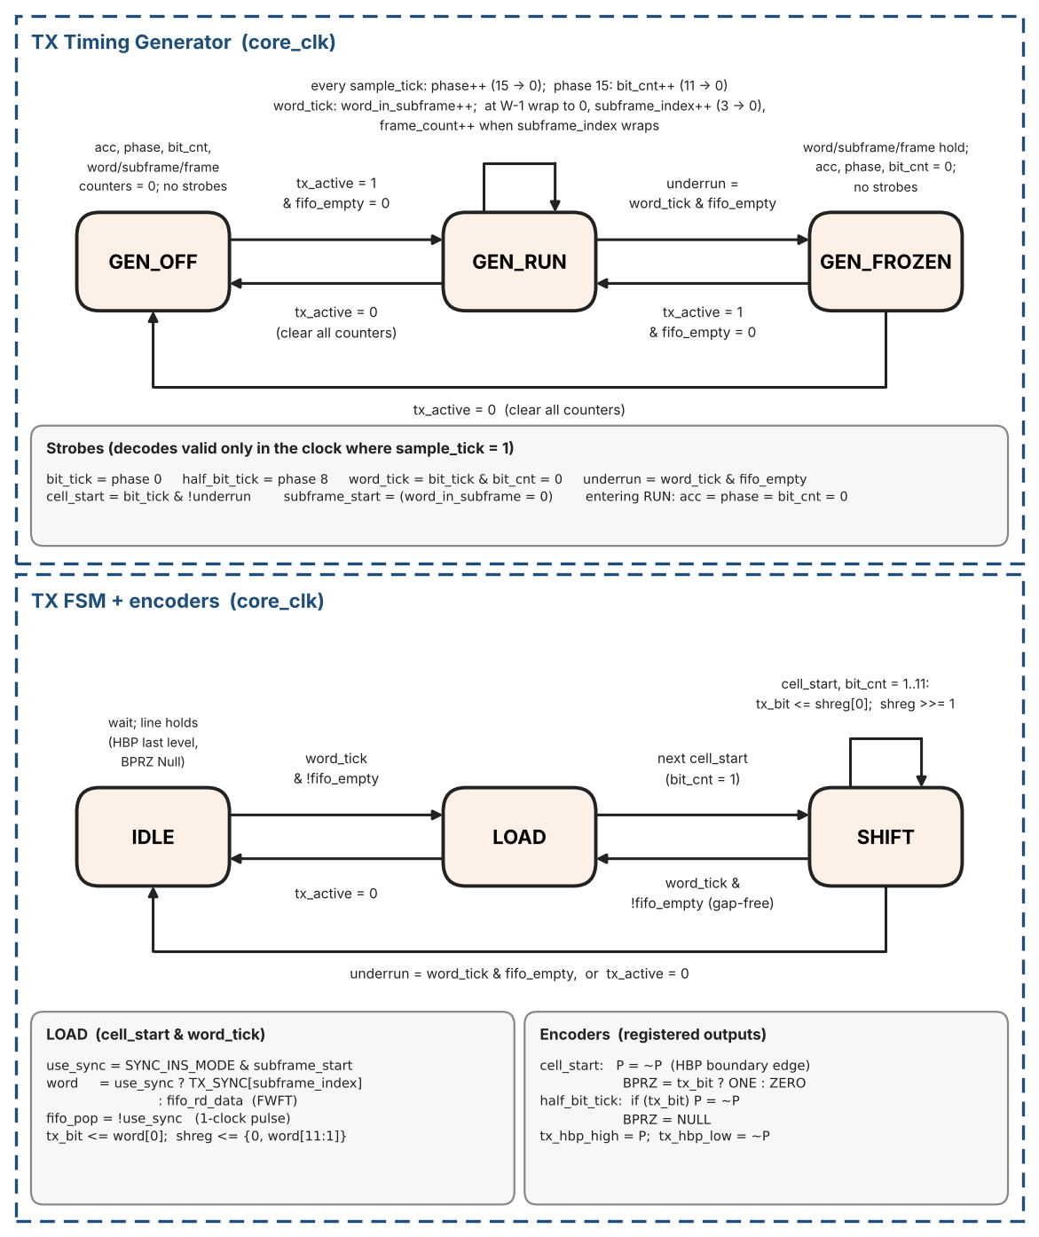
Figure 4: TX Timing Generator and TX FSM / encoder state diagrams
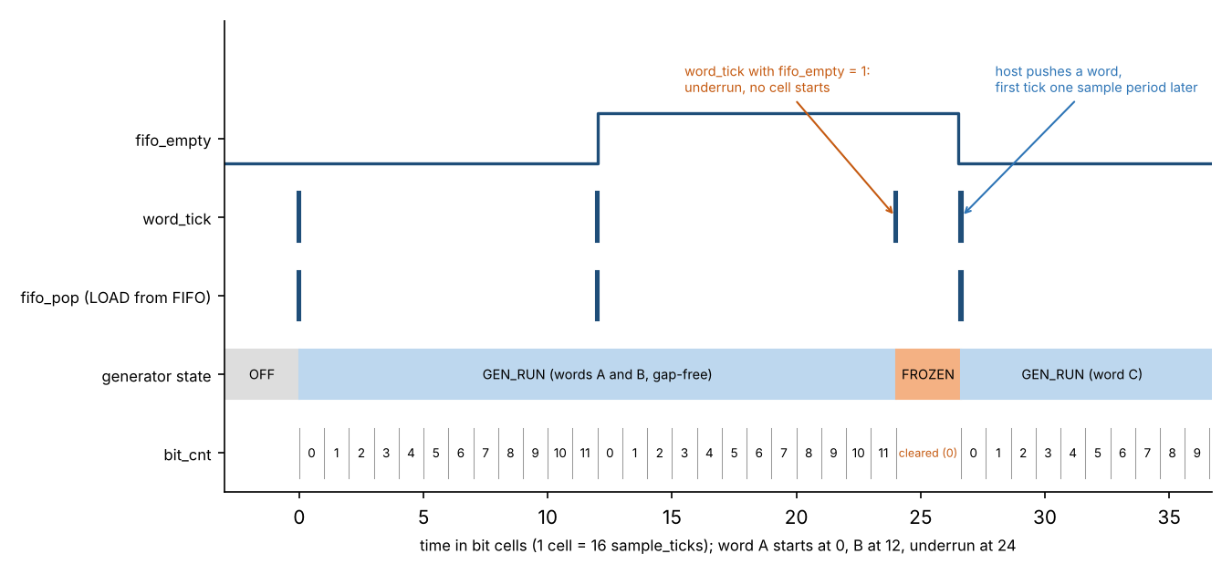
Figure 5: TX Timing Generator and FSM: gap-free load, underrun (GEN_FROZEN) and resume

3.1.3 HBP Encoder (detailed)
Harvard Bi-Phase (HBP) for ARINC 717 encodes each data bit by the presence or absence of a mid-cell transition. Encoder and decoder share one rule: mid-cell transition = logic 1; no mid-cell transition = logic 0. A boundary transition at the start of every bit cell is always generated so the receiver can maintain lock.
Digital outputs: tx_hbp_high and tx_hbp_low are complementary during active bits. Idle and reset: P = 0, i.e. tx_hbp_high = 0 and tx_hbp_low = 1 (Section 2.4).
Algorithm (polarity state P, initial P=0 after reset/enable):
- At cell_start (start of cell): P := not P; drive tx_hbp_high=P, tx_hbp_low=!P. // boundary edge always
- At half_bit_tick (mid-cell): if tx_bit==1 then P := not P; drive outputs. // mid-cell edge only for 1
- If tx_bit==0: no change at half_bit_tick; level stays constant through the second half.
Waveform (one bit cell, time left to right):
- Bit 0: edge at t=0 only; second half is flat.
- Bit 1: edge at t=0 and edge at t=T/2.
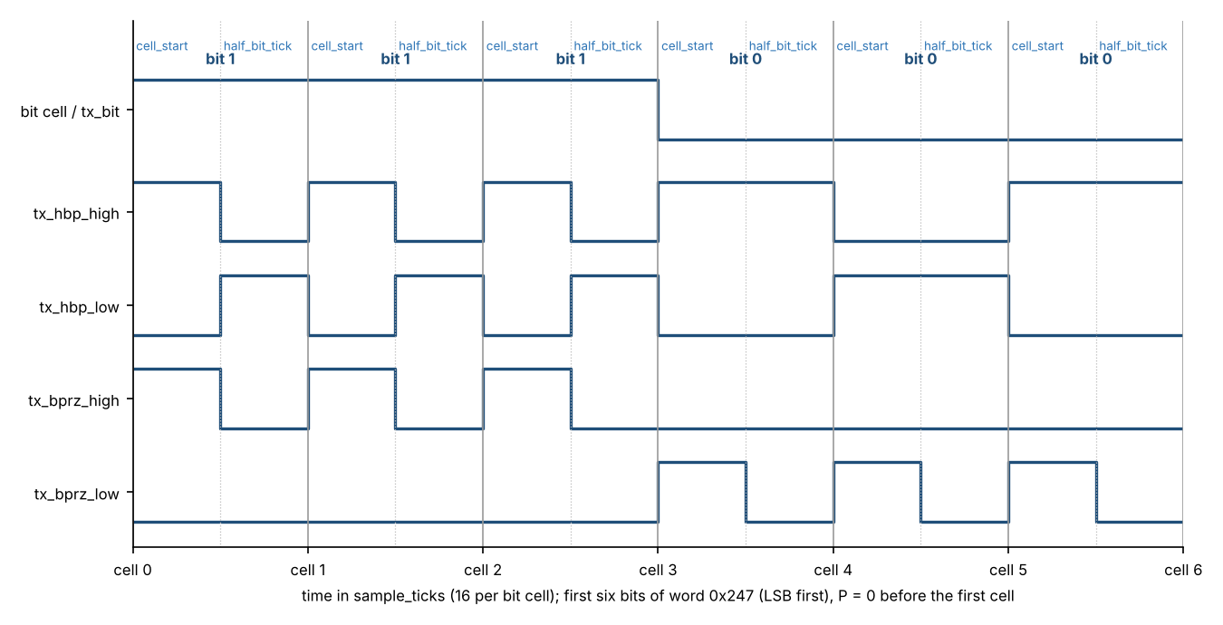
Figure 6: HBP and BPRZ transmit waveforms (first six bits of word 0x247, LSB first)
Waveforms of every cell are listed in Table 58 (Section 12.7).
half_bit_tick is produced by the TX Timing Generator at the midpoint of each bit cell. In loopback (TEST = 1) the TX and RX rates shall match (Section 3.4).
Figure 7 shows the HBP encoder algorithm and an example for the bits 1 0 1 1 0.
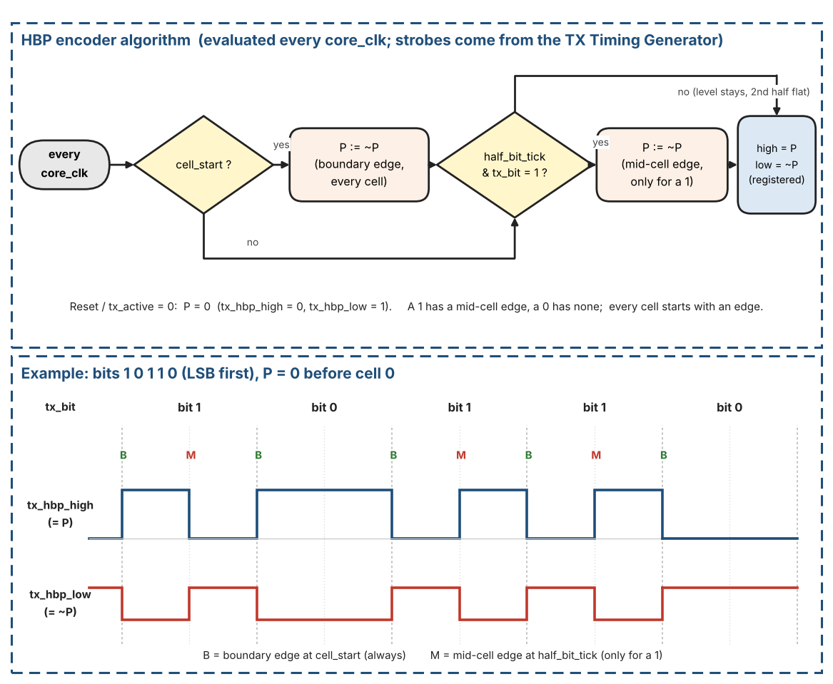
Figure 7: HBP encoder: algorithm and example (bits 1 0 1 1 0)

3.1.4 BPRZ Encoder (detailed)
Bi-Polar Return-to-Zero encoding uses three levels (One / Zero / Null) inside every bit cell:
- A logic 1 is sent as a positive pulse (One) for the first half of the bit cell, then returns to Null for the second half.
- A logic 0 is sent as a negative pulse (Zero) for the first half of the bit cell, then returns to Null for the second half.
- Null is the idle level between pulses and between words.
Implementation inside the core (all digital):
- Two digital outputs, tx_bprz_high and tx_bprz_low, represent the three states: One, Zero, Null. There is no separate Null pin or Null signal: Null is the combination in which both outputs are 0 (Table 3).
Where Null comes from. The BPRZ interface has exactly two digital wires per direction (tx_bprz_high / tx_bprz_low on transmit, rx_bprz_high / rx_bprz_low on receive). The third state, Null, is not a wire: it is what the pair looks like when neither wire is active. On the physical bus Null is about 0 V; the external line driver produces that level when both tx_bprz_* outputs are 0, and the external line receiver drives both rx_bprz_* inputs to 0 when it sees about 0 V. Inside the core, "Null" is only a name for the pair (high, low) = (0, 0): the receiver classifies it as the NULL class (Table 8, Section 3.2.1.1) and, after the 4-sample dwell, raises the internal flag valid_NULL.
Table 3: BPRZ line states and the two digital pins
State | high pin | low pin | Analog bus level | Internal name in the receiver
One | 1 | 0 | positive pulse | class HI, flag valid_HI
Zero | 0 | 1 | negative pulse | class LO, flag valid_LO
Null | 0 | 0 | about 0 V | class NULL, flag valid_NULL
(not allowed) | 1 | 1 | - | class INVALID: never a legal level

In HBP mode the same two pins carry the two complementary levels of the HBP signal, so (0, 0) is not a legal state there and is classified INVALID.
- During the first half of the bit cell the encoder drives One if the data bit = 1, or Zero if the data bit = 0.
- During the second half of the bit cell the encoder always drives Null.
- The half-bit boundary is taken from the same phase-accumulator timing used by the HBP encoder, so both encodings stay perfectly aligned.
The digital BPRZ stream appears on tx_bprz_high and tx_bprz_low. External line drivers (if present) translate the One/Zero/Null codes into the analog ±10 V / 0 V levels required by the physical bus; the IP core itself never generates analog voltages.
Figure 8 shows the BPRZ encoder algorithm and an example for the bits 1 0 1 1 0.
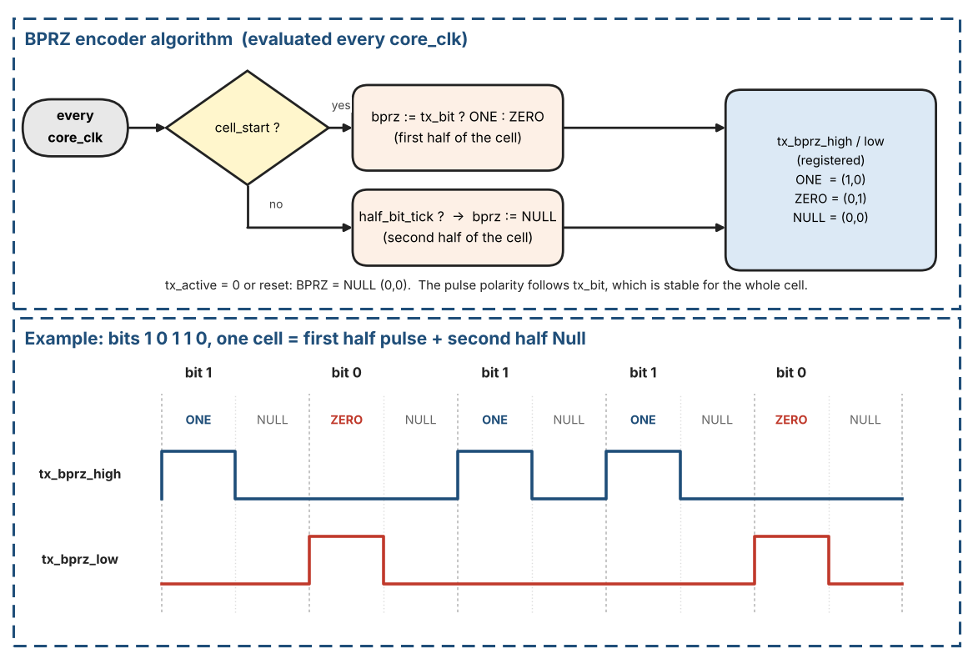
Figure 8: BPRZ encoder: algorithm and example (bits 1 0 1 1 0)

3.1.5 Continuous transmission (no inter-word gap)
Unlike ARINC 429, ARINC 717 does not insert Null gaps between successive words. Within a subframe the bit stream is continuous: the LSB of word N+1 is transmitted in the bit cell that immediately follows the MSB of word N. The TX FSM therefore issues the next Load as soon as the current word’s last bit has been shifted out, provided the FIFO is not empty.
The host shall keep the TX FIFO from running dry for longer than one word-time; otherwise a momentary pause appears on the line until the next word is written. At subframe boundaries the host is still responsible for supplying the correct sync mark as the first word of the new subframe.

Host rule for the TX FIFO
- Keep at least 2 words queued in the TX FIFO while transmitting. Before enabling, push at least 2 words (plus the sync word in software mode).
- Refill when ST_LOW (TX_IRQ_STATUS bit 1: level falls below FIFO_DEPTH/2) is raised, or poll TX_STATUS.HALF. When HALF = 0 at least FIFO_DEPTH/2 words are free, so push up to FIFO_DEPTH/2 words per refill; never push while TX_STATUS.FULL = 1.
- Reason: the core-side EMPTY flag is computed from the synchronized write pointer (Section 4.2.4), so a word pushed just before a word_tick may become visible a few clocks too late. The load decision at word_tick would then see EMPTY and cause a false underrun (GEN_FROZEN, line pause). A word that is already in the FIFO one word-time ahead is always visible. The CDC latency is far shorter than one word-time (122 us at the highest rate of Table 5), so one queued word is the minimum and 2 words give margin.
- Hardware sync-insertion mode: the same rule applies to the payload words; the sync word itself is never popped from the FIFO.

3.1.6 TX status flags
EMPTY, HALF and FULL are generated from the FIFO fill level on both clock domains. The core_clk side uses them to decide whether a Load is permitted; the s_axi_clk side reports them through the TX_STATUS flags for software. A push attempted while FULL returns SLVERR and discards the word. EMPTY of the TX FIFO is computed on core_clk from rlevel and reaches TX_STATUS in the status snapshot; HALF and FULL are computed on s_axi_clk from wlevel (Section 4.2.4).

3.2 Receive Path
The RX path recovers the bit clock from the selected digital input stream (HBP or BPRZ), performs serial-to-parallel conversion, detects subframe synchronization marks, and writes accepted 12-bit words into the RX FIFO. Key blocks:
- Data Sampler & Hold – 16× oversampling relative to the programmed data-bit rate.
- HBP Decoder / BPRZ Decoder – selected by RXSEL (CTRL bit OR-ed with external RSEL pin).
- Sync Detection FSM – 4-sync-word (default), 2-sync-word (SFTSYNC=1) or No-Sync (NOSYNC=1).
- Word-count & subframe tracking – drives MATCH pin and RX_STATUS.SYNC[1:0].
- FIFO_DEPTH × 16-bit Async FIFO RX (default 128; 13 bits used: 12 data bits and the word error flag in bit 12) – write side core_clk; overflow sets the sticky OVERFLOW bit (pin rovf).

Receive path at a glance
The receive path is a chain of stages. Each stage works on a slower time scale than the one before it: core_clk (48 MHz) in the synchronizers, sample_tick (16 per bit) in the sampler and the decoders, one bit_valid pulse per bit in the sync detector, one word (12 bits) in the counters and the FIFO.
Table 4 lists the stages of the receive path and the signals between them.
Table 4: Receive path: stages and the signals between them
Stage | Input | Output | Section
1. Input synchronizers | rx_hbp_high/low, rx_bprz_high/low, rsel (asynchronous pins) | the same signals in the core_clk domain | 4.2.0
2. Sample generator | RX_RATE (applied while rx_active = 0) | sample_tick, 16 per bit cell | 3.2.1.1
3. Sampler | pair (hi, lo) chosen by rxsel_eff; sample_tick | valid_HI, valid_LO, valid_NULL (dwell-validated levels) | 3.2.1.1
4. HBP or BPRZ decoder (chosen by rxsel_eff) | valid_HI, valid_LO (HBP); valid_HI, valid_LO, valid_NULL (BPRZ) | bit_valid, bit_data, framing_error | 3.2.1.2, 3.2.1.3
5. 12-bit window and sync detector | bit_valid, bit_data | candidate sync, INSYNC, subframe_index; bit_valid, bit_data and bit_err pass a one-bit hold register while INSYNC = 1 | 3.2.2.1 to 3.2.2.4, 3.2.4
6. RX timing generator and word counters | recovered bits, INSYNC | accepted 12-bit words, word_in_subframe, MATCH | 3.2.3.1
7. RX FIFO | accepted 12-bit words with their error flag (13 bits) | words popped by the host through the AXI-Lite slave | 3.2.3.2, 3.2.4, 6

3.2.1 Bit Front-End: Sampler and Decoders
The front-end turns the raw line inputs into a stream of recovered bits. It has four parts: the Data Sampler & Hold (Section 3.2.1.1), the HBP decoder (Section 3.2.1.2), the BPRZ decoder (Section 3.2.1.3) and the hand-off to the sync detector (Section 3.2.1.4).

3.2.1.1 Data Sampler & Hold (detailed)
The sampler is the first digital stage after the external line-receiver (or digital isolator). It runs from a sample clock that is exactly sixteen times the programmed data-bit rate. Because both HBP and BPRZ encodings place a transition opportunity in the middle of every bit cell, the 16× sample clock is equivalent to an 8× oversample of the maximum transition rate.
Clock domains: see Section 2. All timing calculations below assume core_clk = 48.000 MHz exactly.

Sample-clock derivation – exact calculation from 48 MHz core_clk
Formulas used throughout this section (core_clk = 48.000 MHz):
- Data-bit rate (bps) = Words/s × 12
- Sample rate (Hz) = Data-bit rate × 16 = Words/s × 192
- Ideal cycles/sample = core_clk / Sample rate = 48 000 000 / (Words/s × 192) = 250 000 / Words/s
- Phase-accumulator residual error < 1 core_clk period = < 20.833 ns
- Relative error (%) ≈ (1 / Ideal_cycles_per_sample) × 100 (accumulator residual bound)
Table 5 is the single definition of the rate-code encoding used by both TX_RATE and RX_RATE, INC and the sample-clock parameters (it also gives the ideal cycles/sample). Implement the tick generator with the phase accumulator below; the edge jitter is bound by one core_clk period.
Table 5: Rate-code encoding (TX_RATE and RX_RATE) and sample-clock parameters (core_clk = 48 MHz) - single definition
Rate code | Words/s (W) | Bit rate (bps) | Bit period (us) | Sample period (us) | Cycles/sample (core_clk, exact) | INC = W x 192 | Max edge jitter (%)
0000 | 64 | 768 | 1302.0833 | 81.3802 | 3906.25 | 12288 | 0.0256
0001 | 128 | 1536 | 651.0417 | 40.6901 | 1953.125 | 24576 | 0.0512
0010 | 256 | 3072 | 325.5208 | 20.3451 | 976.5625 | 49152 | 0.1024
0011 | 512 | 6144 | 162.7604 | 10.1725 | 488.28125 | 98304 | 0.2048
0100 | 1024 | 12288 | 81.3802 | 5.0863 | 244.140625 | 196608 | 0.4096
0101 | 2048 | 24576 | 40.6901 | 2.5431 | 122.0703125 | 393216 | 0.8192
0110 | 4096 | 49152 | 20.3451 | 1.2716 | 61.03515625 | 786432 | 1.6384
0111 | 8192 (optional) | 98304 | 10.1725 | 0.6358 | 30.517578125 | 1572864 | 3.2768
1000-1111 | 64 (reserved codes) | 768 | as code 0000 | as code 0000 | 3906.25 | 12288 | 0.0256

Required and optional rates. Every rate code of Table 5 is required and is verified by the test plan, except the highest code (0111), which is optional in this version: the same logic and the same table row apply; it is still designed, but it will not be tested (its vectors in Section 12.10 are marked optional). Figure 9 shows what changes from rate to rate: INC doubles with every code, so the sample period halves and the tick jitter of one core_clk grows from 0.0256 % of a sample at the lowest rate to 1.64 % at the highest required rate (3.28 % at the optional rate). The decoders are tolerant enough for this (Section 12.10, vector V-RATE).
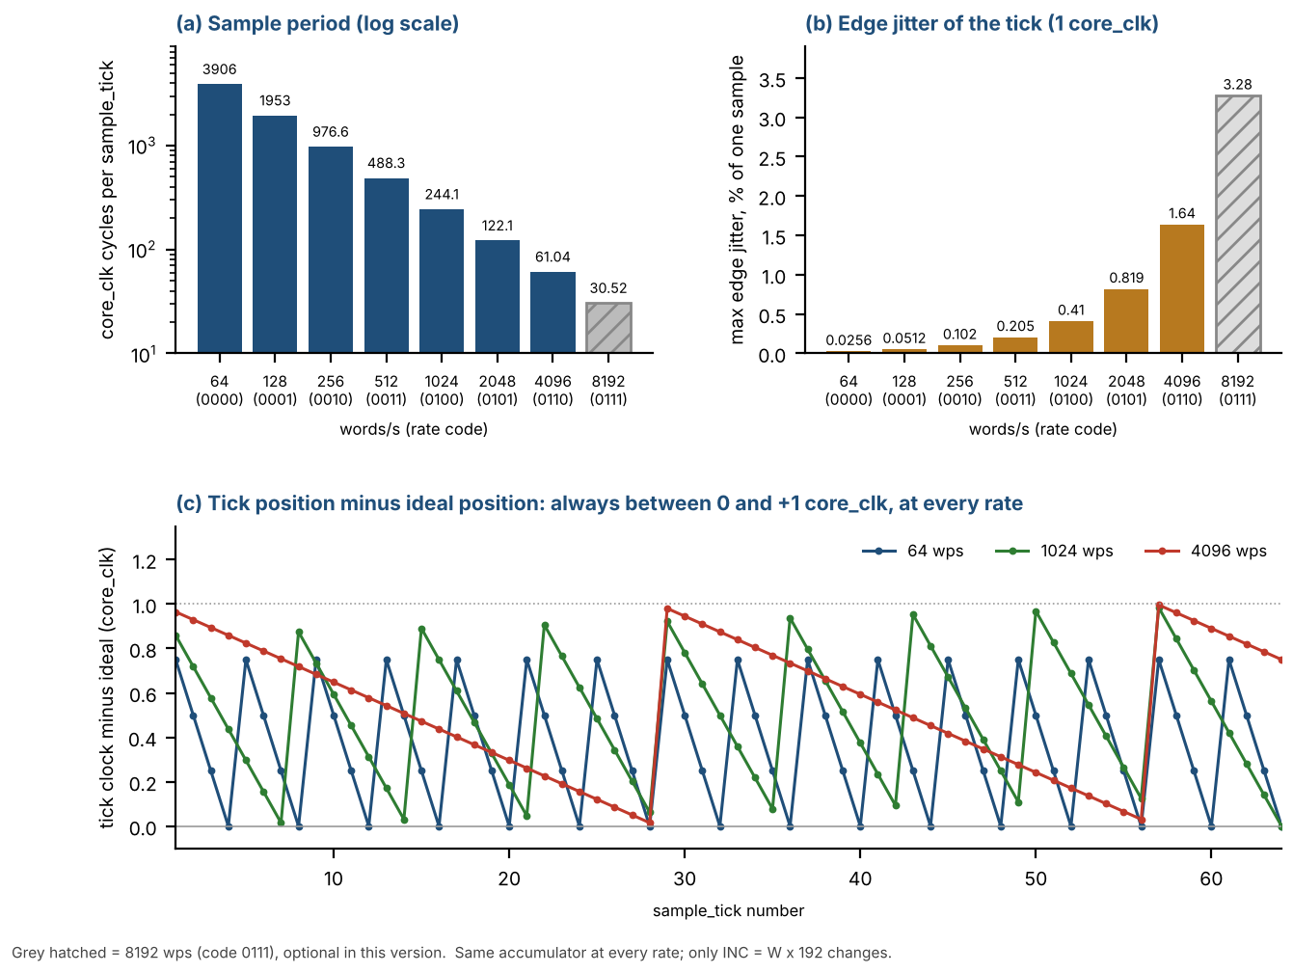
Figure 9: Sample clock at every rate: (a) core_clk cycles per sample_tick, (b) edge jitter in % of a sample, (c) tick position minus ideal position

Sample-tick generation (phase accumulator)
Both TX Timing Generator and RX sample-clock generator use the same algorithm on core_clk:
- Every core_clk: acc := acc + INC(rate); if acc >= 48000000 then sample_tick=1, acc := acc - 48000000; else sample_tick=0.
- INC(rate) = W * 192, with W = words/s from the applied rate code (Table 5): TX_RATE for the TX Timing Generator, RX_RATE for the RX sample generator. Each path has its own accumulator. acc is 26 bits wide (48,000,000 + 1,572,864 < 2^26); the constant 48,000,000 is core_clk in Hz.
A phase counter (0..15) increments on each sample_tick. Derived strobes:
- bit_tick = sample_tick when phase==0 (start of bit cell).
- half_bit_tick = sample_tick when phase==8 (mid-cell).
Edge jitter is < 1 core_clk period (accumulator residual); the long-term average rate is exact. Implement with the accumulator above, not a dual-modulus integer divider. The RX sample-clock generator uses only sample_tick; the HBP decoder keeps its own phase counter (Section 3.2.1.2), independent of the TX phase counter.

How the accumulator works (step by step)
The goal. The sampler (and the transmit timing generator) shall receive exactly 16 sample_ticks per bit cell, evenly spread over time. The distance between two ticks is core_clk / sample rate = 48 000 000 / (W x 192) core_clk periods. This is usually not an integer (3906.25 for W = 64). A counter that always counts the integer 3906 would lose 0.25 clock at every tick: after one second (12288 ticks) the sampling point would have drifted by 3072 clocks and the receiver would slowly slide out of the bit cell. The accumulator avoids this by keeping the remainder of every division and carrying it to the next tick.
Where the numbers come from (W = 64 words/s, core_clk = 48 MHz):
- 64 words/s x 12 bits = 768 bit/s.
- 768 bit/s x 16 samples per bit = 12288 samples/s. This is INC = W x 192 (12 x 16 = 192).
- core_clk = 48 000 000 clocks/s. This is the threshold of the accumulator.
- One sample therefore lasts 48 000 000 / 12288 = 3906.25 clocks.
- Meaning of acc. In one clock the line advances by 12288 / 48 000 000 of a sample. Multiplied by 48 000 000 this means: every clock adds INC = 12288 units to acc, and one complete sample is worth 48 000 000 units. acc is the number of units collected towards the next sample. When acc reaches 48 000 000 one sample has elapsed: sample_tick is raised for exactly one core_clk period and 48 000 000 is subtracted. The units above the threshold are NOT discarded; they stay in acc and count towards the next sample.
Worked example with small numbers: core_clk = 10 clocks/s, 4 samples/s needed (ideal distance 2.5 clocks); so INC = 4 and threshold = 10. acc starts at 0.
Table 6 walks through the accumulator with small numbers.
Table 6: Accumulator example with small numbers (INC = 4, threshold = 10)
Clock | acc after adding INC | sample_tick | acc after subtract
1 | 4 | 0 | 4
2 | 8 | 0 | 8
3 | 12 (>= 10) | 1 | 2
4 | 6 | 0 | 6
5 | 10 (>= 10) | 1 | 0
6 | 4 | 0 | 4
7 | 8 | 0 | 8
8 | 12 (>= 10) | 1 | 2
9 | 6 | 0 | 6
10 | 10 (>= 10) | 1 | 0

Ticks occur at clocks 3, 5, 8 and 10, i.e. at distances 3, 2, 3, 2 clocks. The mean distance is 2.5 clocks and acc returns to 0 after 10 clocks, so the pattern repeats without any drift.
The same calculation with the real numbers (W = 64, INC = 12288, threshold = 48 000 000, acc starts at 0):
Table 7 gives the sample_tick distances for the real numbers.
Table 7: Sample_tick distances for W = 64 (INC = 12288)
Tick | Clocks since previous tick | acc before subtract | acc after subtract
1 | 3907 | 48 009 216 | 9 216
2 | 3906 | 48 006 144 | 6 144
3 | 3906 | 48 003 072 | 3 072
4 | 3906 | 48 000 000 | 0

- Tick 1 needs 3907 clocks: 3906 x 12288 = 47 996 928 is still below 48 000 000, and 3907 x 12288 = 48 009 216 is the first value at or above it. The remainder 9 216 stays in acc.
- Ticks 2 to 4 need only 3906 clocks, because the remainder of the previous tick (9 216, 6 144, 3 072) already counts: for example 9 216 + 3906 x 12288 = 48 006 144.
- After tick 4 the remainder is 0 and the pattern repeats every 4 ticks: 3907 + 3906 + 3906 + 3906 = 15 625 clocks = 4 x 3906.25. Each single distance differs from the ideal 3906.25 by less than 1 clock (< 20.833 ns), and the error never accumulates.

How sample_tick is used
sample_tick is not a clock. All logic keeps running from core_clk. sample_tick is a clock enable: it is 1 for exactly one core_clk period and 0 in all other clocks. The sampler, the decoders and the phase counter change their state only in the clocks where sample_tick = 1 (about once every 3906 clocks for W = 64) and hold their state otherwise. No second clock domain is created.
// every core_clk (separate accumulator for TX and for RX)
acc_next = acc + INC; // INC = W x 192
if (acc_next >= 48000000) { acc <= acc_next - 48000000; sample_tick = 1; }
else { acc <= acc_next; sample_tick = 0; }

// downstream logic (sampler, decoders, phase counter), every core_clk
if (sample_tick) {
// one step: read the line pair, classify it, shift ONES/ZEROS/NULL, run the decoder
}

Level classification (per sample)
Step 1 - select the input pair. After the 2FF synchronizers (Section 4.2.0) the sampler works on one pair of signals, (hi, lo). The pair is chosen by rxsel_eff = RX_CTRL.RXSEL OR rsel:
- rxsel_eff = 0 (HBP): hi = rx_hbp_high, lo = rx_hbp_low.
- rxsel_eff = 1 (BPRZ): hi = rx_bprz_high, lo = rx_bprz_low.
- TEST = 1: the pair comes from the selected TX encoder instead (Section 3.4).
About rxsel_eff. rxsel_eff is an internal one-bit signal of the RX path (Table 55). It is neither a register bit nor a pin. It is defined as rxsel_eff = RX_CTRL.RXSEL OR rsel, where rsel is the external format-select pin after its 2FF synchronizer (Section 4.2.0). The register bit and the pin are two equal ways to choose the format: if either of them is 1 the receiver uses BPRZ, and only when both are 0 it uses HBP.
rxsel_eff does two things: it selects the input pair of the sampler (Step 1) and it selects which decoder is active (bprz_decoder when 1, hbp_decoder when 0; the other decoder is not used). Like the other RX_CTRL fields (and RX_ERR_CTRL.ERRCHK_ENB) it is applied only while rx_active = 0 (Section 2.4): if RXSEL or rsel is changed while a reception is running, the new format is used after rx_active has fallen.
Step 2 - classify the pair. On every RX sample_tick the pair is classified once, as in Table 8: HI, LO, NULL or INVALID. NULL is not an input pin: it is the sample in which both hi and lo are 0, and it exists only in BPRZ mode (Table 3, Section 3.1.4).
Table 8: Sample classification of (hi, lo)
hi | lo | HBP mode (rxsel_eff = 0) | BPRZ mode (rxsel_eff = 1)
1 | 0 | HI | HI (One)
0 | 1 | LO | LO (Zero)
0 | 0 | INVALID | NULL
1 | 1 | INVALID | INVALID

INVALID is never a legal line state (hi = lo = 1 in both modes, or hi = lo = 0 in HBP mode). An INVALID sample clears the history of all three levels (Step 3), so a glitch cannot build up a valid level.

Dwell filter (4-sample minimum)
Step 3 - keep the history. Each class has its own 4-bit shift register: ONES (HI / One), ZEROS (LO / Zero) and NULL (Null). On every sample_tick each register shifts left by one position and its new bit 0 is 1 if the current sample belongs to that class, otherwise 0:
- ONES <<= 1; ONES[0] = 1 if the sample is HI / One, else 0.
- ZEROS <<= 1; ZEROS[0] = 1 if the sample is LO / Zero, else 0.
- NULL <<= 1; NULL[0] = 1 if the sample is NULL, else 0.
- INVALID sample: ONES[0] = ZEROS[0] = NULL[0] = 0.
Step 4 - dwell check. A level is accepted only when it has been seen in four consecutive samples (bits [3:0] of its register): valid_HI = (ONES[3:0] == 4'b1111); valid_LO = (ZEROS[3:0] == 4'b1111); valid_NULL = (NULL[3:0] == 4'b1111). A glitch shorter than four samples therefore never produces a valid flag. A glitch inside a level restarts the history: the flag falls and stays 0 until four new consecutive samples are seen, so a glitch in the first three samples after a transition delays the validated edge. The valid_* flags are levels: each stays 1 for as long as its line level lasts without a glitch, and at most one of them is 1 at any time because the classes exclude each other.
Step 5 - hand-over. The three valid_* flags are the only outputs of the sampler. The HBP decoder uses valid_HI and valid_LO (Section 3.2.1.2). The BPRZ decoder uses valid_HI as a One pulse, valid_LO as a Zero pulse and valid_NULL as the Null half of the cell (Section 3.2.1.3).
Figure 10 shows the datapath of the data sampler.
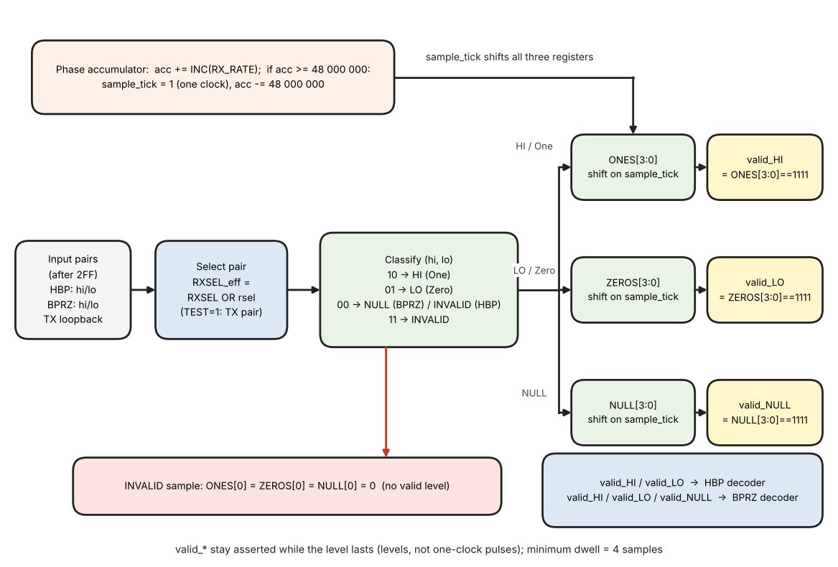
Figure 10: Data sampler datapath: pair select, classification, shift registers and 4-sample dwell

Timing tolerance of the sampler
Decoder tolerance: the received bit cell may be up to 2 samples (12.5 %) longer or 2 samples (12.5 %) shorter than nominal (16 samples), that is 14 to 18 samples. Outside this range the behavior is not guaranteed (the reference model of Section 12.10 flags a cell longer than 18 samples as a framing error, rule F below, and does not decode cells shorter than 14 samples reliably). The core_clk accuracy (+/-0.1 %) and the accumulator residual (< 1 core_clk) are far inside this window.

3.2.1.2 HBP Decoder
What it does. The HBP decoder turns the stream of validated line levels coming from the sampler (Section 3.2.1.1) into one data bit per bit cell. It uses only the two dwell-validated flags valid_HI and valid_LO; it never looks at raw samples. For every recovered bit it produces one clock-wide pulse bit_valid together with the value bit_data, and it produces framing_error when the line does not follow the HBP rule. One bit cell lasts 16 sample_ticks at the nominal rate.
The coding rule (the same rule as the TX encoder, Section 3.1.3). Every bit cell starts with a transition (the boundary edge). A logic 1 has a second transition in the middle of the cell (the mid-cell edge); a logic 0 has none. The decoder therefore has to answer only one question per cell: was there a mid-cell edge or not?

Big picture: what the decoder does in three steps
- Step A - find where the cells are (ACQUISITION). After start-up the decoder does not know where a bit cell begins. It measures the distance between validated edges. A distance of about 16 samples can only be a bit 0 (boundary edge, nothing in the middle, next boundary edge), so the second of the two edges is a cell boundary. The decoder locks: it starts its own phase counter at that edge.
- Step B - count the 16 samples of every cell (TRACKING). The phase counter runs 0..15 and wraps to 0 at the end of every cell. Every edge that arrives at an expected place re-aligns the counter (boundary edge: phase := 3, mid-cell edge: phase := 11), so a small bit-rate error never accumulates.
- Step C - decide the bit. If an edge arrives in the middle of the cell (phases 8 to 13) the bit is a 1, otherwise it is a 0. The bit is output when the counter wraps to 0.
- Anything that does not fit (an edge at phase 14 or 15, two validated edges closer than 6 samples, two mid-cell edges in a row, an edge 14 samples or more after the previous edge where only about 8 is possible, no edge for more than 24 samples, or a boundary edge more than 18 samples after the previous one when no mid-cell edge lies between them: rule F) is a framing error: while INSYNC = 0 the decoder clears its window and trackers and goes back to Step A; while INSYNC = 1 the decoder keeps running and the error is recorded as a bad bit if ERRCHK_ENB = 1 (Section 3.2.4); if ERRCHK_ENB = 0 it is only ignored (Section 3.2.4.8).
Figure 11 shows the three steps on one real stream (bits 0 1 1 0 1 0 0, 16 samples per cell, produced with the reference model of Section 12.10). Read it from left to right. In the blue part the decoder only measures the distance between edges; a distance of 8 samples tells it nothing, then a distance of 16 samples can only be two cell starts, so it locks. In the green part the phase counter runs 0..15 in every cell; an edge at phase 11 is a mid-cell edge, and at the end of the cell the bit is 1 if such an edge was seen and 0 if not. The bits that passed while the decoder was still searching are not output.
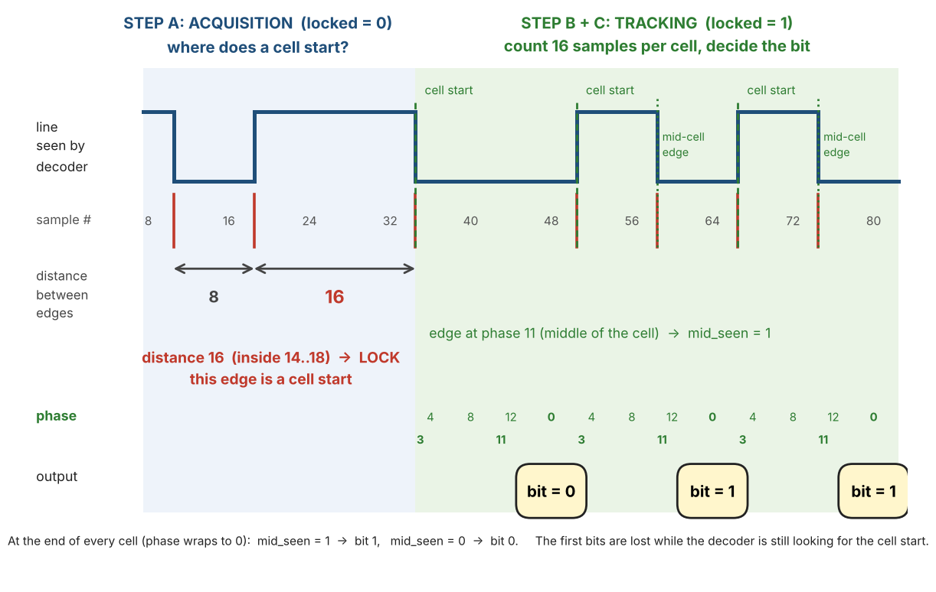
Figure 11: HBP decoder idea: finding the cell start (distance between edges), then counting 16 samples per cell and deciding the bit
Table 9 gives the distance between two consecutive validated edges for a nominal cell of 16 samples.
Table 9: Distance between two consecutive validated edges (nominal cell = 16 samples)
Distance | Where it comes from (HBP rule) | Use in the decoder
less than 6 samples | impossible on a legal line: the shortest legal distance is 7 samples (half of the shortest accepted cell of 14 samples) | tracking: framing error (edge-distance check)
about 8 samples | boundary edge to mid-cell edge, or mid-cell edge to the next boundary edge (the bit is a 1) | tracking: re-aligns the counter; acquisition: ignored
about 16 samples | boundary edge to the next boundary edge, with nothing in between (the bit is a 0) | acquisition: lock (distance 14 to 18); tracking: re-aligns the counter; more than 18 samples after the previous boundary edge, with no mid-cell edge between: framing error (rule F)
more than 24 samples | no edge for more than one and a half cells: line idle, stopped or not HBP | tracking: framing error

Inputs, outputs and registers
Two terms are used in the table. A boundary edge is the transition at the start of a bit cell; a mid-cell edge is the transition in the middle of a cell that carries a 1 (the coding rule above). The decoder tells them apart only by the phase at which the edge is observed (Table 11): phases 0 to 7 are a boundary edge, phases 8 to 13 are a mid-cell edge.
Table 10 lists the inputs, outputs and registers of the HBP decoder.
Table 10: HBP decoder: inputs, outputs and registers
Name | Kind | Meaning | After reset / when rx_active rises
valid_HI, valid_LO | input | Dwell-validated line level from the sampler (Section 3.2.1.1), evaluated on every RX sample_tick while rx_active = 1. They are levels (they stay 1 while the line level lasts) and are never both 1. | -
bit_valid | output | One-clock pulse, one per recovered bit. | 0
bit_data | output | Recovered bit, valid together with bit_valid: 1 = a mid-cell edge was seen in this cell, 0 = none. | 0
framing_error | output | One-clock pulse when the line does not follow the HBP rule. | 0
level | register | HI or LO: the last validated line level. It changes only when the opposite flag is asserted (valid_LO after HI, valid_HI after LO). Samples that are not yet valid leave it unchanged and never create an edge. | not used (level_known = 0)
level_known | 1 bit | 0 until the first validated level. That first level only sets level and is not an edge. | 0
edge | this sample | 1 in the sample where level changes (a validated edge). | -
phase | 0..15 | The decoder's own sample counter inside the current cell; independent of the TX phase counter. Phase 0 is the sample of the true cell start. | not used until locked
mid_seen | 1 bit | 1 when a mid-cell edge (phases 8 to 13) was classified in the current cell. It is cleared at every end of cell and becomes bit_data. | 0
last_mid | 1 bit | Memory of the edge sequence. 1 = the last classified edge was a mid-cell edge; 0 = it was a boundary edge. Every cell starts with a boundary edge, so between two mid-cell edges there is always one boundary edge. A mid-cell edge that arrives while last_mid = 1 means that this boundary edge is missing: framing error. Set by a mid-cell edge, cleared at lock and at every boundary edge. | 0
locked | 1 bit | 1 when the decoder knows where the bit cells are (bit lock). | 0
samples_since_edge | 0..31 | Samples since the last validated edge (saturates at 31). Used for the distance measurement in acquisition and, in tracking, for the minimum edge distance (less than 6 is a framing error), for the maximum edge distance (14 or more at a mid-cell edge, or at a boundary edge after a mid-cell edge, is a framing error), for the maximum cell length (more than 18 at a boundary edge after a boundary edge is a framing error) and for the no-edge timeout. 31 means "no edge seen yet". | 31
insync, errchk | input | INSYNC (receiver locked) and RX_ERR_CTRL.ERRCHK_ENB, both from the RX sync logic and the applied configuration. While insync = 1 an error does not unlock the decoder (Section 3.2.4.3). | 0
resync | 1 bit | Only while insync = 1 and errchk = 1. Set by a framing error: the phase is frozen and every bit that leaves is flagged until a boundary edge 14..18 samples after the previous edge re-locks the phase (Section 3.2.4.3). Cleared at lock of the decoder and when rx_active rises. | 0
cause[9:0], back, cur | output | With framing_error: cause = which check fired (Table 40 mask), back = 1 flags also the bit before, cur = 1 flags the cell in progress (Table 19, Section 3.2.4.2). Used only when errchk = 1. | 0
placeholder | output | With bit_valid: 1 = the bit left while resync = 1, so it is a bad bit (cause RESYNC). | 0

Why the observed edge is late. Because of the 4-sample dwell (Section 3.2.1.1) a validated edge is seen three samples after the true line transition. All windows below are therefore defined for the OBSERVED edge: the true cell start is phase 0, so a nominal boundary edge is observed at phase 3 and a nominal mid-cell edge (true phase 8) at phase 11.

Acceptance windows (observed edges, tracking mode)
Table 11: HBP decoder: acceptance windows (phase at which an edge is observed, tracking mode)
Phase | Meaning | Action | Nominal
0 to 7 | Boundary edge: the start of a cell. It is not a bit; it only re-aligns the counter. | if last_mid = 1 and samples_since_edge >= 14: framing error; else phase := 3; last_mid := 0 | 3
8 to 13 | Mid-cell edge: the bit of this cell is a 1. | if last_mid = 1: framing error; else if samples_since_edge >= 14: framing error; else mid_seen := 1; phase := 11; last_mid := 1 | 11
14, 15 | Forbidden: too late for a boundary edge of this cell and too late for a mid-cell edge. | framing error | -

- Why these limits. The mid window is phases 8 to 13 (nominal phase 11). The boundary window ends at phase 7. A cell that is 2 samples longer than 16 puts the next boundary edge at phase 5, so the window leaves a margin of 2 samples; the upper limit of the cell length is enforced by the check of the maximum cell length below, not by the window. A cell that is 2 samples shorter than 16 puts the next boundary edge at phase 1 (3 samples shorter: phase 0, just after the wrap). Phases 14 and 15 stay forbidden. The windows therefore accept at least the capture range stated below: -2 / +2 samples per 16.

Algorithm: one evaluation per sample_tick
- Step 1 – update the level. new_level = HI if valid_HI, LO if valid_LO, otherwise unchanged. edge = level_known AND (new_level differs from level). Then level := new_level and level_known := level_known OR valid_HI OR valid_LO.
- Step 2 – age the last edge: samples_since_edge := min(samples_since_edge + 1, 31). bit_valid and framing_error default to 0.
- Step 3 – if locked = 0 go to ACQUISITION, otherwise to TRACKING.

ACQUISITION (locked = 0)
- A. Nothing is decoded; no bit_valid is produced. Only the distance between validated edges is measured.
- B. At a validated edge: gap := samples_since_edge, then samples_since_edge := 0.
- C. If gap is 14 to 18: the two edges are consecutive boundary edges around a bit 0 (a mid-cell edge always lies about 8 samples from its neighbors, so a distance of about 16 can only come from a bit 0). Set locked := 1, phase := 3, mid_seen := 0, last_mid := 0. The edge that was just seen is the boundary edge of a new cell, hence phase = 3.
- D. Any other gap (for example about 8 for a 1, or a long gap at the start) is ignored and the decoder keeps waiting.
- E. Start condition. samples_since_edge is 31 after reset and whenever rx_active rises ("no edge seen yet"). The first validated edge therefore only starts the measurement (its gap is 31 and is ignored); a lock needs two edges that really are 14 to 18 samples apart.

TRACKING (locked = 1)
- A. Advance the cell counter: phase := (phase + 1) mod 16.
- B. End of cell: if the new phase is 0 the cell has finished. In this sample bit_valid := 1 and bit_data := mid_seen; then mid_seen := 0. This happens exactly once per cell, independent of any edge.
- C. If a validated edge occurs in this same sample, first check its distance to the previous validated edge: if samples_since_edge is less than 6 the edge is impossible on a legal line and it is a framing error (edge-distance check). Otherwise classify it by the CURRENT phase value (after step A); the distance is used only for the plausibility checks below and never to choose the type: phase 0..7 = boundary edge: if last_mid = 1 and samples_since_edge is 14 or more it is a framing error (maximum edge distance), if last_mid = 0 and samples_since_edge is more than 18 it is a framing error (maximum cell length), otherwise phase := 3, last_mid := 0 (no bit is created); phase 8..13 = mid-cell edge: if last_mid = 1 it is a framing error (two mid-cell edges in a row), else if samples_since_edge is 14 or more it is a framing error (maximum edge distance), otherwise mid_seen := 1, phase := 11, last_mid := 1; phase 14 or 15 = framing error.
- D. Whenever an edge was classified, samples_since_edge := 0.
- E. Timeout: if samples_since_edge is greater than 24 (no edge for more than one and a half cells) the line has stopped or is not HBP: framing error.
- F. Framing error (rule C: distance below 6, two mid-cell edges in a row, distance of 14 or more, a boundary edge more than 18 samples after a boundary edge, or phase 14 or 15; or timeout E). While INSYNC = 0: locked := 0, bit_valid is suppressed (it is 0 even if step B had set it), framing_error pulses, the 12-bit RX shift window and all sync trackers are cleared (shall, REQ-RX-03) and the decoder returns to acquisition. While INSYNC = 1: framing_error pulses with the cause, the decoder does NOT unlock, bit_valid is not suppressed, the edge that caused the error is ignored (it does not change phase, mid_seen or last_mid) and the flag resync is set (Section 3.2.4.3). Window, trackers and bit counters are not touched. With ERRCHK_ENB = 0 the same applies, except that no flag is set (framing_error is not used) and resync is not set: the error edge is only ignored and the phase counter keeps running (Section 3.2.4.8).
- Order matters: step B uses the phase after the increment, so a boundary edge observed in the sample where the phase wraps to 0 gives one bit_valid (from the wrap) and is then classified as a boundary edge (phase := 3). It never produces a second bit.
A sample-by-sample trace of this decoder (the line, the valid flag and every register at every sample_tick, taken from the reference model) is given in Table 61, Section 12.10. Figure 11 above shows the same behavior as a picture.
- Runs of identical bits stay aligned: for all ones every gap is about 8 samples, and both the boundary edges and the mid-cell edges re-align the phase.
Capture range: the bit cell may be 2 samples shorter or 2 samples longer than 16 samples (-12.5 % / +12.5 %), the tolerance accepted for this version (Open Issues); the core_clk accuracy and the accumulator residual are far inside this range. The HBP waveform rule is consistent with the Harvard biphase definition; see Section 1.5 for what is not publicly defined.

Consistency checks on the edges (minimum distance, no two mid-cell edges in a row, maximum distance)
Why they are needed. Every edge re-aligns the phase counter. If the counter is wrong by a fixed number of samples it stays wrong: every later edge is classified wrongly (for example every boundary edge is taken for a mid-cell edge, so every bit reads as 1) and no window is ever violated. The three checks below use only facts that do not depend on the phase counter. They detect such a state and also some glitches on the line (tests ER-04, ER-05 and ER-27).
Minimum edge distance. On a legal HBP line two validated edges are at least 7 samples apart (measured with bit cells of 14 to 18 samples and any sampling phase; the nominal distances are 8 and 16). In tracking mode a validated edge with samples_since_edge less than 6 (HBP_MIN_GAP) is therefore a framing error. The margin is one sample at the shortest accepted cell (14 samples, half cell 7). A typical cause is one INVALID sample, (1,1) or (0,0), on the 4th sample of a validated edge: the dwell restarts, the edge is seen 4 samples late, the phase counter lags by 4 samples, and the real mid-cell edge follows at a distance of 4. Without the check the decoder stays half a cell behind and reads every bit as 1 without any error (Figure 12).
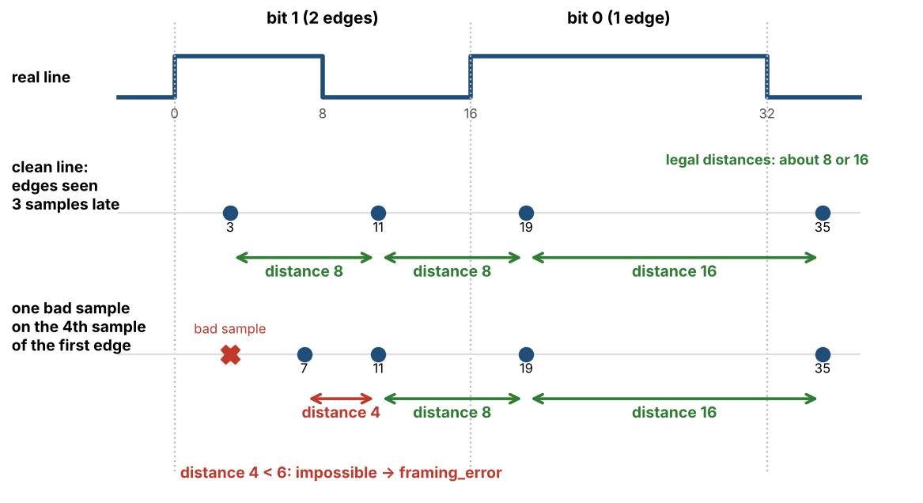
Figure 12: Edge-distance check: one bad sample delays a validated edge and the next edge is only 4 samples away
No two mid-cell edges in a row. A mid-cell edge is always followed by the boundary edge of the next cell, so on a legal line the edge sequence never contains two mid-cell edges without a boundary edge between them. The decoder keeps the type of the last classified edge in last_mid; a mid-cell edge that arrives while last_mid = 1 is a framing error. A typical cause is a glitch that puts the line at the opposite level for 5 samples or more inside a bit 0: a false mid-cell edge is seen, the real boundary edge of the next cell is swallowed, and the next real mid-cell edge is the second one in a row (Figure 13). Without the check the bit 0 is read as a 1 without any error.
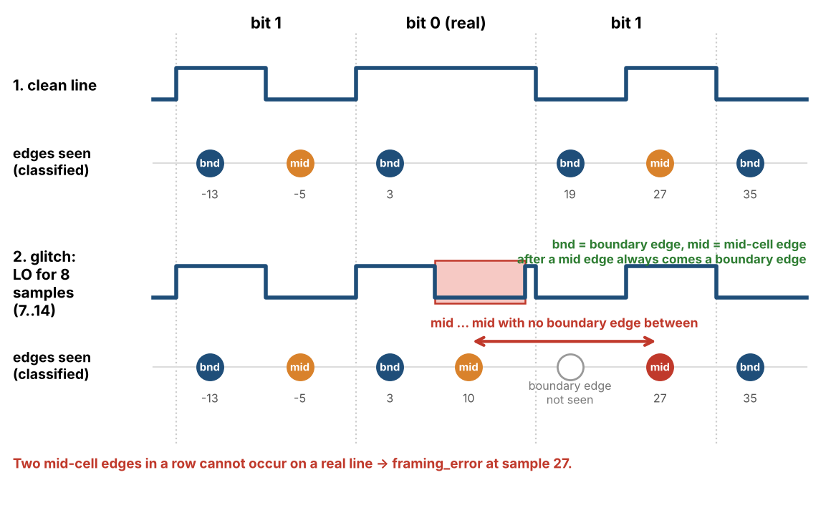
Figure 13: Sequence check: a glitch of 8 samples in a bit 0 gives two mid-cell edges in a row
Maximum edge distance. On a legal HBP line a mid-cell edge comes half a cell after the boundary edge of its cell, and the boundary edge that follows a mid-cell edge also comes half a cell later: 7 to 9 samples for cells of 14 to 18 samples, nominal 8. The decoder therefore also looks at the distance, which does not depend on the phase counter, and compares it with the type of edge that the phase suggests. In tracking mode a mid-cell edge (phase 8 to 13), and a boundary edge (phase 0 to 7) that follows a mid-cell edge (last_mid = 1), with samples_since_edge of 14 or more (HBP_MAX_GAP) is a framing error. The largest legal distance is 10 (cell of 18 samples: half cell 9, plus one sample of jitter); the smallest distance of the faults described here is 19 (cell of 14 samples; 21 for a cell of 16), so HBP_MAX_GAP = 14 leaves a margin of 4 samples on the legal side and of 5 samples on the fault side.
A typical cause is a short glitch right after a boundary edge. The new level has been present for only 3 samples when the glitch arrives, so the dwell of 4 samples (Section 3.2.1.1) starts again after the glitch and the boundary edge is validated late. A glitch of 2 samples on samples 3 and 4 of a bit 0 moves the edge from phase 3 to phase 8, which is inside the mid-cell window: the phase rule alone takes it for a mid-cell edge and reads the bit 0 as a 1 without any error. Its distance to the previous edge is 21 samples, so the maximum-distance check raises a framing error (Figure 14).
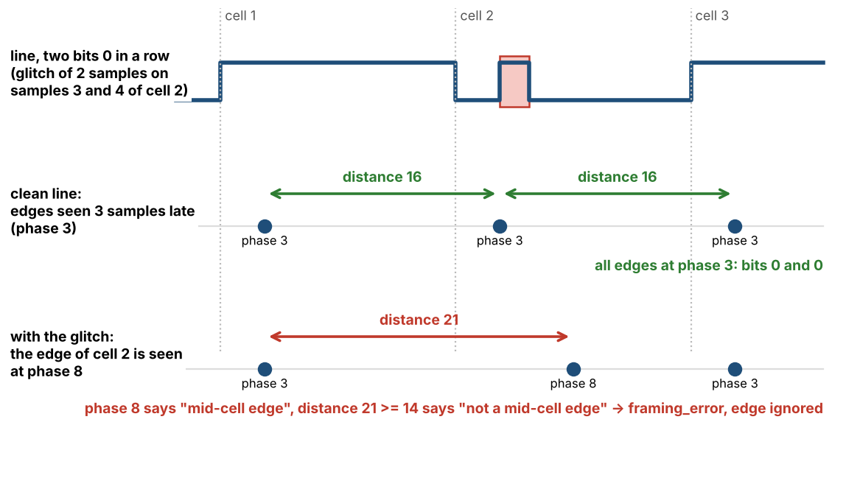
Figure 14: Maximum-distance check: a glitch of 2 samples on samples 3 and 4 of a bit 0 moves the boundary edge from phase 3 to phase 8; its distance of 21 samples shows that it cannot be a mid-cell edge
Maximum cell length. Two boundary edges in a row (last_mid = 0) are one bit 0 apart, so their distance is the length of the cell, 14 to 18 samples on a legal line. In tracking mode a boundary edge (phase 0 to 7) with last_mid = 0 and samples_since_edge of more than 18 (the upper limit of the lock range) is a framing error. The other checks cannot see this case: two glitches of 3 and 4 samples in two bits 1 in a row are filtered or accepted by the dwell so that the first bit 1 loses its mid-cell edge, the second one gives an edge that the phase rule takes for a boundary edge 19 samples after the previous one, and the decoder reads both bits as 0 with no error. With the check the decoder flags the bits (test ER-28). The check detects the fault; it does not rebuild the lost edges.
What the decoder does with the error edge. With INSYNC = 1 the edge is ignored (phase, mid_seen and last_mid are not changed), so the bit is decoded as 0, which is correct in this example. With ERRCHK_ENB = 1 the cell is flagged and the re-synchronization window of Section 3.2.4.3 flags the following cells until two boundary edges 14 to 18 samples apart are seen; with ERRCHK_ENB = 0 nothing is flagged. With INSYNC = 0 the decoder returns to acquisition (step F). The check detects a fault; it does not rebuild an edge that was swallowed. If the glitch swallows both edges of a bit 1 that follows a bit 1 (glitch on samples 2 to 4), the bit is read as 0, and the boundary edge of the next cell arrives 24 samples after the last edge: the second form of the check (a boundary edge after a mid-cell edge) raises the framing error and the bit is flagged (test ER-27).
Table 12 shows which check catches which glitch (reference model, HBP, locked, glitches inside a cell).
Table 12: HBP decoder: what happens with a glitch on the line
Glitch | What the decoder sees | Result
One INVALID sample (1,1) or (0,0) on the 3rd or 4th sample after a line transition | The validated edge is delayed by 3 or 4 samples | Framing error: edge-distance check, or phase 14 / 15 (test ER-04); a delayed boundary edge of a bit 0 may be caught by the phase rule
One INVALID sample on any other sample | No validated edge is delayed | Absorbed: bits unchanged, no flag
Opposite level for 1 to 3 samples (inside a cell, not at an edge) | Never validated (the dwell needs 4 samples) | Absorbed: bits unchanged, no flag
Opposite level for 2 or 3 samples starting on sample 1 to 3 of a cell (right after a boundary edge) | The new level has been seen for fewer than 4 samples, so the boundary edge is validated late: phase 6 to 9 instead of 3 | Framing error (maximum-distance check, or the phase rule at the next edge), or absorbed with unchanged bits; a bit is never wrong without a framing error (test ER-27)
Opposite level for 4 samples from sample 7 of a bit 0 between two 1s | A false mid-cell edge, then the return edge at phase 14 or 15 | Framing error: edge-distance check (the return edge is only 4 samples after the false edge; it also falls in phase 14 or 15)
Opposite level for 5 samples (same position) | Two false edges 5 samples apart | Framing error: edge-distance check
Opposite level for 6 to 9 samples (same position) | A false mid-cell edge, the boundary edge is swallowed, the next real mid-cell edge is the second in a row | Framing error: sequence check
A glitch that leaves a legal edge sequence (it turns the cell into another legal HBP cell) | A legal HBP waveform that carries other bits | Not detected by the core. In the reference model about 3 % of the opposite-level glitches of 5 to 12 samples (all start positions) fall here: none for 5 to 9 samples, 2 to 13 % for 10 to 12 samples

Limits and price. HBP has no parity, so the core can only detect waveforms that cannot be a legal HBP line. Errors that leave a legal edge sequence are not seen: the sync word check (Section 3.2.3.1) sees an error in word 0 only, and the data shall be protected above the core (the software checks the words it needs). The checks also have a price: one INVALID sample on the 3rd or 4th sample after a transition used to produce either a correct bit or one silent wrong bit; it can now produce a framing error: before lock the decoder loses lock; after lock, with ERRCHK_ENB = 1, the bit and the one before it are flagged as bad bits and INSYNC stays (Section 3.2.4); with ERRCHK_ENB = 0 the error is ignored. A framing error is flagged, a silent wrong bit is not. framing_error is one event: ST_BIT_ERR does not say which check fired, RX_BIT_ERR_CAUSE does.
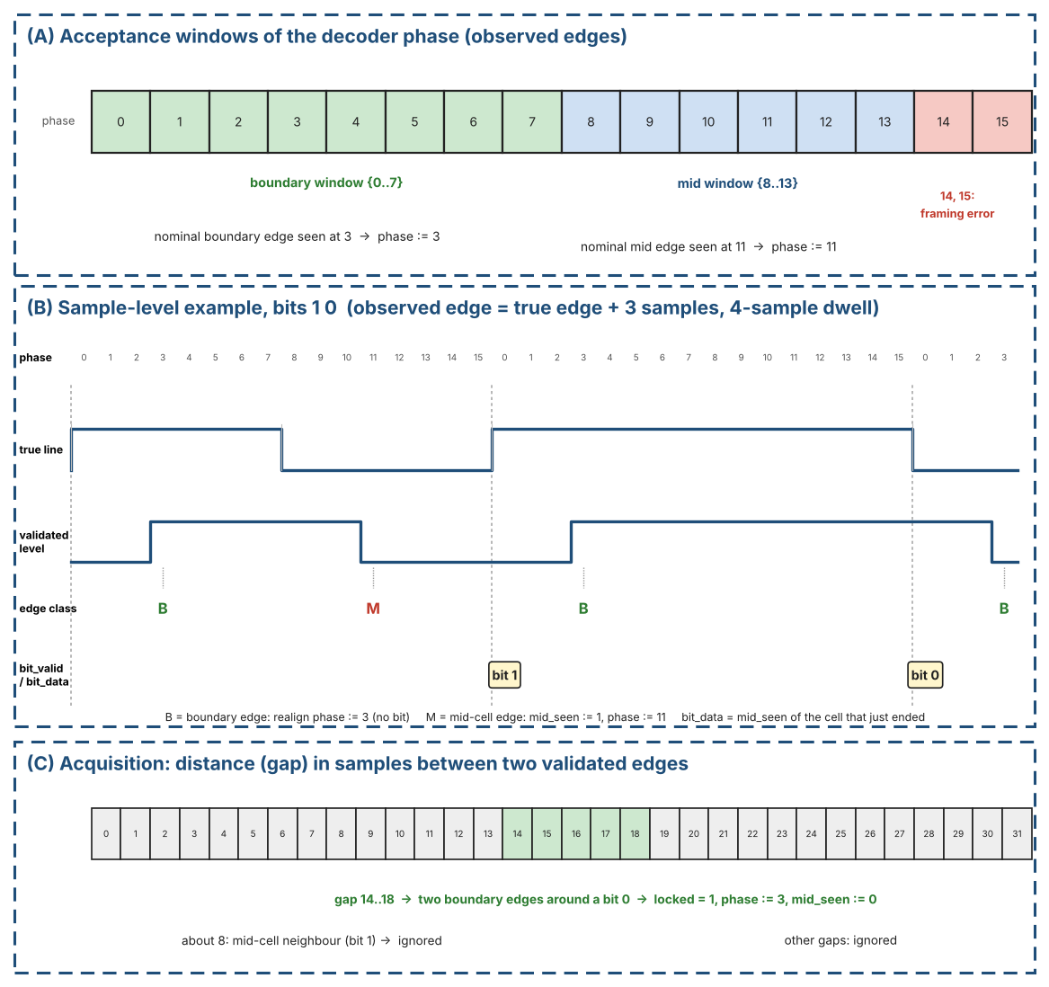
Figure 15: HBP decoder: acceptance windows, sample-level example and acquisition gap
Figure 16 shows the flowchart of one HBP decoder evaluation per RX sample_tick. The left branch is acquisition (locked = 0), the right branch is tracking (locked = 1). When a check fires in tracking, the decoder asks one more question, INSYNC = 0 ?: during acquisition of the sync words the decoder unlocks and starts again; while INSYNC = 1 it stays locked, ignores the error edge and reports the error to the bit-error logic (Section 3.2.4.3).
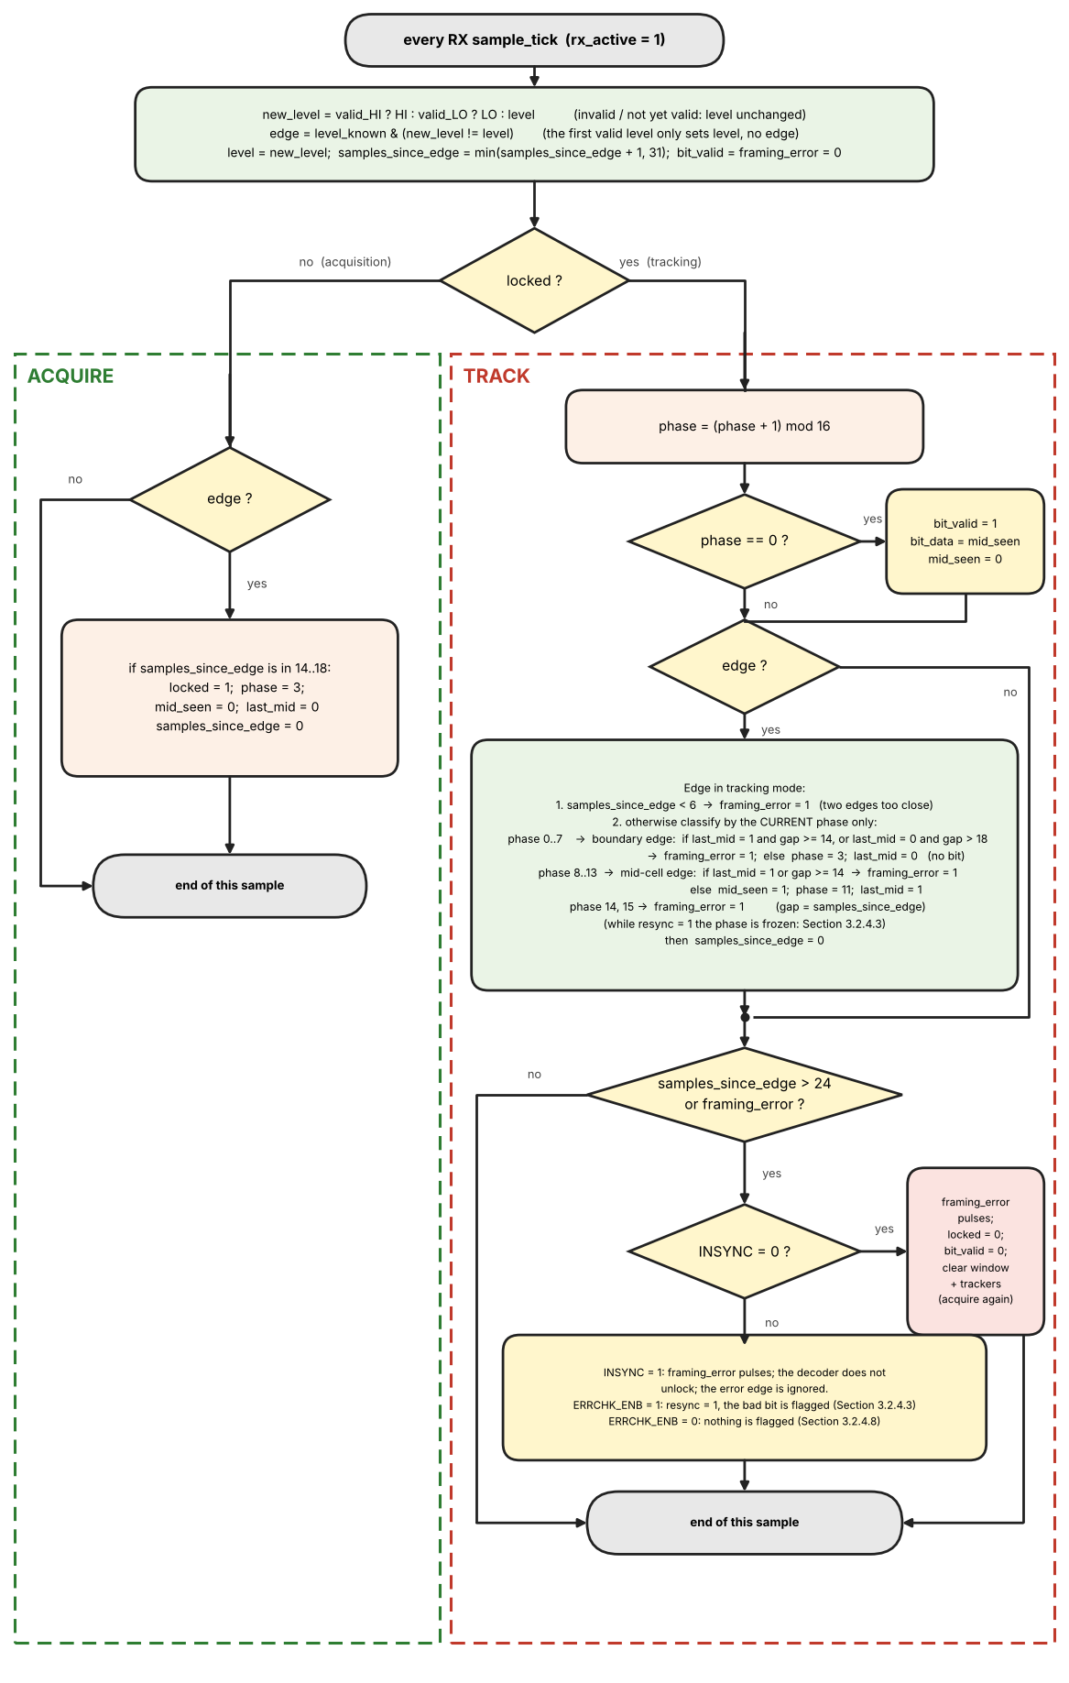
Figure 16: HBP decoder: flowchart of one evaluation per RX sample_tick

HBP decoder reference pseudo-code
// one evaluation per RX sample_tick (rx_active = 1); constants: boundary window {0..7},
// mid window {8..13}, HBP_MIN_GAP = 6, HBP_MAX_GAP = 14, HBP_TIMEOUT = 24, maximum cell length 18 (upper end of the lock range)
// reset / when rx_active rises: locked = 0; level_known = 0; mid_seen = 0; last_mid = 0;
// samples_since_edge = 31 (no edge seen yet)
new_level = valid_HI ? HI : valid_LO ? LO : level // from Table 8 detectors
edge = level_known & (new_level != level) // first valid level: no edge
level = new_level; level_known = level_known | valid_HI | valid_LO
bit_valid = 0; framing_error = 0
samples_since_edge = min(samples_since_edge + 1, 31)
if (!locked) {
if (edge) {
if (samples_since_edge in 14..18) { locked = 1; phase = 3; mid_seen = 0; last_mid = 0 }
samples_since_edge = 0
}
} else {
phase = phase + 1 // mod 16
if (phase == 0) { bit_valid = 1; bit_data = mid_seen; mid_seen = 0 } // end_of_cell
if (edge) {
if (samples_since_edge < 6) framing_error = 1 // edges too close
else if (phase in {0..7}) { // boundary edge
if (last_mid && samples_since_edge >= 14) framing_error = 1 // gap
else if (!last_mid && samples_since_edge > 18) framing_error = 1 // cell longer than 18
else { phase = 3; last_mid = 0 } // realign
}
else if (phase in {8..13}) { // mid-cell edge
if (last_mid) framing_error = 1 // two mid edges in a row
else if (samples_since_edge >= 14) framing_error = 1 // gap
else { mid_seen = 1; phase = 11; last_mid = 1 }
}
else framing_error = 1 // phase 14 or 15
samples_since_edge = 0
}
if (samples_since_edge > 24) framing_error = 1
if (framing_error && !INSYNC) { locked = 0; bit_valid = 0 } // acquisition only
}

3.2.1.3 BPRZ Decoder
The BPRZ decoder turns the three validated level flags of the sampler into one data bit per bit cell. Figure 17 shows the whole decoder on one page: the two-state machine on top, and below it what the line, the valid flags, the state and the output do over two consecutive bit cells (a 1 and a 0). The text that follows explains the figure step by step.
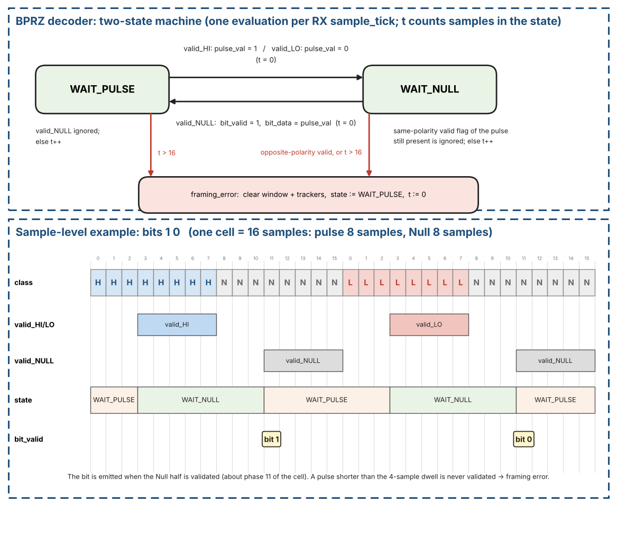
Figure 17: BPRZ decoder: the two-state machine (top) and what the flags and the state do over two bit cells, bits 1 and 0 (bottom)
What it does. The BPRZ decoder recovers one data bit per bit cell from the three dwell-validated level flags valid_HI (One), valid_LO (Zero) and valid_NULL (Section 3.2.1.1). Each cell on the line is a pulse in the first half (One for a 1, Zero for a 0) followed by Null in the second half, so the decoder only has to see "a pulse, then a Null" and remember the polarity of the pulse. No phase counter and no separate bit-lock state are needed: the Null that always follows a pulse re-synchronizes the decoder in every cell, so each emitted bit is its own recovered bit-clock. valid_NULL is not a separate input: it is derived inside the sampler from rx_bprz_high = rx_bprz_low = 0 (Section 3.2.1.1).

Step by step (follow the figure from left to right)
- Step 1 - Wait for a pulse (state WAIT_PULSE). After reset, after every recovered bit and after every framing error the decoder is here. It looks only at valid_HI and valid_LO. A Null (the idle level and the second half of every cell) tells it nothing, so it is ignored; the counter t only counts how many samples have passed without a pulse.
- Step 2 - Remember the polarity (WAIT_PULSE -> WAIT_NULL). When valid_HI appears (a One pulse) the decoder stores pulse_val = 1; when valid_LO appears (a Zero pulse) it stores pulse_val = 0. It clears t and moves to WAIT_NULL. Because of the 4-sample dwell this happens at the fourth sample of the pulse (sample 3 of the cell in the figure). The decoder does not measure how long the pulse lasts.
- Step 3 - Wait for the Null half (state WAIT_NULL). The valid flag of the pulse stays asserted for as long as the pulse lasts. This is normal: a flag of the same polarity as pulse_val is ignored (without this rule every bit would raise a framing error). t counts the samples spent waiting.
- Step 4 - Output the bit (WAIT_NULL -> WAIT_PULSE). When valid_NULL appears the cell is complete: bit_valid pulses for one clock with bit_data = pulse_val, t is cleared and the decoder returns to WAIT_PULSE. This happens at the fourth sample of the Null (sample 11 of the cell, about phase 11), roughly 8 samples before the next pulse is validated. The Null that follows every pulse is what puts the decoder back into a known state, so no phase counter and no bit-lock search are needed. Before the bit is output the decoder checks the distance to the previous bit (Step 7).
- Step 5 - Framing errors. Four things are errors: (a) in WAIT_NULL a pulse of the OPPOSITE polarity is validated before the Null; (b) in WAIT_NULL, t becomes greater than 16 (the Null never came); (c) in WAIT_PULSE, t becomes greater than 16 (no pulse at all); (d) a Null would complete a bit less than 10 samples after the previous bit (Step 7). On an error framing_error pulses, the decoder goes back to WAIT_PULSE with t = 0, and, while INSYNC = 0, the 12-bit RX window and all sync trackers are cleared; while INSYNC = 1 nothing is cleared: with ERRCHK_ENB = 1 the error becomes a bad bit (Section 3.2.4), with ERRCHK_ENB = 0 it is ignored (Section 3.2.4.8).
- Step 6 - What is ignored on purpose. A valid_NULL while in WAIT_PULSE; the same-polarity flag in WAIT_NULL (Step 3); and any glitch shorter than the 4-sample dwell, because a flag is never raised for it. Such a glitch can only delay the next valid flag by up to four samples; it is an error only if the wait exceeds 16 samples. A worked sample-by-sample example, including a one-sample glitch, is given in Table 62, Section 12.10.
Step 7 - Distance between two bits. The decoder counts the samples since the last bit it output (samples_since_bit). When a Null would complete a bit while this counter is less than 10 (BPRZ_MIN_BIT_GAP), the bit is blocked and it is a framing error: a legal line never sends two bits that close. Why the limit is 10 and what the check catches is explained in the subsection "Distance between two bits" below (Figure 19).

Inputs, outputs and registers
Table 13 lists the inputs, outputs and registers of the BPRZ decoder.
Table 13: BPRZ decoder: inputs, outputs and registers
Name | Kind | Meaning | After reset / when rx_active rises
valid_HI, valid_LO, valid_NULL | input | Dwell-validated line levels from the sampler (Section 3.2.1.1), evaluated on every RX sample_tick while rx_active = 1. They are levels, not pulses: each stays asserted for as long as its level lasts. | -
bit_valid | output | One-clock pulse, one per recovered bit. | 0
bit_data | output | Recovered bit (1 = One pulse, 0 = Zero pulse), valid together with bit_valid. | 0
framing_error | output | One-clock pulse when the line does not follow the BPRZ rule. | 0
st | 1 bit | State: WAIT_PULSE or WAIT_NULL. | WAIT_PULSE (also after every framing error)
pulse_val | 1 bit | Polarity of the pulse that was seen (1 = One, 0 = Zero). Meaningful only in WAIT_NULL. | 0
t | 0..17 | Number of samples spent in the current state; cleared at every state change. | 0
samples_since_bit | 0..31 | Samples since the last bit was output; increments on every sample_tick and saturates at 31. A Null that would complete a bit while samples_since_bit is less than 10 is a framing error (Step 7). Cleared when a bit is output, set to 31 by a framing error. | 31
insync, errchk | input | INSYNC (receiver locked) and RX_ERR_CTRL.ERRCHK_ENB, from the RX sync logic and the applied configuration. | 0
bit_slot | 0..63 | Only while insync = 1 and errchk = 1. Samples since the last bit; increments on every sample_tick and saturates at 63. Cleared when a bit is output. At 24 (BPRZ_SLOT_TIMEOUT) without a bit the decoder outputs a placeholder bit and sets bit_slot to 8 (Section 3.2.4.4). | 0
placeholder | output | With bit_valid: 1 = the bit was invented (value 0, bad bit, cause BIT_LOST). | 0
cause[9:0], back, cur | output | With framing_error: as for the HBP decoder (Table 19). Used only when errchk = 1. | 0

Algorithm: one evaluation per sample_tick
Every sample first: samples_since_bit := min(samples_since_bit + 1, 31). After reset and after every framing error samples_since_bit is 31 (no bit yet).
- State WAIT_PULSE (waiting for the first half of a cell). If valid_HI: pulse_val := 1, st := WAIT_NULL, t := 0. Else if valid_LO: pulse_val := 0, st := WAIT_NULL, t := 0. Otherwise (Null or nothing valid yet): t := t + 1; if t is greater than 16 the line has no pulse: framing error. A valid_NULL in this state is simply ignored.
- State WAIT_NULL (a pulse was seen, waiting for the Null half). If valid_NULL and samples_since_bit is less than 10, the bit is blocked and it is a framing error (two bits too close). If valid_NULL and samples_since_bit is 10 or more: bit_valid := 1, bit_data := pulse_val, st := WAIT_PULSE, t := 0, samples_since_bit := 0. Otherwise t := t + 1 and two error checks are made: (a) a pulse of the OPPOSITE polarity is validated before the Null (valid_LO while pulse_val = 1, or valid_HI while pulse_val = 0); (b) t is greater than 16 (the Null never came). Either one is a framing error.
- The valid flag of the SAME polarity as pulse_val is still asserted for as long as the pulse lasts; it is ignored and is not an error. Without this rule every bit would raise a framing error.
- Framing error: st := WAIT_PULSE, t := 0, samples_since_bit := 31, framing_error pulses, and, while INSYNC = 0, the 12-bit RX shift window and all sync trackers are cleared (shall, REQ-RX-03); while INSYNC = 1 nothing is cleared: with ERRCHK_ENB = 1 the error becomes a bad bit (Section 3.2.4), with ERRCHK_ENB = 0 it is ignored (Section 3.2.4.8). The decoder then waits for the next pulse.
- Placeholder (only while INSYNC = 1 and ERRCHK_ENB = 1): bit_slot := min(bit_slot + 1, 63) on every sample_tick and bit_slot := 0 when a bit is output. If bit_slot reaches 24 without a bit, bit_valid := 1, bit_data := 0, the bit is a bad bit (cause BIT_LOST) and bit_slot := 8 (Section 3.2.4.4).

Timing of a nominal cell (16 samples, 8 pulse + 8 Null; Figure 17)
- Samples 0 to 7 carry the pulse. valid_HI (or valid_LO) is asserted at sample 3, the fourth consecutive pulse sample (4-sample dwell); the decoder leaves WAIT_PULSE there and stores pulse_val.
- Samples 8 to 15 carry the Null. valid_NULL is asserted at sample 11; the decoder emits bit_valid in that sample (about phase 11 of the cell) and returns to WAIT_PULSE, about 8 samples before the next pulse is validated.
- Tolerance. The decoder only needs a pulse of at least 4 samples and a Null of at least 4 samples, and never waits more than 16 samples in a state (the longest normal wait is 8 samples, with a cell of 18 samples), so it does not depend on an exact 16-sample cell; it is more tolerant of rate error than the HBP decoder.
- A pulse shorter than the 4-sample dwell is never validated; it counts as a missing pulse and ends in a framing error (WAIT_PULSE timeout, or WAIT_NULL timeout if the pulse was seen).
Why the timeout is 16 samples. A lost pulse (for example an INVALID sample run that stops the pulse reaching 4 valid samples) shall be seen in the same cell. The decoder waits in WAIT_PULSE from the Null of the previous cell; the next valid pulse would normally come about 8 samples later, but after a lost pulse the pulse after that comes 24 samples later. With a threshold of 24 that wait is accepted and the bit is lost without any error; with 16 the framing error is raised in the same cell (test ER-06). The longest wait in normal operation is 8 samples (cell of 18 samples), so 16 leaves a margin of 8 samples.
- Idle line. An idle line in BPRZ mode (both inputs low = Null) is a missing pulse: WAIT_PULSE times out and raises a framing error every 17 samples. This is harmless, because the window and trackers are already clear and INSYNC is 0. While INSYNC = 1 and ERRCHK_ENB = 1 a line that goes idle produces placeholder bits instead (Section 3.2.4.4); with ERRCHK_ENB = 0 it produces no bits.
Error detection in BPRZ. The decoder raises framing_error in four cases: (1) in WAIT_PULSE no pulse has been validated for more than 16 samples (lost pulse, idle line); (2) in WAIT_NULL the pulse of the opposite polarity is validated instead of the Null; (3) in WAIT_NULL the Null does not arrive within 16 samples; (4) a Null would complete a bit less than 10 samples after the previous bit (two bits too close, next subsection). Figure 18 shows cases (1) and (2) sample by sample (reference model). A single INVALID sample never causes an error (test ER-03). A flipped bit with a legal shape (a valid pulse of the wrong polarity followed by a Null) cannot be detected: BPRZ carries no parity, so the word-0 sync check and the software checks remain responsible for the data.
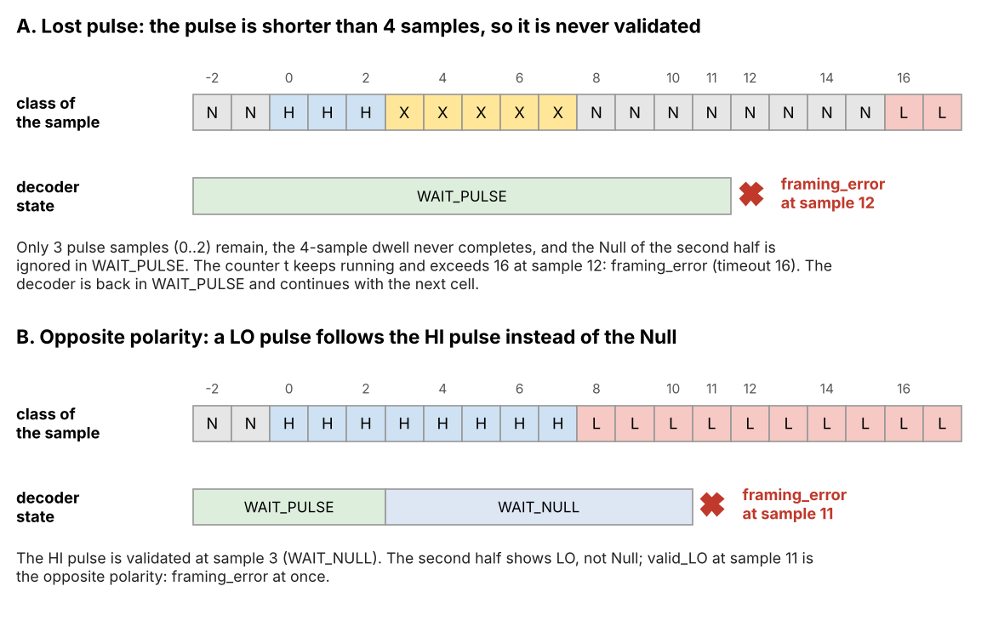
Figure 18: BPRZ error detection (H = HI pulse, L = LO pulse, N = Null, X = INVALID): (A) lost pulse, (B) opposite polarity instead of the Null

Distance between two bits (no two bits closer than 10 samples)
Why it is needed. Each half of a cell looks legal on its own: a pulse of 4 samples is validated, a Null of 4 samples is validated. If one cell of 16 samples carries pulse 4 / Null 4 / pulse 4 / Null 4 samples (Figure 19, bottom), the decoder follows its normal path twice and outputs two bits. No other check fires: the timeout is not reached and the polarity is not opposite. All later bits are shifted by one position, and the fault would only be noticed by the sync detector, much later. In a cell of 16 samples this is the only way to get two bits, because every run needs at least 4 samples; the two bits are then 8 samples apart.
The check. A bit is output at the same place of every cell (the fourth sample of the Null), so two consecutive bits of a legal line are one cell apart: 16 samples nominal, 14 to 20 samples over the tolerance range. The decoder counts the samples since the last bit in samples_since_bit. If a Null would complete a bit while samples_since_bit is less than 10 (BPRZ_MIN_BIT_GAP), the bit is not output and framing_error is raised. After every framing error samples_since_bit is set to 31, so the first bit after an error is always accepted.
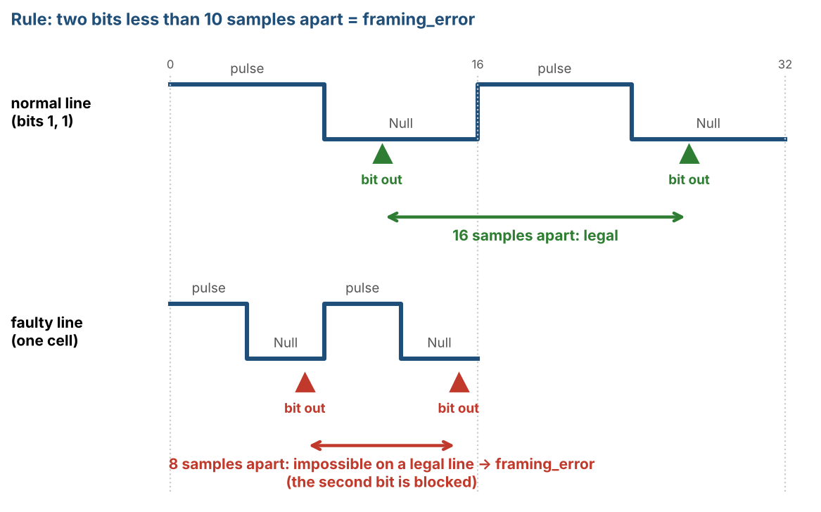
Figure 19: Distance check: a normal line gives bits 16 samples apart, a cell with two pulse / Null pairs gives two bits 8 samples apart
Why the limit is 10. The limit shall be above the faulty distance (8) and below the shortest legal distance. One INVALID sample inside a Null restarts the dwell of that Null and delays its bit by up to 4 samples, while the next bit is not delayed; so the distance between two legal bits can be 4 samples shorter than the cell: 14 - 4 = 10 for the shortest accepted cell of 14 samples. A distance of 10 is legal; 9 or less is an error (Figure 20).
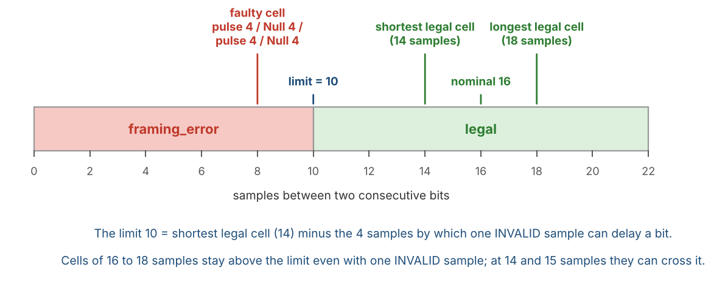
Figure 20: Distance between two bits: the limit of 10 samples separates the faulty cell (8) from the legal cells (14 to 18)
Table 14 shows what the check does with the cases of this section (reference model, BPRZ, locked).
Table 14: BPRZ decoder: what the distance check does
Case | What the decoder sees | Result
A cell turned into pulse 4 / Null 4 / pulse 4 / Null 4 samples (Figure 19) | Two bits 8 samples apart | Framing error, the second bit is blocked (test ER-07)
Legal lines with cells of 14 to 18 samples | Bits 14 to 20 samples apart | No error (test ER-08a)
One INVALID sample at any position, cells of 16 to 18 samples | One bit delayed by at most 4 samples | No error, bits unchanged (tests ER-03, ER-08b)
One INVALID sample, cell of 14 or 15 samples (end of the tolerance range) | The distance of two bits can fall below 10 | A framing error is possible (price of the check; in the model 40 of 280 positions at 14 samples, 20 of 300 at 15 samples)
A valid pulse of the wrong polarity followed by a Null (flipped bit) | A legal cell with another value | Not detected: BPRZ has no parity

Limits and price. The check only catches bits that arrive too early. A bit that arrives on time with the wrong value cannot be seen, so the word-0 check of the sync detector and the software checks remain responsible for the data. The price is a possible framing error at the end of the tolerance range (cells of 14 and 15 samples with one INVALID sample); cells of 16 to 18 samples are not affected. The limit of 10 samples is verified with the reference model only and shall be confirmed with line measurements on the board (Open Issues).
A sample-by-sample trace of this decoder (bits 1, 0, 1 with a one-sample glitch in the last cell: the line, the valid flag, the state, pulse_val and t at every sample_tick, taken from the reference model) is given in Table 62, Section 12.10.

BPRZ decoder reference pseudo-code
// one evaluation per RX sample_tick (rx_active = 1); t counts samples in the current state.
// valid_HI / valid_LO / valid_NULL stay asserted for as long as the level lasts (not
// one-clock pulses). Constants: BPRZ_TIMEOUT = 16, BPRZ_MIN_BIT_GAP = 10.
// reset / when rx_active rises: st = WAIT_PULSE; t = 0; samples_since_bit = 31
bit_valid = 0; framing_error = 0
samples_since_bit = min(samples_since_bit + 1, 31)
WAIT_PULSE: if (valid_HI) { pulse_val = 1; st = WAIT_NULL; t = 0 }
else if (valid_LO) { pulse_val = 0; st = WAIT_NULL; t = 0 }
else { t = t + 1; if (t > 16) framing_error = 1 }
WAIT_NULL : if (valid_NULL) {
if (samples_since_bit < 10) framing_error = 1 // two bits too close
else { bit_valid = 1; bit_data = pulse_val; st = WAIT_PULSE; t = 0
samples_since_bit = 0 }
} else { t = t + 1
// same-polarity valid flag of the pulse still present is ignored
if ((pulse_val ? valid_LO : valid_HI) | (t > 16)) framing_error = 1 }
on framing_error: st = WAIT_PULSE; t = 0; samples_since_bit = 31 // REQ-RX-03 (window / trackers cleared only while INSYNC = 0)

3.2.1.4 Hand-off to the Sync Detector
Both decoders present an identical interface to the rest of the receive path: a serial data-bit stream and a recovered bit-clock. The 12-bit sliding window of the sync detector is clocked exclusively by this recovered bit-clock, guaranteeing that every shift occurs on a validated data boundary. Consequently the sync state machine never has to deal with raw sample-level timing; it only sees clean, already-decoded bits.

3.2.2 Sync Detection
The sync detector finds the sync marks in the recovered bit stream and aligns the word boundaries. Section 3.2.2.1 describes the sliding window and the four code comparators, Section 3.2.2.2 the tracker algorithm of the default 4-sync mode, Section 3.2.2.3 the 2-sync mode (SFTSYNC = 1) and Section 3.2.2.4 the no-sync mode (NOSYNC = 1).

3.2.2.1 Sliding Window and Sync-Code Comparison
The sync detector operates on the stream of recovered data bits that leave the HBP/BPRZ decoder. Every recovered bit is shifted into a 12-bit sliding window (shift register). After each new bit the window is compared in parallel against the four legal subframe sync codes:
Table 15 lists the four sync codes that the 12-bit window is compared against.
Table 15: Sync detection comparison codes (12-bit window)
Code | Octal | Binary (MSB←LSB of window) | Subframe
SYNC1 | 1107 | 001 001 000 111 | Subframe 1
SYNC2 | 2670 | 010 110 111 000 | Subframe 2
SYNC3 | 5107 | 101 001 000 111 | Subframe 3
SYNC4 | 6670 | 110 110 111 000 | Subframe 4

Because the ARINC 717 bus transmits LSB first, the first bit that enters the shift register is the LSB of the 12-bit word; after twelve shifts the register holds a complete candidate word with the original LSB at the bottom and the MSB at the top. The four comparators examine this window every bit cell.
on every bit_valid: win <= {bit_data, win[11:1]}; // new bit enters at the MSB; after 12
shifts win[0] is the first received bit (LSB)

Figure 21 shows what the paragraphs above and the next section describe: every recovered bit pushes the 12-bit window one place, the four comparators look at all 12 bits at once, and a match produces a candidate sync event together with the code that matched. In the example the window holds 001 001 000 111, which is SYNC1.
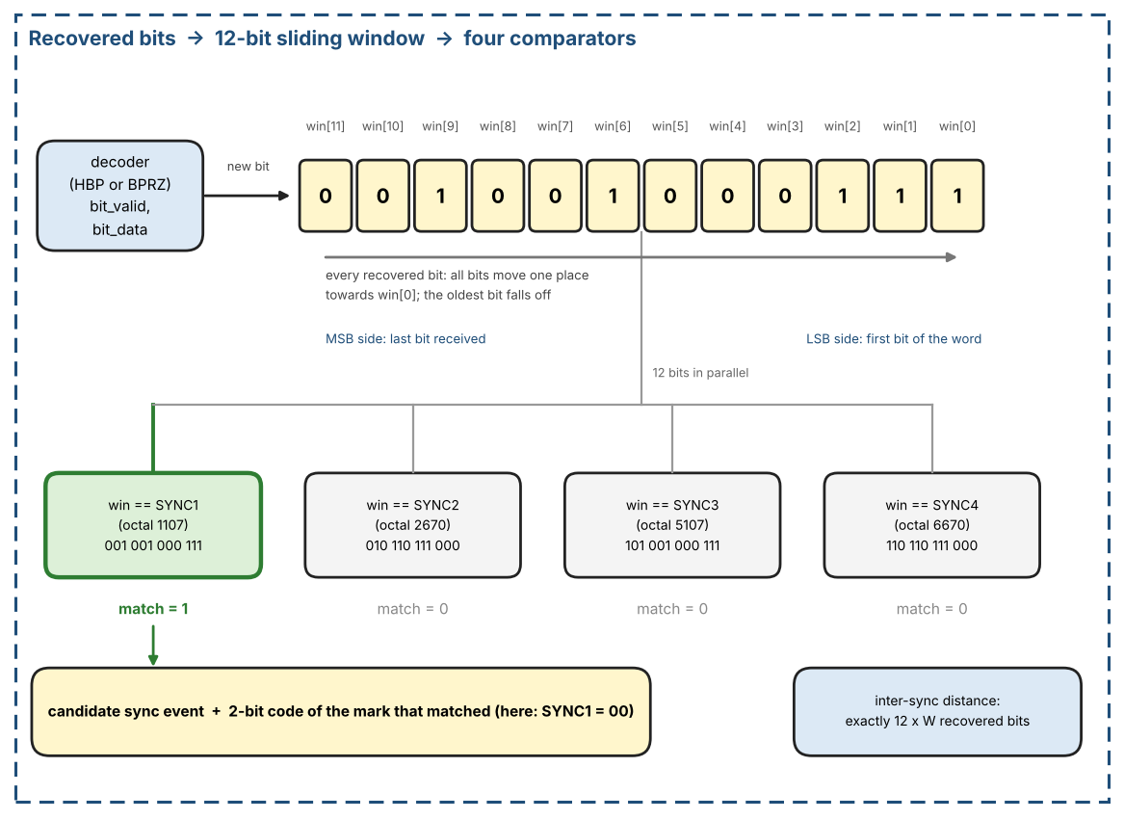
Figure 21: Sync detector: recovered bits enter a 12-bit window that is compared with the four sync codes after every bit
- On every recovered bit clock the oldest bit is discarded and the newest bit is shifted in (serial-in, parallel-out 12-bit shift register).
- Immediately after the shift, the 12-bit parallel value is presented to four equality comparators (one for each sync code).
- If any comparator asserts, a “candidate sync” event is generated together with a 2-bit code identifying which of the four marks was recognized.
- A free-running word-period counter (clocked by the recovered bit clock and reset by a successful sync match) measures the exact number of bit cells that have elapsed since the previous accepted sync mark. For a given programmed word rate the legal inter-sync distance is exactly one second, i.e. N words × 12 bits, where N is the number of words per subframe (W, Table 5).

3.2.2.2 Sync Acquisition with Trackers (4-sync mode)
Idea
In a real ARINC 717 stream the four sync words follow one another at exactly one subframe distance, 12 x W recovered bits, where W is the words per subframe of the applied RX_RATE (Table 5). The same 12-bit pattern can also appear by chance inside the data, so a single match proves nothing. A tracker is a small counter that tells the two cases apart: it waits for the next sync code in the expected order and accepts it only if it arrives exactly 12 x W bits after the previous mark. A candidate that keeps this rhythm for the required number of marks is a real sync sequence; a candidate that breaks it is dropped. Random matches therefore never disturb a tracker that is following the real sequence.
Tracker slot
The detector has four tracker slots, so up to four candidates are followed in parallel. Acquisition uses only these slots (there is no separate primary state during acquisition).
Table 16 lists the fields of one tracker slot.
Table 16: Fields of one tracker slot
Field | Width | Meaning
next_code | 2 bits | Index k (0..3 = SYNC1..SYNC4) of the sync code this tracker expects next
bit_count | 17 bits | Recovered bits since the last mark; the timeout is 12 x W, and 12 x W_max (W_max = the largest W of Table 5) is below 2^17, so 17 bits are enough
marks | 3 bits | Number of correct marks collected so far (1..5)
active | 1 bit | 1 = slot in use, 0 = free; a new tracker takes the lowest-numbered free slot

Operation on every recovered bit
Figure 22 shows what happens on every recovered bit_valid while INSYNC = 0. The steps (a) to (d) are executed in this order within the same core_clk cycle:
- (a) The new bit is shifted into the 12-bit window (Section 3.2.2.1).
- (b) Every active tracker increments bit_count. A tracker therefore matches when bit_count = 12 x W after this step.
- (c) If the window equals SYNC[k] (k = 0..3 for SYNC1..SYNC4), evaluate in order: (1) Consume: every active tracker with next_code = k and bit_count = 12 x W gets marks + 1, next_code = (k + 1) mod 4, bit_count = 0. (2) Allocate: if no tracker consumed the match and a free slot exists, a new tracker is started with marks = 1, next_code = (k + 1) mod 4, bit_count = 0, active = 1; this is allowed only if SFTSYNC = 1, or SFTSYNC = 0 and k = 0 (Table 17). Otherwise the match is ignored.
- (d) Timeout, evaluated last: a tracker whose bit_count exceeds 12 x W (exact, no extra tolerance) is freed. Because (d) comes after (c), a tracker that was just consumed (bit_count = 0) is never freed in the same cycle. A match that arrives at a wrong distance does not penalize a tracker; the tracker simply keeps counting until it either matches at the right distance or times out.
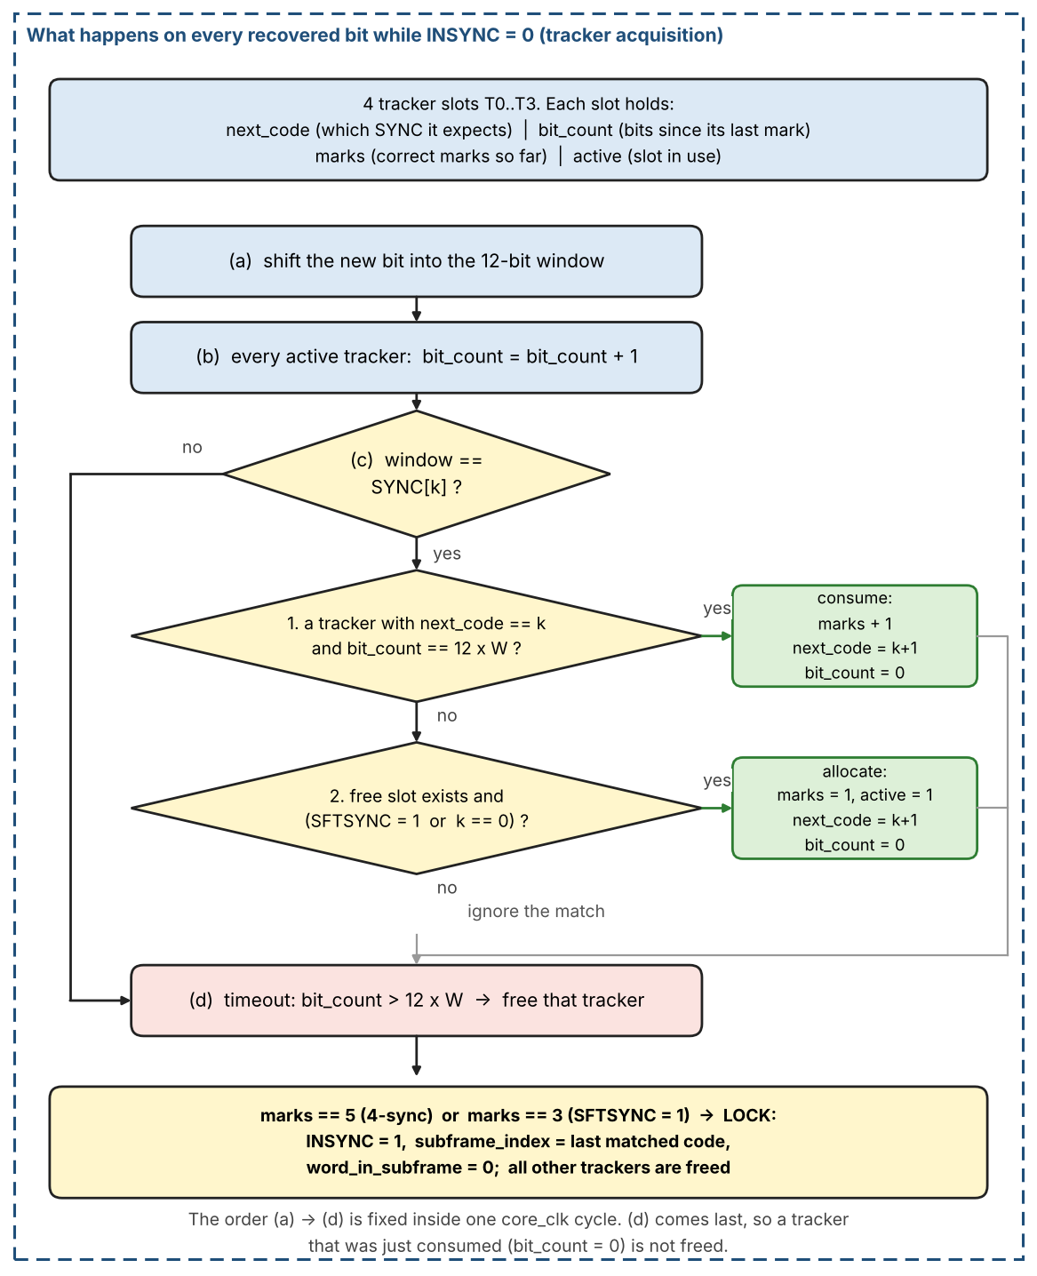
Figure 22: Per-bit operation of the tracker acquisition: window shift, bit_count update, code match (consume or allocate) and timeout
Lock conditions
Table 17: Acquisition parameters of the two modes
Mode | SFTSYNC | Marks needed for lock | Codes that may start a tracker
4-sync (default) | 0 | 5: SYNC1, SYNC2, SYNC3, SYNC4, SYNC1 | SYNC1 only (k = 0)
2-sync | 1 | 3: any three consecutive codes of the cycle | Any code SYNC[k]

When any tracker reaches the required number of marks: INSYNC = 1, subframe_index = index of the last matched code, word_in_subframe = 0. That tracker becomes the primary one and all other trackers are freed. From then on lock is maintained solely by the word-0 check of Section 3.2.3.1 (the assembled word shall equal RX_SYNC[subframe_index] at each subframe start); the tracker machinery is idle until INSYNC drops.
Decoder errors and acquisition time
While INSYNC = 0 a decoder framing error or loss of bit lock (Sections 3.2.1.2 and 3.2.1.3) frees all trackers and clears the window and the bit counters, because their bit_count values are no longer meaningful. While INSYNC = 1 it does not: with ERRCHK_ENB = 1 the error is recorded as a bad bit and counting goes on (Section 3.2.4); with ERRCHK_ENB = 0 the error is ignored (Section 3.2.4.8). INSYNC falls only after RX_ERR_LIMIT bad bits in a row, or when the sync word (word 0) has a wrong code or does not arrive in time (Section 3.2.3.1); it raises ST_INSYNC_LOST and acquisition restarts.
Worst-case acquisition takes on the order of two frames, when the first examined bit falls just after a SYNC1. A typical acquisition takes about one frame.
Implementation notes
- Trackers and the window run only while rx_active = 1 and INSYNC = 0.
- The window, the trackers and the lock logic are all clocked by core_clk and advance once per recovered bit_valid.

Worked example: 4-sync mode, W = 64 words per subframe
The distance between two sync words is 12 x W = 768 recovered bits. The receiver starts at bit 0 in the middle of a subframe (29 bits before the first SYNC1). Two words inside the data happen to equal a sync code (a false SYNC1 in the first subframe and a false SYNC3 in the second). The table lists the events in the order they happen. The bit index is the index of the last bit of the matching window; T0 and T1 are tracker slots after the evaluation of that bit.
Figure 23 draws the same events as the table below on a bit axis. Green dots are real sync marks, red circles are false hits inside the data. T0 advances only when the next code arrives exactly 768 bits after the previous one; T1, started by a false SYNC1, never sees SYNC2 at the right distance and times out.
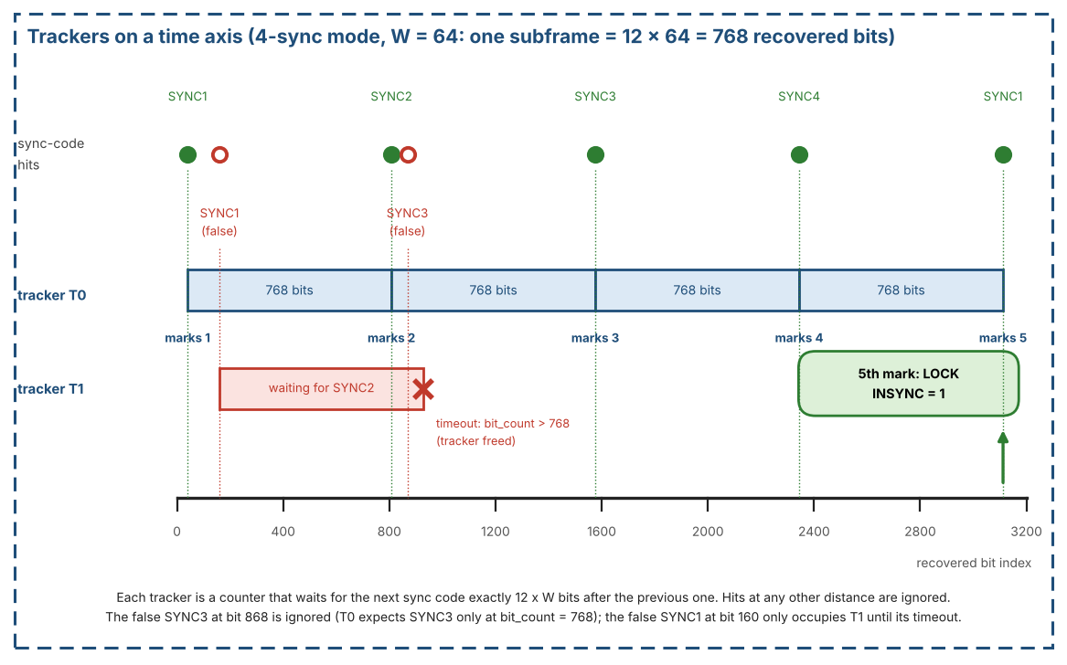
Figure 23: Sync acquisition on a time axis: tracker T0 reaches 5 marks and locks, tracker T1 times out (4-sync mode, W = 64)
Table 18 shows an example of sync acquisition in 4-sync mode with W = 64.
Table 18: Sync acquisition example (4-sync mode, W = 64)
Bit | Window | T0 | T1 | Result
40 | SYNC1 | next SYNC2, bit_count 0, marks 1 | free | No tracker expects it. SYNC1 may allocate: T0 allocated.
160 | SYNC1 | next SYNC2, bit_count 120, marks 1 | next SYNC2, bit_count 0, marks 1 | False mark inside the subframe. T0 expects SYNC2 and its bit_count is 120, not 768, so it is not consumed. SYNC1 allocates T1.
808 | SYNC2 | next SYNC3, bit_count 0, marks 2 | next SYNC2, bit_count 648, marks 1 | T0: bit_count = 768 = 12 x W, code matches: consumed, marks = 2. T1 (bit_count 648) does not match.
868 | SYNC3 | next SYNC3, bit_count 60, marks 2 | next SYNC2, bit_count 708, marks 1 | False SYNC3 (T0 expects SYNC3 only at bit_count 768, and SYNC3 cannot allocate in 4-sync mode): ignored.
929 | - | next SYNC3, bit_count 121, marks 2 | free | T1: bit_count exceeds 12 x W = 768: tracker freed (timeout).
1576 | SYNC3 | next SYNC4, bit_count 0, marks 3 | free | T0 consumed, marks = 3.
2344 | SYNC4 | next SYNC1, bit_count 0, marks 4 | free | T0 consumed, marks = 4.
3112 | SYNC1 | locked (primary) | free | T0 consumed, marks = 5: LOCK. INSYNC = 1, subframe_index = 0, this window is word 0. The other trackers are freed.

- Random matches do no harm. The false SYNC1 only costs a tracker slot until it times out (bit 929); the false SYNC3 is ignored. Neither one changes T0.
- Lock needs five marks, each exactly 768 bits after the previous one: SYNC1, SYNC2, SYNC3, SYNC4 and SYNC1 again. The first mark starts the tracker, so after it four consecutive correct distances are needed.

Sync Detection FSM and tracker state diagram
The Sync Detection FSM and the tracker slots follow the state diagrams of Figure 24. Within one recovered bit the order of steps (a) to (d) in the diagram is fixed. W is the words per subframe of the applied RX_RATE (Table 5).
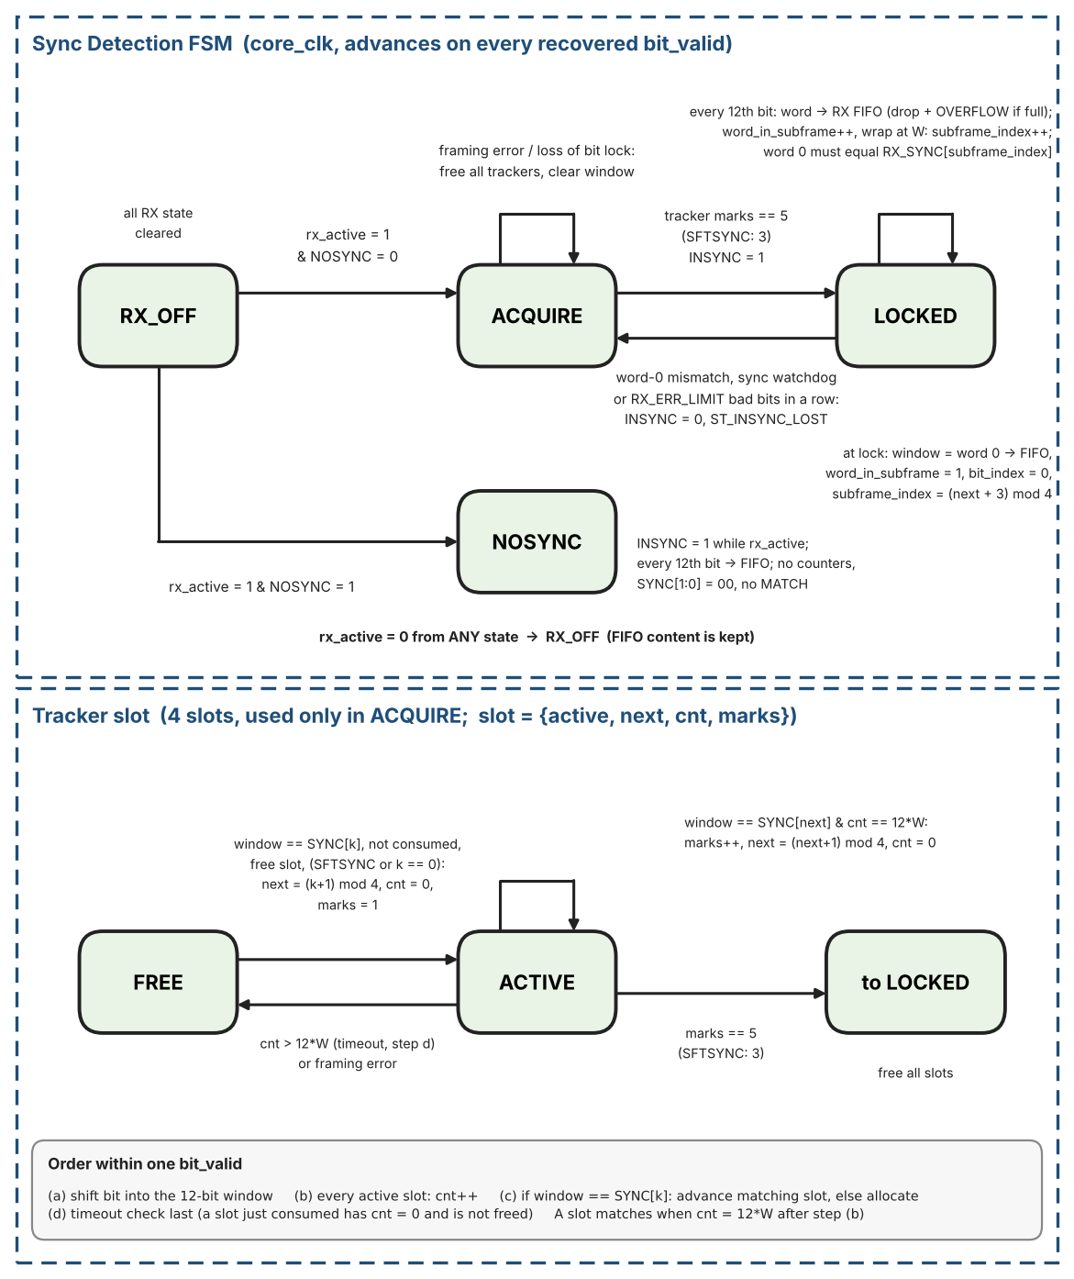
Figure 24: Sync Detection FSM and tracker slot state diagrams

3.2.2.3 Two-Sync-Word Mode (SFTSYNC = 1)
When RX_CTRL.SFTSYNC=1 the tracker rules of Section 3.2.2.2 use marks==3 for lock and may allocate a tracker on any SYNC[k] (not only SYNC1). Maintenance while INSYNC remains the word-0 check in Section 3.2.3.1.
Use when the absolute identity of the first observed subframe is unimportant.

3.2.2.4 No-Sync Mode (NOSYNC = 1)
When RX_CTRL.NOSYNC = 1 the trackers, the word-0 check and the sync watchdog are bypassed. INSYNC reads 1 while rx_active = 1. bit_index counts recovered bits from 0 at the first bit_valid after rx_active rises, so the word alignment is arbitrary and software shall locate subframe marks in the data. Every 12th recovered bit the assembled word is written to the RX FIFO. word_in_subframe and subframe_index do not run: SYNC[1:0] = 00, MATCH is never asserted and ST_INSYNC_LOST is not generated. With ERRCHK_ENB = 1 bad bits are flagged and counted as in Section 3.2.4 (the word, subframe and frame fields of their positions are 0); RX_ERR_LIMIT does not apply because INSYNC stays 1. With ERRCHK_ENB = 0 nothing is flagged or counted (Section 3.2.4.8).
Figure 25 compares the three modes of Sections 3.2.2.2 to 3.2.2.4 side by side: how many marks are needed to lock, which codes may start a tracker, and what happens in no-sync mode.
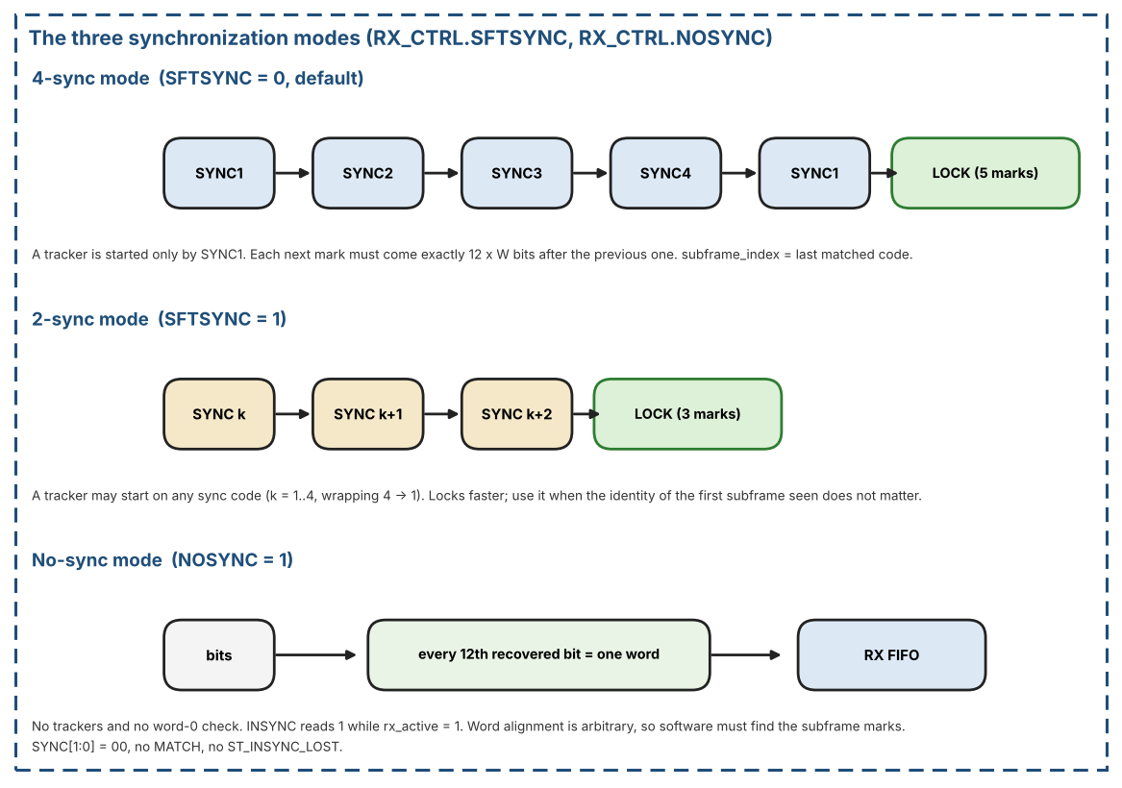
Figure 25: The three synchronization modes: 4-sync, 2-sync and no-sync

3.2.3 Word Framing After Lock
After lock the receiver counts bits and words from the matched sync mark: Section 3.2.3.1 describes the RX Timing Generator and its counters, Section 3.2.3.2 how each completed word is delivered to the RX FIFO.

3.2.3.1 RX Timing Generator and word counters
Once INSYNC is asserted, the RX Timing Generator produces recovered bit_tick/word_tick locked to the decoder.
Figure 26 shows the timing in units of recovered bits. Part A: at lock the window that matched the sync code is word 0 and is written to the RX FIFO in the same cycle; from then on bit_index counts 0..11, and every 12th recovered bit completes a word, increments word_in_subframe and writes the word. Part B: when word_in_subframe wraps to 0, the assembled word shall equal RX_SYNC[subframe_index]; a mismatch drops INSYNC and the word is not written.
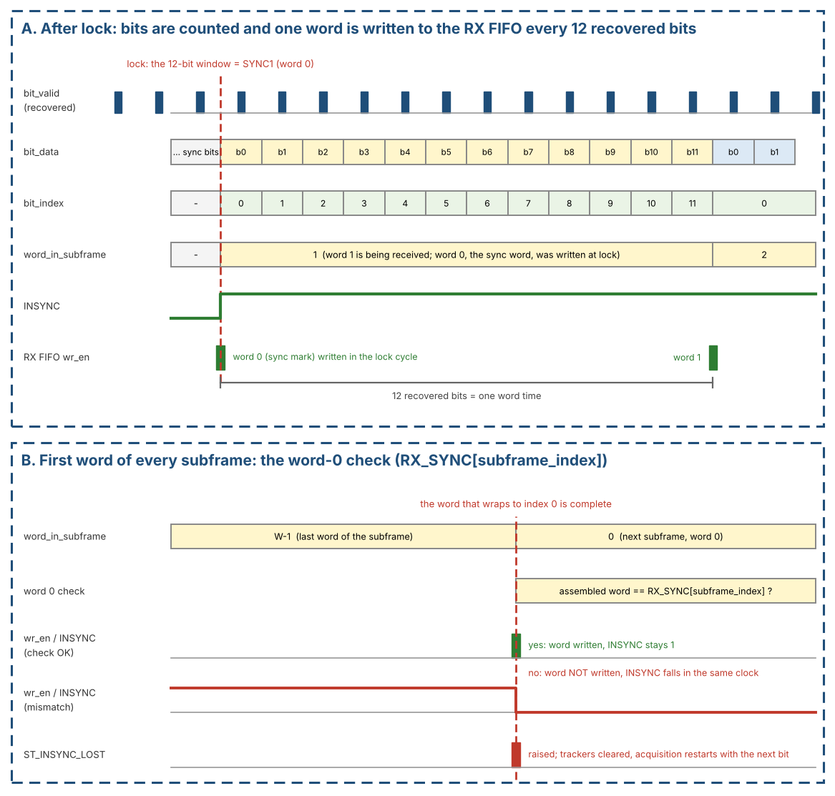
Figure 26: RX timing after lock: bit_index, word_in_subframe, FIFO write, and the word-0 check at the start of a subframe
Counters:
- bit_index (mod 12): counts recovered bits in the current word; resets to 0 at lock and after each completed word.
- word_in_subframe resets to 0 on the word that caused lock (that sync mark is word 0).
- Each subsequent accepted word increments word_in_subframe; at W words/s it wraps and subframe_index advances 0->1->2->3->0.
- At word_in_subframe = 0 of every subframe (the word whose index wraps to 0) the assembled word shall equal RX_SYNC[subframe_index]. On a mismatch the word is NOT written to the RX FIFO, INSYNC falls in the same clock, ST_INSYNC_LOST is raised, all trackers are cleared and acquisition restarts with the next bit (the 12-bit window keeps shifting). A word 0 with the right code is accepted even if it carries the error flag: the match proves its 12 bits and the alignment, so the flag is cleared before the word is written (Section 3.2.4.5).
- SFTSYNC lock: subframe_index initializes to the index of the last matched code. NOSYNC: see Section 3.2.2.4 (the counters do not run).
- SYNC[1:0] status mirrors subframe_index while INSYNC=1.
- RX FIFO write: when bit_index reaches 12 and the word is accepted it is written in that core_clk cycle together with its error flag (bit 12; the cycle is one bit cell after the last bit of the word when ERRCHK_ENB = 1, Section 3.2.4.2; in the cycle of the 12th bit when ERRCHK_ENB = 0); if the FIFO is full the word is dropped and OVERFLOW is signaled.
- A decoder framing error while INSYNC = 1 does not de-assert INSYNC; with ERRCHK_ENB = 1 it marks a bad bit (Section 3.2.4), with ERRCHK_ENB = 0 it is ignored. INSYNC falls after RX_ERR_LIMIT consecutive bad bits (same actions as a sync word error).
- Sync watchdog (time check): the word-0 comparison above needs bits, so it cannot see a line that has stopped. A counter in core_clk counts the RX sample_ticks (192 x W per subframe) since the lock or since the last accepted word 0; it counts only while rx_active = 1, INSYNC = 1 and NOSYNC = 0, and is cleared at the lock and every time a word 0 is accepted. If it exceeds (16 + MARGIN) x 12 x W sample_ticks, with MARGIN = RX_SYNC_WD.MARGIN (Section 7.4), i.e. one subframe plus MARGIN/16 of a subframe, the sync word is considered missing: same actions as a word 0 with a wrong code (INSYNC falls in the same clock, ST_INSYNC_LOST is raised, the word being assembled is not written, all trackers are cleared and acquisition restarts). Reset value MARGIN = 8 (1.5 subframes); MARGIN = 0 switches the watchdog off. The limit is applied immediately (like RX_ERR_LIMIT), the watchdog works with ERRCHK_ENB = 0 and 1, and the counter needs 25 bits ((16 + 255) x 12 x 8192 < 2^25). A running line never reaches the limit: two sync words are 12 x W bit cells apart, i.e. 192 x W sample_ticks at the nominal cell of 16 samples and 216 x W at the longest legal cell of 18 samples (Section 3.2.1.1); the second case needs MARGIN of at least 3 (test SY-08 uses 3, 5 and 8), a smaller value may time out on a line with long bit cells. With ERRCHK_ENB = 1 and a dead line RX_ERR_LIMIT is normally reached first; the watchdog is the only protection when the decoder produces no bit at all (BPRZ with ERRCHK_ENB = 0). The counter saturates at its maximum value and is not used while MARGIN = 0. If MARGIN is changed while the receiver is locked, the new limit is compared with the running count from the next sample_tick (a limit below the count drops INSYNC at once).
- LOST_CAUSE (RX_STATUS bits [9:8], Section 7.4): every time INSYNC falls, the cause is stored together with the ST_INSYNC_LOST event: 01 = sync word (word 0) with a wrong code, 10 = RX_ERR_LIMIT bad bits in a row, 11 = sync watchdog. If more than one condition is true in the same clock, RX_ERR_LIMIT wins over the sync word and the sync word over the watchdog. The field keeps the cause of the last loss (00 after reset); it is cleared when GLOBAL_EN AND RX_EN rises and by SOFT_RESET, not by RX_ERR_CLEAR and not when INSYNC rises again. The cause is held stable in core_clk with the event and loaded on s_axi_clk like the bit-error registers.
- MATCH compares (subframe_index, word_in_subframe) of the word being written against WRDCNT; word 0 is the sync word. The match pin and RX_STATUS.MATCH are registered high in the clock where the matching word is written to the RX FIFO and stay high until the next word is written (one word-time); a one-clock event goes to the CPU IF for ST_MATCH. WORD_CNT >= W never matches. The MATCH bit and pin are only one word-time wide (244 us at the highest required rate of Table 5), so software that shall not miss the event uses the sticky ST_MATCH bit and does not poll RX_STATUS.MATCH.

3.2.3.2 Word Delivery After Lock
Once INSYNC rises, the 12-bit window that caused the lock (SYNC1 in 4-sync-word mode, the third matching mark in 2-sync-word mode) is word 0 and is written to the RX FIFO in the same core_clk cycle. Subsequent words are written every 12 recovered bits, each with its error flag (Section 3.2.4). RX_STATUS.EMPTY therefore falls shortly after INSYNC asserts (FIFO pointer CDC latency, Section 4.2.4). If the receiver later loses lock, the FIFO write port is gated off immediately; words already stored remain readable by the host.
Worst-case acquisition is about two frames (8 s). If INSYNC remains de-asserted for much longer, software may clear and set RX_EN (or use SOFT_RESET, which also flushes the FIFOs) to force a clean re-acquisition.

3.2.4 Bit Errors After Lock
What this section does. While the receiver is in sync (INSYNC = 1) one damaged bit shall not cost a whole re-synchronization, which can take up to about 8 s. The receiver therefore notes where the bad bit is and keeps going: the bit, word, subframe and frame counters keep running, INSYNC stays 1, and the damaged word is delivered with an error flag. Software then decides what to do with that word. The sync word (word 0 of a subframe) is different: it is compared with a known code, and a wrong code ends INSYNC whether or not a bad bit was flagged (Section 3.2.4.5). The connections of the block in the block diagram are listed in Section 3.2.4.9. Before lock (INSYNC = 0) nothing of this section applies: a decoder framing error clears the window and the trackers as described in Sections 3.2.1 and 3.2.2.
Enable. Everything in Sections 3.2.4.1 to 3.2.4.7 applies only when RX_ERR_CTRL.ERRCHK_ENB = 1. The frame counter and RX_BIT_POS_NOW (Section 3.2.4.5) are the exception: they run whenever INSYNC = 1. The reset value is 0: the receiver then checks no bit error after lock (Section 3.2.4.8). ERRCHK_ENB is applied only while rx_active = 0, like RX_RATE and NOSYNC (Section 2.4).

3.2.4.1 The bit error flag and the word error flag
Every bit_valid pulse has a companion flag bit_err. The bit is still delivered (bit_data is the best value the decoder has); bit_err = 1 means "do not trust this bit". bit_err is 1 when a decoder check of Section 3.2.1.2 or 3.2.1.3 fired for the bit (Table 19), when the decoder had to invent the bit (BPRZ placeholder, Section 3.2.4.4) or when the bit lies in an HBP re-synchronization window (Section 3.2.4.3).
The flag of a word is the OR of the 12 bit_err flags of its bits: one bad bit makes the word bad. It is stored in the RX FIFO next to the word as bit 12, so an RX FIFO entry uses 13 of its 16 bits: data [11:0] and the flag in bit 12 (the TX FIFO uses 12 of 16 bits). A read of RX_RD_DATA returns the word in bits [11:0] and the flag in bit 12 (Section 7.6); the flag is always 0 when ERRCHK_ENB = 0: software gets data and flag in one access (Figure 27).
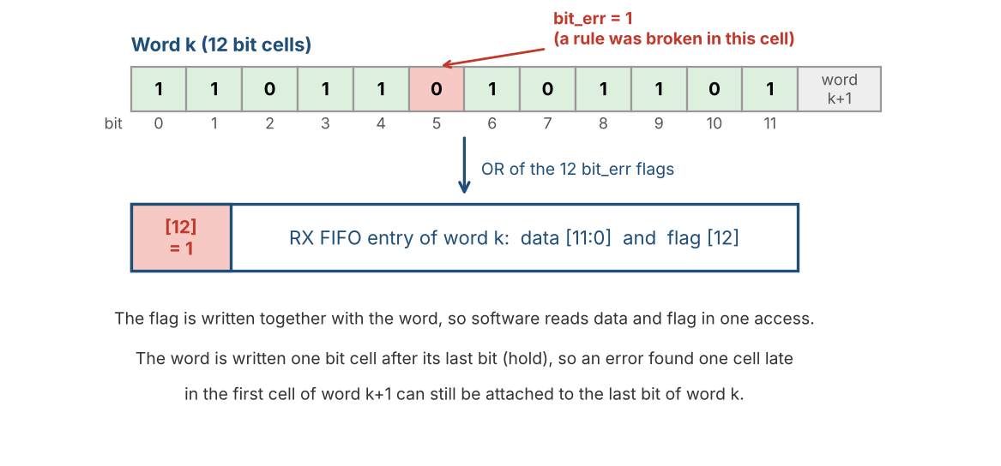
Figure 27: One bad bit makes the word bad: bit_err of the bits are OR-ed and stored as bit 12 of the RX FIFO entry

3.2.4.2 Which bits get the flag
A decoder check can notice a fault one bit cell after the damage was done. For example, an HBP glitch at the end of the last bit of a word may be seen only at the first edge of the next word. The flag shall still reach the right word. Two rules do this:
- The HBP checks flag the bit cell in which they fired and the bit before it. The BPRZ checks flag the exact bit (Table 19).
- The receiver holds every bit for one bit cell in a one-bit hold register before it enters the 12-bit window. A flag set one cell late can therefore still change the held bit. The word is written to the RX FIFO one bit cell after its last bit (one bit cell = 1/(12 x W) s, with W the words per subframe of Table 5).
Table 19: Which bits are flagged for each check
Decoder | Check that fires | Bits flagged
HBP | Two validated edges less than 6 samples apart (rule B) | This cell and the previous one
HBP | Edge in phase 14 or 15 | This cell and the previous one
HBP | Two mid-cell edges in a row (rule D) | This cell and the previous one
HBP | Edge 14 samples or more after the previous edge, where only about 8 is possible (rule E) | This cell and the previous one
HBP | Boundary edge more than 18 samples after the previous boundary edge, no mid-cell edge between (rule F) | This cell and the previous one
HBP | No edge for more than 24 samples | This cell and the previous one; again in every following cell while the line stays silent
HBP | Bit left while resync = 1 | Every bit in the re-synchronization window
BPRZ | No pulse for more than 16 samples | This cell (the bit that did not come is replaced by a placeholder)
BPRZ | Pulse of the opposite polarity before the Null | This cell
BPRZ | The Null does not come within 16 samples | This cell
BPRZ | Null less than 10 samples after the previous bit | The previous bit (it is one of two bits in one cell; the second one is blocked)
BPRZ | No bit for 24 samples (placeholder) | The placeholder bit

The price of the rule for HBP: an error found in the first cell of a word may also flag the last bit of the word before, so up to two neighboring words are flagged instead of one. A flag that is too wide is harmless; a missing flag is not. In the reference model a flag never landed on the neighbor word while the damaged word stayed unflagged (test ER-10).
The hold also covers a line that stops: while INSYNC = 1 the decoder keeps producing one bit per bit cell (Sections 3.2.4.3 and 3.2.4.4), so the held bit is always released one bit cell later and the last word before the stop is written (test ER-12).
The hold is used only while INSYNC = 1 and ERRCHK_ENB = 1. While INSYNC = 0 (acquisition) every bit goes straight into the 12-bit window, so lock detection (Section 3.2.2) is not delayed. At lock the hold is empty (hold_valid = 0): the lock word is word 0 and is written at once (Section 3.2.3.2), and the first bit after it is the first bit to enter the hold. A flag set back one bit for that first bit would fall on the last bit of word 0, which is already written; it is ignored. When INSYNC falls, hold_valid, pend_err and pend_cause are cleared, so no old bit appears after the next lock.

3.2.4.3 HBP: the decoder keeps running after an error
In acquisition an HBP error means "start again". After lock that would lose bits, so the decoder works differently while INSYNC = 1:
- The decoder does not unlock. The phase counter keeps counting 0..15 and one bit leaves at every wrap, so the bit count is not disturbed. The edge that caused the error is ignored (it does not change phase, mid_seen or last_mid), and the flag resync is set.
- While resync = 1 the phase is frozen: no edge changes it (a mid-cell edge still sets mid_seen). Every bit that leaves is flagged (cause RESYNC). The phase may be wrong by a few samples, and a wrong correction could be half a bit cell off, which would shift all later bits; so no correction is made until a safe reference appears.
- The safe reference is the same as in acquisition: a validated edge 14 to 18 samples after the previous validated edge. These are two boundary edges one bit 0 apart. The phase is then set to 3 and resync is cleared. If the edge arrives in phase 14 or 15 the bit cell is closed first (the bit leaves now). The correction is accepted only if the edge arrives in phase 14, 15 or 0..8 (HBP_RELOCK_MAX = 8, a correction of at most 5 samples); an edge in phase 9..13 would need a larger correction and is not accepted, resync goes on.
Figure 28 shows the behavior of the HBP decoder after an error.
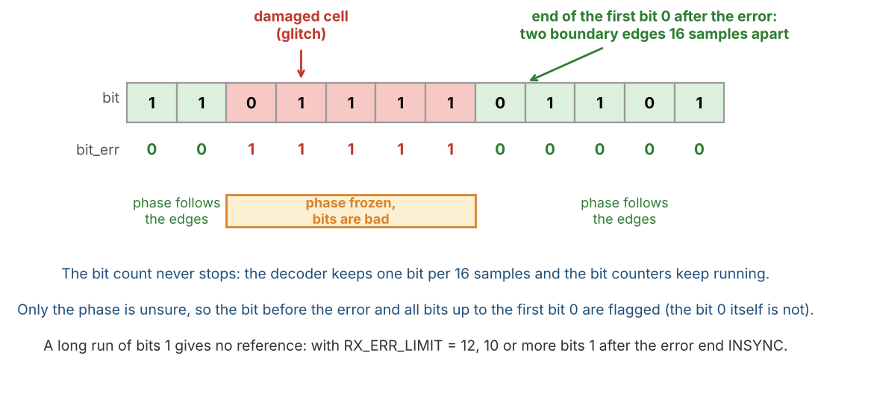
Figure 28: HBP after an error: the phase is frozen and the bit before the error and every bit up to the first bit 0 are flagged
Limit. Resync cannot end without a bit 0, so after an error every bit stays bad until the first bit 0 arrives. The bit before the error and the cell of the error are flagged too, so an error followed by n bits 1 gives n + 2 consecutive bad bits. If n + 2 reaches RX_ERR_LIMIT, INSYNC falls (Section 3.2.4.5) before the bit 0 arrives and the receiver acquires again. With the default limit of 12 this happens for n = 10 or more (reference model: 9 keeps INSYNC, 10 ends it); in general for n >= RX_ERR_LIMIT - 2 (limit 24: n >= 22; limit 36: n >= 34; test ER-21). For random data about 1 error in 1000 is followed by 10 bits 1. The same happens if the phase error is larger than the accepted correction. Data without errors is not affected, and a run of bits 0 is not a problem. Recommendation: if the data can contain long runs of bits 1 (for example several fill words 0xFFF in a row, longer than any useful limit), set RX_ERR_LIMIT = 0. A line that is cut for good is then still found by the next sync word comparison, which fails (word 0 has a wrong code): INSYNC falls up to one subframe (1 s) later instead of after RX_ERR_LIMIT bad bits, and every bit delivered meanwhile is flagged (test ER-23). A better phase recovery is not part of this version.

3.2.4.4 BPRZ: a placeholder for a lost bit
The BPRZ decoder has no phase: after an error it simply waits for the next pulse, as before. A bit that was destroyed never arrives, so the bit count shall be kept by a timer. The decoder counts the samples since the last bit (bit_slot). While INSYNC = 1, if bit_slot reaches 24 (BPRZ_SLOT_TIMEOUT) without a bit, the decoder outputs a placeholder bit (value 0, bit_err = 1) and sets bit_slot to 8, so that the next placeholder, if any, follows 16 samples later. A real bit sets bit_slot to 0. The limit 24 is above the longest legal distance between two bits (20 samples, Section 3.2.1.3), so a legal line never gets a placeholder (Figure 29).
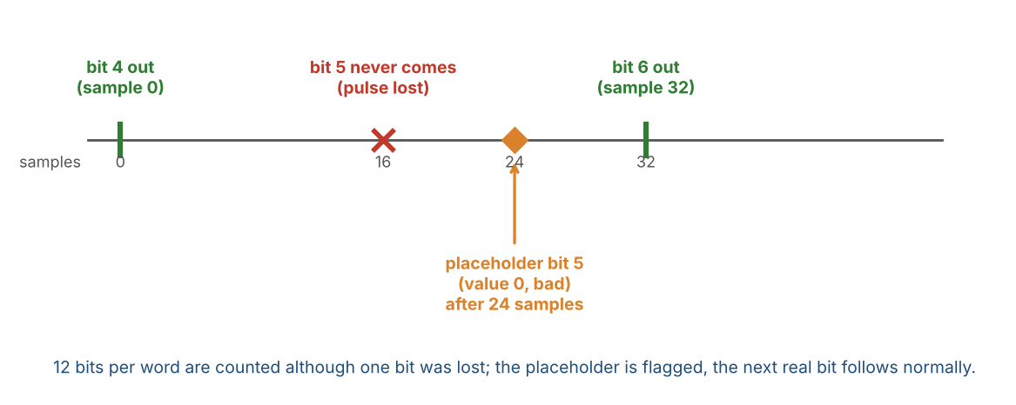
Figure 29: BPRZ after a lost pulse: a placeholder keeps the bit count
A placeholder every 16 samples keeps the count exact on a line with cells of 16 samples. With cells longer than 20 samples (outside the tolerance range) a lost bit can produce one placeholder too many; the word-0 check finds such a shift at the next subframe (Open Issues).

3.2.4.5 Counters, positions and the limit
Everything below happens only while INSYNC = 1 and ERRCHK_ENB = 1, when a held bit is released to the 12-bit window. Before lock nothing is counted and no event is created. RX_BIT_POS_NOW and the frame counter are the exception: they run whenever INSYNC = 1, also with ERRCHK_ENB = 0.
- RX_BIT_ERR_CNT counts the bad bits and RX_WORD_ERR_CNT counts the words that were written with the error flag. Both are 32-bit and saturate.
- RX_BIT_ERR_POS holds the position of the last bad bit and RX_BIT_ERR_POS0 the position of the first bad bit since the last clear. A position is {frame[12:0], subframe[1:0], word[12:0], bit[3:0]} (Table 39): the bit in the word (0..11), the word in the subframe (0..W-1), the subframe index (0..3) and the frame counter. The frame counter is 0 when INSYNC rises and increases by 1 each time the subframe index wraps from 3 to 0; it restarts at every lock and wraps from 8191 to 0 (after about 9 hours of lock). It is a position counter, not part of the error check, so it runs whenever INSYNC = 1, also with ERRCHK_ENB = 0. In NOSYNC mode the word, subframe and frame fields of a position are 0 because those counters do not run (Section 3.2.2.4); the bit field is valid.
- RX_BIT_ERR_CAUSE collects, as sticky bits, which checks produced a bad bit since the last clear (Table 40). If it is 0 there was no bad bit and the two positions are not valid.
- RX_ERR_LIMIT is the number of consecutive bad bits that ends INSYNC (default 12, 0 = off). When the counter of consecutive bad bits reaches the limit, INSYNC falls (ST_INSYNC_LOST), the trackers are cleared, the word being assembled is not written and acquisition restarts. One good bit sets the consecutive counter to 0.
- The sync word (word 0 of every subframe) is compared with RX_SYNC[subframe_index]. If the code is wrong, with or without an error flag, INSYNC falls (ST_INSYNC_LOST), the word is not written and acquisition restarts (Section 3.2.3.1): a real bad bit in the sync word changes the code, and a bit shift also gives a wrong code. If the code is right, the 12 bits and the alignment are proven, whatever the flags say: INSYNC stays and the error flag of the word is cleared before the word is written. The bad bits are still counted in RX_BIT_ERR_CNT and RX_BIT_ERR_POS; RX_WORD_ERR_CNT does not count the sync word.
- Counters, positions and cause are cleared by RX_ERR_CLEAR, by SOFT_RESET and when GLOBAL_EN AND RX_EN rises on the s_axi_clk side (Section 2.4); they are not cleared at lock. The ST_BIT_ERR event is one per counted bad bit.
- RX_BIT_POS_NOW is a read-only monitor of the position counters (bit, word, subframe, frame, layout of Table 39). It never changes the counters or the alignment of the receiver and cannot be written. It follows the bit that was released to the 12-bit window last, so it shows the position of the receiver, not of an error. It is valid while INSYNC = 1, with ERRCHK_ENB = 0 or 1; software reads RX_STATUS.INSYNC to know this. With ERRCHK_ENB = 0 it follows the bit delivered last. With ERRCHK_ENB = 1 the same bit is released one bit cell later, because every bit waits one bit cell in the one-bit hold register (Section 3.2.4.2); for the same line the position is therefore one bit cell later than with ERRCHK_ENB = 0. When INSYNC falls the register keeps its last value; it is cleared when GLOBAL_EN AND RX_EN rises and by SOFT_RESET, but not by RX_ERR_CLEAR. In NOSYNC mode the word, subframe and frame fields are 0 and only the bit field runs (Section 3.2.2.4). Transfer: for every released bit the core holds the position stable for the next full bit cell and sends a toggle event, the same way as for a bad bit; s_axi_clk loads the value after it has seen the toggle, so a read is at most one bit cell old and the four fields always belong together.

3.2.4.6 Reference pseudo-code
One block per bit_valid of the decoder (core_clk, rx_active = 1, INSYNC = 1, ERRCHK_ENB = 1). The position part is the exception and also runs with ERRCHK_ENB = 0: for every bit that enters the window, pos_cur = {frame, subframe_index, word_in_subframe, bit_index} is held for one bit cell and ev_pos is toggled (RX_BIT_POS_NOW, Section 3.2.4.5). dec_err is the framing_error pulse of the decoder with its cause c, back (1 = also flag the previous bit) and cur (1 = flag the cell in progress). The held bit is hold = {data, err, cause}.
// decoder events: back-date and mark the cell in progress
on dec_err(c, back, cur):
if (back and hold_valid) { hold.err = 1; hold.cause |= c }
if (cur) { pend_err = 1; pend_cause |= c }
// one bit leaves the decoder (real bit, HBP resync bit or BPRZ placeholder p)
on bit_valid(b, p, c_p):
if (hold_valid) release(hold)
hold = { b, pend_err | p, pend_cause | c_p }; hold_valid = 1
pend_err = 0; pend_cause = 0
// the held bit enters the window (its flag is final)
release(bit):
window = {bit.data, window[11:1]}; word_err |= bit.err
if (bit.err) {
bit_err_cnt++; pos = {frame, subframe_index, word_in_subframe, bit_index}
if (pos0_empty) { pos0 = pos; pos0_empty = 0 } // pos0_empty = 1 after RX_ERR_CLEAR
cause |= bit.cause; bad_run++; event ev_bit_err
} else bad_run = 0
if (RX_ERR_LIMIT != 0 and bad_run >= RX_ERR_LIMIT) {
INSYNC = 0; ST_INSYNC_LOST; return // the word is not written
// INSYNC fall: clear trackers, hold, pend, bad_run
}
bit_index++
if (bit_index == 12) {
bit_index = 0
if (word_in_subframe == 0) {
if (window != RX_SYNC[subframe_index]) { INSYNC = 0; ST_INSYNC_LOST; return } //
lock lost
word_err = 0 // right code: the flag is void
}
fifo_write({word_err, window})
if (word_err) { word_err_cnt++; event ev_word_err }
word_err = 0; word_in_subframe++ // at W: subframe_index++ (frame++ after 3)
}

3.2.4.7 Limits and use by software
- Only what breaks a rule of the line coding is detected. Neither HBP nor BPRZ has a parity, so a damaged bit that still looks legal is delivered without a flag (about 3 % of the opposite-level glitches of 5 to 12 samples in HBP, none of those shorter than 10 samples; a BPRZ pulse of the wrong polarity). The data shall still be protected above the core.
- The last bit before the data stops cannot be checked by a bit after it. It is delivered without flag unless its own cell broke a rule; in HBP it is flagged when it is a 0, because the missing edge after it is a timeout. The word is written in any case (test ER-12). Software should not trust the last word before a stop.
- A long damage (with RX_ERR_LIMIT = 12 a line cut of 11 bit cells or more in HBP, or 12 or more in BPRZ; test ER-22) reaches RX_ERR_LIMIT = 12 and ends INSYNC; a short one (up to a few bit cells) keeps INSYNC and flags the words at the cut, unless it hits the sync word (word 0), which ends INSYNC.
- The sync word is the only word that is checked against a known value. A real bad bit in it changes the code and costs the lock; a new lock takes up to about 8 s. A flag set only by the back-dating of HBP (a bad first cell of the word after the sync word) does not matter when the code matches. Words between a bit shift and the next sync word check are still delivered without flag when the shift itself raised no error (for example a legal-looking glitch); the sync word check then finds it at the next subframe. Software therefore shall treat the words delivered since the last good sync word as suspect when ST_INSYNC_LOST is raised by the sync word check.
- Software procedure: (0) write RX_ERR_CTRL.ERRCHK_ENB = 1 while rx_active = 0 (before RX_EN); (1) read each RX word and test bit 12; a flagged word is not used or is checked by other means (mask bit 12 before using the word as data: the data is bits [11:0]); (2) to find out how often and where, read RX_BIT_ERR_CNT, RX_WORD_ERR_CNT, RX_BIT_ERR_POS0 and RX_BIT_ERR_CAUSE (these are separate reads: read RX_BIT_ERR_CNT first and again after the others; if it changed, read the set again); (3) write RX_ERR_CLEAR to start a new observation; (4) enable EN_BIT_ERR only if an interrupt per bad bit is wanted; ST_INSYNC_LOST still reports the loss of sync.
The thresholds (6, 10, 14 and 18 samples, 16 and 24 samples, RX_ERR_LIMIT = 12, HBP_RELOCK_MAX = 8, RX_SYNC_WD.MARGIN = 8) are verified with the reference model only and shall be confirmed with line measurements on the board (Open Issues).

3.2.4.8 ERRCHK_ENB = 0: no error check after lock
RX_ERR_CTRL.ERRCHK_ENB = 0 is the reset state. After lock the receiver then does only what it needs to deliver the words: no bit is checked, no flag is set and nothing is counted (Table 20). INSYNC is checked only by the sync word comparison and the sync watchdog of Section 3.2.3.1. Before lock nothing changes: the decoders still report a framing error that frees the trackers (Sections 3.2.1 and 3.2.2).
Table 20: Receiver after lock, ERRCHK_ENB = 0 and 1
Item | ERRCHK_ENB = 0 (reset) | ERRCHK_ENB = 1
Check of bit errors after lock | None | Sections 3.2.4.1 to 3.2.4.7
HBP decoder after an error | The edge that broke a rule is ignored; the phase counter keeps running; no re-synchronization window | Re-synchronization window, every bit flagged (Section 3.2.4.3)
BPRZ decoder after a lost pulse | No placeholder: the bit is missing | Placeholder bit after 24 samples (Section 3.2.4.4)
One-bit hold | Not used; the word is written in the cycle of its 12th bit | Used; the word is written one bit cell later
Bit 12 of the RX FIFO entry | Always 0 | OR of the bit_err of the 12 bits
RX_BIT_ERR_CNT, RX_WORD_ERR_CNT, POS, POS0, CAUSE | Not changed | Counted and located
ST_BIT_ERR | Never set | One event per bad bit
RX_ERR_LIMIT | No effect | Consecutive bad bits end INSYNC
INSYNC falls | Only when a sync word (word 0) has a wrong code (Section 3.2.3.1) or does not arrive in time (sync watchdog) | Also at RX_ERR_LIMIT
Frame counter, RX_BIT_POS_NOW | Run while INSYNC = 1 | Run while INSYNC = 1

What software sees with ERRCHK_ENB = 0:
- HBP: a damaged cell does not move the phase (the damaged edge is ignored), so the bits that follow stay aligned (test ER-18). A line cut keeps INSYNC until the next sync word comparison: the phase counter goes on and delivers bits 0 for the cut, without flag, and when the cut ends before the next sync word the data after it is aligned again (test ER-20). A cut that covers word 0, or a line that stays cut, ends INSYNC at that comparison. Nothing tells software that the line was cut.
- BPRZ: a pulse that is lost is a bit that is lost. Every later bit moves by one place, without flag, until the next sync word comparison: INSYNC falls there (ST_INSYNC_LOST), up to one subframe (1 s) later (tests ER-19, ER-20). If the line stops for good, the BPRZ decoder produces no bit at all (there is no placeholder without the check), so no sync word can be compared; the sync watchdog (Section 3.2.3.1) then ends INSYNC within the watchdog time (default 1.5 subframes) after the last accepted sync word (test SY-08). In HBP the phase counter keeps delivering bits 0, so the sync word comparison fails within one subframe and INSYNC falls.
- A damaged bit that keeps a legal shape is delivered as before, without flag (Section 3.2.4.7).
- The registers of Section 7.4 (RX_ERR_LIMIT, counters, positions, cause) keep their values and the ST_BIT_ERR bit is never set. They can be read and written; they act only when ERRCHK_ENB = 1. RX_BIT_POS_NOW is not one of them: it keeps running (Table 20).
- Software that needs to know about bad bits shall set ERRCHK_ENB = 1 before RX_EN. RX_RD_DATA bit 12 is 0 in every word when ERRCHK_ENB = 0.

3.2.4.9 Bit Error Check block: connections
In the block diagram (Section 2.2) the bit-error check of Sections 3.2.4.1 to 3.2.4.8 is one block, Bit Error Check. Table 21 lists the blocks that drive its inputs and Table 22 the blocks that receive its outputs. All signals are in the core_clk domain. The signal names are those of the port table (Table 55): word_err_flag is bit 12 of rx_wr_data and err_limit_hit is internal to rx_sync_detect. The block has no data path of its own: it only reads bit_err and cause and does not change the data bits.
Table 21: Bit Error Check: inputs
From block | Signals | Meaning
HBP Clock Recovery, BPRZ Clock Recovery (through the MUX) | bit_err, cause[9:0] (one value per recovered bit) | The decoder of the selected encoding says whether this bit is bad and why. Main input: only the decoder knows the edge, pulse and null rules (Sections 3.2.4.3 and 3.2.4.4).
Rx Control (after CDC) | ERRCHK_ENB, RX_ERR_LIMIT[7:0] | Configuration of the block. ERRCHK_ENB is applied while rx_active = 0 (Section 2.4); RX_ERR_LIMIT is applied immediately and the new limit is used from the next bit. RX_ERR_CLEAR is not an input: it clears the registers on the s_axi_clk side (Section 3.2.4.5).
RX Timing Generator | Bit Tick, Word Tick, Subframe Tick | Count the position of every bit: bit, word, subframe and frame. The position of a bad bit goes to RX_BIT_ERR_POS and RX_BIT_ERR_POS0, the position of the bit released last to RX_BIT_POS_NOW.
SYNC Detection FSM | insync, lock | Errors are checked only while insync = 1. At lock the frame counter and the one-bit hold are reset (Sections 3.2.4.2 and 3.2.4.5). Also soft_reset and rx_active (Section 3.2.4.5).

Table 22: Bit Error Check: outputs
To block | Signals | Meaning
Async RxFIFO | word_err_flag | OR of the bit_err of the 12 bits of the word. Stored as bit 12 of the 16-bit FIFO entry (13 bits used), together with the word; bits [15:13] are 0. With ERRCHK_ENB = 0 it is 0.
SYNC Detection FSM | err_limit_hit | Set when RX_ERR_LIMIT bad bits in a row are counted; the FSM then ends INSYNC (Section 3.2.4.5). RX_ERR_LIMIT = 0 never sets it.
RX STATUS / RX IRQ STATUS | RX_BIT_ERR_CNT, RX_WORD_ERR_CNT, RX_BIT_ERR_POS, RX_BIT_ERR_POS0, RX_BIT_ERR_CAUSE, ev_bit_err | The counters and registers of Section 7.4. ev_bit_err sets ST_BIT_ERR, which becomes an interrupt with EN_BIT_ERR and reaches rx_irq_status.
RX STATUS | pos_cur[31:0], ev_pos | The position of the receiver (bit, word, subframe, frame) for the register RX_BIT_POS_NOW. ev_pos is a toggle once per released bit; pos_cur is held stable for one bit cell (Section 3.2.4.5). No interrupt.

With ERRCHK_ENB = 0 the check does nothing: word_err_flag, err_limit_hit and ev_bit_err stay 0, the counters and registers of the check do not change, and the RX path works as in Section 3.2.4.8. The position outputs pos_cur and ev_pos keep running (RX_BIT_POS_NOW, Section 3.2.4.5).

3.3 Bit Rate and Clock Requirements
A 48 MHz ±0.1 % reference (core_clk) is required. The sample_tick generator of Section 3.2.1.1 derives all bit and word timing from a 4-bit rate field: TX_CTRL.TX_RATE[3:0] for the transmitter and RX_CTRL.RX_RATE[3:0] for the receiver (same bit positions, same encoding). The encoding (rate code to words/s, bits/s and INC) is defined once, in Table 5.
Changing the rate on-the-fly is not supported; follow the rate-change procedure of Section 2.4 (separately for TX and RX).

3.4 Digital Loopback
Setting TEST = 1 disconnects the external RX inputs inside the FPGA and routes the TX encoder outputs selected by RX_CTRL.RXSEL into the RX sampler/decoder: RXSEL=0 loops HBP (tx_hbp_high/low); RXSEL=1 loops BPRZ (tx_bprz_high/low). External TX pins continue to drive; they are not high-impedance. All status flags and FIFOs operate normally, allowing a pure digital self-test. The loopback pair is already in the core_clk domain and bypasses the pin synchronizers. In loopback TX_RATE and RX_RATE shall be programmed to the same code, otherwise the receiver samples at a different rate than the transmitter and will not lock. The board self-test of Section 12.13 uses this loopback. The built-in pattern injector (Section 12.14) with INJ_DST = 0 drives the TX pins instead of the encoders; the loopback tap is taken after that multiplexer, so with TEST = 1 the receiver then decodes the injector stream (test IN-08). With INJ_DST = 1 the injector replaces the loopback tap.

4. AXI4-Lite Protocol & Clock-Domain Crossing

4.1 AXI4-Lite Protocol
- At most one outstanding transaction.
- AW and W may arrive on different cycles; BVALID held until BREADY; RVALID held until RREADY.
- Write to a read-only register, or access outside the decode window 0x0000-0x014F -> SLVERR. Read of a pure write-only register (e.g. FIFO_CLEAR) -> SLVERR. Reserved offsets inside a block return OKAY (Table 24). TX_DATA is a read/write latch: a read returns the last latched word with OKAY, and a write alone never pushes (Section 7.5).
- TX push (TX_WR_ADDR write while TX_WR_EN = 1) when write-side FULL → BRESP = SLVERR, word not written.
- RX data read when read-side EMPTY → RRESP = SLVERR, no pop.

4.1.1 Register access rules (normative)
- Address decode: AWADDR/ARADDR[1:0] are ignored (word access); [15:2] is decoded. Addresses above 0x014F are unmapped.
- WSTRB: only 4'b1111 is accepted on writes; any other value returns BRESP = SLVERR with no side effect.
- A read and a write request that arrive together are served one at a time, write first.
- While GLOBAL_STATUS.CLR_BUSY = 1 (SOFT_RESET or a FIFO clear in progress): TX pushes (TX_WR_ADDR writes while TX_WR_EN = 1), RX_RD_DATA accesses and writes to TX_FIFO_CLEAR / RX_FIFO_CLEAR return SLVERR with no side effect, and a new SOFT_RESET write is ignored. All other accesses behave normally.
Table 23: Register access rules
Register / range | Read | Write
CORE_VERSION, GLOBAL_STATUS, IRQ_SOURCE, TX_STATUS, TX_WORD_CNT, TX_BIT_CNT, RX_STATUS, INJ_STATUS, RX_BIT_ERR_CNT, RX_WORD_ERR_CNT, RX_BIT_ERR_POS, RX_BIT_ERR_POS0, RX_BIT_ERR_CAUSE, RX_BIT_POS_NOW | value, OKAY | SLVERR, no effect
GLOBAL_CTRL, TX_CTRL, RX_CTRL, TX_WR_EN, RX_RD_EN, RX_RD_ADDR, TX_SYNCx, RX_SYNCx, WRDCNT, INJ_CTRL, TX/RX_IRQ_ENABLE, RX_ERR_CTRL, RX_ERR_LIMIT, RX_SYNC_WD | value, OKAY | OKAY (reserved bits ignored, read 0)
TX_IRQ_STATUS, RX_IRQ_STATUS | value, OKAY | OKAY; writing 1 clears that bit (W1C; a bit of the core_clk side through the clear request, Section 8.5), writing 0 has no effect
TX_FIFO_CLEAR, RX_FIFO_CLEAR | SLVERR | OKAY; writing 1 starts the clear (SLVERR if CLR_BUSY = 1), writing 0 has no effect
RX_ERR_CLEAR | SLVERR | OKAY; writing 1 clears the counters, positions and cause (Section 7.4), writing 0 has no effect
TX_CNT_CLEAR | SLVERR | OKAY; writing 1 clears TX_WORD_CNT and TX_BIT_CNT (Section 7.3), writing 0 has no effect
TX_DATA | last latched word, OKAY | latch bits[11:0], OKAY (no push)
TX_WR_ADDR | value, OKAY | store value; if TX_WR_EN = 1 push the latched TX_DATA word, SLVERR if FULL or CLR_BUSY = 1; if TX_WR_EN = 0 OKAY, no push
RX_RD_DATA | pop; SLVERR if EMPTY or CLR_BUSY = 1 | SLVERR, no effect
Reserved offsets inside defined blocks (Table 24) | 0, OKAY | OKAY, ignored
Outside 0x0000-0x014F | SLVERR | SLVERR

Figure 30 shows the AXI-Lite slave: channel capture, write ladder and read ladder.
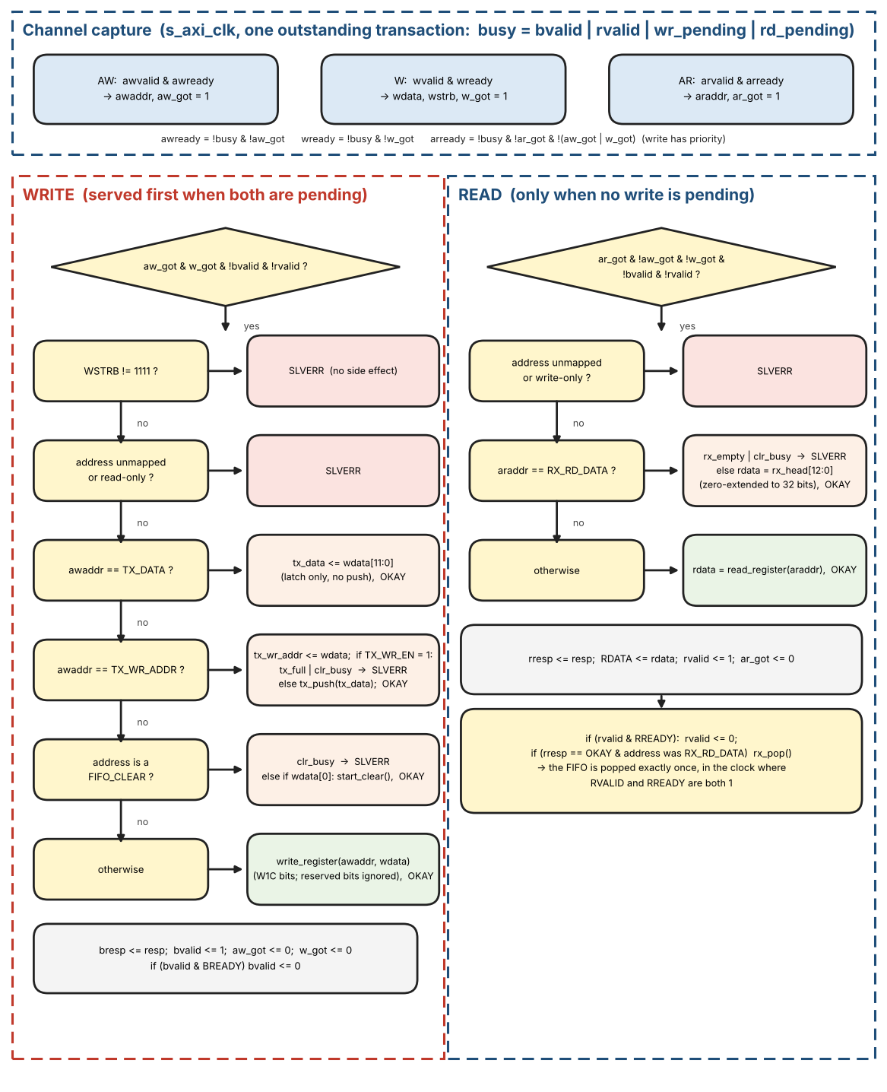
Figure 30: AXI-Lite slave: channel capture, write ladder and read ladder

AXI-Lite slave reference pseudo-code
The slave accepts one transaction at a time. RDATA stays stable while RVALID waits for RREADY because the FWFT head does not change before the pop; the pop happens in the clock where RVALID and RREADY are both 1.
// s_axi_clk. One outstanding transaction: busy = bvalid | rvalid | wr_pending | rd_pending
awready = !busy & !aw_got; wready = !busy & !w_got; arready = !busy & !ar_got & !(aw_got |
w_got)
on (awvalid & awready) { awaddr <= AWADDR; aw_got <= 1 }
on (wvalid & wready ) { wdata <= WDATA; wstrb <= WSTRB; w_got <= 1 }
on (arvalid & arready) { araddr <= ARADDR; ar_got <= 1 }

// WRITE (served first when both are pending)
if (aw_got & w_got & !bvalid & !rvalid) {
resp = OKAY
if (wstrb != 4'b1111) resp = SLVERR // no side effect
else if (!mapped(awaddr) | read_only(awaddr)) resp = SLVERR
else if (awaddr == TX_DATA) tx_data <= wdata[11:0] // latch only, no push
else if (awaddr == TX_WR_ADDR) { tx_wr_addr <= wdata // index, no hardware meaning
if (tx_wr_en) { if (tx_full | clr_busy) resp = SLVERR else tx_push(tx_data) } }
else if (is_fifo_clear(awaddr)) { if (clr_busy) resp = SLVERR else if (wdata[0])
start_clear() }
else write_register(awaddr, wdata) // W1C, reserved
bits ignored
bresp <= resp; bvalid <= 1; aw_got <= 0; w_got <= 0
}
if (bvalid & BREADY) bvalid <= 0

// READ
if (ar_got & !aw_got & !w_got & !bvalid & !rvalid) {
resp = OKAY; rdata = 0
if (!mapped(araddr) | write_only(araddr)) resp = SLVERR
else if (araddr == RX_RD_DATA) { if (rx_empty | clr_busy) resp = SLVERR else
rdata = {19'b0, rx_head[12:0]} }
else rdata = read_register(araddr)
rresp <= resp; RDATA <= rdata; rvalid <= 1; ar_got <= 0
}
if (rvalid & RREADY) { rvalid <= 0; if (rresp == OKAY & raddr_was_RX_RD_DATA) rx_pop() } //
pop exactly once

4.2 Clock-Domain Crossing

4.2.0 Input pin synchronizers
rx_hbp_high, rx_hbp_low, rx_bprz_high, rx_bprz_low, and rsel shall each pass through a 2FF synchronizer into core_clk before the sampler/classifier. These are single-bit CDC paths.

4.2.1 Config / Status
All configuration registers used by the core_clk logic cross as ONE configuration bundle with a single request/acknowledge handshake: GLOBAL_CTRL (GLOBAL_EN, TX_EN, RX_EN, INJ_DST), TX_CTRL (including TX_RATE), RX_CTRL (including RX_RATE), RX_ERR_CTRL, RX_ERR_LIMIT, RX_SYNC_WD, WRDCNT, INJ_CTRL, TX_SYNC1..4 and RX_SYNC1..4. The bundle is applied atomically on the core_clk side, so enables can never overtake TX_RATE / RX_RATE or the sync codes and software needs no CFG_BUSY bit or ordering rule. SOFT_RESET and the FIFO_CLEAR bits are not part of the bundle; they use their own handshakes (Section 5). GLOBAL_CTRL.IRQ_ENABLE and the per-source IRQ_ENABLE registers stay in the s_axi_clk domain (Section 8).
Handshake: any write to a bundle register sets cfg_dirty (s_axi_clk). When no handshake is in flight and cfg_dirty = 1, the s_axi side copies the whole bundle into cfg_hold, clears cfg_dirty and toggles cfg_req. The core side synchronizes cfg_req (2FF), loads cfg_hold into its working registers in one clock cycle and toggles cfg_ack; the s_axi side synchronizes cfg_ack (2FF). cfg_hold shall not change between cfg_req and cfg_ack. A write that arrives while a handshake is in flight only updates the register and sets cfg_dirty again; a new handshake starts after cfg_ack, so the last value written always reaches the core.
The AXI write response is OKAY as soon as the register is written (it does not wait for the handshake). Bounded latency: after the last write the final bundle is applied on the core_clk side within 2 x (3 core_clk + 3 s_axi_clk) + 2 s_axi_clk cycles. Because the bundle is atomic no write ordering is required; the bound only tells software how long to wait before relying on a change (for example before expecting TX to start after enabling, or before re-enabling after a rate change).

Configuration handshake reference pseudo-code
// ---- s_axi_clk ----
on write to a bundle register: cfg_dirty <= 1
if (cfg_dirty & !inflight) {
cfg_hold <= bundle; cfg_dirty <= 0 // a write in this same clock keeps cfg_dirty =
1
cfg_req <= ~cfg_req; inflight <= 1 }
ack_s <= {ack_s[0], cfg_ack}
if (ack_s[1] != ack_seen) { ack_seen <= ack_s[1]; inflight <= 0 }

// ---- core_clk ----
req_s <= {req_s[0], cfg_req}
if (req_s[1] != req_seen) {
req_seen <= req_s[1]
cfg_applied <= cfg_hold // all fields in one clock
cfg_ack <= ~cfg_ack }

// latch rules (Section 2.4), core_clk:
if (!tx_active) tx_rate_applied <= cfg_applied.TX_RATE
if (!rx_active) rx_rate_applied <= cfg_applied.RX_RATE
if (!tx_active) sync_ins_applied <= cfg_applied.SYNC_INS_MODE
if (!rx_active) rxsel/nosync/sftsync/test/errchk_enb_applied <= cfg_applied.(same fields)

Figure 31 shows the configuration bundle handshake between s_axi_clk and core_clk.
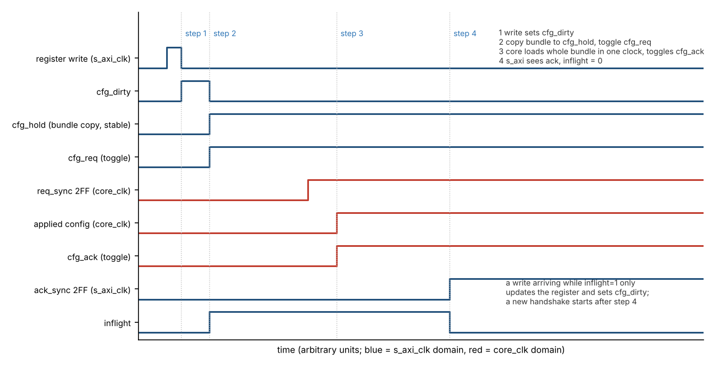
Figure 31: Configuration bundle handshake (s_axi_clk to core_clk)
Core to s_axi_clk: the status snapshot. It holds INSYNC, SYNC[1:0], the core-side flags (TX_STATUS.EMPTY, RX_STATUS.FULL, RX_STATUS.MATCH), the core-side sticky bits of TX_IRQ_STATUS and RX_IRQ_STATUS and the TX word and bit counters; it is captured in one core_clk cycle and crosses with a request/acknowledge handshake like the configuration bundle (Section 8.5). It is refreshed continuously, so a status register read returns values that are at most one handshake old. In the other direction the clear request (the W1C bits of the core-side sticky bits and TX_CNT_CLEAR) crosses with its own handshake (Section 8.5).

4.2.2 Data Path
Data movement uses only the dual-clock asynchronous FIFOs. Push/pop accept/reject decisions are taken from the native same-clock FULL (TX write side) or EMPTY (RX read side) flags; they never depend on CDC-lagged STATUS registers.

4.2.3 Direction Map (frozen)
- Config write (s_axi_clk to core_clk): the atomic configuration bundle (Section 4.2.1); soft-reset and FIFO-clear requests (Section 5).
- Core to s_axi_clk: the status snapshot (INSYNC / SYNC[1:0], TX_STATUS.EMPTY, RX_STATUS.FULL, RX_STATUS.MATCH, the core-side sticky bits, the TX word and bit counters); the bad-bit and bad-word counters, RX_BIT_ERR_POS, RX_BIT_ERR_POS0, RX_BIT_ERR_CAUSE, RX_BIT_POS_NOW and LOST_CAUSE live in s_axi_clk and are loaded from event payloads held stable in core_clk (Section 7.4). s_axi_clk to core_clk: also the clear request of Section 8.5. The write-side flags of the TX FIFO (FULL, HALF) and the read-side flags of the RX FIFO (EMPTY, HALF) are computed on s_axi_clk from the FIFO pointers (Section 4.2.4).
- Push/pop accept: native FIFO flags on s_axi_clk only.

4.2.4 FIFO level and flag computation
Each async FIFO has a binary write pointer and read pointer of ceil(log2(FIFO_DEPTH))+1 bits (8 bits at the default depth 128); the extra MSB distinguishes full from empty. Gray-coded copies cross to the other domain through 2FF synchronizers.
- TX FIFO, s_axi_clk side: level = wr_ptr - rd_ptr_sync (Gray to binary after synchronization). rd_ptr_sync lags, so level is never lower than the true occupancy. FULL = (level = FIFO_DEPTH) guards pushes, so a push can never overflow the FIFO. The TX_STATUS flags HALF and FULL and the events ST_LOW and ST_FULL use this value.
- TX FIFO, core_clk side: EMPTY is computed from rd_ptr and wr_ptr_sync. The lag makes EMPTY pessimistic: the core may see EMPTY a few cycles after a word was pushed, but never reads a word that is not yet written. The TX_STATUS flag EMPTY and the event ST_EMPTY use this core_clk value; they reach software in the status snapshot.
- RX FIFO, s_axi_clk side: level = wr_ptr_sync - rd_ptr; it is never higher than the true occupancy. EMPTY guards pops. The RX_STATUS flags EMPTY and HALF and the events ST_EMPTY and ST_HALF use this value.
- RX FIFO, core_clk side: FULL is computed from wr_ptr and rd_ptr_sync (conservative). A word arriving while FULL is dropped and OVERFLOW is signaled. The RX_STATUS flag FULL and the event ST_FULL use this core_clk value; they reach software in the status snapshot.
The FIFO fields of TX_STATUS / RX_STATUS and the interrupt events are therefore computed on the side of the FIFO to which they belong (TX write side and RX read side on s_axi_clk, TX read side and RX write side on core_clk), conservative by at most a few clock cycles; the core_clk ones reach software after the crossing of the snapshot. A read of TX_STATUS or RX_STATUS is therefore not one sample of one instant: the flags computed in s_axi_clk are current, the flags that come from the snapshot (TX EMPTY, RX FULL, INSYNC, SYNC) are up to one handshake old, and a TX EMPTY that was read as 1 can still be 1 for the first few cycles after a push.
Figure 32 shows the async FIFO: binary pointers, Gray-code crossing and the full and empty flags.
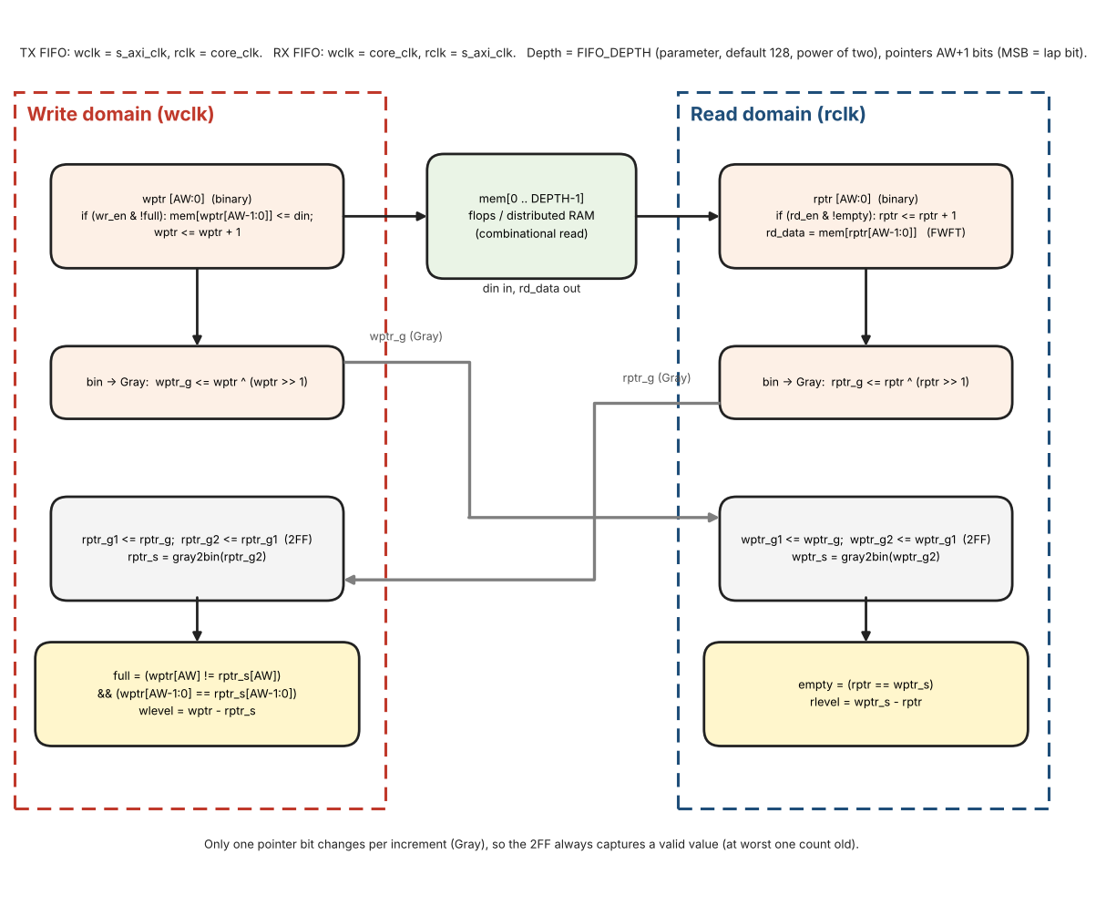
Figure 32: Async FIFO: binary pointers, Gray-code crossing and full / empty flags

Async FIFO reference pseudo-code
Full and empty use the extra-MSB pointer scheme (the lap bit toggles each time a pointer wraps): the FIFO is empty when the full pointers are equal and full when the MSBs differ while the lower bits are equal. All FIFO_DEPTH entries are usable (the simple scheme without the extra bit, which reports full one entry early, is NOT used). The comparison is made on binary pointers: the remote pointer is crossed as Gray code through a 2FF synchronizer and converted back to binary before the comparison. TX FIFO: write side = s_axi_clk, read side = core_clk. RX FIFO: write side = core_clk, read side = s_axi_clk. FIFO_DEPTH is a power of two (16 or more; default 128), so the pointers wrap naturally. Use flops or distributed RAM for the memory so that rd_data is a combinational read (FWFT).
AW = clog2(FIFO_DEPTH) // 7 for depth 128 (default); pointers are AW+1 bits, MSB = lap bit
reg [AW:0] wptr, rptr // binary pointers; memory index = ptr[AW-1:0]

// write domain (wclk)
if (wr_en & !full) { mem[wptr[AW-1:0]] <= din; wptr <= wptr + 1 }
wptr_g <= wptr ^ (wptr >> 1) // Gray code, registered
rptr_g1 <= rptr_g; rptr_g2 <= rptr_g1 // 2FF of the read pointer (rptr_g comes from rclk)
rptr_s = gray2bin(rptr_g2)

// read domain (rclk)
if (rd_en & !empty) rptr <= rptr + 1
rd_data = mem[rptr[AW-1:0]] // FWFT: combinational read, valid while !empty
rptr_g <= rptr ^ (rptr >> 1)
wptr_g1 <= wptr_g; wptr_g2 <= wptr_g1 // 2FF of the write pointer (wptr_g comes from wclk)
wptr_s = gray2bin(wptr_g2)

// flags: extra-MSB pointer scheme as described above
full = (wptr[AW] != rptr_s[AW]) && (wptr[AW-1:0] == rptr_s[AW-1:0]) // write domain
empty = (rptr == wptr_s) // read domain
wlevel = wptr - rptr_s // write domain, never lower than the true occupancy
rlevel = wptr_s - rptr // read domain, never higher than the true occupancy

s_axi side: TX_STATUS.FULL = full, TX_STATUS.HALF = (wlevel >= FIFO_DEPTH/2); RX_STATUS.EMPTY = empty, RX_STATUS.HALF = (rlevel >= FIFO_DEPTH/2). HALF = (level >= FIFO_DEPTH/2). The pointers are cleared by the sequences of Section 5.2. core_clk side (crossed in the snapshot): TX_STATUS.EMPTY = (rlevel == 0) of the TX FIFO; RX_STATUS.FULL = (wlevel == FIFO_DEPTH) of the RX FIFO.

4.2.5 Implementation notes: clock frequencies, synchronizers, constraints, FIFO memory
This subsection is informative for the design behavior and normative for the clock frequencies it names. The constraint lines are written in SDC style; adapt them to the tool in use.
Clock frequencies. core_clk = 48 MHz (+/-0.1 %, Section 3.3). s_axi_clk = 50 MHz is the design frequency; the two clocks are asynchronous. The core events that load the s_axi_clk-side counters and registers (INSYNC_LOST with LOST_CAUSE, BIT_ERR and the position event ev_pos of RX_BIT_POS_NOW) cross as toggles, and a toggle is seen only if the next toggle comes at least three s_axi_clk periods later. At 50 MHz three periods are 60 ns. Every core event is produced from a sample_tick or a word_tick, so two events are at least one sample period apart: 0.64 us at the highest rate of Table 5, i.e. more than 10 times 60 ns. 50 MHz is what the timing bounds of this document assume.
Synchronizer chains. Every 2FF synchronizer (input pins, toggles, ready flags, pointers) is two flops in a row clocked by the destination clock, with no logic between them and none between the source flop and the first synchronizer flop (the source is a register). Mark the two flops so that the tool keeps them together and does not retime or merge them (for example the ASYNC_REG attribute in Xilinx tools). Gray-coded pointers cross bit by bit through such chains; the pointers change by one bit at a time, so the converted value is always the old or the new pointer.
Constraints. The two clocks are declared asynchronous and the crossings are constrained by delay, so that the tool neither times them as synchronous paths nor ignores them:
set_clock_groups -asynchronous -group [get_clocks s_axi_clk] -group [get_clocks core_clk]
# Gray pointers: source register -> first synchronizer flop, both directions
set_max_delay -datapath_only <one period of the faster clock> -from <ptr_gray regs> -to <sync flop 1>
set_bus_skew <one period of the faster clock> -from <ptr_gray regs> -to <sync flop 1> ;# if the tool supports it
# configuration bundle: cfg_hold (s_axi_clk) -> cfg_applied (core_clk), stable between cfg_req and cfg_ack
set_max_delay -datapath_only <one core_clk period> -from <cfg_hold regs> -to <cfg_applied regs>
The single-bit toggles and level flags need only the 2FF rules; they are covered by the clock-group declaration. FIFO data words need no constraint of their own: the memory is written and read in different clocks, and a word is read only after its write pointer has crossed (Section 4.2.4).
FIFO memory. The read side of the FIFO is first-word-fall-through with a combinational read, rd_data = mem[rptr] (Section 4.2.4). For 128 x 16 bit in both FIFOs (12 bits used in TX, 13 in RX) this maps to distributed (LUT) RAM. Block RAM has a registered read and would need an output register stage with a changed empty / pop rule; that variant is not specified in this version.

5. Reset & FIFO Clear

5.1 Hardware Reset
Assertion of s_axi_aresetn or core_aresetn (asynchronous assert, synchronous de-assert) returns every register to its reset value, empties both FIFOs and clears the sync-detection logic. GLOBAL_EN is forced to 0.
Reset synchronizer (one per domain). The external active-low reset is applied asynchronously to a two-flop synchronizer whose flops are cleared by it and whose first flop has D = 1. Its output (s_axi_rstn_sync in the s_axi_clk domain, core_rstn_sync in the core_clk domain) is the reset of every flop of that domain: it asserts at once and releases synchronously with the clock of the domain. Both synchronizer flops are part of the 2FF chain rules of Section 4.2.5.
Reset-done flags. axi_rst_done = s_axi_rstn_sync and core_rst_done = core_rstn_sync (1 = the domain is out of reset). Each flag crosses into the other domain through a 2FF synchronizer: core_rst_done_axi (in s_axi_clk) and axi_rst_done_core (in core_clk). Two ready levels follow:
axi_ready = axi_rst_done & core_rst_done_axi // s_axi_clk
core_ready = core_rst_done & axi_rst_done_core // core_clk
While axi_ready = 0 the data ports return SLVERR (a push in TX_WR_ADDR and a read of RX_RD_DATA do nothing); the other registers can be accessed. While core_ready = 0, tx_active and rx_active are 0 (Section 2.4): the TX Timing Generator stays in GEN_OFF, the TX FSM in IDLE, and nothing is written to the RX FIFO. The two reset releases may come in any order and at any time apart.

5.2 Soft Reset & FIFO Clear
Writing SOFT_RESET = 1 in GLOBAL_CTRL initiates a dual-clock clear sequence: both sides of the TX and RX FIFOs are flushed, sync logic is reset, and sticky IRQ bits, the TX counters and the bit-error registers (counters, positions, cause, RX_BIT_POS_NOW, LOST_CAUSE) are cleared. All other configuration registers remain unchanged. The bit is self-clearing once the clear handshake completes. A per-FIFO clear is also available via TX_FIFO_CLEAR / RX_FIFO_CLEAR. The enable bits are not changed (see Section 12.3 for what that means for TX and RX after the reset).

SOFT_RESET sequence (normative)
Goal: both pointer sets of a FIFO and the flops that synchronize them are cleared while the opposite side is also in reset, so no stale pointer can be re-captured. Handshake signals: srst_req, srst_ack, axi_clr_done (toggles) and core_rst_active (level, core_clk to s_axi_clk, 2FF).
- 1. s_axi side: a write of SOFT_RESET = 1 sets CLR_BUSY = 1; SOFT_RESET reads 1. Data-port accesses return SLVERR. The side toggles srst_req.
- 2. core side (after 2FF of srst_req): asserts srst_core and HOLDS it. tx_active and rx_active become 0: the TX Timing Generator (GEN_OFF), TX FSM, both sample accumulators, decoders, trackers, INSYNC, RX counters, the core-side FIFO pointers, the flops that synchronize the s_axi-side pointers, the core-side sticky IRQ bits (OVERFLOW included), the TX word and bit counters and the status snapshot are cleared. core_rst_active = 1.
- 3. s_axi side (after 2FF of core_rst_active = 1): asserts srst_axi for 4 s_axi_clk cycles. It clears the s_axi-side FIFO pointers, their synchronizer flops, the s_axi-side sticky IRQ bits, the copy of the status snapshot (reset to its reset values), the pending clear request and its masks, the bit-error counters, both positions, the cause, RX_BIT_POS_NOW and LOST_CAUSE, then toggles axi_clr_done.
- 4. core side (after 2FF of axi_clr_done AND 4 more core_clk cycles, so the synchronizers capture the cleared pointers): releases srst_core, clears core_rst_active and toggles srst_ack.
- 5. s_axi side (after 2FF of srst_ack): SOFT_RESET reads 0, CLR_BUSY = 0, data ports are enabled again.
The core is released last, so it never sees a stale s_axi-side pointer, and a TX that is still enabled finds an empty FIFO (GEN_OFF) instead of transmitting garbage. Configuration registers (TX_RATE, RX_RATE, enables, SYNC codes, ...) are unchanged.
// ---- s_axi_clk ----
S0: write SOFT_RESET = 1 while CLR_BUSY = 0: CLR_BUSY <= 1; srst_req <= ~srst_req
S1: when core_rst_active_s[1] == 1: srst_axi <= 1 for 4 clocks, clearing the s_axi side
(FIFO pointers + sync flops, s_axi-side sticky IRQ, pending clear request, bit-error counters, positions, cause, RX_BIT_POS_NOW); then axi_clr_done <= ~axi_clr_done
S5: when srst_ack_s[1] != srst_ack_seen: CLR_BUSY <= 0 (SOFT_RESET reads 0)

// ---- core_clk ----
S2: when srst_req_s[1] != srst_req_seen: srst_core <= 1 (HELD); core_rst_active <= 1;
clear the core side
S4: when clr_done_s[1] != clr_done_seen: wait 4 core_clk; srst_core <= 0; core_rst_active
<= 0
srst_ack <= ~srst_ack

Figure 33 shows the SOFT_RESET sequence.
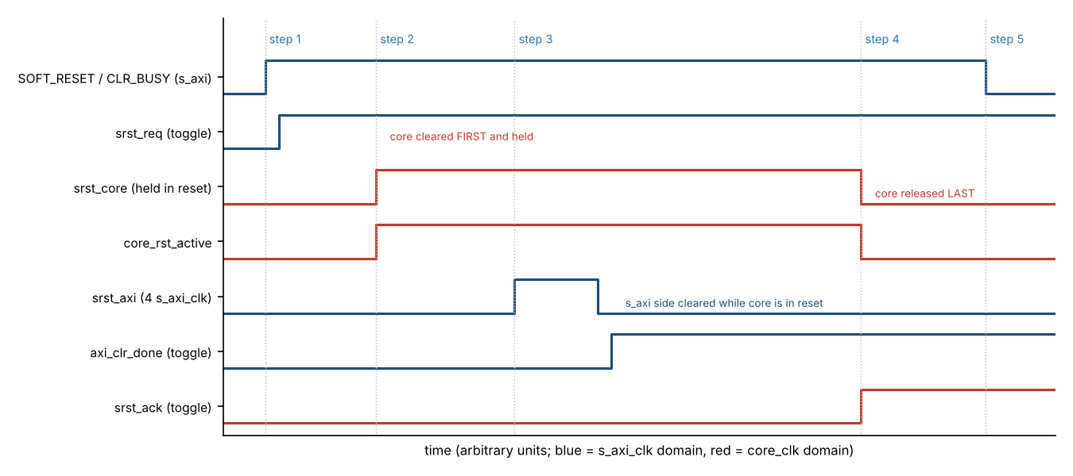
Figure 33: SOFT_RESET sequence: core cleared first and held, s_axi side cleared, core released last

FIFO_CLEAR sequence
TX_FIFO_CLEAR and RX_FIFO_CLEAR use the same five steps with fclr_req / fclr_ack, but only the selected FIFO is involved: TX FIFO = s_axi wr_ptr and core rd_ptr with their synchronizer flops; RX FIFO = core wr_ptr and s_axi rd_ptr with their synchronizer flops. CLR_BUSY = 1 and that FIFO data port returns SLVERR while busy. Sticky IRQ bits are not cleared. A TX_FIFO_CLEAR during transmission lets the word already loaded in shreg finish; at the next word_tick the Generator sees fifo_empty = 1 and freezes (underrun). Words that the receiver delivers while the RX FIFO is being cleared are discarded without setting OVERFLOW.

6. FIFO Behavior
Both FIFOs are FIFO_DEPTH words deep (16 bits per entry; TX uses 12 bits, RX uses 13 bits: data [11:0] and the word error flag in bit 12; unused bits are 0; synthesis parameter, default 128; legal: a power of two, 16 or more). LEVEL = 0..FIFO_DEPTH. HALF when LEVEL >= FIFO_DEPTH/2. FULL when LEVEL = FIFO_DEPTH. EMPTY when LEVEL = 0.
- RX FIFO: a word that arrives while FULL is discarded and the sticky OVERFLOW bit is set.
- TX FIFO: a push attempted while FULL returns SLVERR and the word is not written.
- FIFO_CLEAR flushes the selected FIFO; it does not clear sticky IRQ bits.
- Full / empty detection uses the extra-MSB pointer scheme of Section 4.2.4 (all FIFO_DEPTH entries usable).

7. Memory Map & Register Reference

7.1 Memory Map Organization
Register tables list block-relative Off. The address of a register is base_addr + block_base + Off, where base_addr is the base address of the core in the address map of the SoC (chosen by the system integrator; it is not a parameter of the core). The core itself sees only the offset block_base + Off: s_axi_awaddr / s_axi_araddr are 16 bits wide and the core decodes the offsets 0x0000 - 0x014F (the interconnect removes base_addr). Example: TX_SYNC4 has Off 0x28 at TX base 0x0020, so the offset is 0x0048 and the CPU address is base_addr + 0x0048.
Control and status registers (Global, TX Control/Status, RX Control/Status) occupy the contiguous offsets 0x0000 – 0x00FF. Both data ports live in the offsets 0x01xx: TX Data Port at 0x0100, then a reserved gap, then RX Data Port at 0x0140. Reserved gaps separate the blocks so that future registers can be inserted without moving existing addresses.
Table 24: Memory map organization
Block base | Block | Description
0x0000 | Global Registers | Version, Soft-Reset, Enables, IRQ (within 0x00–0x0F)
0x0010–0x001F | Reserved gap | OKAY; write ignored; read 0
0x0020 | TX Control / Status | TX_CTRL … TX_SYNC4 (within 0x20–0x4F), TX counters (within 0x50–0x5B)
0x005C–0x005F | Reserved gap | OKAY; write ignored; read 0
0x0060 | RX Control / Status | RX_CTRL … RX_SYNC4, WRDCNT (within 0x60–0x9F)
0x00A0 | RX Bit-Error Registers | RX_ERR_LIMIT … RX_SYNC_WD (within 0xA0–0xDF)
0x00E0–0x00FF | Reserved gap | OKAY; write ignored; read 0
0x0100 | TX Data Port | Push 12-bit words into TX FIFO (0x100–0x10F)
0x0110–0x013F | Reserved gap | OKAY; write ignored; read 0
0x0140 | RX Data Port | Pop RX words from RX FIFO: data [11:0] and error flag in bit 12 (0x140–0x14F)

Table 25 lists every implemented register in address order, as one flat list for the register file and for the software header. Every other offset inside 0x0000 - 0x014F is reserved (write ignored, read 0, response OKAY, Table 24); an address outside the window returns SLVERR (Section 4.1). The Section column points to the bit-field tables.
Table 25: Flat register address map (offset from base_addr)
Offset (block_base + Off) | Register | Access | Reset value | Section
0x0000 | CORE_VERSION | R | 0x0001_0000 | 7.2
0x0004 | GLOBAL_CTRL | R/W | 0x0000_0000 | 7.2
0x0008 | GLOBAL_STATUS | R | 0x0000_0000 | 7.2
0x000C | IRQ_SOURCE | R | 0x0000_0000 | 7.2, 8.3
0x0020 | TX_CTRL | R/W | 0x0000_0000 | 7.3
0x0024 | TX_STATUS | R | 0x0000_0001 | 7.3
0x0030 | TX_IRQ_ENABLE | R/W | 0x0000_0000 | 7.3, 8.1
0x0034 | TX_IRQ_STATUS | R/W1C | 0x0000_0000 | 7.3, 8.1
0x0038 | TX_FIFO_CLEAR | W | 0x0000_0000 | 7.3
0x003C | TX_SYNC1 | R/W | 0x0000_0247 | 7.3
0x0040 | TX_SYNC2 | R/W | 0x0000_05B8 | 7.3
0x0044 | TX_SYNC3 | R/W | 0x0000_0A47 | 7.3
0x0048 | TX_SYNC4 | R/W | 0x0000_0DB8 | 7.3
0x0050 | TX_WORD_CNT | R | 0x0000_0000 | 7.3
0x0054 | TX_BIT_CNT | R | 0x0000_0000 | 7.3
0x0058 | TX_CNT_CLEAR | W | 0 | 7.3
0x0060 | RX_CTRL | R/W | 0x0000_0000 | 7.4
0x0064 | RX_STATUS | R | 0x0000_0001 | 7.4
0x0068 | INJ_CTRL | R/W | 0x0000_0000 | 7.4, 12.14
0x006C | INJ_STATUS | R | 0x0000_0000 | 7.4, 12.14
0x0070 | RX_IRQ_ENABLE | R/W | 0x0000_0000 | 7.4, 8.2
0x0074 | RX_IRQ_STATUS | R/W1C | 0x0000_0000 | 7.4, 8.2
0x0078 | RX_FIFO_CLEAR | W | 0x0000_0000 | 7.4
0x007C | WRDCNT | R/W | 0x0000_0000 | 7.4
0x0080 | RX_SYNC1 | R/W | 0x0000_0247 | 7.4
0x0084 | RX_SYNC2 | R/W | 0x0000_05B8 | 7.4
0x0088 | RX_SYNC3 | R/W | 0x0000_0A47 | 7.4
0x008C | RX_SYNC4 | R/W | 0x0000_0DB8 | 7.4
0x00A0 | RX_ERR_LIMIT | R/W | 0x0000_000C | 7.4, 3.2.4
0x00A4 | RX_ERR_CLEAR | W | 0x0000_0000 | 7.4, 3.2.4
0x00A8 | RX_BIT_ERR_CNT | R | 0x0000_0000 | 7.4, 3.2.4
0x00AC | RX_WORD_ERR_CNT | R | 0x0000_0000 | 7.4, 3.2.4
0x00B0 | RX_BIT_ERR_POS | R | 0x0000_0000 | 7.4, 3.2.4
0x00B4 | RX_BIT_ERR_POS0 | R | 0x0000_0000 | 7.4, 3.2.4
0x00B8 | RX_BIT_ERR_CAUSE | R | 0x0000_0000 | 7.4, 3.2.4
0x00BC | RX_ERR_CTRL | R/W | 0x0000_0000 | 7.4, 3.2.4.8
0x00C0 | RX_BIT_POS_NOW | R | 0x0000_0000 | 7.4, 3.2.4.5
0x00C4 | RX_SYNC_WD | R/W | 0x0000_0008 | 7.4, 3.2.3.1
0x0100 | TX_DATA | R/W | 0x0000_0000 | 7.5
0x0104 | TX_WR_EN | R/W | 0x0000_0000 | 7.5
0x0108 | TX_WR_ADDR | R/W | 0x0000_0000 | 7.5
0x0140 | RX_RD_DATA | R (pop) | 0x0000_0000 (SLVERR if EMPTY) | 7.6
0x0144 | RX_RD_EN | R/W | 0x0000_0000 | 7.6
0x0148 | RX_RD_ADDR | R/W | 0x0000_0000 | 7.6

7.2 Global Registers (block_base 0x0000)
Table 26 lists the global registers.
Table 26: Global registers
Off | Name | Acc | Rst | Description
0x00 | CORE_VERSION | R | 0x0001_0000 | RTL version (constant): Major[31:16] = 1, Minor[15:0] = 0. Not tied to the document revision.
0x04 | GLOBAL_CTRL | R/W | 0x0 | SOFT_RESET, GLOBAL_EN, TX_EN, RX_EN, IRQ_ENABLE, INJ_DST
0x08 | GLOBAL_STATUS | R | 0x0 | bit 0 core_pending – any enabled sticky IRQ source is set (IRQ_SOURCE is not 0); bit 1 CLR_BUSY – 1 while SOFT_RESET or a FIFO clear is in progress; [31:2] reserved, read 0
0x0C | IRQ_SOURCE | R | 0x0 | Source of the interrupt, read in one access: bits [3:0] = TX_IRQ_STATUS[3:0] AND TX_IRQ_ENABLE[3:0]; bits [22:16] = RX_IRQ_STATUS[6:0] AND RX_IRQ_ENABLE[6:0] (bit n of RX_IRQ_STATUS is bit 16 + n); all other bits reserved, read 0. A bit is 1 while its sticky bit and its enable are both 1. Not gated by GLOBAL_CTRL.IRQ_ENABLE, so software that polls can use it with irq masked. Read only; the bits are cleared by W1C on TX_IRQ_STATUS / RX_IRQ_STATUS (Section 8.3).

GLOBAL_CTRL bits
Table 27 lists the bit fields of GLOBAL_CTRL.
Table 27: GLOBAL_CTRL bit fields
Bit | Name | Rst | Meaning
0 | SOFT_RESET | 0 | Write 1 starts soft-reset (flush FIFOs, clear sync/sticky/bit-error counters). Stays 1 while busy, self-clears to 0 when done. Poll until 0 before further config.
1 | GLOBAL_EN | 0 | 1 = core operational; 0 = all TX/RX activity gated off
2 | TX_EN | 0 | 1 = enable transmit path (also requires GLOBAL_EN)
3 | RX_EN | 0 | 1 = enable receive path (also requires GLOBAL_EN)
4 | IRQ_ENABLE | 0 | 1 = enable aggregated IRQ output
5 | INJ_DST | 0 | Destination of the built-in pattern injector (Section 12.14): 0 = the TX pins (reset value), 1 = the RX input. Written only while INJ_EN = 0 and applied only while INJ_EN = 0; software that uses the injector on the receive side shall write 1 before it sets INJ_EN. SOFT_RESET does not change it. No effect when INCLUDE_INJECTOR = 0.
31:6 | Reserved | 0 | Write 0; read 0

7.3 Transmit – Control / Status (block_base 0x0020)
Table 28 lists the TX control and status registers.
Table 28: TX Control / Status registers
Off | Name | Acc | Rst | Description
0x00 | TX_CTRL | R/W | 0x0 | TX_RATE[3:0] (bits [11:8]), SYNC_INS_MODE (bit 0)
0x04 | TX_STATUS | R | 0x01 | EMPTY / HALF / FULL flags (HALF and FULL computed on s_axi_clk from the write pointer, EMPTY on core_clk and crossed in the status snapshot, Section 4.2.4). Reset = EMPTY set.
0x08 | Reserved | — | 0 | Write ignored; read 0; response OKAY (not SLVERR). Former FIFO level / room register.
0x0C | Reserved | — | 0 | Write ignored; read 0; response OKAY (not SLVERR). Former FIFO level / room register.
0x10 | TX_IRQ_ENABLE | R/W | 0 | EN_EMPTY / EN_LOW / EN_FULL / EN_UNDERRUN
0x14 | TX_IRQ_STATUS | R/W1C | 0 | Sticky EMPTY / LOW / FULL / UNDERRUN (edge-triggered)
0x18 | TX_FIFO_CLEAR | W | 0 | Write 1 to flush TX FIFO only
0x1C | TX_SYNC1 | R/W | 0x247 | Programmable SYNC1 code (12-bit, default octal 1107 = 0x247)
0x20 | TX_SYNC2 | R/W | 0x5B8 | Programmable SYNC2 code (12-bit, default octal 2670 = 0x5B8)
0x24 | TX_SYNC3 | R/W | 0xA47 | Programmable SYNC3 code (12-bit, default octal 5107 = 0xA47)
0x28 | TX_SYNC4 | R/W | 0xDB8 | Programmable SYNC4 code (12-bit, default octal 6670 = 0xDB8)
0x30 | TX_WORD_CNT | R | 0 | Number of words started by the TX path since the last clear (32-bit, saturating)
0x34 | TX_BIT_CNT | R | 0 | Number of bit cells started by the TX path since the last clear (32-bit, saturating)
0x38 | TX_CNT_CLEAR | W | 0 | Write 1 to bit 0: clears TX_WORD_CNT and TX_BIT_CNT; a read is SLVERR
0x3C–0x3F | Reserved | — | 0 | Write ignored; read 0; response OKAY (not SLVERR).

TX word and bit counters (TX base + 0x30 to 0x38). TX_WORD_CNT counts the words started by the TX path: one count at every word_tick that loads a word, whether it comes from the TX FIFO or is a sync word inserted by hardware (SYNC_INS_MODE = 1). TX_BIT_CNT counts the bit cells started: one count at every bit_tick while a word is being sent. After the word_tick of word n the counters read TX_WORD_CNT = n and TX_BIT_CNT = 12 x (n - 1) + 1; after the last bit cell of word n, TX_BIT_CNT = 12 x n.
Nothing is counted while the TX Timing Generator is frozen (underrun), while tx_active = 0 or while the built-in injector drives the TX pins (INJ_DST = 0). Both counters are 32-bit, read-only and saturate at 0xFFFF_FFFF. They are counted in core_clk and cross in the status snapshot (Section 8.5): both values of one snapshot were captured in the same core_clk cycle, but two AXI reads can come from two snapshots, so software that needs a consistent pair stops the transmitter (clears TX_EN) before it reads both.
TX_CNT_CLEAR is write-only: writing 1 to bit 0 clears both counters through the clear request of Section 8.5, writing 0 has no effect, a read returns SLVERR. The counters are also cleared by SOFT_RESET and when tx_active rises (GLOBAL_EN AND TX_EN, the start of a transmission); they keep their values when the transmitter is stopped, so that software can read them afterwards. If a count and the clear reach the counters in the same core_clk cycle, the clear wins.

TX_CTRL bits
Table 29 lists the bit fields of TX_CTRL.
Table 29: TX_CTRL bit fields
Bit | Name | Rst | Meaning
0 | SYNC_INS_MODE | 0 | 0 = software inserts sync into FIFO; 1 = hardware auto-inserts TX_SYNCx at subframe start
7:1 | Reserved | 0 | Write 0; read 0
11:8 | TX_RATE[3:0] | 0000 | Transmit word-rate select (encoding: Table 5). Applied only while tx_active = 0 (Section 2.4). Codes 1000–1111 are reserved and behave as code 0000 (64 wps).
31:12 | Reserved | 0 | Write 0; read 0

TX_RATE[3:0] and RX_RATE[3:0] are symmetric: both sit at bits [11:8] of their own control register (TX_CTRL / RX_CTRL), reset to 0000 and use the same encoding (Table 5). They are independent: writing TX_CTRL never changes RX_RATE and vice versa. The TX Timing Generator reads the applied TX_RATE, the RX sample generator reads the applied RX_RATE.

TX_STATUS bits
Table 30 lists the bit fields of TX_STATUS.
Table 30: TX_STATUS bit fields
Bit | Name | Rst | Meaning
0 | EMPTY | 1 | 1 when TX FIFO contains 0 words
1 | HALF | 0 | 1 when LEVEL >= FIFO_DEPTH/2. (The TX interrupt for this condition is ST_LOW: level falls below FIFO_DEPTH/2, Section 8.4.)
2 | FULL | 0 | 1 when LEVEL = FIFO_DEPTH
31:3 | Reserved | 0 | Read 0

7.4 Receive – Control / Status (block_base 0x0060)
Table 31 lists the RX control and status registers.
Table 31: RX Control / Status registers
Off | Name | Acc | Rst | Description
0x00 | RX_CTRL | R/W | 0x0 | RX_RATE[3:0] (bits [11:8]), RXSEL, NOSYNC, SFTSYNC, TEST
0x04 | RX_STATUS | R | 0x01 | INSYNC, SYNC[1:0], MATCH, EMPTY/HALF/FULL, OVERFLOW, LOST_CAUSE[1:0] (bits [9:8]). Reset = EMPTY set.
0x08 | INJ_CTRL | R/W | 0x0 | Built-in pattern injector control: INJ_EN, INJ_START, INJ_MODE (Section 12.14, bits below)
0x0C | INJ_STATUS | R | 0x0 | Built-in pattern injector status: INJ_BUSY, INJ_DONE (bits below)
0x10 | RX_IRQ_ENABLE | R/W | 0 | EN_EMPTY/HALF/FULL/OVERFLOW/MATCH/INSYNC_LOST/BIT_ERR
0x14 | RX_IRQ_STATUS | R/W1C | 0 | Sticky bits (edge-triggered), incl. ST_BIT_ERR
0x18 | RX_FIFO_CLEAR | W | 0 | Write 1 to flush RX FIFO only
0x1C | WRDCNT | R/W | 0 | Word-count / subframe match utility
0x20 | RX_SYNC1 | R/W | 0x247 | Programmable SYNC1 code (12-bit, default octal 1107 = 0x247)
0x24 | RX_SYNC2 | R/W | 0x5B8 | Programmable SYNC2 code (12-bit, default octal 2670 = 0x5B8)
0x28 | RX_SYNC3 | R/W | 0xA47 | Programmable SYNC3 code (12-bit, default octal 5107 = 0xA47)
0x2C | RX_SYNC4 | R/W | 0xDB8 | Programmable SYNC4 code (12-bit, default octal 6670 = 0xDB8)
0x30–0x3F | Reserved | — | 0 | Write ignored; read 0; response OKAY (not SLVERR).
0x40 | RX_ERR_LIMIT | R/W | 12 | Number of consecutive bad bits that ends INSYNC; bits [7:0], 0 = off, reset 12 (Table 37)
0x44 | RX_ERR_CLEAR | W | 0 | Write 1 to bit 0: clears RX_BIT_ERR_CNT, RX_WORD_ERR_CNT, RX_BIT_ERR_POS, RX_BIT_ERR_POS0 and RX_BIT_ERR_CAUSE (Table 38)
0x48 | RX_BIT_ERR_CNT | R | 0 | Bad bits counted while INSYNC = 1; 32 bits, saturating
0x4C | RX_WORD_ERR_CNT | R | 0 | Words written with the error flag (bit 12 of the FIFO entry); 32 bits, saturating
0x50 | RX_BIT_ERR_POS | R | 0 | Position of the last bad bit: frame[31:19], subframe[18:17], word[16:4], bit[3:0] (Table 39)
0x54 | RX_BIT_ERR_POS0 | R | 0 | Position of the first bad bit since the last clear; same format
0x58 | RX_BIT_ERR_CAUSE | R | 0 | Sticky: which checks produced a bad bit since the last clear (Table 40)
0x5C | RX_ERR_CTRL | R/W | 0 | Bit 0 ERRCHK_ENB: 1 = bit-error check after lock on; 0 = off (Table 41)
0x60 | RX_BIT_POS_NOW | R | 0 | Bit, word, subframe and frame of the bit released to the 12-bit window last, while INSYNC = 1 (Table 42)
0x64 | RX_SYNC_WD | R/W | 8 | Sync watchdog time limit: MARGIN[7:0], 0 = off, reset 8 (Table 43)

RX_CTRL bits
Table 32 lists the bit fields of RX_CTRL.
Table 32: RX_CTRL bit fields
Bit | Name | Rst | Meaning
0 | RXSEL | 0 | 0 = HBP decoder; 1 = BPRZ decoder (OR-ed with external RSEL pin)
1 | NOSYNC | 0 | 1 = disable sync detection; all recovered words enter FIFO
2 | SFTSYNC | 0 | 1 = 2-sync-word mode; 0 = 4-sync-word mode
3 | TEST | 0 | 1 = digital loopback (TX encoders → RX decoder)
7:4 | Reserved | 0 | Write 0; read 0
11:8 | RX_RATE[3:0] | 0000 | Receive word-rate select (encoding: Table 5, same as TX_RATE). Applied only while rx_active = 0 (Section 2.4). Codes 1000–1111 are reserved and behave as code 0000 (64 wps).
31:12 | Reserved | 0 | Write 0; read 0

RX_STATUS bits
Table 33 lists the bit fields of RX_STATUS.
Table 33: RX_STATUS bit fields
Bit | Name | Rst | Meaning
0 | EMPTY | 1 | 1 when RX FIFO contains 0 words
1 | HALF | 0 | 1 when LEVEL >= FIFO_DEPTH/2. RX ST_HALF interrupt on the rising edge.
2 | FULL | 0 | 1 when LEVEL = FIFO_DEPTH
3 | OVERFLOW | 0 | Sticky: set when a valid word arrives while FULL. Cleared by W1C on RX_IRQ_STATUS.ST_OVERFLOW, or by SOFT_RESET / hard reset.
4 | INSYNC | 0 | 1 when receiver is frame-synchronized
6:5 | SYNC[1:0] | 00 | Realtime subframe indicator (valid only while INSYNC=1): 00=SYNC1, 01=SYNC2, 10=SYNC3, 11=SYNC4
7 | MATCH | 0 | 1 for one word-time when word-count/subframe matches WRDCNT. Only one word-time wide: use the sticky RX_IRQ_STATUS.ST_MATCH to catch it.
9:8 | LOST_CAUSE | 00 | Why INSYNC fell the last time (valid when ST_INSYNC_LOST is set): 00 = no loss yet, 01 = sync word (word 0) with a wrong code, 10 = RX_ERR_LIMIT bad bits in a row, 11 = sync watchdog (Section 3.2.3.1). Keeps the last cause; cleared by hardware reset, SOFT_RESET and when GLOBAL_EN AND RX_EN rises (not by RX_ERR_CLEAR).
31:10 | Reserved | 0 | Read 0

WRDCNT bits (Word-Count Utility)
Table 34 lists the bit fields of WRDCNT.
Table 34: WRDCNT bit fields
Bit | Name | Rst | Meaning
1:0 | SUBFRAME[1:0] | 00 | Target subframe: 00=subframe 1 (SYNC1), 01=subframe 2 (SYNC2), 10=subframe 3 (SYNC3), 11=subframe 4 (SYNC4).
14:2 | WORD_CNT[12:0] | 0 | Target word count inside the selected subframe (0…8191). Compared against the running word counter when INSYNC is high.
31:15 | Reserved | 0 | Write 0; read 0

When the running subframe index matches SUBFRAME[1:0] and the running word count matches WORD_CNT[12:0], the MATCH flag (RX_STATUS bit and external match pin) is asserted for one word-time. WORD_CNT >= W (words per subframe at the applied RX_RATE) never matches.
INJ_CTRL and INJ_STATUS (built-in pattern injector, Section 12.14). Both registers are cleared by SOFT_RESET. They serve both destinations of the injector; the destination is selected by GLOBAL_CTRL.INJ_DST (Section 7.2), which SOFT_RESET does not change. INJ_CTRL and INJ_STATUS stay in the RX register block.
Table 35: INJ_CTRL bit fields (RX base + 0x08, address 0x0068)
Bit | Name | Rst | Meaning
0 | INJ_EN | 0 | 1 = the injector is enabled and drives the destination selected by GLOBAL_CTRL.INJ_DST: INJ_DST = 1 (RX) replaces the loopback tap or the pins at TP5 and RX_CTRL.RXSEL selects the HBP or BPRZ pair; INJ_DST = 0 (TX) replaces the encoders at the TX pins (TP3). Applied only while the path of the destination is inactive (rx_active = 0 or tx_active = 0, Section 2.4).
1 | INJ_START | 0 | Write 1 starts a run; self-clearing, always reads 0. Ignored if INJ_EN = 0 or INJ_BUSY = 1. The enable of the destination shall be set before the start (RX_EN for INJ_DST = 1, TX_EN for INJ_DST = 0).
2 | INJ_MODE | 0 | 0 = run once (1 + 6 x W words, then idle); 1 = continuous until INJ_EN is cleared.
31:3 | Reserved | 0 | Write 0; read 0

Table 36: INJ_STATUS bit fields (RX base + 0x0C, address 0x006C), read-only
Bit | Name | Rst | Meaning
0 | INJ_BUSY | 0 | 1 while a run is in progress; in continuous mode it stays 1 until INJ_EN is cleared.
1 | INJ_DONE | 0 | Set when a run-once has ended. Cleared by the next INJ_START, by clearing INJ_EN, or by SOFT_RESET.
31:2 | Reserved | 0 | Read 0

Bit-error registers (Section 3.2.4). RX_SYNC_WD (RX base + 0x64) is not a bit-error register: it sets the time limit of the sync watchdog (Section 3.2.3.1) and acts with ERRCHK_ENB = 0 and 1; it is a configuration register like RX_ERR_LIMIT (Section 4.2.1). The registers RX_ERR_LIMIT to RX_BIT_ERR_CAUSE act only when RX_ERR_CTRL.ERRCHK_ENB = 1. RX_BIT_POS_NOW (RX base + 0x60) is read-only, has the same layout as RX_BIT_ERR_POS and lets software monitor the position of the receiver; it works with ERRCHK_ENB = 0 or 1 (Section 3.2.4.5). The block at RX base + 0x40 (address 0x00A0) is read and written like any other register of the RX block. The counters, the two positions and the cause are kept on s_axi_clk: for every counted bad bit the core holds the position and the cause stable in core_clk for the next full bit cell and sends a toggle event; s_axi_clk loads them after it has seen the toggle. A bit cell lasts at least 10 us (8192 wps), far more than the three s_axi_clk periods the toggle needs, so no value changes while it is loaded. RX_BIT_POS_NOW is loaded the same way for every bit that enters the window. RX_ERR_LIMIT and RX_ERR_CTRL are configuration registers like RX_CTRL (Section 4.2.1).
Table 37: RX_ERR_LIMIT bit fields (RX base + 0x40, address 0x00A0)
Bit | Name | Rst | Meaning
7:0 | LIMIT | 12 | Consecutive bad bits that end INSYNC; 0 = the limit is off
31:8 | Reserved | 0 | Read 0, write ignored

Table 38: RX_ERR_CLEAR bit fields (RX base + 0x44, address 0x00A4), write only
Bit | Name | Rst | Meaning
0 | CLR | 0 | Write 1: clears the two counters, the two positions and the cause. Self-clearing. RX_BIT_POS_NOW is not changed. A read returns SLVERR (write-only register)
31:1 | Reserved | 0 | Write ignored

Table 39: RX_BIT_ERR_POS and RX_BIT_ERR_POS0 bit fields (RX base + 0x50 / 0x54, address 0x00B0 / 0x00B4), read-only
Bits | Name | Rst | Meaning
3:0 | BIT | 0 | Bit in the word (0..11); the first received bit is bit 0
16:4 | WORD | 0 | Word in the subframe (0..W-1; word 0 is the sync word)
18:17 | SUBFRAME | 0 | Subframe index 0..3 (SYNC1..SYNC4)
31:19 | FRAME | 0 | Frame counter, 0 at lock, +1 when the subframe index wraps from 3 to 0

Table 40: RX_BIT_ERR_CAUSE bit fields (RX base + 0x58, address 0x00B8), read-only, sticky
Bit | Name | Rst | Check that produced a bad bit
0 | EDGE_DIST | 0 | HBP: two validated edges less than 6 samples apart, an edge 14 samples or more after the previous one that is a mid-cell edge or follows a mid-cell edge, or a boundary edge more than 18 samples after the previous boundary edge (rule F)
1 | PHASE | 0 | HBP: edge in phase 14 or 15
2 | MID_MID | 0 | HBP: two mid-cell edges in a row
3 | NO_EDGE | 0 | HBP: no edge for more than 24 samples
4 | NO_PULSE | 0 | BPRZ: no pulse for more than 16 samples
5 | WRONG_POL | 0 | BPRZ: pulse of the opposite polarity before the Null
6 | NO_NULL | 0 | BPRZ: the Null did not come within 16 samples
7 | BIT_GAP | 0 | BPRZ: Null less than 10 samples after the previous bit
8 | BIT_LOST | 0 | BPRZ: placeholder bit (no bit for 24 samples)
9 | RESYNC | 0 | HBP: bit left in a re-synchronization window
31:10 | Reserved | 0 | Read 0

Table 41: RX_ERR_CTRL bit fields (RX base + 0x5C, address 0x00BC)
Bit | Name | Rst | Meaning
0 | ERRCHK_ENB | 0 | 1 = the bit-error check after lock of Section 3.2.4 is on; 0 = nothing is checked, flagged or counted after lock (Section 3.2.4.8). Applied only while rx_active = 0; a write while rx_active = 1 changes nothing in the receiver until rx_active falls
31:1 | Reserved | 0 | Read 0, write ignored

Table 42: RX_BIT_POS_NOW bit fields (RX base + 0x60, address 0x00C0), read-only
Bits | Name | Rst | Meaning
3:0 | BIT | 0 | Bit in the word (0..11) of the bit released to the 12-bit window last; the first received bit is bit 0
16:4 | WORD | 0 | Word in the subframe (0..W-1; word 0 is the sync word)
18:17 | SUBFRAME | 0 | Subframe index 0..3 (SYNC1..SYNC4)
31:19 | FRAME | 0 | Frame counter, 0 at lock, +1 when the subframe index wraps from 3 to 0 (as in Table 39)

Table 43: RX_SYNC_WD bit fields (RX base + 0x64, address 0x00C4)
Bits | Name | Rst | Meaning
7:0 | MARGIN | 8 | Sync watchdog limit = (16 + MARGIN) x 12 x W RX sample_ticks = 1 + MARGIN/16 subframes (Section 3.2.3.1). Reset 8 = 1.5 subframes; 0 = watchdog off. Use at least 3 for lines with bit cells up to 18 samples. Applied immediately.
31:8 | Reserved | 0 | Read 0, write ignored

7.5 TX Data Port (block_base 0x0100)
Table 44 lists the registers of the TX data port.
Table 44: TX Data Port registers
Off | Name | Description
0x00 | TX_DATA | R/W, reset 0. Write bits[11:0]: LATCHES the 12-bit word to be pushed. A write here alone does NOT push the FIFO and always returns OKAY; bits[31:12] are ignored. Read returns the last latched word (bits[31:12] = 0).
0x04 | TX_WR_EN | R/W, reset 0, bit 0 only (bits[31:1] reserved, read 0). Level arm: may stay 1 for a burst of pushes. Alone it does not write the FIFO. While it is 0 a TX_WR_ADDR write pushes nothing.
0x08 | TX_WR_ADDR | R/W, reset 0. Software word index 0, 1, 2, ... (bookkeeping only: it is not the FIFO write pointer and does not select a location). A write while TX_WR_EN = 1 is the push strobe: the word latched in TX_DATA is pushed into the TX FIFO. !FULL and CLR_BUSY = 0 -> OKAY; FULL or CLR_BUSY = 1 -> SLVERR and the word is not written. A write while TX_WR_EN = 0 -> OKAY, nothing is pushed.
0x0C–0x0F | Reserved | Write 0; read 0 (OKAY).

TX push (two steps): TX_DATA only latches the word; the push itself happens on a write to TX_WR_ADDR while TX_WR_EN = 1. Writing a new word to TX_DATA before TX_WR_ADDR replaces the latched word (an unpushed word is lost); two TX_WR_ADDR writes without a TX_DATA write in between push the same word twice. TX_DATA, TX_WR_EN and TX_WR_ADDR live in s_axi_clk, are not part of the configuration bundle that crosses into core_clk, are cleared by hardware reset and are left unchanged by SOFT_RESET (like every other configuration register).
- TX push flow:
- 1. Optional: read TX_STATUS (FULL flag). It is CDC telemetry and may lag; the OKAY/SLVERR of step 4 is decided from the live FIFO flag.
- 2. Write TX_WR_EN = 1 (once per burst).
- 3. For each word: write TX_DATA = word, then write TX_WR_ADDR = i (i = 0, 1, 2, ...).
- 4. On the TX_WR_ADDR write: if the FIFO is not FULL and CLR_BUSY = 0 the latched word is pushed (OKAY); otherwise BRESP = SLVERR and nothing is written.
- 5. Optional: write TX_WR_EN = 0 when the burst is finished.

7.6 RX Data Port (block_base 0x0140)
Table 45 lists the registers of the RX data port.
Table 45: RX Data Port registers
Off | Name | Description
0x00 | RX_RD_DATA | AXI READ = one pop from RX FIFO. Bits[11:0] = ARINC word; bit 12 = error flag of the word (0 when RX_ERR_CTRL.ERRCHK_ENB = 0) (1 = at least one bit of the word is bad, Section 3.2.4); bits[31:13] = 0. OKAY+data, or SLVERR if EMPTY or CLR_BUSY = 1. A write is SLVERR with no effect.
0x04 | RX_RD_EN | R/W, reset 0, bit 0 only (bits[31:1] reserved, read 0). Optional, kept for symmetry with TX_WR_EN: software may set it, but it does NOT gate the pop. The pop is always done by a read of RX_RD_DATA. A read of this register never returns FIFO data.
0x08 | RX_RD_ADDR | R/W, reset 0. Software word index 0, 1, 2, ... (bookkeeping only, same as TX_WR_ADDR): it is not the FIFO read pointer, does not select a word, and reading or writing it never pops the FIFO. The pop is done only by a read of RX_RD_DATA.
0x0C–0x0F | Reserved | Write 0; read 0 (OKAY).

RX pop: On AR handshake sample read-side EMPTY. If EMPTY -> RRESP=SLVERR, RDATA=0, no pop. If !EMPTY -> capture RDATA, RRESP=OKAY; pop once when RVALID && RREADY complete.
RX_RD_EN and RX_RD_ADDR mirror TX_WR_EN and TX_WR_ADDR, so the RX data port has the same register set as the TX data port. Neither affects the pop: reading RX_RD_DATA is enough to pop one word, and software may ignore both (RX_RD_ADDR can serve as a software word counter). Both are cleared by hardware reset and left unchanged by SOFT_RESET.

7.7 From register accesses to FIFO signals
The registers of the data ports (TX_DATA, TX_WR_EN, TX_WR_ADDR, RX_RD_DATA, RX_RD_EN, RX_RD_ADDR) are an AXI view. The FIFO itself knows nothing about them: it only has the write-side ports wr_en, din and full, and the read-side ports rd_en, dout and empty (Section 4.2.4). Figure 34 and Table 46 show how an AXI access becomes those signals; the data-port logic of the AXI slave (Section 4.1.1) generates them.
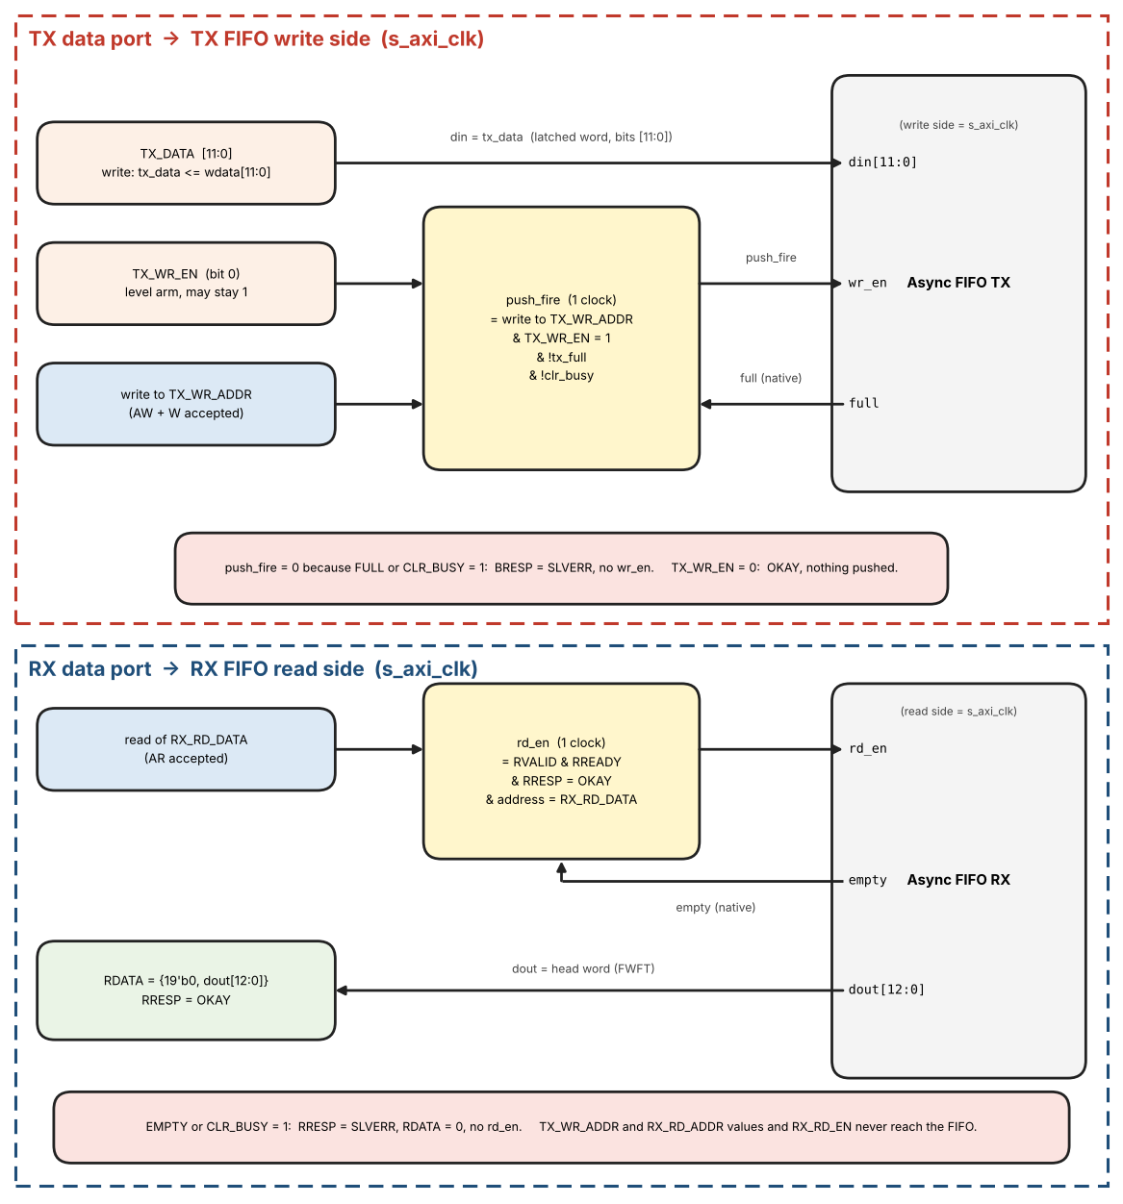
Figure 34: Data ports: from AXI register accesses to the TX and RX FIFO ports
Table 46: AXI access and the FIFO signals it produces
AXI access | FIFO signals and response
Write TX_DATA | tx_data <= wdata[11:0]. No FIFO signal. BRESP = OKAY.
Write TX_WR_EN | tx_wr_en <= wdata[0]. No FIFO signal. BRESP = OKAY.
Write TX_WR_ADDR with TX_WR_EN = 1, FIFO not FULL, CLR_BUSY = 0 | TX FIFO wr_en = 1 for exactly one s_axi_clk, din = tx_data. BRESP = OKAY.
Write TX_WR_ADDR with TX_WR_EN = 1, FIFO FULL or CLR_BUSY = 1 | wr_en stays 0, the word is not written. BRESP = SLVERR.
Write TX_WR_ADDR with TX_WR_EN = 0 | wr_en stays 0. BRESP = OKAY.
Read RX_RD_DATA, FIFO not EMPTY, CLR_BUSY = 0 | RDATA = {19'b0, dout[12:0]}, RRESP = OKAY. RX FIFO rd_en = 1 for exactly one s_axi_clk, in the clock where RVALID and RREADY are both 1.
Read RX_RD_DATA, FIFO EMPTY or CLR_BUSY = 1 | rd_en stays 0, RDATA = 0. RRESP = SLVERR.
Write or read RX_RD_EN, RX_RD_ADDR | Stored only (read returns the stored value). No FIFO signal.

- full and empty used to choose OKAY or SLVERR are the FIFO's own native flags in the same clock (Section 4.2.4), not the TX_STATUS / RX_STATUS bits, which have crossed a clock domain and lag.
- The FIFO keeps its own write and read pointers. The values written to TX_WR_ADDR and RX_RD_ADDR are never sent to the FIFO.
- Each push and each pop is a single-clock pulse per transaction. A transaction that has to wait (BVALID or RVALID held until BREADY or RREADY) shall not repeat the pulse.

8. Interrupt System
Policy: every monitored condition produces an edge-triggered sticky bit. Each sticky bit lives in the clock domain of the FIFO side or of the core block that produces its event: TX FULL-side bits (ST_LOW, ST_FULL) and RX read-side bits (ST_EMPTY, ST_HALF) in s_axi_clk; TX read-side and core bits (ST_EMPTY, ST_UNDERRUN) and RX write-side and core bits (ST_FULL, ST_OVERFLOW, ST_MATCH, ST_INSYNC_LOST, ST_BIT_ERR) in core_clk. FIFO conditions use the levels of Section 4.2.4 (wlevel for the write side, rlevel for the read side) and are detected as transitions of registered flags. Core events are one-clock pulses in core_clk and set their sticky bit directly. The core_clk bits reach software in the status snapshot and are cleared by a clear request (Section 8.5); the s_axi_clk bits are read and cleared directly. The IRQ_ENABLE registers and the aggregation stay in s_axi_clk.

8.1 TX_IRQ_ENABLE / TX_IRQ_STATUS
- Bit 0 – EN_EMPTY / ST_EMPTY
- Bit 1 – EN_LOW / ST_LOW
- Bit 2 – EN_FULL / ST_FULL
- Bit 3 – EN_UNDERRUN / ST_UNDERRUN (the TX Timing Generator froze because the FIFO was empty at a word_tick)
- Bits 31:4 – reserved

8.2 RX_IRQ_ENABLE / RX_IRQ_STATUS
- Bit 0 – EN_EMPTY / ST_EMPTY
- Bit 1 – EN_HALF / ST_HALF
- Bit 2 – EN_FULL / ST_FULL
- Bit 3 – EN_OVERFLOW / ST_OVERFLOW
- Bit 4 – EN_MATCH / ST_MATCH
- Bit 5 – EN_INSYNC_LOST / ST_INSYNC_LOST (falling edge of INSYNC; the reason is in RX_STATUS.LOST_CAUSE)
- Bit 6 – EN_BIT_ERR / ST_BIT_ERR (a bad bit was counted while INSYNC = 1 and RX_ERR_CTRL.ERRCHK_ENB = 1, Section 3.2.4)
- Bits 31:7 – reserved

8.3 Aggregation
irq = (OR over TX and RX of (sticky[k] AND enable[k])) AND GLOBAL_CTRL.IRQ_ENABLE, computed in s_axi_clk. For a bit of the s_axi_clk side sticky[k] is the bit itself; for a bit of the core_clk side it is the copy in the status snapshot (Section 8.5), masked while a clear of that bit is in flight. irq is registered in s_axi_clk and needs no further synchronizer (the same AND is read through IRQ_SOURCE), because every input is already an s_axi_clk signal. GLOBAL_STATUS.core_pending is the same OR before the IRQ_ENABLE gate.
IRQ_SOURCE (Section 7.2) tells software which sources raised the interrupt, in one read. It is the AND of every sticky bit with its enable, before the IRQ_ENABLE gate: IRQ_SOURCE[3:0] = TX_IRQ_STATUS[3:0] AND TX_IRQ_ENABLE[3:0] and IRQ_SOURCE[22:16] = RX_IRQ_STATUS[6:0] AND RX_IRQ_ENABLE[6:0]. The TX bits sit in the lower half and the RX bits in the upper half, with the bit numbers of the two status registers kept inside each half, so that bits [15:4] and [31:23] are free for later sources. The register is built from the signals that already form irq: bits of the s_axi_clk side are the sticky bits themselves, bits of the core_clk side are the copies of the status snapshot, masked while a clear of that bit is in flight (Section 8.5). It adds no clock domain crossing, and irq = (IRQ_SOURCE is not 0) AND GLOBAL_CTRL.IRQ_ENABLE. Table 47 lists all interrupt sources.
Table 47: Interrupt sources and their bit in IRQ_SOURCE
IRQ_SOURCE bit | Source | Clock domain of the sticky bit | Event (edge, Section 8.4) | Cleared by W1C on
0 | TX ST_EMPTY | core_clk | TX FIFO becomes empty (rlevel = 0) | TX_IRQ_STATUS[0]
1 | TX ST_LOW | s_axi_clk | TX FIFO level falls below FIFO_DEPTH / 2 (refill) | TX_IRQ_STATUS[1]
2 | TX ST_FULL | s_axi_clk | TX FIFO becomes full (wlevel = FIFO_DEPTH) | TX_IRQ_STATUS[2]
3 | TX ST_UNDERRUN | core_clk | Timing Generator goes from GEN_RUN to GEN_FROZEN (word_tick with the TX FIFO empty) | TX_IRQ_STATUS[3]
16 | RX ST_EMPTY | s_axi_clk | RX FIFO becomes empty (rlevel = 0) | RX_IRQ_STATUS[0]
17 | RX ST_HALF | s_axi_clk | RX FIFO level rises to FIFO_DEPTH / 2 or more (read out) | RX_IRQ_STATUS[1]
18 | RX ST_FULL | core_clk | RX FIFO becomes full (wlevel = FIFO_DEPTH) | RX_IRQ_STATUS[2]
19 | RX ST_OVERFLOW | core_clk | A received word is dropped because the RX FIFO is full | RX_IRQ_STATUS[3]
20 | RX ST_MATCH | core_clk | Word-count / subframe match of WRDCNT (Section 3.2.3.1) | RX_IRQ_STATUS[4]
21 | RX ST_INSYNC_LOST | core_clk | Falling edge of INSYNC; the reason is in RX_STATUS.LOST_CAUSE | RX_IRQ_STATUS[5]
22 | RX ST_BIT_ERR | core_clk | A bad bit is counted (INSYNC = 1 and ERRCHK_ENB = 1); cause in RX_BIT_ERR_CAUSE, position in RX_BIT_ERR_POS | RX_IRQ_STATUS[6]

Service routine: (1) read IRQ_SOURCE once; every bit that is 1 is a source to serve; (2) for each of them read the detail register only when the source needs it (RX_STATUS.LOST_CAUSE for ST_INSYNC_LOST, RX_BIT_ERR_CAUSE and RX_BIT_ERR_POS for ST_BIT_ERR); (3) write 1 to the bits served in TX_IRQ_STATUS / RX_IRQ_STATUS; (4) read IRQ_SOURCE again until it is 0 (a core_clk bit reads 0 from the first read after its clear, Section 8.5). Without IRQ_SOURCE software would read the two IRQ_STATUS and the two IRQ_ENABLE registers and combine them itself.

8.4 Sticky Edge Rules (frozen)
Sticky bits are set only on a transition of the event condition, never while it persists. After a W1C clear a new transition is required before the bit can be set again; this prevents IRQ storms. If a clear and a new event reach the sticky bit in the same clock cycle of its own domain (the W1C write cycle in s_axi_clk, the cycle in which the clear request is applied in core_clk), the new event wins (the bit stays set). Event definitions:
- TX: ST_EMPTY = rlevel becomes 0 (core_clk); ST_LOW = wlevel falls below FIFO_DEPTH/2 (the FIFO needs refilling); ST_FULL = wlevel reaches FIFO_DEPTH; ST_UNDERRUN = one event each time the Timing Generator goes from GEN_RUN to GEN_FROZEN (word_tick with fifo_empty = 1 while tx_active = 1). Waiting for the first word after the TX is enabled is not an underrun.
- RX: ST_EMPTY = rlevel becomes 0; ST_HALF = rlevel rises to FIFO_DEPTH/2 or more; ST_FULL = wlevel reaches FIFO_DEPTH.
- RX: ST_OVERFLOW = a word is dropped because the FIFO is full; ST_MATCH = MATCH event (Section 3.2.3.1); ST_INSYNC_LOST = falling edge of INSYNC; ST_BIT_ERR = one event for every bad bit that is counted (Section 3.2.4), i.e. only while INSYNC = 1 and ERRCHK_ENB = 1; the cause is in RX_BIT_ERR_CAUSE and the position in RX_BIT_ERR_POS. Nothing is counted and no event is created while INSYNC = 0, so an idle line does not set ST_BIT_ERR (use INSYNC and ST_INSYNC_LOST for "no valid signal"). A burst of bad bits gives one event per bit: leave EN_BIT_ERR = 0 unless every bad bit shall interrupt, and poll RX_BIT_ERR_CNT otherwise.
- The reset value of a flag does not create an event (for example TX EMPTY = 1 after reset does not set ST_EMPTY).
Figure 35 shows the interrupt logic: edge event, sticky bit with W1C, aggregation and IRQ.
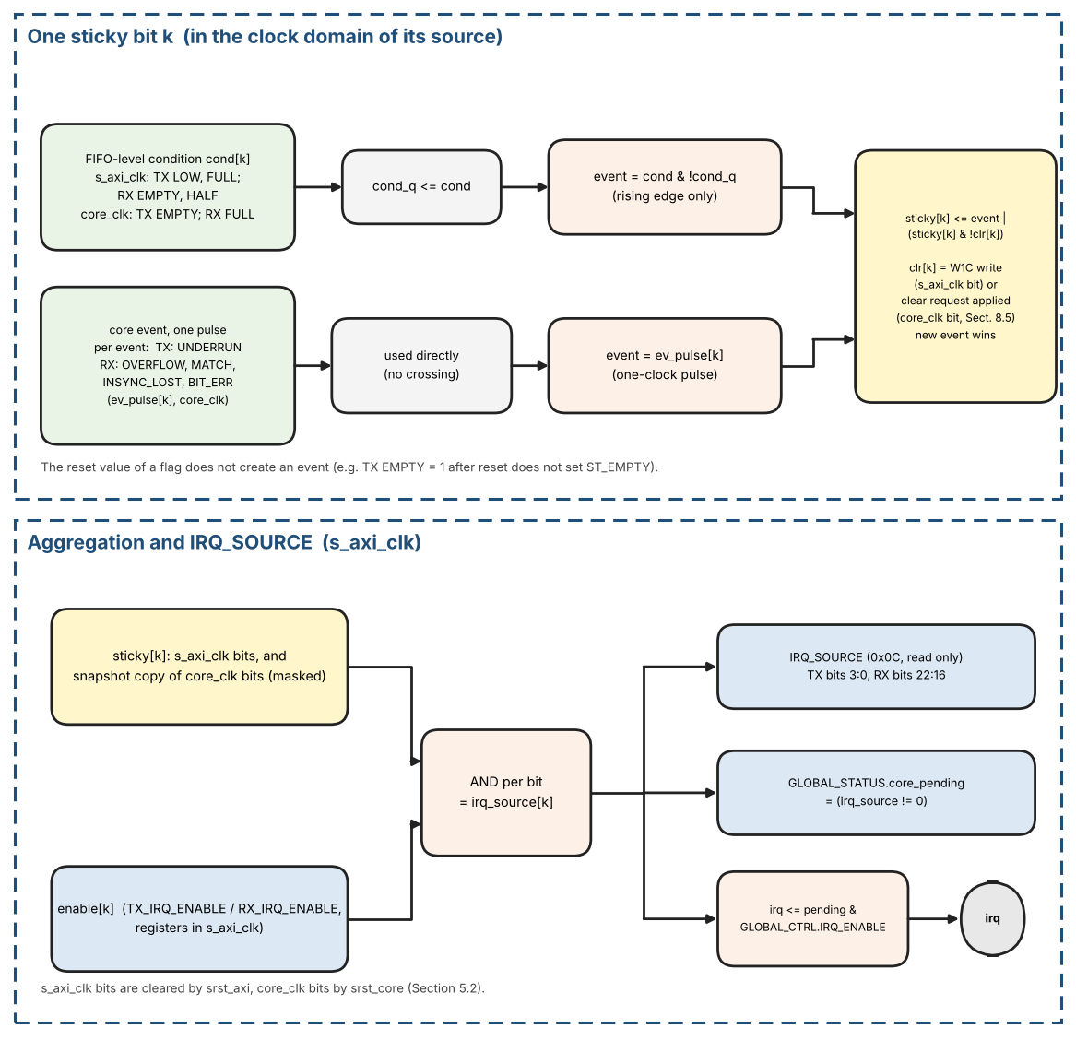
Figure 35: Interrupt logic: edge event, sticky bit with W1C, aggregation and IRQ

Interrupt reference pseudo-code
After a W1C clear the condition shall go false and true again before the bit can be set again, because the event is an edge. If the condition is still true when software clears the bit, no new event is generated.
// one block per sticky bit k, in the clock domain of the side that produces it. s_axi_clk: TX LOW, FULL; RX EMPTY, HALF. core_clk: TX EMPTY, UNDERRUN; RX FULL, OVERFLOW, MATCH, INSYNC_LOST, BIT_ERR.
// Registered conditions (from the FIFO levels of Section 4.2.4):
// TX: cond_EMPTY = (rlevel == 0) [core_clk] cond_LOW = (wlevel < FIFO_DEPTH/2) cond_FULL = (wlevel == FIFO_DEPTH) [s_axi_clk]
// RX: cond_EMPTY = (rlevel == 0) cond_HALF = (rlevel >= FIFO_DEPTH/2) [s_axi_clk] cond_FULL = (wlevel == FIFO_DEPTH) [core_clk]
cond_q[k] <= cond[k] // reset value = reset value of cond[k]: EMPTY = 1, TX
LOW = 1, others 0
event[k] = cond[k] & !cond_q[k] // rising edge only: never while the condition persists

// core events (TX UNDERRUN; RX OVERFLOW, MATCH, INSYNC_LOST, BIT_ERR): one-clock pulses of core_clk, used directly
event[k] = ev_pulse[k] // core event: one-clock pulse; FIFO condition: edge detection above

// sticky bit: the new event wins over a W1C in the same clock
clr[k] = s_axi_clk bit: (write to *_IRQ_STATUS accepted in this clock) & WDATA[k]; core_clk bit: clear request applied in this clock (Section 8.5)
sticky[k] <= event[k] | (sticky[k] & !clr[k]) // in the clock of its own domain

// aggregation (registered)
pending = |(sticky[k] & enable[k]) // s_axi_clk; over all TX and RX bits (core_clk bits from the masked snapshot, Section 8.5); GLOBAL_STATUS.core_pending
irq_source = {TX: sticky & enable (bits [3:0]), RX: sticky & enable (bits [22:16])} // read-only register IRQ_SOURCE; pending = |irq_source
irq <= pending & GLOBAL_CTRL.IRQ_ENABLE // s_axi_clk
// sticky and cond_q are cleared by srst_axi (s_axi_clk bits) or srst_core (core_clk bits), Section 5.2

8.5 Status snapshot and clear request
Part of the status is produced in core_clk and part in s_axi_clk (Section 8). The s_axi_clk part is read and cleared directly. The core_clk part is a set of copies read in s_axi_clk, and a W1C write of one of its bits has to reach core_clk. Two small handshakes, the same kind as the configuration bundle of Section 4.2.1, do this.
Status snapshot (core_clk to s_axi_clk). A capture register stat_hold takes, in one core_clk cycle, INSYNC, SYNC[1:0], TX_STATUS.EMPTY, RX_STATUS.FULL, RX_STATUS.MATCH, the core_clk sticky bits of TX_IRQ_STATUS (ST_EMPTY, ST_UNDERRUN) and RX_IRQ_STATUS (ST_FULL, ST_OVERFLOW, ST_MATCH, ST_INSYNC_LOST, ST_BIT_ERR) and the counters TX_WORD_CNT and TX_BIT_CNT, and toggles stat_req. The s_axi_clk side synchronizes stat_req (2FF), copies stat_hold into the registers that AXI reads return, and toggles stat_ack; the core side synchronizes stat_ack (2FF) and starts the next capture. stat_hold does not change between stat_req and stat_ack. The registers are therefore refreshed continuously and every read returns one coherent snapshot that is at most one handshake old; the bound is the same as for the configuration bundle: 2 x (3 core_clk + 3 s_axi_clk) + 2 s_axi_clk cycles.
Clear request (s_axi_clk to core_clk). A write of 1 to a core_clk bit k of TX_IRQ_STATUS or RX_IRQ_STATUS sets clr_pend[k], and a write of 1 to TX_CNT_CLEAR sets cnt_clr_pend (s_axi_clk). Writes to s_axi_clk bits do not use the handshake. When no clear handshake is in flight, the s_axi side copies clr_pend and cnt_clr_pend into clr_hold, clears them and toggles clr_req. The core side synchronizes clr_req (2FF), applies clr_hold in one core_clk cycle (sticky[k] <= event[k] | (sticky[k] & !clr[k]); the TX counters are cleared) and toggles clr_ack; the s_axi side synchronizes clr_ack (2FF). A write during the handshake only adds to clr_pend and is sent by the next handshake, so no clear is lost. The AXI write response is OKAY at once.
Read after clear. A core_clk bit cleared by W1C reads 0 at once: for every bit with a clear in flight the s_axi side keeps a mask and applies it to the snapshot copy, until clr_ack has been seen and two more snapshots have arrived (the first of them may have been captured before the clear was applied). The aggregation of Section 8.3 uses the masked copy, so a handler that clears its source and returns does not see a second interrupt for the same event. An event of the same bit in core_clk during this time is not lost: the sticky bit stays set in the core and appears in the first snapshot after the mask is released.
Latency. A core_clk event reaches the status registers within one snapshot period and the irq pin one s_axi_clk cycle after that; an s_axi_clk event reaches the irq pin one s_axi_clk cycle after the event. The pending clear request and the masks are cleared by srst_axi, the core side of both handshakes by srst_core (Section 5.2).
Handshake reference pseudo-code
// ---- core_clk ---- (stat_hold is stable between stat_req and stat_ack)
stat_ack_s <= {stat_ack_s[0], stat_ack}; if (stat_ack_s[1] != stat_ack_seen | !stat_busy) { stat_ack_seen <= stat_ack_s[1]; stat_hold <= {core_clk status fields}; stat_req <= ~stat_req; stat_busy <= 1 }
clr_req_s <= {clr_req_s[0], clr_req}; if (clr_req_s[1] != clr_req_seen) { clr_req_seen <= clr_req_s[1]; clr <= clr_hold; clr_ack <= ~clr_ack }
// ---- s_axi_clk ----
stat_req_s <= {stat_req_s[0], stat_req}; if (stat_req_s[1] != stat_req_seen) { stat_req_seen <= stat_req_s[1]; status_regs <= stat_hold; stat_ack <= ~stat_ack }
on W1C write of a core_clk bit: clr_pend[k] <= 1 and mask[k] <= 1; if (clr_pend != 0 & !clr_inflight) { clr_hold <= clr_pend; clr_pend <= 0; clr_req <= ~clr_req; clr_inflight <= 1 }
when clr_ack_s[1] != clr_ack_seen: clr_inflight <= 0; start counting two further snapshots, then release the masks of the cleared bits
status_view = status_regs & ~mask; pending uses status_view (Section 8.3)

9. AXI Error Handling
Table 48: AXI error response matrix
Condition | AXI Response | Side Effect
Unmapped address (outside 0x0000–0x014F decode window) | SLVERR | None
TX push (TX_WR_ADDR write, TX_WR_EN = 1) while write-side FULL | BRESP=SLVERR | Word not written
RX read while read-side EMPTY | RRESP=SLVERR | No pop
RX word arrives while FIFO FULL | N/A | Word dropped; OVERFLOW sticky set
Reserved offset inside a defined block | OKAY | Write ignored; read returns 0
Write to a read-only register, or read of a write-only register (Table 23) | SLVERR | None
WSTRB != 4'b1111 on a write | BRESP=SLVERR | None
Data-port access or FIFO_CLEAR write while CLR_BUSY = 1 | SLVERR | None

10. Interface Description

10.1 Configuration Parameters (synthesis-time)
Table 49 lists the synthesis-time configuration parameters.
Table 49: Synthesis-time configuration parameters
Parameter | Description | Allowed | Default
FIFO_DEPTH | Depth of TX and RX FIFOs in words (power of two); each entry is 16 bits; TX uses 12 bits, RX uses 13 bits (12 data bits and the word error flag) | power of 2, >= 16 | 128
INCLUDE_INJECTOR | 1 = the built-in pattern injector (Section 12.14: ROM of about 1128 bits, sequencer, TX pin multiplexer, INJ_CTRL / INJ_STATUS logic) is synthesized; 0 = it is left out | 0 or 1 | 1
CORE_VERSION | RTL version reported by the CORE_VERSION register (major[31:16], minor[15:0]); changed only by RTL or register-map changes | 32-bit | 0x0001_0000
INCLUDE_INJECTOR = 0: INJ_CTRL and INJ_STATUS still exist at their addresses (Table 25) but INJ_CTRL ignores writes and both read 0; INJ_START has no effect, GLOBAL_CTRL.INJ_DST is stored but has no effect, TP5 always follows the loopback tap or the pins and the TX pins are always driven by the encoders. The injector tests (IN-01 to IN-09) and the injector steps of the board self-test do not apply to such a build.
Table 50 collects the fixed numbers that the RTL needs. They are defined in the sections named in the last column; this table is a summary for the coder, and a value is changed in both places.
Table 50: Fixed design constants
Name | Value | Meaning / where it is used | Section
THRESH | 48 000 000 | Sample accumulator threshold: acc_next >= THRESH gives a sample_tick; core_clk in Hz | 3.2.1.1
INC | W x 192 (Table 5) | Accumulator step per core_clk; W = words per subframe = words/s of the applied rate | 3.2.1.1
Accumulator width | 26 bits | acc < THRESH + INC, at most 2^26 | 3.2.1.1
Samples per bit cell | 16 (half cell = 8) | sample_tick per data bit; one bit = 16 ticks, one word = 12 bits | 3.2.1.1
Dwell | 4 consecutive samples | 4-bit shift registers ONES / ZEROS / NULL; a level is valid when all four bits are 1 | 3.2.1.1
HBP phase counter | 0..15 | Boundary edges in phases 0..7 set phase := 3; mid-cell edges in phases 8..13 set phase := 11; edges in phases 14 and 15 are a framing error | 3.2.1.2, 12.6
HBP acquisition lock | gap of 14..18 samples | Two consecutive boundary edges around a bit 0; sets phase := 3 | 3.2.1.2
HBP no-edge timeout | samples_since_edge > 24 | framing_error; samples_since_edge saturates at 31 (31 = no edge yet) | 3.2.1.2
HBP minimum edge distance | samples_since_edge < 6 (HBP_MIN_GAP) | framing_error at a validated edge in tracking; the shortest legal distance is 7 | 3.2.1.2
HBP mid-cell edge sequence | mid-cell edge while last_mid = 1 | framing_error (two mid-cell edges in a row); last_mid = 0 after lock and after every boundary edge | 3.2.1.2
HBP maximum edge distance | samples_since_edge >= 14 (HBP_MAX_GAP) at a mid-cell edge, or at a boundary edge while last_mid = 1 | framing_error (EDGE_DIST); the largest legal distance is 10 | 3.2.1.2
HBP maximum cell length | samples_since_edge > 18 at a boundary edge while last_mid = 0 (rule F) | framing_error (EDGE_DIST); the longest legal cell is 18 samples | 3.2.1.2
BPRZ cell | 8 pulse samples + 8 Null samples | valid_* at the 4th sample of a half; bit_valid at sample 11 of the cell | 3.2.1.3
BPRZ timeout | t > 16 | framing_error (Null never came, or no pulse at all); the longest normal wait is 8 samples | 3.2.1.3
BPRZ minimum bit distance | samples_since_bit < 10 (BPRZ_MIN_BIT_GAP) | framing_error when a Null would complete a bit; the second bit is blocked. Legal bits are 14 to 20 samples apart; one INVALID sample can shorten the distance by 4 | 3.2.1.3
RX bad-bit limit | RX_ERR_LIMIT = 12 consecutive bad bits (register, 0 = off) | INSYNC falls when the limit is reached | 3.2.4.5, 7.4
BPRZ lost-bit timeout | BPRZ_SLOT_TIMEOUT = 24 samples; then a placeholder every 16 samples | Placeholder bit keeps the bit count while INSYNC = 1 | 3.2.4.4
HBP re-lock window | HBP_RELOCK_MAX = 8: re-lock only if the boundary edge arrives in phase 14, 15 or 0..8 | Correction of at most 5 samples after an error | 3.2.4.3
TX phase counter | 0..15 | bit_tick at phase 0, half_bit_tick at phase 8, bit_cnt advances at phase 15; outputs change one core_clk after the strobe | 3.1.2b
Word length | 12 bits, LSB first | bit_cnt 0..11; word_tick every 12th bit_tick | 3.1.2b
Words per subframe W | W of the applied rate (Table 5) | word_in_subframe is 13 bits (0..W-1); 4 subframes make one frame | 3.1.2b, 3.3
Sync trackers | 4 slots | Lock after 5 marks (4-sync) or 3 marks (2-sync); next mark at exactly 12 x W bits; timeout when bit_count > 12 x W; bit_count 17 bits | 3.2.2.2
FIFO | FIFO_DEPTH words (default 128), pointers clog2(FIFO_DEPTH) + 1 bits | HALF at level >= FIFO_DEPTH / 2; FULL at FIFO_DEPTH | 4.2.4, 6
Soft-reset hold times | 4 s_axi_clk (srst_axi); 4 core_clk after axi_clr_done | Dual-clock clear sequence | 5.2
Sync watchdog limit | (16 + RX_SYNC_WD.MARGIN) x 12 x W RX sample_ticks; reset MARGIN = 8 (1.5 subframes), 0 = off; counter 25 bits | INSYNC falls if no sync word is accepted within this time while INSYNC = 1 (not NOSYNC) | 3.2.3.1, 7.4
Configuration latency | 2 x (3 core_clk + 3 s_axi_clk) + 2 s_axi_clk | Bound from the last bundle write to the applied value | 4.2.1
Default sync codes | 0x247, 0x5B8, 0xA47, 0xDB8 (octal 1107, 2670, 5107, 6670) | TX_SYNC1..4 and RX_SYNC1..4 reset values | 7.3, 7.4
Idle levels | HBP (high, low) = (0, 1); BPRZ Null (0, 0) | After reset, when tx_active = 0; during underrun HBP holds, BPRZ is Null | 2.4
Reserved rate codes | 1000 .. 1111 behave as 0000 (64 wps) | TX_RATE and RX_RATE | 7.3, 7.4

10.2 I/O Signal Descriptions

Clocks and Resets
Table 51 lists the clock and reset signals.
Table 51: Clock and reset signals
Name | Dir | Description
s_axi_clk | In | AXI4-Lite and register-file clock; also TX-FIFO write / RX-FIFO read side
s_axi_aresetn | In | Active-low async-assert / sync-deassert reset of s_axi_clk domain
core_clk | In | Encode/decode/sync clock (48 MHz +/-0.1%)
core_aresetn | In | Active-low async-assert / sync-deassert reset of core_clk domain

ARINC Digital Interface
Table 52 lists the ARINC digital interface signals.
Table 52: ARINC digital interface signals
Name | Dir | Description
rx_hbp_high | In | HBP receive High leg (digital, from external line receiver)
rx_hbp_low | In | HBP receive Low leg (digital)
rx_bprz_high | In | BPRZ receive High/One (digital)
rx_bprz_low | In | BPRZ receive Low/Zero (digital). Null is not a pin: Null = rx_bprz_high and rx_bprz_low both 0 (Table 3)
tx_hbp_high | Out | HBP transmit High leg (digital, to external line driver)
tx_hbp_low | Out | HBP transmit Low leg (digital, complement of tx_hbp_high during data)
tx_bprz_high | Out | BPRZ transmit High/One (digital)
tx_bprz_low | Out | BPRZ transmit Low/Zero (digital); both low = Null
rsel | In | External RX format select (OR-ed with RX_CTRL.RXSEL)
insync | Out | Receiver subframe lock indicator
sync[1:0] | Out | Current subframe index while insync=1
match | Out | WRDCNT match pulse (one word-time)
rovf | Out | RX FIFO overflow (level, mirrors sticky until cleared)

Output timing: tx_hbp_*, tx_bprz_*, insync, sync[1:0] and match are registered in core_clk (match is a one-word-time pulse). irq is registered in s_axi_clk (the aggregation of Section 8.3). rovf is the core_clk OVERFLOW sticky level; it is also the source of the OVERFLOW bit in the status snapshot. External logic shall synchronize insync, sync, match and rovf to its own clock.

AXI4-Lite Slave (s_axi_clk domain)
Standard AXI4-Lite 32-bit slave interface. Port names (all in the s_axi_clk domain, reset s_axi_aresetn): s_axi_awaddr[15:0], s_axi_awvalid, s_axi_awready, s_axi_wdata[31:0], s_axi_wstrb[3:0], s_axi_wvalid, s_axi_wready, s_axi_bresp[1:0], s_axi_bvalid, s_axi_bready, s_axi_araddr[15:0], s_axi_arvalid, s_axi_arready, s_axi_rdata[31:0], s_axi_rresp[1:0], s_axi_rvalid, s_axi_rready. The protection signals AWPROT and ARPROT are not implemented: if the interconnect provides them they are left unconnected and ignored. The address ports are 16 bits wide; if the SoC address is wider, only the lower 16 bits are connected (the interconnect removes base_addr, so the core sees the offsets 0x0000-0x014F, Section 7.1).

Interrupt
irq – single aggregated interrupt output (core_pending AND GLOBAL_CTRL.IRQ_ENABLE). It is a level output, active high, registered in s_axi_clk: irq = 1 while at least one enabled sticky bit is set, and it falls after software clears those bits with W1C (or clears the enable). Reset value 0. The sources are read in one access in IRQ_SOURCE (Section 8.3).

10.3 FIFO Micro-Architecture
- Dual-clock async FIFO, FWFT (First-Word Fall-Through) on the read side so the first word is visible on rd_data as soon as empty deasserts — required for gap-free TX Load.
- HALF = (occupancy >= FIFO_DEPTH/2). FULL when occupancy = FIFO_DEPTH. EMPTY when occupancy = 0.
- TX underrun: finish current word, then freeze Timing Generator (Section 3.1.2b).

10.4 Subframe Index Mapping
Table 53: subframe_index to SYNC register mapping
subframe_index | TX/RX_SYNCx | Default octal | ARINC name
0 | SYNC1 | 1107 | Subframe 1
1 | SYNC2 | 2670 | Subframe 2
2 | SYNC3 | 5107 | Subframe 3
3 | SYNC4 | 6670 | Subframe 4

10.5 Module Port Tables
Ports of the main core_clk modules. Signals marked "from tx_timing_gen" etc. are internal; all widths in bits. Names follow the state diagrams (Sections 3.1.2b and 3.2.2.2) and the pseudo-code of Sections 3.2.1.2 and 3.2.1.3.
Table 54 lists the ports of the TX path modules.
Table 54: TX path module ports (core_clk)
Module | Signal(s) | Dir | Width | Description
tx_timing_gen | tx_active, tx_rate_code[3:0], fifo_empty | in | 1 / 4 / 1 | tx_active (Section 2.4); applied TX_RATE (Table 5); core-side FIFO empty flag (Section 4.2.4)
tx_timing_gen | sample_tick | out | 1 | Registered, 1 clock wide
tx_timing_gen | phase, bit_cnt | out | 4 / 4 | Sample counter 0..15 and bit cell index 0..11
tx_timing_gen | bit_tick, half_bit_tick, word_tick | out | 1 each | Decodes of sample_tick (valid only in the clock where sample_tick = 1)
tx_timing_gen | word_in_subframe, subframe_index, subframe_start | out | 13 / 2 / 1 | Index of the next word to load; subframe_start = (word_in_subframe == 0)
tx_timing_gen | gen_state | out | 2 | OFF / RUN / FROZEN
tx_timing_gen | ev_tx_underrun | out | 1 | One-clock event when the Generator goes from GEN_RUN to GEN_FROZEN; sets the sticky bit ST_UNDERRUN in TX STATUS / TX IRQ STATUS (core_clk)
tx_fsm_enc | tx_active, bit_tick, half_bit_tick, word_tick, subframe_start, subframe_index | in | – | From tx_timing_gen
tx_fsm_enc | sync_ins_mode, tx_sync1..tx_sync4 | in | 1 / 12 each | Applied TX_CTRL.SYNC_INS_MODE and TX_SYNCx
tx_fsm_enc | fifo_rd_data, fifo_empty | in | 16 / 1 | FWFT head of the TX FIFO: [11:0] = word, [15:12] unused (valid while fifo_empty = 0)
tx_fsm_enc | fifo_pop | out | 1 | One-clock pop pulse, only for a LOAD from the FIFO
tx_fsm_enc | tx_hbp_high, tx_hbp_low | out | 1 each | Registered HBP pair, 1 core_clk after the strobe
tx_fsm_enc | tx_bprz_high, tx_bprz_low | out | 1 each | Registered BPRZ pair: One (1,0), Zero (0,1), Null (0,0)
tx_status | load, bit_tick, tx_active | in | 1 each | Count events of the TX counters: load is the Load pulse of the TX FSM that starts a word (hardware sync words included), bit_tick starts a bit cell; nothing is counted while the Generator is frozen or the injector drives the TX pins
tx_status | cnt_clr, srst_core | in | 1 each | cnt_clr = TX_CNT_CLEAR after the clear request (Section 8.5); the counters are also cleared by srst_core and when tx_active rises; the clear wins over a count in the same clock
tx_status | tx_word_cnt[31:0], tx_bit_cnt[31:0] | out | 32 each | TX_WORD_CNT and TX_BIT_CNT (saturating at 0xFFFF_FFFF); captured together in the status snapshot (Section 8.5)

Table 55: RX path module ports (core_clk)
Module | Signal(s) | Dir | Width | Description
rx_sampler | rx_active, rx_rate_code[3:0] | in | 1 / 4 | Section 2.4; applied RX_RATE
rx_sampler | rxsel_eff | in | 1 | RX_CTRL.RXSEL OR synchronized rsel (applied while rx_active = 0)
rx_sampler | hi, lo | in | 1 each | Selected input pair after the 2FF, or the TX loopback pair (Table 8)
rx_sampler | sample_tick | out | 1 | RX sample clock, runs only while rx_active = 1
rx_sampler | valid_HI, valid_LO, valid_NULL | out | 1 each | 4-sample dwell flags, per sample_tick
hbp_decoder / bprz_decoder | sample_tick, valid_HI, valid_LO, valid_NULL, insync, errchk_enb | in | – | From rx_sampler (only the decoder selected by rxsel_eff is active); insync and errchk_enb (from RX_ERR_CTRL) choose between the simple path and the bit-error path (Section 3.2.4.8)
hbp_decoder / bprz_decoder | bit_valid, bit_data, bit_p, bit_cause[9:0] | out | 1 / 1 / 1 / 10 | One-clock pulse per recovered bit and the bit. bit_p = 1 marks a bit that the decoder made up (HBP resynchronization bit, BPRZ placeholder) and bit_cause its cause; both are 0 when errchk_enb = 0
hbp_decoder / bprz_decoder | framing_error, err_cause[9:0], err_back, err_cur | out | 1 / 10 / 1 / 1 | One-clock pulse. Before lock: clears window and trackers. While insync = 1 and errchk_enb = 1: reports a bad bit with its cause; err_back = also flag the previous bit, err_cur = flag the cell in progress (Section 3.2.4.6). While insync = 1 and errchk_enb = 0: not raised
rx_sync_detect | bit_valid, bit_data, bit_p, bit_cause[9:0], framing_error, err_cause[9:0], err_back, err_cur, rx_active | in | – | All outputs of the decoder (the signals of Section 3.2.4.6)
rx_sync_detect | nosync, sftsync, rx_rate_code[3:0] | in | 1 / 1 / 4 | Applied RX_CTRL bits and RX_RATE (gives W)
rx_sync_detect | errchk_enb, rx_err_limit[7:0], rx_sync_wd[7:0] | in | 1 / 8 / 8 | Applied RX_ERR_CTRL.ERRCHK_ENB (while rx_active = 0) and RX_ERR_LIMIT (immediately) (Section 3.2.4); RX_SYNC_WD.MARGIN (immediately), time limit of the sync watchdog (Section 3.2.3.1)
rx_sync_detect | rx_sync1..rx_sync4, wrdcnt_subframe, wrdcnt_word | in | 12 each / 2 / 13 | Applied RX_SYNCx and WRDCNT
rx_sync_detect | rx_fifo_full | in | 1 | Core-side conservative FULL flag
rx_sync_detect | sample_tick | in | 1 | RX sample clock of rx_sampler; clocks the sync watchdog counter (Section 3.2.3.1)
rx_sync_detect | rx_wr_en, rx_wr_data | out | 1 / 16 | RX FIFO write strobe and entry: [11:0] word, [12] word error flag (always 0 when errchk_enb = 0), [15:13] = 0
rx_sync_detect | insync, sync[1:0], match | out | 1 / 2 / 1 | Status pins (core_clk)
rx_sync_detect | ev_overflow, ev_match, ev_insync_lost, ev_bit_err | out | 1 each | One-clock events (ev_bit_err = one per counted bad bit, only when errchk_enb = 1, Section 3.2.4.5); they set the sticky bits in RX STATUS / RX IRQ STATUS (core_clk); ev_insync_lost and ev_bit_err are also converted to toggles that load the s_axi_clk-side registers (Section 7.4)
rx_sync_detect | lost_cause[1:0] | out | 2 | Reason of the last INSYNC fall (1 = word 0, 2 = RX_ERR_LIMIT, 3 = watchdog); held stable with ev_insync_lost; loaded into RX_STATUS.LOST_CAUSE
rx_sync_detect | pos_cur[31:0], ev_pos | out | 32 / 1 | Position of the receiver for RX_BIT_POS_NOW; ev_pos toggles once per released bit (INSYNC = 1, ERRCHK_ENB = 0 or 1)
rx_sync_detect | err_pos[31:0], err_cause[9:0] | out | 32 / 10 | Position (format of RX_BIT_ERR_POS) and cause of the counted bad bit; held stable for one bit cell after ev_bit_err (Section 7.4). The counters and POS0 are kept on s_axi_clk

11. Frozen Decisions (Summary)
- Single TX FIFO + single RX FIFO (depth = FIFO_DEPTH, default 128; both 16-bit: TX uses 12 bits, RX uses 13 bits).
- Push/pop accept-reject uses native same-clock FULL/EMPTY – never CDC STATUS.
- TX push = write TX_DATA[11:0] (latch), then write TX_WR_ADDR while TX_WR_EN = 1; FULL returns SLVERR on the TX_WR_ADDR write.
- RX pop = AXI read of RX_RD_DATA; pop once at RVALID && RREADY when !EMPTY. RX_RD_EN is optional and does not gate the pop.
- TX_RATE[3:0] (TX_CTRL[11:8]) and RX_RATE[3:0] (RX_CTRL[11:8]) are symmetric and independent; TX Timing Generator and RX sample-clock are independent machines.
- Rate change (per path): clear TX_EN / RX_EN, write the new TX_RATE / RX_RATE, wait for the CDC latency, then enable (Section 2.4). Each rate is latched in the core only while its own path is inactive.
- SOFT_RESET flushes both FIFOs and clears sticky IRQs, the TX word and bit counters and the bit-error counters; other config preserved.
- FIFO_CLEAR flushes only that FIFO; sticky bits unchanged.
- Reserved offsets inside a block: OKAY, read 0. Unmapped: SLVERR.
- Loopback TEST=1 uses internal mux; external pins are not high-Z.
- WSTRB: only 0xF accepted; any other value -> SLVERR, no write.
- Configuration registers cross as one atomic bundle (Section 4.2.1); enables cannot overtake TX_RATE, RX_RATE or SYNC codes.
- Sticky interrupt bits and FIFO status flags live in the clock domain of the FIFO side or core block that produces them (write side of the TX FIFO and read side of the RX FIFO in s_axi_clk, the rest in core_clk); the core_clk part crosses to s_axi_clk as a snapshot, W1C clears of it cross back as a clear request, and the IRQ aggregation is done in s_axi_clk (Section 8).
- TX underrun: load decision at word_tick uses fifo_empty; Timing Generator goes to GEN_FROZEN (Section 3.1.2b).
- Soft reset and FIFO clear overlap both clock domains and release the core side last (Section 5.2); GLOBAL_STATUS.CLR_BUSY reports completion.
- NOSYNC: INSYNC = 1 while rx_active, a word every 12 bits, SYNC[1:0] = 00, no MATCH (Section 3.2.2.4).
- A sync word (word 0) with a wrong code, a sync word that does not arrive in time (sync watchdog, RX_SYNC_WD), or RX_ERR_LIMIT bad bits in a row, drops INSYNC while INSYNC = 1; a decoder error alone only marks a bad bit (Sections 3.2.3.1 and 3.2.4); the reason is stored in RX_STATUS.LOST_CAUSE.
- TX interrupt for the low-watermark condition is ST_LOW (level falls below FIFO_DEPTH/2).

12. Operational Flows

12.1 Reset Flow
- Assert s_axi_aresetn and core_aresetn (async). Registers at reset, FIFOs empty, GLOBAL_EN=0.
- Deassert resets synchronously in each domain (core_aresetn may release first or together).
- Host reads CORE_VERSION (expect 0x0001_0000).

12.2 Initialization Sequence
- Write TX_CTRL (TX_RATE, SYNC_INS_MODE); write RX_CTRL (RX_RATE, RXSEL, NOSYNC, SFTSYNC, TEST=0); optionally write RX_ERR_CTRL (ERRCHK_ENB = 1 if bad bits shall be flagged and counted), RX_ERR_LIMIT and RX_SYNC_WD (sync watchdog time limit).
- Program TX_SYNCx / RX_SYNCx if needed; optionally WRDCNT.
- Write IRQ enables.
- Write GLOBAL_CTRL with enables (SOFT_RESET=0). Wait for CDC settle before traffic.

12.3 FIFO_CLEAR versus SOFT_RESET
- FIFO_CLEAR: dual-clock clear of one FIFO only; push/pop SLVERR while clear in progress.
- SOFT_RESET: clear both FIFOs, clear sticky OVERFLOW/IRQ bits, clear the TX word and bit counters, clear the bit-error counters, positions, cause, RX_BIT_POS_NOW and LOST_CAUSE, hold timing gens in reset; CTRL (incl. TX_RATE/RX_RATE)/SYNCx preserved. GLOBAL_EN, TX_EN and RX_EN are configuration bits and keep their values, so the paths restart by themselves when the reset ends: TX starts from subframe 0 as soon as the TX FIFO is not empty (it is empty after the reset, so TX stays idle until software pushes new words) and RX starts a new acquisition. Software that wants the paths to stay stopped clears TX_EN / RX_EN (or GLOBAL_EN) before it writes SOFT_RESET.

12.4 TX FSM States
Table 56 lists the states of the TX FSM.
Table 56: TX FSM states
State | Entry | Action / next
IDLE | tx_active = 0, or underrun (word_tick with fifo_empty = 1) | Wait. The Generator is in GEN_OFF or GEN_FROZEN and leaves it when tx_active = 1 and fifo_empty = 0; the first word_tick after that (one sample period later) moves the FSM to LOAD.
LOAD | word_tick and fifo_empty = 0 | Select source (TX_SYNCx if SYNC_INS_MODE and subframe_start, else FIFO pop). tx_bit <= word[0]; shreg <= word >> 1. Go to SHIFT.
SHIFT | After LOAD | At each cell_start with bit_cnt = 1..11: tx_bit <= shreg[0]; shreg >>= 1. At the next word_tick: fifo_empty = 0 -> LOAD (gap-free); fifo_empty = 1 -> IDLE. There is no bit_index in the FSM; bit_cnt belongs to the Generator.

The Timing Generator owns phase, bit_cnt, word_in_subframe, subframe_index and subframe_start; the FSM only owns IDLE / LOAD / SHIFT, shreg and tx_bit.

12.5 Sync Acquisition (tracker model)
Table 57 shows the sync acquisition as it is modeled with trackers.
Table 57: Sync acquisition (tracker model, see Section 3.2.2.2)
Event | Action | Notes
SYNC[k] window | Update matching tracker or allocate (4-sync: only k=0) | consumed flag prevents double-allocate
bit_count == 12*W | Expect next_code match | Exact count, no +/- window
bit_count > 12*W | Free tracker | Timeout: exact, no extra tolerance (Section 3.2.2.2, step d)
marks==5 or 3 | INSYNC=1; primary tracker kept | 5 for 4-sync; 3 for SFTSYNC
word0 mismatch | INSYNC=0; free all | Maintained by Section 3.2.3.1 only

RX shift register fills LSB-first (Section 3.2.2.1). bit_count is 17 bits wide (12 x W_max < 2^17, W_max = the largest W of Table 5); a new tracker takes the lowest-numbered free slot.

12.6 RX Sample Phase
- HBP decoder phase counter 0..15: phase 0 = true cell start; observed boundary edge at phase 3, observed mid-cell edge at phase 11 (Section 3.2.1.2).
- Boundary edges (phases 0..7) realign phase to 3; mid-cell edges (phases 8..13) realign phase to 11; phases 14 and 15 are a framing error.
- BPRZ has no phase counter: it emits a bit when the Null half of a pulse is validated (Section 3.2.1.3).
- TX phase counter (0..15) lives in the TX Timing Generator: bit_tick at phase 0, half_bit_tick at phase 8 (Section 3.1.2b).

12.7 Worked Example – 64 wps, three words (SYNC_INS_MODE=0)
TX_RATE=0000 (64 wps), core_clk=48 MHz, software writes sync.
- 1. Configure TX_CTRL.TX_RATE = 0000 and GLOBAL_EN/TX_EN=1.
- 2. Write TX_WR_EN = 1; then for each word write TX_DATA (0x247 = SYNC1, then payload D0, D1) followed by TX_WR_ADDR = 0, 1, 2 (each TX_WR_ADDR write pushes one word).
- 3. Timing Generator starts; word period ~15.625 ms; LOAD/SHIFT each word with no inter-word gap.
- 4. After D1, FIFO empty -> IDLE; generator freezes.
- 5. RX (loopback or external) locks after full sync sequence; host reads RX_RD_DATA.

Tick-level data at 64 wps
- TX_RATE = 0000: W = 64, INC = 12288. A sample_tick occurs every 3906.25 core_clk on average (3907, 3906, 3906, 3906, ... starting from acc = 0, see Section 3.2.1.1). One bit = 16 ticks = 62 500 clocks = 1302.083 us; one word = 12 bits = 750 000 clocks = 15.625 ms; 64 words = 1 s.
- Start: the host pushes 0x247, D0, D1 and sets GLOBAL_EN = TX_EN = 1. The generator enters GEN_RUN when fifo_empty = 0; with acc = 0 the first sample_tick comes after about 3907 clocks (it is also bit_tick and word_tick: phase 0, bit_cnt 0). In that clock: LOAD of 0x247, fifo_pop = 1, word_in_subframe 0 -> 1, shreg = 0x123, tx_bit = 1. The outputs change one core_clk later.
- 0x247 is sent LSB first: 1,1,1,0,0,0,1,0,0,1,0,0. Table 58 lists the first six cells (P = 0 before cell 0); Figure 6 draws them.
- Twelve cells (750 000 clocks) later the next word_tick sees fifo_empty = 0 and loads D0 with no gap; D1 follows in the same way. After D1 the next word_tick sees fifo_empty = 1: underrun, GEN_FROZEN, outputs hold (HBP keeps its last P, BPRZ is Null), word_in_subframe = 3. A new push resumes transmission one sample period after the generator re-enters GEN_RUN.
- With SYNC_INS_MODE = 1 the host pushes only the W-1 payload words of a subframe (W = words per subframe = word rate in words/s, e.g. 63 payload words at 64 wps). The first LOAD (word_in_subframe = 0, subframe_index = 0) sends TX_SYNC1 and does not pop; the next W-1 LOADs pop the FIFO; the following LOAD wraps to word 0 of subframe 1 and sends TX_SYNC2. If the FIFO is empty at that word_tick the generator freezes with word_in_subframe = 0, subframe_index = 1, so no sync word is sent until a payload word is available. On resume nothing is reset: subframe_index and word_in_subframe keep the held values, so the first word sent is the held sync word (here TX_SYNC2), followed by the payload, and subframe_index continues 1 -> 2 -> 3 -> 0. Only a TX_EN toggle (GEN_OFF) restarts at subframe 0 / TX_SYNC1.
Table 58: First six bit cells of word 0x247 (HBP polarity P starts at 0)
Cell | tx_bit | HBP first half (high,low) | HBP second half | BPRZ first half | BPRZ second half
0 | 1 | (1,0) | (0,1) | (1,0) One | (0,0) Null
1 | 1 | (1,0) | (0,1) | (1,0) One | (0,0) Null
2 | 1 | (1,0) | (0,1) | (1,0) One | (0,0) Null
3 | 0 | (1,0) | (1,0) | (0,1) Zero | (0,0) Null
4 | 0 | (0,1) | (0,1) | (0,1) Zero | (0,0) Null
5 | 0 | (1,0) | (1,0) | (0,1) Zero | (0,0) Null

12.8 Verification Minimum Checklist
- Reset: CORE_VERSION=0x0001_0000; EMPTY=1; GLOBAL_EN=0.
- TX_WR_ADDR write (TX_WR_EN = 1) while FULL -> SLVERR; !FULL -> OKAY; a TX_DATA write alone, or TX_WR_EN = 0, never pushes.
- RX EMPTY pop -> SLVERR; !EMPTY -> OKAY + data.
- SYNC_INS_MODE=1 inserts SYNCx only if FIFO not empty at subframe_start.
- SOFT_RESET clears OVERFLOW; FIFO_CLEAR does not.
- Loopback: TX words appear on RX after INSYNC. The test points, test patterns and test cases are defined in Sections 12.11 and 12.12.
- INSYNC drops at the first word 0 with a wrong code (Section 3.2.3.1).
- Tick generator: for every rate code (TX_RATE and RX_RATE tested separately) the number of sample_ticks in 1 s equals W x 192 (+/-1); first tick after entering GEN_RUN after about ceil(48 000 000 / INC) clocks.
- TX bit-exact: words 0x000, 0xFFF and 0x247 on HBP and BPRZ (Figure 6, Table 58), no gap between words, outputs one clock after the strobe, idle levels HBP (0,1) / BPRZ Null on reset and when disabled.
- TX underrun and resume: word, subframe and frame counters held in GEN_FROZEN (bit_cnt cleared), resume one sample period after the push, TX_EN toggle clears counters.
- SYNC_INS_MODE = 1: order SYNC1..SYNC4, W-1 payload words per subframe, frozen with a sync word pending when the FIFO is empty.
- Rate change: TX_RATE is not applied while tx_active = 1 and RX_RATE not while rx_active = 1; each is applied once its own path is inactive; the procedure of Section 2.4 works. TX and RX run at different rates simultaneously (TEST = 0).
- Sampler: all (hi,lo) combinations in both modes (Table 8); a one-sample glitch is ignored by the 4-sample dwell.
- HBP decoder: lock on a gap of 14..18 samples; all-ones, all-zeros and alternating patterns; bit cell length -2 / +2 samples decodes cleanly; a boundary edge more than 18 samples after a boundary edge gives a framing error (test ER-28); an edge at phase 14 or 15 gives a framing error; no double bit at the phase wrap; a glitch of 2 samples right after a boundary edge gives a framing error (test ER-27).
- BPRZ decoder: missing pulse and missing Null give a framing error; an idle line causes no spurious bits.
- Sync: 0 to 3 false marks in the data still lock; lock after exactly 5 (4-sync) or 3 (2-sync) marks; a sync word (word 0) with a wrong code, or none in time (sync watchdog, RX_SYNC_WD, test SY-08; the reason is in LOST_CAUSE, test SY-09), drops INSYNC; a decoder error with INSYNC = 1 only flags a bad bit (tests ER-01 to ER-16).
- Bit errors: with ERRCHK_ENB = 1 the word flag is bit 12 of RX_RD_DATA, the counters, POS, POS0 and CAUSE follow the bad bits, RX_ERR_LIMIT ends INSYNC, a sync word with the right code keeps INSYNC (tests ER-09 to ER-16); an error followed by RX_ERR_LIMIT - 2 bits 1 and a line cut of 11 (HBP) or 12 (BPRZ) cells end INSYNC, and with RX_ERR_LIMIT = 0 a dead line still ends it at the next sync word (tests ER-21 to ER-23); with ERRCHK_ENB = 0 (reset) there is no flag, no count and no ST_BIT_ERR (tests ER-17 to ER-20); RX_BIT_POS_NOW shows the receiver position while INSYNC = 1 in both modes (tests ER-24 to ER-26).
- NOSYNC: a word every 12 bits, SYNC[1:0] = 00, no MATCH. MATCH timing at W = 64 and WORD_CNT >= W never matches.
- Reset: SOFT_RESET with enables set during traffic transmits no garbage word, empties both sides of both FIFOs and CLR_BUSY returns to 0; FIFO_CLEAR during TX and during RX.
- AXI: WSTRB != 0xF, write to a read-only register, read of a write-only register, unaligned address, simultaneous read and write, accesses while CLR_BUSY = 1.
- CDC: random clock ratios; the last written bundle value always reaches the core; enables never take effect before TX_RATE / RX_RATE.
- Interrupts: sticky bits set only on a transition; a W1C and a new event in the same cycle keep the bit set; reset values create no event; IRQ_SOURCE (read-only) shows sticky AND enable of every source (test IR-07).

12.9 Requirement Index
Normative requirements with IDs for test cases and traceability. The referenced section holds the full rule.
Table 59: Requirement index
ID | Requirement | Section
REQ-CFG-01 | Configuration crosses as one atomic Req/Ack bundle; the last value written always reaches the core | 4.2.1
REQ-CFG-02 | TX_RATE is applied only while tx_active = 0 and RX_RATE only while rx_active = 0; mode bits only while their path is inactive | 2.4
REQ-CFG-03 | Rate change (per path) = clear the enable, write the rate, wait for the latency bound, enable again | 2.4
REQ-TICK-01 | sample_tick uses the phase accumulator (THRESH = 48 000 000, INC from Table 5) | 3.2.1.1
REQ-TICK-02 | Edge jitter < 1 core_clk; long-term rate exact | 3.2.1.1
REQ-TICK-03 | All rate codes of Table 5 are required and verified, except the highest code 0111, which is optional in this version | 3.2.1.1, 12.10
REQ-TX-01 | LOAD only at word_tick with fifo_empty = 0; otherwise underrun and GEN_FROZEN | 3.1.2b
REQ-TX-02 | Words are sent back-to-back with no gap while the FIFO is not empty | 3.1.5
REQ-TX-03 | Hardware sync insertion only when the FIFO is not empty; W-1 payload words per subframe | 3.1.2a
REQ-TX-04 | Idle levels HBP (0,1), BPRZ Null on reset and when tx_active = 0 | 2.4
REQ-TX-05 | TX outputs are registered, one core_clk after the strobe | 3.1.2b
REQ-TX-06 | Host keeps at least 2 words queued in the TX FIFO while transmitting and refills on ST_LOW (core-side EMPTY is pessimistic by the CDC latency) | 3.1.5
REQ-TX-07 | TX_WORD_CNT counts the words started and TX_BIT_CNT the bit cells started by the TX path (32-bit, saturating); cleared by TX_CNT_CLEAR, SOFT_RESET and when tx_active rises; nothing is counted while frozen, stopped or driven by the injector | 7.3, 2.4
REQ-HBP-01 | HBP encoder: boundary edge in every cell, mid-cell edge for a 1 | 3.1.3
REQ-BPRZ-01 | BPRZ encoder: One/Zero in the first half, Null in the second half | 3.1.4
REQ-RX-01 | Inputs pass 2FF; (hi,lo) classified as in Table 8 | 3.2.1.1, 4.2.0
REQ-RX-02 | Decoders emit one bit_valid per bit cell (HBP never twice per cell) | 3.2.1.2
REQ-RX-03 | Framing error while INSYNC = 0 clears window and trackers; while INSYNC = 1 it only marks a bad bit (no clearing, INSYNC stays) | 3.2.1.2, 3.2.2.2, 3.2.3.1, 3.2.4
REQ-RX-04 | Window shifts as {bit, win[11:1]}; the first received bit is the LSB | 3.2.2.1
REQ-RX-05 | Decoders accept a bit cell length of -2 / +2 samples (16 nominal) without error | 3.2.1.1, 3.2.1.2
REQ-RX-06 | HBP decoder in tracking: a validated edge less than 6 samples after the previous one, and a mid-cell edge directly after a mid-cell edge, are framing errors | 3.2.1.2
REQ-RX-07 | BPRZ decoder: no pulse and no Null within 16 samples is a framing error | 3.2.1.3
REQ-RX-08 | BPRZ decoder: a bit that would be output less than 10 samples after the previous bit is blocked and is a framing error | 3.2.1.3
REQ-RX-09 | Each bit has bit_err; the flag of a word is the OR of its bits and is stored as bit 12 of the RX FIFO entry (13 of 16 bits used) | 3.2.4.1, 3.2.3.2
REQ-RX-10 | While INSYNC = 1 the bit count continues after an error: HBP phase counter keeps running (re-sync window), BPRZ placeholder after 24 samples | 3.2.4.3, 3.2.4.4
REQ-RX-11 | Every bit is held one bit cell before it enters the window; HBP checks flag the cell and the one before, BPRZ checks flag the bit of Table 19; the held word is written even if the line stops | 3.2.4.2
REQ-RX-12 | RX_ERR_LIMIT consecutive bad bits end INSYNC (0 = off; a line that is cut for good still ends INSYNC at the next sync word comparison); the word being assembled is not written | 3.2.4.5
REQ-RX-13 | Bad bits and bad words are counted and located (RX_BIT_ERR_CNT, RX_WORD_ERR_CNT, POS, POS0, CAUSE) and ST_BIT_ERR is set only while INSYNC = 1 and ERRCHK_ENB = 1; counters are cleared by RX_ERR_CLEAR, SOFT_RESET and GLOBAL_EN AND RX_EN rising | 3.2.4.5, 7.4, 8.4
REQ-RX-14 | RX_ERR_CTRL.ERRCHK_ENB (reset 0, applied only while rx_active = 0): 0 = no bit-error check after lock (no flag, no count, no ST_BIT_ERR, FIFO bit 12 = 0, no hold, INSYNC falls only by the sync word check or the sync watchdog); 1 = Section 3.2.4 | 3.2.4.8, 7.4
REQ-RX-15 | RX_BIT_POS_NOW (RX base + 0x60, read-only): the bit, word, subframe and frame of the receiver while INSYNC = 1, with ERRCHK_ENB = 0 or 1; it keeps its last value when INSYNC falls; it is cleared by GLOBAL_EN AND RX_EN rising and by SOFT_RESET, not by RX_ERR_CLEAR; in NOSYNC mode the word, subframe and frame fields are 0. It never changes the counters or the alignment | 3.2.4.5, 7.4
REQ-RX-16 | HBP decoder in tracking: a mid-cell edge, or a boundary edge that follows a mid-cell edge, 14 samples or more after the previous validated edge is a framing error; the check does not depend on the phase counter | 3.2.1.2
REQ-RX-17 | HBP decoder in tracking: a boundary edge more than 18 samples after the previous boundary edge (a cell longer than 18 samples) is a framing error; the check does not depend on the phase counter | 3.2.1.2
REQ-SYNC-01 | Trackers: ordering, allocation (k = 0 only in 4-sync mode), exact 12*W timeout | 3.2.2.2
REQ-SYNC-02 | Lock after 5 (4-sync) or 3 (2-sync) ordered marks | 3.2.2.2
REQ-SYNC-03 | The locking window is word 0 and is written to the RX FIFO | 3.2.3.2
REQ-SYNC-04 | Sync word (word 0) with a wrong code, with or without an error flag: word not written, INSYNC falls, trackers cleared, acquisition restarts. Right code: INSYNC stays and the word is written without flag | 3.2.3.1
REQ-SYNC-05 | NOSYNC: INSYNC = 1, a word every 12 bits, SYNC = 00, no MATCH | 3.2.2.4
REQ-SYNC-06 | Sync watchdog: while INSYNC = 1 (not NOSYNC) a sync word shall be accepted within (16 + RX_SYNC_WD.MARGIN) x 12 x W RX sample_ticks (reset: 1.5 subframes; MARGIN = 0 = off) of the previous one, otherwise INSYNC falls like after a wrong word 0; a running line with MARGIN >= 3 never triggers it | 3.2.3.1, 7.4
REQ-SYNC-07 | RX_STATUS.LOST_CAUSE[1:0] gives the reason of the last INSYNC fall: 1 = wrong word 0, 2 = RX_ERR_LIMIT, 3 = sync watchdog (priority in this order of 2, 1, 3 when simultaneous); 00 after reset, cleared by GLOBAL_EN AND RX_EN rising and SOFT_RESET | 3.2.3.1, 7.4
REQ-FIFO-01 | Push/pop decisions use the native same-clock flags | 4.2.2
REQ-FIFO-02 | Level and flags are conservative as in 4.2.4 | 4.2.4
REQ-FIFO-03 | An RX word arriving while FULL is dropped and OVERFLOW signaled | 6
REQ-FIFO-04 | Full/empty by the extra-MSB pointer scheme (all FIFO_DEPTH entries usable); remote pointer crossed as Gray code + 2FF | 4.2.4
REQ-AXI-01 | One outstanding transaction; write served before read | 4.1.1
REQ-AXI-02 | WSTRB shall be 4'b1111 | 4.1.1
REQ-AXI-03 | SLVERR matrix as Table 23 and Table 48 | 4.1.1, 9
REQ-AXI-04 | RX_RD_DATA pops exactly once, at RVALID && RREADY, when not EMPTY | 7.6
REQ-AXI-05 | A TX push happens only on a TX_WR_ADDR write while TX_WR_EN = 1 (a TX_DATA write only latches); FULL or CLR_BUSY returns SLVERR; RX_RD_EN does not gate the RX pop | 7.5, 7.6
REQ-RST-01 | Soft reset and FIFO clear overlap both domains; the core side is released last | 5.2
REQ-RST-02 | While CLR_BUSY = 1 the data ports return SLVERR | 4.1.1
REQ-VER-01 | CORE_VERSION is an RTL constant, independent of the document revision | 7.2
REQ-IRQ-01 | Sticky bits are set only on a transition; reset values create no event | 8.4
REQ-IRQ-02 | A new event wins over a simultaneous W1C | 8.4
REQ-IRQ-03 | Sticky = (event OR sticky) AND NOT W1C, event from edge detection of the registered condition; irq = (OR of sticky AND enable) AND IRQ_ENABLE | 8.4
REQ-IRQ-04 | Sticky bits and FIFO status flags are kept in the clock domain of the FIFO side or core block that produces them; the core_clk part crosses to s_axi_clk as a coherent snapshot and its W1C clears cross back as a clear request; the IRQ aggregation is done in s_axi_clk; a bit cleared by W1C reads 0 at once and irq does not repeat the cleared event | 8, 8.5
REQ-IRQ-05 | IRQ_SOURCE (0x000C, read-only) returns, for every interrupt source, sticky AND enable (TX in bits [3:0], RX in bits [22:16], other bits 0); it is not gated by IRQ_ENABLE; IRQ_SOURCE is not 0 exactly when GLOBAL_STATUS.core_pending = 1; a core_clk bit follows the masked snapshot and reads 0 from the first read after its clear | 8.3
REQ-INJ-01 | GLOBAL_CTRL.INJ_DST selects the destination of the built-in pattern injector: 0 = TX pins (reset value), 1 = RX input; it is applied only while INJ_EN = 0 | 7.2, 12.14.5
REQ-INJ-02 | With INJ_DST = 0 the injector drives the four TX pins from the ROM instead of the encoders at the TX sample_tick rate; the TX FIFO is not read, no UNDERRUN is raised and the pins return to their idle levels at the end of the run | 12.14.1, 12.14.5
REQ-INJ-03 | With INJ_DST = 1 the injector drives TP5 (RX input) and the TX pins stay with the encoders | 12.14.1

12.10 Reference Model and Test Vectors
A Python reference model (arinc717_model.py, delivered with this document, plus arinc717_vectors.json, which also holds the per-rate vectors under the key per_rate) mirrors the state diagrams and pseudo-code of Sections 3.1.2b, 3.1.3, 3.1.4, 3.2.1.1, 3.2.1.2, 3.2.1.3 and 3.2.2.2 at sample_tick level. Run it with python3 arinc717_model.py: it prints PASS/FAIL for every row of Table 60 and writes the vector file. RTL simulation shall reproduce the same results; testbenches may read the JSON vectors.
Scope: the model is a sample-level golden model of the algorithms, not a cycle-accurate model of the RTL; it does not model the AXI interface, FIFO CDC or the registered-output delay of one core_clk. Running it already found and fixed one defect in an early version of the BPRZ decoder pseudo-code (the valid flag of the pulse that is still present was treated as a framing error).
Table 60: Self-test vectors of the reference model
Stimulus | Expected result | Checks
Every required rate of Table 5 (the optional rate if implemented) | core_clk index of sample_tick number W x 192 is exactly 48 000 000 | tick generator
64 wps, first sample_ticks | core_clk 3907, 7813, 11719, 15625, 19532, 23438 (gaps 3906/3907 follow the phase accumulator) | tick generator
HBP, word 0x247, first six cells | Table 58 (P starts at 0) | encoder
HBP/BPRZ loopback of 8 words | decoded bit stream equals the transmitted stream (lock bits dropped at the start) | decoders
Cell length 14 to 18 samples (-12.5 % .. +12.5 %) | HBP: clean decode, no framing error; BPRZ: clean decode | decoder tolerance
W = 64, 12 subframes, random payload | 4-sync lock (5 marks) and 2-sync lock (3 marks): word 0 is a sync word, words delivered back-to-back | trackers
Two false sync marks inside the data | 4-sync mode still locks on the real sequence | trackers
Word 0 of a later subframe replaced by 0x111 | INSYNC drops once, mismatching word not delivered; reason code 1 (word 0) | word-0 check
Rate sweep, each rate: first 16 sample_ticks and the 9 output edges of word 0x247 (V-TICK, V-RATE) | Clock indices equal to per_rate in the JSON file (Table 63); distance error of every tick below 1 core_clk | tick generator, encoder
Cycle-level loopback, 40 random words, each rate, HBP and BPRZ; TX error 0 / +1000 / -1000 ppm; RX tick clock started 0, 1, 7 and three random core_clk later (V-RATE) | Decoded bits equal the sent bits, at most one framing error (at the start) | decoders, tick jitter
Injector run (1 + 6 x W words) at three rates of Table 5, HBP and BPRZ (V-ROM) | INSYNC; the 2 x W words of subframes 5 and 6 are delivered; run length per Table 70 for every rate | injector rule, trackers
One disturbed bit in a locked stream (HBP and BPRZ), six positions | INSYNC stays, exactly the damaged word is flagged, later words correct, POS0 names it | bit_err, word flag (ER-09)
160 disturbed cells per mode, random kind and position | No INSYNC loss, no bit shift, no flag on the wrong word | HBP resync, BPRZ placeholder (ER-10)
Line cut of 2, 4 and 20 bit cells; RX_ERR_LIMIT = 0 | Aligned after 2 and 4; INSYNC falls after exactly 12 bad bits at 20; limit off works | RX_ERR_LIMIT (ER-11)
Line dead for good after lock (HBP, BPRZ; ERRCHK_ENB 0 and 1; limit 0 and 12; MARGIN 8, 5, 0); clean streams with bit cells of 18 samples (MARGIN 8, 5, 3) | INSYNC falls within (16 + MARGIN) x 12 x W samples of the last sync word (MARGIN = 0: stays 1 on a dead BPRZ line); no timeout with 18-sample cells; reason code 3 (watchdog) | sync watchdog (SY-08)
Word 0 with the correct code and one flagged bit | INSYNC stays, word written without flag, bit counted | sync word rule (ER-16)
Data stops after word 842 | Word 842 is the last word written, INSYNC falls after 12 bad bits | hold and end of data (ER-12)
Idle line / unlocked stream; word 0 with and without flag | No counts before lock; word 0 with a wrong code drops INSYNC with or without flag | counters, word-0 rule (ER-13, ER-14)
ERRCHK_ENB = 0: clean stream, 160 disturbed cells, line cut of 4 and 20 cells | No flag, no count; HBP stays aligned; BPRZ loses INSYNC at the next sync word after a lost bit | ERRCHK_ENB = 0 (ER-17 to ER-20)
Run of bits 1 after an error, line cut length, RX_ERR_LIMIT = 0 | INSYNC falls for n >= RX_ERR_LIMIT - 2; cut of 11 (HBP) or 12 (BPRZ) cells ends INSYNC; limit 0: a dead line ends INSYNC at the next sync word | ER-21 to ER-23
RX_BIT_POS_NOW: position at every delivered word, frame counter, last value kept when INSYNC falls | Position = (frame, subframe, word, bit 11) when a word is written, with ERRCHK_ENB = 0 and 1, HBP and BPRZ; after a wrong sync word the value stays | ER-24, ER-25
HBP maximum edge distance: short glitch right after a boundary edge | Opposite level for 2 samples from sample 3 of a bit 0 after a bit 0: one framing error, bits unchanged (INSYNC = 1), lock again (INSYNC = 0); 1 to 3 samples from sample 1 to 4: no wrong bit without a framing error | ER-27
HBP maximum cell length: a bit 0 stretched past 18 samples | Boundary edge 19 samples after the previous one with no mid-cell edge between: one framing error (rule F); INSYNC = 0 locks again; the following words are correct | ER-28

Worked example: HBP decoder, sample by sample (acquisition, then bits 1 and 0; compare Figure 15 B)
The receiver is switched on at sample 0 while the line still carries the end of a cell (HI); then come the bits 0, 1, 0 (the true cell starts are at samples 4, 20 and 36; the decoder does not know this). The column "Line" is the true level. A level becomes valid three samples after it changes (4-sample dwell: it shall be seen in four consecutive samples), so every edge is seen three samples late. A dash means: no valid flag yet, or not locked yet. The columns show the values after the evaluation of that sample.
Table 61: HBP decoder example, sample by sample (taken from the reference model)
Sample | Line | Valid flag | level | edge | phase | mid_seen | since edge | Note
0 | HI | - | - | 0 | - | - | 31 | receiver starts, samples_since_edge = 31
1 | HI | - | - | 0 | - | - | 31
2 | HI | - | - | 0 | - | - | 31
3 | HI | HI | HI | 0 | - | - | 31 | first valid level (HI): level set, not an edge
4 | LO | - | HI | 0 | - | - | 31 | line changes to LO (not valid yet)
5 | LO | - | HI | 0 | - | - | 31
6 | LO | - | HI | 0 | - | - | 31
7 | LO | LO | LO | 1 | - | - | 0 | edge 1: gap = 31 (no edge before), ignored; counter restarts
8 | LO | LO | LO | 0 | - | - | 1
9 | LO | LO | LO | 0 | - | - | 2
10 | LO | LO | LO | 0 | - | - | 3
11 | LO | LO | LO | 0 | - | - | 4
12 | LO | LO | LO | 0 | - | - | 5
13 | LO | LO | LO | 0 | - | - | 6
14 | LO | LO | LO | 0 | - | - | 7
15 | LO | LO | LO | 0 | - | - | 8
16 | LO | LO | LO | 0 | - | - | 9
17 | LO | LO | LO | 0 | - | - | 10
18 | LO | LO | LO | 0 | - | - | 11
19 | LO | LO | LO | 0 | - | - | 12
20 | HI | - | LO | 0 | - | - | 13 | line changes to HI (not valid yet)
21 | HI | - | LO | 0 | - | - | 14
22 | HI | - | LO | 0 | - | - | 15
23 | HI | HI | HI | 1 | 3 | 0 | 0 | edge 2: gap = 16 (14..18): locked, phase := 3
24 | HI | HI | HI | 0 | 4 | 0 | 1
25 | HI | HI | HI | 0 | 5 | 0 | 2
26 | HI | HI | HI | 0 | 6 | 0 | 3
27 | HI | HI | HI | 0 | 7 | 0 | 4
28 | LO | - | HI | 0 | 8 | 0 | 5 | line changes to LO: mid-cell edge (not valid yet)
29 | LO | - | HI | 0 | 9 | 0 | 6
30 | LO | - | HI | 0 | 10 | 0 | 7
31 | LO | LO | LO | 1 | 11 | 1 | 0 | edge at phase 11 (mid window): mid_seen := 1
32 | LO | LO | LO | 0 | 12 | 1 | 1
33 | LO | LO | LO | 0 | 13 | 1 | 2
34 | LO | LO | LO | 0 | 14 | 1 | 3
35 | LO | LO | LO | 0 | 15 | 1 | 4
36 | HI | - | LO | 0 | 0 | 0 | 5 | phase wraps to 0: bit_valid = 1, bit_data = 1; line changes to HI (not valid yet)
37 | HI | - | LO | 0 | 1 | 0 | 6
38 | HI | - | LO | 0 | 2 | 0 | 7
39 | HI | HI | HI | 1 | 3 | 0 | 0 | edge at phase 3: boundary edge, phase := 3
40 | HI | HI | HI | 0 | 4 | 0 | 1
41 | HI | HI | HI | 0 | 5 | 0 | 2
42 | HI | HI | HI | 0 | 6 | 0 | 3
43 | HI | HI | HI | 0 | 7 | 0 | 4
44 | HI | HI | HI | 0 | 8 | 0 | 5
45 | HI | HI | HI | 0 | 9 | 0 | 6
46 | HI | HI | HI | 0 | 10 | 0 | 7
47 | HI | HI | HI | 0 | 11 | 0 | 8 | phase 11 passes without an edge: mid_seen stays 0
48 | HI | HI | HI | 0 | 12 | 0 | 9
49 | HI | HI | HI | 0 | 13 | 0 | 10
50 | HI | HI | HI | 0 | 14 | 0 | 11
51 | HI | HI | HI | 0 | 15 | 0 | 12
52 | LO | - | HI | 0 | 0 | 0 | 13 | phase wraps to 0: bit_valid = 1, bit_data = 0; line changes to LO (not valid yet)

- Samples 0 to 7 (searching). At sample 3 the first level (HI) becomes valid; it only sets level. At sample 7 the first edge arrives (the line changed to LO at sample 4), but samples_since_edge is 31, so its gap does not count and the measurement starts from 0.
- Sample 23 (lock). The second edge arrives 16 samples after the first: two boundary edges around a bit 0 (the cell that started at sample 4). The decoder locks and sets phase := 3, because the edge is the boundary edge of a new cell seen three samples late. The bit 0 before the lock is not output.
- Samples 24 to 36 (bit 1). The mid-cell edge is seen at sample 31 (phase 11, inside the mid window 8..13): mid_seen := 1. At sample 36 the phase wraps to 0: bit_valid = 1 and bit_data = mid_seen = 1; mid_seen is cleared.
- Samples 37 to 52 (bit 0). The boundary edge at sample 39 (phase 3) re-aligns the counter. No edge arrives while the phases 8 to 13 pass, so mid_seen stays 0 and at sample 52 the decoder outputs bit_valid = 1 and bit_data = 0.

Worked example: BPRZ decoder, sample by sample (bits 1, 0, 1; the last cell contains a one-sample glitch)
The line is idle (Null) at the start and then carries three cells of 8 pulse samples and 8 Null samples (the true cell starts are at samples 4, 20 and 36). The column "Line" is the true level. A level becomes valid three samples after it changes (4-sample dwell). A dash means: no valid flag yet, or pulse_val not used. The columns show the values after the evaluation of that sample.
Table 62: BPRZ decoder example, sample by sample (taken from the reference model)
Sample | Line | Valid flag | State | pulse_val | t | Note
0 | NULL | - | WAIT_PULSE | - | 1
1 | NULL | - | WAIT_PULSE | - | 2
2 | NULL | - | WAIT_PULSE | - | 3
3 | NULL | NULL | WAIT_PULSE | - | 4
4 | HI | - | WAIT_PULSE | - | 5 | pulse starts (not valid yet)
5 | HI | - | WAIT_PULSE | - | 6
6 | HI | - | WAIT_PULSE | - | 7
7 | HI | HI | WAIT_NULL | 1 | 0 | valid_HI: pulse_val := 1, st := WAIT_NULL
8 | HI | HI | WAIT_NULL | 1 | 1
9 | HI | HI | WAIT_NULL | 1 | 2
10 | HI | HI | WAIT_NULL | 1 | 3
11 | HI | HI | WAIT_NULL | 1 | 4
12 | NULL | - | WAIT_NULL | 1 | 5 | Null starts (not valid yet)
13 | NULL | - | WAIT_NULL | 1 | 6
14 | NULL | - | WAIT_NULL | 1 | 7
15 | NULL | NULL | WAIT_PULSE | - | 0 | valid_NULL: bit_valid = 1, bit_data = 1
16 | NULL | NULL | WAIT_PULSE | - | 1
17 | NULL | NULL | WAIT_PULSE | - | 2
18 | NULL | NULL | WAIT_PULSE | - | 3
19 | NULL | NULL | WAIT_PULSE | - | 4
20 | LO | - | WAIT_PULSE | - | 5 | pulse starts (not valid yet)
21 | LO | - | WAIT_PULSE | - | 6
22 | LO | - | WAIT_PULSE | - | 7
23 | LO | LO | WAIT_NULL | 0 | 0 | valid_LO: pulse_val := 0, st := WAIT_NULL
24 | LO | LO | WAIT_NULL | 0 | 1
25 | LO | LO | WAIT_NULL | 0 | 2
26 | LO | LO | WAIT_NULL | 0 | 3
27 | LO | LO | WAIT_NULL | 0 | 4
28 | NULL | - | WAIT_NULL | 0 | 5 | Null starts (not valid yet)
29 | NULL | - | WAIT_NULL | 0 | 6
30 | NULL | - | WAIT_NULL | 0 | 7
31 | NULL | NULL | WAIT_PULSE | - | 0 | valid_NULL: bit_valid = 1, bit_data = 0
32 | NULL | NULL | WAIT_PULSE | - | 1
33 | NULL | NULL | WAIT_PULSE | - | 2
34 | NULL | NULL | WAIT_PULSE | - | 3
35 | NULL | NULL | WAIT_PULSE | - | 4
36 | HI | - | WAIT_PULSE | - | 5 | pulse starts (not valid yet)
37 | HI | - | WAIT_PULSE | - | 6
38 | HI | - | WAIT_PULSE | - | 7
39 | HI | HI | WAIT_NULL | 1 | 0 | valid_HI: pulse_val := 1, st := WAIT_NULL
40 | HI | HI | WAIT_NULL | 1 | 1
41 | HI | HI | WAIT_NULL | 1 | 2
42 | HI | HI | WAIT_NULL | 1 | 3
43 | HI | HI | WAIT_NULL | 1 | 4
44 | NULL | - | WAIT_NULL | 1 | 5 | Null starts (not valid yet)
45 | HI | - | WAIT_NULL | 1 | 6 | one-sample glitch (HI): never valid, ignored
46 | NULL | - | WAIT_NULL | 1 | 7
47 | NULL | - | WAIT_NULL | 1 | 8
48 | NULL | - | WAIT_NULL | 1 | 9
49 | NULL | NULL | WAIT_PULSE | - | 0 | valid_NULL (four Null samples in a row again): bit_valid = 1, bit_data = 1
50 | NULL | NULL | WAIT_PULSE | - | 1
51 | NULL | NULL | WAIT_PULSE | - | 2

- Each bit is output when the Null half of its cell becomes valid (samples 15, 31 and 49), about phase 11 of the cell. No phase counter is needed: the Null that follows every pulse puts the decoder back in WAIT_PULSE.
- The one-sample HI glitch at sample 45 is shorter than the 4-sample dwell, so valid_HI never rises and the glitch is ignored. It only delays valid_NULL (sample 49 instead of 47); the bit is still correct and there is no framing error.

Test vectors for different rates
The decoders work on samples, so the line sequences C_HBP and C_BPRZ (Section 12.11.2) are the same at every rate. Only three things change with the rate: the time between two sample_ticks, the number of words per subframe (W) and the length of a run. Three kinds of vector therefore cover the rates. The model prints one PASS line per rate and kind, and writes the values to the key per_rate of arinc717_vectors.json. The required rates of Table 5 are verified; the vectors of the optional rate (code 0111) are marked optional.
- V-TICK (tick generator). For every rate: the clock indices of the first 16 sample_ticks and the index of tick number 192 x W (always 48 000 000). Table 63 lists the first six. Figure 9 shows the sample period and the jitter at every rate.
- V-RATE (cycle level). The clock indices of the output edges of the first six cells of word 0x247: the first sample_tick is the bit_tick of cell 0 and the outputs change one core_clk later (BPRZ has the same instants: pulse start and return to Null). The same instants are used as a receive stimulus: 40 random words are applied with the TX tick clock, with a TX rate error of 0, +1000 and -1000 ppm, and the RX tick clock is started 0, 1, 7 and three random core_clk later. The decoder shall return the sent bits with at most one framing error (at the start), in HBP and in BPRZ, at every required rate. This is the vector that exercises the jitter of the tick, which the sample-level sequences cannot do. Figure 36 shows one bit cell at four rates.
- V-ROM (injector). The word sequence of one injector run (Section 12.14) for every rate: 1 + 6 x W words, of which 2 x W are delivered after the lock (Table 70). The model decodes the runs of three rates of Table 5 for HBP and BPRZ and checks the delivered words; the other rates follow from the same rule (Section 12.14.3).
- Golden files: the sample-level line sequence is stored only for W = 64 (Section 12.11.2). At W = 4096 one run has 4 718 784 samples, so it is generated by the rule and not stored.
Table 63: Tick and output-edge vectors per rate (core_clk indices, first sample_tick = clock 3907 at 64 wps)
Rate wps (code) | INC | First 6 sample_tick clocks | Output edges of word 0x247 (HBP): the 9 edges of the first six cells
64 (0000) | 12288 | 3907, 7813, 11719, 15625, 19532, 23438 | 3908, 35158, 66408, 97658, 128908, 160158, 191408, 253908, 316408
128 (0001) | 24576 | 1954, 3907, 5860, 7813, 9766, 11719 | 1955, 17580, 33205, 48830, 64455, 80080, 95705, 126955, 158205
256 (0010) | 49152 | 977, 1954, 2930, 3907, 4883, 5860 | 978, 8791, 16603, 24416, 32228, 40041, 47853, 63478, 79103
512 (0011) | 98304 | 489, 977, 1465, 1954, 2442, 2930 | 490, 4396, 8302, 12209, 16115, 20021, 23927, 31740, 39552
1024 (0100) | 196608 | 245, 489, 733, 977, 1221, 1465 | 246, 2199, 4152, 6105, 8058, 10011, 11964, 15871, 19777
2048 (0101) | 393216 | 123, 245, 367, 489, 611, 733 | 124, 1100, 2077, 3053, 4030, 5006, 5983, 7936, 9889
4096 (0110) | 786432 | 62, 123, 184, 245, 306, 367 | 63, 551, 1039, 1527, 2016, 2504, 2992, 3969, 4945
8192 (0111) optional | 1572864 | 31, 62, 92, 123, 153, 184 | 32, 276, 520, 764, 1009, 1253, 1497, 1985, 2473

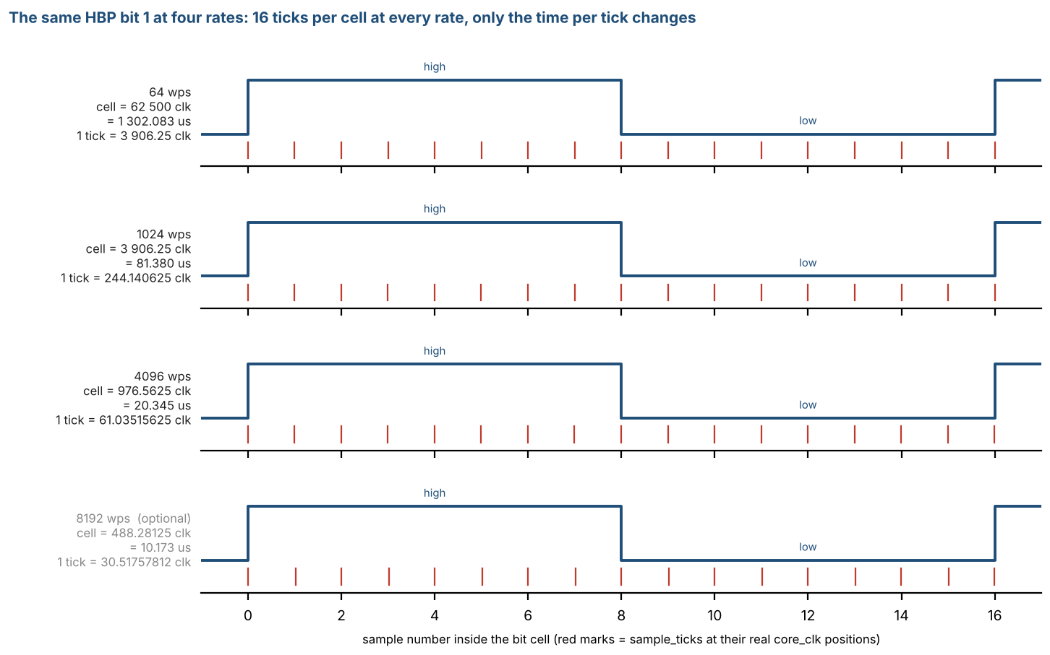
Figure 36: The same HBP bit 1 at four rates: 16 ticks per cell at every rate, only the time per tick changes

12.11 Test Patterns and Test Points
This section defines the stimulus used to verify the core: the test points where a pattern enters or is observed (12.11.1) and the patterns themselves (12.11.2). The patterns are defined once, as rules, so that the simulation testbench and the board firmware generate and check exactly the same data. A pattern is a rule (a formula), not a stored table: the sender generates word n from the rule and the checker recomputes it, so no reference file has to be stored on the board. The test cases that combine patterns, test points and configurations are in Section 12.12; the self-test that runs on the board is in Section 12.13.

12.11.1 Test points
Figure 37 shows where a pattern is injected and where the result is observed. Eight test points (TP1 - TP8) are defined along the data path; Table 64 gives their signals and says whether they are available in simulation and on the board.
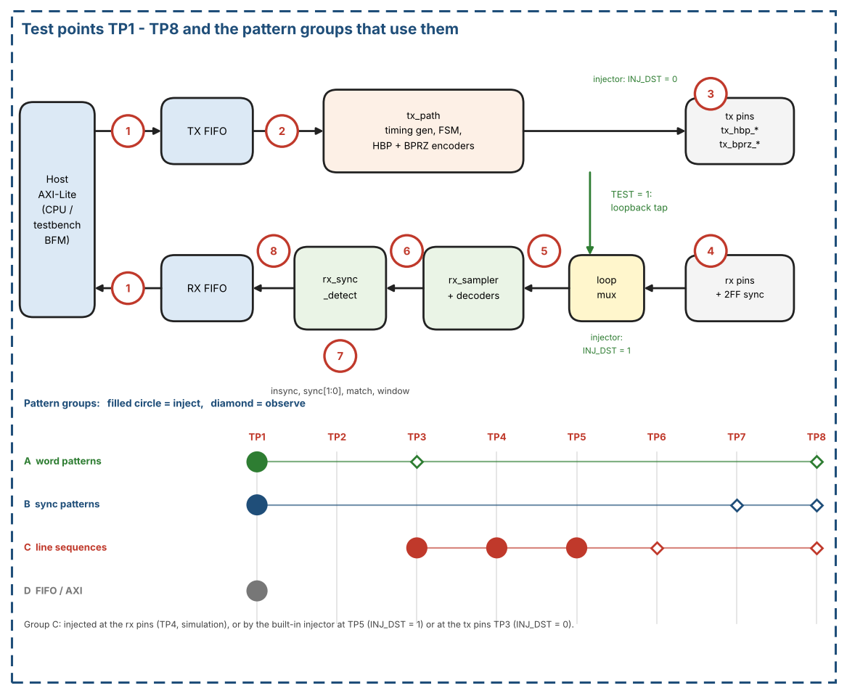
Figure 37: Test points TP1 - TP8 and the pattern groups that use them
Table 64: Test points
TP | Location | Signals | Simulation | Board
TP1 | Host side of the data ports | AXI-Lite writes to TX_DATA / TX_WR_ADDR, reads of RX_RD_DATA, status flags and SLVERR responses | Yes | Yes (firmware)
TP2 | TX FIFO output | async_fifo_tx rd_data | Yes | No
TP3 | TX line pins | tx_hbp_high/low, tx_bprz_high/low (registered, one core_clk after the strobe); also the injection point of the built-in pattern injector when INJ_DST = 0 (Section 12.14) | Yes | Pins only (logic analyzer)
TP4 | RX line pins, before the pin synchronizers | rx_hbp_high/low, rx_bprz_high/low | Yes | Pins only
TP5 | Input of rx_sampler after the loopback mux | With TEST = 1 the loopback tap, which bypasses the pin synchronizers (Section 3.4); with TEST = 0 the synchronized pins. Also the injection point of the built-in pattern injector when INJ_DST = 1 (Section 12.14) | Yes | No
TP6 | Decoder output | bit_valid, bit_data of the selected decoder | Yes | No
TP7 | Sync detector | insync, sync[1:0], match, 12-bit window, tracker state | Yes | Pins insync / sync / match and the status register
TP8 | RX FIFO write port | wr_en, wr_data | Yes | No (read back through TP1)

Because TEST = 1 bypasses the pin synchronizers, a loopback run never exercises them: they are covered only by injecting at TP4 in simulation.

12.11.2 Pattern definitions
Conventions
- A word is 12 bits, written in hexadecimal. Words are sent LSB first (Section 1.6).
- A stream is a sequence of subframes of W words. Word 0 of every subframe is the sync word of that subframe (subframe_index 0..3 = SYNC1..SYNC4 = 0x247, 0x5B8, 0xA47, 0xDB8, i.e. octal 1107, 2670, 5107, 6670, Table 53). The other words k = 1 .. W-1 are payload.
- n is the running number of the payload word in the stream, starting at 0 at the first payload word; k is the word index inside the subframe (word_in_subframe); s is subframe_index.
- Default for simulation: W = 64 (rate code 0000). A subframe lasts 1 s of line time at every rate, so a full lock sequence takes several seconds of line time whatever the rate (Section 12.12).
Group A - payload word patterns
Table 65 lists the payload word patterns.
Table 65: Payload word patterns (word value for payload word n)
Name | Word value | Purpose
P_ZERO | 0x000 | Constant level, no data transitions
P_ONES | 0xFFF | Constant level, opposite polarity
P_ALT | 0x555 for even n, 0xAAA for odd n | Most transitions, stresses the decoders
P_WALK1 | 1 << (n mod 12) | A single 1 moves through the word: finds swapped or shifted bits
P_WALK0 | 0xFFF xor (1 << (n mod 12)) | A single 0 moves through the word
P_COUNT | k (the word index inside the subframe) | A lost, repeated or moved word is visible at once
P_POS | { s[1:0], k[9:0] } | Each word carries its own position; helps to locate a fault
P_PRBS | 12-bit LFSR, seed 0xACE; next = (state << 1) | (b12 xor b6 xor b4 xor b1) over the 12-bit state, word n = state after n + 1 steps; if the value equals one of the four sync codes the word 0x000 is sent instead | Pseudo-random data with period 4095; first words 0x59C, 0xB39, 0x672, 0xCE5, 0x9CB, 0x397
P_BLK8 | B[(k - 1) mod 8] with B = 0x555, 0xAAA, 0x3C3, 0xC3C, 0x999, 0x666, 0x0F0, 0xF0F (k = word index inside the subframe) | Payload of the built-in pattern injector (Section 12.14); all words have an even number of ones

At W = 64 no pattern of Group A produces a sync code by accident (P_COUNT stays below 0x040; P_PRBS is handled by its replacement rule). The sender and the checker apply the same rules.
Group B - sync patterns
Group B streams are built from the sync words and P_COUNT payload; the host writes the sync words itself (SYNC_INS_MODE = 0) unless S6 says otherwise (Section 3.1.2a). Lead-in word: the HBP decoder needs about four bit cells to lock, and the bits of these cells are lost (Table 60). A stream written in software mode therefore starts with one lead-in word 0x000 before the first SYNC1; without it the first sync mark would be damaged and the HBP lock would be delayed by four subframes. The reference model locks and delivers all 128 words of S1 for both HBP and BPRZ with this lead-in.
Table 66 lists the sync pattern streams.
Table 66: Sync pattern streams
Name | Stream | What it checks
S1 P_SYNC_OK | Lead-in word 0x000, then 6 subframes: SYNC1, SYNC2, SYNC3, SYNC4, SYNC1, SYNC2, each followed by 63 P_COUNT words (W = 64): 385 words | 4-sync lock at the 5th mark (start of subframe 5); delivered words: the 128 words of subframes 5 and 6
S2 P_SYNC_2 | As S1, with SFTSYNC = 1 | 2-sync lock at the 3rd mark (start of subframe 3, subframe_index = 2); delivery from that word onward
S3 P_FALSE_SYNC | As S1, plus a false SYNC1 (0x247) as word 20 of subframe 1 and a false SYNC3 (0xA47) as word 40 of subframe 2 | The false marks cost a tracker slot at most; lock still comes at the 5th real mark and no wrong word is delivered
S4 P_WORD0_BAD | As S1, with word 0 of subframe 6 replaced by 0x111 | After lock the word-0 check fails: INSYNC falls, ST_INSYNC_LOST is raised, the word is not written, acquisition restarts
S5 P_START_MID | S1 extended to at least 10 subframes; RX_EN is set while the transmitter is inside subframe 1 (about word 29) | Acquisition from an arbitrary point: INSYNC rises no later than two frames after RX_EN and the first delivered word is a SYNC1
S6 P_SYNC_HW | As S1 without the lead-in word, but with SYNC_INS_MODE = 1 and only 63 payload words written per subframe; 10 subframes | From SYNC1 on, the line sequence at TP3 is identical to the one of S1 (hardware insertion equals software insertion). Without a lead-in word the first sync mark is damaged for HBP, so the HBP receiver locks at subframe 9 and delivers 128 words
S7 P_NOSYNC | Continuous P_COUNT words, RX_CTRL.NOSYNC = 1 | INSYNC = 1 while rx_active, one word per 12 recovered bits, SYNC[1:0] = 00, no MATCH; the word alignment is arbitrary

Group C - line sequences (HBP and BPRZ, no errors)
Group C gives the complete, error-free line sequence of the stream S1, once for HBP (C_HBP) and once for BPRZ (C_BPRZ). It is written at sample level, 16 samples per bit cell, one (high, low) pair per sample, starting at the first cell of the first word:
- Coding rules: HBP as in Section 3.1.3 (polarity P starts at 0; boundary edge in every cell, mid-cell edge for a 1; half cells of 8 samples), BPRZ as in Section 3.1.4 (One or Zero in the first 8 samples, Null in the last 8). Table 58 lists the first six cells of the first word.
- Size at W = 64: 385 words (lead-in word and 6 subframes) x 12 bits x 16 samples = 73 920 samples (about 6 s of line time). Each sequence is preceded and followed by 32 idle samples (HBP (0,1), BPRZ Null).
- Use as a transmit reference: when the TX is loaded with S1 (or S6), the pins at TP3 shall equal the sequence sample by sample, with no gap between words.
- Use as a receive stimulus: the sequence is applied at TP4 (RXSEL selects the format). Expected at TP6: the bits of all words, LSB first, from the first decoded cell after the decoder has locked (the lock cells at the start are dropped, Table 60). Expected at TP8: the 128 words of subframes 5 and 6 (SYNC1, 63 P_COUNT words, SYNC2, 63 P_COUNT words).
- A system-level run needs about 288 million core_clk cycles (6 s x 48 MHz). For a fast run of the receiver alone, the sequence can be applied to rx_path with sample_tick driven directly: only 73 920 sample_ticks are then needed.
- The golden files (one line per sample) are generated from the reference model of Section 12.10 and are not part of this revision of the document.
- Built-in form: the same kind of sequence is available on the board and in simulation from the built-in pattern injector (Section 12.14). It plays a pre-encoded ROM at TP5 (INJ_DST = 1) or at the TX pins TP3 (INJ_DST = 0) and uses the payload P_BLK8 instead of P_COUNT, so that the payload repeats and the ROM stays small.
Group D - FIFO and interface patterns
- D1: write words with TX disabled until the TX FIFO is FULL (FIFO_DEPTH words), then one more TX_WR_ADDR write (TX_WR_EN = 1).
- D2: pop RX_RD_DATA while EMPTY = 1.
- D3: TX_DATA and TX_WR_ADDR writes with TX_WR_EN = 0.
- D4: loopback with no host read until more than FIFO_DEPTH words have arrived.
- D5: FIFO_CLEAR and SOFT_RESET during TX and RX traffic.
- D6: AXI misuse: WSTRB != 0xF, write to a read-only register, read of a write-only register, unaligned address, accesses while CLR_BUSY = 1.

12.12 Test Plan
Table 67 combines the patterns of Section 12.11 with test points and configurations. Where: S = simulation, B = board (Section 12.13). In simulation the system tests use the lowest rate of Table 5 (the rate-dependent case IN-06 also the highest required rate), because every subframe lasts 1 s of line time. The other rates are covered by the tick-level and cycle-level vectors TK-02 and RT-01 and, on the board, by the rate sweep LB-05 (every required rate, the optional rate if implemented). Each case lists the requirements of Table 59 that it checks.
Table 67: Test plan
ID | Where | Inject -> observe | Configuration | Pattern and expected result | Requirements
TX-01 | S | TP1 -> TP3 | HBP, SYNC_INS_MODE = 0 | S1 words (including the lead-in word). TP3 equals C_HBP sample by sample; no gap between words; outputs one clock after the strobe | REQ-HBP-01, REQ-TX-02, REQ-TX-05
TX-02 | S | TP1 -> TP3 | BPRZ, SYNC_INS_MODE = 0 | S1 words. TP3 equals C_BPRZ sample by sample | REQ-BPRZ-01, REQ-TX-02
TX-03 | S | TP3 | Reset, TX_EN = 0 | No traffic. HBP (0,1), BPRZ Null | REQ-TX-04
TX-04 | S | TP1 -> TP3 | HBP and BPRZ (SYNC_INS_MODE = 0): the same test is run twice, once per format | S1, stop writing mid-stream (the FIFO runs empty at a word_tick). The word already loaded finishes, then the Generator freezes (GEN_FROZEN) and no new cell starts. HBP: the outputs hold the last polarity, high and low stay inverse of each other. BPRZ: the outputs stay Null (0,0), because the last cell already ended in its Null half; no pulse and no edge appears while frozen. word_in_subframe, subframe_index and frame_count hold their values. After the next push the generator resumes one sample period after it re-enters GEN_RUN, and the stream continues without a gap inside the word and without a return to subframe 0 (HBP and BPRZ). A TX_EN toggle then restarts at subframe 0 | REQ-TX-01, REQ-BPRZ-01
TX-05 | S, B | TP1 -> TP3 | SYNC_INS_MODE = 1, firmware refill on ST_LOW; RX_RATE = TX_RATE = 0110 (the highest required rate) | Host rule of Section 3.1.5: keep at least 2 words queued, refill on ST_LOW, 10 subframes. No underrun (no GEN_FROZEN), no gap between words | REQ-TX-06, REQ-TX-02
TX-06 | S, B | TP1 -> TP3 | SYNC_INS_MODE = 0 and 1, W = 64, 3 subframes, TX_CNT_CLEAR before the start | With the transmitter stopped after n words: TX_WORD_CNT = n and TX_BIT_CNT = 12 x n (sync words included); during a run TX_BIT_CNT = 12 x (TX_WORD_CNT - 1) + (bit cells started in the current word); nothing counts during an underrun; TX_CNT_CLEAR, SOFT_RESET and a new TX_EN clear both; a read of TX_CNT_CLEAR is SLVERR | REQ-TX-07
RX-01 | S | TP4 -> TP6, TP8 | RXSEL = 0 (HBP) | C_HBP. TP6 bits = golden bits; TP8 = 128 words of subframes 5 and 6; INSYNC rises at the 5th mark | REQ-RX-01, REQ-RX-02, REQ-RX-04, REQ-SYNC-02, REQ-SYNC-03
RX-02 | S | TP4 -> TP6, TP8 | RXSEL = 1 (BPRZ) | C_BPRZ. Same expected result as RX-01 | As RX-01
RX-03 | S | TP5 -> TP8 | rx_path alone, sample_tick forced | C_HBP and C_BPRZ in 73 920 sample_ticks. Same words at TP8 as RX-01 and RX-02 | As RX-01
LB-01 | S, B | TP1 -> TP1 | TEST = 1, RXSEL = 0 | S1 words (P_COUNT). RX_RD_DATA returns the 128 expected words; INSYNC = 1 | REQ-SYNC-02, REQ-SYNC-03
LB-02 | S, B | TP1 -> TP1 | TEST = 1, RXSEL = 1 | As LB-01 for BPRZ | As LB-01
LB-03 | S, B | TP1 -> TP1 | TEST = 1, both formats | S1 with payload P_ZERO, P_ONES, P_ALT, P_WALK1, P_WALK0, P_POS, one run each. Zero word errors | REQ-RX-02, REQ-RX-05
LB-04 | B | TP1 -> TP1 | TEST = 1, both formats | S1 with P_PRBS, at least 60 subframes. Zero word errors, no INSYNC loss | REQ-SYNC-03
LB-05 | B | TP1 -> TP1 | TEST = 1, every required rate of Table 5 (the optional rate if implemented) | S1 with P_COUNT at each TX_RATE = RX_RATE. Lock and zero word errors at every rate | REQ-TICK-01, REQ-CFG-03
SY-01 | S, B | TP1 -> TP7, TP8 | 4-sync (SFTSYNC = 0) | S1. INSYNC rises exactly at the 5th mark, sync[1:0] = 0 (SYNC1) | REQ-SYNC-01, REQ-SYNC-02
SY-02 | S, B | TP1 -> TP7, TP8 | 2-sync (SFTSYNC = 1) | S2. INSYNC rises at the 3rd mark, subframe_index = 2 | REQ-SYNC-02
SY-03 | S, B | TP1 -> TP7, TP8 | 4-sync | S3. Lock at the 5th real mark; no wrong word delivered | REQ-SYNC-01
SY-04 | S, B | TP1 -> TP7, TP8 | 4-sync | S4. INSYNC falls once, ST_INSYNC_LOST raised, the word with 0x111 is not written | REQ-SYNC-04, REQ-RX-03
SY-05 | S, B | TP1 -> TP7, TP8 | 4-sync, RX_EN set late | S5. Lock within two frames; first delivered word is a SYNC1 | REQ-SYNC-01, REQ-SYNC-02
SY-06 | S | TP1 -> TP3 | HBP and BPRZ | S1 with SYNC_INS_MODE = 0, then S6 with SYNC_INS_MODE = 1. From SYNC1 on, the two sequences at TP3 are identical | REQ-TX-03
SY-07 | S, B | TP1 -> TP7, TP8 | NOSYNC = 1 | S7. INSYNC = 1, one word per 12 bits, SYNC[1:0] = 00, no MATCH | REQ-SYNC-05
SY-08 | S | TP5 -> TP7 | HBP and BPRZ, 4-sync, locked; ERRCHK_ENB = 0 and 1; RX_ERR_LIMIT = 0 and 12; RX_SYNC_WD: MARGIN = 8 (reset), 5 and 0 | RX_SYNC_WD resets to 8 and reads back. The line is cut for good (idle level) after a sync word: INSYNC falls no later than (16 + MARGIN) x 12 x W sample_ticks after the last accepted sync word, ST_INSYNC_LOST is raised, the word being assembled is not written (in BPRZ with ERRCHK_ENB = 0 only the watchdog can do this). MARGIN = 0: the watchdog is off, INSYNC stays 1 in that case. A clean stream with bit cells of 18 samples (MARGIN = 8, 5 and 3): no loss of INSYNC. NOSYNC = 1: no watchdog (RTL simulation only) | REQ-SYNC-06
SY-09 | S | TP5 -> TP7 | HBP and BPRZ, locked | Three runs: (a) word 0 replaced by a wrong code, (b) ERRCHK_ENB = 1 and a line cut of 20 bit cells, (c) ERRCHK_ENB = 0 and a BPRZ line cut for good (sync watchdog). LOST_CAUSE reads 00 after reset, then 01 in (a), 10 in (b), 11 in (c); ST_INSYNC_LOST is set each time; SOFT_RESET clears LOST_CAUSE | REQ-SYNC-07
IN-01 | S, B | TP5 -> TP7, TP8 | Injector, INJ_DST = 1, run once, RXSEL = 0 (HBP), 4-sync, W = 64 | Injector stream. INSYNC rises at the 5th mark; 128 words delivered: SYNC1, 63 words P_BLK8, SYNC2, 63 words P_BLK8 | REQ-RX-02, REQ-RX-04, REQ-SYNC-02, REQ-SYNC-03, REQ-INJ-03
IN-02 | S, B | TP5 -> TP7, TP8 | Injector, INJ_DST = 1, run once, RXSEL = 1 (BPRZ) | As IN-01 for BPRZ | As IN-01
IN-03 | S, B | TP5 -> TP7, TP8 | Injector, INJ_DST = 1, run once, RX_RATE = 0001 (W = 128) | As IN-01 with 256 words delivered (2 x W); the stream has 1 + 6 x W words | REQ-SYNC-01, REQ-SYNC-02
IN-04 | S, B | TP5 -> TP7, TP8 | Injector, INJ_DST = 1, continuous mode, both formats | At least 10 subframes: no INSYNC loss, every delivered word follows the sync / P_BLK8 rule | REQ-SYNC-03, REQ-SYNC-04
IN-05 | S, B | TP1 -> TP5 | Injector, both destinations | INJ_START with INJ_EN = 0 is ignored; INJ_START while INJ_BUSY = 1 does not restart the run; INJ_DONE is set at the end of a run once and cleared by the next INJ_START; clearing INJ_EN in continuous mode stops the run and INJ_BUSY falls (Section 12.14.5). The same rules hold for INJ_DST = 0 with TX_EN in place of RX_EN | Section 12.14.5
IN-06 | S, B | TP5 -> TP7, TP8 | Injector, INJ_DST = 1, run once, each required rate of Table 5 (RX_RATE = its code), HBP and BPRZ | Run length 1 + 6 x W words = (1 + 6 x W) x 192 sample_ticks (Table 70). INSYNC at the 5th mark; 2 x W words delivered: SYNC1, W - 1 words P_BLK8, SYNC2, W - 1 words P_BLK8; INJ_DONE at the end. Simulation: the lowest and the highest required rate at system level (about 288 million core_clk cycles each), the other rates with sample_tick forced (as RX-03) or on the board | REQ-SYNC-01, REQ-SYNC-02, REQ-RX-04, REQ-TICK-03
IN-07 | S, B | TP1 -> TP3 | Injector, INJ_DST = 0, TX_EN = 1, TX FIFO empty (and once with a word in it), run once, W = 64 | The four TX pins follow the ROM sequence of the run: HBP and BPRZ at the same time, first cells of SYNC1 (word 0x247, P = 0), 1 + 6 x W words, then the idle levels of Section 2.4. INJ_DONE is set; no UNDERRUN; the word in the TX FIFO is not read and stays | REQ-INJ-02
IN-08 | S, B | TP3 -> TP5 -> TP7, TP8 | Injector, INJ_DST = 0, TEST = 1, TX_EN = 1, RX_EN = 1, TX_RATE = RX_RATE, run once, HBP and BPRZ (RXSEL), W = 64 | As IN-01: the receiver decodes the injector stream through the loopback tap, INSYNC at the 5th mark, 128 words delivered | REQ-INJ-02, REQ-RX-04
IN-09 | S, B | TP1 -> TP3, TP5 | Injector, destination switch: read INJ_DST after reset, run with INJ_DST left at 0, run with INJ_DST = 1, write INJ_DST while INJ_EN = 1 | INJ_DST reads 0 after reset and is kept by SOFT_RESET. With 0 only the TX pins move and TP5 follows the pins or the loopback tap; with 1 the TX pins stay at the idle levels and TP5 carries the stream. A write of INJ_DST while INJ_EN = 1 is not applied until INJ_EN = 0 | REQ-INJ-01, REQ-INJ-03
FI-01 | S, B | TP1 | TX disabled | D1. The write beyond FIFO_DEPTH returns SLVERR; no word is lost | REQ-AXI-05, REQ-FIFO-01
FI-02 | S, B | TP1 | RX empty | D2. SLVERR, no pop | REQ-AXI-04
FI-03 | S, B | TP1 | TX_WR_EN = 0 | D3. OKAY, no push | REQ-AXI-05
FI-04 | S, B | TP1 | TEST = 1 | D4. Words beyond FIFO_DEPTH are dropped and OVERFLOW is set; the stored words stay readable | REQ-FIFO-03
FI-05 | S | TP1 | Traffic running | D5. No garbage word, both FIFOs empty, CLR_BUSY returns to 0 | REQ-RST-01, REQ-RST-02
FI-06 | S | TP1 | Any | D6. SLVERR / error responses as in Table 23 and Table 48 | REQ-AXI-02, REQ-AXI-03
FI-07 | S, B | TP1 | Random ratios s_axi_clk : core_clk | Push and pop more than 2 x FIFO_DEPTH words through both FIFOs (pointers wrap). FULL appears after exactly FIFO_DEPTH words (all entries usable); EMPTY after the last pop; FULL is never reported late (no overflow) and EMPTY is never reported early (no false pop) | REQ-FIFO-02, REQ-FIFO-04
TK-01 | S | Internal sample_tick | Each required rate of Table 5 and, if implemented, the optional rate; TEST = 0 | Count core_clk cycles between sample_ticks over 192 x W ticks: the sum is exactly 48 000 000 cycles (INC from Table 5); no single distance differs from the ideal by more than 1 core_clk | REQ-TICK-01, REQ-TICK-02, REQ-TICK-03
TK-02 | S | Internal sample_tick, TP3 | Each required rate of Table 5, TEST = 0 | Vectors V-TICK and V-RATE (Section 12.10): the first 16 sample_tick clocks and the 9 output edge clocks of word 0x247 equal the values of per_rate in arinc717_vectors.json (Table 63). The optional rate (code 0111) is not part of the acceptance: a deviation there is not a failure of this version | REQ-TICK-01, REQ-TICK-02, REQ-TICK-03
RT-01 | S | TP4 -> TP6 | Each required rate, RXSEL = 0 and 1, rx_path alone | Vector V-RATE as a core_clk-accurate line: 40 random words (first word 0x000), TX rate error 0, +1000 and -1000 ppm, RX tick clock started 0, 1, 7 and three random core_clk after the first TX tick. Bits at TP6 equal the sent bits; at most one framing error (at the start) | REQ-RX-05, REQ-TICK-02
ER-01 | S | TP4 -> TP6, TP7 | HBP, 4-sync, locked (INSYNC = 1), ERRCHK_ENB = 1 | Hold the last level for 30 samples (line stops). Every bit after the stop is a bad bit (the decoder keeps one bit per cell); after exactly 12 consecutive bad bits INSYNC falls, ST_INSYNC_LOST is raised, the word being assembled is not written, the window and the trackers are cleared; the next lock needs 5 new marks. Also: an edge at phase 14 or 15 gives a bad bit and INSYNC stays | REQ-RX-03
ER-02 | S | TP4 -> TP6, TP7 | BPRZ, 4-sync, locked, ERRCHK_ENB = 1 | (a) Opposite-polarity pulse before the Null; (b) pulse held for 32 samples (no Null); (c) Null for 30 samples (no pulse). Each gives a bad bit (a placeholder for (b) and (c)) and INSYNC stays. A line that stays Null gives placeholder bits and INSYNC falls after 12 bad bits (as ER-01) | REQ-RX-03
ER-03 | S | TP5 -> TP6 | Both modes | All four (hi, lo) combinations as in Table 8. (1,1) in both modes and (0,0) in HBP mode are INVALID and clear the history; a glitch shorter than 4 samples never produces a valid_ flag; in BPRZ mode the decoded bits of S1 are unchanged when any one sample is replaced by (1,1), with no framing error; in HBP mode one sample on the 3rd or 4th sample after a line transition delays the validated edge and may raise a framing error (ER-04), any other single sample changes nothing | REQ-RX-01
ER-04 | S | TP5 -> TP6, TP7 | HBP, 4-sync, locked (INSYNC = 1), ERRCHK_ENB = 1 | One (1,1) sample on the 4th sample of the boundary edge of a bit-1 cell (sample 3 of the cell). Edge-distance check: the word that holds the bit is flagged (bit 12 of the FIFO entry), INSYNC stays, ST_BIT_ERR is raised, RX_BIT_ERR_POS0 names the word, all following words are correct. Without the check the decoder would read every following bit as 1 with no error | REQ-RX-06, REQ-RX-03
ER-05 | S | TP5 -> TP6, TP7 | HBP, 4-sync, locked, ERRCHK_ENB = 1 | Opposite level (hi and lo swapped) for 4, 5, 6, 7, 8 and 9 samples from sample 7 of a bit 0 between two bits 1: a bad bit (the word is flagged, INSYNC stays) in every case (4 and 5: edge distance; 6 to 9: two mid-cell edges in a row). Opposite level for 1 to 3 samples: no error and unchanged bits | REQ-RX-06
ER-06 | S | TP5 -> TP6, TP7 | BPRZ, 4-sync, locked, ERRCHK_ENB = 1 | (1,1) on samples 3 to 7 of a bit-1 cell (the pulse is lost): one placeholder bit (flagged) 24 samples after the previous bit, then the decoder continues with the next cell; INSYNC stays, the word is flagged and the bit count is not disturbed | REQ-RX-07
ER-07 | S | TP5 -> TP6, TP7 | BPRZ, 4-sync, locked, ERRCHK_ENB = 1 | A bit-1 cell turned into pulse 4 samples, Null 4, pulse 4, Null 4: the second bit is blocked and the first bit is flagged (two bits too close); the decoder continues with the next cell; INSYNC stays | REQ-RX-08
ER-08 | S | TP5 -> TP6 | BPRZ | (a) Legal lines with cells of 14 to 18 samples: no framing error. (b) One INVALID sample (1,1) at any position, cells of 16, 17 and 18 samples: no framing error and the bits are unchanged | REQ-RX-08
ER-09 | S | TP5 -> TP6, TP8 | HBP and BPRZ, 4-sync, locked, ERRCHK_ENB = 1 | One disturbed bit at six positions of one data word (not a sync word) (HBP: (1,1) on the 4th sample of the boundary edge; BPRZ: lost pulse). INSYNC stays, all words after it are correct, exactly the word that holds the bit is flagged (bit 12), RX_WORD_ERR_CNT = 1, RX_BIT_ERR_POS0 names its subframe and word and a bit at most one away from the disturbed cell | REQ-RX-09, REQ-RX-10, REQ-RX-13
ER-10 | S | TP5 -> TP6, TP8 | HBP and BPRZ, locked, ERRCHK_ENB = 1 | 160 disturbed cells per mode in a data word (INVALID 1 to 5 samples, opposite level 4 to 12 samples, random position). INSYNC is never lost, no bit shift (all words after the disturbance are correct), a flag never lands on the neighbor word while the damaged word stays unflagged. Undetectable waveforms (legal shape) are delivered without flag | REQ-RX-10, REQ-RX-11
ER-11 | S | TP5 -> TP6, TP7 | HBP and BPRZ, locked, ERRCHK_ENB = 1 | Line cut for 2 and 4 bit cells: INSYNC stays, only the words at the cut are flagged, the words after it are correct. Line cut for 20 bit cells: INSYNC falls after exactly 12 counted bad bits (ST_INSYNC_LOST), the word being assembled is not written. RX_ERR_LIMIT = 0: INSYNC is not lost by the limit | REQ-RX-12
ER-12 | S | TP5 -> TP8 | HBP and BPRZ, locked, ERRCHK_ENB = 1 | The data stops after word 842 (idle line): word 842 is the last word written, it is written without waiting for more data, no word is added, INSYNC falls after 12 bad bits. In HBP the word is flagged when its last bit is a 0 (timeout) | REQ-RX-11, REQ-RX-12
ER-13 | S | TP5 -> TP6 | HBP and BPRZ, INSYNC = 0, ERRCHK_ENB = 1 | Idle line and a stream that is not yet locked: RX_BIT_ERR_CNT and RX_WORD_ERR_CNT stay 0, ST_BIT_ERR is not set, RX_BIT_ERR_CAUSE = 0 | REQ-RX-13
ER-14 | S | TP5 -> TP8 | 4-sync, locked, ERRCHK_ENB = 1 | Word 0 of a subframe with a wrong code AND a bit with the error flag, and wrong code without any flag: in both cases INSYNC falls and the word is not written (REQ-SYNC-04) | REQ-SYNC-04, REQ-RX-03
ER-15 | S | TP1 -> TP8 | Register access, locked, ERRCHK_ENB = 1 | RX_ERR_LIMIT resets to 12 and reads back; RX_ERR_CLEAR (write 1) clears CNT, WORD_CNT, POS, POS0 and CAUSE; a read of RX_ERR_CLEAR is SLVERR; CAUSE bits are sticky; POS format {frame, subframe, word, bit}; counters saturate at 0xFFFF_FFFF; RX_RD_DATA bit 12 equals the flag of the word and bits [31:13] are 0 | REQ-RX-09, REQ-RX-12, REQ-RX-13
ER-16 | S | TP5 -> TP8 | 4-sync, locked, ERRCHK_ENB = 1 | Word 0 with the correct code but one flagged bit: INSYNC stays, the word is written without flag (the code match proves it), the bit is counted in RX_BIT_ERR_CNT, RX_WORD_ERR_CNT is not incremented | REQ-SYNC-04, REQ-RX-12
ER-17 | S | TP5 -> TP8 | HBP and BPRZ, ERRCHK_ENB = 0, locked | Clean stream: INSYNC, words correct, no flag, RX_BIT_ERR_CNT = RX_WORD_ERR_CNT = 0, CAUSE = 0, bit 12 of every word = 0. RX_ERR_CTRL resets to 0 and reads back; a write while rx_active = 1 does not change the receiver | REQ-RX-14
ER-18 | S | TP5 -> TP6, TP8 | HBP and BPRZ, ERRCHK_ENB = 0, locked | 160 disturbed cells per mode in a data word (as ER-10): no flag, no count, no ST_BIT_ERR. HBP: INSYNC stays and no bit shift. BPRZ: a lost pulse is not flagged | REQ-RX-14
ER-19 | S | TP5 -> TP6, TP8 | BPRZ, ERRCHK_ENB = 0, locked | A lost pulse in a data word: no flag, no count; INSYNC falls at the next sync word comparison (ST_INSYNC_LOST) | REQ-RX-14, REQ-SYNC-04
ER-20 | S | TP5 -> TP6, TP8 | HBP and BPRZ, ERRCHK_ENB = 0, locked | Line cut of 4 and 20 bit cells. HBP: INSYNC stays, the data after the cut is aligned, no flag. BPRZ: INSYNC falls at the next sync word comparison | REQ-RX-14
ER-21 | S | TP5 -> TP6, TP8 | HBP, ERRCHK_ENB = 1, locked | One damaged cell followed by n bits 1: INSYNC stays for n <= RX_ERR_LIMIT - 3 and falls for n >= RX_ERR_LIMIT - 2 (limit 12: n = 9 / 10; limit 24: 21 / 22; limit 36: 33 / 34) | REQ-RX-12
ER-22 | S | TP5 -> TP6, TP8 | HBP and BPRZ, ERRCHK_ENB = 1, RX_ERR_LIMIT = 12, locked | Line cut of 10, 11 and 12 bit cells. HBP: INSYNC stays at 10 and falls at 11. BPRZ: stays at 11 and falls at 12 | REQ-RX-12
ER-23 | S | TP5 -> TP6, TP8 | HBP and BPRZ, ERRCHK_ENB = 1, RX_ERR_LIMIT = 0, locked | The line is cut for good: INSYNC falls at the next sync word comparison (word 0 has a wrong code), not by the limit; the bits delivered meanwhile are flagged | REQ-RX-12, REQ-SYNC-04
ER-24 | S | TP5 -> TP8 | HBP and BPRZ, ERRCHK_ENB = 0 and 1, locked | Clean stream of at least 12 subframes: when a word is written to the RX FIFO the position of the receiver is (frame, subframe, word of that word, bit 11); the frame field counts the transitions from subframe 4 to subframe 1 since the lock. RX_BIT_POS_NOW shows this position after the toggle delay (at most one bit cell) | REQ-RX-15
ER-25 | S | TP5 -> TP8 | HBP and BPRZ, ERRCHK_ENB = 0 and 1, locked | The sync word of a later subframe has a wrong code (0x111): INSYNC falls, ST_INSYNC_LOST is raised, RX_BIT_POS_NOW keeps the position of that word (bit 11, word 0) and does not change during the following cells. It is cleared by GLOBAL_EN AND RX_EN rising and by SOFT_RESET, not by RX_ERR_CLEAR (RTL simulation) | REQ-RX-15, REQ-SYNC-04
ER-26 | S | TP1 -> TP7, TP8 | NOSYNC = 1, ERRCHK_ENB = 0 and 1 | The word, subframe and frame fields of RX_BIT_POS_NOW and of RX_BIT_ERR_POS / RX_BIT_ERR_POS0 stay 0; the bit field counts 0 to 11 from the first recovered bit. RTL simulation only: the reference model does not model NOSYNC | REQ-RX-15, REQ-SYNC-05
ER-27 | S | TP5 -> TP6, TP7 | HBP, 4-sync, locked, ERRCHK_ENB = 1 | Opposite level (hi and lo swapped) for 2 samples from sample 3 of a bit 0 that follows a bit 0: the boundary edge is validated at phase 8 instead of 3. Exactly one framing error (maximum-distance check, cause EDGE_DIST) and the edge is ignored: with INSYNC = 1 the bits are unchanged, with INSYNC = 0 the decoder returns to acquisition and locks again. Opposite level for 1 to 3 samples from sample 1, 2, 3 or 4 of a bit 0 after a bit 0 and of a bit 1 after a bit 1: never a wrong bit without a framing error. Without the check the bit 0 would be read as a 1 with no error | REQ-RX-16
ER-28 | S | TP5 -> TP6, TP7 | HBP, 4-sync, INSYNC = 0 then locked, ERRCHK_ENB = 1 | Two bits 1 in a row where the first bit has samples 8 to 10 high, 11 and 12 low, 13 to 15 high (its first half low), and the second bit has samples 3 to 6 high, sample 7 low, samples 8 to 15 high: the boundary edge of the second bit comes 19 samples after the previous boundary edge. Maximum cell length check: framing error; with INSYNC = 0 the decoder returns to acquisition and locks again; the following words are correct. Without the check both bits are read as 0 with no error | REQ-RX-17
TO-01 | S | TP5 -> TP6 | Both modes, no sync | Stream of 60 P_COUNT words with the bit cell length set to 14, 15, 16, 17 and 18 samples (stretch of the C_HBP / C_BPRZ cells). Decoded bits equal the sent bits at TP6; no framing error. The behavior outside this range is not specified and not tested | REQ-RX-05
WI-01 | S | TP5 -> TP7 | 4-sync, 12-bit window | Send the words 0x001 and 0x800 (bit 0 is sent first) and read them at TP8: the delivered words are 0x001 and 0x800. A decoder that took the first received bit as the MSB would return them swapped (0x800 and 0x001) | REQ-RX-04
CF-01 | S | TP1 -> core | Random ratios s_axi_clk : core_clk (for example 1:3 to 8:1) | Write TX_CTRL / RX_CTRL / TX_SYNCx / RX_SYNCx back to back, with a different value each time. After the latency bound the core holds the last value written; no intermediate value is applied twice and no enable is seen before its rate | REQ-CFG-01
CF-02 | S, B | TP1 -> TP3, TP4 | TX and RX running at 64 wps | Write TX_RATE and RX_RATE (and RXSEL) while the path is active: the line keeps the old rate and format. Clear the enable, wait for the latency bound, enable again: the new value is used. TX and RX run at different rates at the same time (TEST = 0) | REQ-CFG-02, REQ-CFG-03
AX-01 | S | TP1 | Any register | AWVALID/WVALID and ARVALID in the same cycle, same address: one transaction is served at a time, the write first, so the read returns the new value. A second request is accepted only after the response of the first | REQ-AXI-01
AX-02 | S, B | TP1 | Each row of Table 23 | One access per row (read and write): the response is OKAY or SLVERR exactly as listed, including WSTRB != 0xF, write to INJ_STATUS / CORE_VERSION / IRQ_SOURCE, read of TX_FIFO_CLEAR, the reserved offsets 0x08 and 0x0C of the TX block, and an address outside 0x0000 - 0x014F | REQ-AXI-02, REQ-AXI-03
IR-01 | S, B | TP1 | After SOFT_RESET, all IRQ_ENABLE = 1 | TX_IRQ_STATUS, RX_IRQ_STATUS and IRQ_SOURCE read 0 and irq = 0: the reset values (TX EMPTY = 1, TX LOW = 1) create no event | REQ-IRQ-01
IR-02 | S, B | TP1 | TX disabled | Fill the TX FIFO to FIFO_DEPTH/2 words or more, TX enabled, and let it drain below FIFO_DEPTH/2: ST_LOW rises once. Clear it with W1C while the condition is still true: it stays 0. Fill and drain again: it is set again. The same edge rule for ST_EMPTY and ST_FULL | REQ-IRQ-01
IR-03 | S | TP1 | RX FIFO one word below FULL | Make the FULL event happen in the same clock cycle of the bit's own domain in which the clear is applied (W1C write cycle in s_axi_clk, or application of the clear request in core_clk): the bit stays 1 (the new event wins). Repeat with ST_OVERFLOW | REQ-IRQ-02
IR-04 | S, B | TP1 | Individual enables | irq = (OR of sticky AND enable) AND GLOBAL_CTRL.IRQ_ENABLE. A sticky bit with its enable = 0 does not raise irq; IRQ_ENABLE = 0 holds irq = 0 while core_pending = 1; clearing the last enabled sticky bit drops irq | REQ-IRQ-03
IR-05 | S, B | TP1, TP7 | 4-sync lock, then loss; WRDCNT set; RX FIFO filled | The core events each set their bit once per event: ST_INSYNC_LOST (as SY-04), ST_MATCH (WRDCNT = subframe 1, word 1) and ST_OVERFLOW (as FI-04), after the 2FF synchronization | REQ-IRQ-01
IR-06 | S, B | TP1 | Event pending in TX_IRQ_STATUS (ST_EMPTY, a core_clk bit, and ST_LOW, an s_axi_clk bit) with its enable set; write 1 to the bit and read the register at once, in a loop | The bit reads 0 from the first read after the write (both domains); irq falls and does not rise again for that event; an event of the same bit during the clear is not lost (the bit is set again in a later snapshot); TX_IRQ_STATUS reads agree with the sticky bits of the core after the latency bound of Section 4.2.1 | REQ-IRQ-04
IR-07 | S, B | TP1 | Cause each of the 11 sources in turn (the s_axi_clk and the core_clk ones), with its enable set, then with it clear; two sources at the same time; IRQ_ENABLE = 0 and 1; read IRQ_SOURCE after every step, then clear by W1C | Only the bit of the source is 1 in IRQ_SOURCE (all others 0, bits [15:4] and [31:23] always 0); a source with its enable = 0 gives 0; two sources give both bits; IRQ_SOURCE is not 0 exactly when core_pending = 1, and irq = core_pending AND IRQ_ENABLE; IRQ_SOURCE ignores IRQ_ENABLE; after W1C of a bit its bit reads 0 from the first read (both domains); a write to IRQ_SOURCE returns SLVERR | REQ-IRQ-05
RS-01 | S | TP1, TP3, TP7 | Traffic running, injector run active | SOFT_RESET: outputs go to the idle levels, no garbage word is sent, INSYNC = 0, both FIFOs are empty, INJ_CTRL and INJ_STATUS read 0, CLR_BUSY returns to 0. FIFO_CLEAR during TX and during RX leaves the other FIFO untouched | REQ-RST-01, REQ-RST-02, REQ-TX-04
VR-01 | S, B | TP1 | Any | CORE_VERSION reads 0x0001_0000, a write returns SLVERR, the value does not change with the document revision | REQ-VER-01

12.13 Board Self-Test
The board self-test runs on the target board with the digital loopback (TEST = 1) and needs no external cable or instrument. It is a sequence of cases from Section 12.12 driven by firmware through TP1 (Section 12.11.1); the core status (INSYNC, ST_INSYNC_LOST, OVERFLOW, EMPTY) is read back through the same ports.
Table 68 lists the board self-test sequence.
Table 68: Board self-test sequence
Step | Action | Pass criterion
1 | Read CORE_VERSION and the status after reset | CORE_VERSION = 0x0001_0000; EMPTY = 1; GLOBAL_EN = 0
2 | Configure TEST = 1, RXSEL = 0 (HBP), TX_RATE = RX_RATE = 0000 (64 wps), 4-sync, SYNC_INS_MODE = 0; set GLOBAL_EN, RX_EN, then TX_EN | Configuration accepted; no error response
3 | Send S1 (lead-in word, then 6 subframes of a sync word and 63 P_COUNT words, 385 words in all); keep at least 2 words queued and refill on ST_LOW (REQ-TX-06) | No TX underrun
4 | Wait for INSYNC; record the lock time | INSYNC = 1 at the 5th mark (about 4 subframes after the start) and no later than 8 s
5 | Read all received words, mask bit 12 (bits [11:0] are the data) and compare them with the P_COUNT rule; bit 12 = 0 | 128 words; zero mismatches; first word = SYNC1
6 | Repeat steps 2 - 5 with RXSEL = 1 (BPRZ) | Same result
7 | Repeat 3 - 5 for both formats with P_ALT, P_WALK1, P_WALK0, P_POS and P_PRBS (6 subframes each) | Zero mismatches; no INSYNC loss
8 | Negative check: SYNC_INS_MODE = 0, S4 (word 0 of subframe 6 replaced by 0x111) | INSYNC falls and ST_INSYNC_LOST is raised: the detection chain is alive
9 | Optional: repeat steps 2 - 5 with SYNC_INS_MODE = 1 and S6 (10 subframes, 63 payload words per subframe) | Lock at subframe 9 for HBP (subframe 5 for BPRZ) and zero mismatches
10 | Optional: repeat steps 2 - 5 for the other rates of Table 5 (TX_RATE and RX_RATE changed with the procedure of Section 2.4) | Lock and zero mismatches at every rate
11 | Built-in injector (Section 12.14): run once at 64 wps for HBP and BPRZ, with INJ_DST = 1 and then with INJ_DST = 0 and TEST = 1 | As IN-01, IN-02 and IN-08: INSYNC at the 5th mark, 128 words, zero mismatches against the P_BLK8 rule
12 | Report | PASS only if all steps pass; report lock time, word error count, first error index, number of INSYNC losses, OVERFLOW

One run of steps 2 - 5 takes about 6 s of line time at any rate (about 4 s to lock, then two subframes of words). The self-test covers the digital path inside the core, the encoders and decoders, and the sync logic. It does not cover the pins, the line drivers and receivers or the pin synchronizers (the loopback tap bypasses them, Section 3.4). With the built-in pattern injector (step 11) the decoders and the sync detector are also tested independently of the transmit encoder; with INJ_DST = 0 the same stream also passes the TX pin multiplexer and the loopback tap.

12.14 Built-in Pattern Injector
The built-in pattern injector is a test block that plays a fixed, error-free line sequence stored in a small ROM. One ROM serves both paths: GLOBAL_CTRL.INJ_DST selects whether the sequence feeds the receiver (INJ_DST = 1) or drives the TX pins (INJ_DST = 0, the reset value). It makes the Group C patterns of Section 12.11.2 available on the board as well as in simulation, it tests the decoders and the sync detector independently of the transmit encoder (INJ_DST = 1), and it gives the line side a known stream without a host that writes words (INJ_DST = 0). It holds pre-encoded line values only: it contains no line coder.

12.14.1 Purpose and position
- Destination INJ_DST = 1 (RX), position: at TP5 (Figure 37). When enabled, the injector replaces the loopback tap or the synchronized pins at the input of rx_sampler. The pin synchronizers are therefore not tested by it.
- Destination INJ_DST = 0 (TX), position: at the TX pins (TP3). When enabled, tx_hbp_high/low and tx_bprz_high/low are driven by the ROM instead of the encoders; both pairs carry their sequence at the same time. The TX FSM and the TX FIFO are not used: no word is read, no UNDERRUN is raised and a word already in the FIFO stays there. The loopback tap (Section 3.4) is taken after this multiplexer, so with TEST = 1 the receiver decodes the injector stream. At the end of a run once the pins return to their idle levels (Section 2.4). The destination bit INJ_DST is a global bit (GLOBAL_CTRL, Section 7.2) and is changed only while INJ_EN = 0.
- Both formats: the injector provides the HBP pair and the BPRZ pair at the same time; for INJ_DST = 1 RX_CTRL.RXSEL selects the pair, as it does for the pins; for INJ_DST = 0 both pairs are driven.
- Time base: the stored values change on the sample_tick of the destination path (the RX sample_tick for INJ_DST = 1; for INJ_DST = 0 the TX sample_tick, whose Timing Generator is started by INJ_START and does not wait for the TX FIFO), so the edges are aligned with the sampling instants and the sampling phase is fixed. The result of a run is deterministic.
- Independence: the sequence does not come from tx_path. A failure with the injector but not in loopback points to the decoders or the sync detector; a failure in loopback but not with the injector points to the transmit side. With INJ_DST = 0 the pins show the stored sequence instead of the encoder output: comparing the two for the same words checks the encoders against the ROM.

12.14.2 What the ROM stores
A bit cell lasts 16 sample_ticks, in two halves of 8. In each half the line pair is constant, so the ROM stores one value per half cell and the sequencer holds it for 8 sample_ticks. HBP needs 1 bit per half cell (the level of high; low is its inverse). BPRZ needs 2 bits per half cell, the pair (high, low), because it has three states: One = (1,0), Zero = (0,1) and Null = (0,0). The Null half is stored like any other value, so that no line coding is needed. Figure 38 shows the values for two bits, 1 then 0; the first six cells of word 0x247 are listed in Table 58.
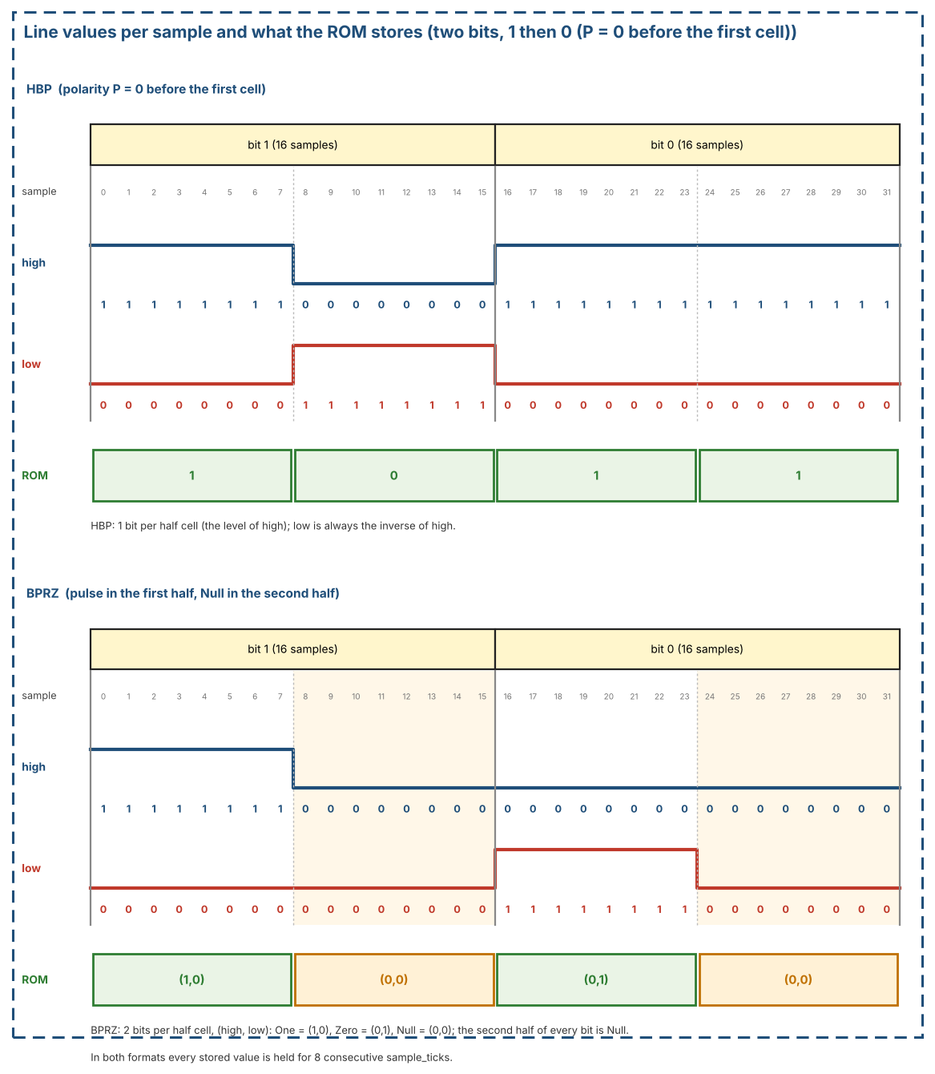
Figure 38: Line values per sample for HBP and BPRZ, and what the ROM stores (bits 1, 0)
The ROM holds whole words as segments of 12 cells (24 half-cell values). Table 69 lists the segments. P is the HBP polarity state before the first cell of the word (Section 3.1.3); P = 0 before the lead-in word.
Table 69: ROM segments
Segment | Word | HBP versions | BPRZ versions
LEAD | 0x000 | P = 0 | 1
SYNC1 | 0x247 | P = 0 | 1
SYNC2 | 0x5B8 | P = 1 | 1
SYNC3 | 0xA47 | P = 1 | 1
SYNC4 | 0xDB8 | P = 1 | 1
B1 .. B8 | 0x555, 0xAAA, 0x3C3, 0xC3C, 0x999, 0x666, 0x0F0, 0xF0F | P = 0 and P = 1 (16) | 1 each (8)
Total | 13 words | 21 segments | 13 segments

Why HBP needs two versions of the payload words: HBP has a memory. A word with an odd number of ones inverts the polarity P, a word with an even number of ones leaves it unchanged. All words of the block B have an even number of ones, so they can follow each other in any order and the block can be repeated or cut at any word. The payload words are stored for both values of P (the second version is the first one with high and low swapped); the sync words are stored only for the polarity at which they occur in the stream (Table 71). BPRZ has no polarity state, so one version of each word is enough.

12.14.3 Playback order
Figure 39 shows the ROM, the playback order and the output. The sequencer only selects addresses and counts; it computes no line coding.
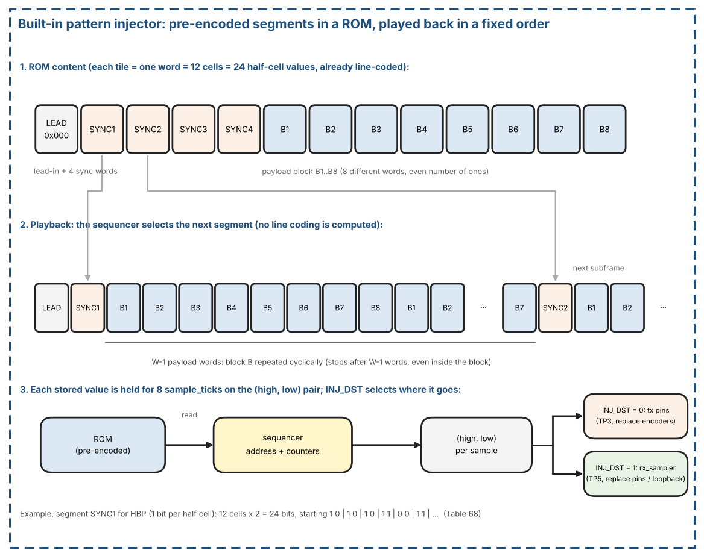
Figure 39: Built-in pattern injector: ROM segments, playback order and output
- A run starts with the lead-in word 0x000, followed by 6 subframes in the order SYNC1, SYNC2, SYNC3, SYNC4, SYNC1, SYNC2.
- A subframe is one sync segment followed by W - 1 payload words, where W is the words per subframe of the applied rate of the destination (RX_RATE for INJ_DST = 1, TX_RATE for INJ_DST = 0) (Table 5). Payload word k (k = 1 .. W - 1) is the segment B[(k - 1) mod 8], so the block restarts at B1 in every subframe and is cut after W - 1 words.
- The HBP version of every segment follows Table 71. The pattern repeats every four subframes.
- Counters: sample (0..7, holding time of a value), half cell, cell (0..11), word in subframe (0..W - 1) and subframe (0..5, or free-running modulo 4 in continuous mode).
- Length of a run: 1 + 6 x W words; at W = 64 that is 385 words, 73 920 sample_ticks, about 6 s of line time.
Rate dependence. The ROM content, the order of the segments and the ROM size do not depend on the rate. Only W changes: a subframe is one sync word and W - 1 payload words. For every legal W (a power of two of at least 8, as in Table 5) the last payload word is B7, because (W - 2) mod 8 = 6, and every word of B has an even number of ones, so the HBP polarity versions of Table 71 are the same at every rate. A run has 1 + 6 x W words and (1 + 6 x W) x 192 sample_ticks. Because W words last 1 s, the run is always about 6 s of line time and about 288 million core_clk cycles (Table 70, Figure 40). The cut of the 8-word block at W - 1 words is checked at every required rate by test IN-06.
Table 70: Injector run per rate
Rate wps (code) | Words (1 + 6 x W) | sample_ticks (words x 192) | core_clk cycles (rounded down) | Words delivered (2 x W)
64 (0000) | 385 | 73 920 | 288 750 000 | 128
128 (0001) | 769 | 147 648 | 288 375 000 | 256
256 (0010) | 1 537 | 295 104 | 288 187 500 | 512
512 (0011) | 3 073 | 590 016 | 288 093 750 | 1 024
1024 (0100) | 6 145 | 1 179 840 | 288 046 875 | 2 048
2048 (0101) | 12 289 | 2 359 488 | 288 023 437 | 4 096
4096 (0110) | 24 577 | 4 718 784 | 288 011 718 | 8 192
8192 (0111) optional | 49 153 | 9 437 376 | 288 005 859 | 16 384

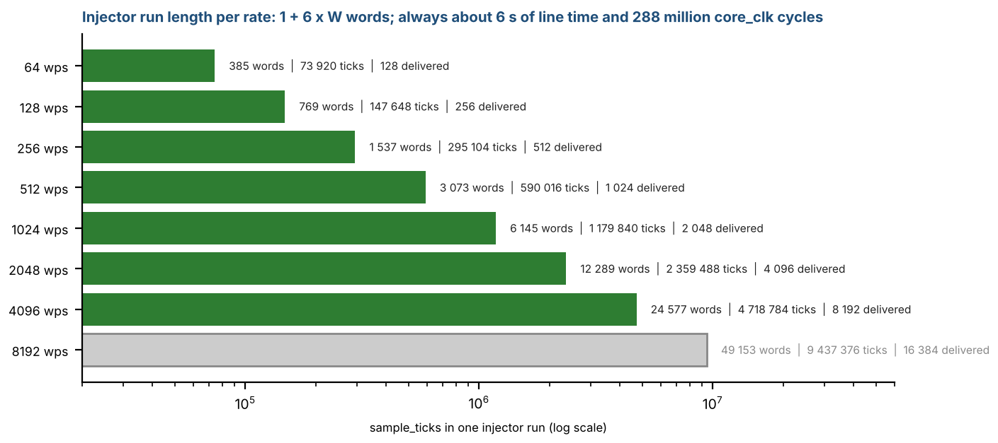
Figure 40: Injector run length at every rate
Table 71: HBP polarity versions used in each subframe (P = state before the first cell of the word)
Subframe | Sync segment | P at the sync word | P at the payload words
1 | SYNC1 | 0 | 1
2 | SYNC2 | 1 | 1
3 | SYNC3 | 1 | 1
4 | SYNC4 | 1 | 0
5 | SYNC1 | 0 | 1
6 | SYNC2 | 1 | 1

12.14.4 ROM size
HBP: 21 segments x 24 values x 1 bit = 504 bits. BPRZ: 13 segments x 24 values x 2 bits = 624 bits. Together 1 128 bits. Storing the same HBP sequence sample by sample would need 73 920 bits at W = 64 (4 718 784 bits at W = 4096).

12.14.5 Control and status
The injector is controlled through the bits of INJ_CTRL (RX base + 0x08) and INJ_STATUS (RX base + 0x0C), defined in Section 7.4 (Table 35 and Table 36). The bits are listed here with their use.
- INJ_DST (GLOBAL_CTRL bit 5): 0 = TX pins (reset value), 1 = RX input. It is written while INJ_EN = 0 and applied only while INJ_EN = 0. Software that uses the injector on the receive side therefore writes INJ_DST = 1 before INJ_EN.
- INJ_EN: 1 = the injector drives the destination selected by INJ_DST: TP5 (INJ_DST = 1, instead of the loopback tap or the pins) or the TX pins (INJ_DST = 0, instead of the encoders). Changed only while the path of the destination is inactive (rx_active = 0 or tx_active = 0).
- INJ_START: writing 1 starts a run (self-clearing). The enable of the destination shall be set before the start: RX_EN for INJ_DST = 1, so that the decoders see the lead-in word, and TX_EN for INJ_DST = 0.
- INJ_MODE: 0 = run once (1 + 6 x W words, then idle); 1 = continuous: the sequence goes on with SYNC3, SYNC4, SYNC1, ... until INJ_EN = 0.
- INJ_BUSY: 1 while a run is in progress. INJ_DONE: set when a run once has ended, cleared by the next start.

12.14.6 Expected result and checking
- The receiver locks at the 5th mark (the SYNC1 at the start of subframe 5) in 4-sync mode, for both formats.
- The delivered words are the 2 x W words of subframes 5 and 6: SYNC1, W - 1 words P_BLK8, SYNC2, W - 1 words P_BLK8 (128 words at W = 64).
- No checker is built in. The host (firmware or testbench) reads the words, masks bit 12 (data = bits [11:0], bit 12 shall be 0) and compares them with the rule above; tests IN-01 to IN-04 in Table 67.
- INJ_DST = 0: the core delivers no word itself. The sequence is observed at the TX pins (TP3), with a logic analyzer or in simulation; it shall be the same sequence as at TP5 for INJ_DST = 1, with the first sample_tick of the TX Timing Generator as time base. With TEST = 1 and RX_EN = 1 the receiver locks and delivers the same words as for INJ_DST = 1 (test IN-08).
- Checked with the reference model of Section 12.10 (encode, decode, sync detector): at W = 64 and W = 128 both formats lock at the 5th mark and deliver 2 x W words without loss of lock.

12.14.7 Limits
- The payload repeats with a period of 8 words: wrong word values and wrong bits are detected, but a loss of exactly a multiple of 8 payload words cannot be seen in the payload values. The sync words and the word count still show it. The patterns of Group A, with P_COUNT, remain available in loopback.
- The ROM is written from the same specification as the transmit encoder. A common misreading (for example the initial polarity) would not be detected; the first cells of SYNC1 are therefore checked by hand against Table 58.
- Only error-free sequences are stored. Error injection (bit cell length, missing pulses) is not part of the injector. With INJ_DST = 0 the encoders and the TX FIFO are not exercised; they are covered by the loopback tests of Section 12.12.

13. Glossary
- HBP – Harvard Bi-Phase (ARINC 717 main bus).
- BPRZ – Bi-Polar Return-to-Zero.
- CDC – Clock-Domain Crossing.
- FWFT – First-Word Fall-Through FIFO.
- INSYNC – Receiver locked to subframe sequence.
- SYNC_INS_MODE – 0 software sync in FIFO; 1 hardware TX_SYNCx insert.
- shall – Mandatory requirement for a compliant implementation.
- should – Recommendation: the design is expected to follow it, but a deviation does not make an implementation non-compliant.
- W – words per second, equal to the words per subframe, Table 5.
- Subframe – 1 second of W words; its first word is a sync mark. Frame – 4 subframes.
- sample_tick – generator pulse, 16 per bit cell (W x 192 per second).
- phase – sample counter 0..15 inside a bit cell. Bit cell – the time of one data bit (other ARINC texts call it bit period or bit time): 16 sample_ticks, the same term for TX and RX; cell_start marks its start.
- Dwell – a classified level shall hold for 4 consecutive samples to become valid.
- Tracker – one of 4 slots following a candidate sync sequence (Section 3.2.2.2).
- Sync watchdog – counter of RX sample_ticks since the last accepted sync word; INSYNC falls when it exceeds (16 + RX_SYNC_WD.MARGIN) x 12 x W, default 1.5 subframes (Section 3.2.3.1).
- LOST_CAUSE – RX_STATUS bits [9:8]: reason of the last loss of INSYNC (1 = wrong word 0, 2 = RX_ERR_LIMIT, 3 = sync watchdog; Section 3.2.3.1).
- ERRCHK_ENB – Error Check Enable, bit 0 of RX_ERR_CTRL: 1 = the bit-error check after lock is on (Section 3.2.4); 0 = off (reset).
- RX_BIT_POS_NOW – read-only register (RX base + 0x60) with the bit, word, subframe and frame of the receiver, for monitoring; valid while INSYNC = 1, it keeps its last value when INSYNC falls (Section 3.2.4.5).
- Bad bit / error flag – a bit that broke a decoder rule or was invented (bit_err); the flag of a word is the OR of its 12 bits and is bit 12 of the RX FIFO entry (Section 3.2.4.1).
- Re-synchronization window – HBP: the time after an error in which the phase is frozen and every bit is flagged (Section 3.2.4.3). Placeholder bit – BPRZ: a bit of value 0 made by the decoder for a lost bit (Section 3.2.4.4).
- Underrun – the TX FIFO is empty at a word_tick; the Timing Generator freezes.
- Sticky bit / W1C – IRQ status bit set by an event and cleared by writing 1 to it. A bit of the core_clk side is cleared through the clear request (Section 8.5).
- Applied configuration – the values latched in core_clk from the configuration bundle (Section 4.2.1, Section 2.4).

14. Open Issues
- HBP waveform rule (boundary edge in every cell, mid-cell edge = 1) and the set of word rates of Table 5 were checked against public device data and the Harvard biphase definition (Section 1.5). Decided: the HBP polarity at the start of the first cell is P = 0. Still open: any revision of ARINC 717 later than 717-15.
- OPEN QUESTION: the HBP idle/reset level (tx_hbp_high, tx_hbp_low) = (0,1) is kept for now as a design choice; the public sources do not define the idle level of the digital outputs. It shall be revisited when the line driver of the board is known.
- OPEN QUESTION: the RTL is intended to be written in Verilog-2001; this is not final. The language and the coding conventions (reset style per register type, signal naming, no latches) are still to be decided and will be added to this document.
- Decoder tolerance of -2 / +2 samples per bit (16 samples per cell) is accepted for this version. Re-check it only if the line source is not derived from the same clock accuracy.
- HBP error detection has limits. HBP carries no parity, so a glitch that leaves a legal edge sequence is not detected by the core (in the reference model about 3 % of the opposite-level glitches of 5 to 12 samples, Table 12). The core detects what cannot be a legal HBP line; the data shall be protected above the core (word-0 sync check, software checks). The edge-distance thresholds (6 and 14 samples), the BPRZ timeout (16 samples), the BPRZ minimum bit distance (10 samples), the BPRZ lost-bit timeout (24 samples), HBP_RELOCK_MAX (8), RX_ERR_LIMIT (12) and the reset value of RX_SYNC_WD.MARGIN (8, i.e. 1.5 subframes) are verified with the reference model only and shall be confirmed with line measurements on the board.
- OPEN QUESTION: a counter of consecutive INVALID samples (a line-fault event that does not drop sync) was considered and is not implemented in this version. It needs a threshold taken from board measurements: one INVALID sample can occur naturally from skew between the two input legs.
- Decided: after an HBP error the bits stay flagged until a boundary edge pair 14 to 18 samples apart gives a safe phase again (Section 3.2.4.3). An error followed by RX_ERR_LIMIT - 2 or more bits 1 (10 with the default limit) therefore ends INSYNC through RX_ERR_LIMIT. This limit is accepted; the recommendation is RX_ERR_LIMIT = 0 when long runs of bits 1 are expected: a dead line is then found by the next sync word comparison (up to 1 s). No better phase recovery is planned.
- OPEN QUESTION: BPRZ placeholders keep the bit count exact for cells of 16 samples; for cells longer than 20 samples (outside the tolerance range) a lost bit can produce one placeholder too many (Section 3.2.4.4). The word-0 check finds the shift at the next subframe. To be checked against the real line tolerance.
- Multi-channel expansion out of scope for v1.85.

