AXI-Lite Wrapper for ARINC 717 Protocol IP
Complete Design Specification
Single RX (HBP/BPRZ selectable) · Dual TX (HBP + BPRZ) · 128×12-bit Async FIFOs (FIFO_DEPTH parameter) · CDC-safe config/status · TX/RX path operation · Full registers · FIFO & IRQ modes · Sync detection
Revision History
Table 1. Revision History
Date | Rev | Change
15 Oct 2026 | 1.0–1.23 | First full AXI-Lite specification (Core429 format): memory map, registers, FIFOs, interrupts, reset, TX Timing Generator, HBP / BPRZ encoders and decoders, sync detection, pseudo-code and diagrams. Then clarified the RX path (sample tick, level classification, rxsel_eff, decoder examples), removed the 32 wps rate (rates 64 ... 8192 wps, codes renumbered) and made FIFO_DEPTH a parameter (default 128).
16 Oct 2026 | 1.24–1.40 | Removed the last 32 wps remnant; stated SYNC_INS_MODE resume and W-1 payload words; aligned the TX / RX data ports with Core429 (TX_WR_EN, TX_WR_ADDR, RX_RD_EN, RX_RD_ADDR); new Section 7.7 (register accesses to FIFO signals); revision history shortened to one entry per day; figure added to Section 3.2.1.2 (HBP decoder idea); the sample-by-sample HBP table moved to Section 12.10. Section 3.2.1.3 (BPRZ decoder) restructured: figure first, step by step; its sample-by-sample table moved to Section 12.10. Three figures added to Section 3.2.2.1 (sliding window, tracker timeline, sync modes). Receive Path regrouped: 3.2.1 Bit Front-End, 3.2.2 Sync Detection (3.2.2.1 - 3.2.2.4), 3.2.3 Word Framing After Lock; cross-references renumbered. Section 3.2.2.2 rewritten (idea, tracker slot, per-bit flow chart, mode table, lock, errors). Timing figure added to Section 3.2.3.1. Test points, test patterns, test plan and board self-test added (Sections 12.11 - 12.13). Built-in pattern injector described (Section 12.14); related test cases added. Origin of the BPRZ Null state explained (Section 3.1.4, Table 3). TX/RX_FIFO_LEVEL and TX/RX_FIFO_ROOM registers removed (offsets 0x08 / 0x0C reserved in TX; RX 0x08 / 0x0C now INJ_CTRL / INJ_STATUS); Open Issues updated.

Confidentiality Status
This is a confidential document.
Table of Contents
Preface 3
About this Document 3
Intended Audience 3
1. Introduction 3
1.1 Scope and Overview 3
1.2 Key Features 3
1.3 Core Version 3
1.4 External Components 3
1.5 ARINC 717 Protocol Overview 3
1.6 ARINC 717 Message and Bit Ordering 4
2. System Architecture 5
2.1 Top-Level Block Diagram 5
2.2 Detailed Design Block Diagram 7
2.3 Clock-domain summary 8
2.4 Enable, Active and Idle Behaviour 8
3. TX PATH and RX PATH Operation 9
3.1 Transmit Path 9
3.2 Receive Path 16
3.3 Bit Rate and Clock Requirements 37
3.4 Digital Loopback 37
4. AXI4-Lite Protocol & Clock-Domain Crossing 37
4.1 AXI4-Lite Protocol 37
4.2 Clock-Domain Crossing 40
5. Reset & FIFO Clear 43
5.1 Hardware Reset 43
5.2 Soft Reset & FIFO Clear 43
6. FIFO Behaviour 44
7. Memory Map & Register Reference 44
7.1 Memory Map Organisation 44
7.2 Global Registers (base 0x0001_0000) 45
7.3 Transmit – Control / Status (base 0x0001_0020) 46
7.4 Receive – Control / Status (base 0x0001_0060) 47
7.5 TX Data Port (base 0x0001_0100) 49
7.6 RX Data Port (base 0x0001_0140) 49
7.7 From register accesses to FIFO signals 50
8. Interrupt System 52
8.1 TX_IRQ_ENABLE / TX_IRQ_STATUS 52
8.2 RX_IRQ_ENABLE / RX_IRQ_STATUS 52
8.3 Aggregation 52
8.4 Sticky Edge Rules (frozen) 52
9. AXI Error Handling 54
10. Interface Description 54
10.1 Configuration Parameters (synthesis-time) 54
10.2 I/O Signal Descriptions 54
10.3 Suggested RTL Module Hierarchy 55
10.4 FIFO Micro-Architecture 55
10.5 Subframe Index Mapping 55
10.6 Module Port Tables 56
11. Frozen Decisions (Summary) 57
12. Operational Flows 57
12.1 Reset Flow 57
12.2 Initialisation Sequence 58
12.3 FIFO_CLEAR versus SOFT_RESET 58
12.4 TX FSM States 58
12.5 Sync Acquisition (tracker model) 58
12.6 RX Sample Phase 58
12.7 Worked Example – 64 wps, three words (SYNC_INS_MODE=0) 59
12.8 Verification Minimum Checklist 59
12.9 Requirement Index 60
12.10 Reference Model and Test Vectors 61
12.11 Test Patterns and Test Points 64
12.12 Test Plan 68
12.13 Board Self-Test 69
12.14 Built-in Pattern Injector 70
13. Glossary 73
14. Open Issues 74

Preface

About this Document
This document is the design specification of the AXI-Lite Wrapper for ARINC 717 Protocol IP (Core717). It describes the operating principles of the TX PATH and RX PATH, the CPU TOP IF (AXI4-Lite slave, address decoding, register blocks and clock-domain-crossing rules), the memory map and every register, the FIFO, interrupt, reset and error behaviour, the interface of the core, and how to use them.

Intended Audience
FPGA/ASIC hardware designers integrating the core into a system, and software engineers programming it through the AXI4-Lite register interface.

1. Introduction

1.1 Scope and Overview
This document is the authoritative design specification for an AXI4-Lite wrapper connecting a host (ARM) to an ARINC 717 protocol engine (Core717). It defines the CPU TOP IF module split, complete memory map, every register bit field, Tx/Rx flows, CDC rules, Async FIFO behaviour (EMPTY/HALF/FULL), interrupt model, reset including async FIFO flush, and AXI error responses.
The IP implements the digital behaviour of the HI-3717 (Holt Integrated Circuits) while replacing the original SPI interface with a standards-compliant AXI4-Lite slave. All analogue functions (line receivers, line drivers, DC-DC converters, physical slew-rate control) are omitted; the core operates exclusively on digital bit-streams.
Core717 provides one selectable receive channel (Harvard Bi-Phase or Bi-Polar Return-to-Zero) and simultaneous Harvard Bi-Phase and Bi-Polar Return-to-Zero transmit channels. Each path contains a dual-clock asynchronous FIFO of FIFO_DEPTH words × 12 bits (synthesis parameter, default 128). Configuration, status and data movement are performed through a 32-bit AXI4-Lite register interface with deterministic OKAY/SLVERR responses. Data-path clock crossing uses dual-clock asynchronous FIFOs; control and status use coherent multi-bit CDC or 2FF synchronisers.

1.2 Key Features
- Targets the ARINC 717 digital protocol (latest public revision found: 717-15, 2011) and follows the published device data for data rates, sync words and decoder tolerance. See the conformance notes in Section 1.5.
- One RX channel selectable as HBP or BPRZ; simultaneous HBP and BPRZ TX channels.
- Dual-clock asynchronous FIFOs for TX and RX, FIFO_DEPTH words × 12 bits each (synthesis parameter, default 128).
- Programmable word rates: 64, 128, 256, 512, 1024, 2048, 4096, 8192 words/s.
- Enhanced subframe sync detection: 4-sync-word mode (lock after 5 ordered marks), 2-sync-word mode (lock after 3 marks) or no-sync mode, with tolerance of up to three false sync marks inside the data.
- AXI4-Lite 32-bit slave interface (one outstanding transaction) with coherent multi-bit CDC for control/status.
- Global soft-reset, version register, MATCH interrupt on programmed word-count/subframe.
- Digital loopback mode for self-test.
- Sticky interrupt sources with write-1-to-clear semantics.

1.3 Core Version
This document is revision 1.40 of the Core717 (AXI-Lite Wrapper for ARINC 717 Protocol IP) specification (see Revision History). The document revision is independent of the RTL version in the CORE_VERSION register. CORE_VERSION resets to 0x0001_0000 (major = 1, minor = 0); it reports the version of the RTL, a constant that changes only when the RTL behaviour or the register map changes, never when only this document changes.

1.4 External Components
The core expects digital bit-streams at its RX input and produces digital bit-streams at its TX outputs. External ARINC 717 line receivers and line drivers (or FPGA SERDES / isolators) must be provided by the system. The AXI4-Lite master (typically an ARM or soft-CPU) is external to the core.

1.5 ARINC 717 Protocol Overview
ARINC 717 defines continuous transmission of 12-bit words organised into 4-second frames that are subdivided into four 1-second subframes. The number of words per subframe is determined by the selected data rate (64 … 8192 words/s). The first word of each subframe is a unique Barker-code synchronisation mark:
Table 2. ARINC 717 subframe synchronisation codes
Subframe | Octal | Binary (12-bit) | Name
1 | 1107 | 001001000111 | SYNC1
2 | 2670 | 010110111000 | SYNC2
3 | 5107 | 101001000111 | SYNC3
4 | 6670 | 110110111000 | SYNC4

Bits are transmitted LSB-first on the ARINC bus. Encoding may be Harvard Bi-Phase (HBP – main DFDR bus) or Bi-Polar Return-to-Zero (BPRZ – auxiliary AIDS bus).

Conformance notes
- Word rates: the supported rates are 64, 128, 256, 512, 1024, 2048, 4096 and 8192 words/s. ARINC 717-15 itself expanded the bus to 1024 wps, so 2048-8192 wps are HI-3717 extensions (the legacy ARINC 573 rate is 64 wps).
- Sync words 1107 / 2670 / 5107 / 6670 octal (0x247 / 0x5B8 / 0xA47 / 0xDB8), 12-bit words sent LSB first, 4-second frame of four 1-second subframes: consistent with the published device data.
- Harvard Bi-Phase: a transition at every bit-cell boundary and an additional mid-cell transition for logic 1 only (decoder output 1 if a transition is present in the bit period, otherwise 0). BPRZ: One/Zero pulse followed by Null.
- Not defined by the public sources: the HBP level at the start of a cell and the idle level of the digital outputs. This core drives P = 0 after reset (Section 2.4), a design choice; the decoder is polarity-insensitive because it only looks at transitions.
- The 717 standard text itself is not publicly available; revisions after 717-15 (if any) were not checked against the document.

1.6 ARINC 717 Message and Bit Ordering
This section summarises how an ARINC 717 message is organised on the bus. It is the reference for the word, subframe and frame terms used in the rest of this document.
- Frame: an ARINC 717 message is a continuous stream of 12-bit words sent in a 4-second frame that is divided into four 1-second subframes (Figure 1).
- Subframe size: a subframe consists of 64 (basic rate), 128, 256, 512, 1024, 2048, 4096 or 8192 words, depending on the data rate of the target system; because a subframe lasts 1 second, the number of words per subframe equals the word rate in words/s.
- Synchronisation word: the first 12-bit word of every subframe is a unique Barker-code synchronisation pattern that identifies the subframe. The octal codes for subframes 1 to 4 are 1107, 2670, 5107 and 6670 (Table 2).
- Data words: the sync word is followed immediately by up to 8191 12-bit data words, all within 1 second from the start of the synchronisation code. The next three subframes follow immediately, each starting with its own sync word and carrying the same number of data words as the first subframe.
- Bit ordering: every word, the sync word included, is sent LSB first: bit 0 first, bit 11 last. The sync word 1107 octal (0x247) therefore appears on the bus as 1, 1, 1, 0, 0, 0, 1, 0, 0, 1, 0, 0.
- Continuity: words follow each other back-to-back with no gap; the bit stream is continuous across word and subframe boundaries.
Mapping to Core717: the host writes and reads each word as a 12-bit value in bits [11:0] of TX_DATA and RX_RD_DATA (Section 7). TX shifts bit 0 out first. RX assembles the received bits so that the first received bit lands in bit 0 (Section 3.2.2.1). The line coding of each bit (Harvard Bi-Phase or Bi-Polar Return-to-Zero) is described in Sections 3.1.3 and 3.1.4.
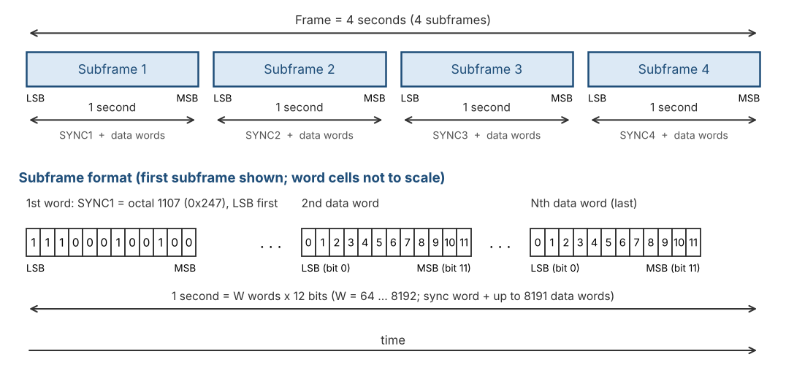
Figure 1. ARINC 717 message: frame, subframes and word bit ordering

2. System Architecture
The core is partitioned into two asynchronous clock domains:
- core_clk (24 MHz ±0.1 %) – entire TX path, RX path (sampler, decoder, sync FSM, word-count), read side of TX FIFO, write side of RX FIFO. This is the ARINC timing reference; all bit-period and sample-period calculations are performed from this clock.
- s_axi_clk – AXI4-Lite slave, register file, write side of TX FIFO, read side of RX FIFO. Frequency and phase are independent of core_clk.
Data-path clock crossing is performed exclusively by dual-clock asynchronous FIFOs. Configuration and status words use coherent multi-bit CDC (Req/Ack or toggle-strobe). Enables travel inside the atomic configuration bundle (Section 4.2.1); single-bit status and pulses use 2FF or toggle synchronisers.

2.1 Top-Level Block Diagram
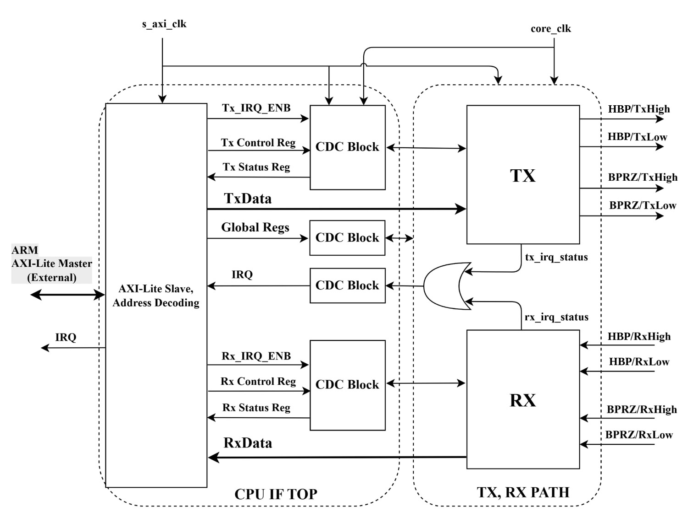
Figure 2. Top-level architecture (CPU IF TOP and TX/RX PATH)
Figure 2 shows the two major partitions of the IP core and the external ARM AXI-Lite master.

CPU IF TOP (s_axi_clk domain)
- AXI-Lite Slave, Address Decoding – decodes the 32-bit AXI address space, accepts one outstanding transaction, and routes register / data-port accesses.
- Tx_IRQ_ENB / Tx Control Reg / Tx Status Reg – TX-side control and status registers on the s_axi_clk side of the CDC.
- TxData – write port that pushes 12-bit words into the TX asynchronous FIFO.
- Global Regs – VERSION, SOFT_RESET, GLOBAL_EN, TX_EN / RX_EN and aggregate IRQ enables.
- Rx_IRQ_ENB / Rx Control Reg / Rx Status Reg – RX-side control and status registers on the s_axi_clk side of the CDC.
- RxData – read port that pops 12-bit words from the RX asynchronous FIFO.
- IRQ – combined interrupt output to the external ARM (aggregation of the sticky TX/RX interrupt bits kept in the CPU IF, s_axi_clk domain).

CDC Blocks
- Each CDC Block crosses multi-bit control/status words (or single-bit IRQ enables) between s_axi_clk and core_clk using coherent handshaking or 2FF synchronisers. Data-path words cross only through the async FIFOs (not shown explicitly in Figure 2; see Figure 3).

TX PATH (core_clk domain)
- TX – complete transmit path: Timing Generator, FSM, Sync Insertion, Shift Register, HBP Encoder and BPRZ Encoder.
- Outputs: HBP/TxHigh, HBP/TxLow, BPRZ/TxHigh, BPRZ/TxLow (digital line levels for external drivers).
- tx_irq events – interrupt event pulses from the TX path (toggle-synchronised into the CPU IF, where the sticky bits live).

RX PATH (core_clk domain)
- RX – complete receive path: Sample & Hold, HBP/BPRZ Clock Recovery, Shift Register, SYNC Detection FSM, Timing Generator.
- Inputs: HBP/RxHigh, HBP/RxLow, BPRZ/RxHigh, BPRZ/RxLow.
- rx_irq events – interrupt event pulses from the RX path (OVERFLOW, MATCH, INSYNC_LOST), toggle-synchronised into the CPU IF.
- INSYNC – digital status pin indicating subframe lock.

2.2 Detailed Design Block Diagram
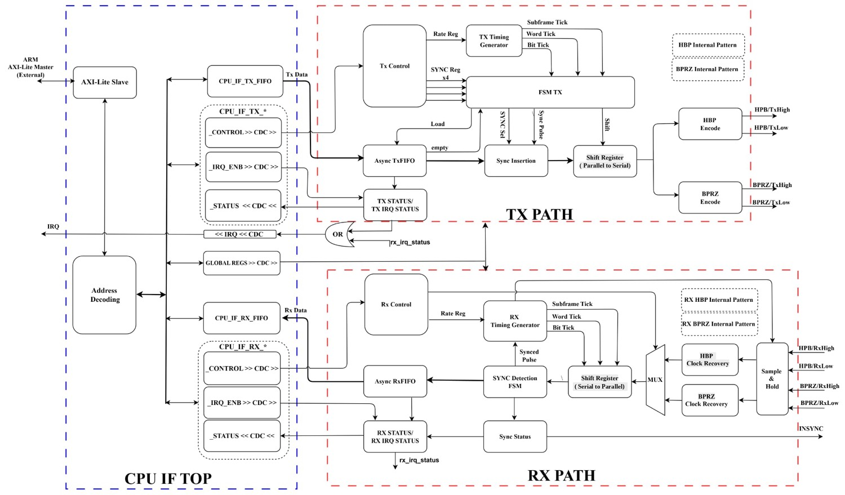
Figure 3. Detailed TX PATH and RX PATH design
Figure 3 expands every major functional block inside the TX and RX paths and shows the exact data-flow and control connections.

CPU IF TOP blocks (left, blue boundary)
- AXI-Lite Slave – protocol engine (AW/W/B and AR/R channels).
- Address Decoding – maps base offsets to Global, TX, RX register banks and the two data ports.
- CPU_IF_TX_FIFO / CPU_IF_RX_FIFO – s_axi_clk-side views of the dual-clock FIFOs (write side of TX FIFO, read side of RX FIFO).
- CPU_IF_TX_* / CPU_IF_RX_* – register shadows (CONTROL, IRQ_ENB, STATUS) that are CDC’d into / out of the core_clk domain.
- GLOBAL REGS >> CDC >> – global enable, soft-reset and version registers crossed into core_clk.

TX PATH blocks (upper red boundary)
- Tx Control – holds TX_RATE[3:0], SYNC_INS_MODE and the four TX_SYNCx codes after CDC.
- TX Timing Generator – produces Bit Tick, Word Tick and Subframe Tick from core_clk according to the programmed rate; starts only when enables are set and the TX FIFO is not empty (see 3.1.2b).
- Async TxFIFO – dual-clock FIFO (wr = s_axi_clk, rd = core_clk); supplies payload words and the empty flag to the FSM.
- Sync Insertion – selects either the FIFO data word or the appropriate TX_SYNCx word when SYNC_INS_MODE = 1 and subframe_start is asserted.
- FSM TX – sequences Load, Shift and sync-insert decisions under control of the timing ticks.
- Shift Register (Parallel to Serial) – 12-bit parallel-load, serial-out LSB-first register clocked by Bit Tick.
- HBP Encode / BPRZ Encode – dual digital encoders driven from the same shift-register bit stream; produce HBP/TxHigh·TxLow and BPRZ/TxHigh·TxLow.
- TX STATUS / TX IRQ STATUS – EMPTY / HALF / FULL flags and sticky IRQ bits, computed in the CPU IF (s_axi_clk) from the FIFO pointers.

RX PATH blocks (lower red boundary)
- Sample & Hold – 8× oversampling front-end that classifies the incoming digital levels into ONES / ZEROS / NULL windows (see 3.2.1.1).
- HBP Clock Recovery / BPRZ Clock Recovery – edge-based and pulse-based bit-clock recovery for the two encodings.
- MUX – selects the recovered bit stream according to RX_CTRL.RXSEL.
- Shift Register (Serial to Parallel) – assembles 12 recovered bits into a parallel word.
- SYNC Detection FSM – tracker-based acquisition (see 3.2.2.2) and word-0 maintenance (3.2.3.1).
- RX Timing Generator – produces Bit Tick, Word Tick and Subframe Tick locked to the recovered bit rate once INSYNC is asserted; receives the Synced Pulse from the detection FSM.
- Async RxFIFO – dual-clock FIFO (wr = core_clk, rd = s_axi_clk); stores recovered words for the host.
- Sync Status / RX STATUS / RX IRQ STATUS – INSYNC, SYNC[1:0], FIFO flags and sticky IRQs.
- INSYNC – external status pin reflecting subframe lock.

2.3 Clock-domain summary
- 1 × Async FIFO TX (FIFO_DEPTH × 12-bit, default 128, wr_clk = s_axi_clk, rd_clk = core_clk).
- 1 × Async FIFO RX (FIFO_DEPTH × 12-bit, default 128, wr_clk = core_clk, rd_clk = s_axi_clk).
- All multi-bit control/status crossings use dedicated CDC blocks (Figure 2).
- IRQ is the aggregation (sticky AND enable, then AND GLOBAL_CTRL.IRQ_ENABLE) of the TX and RX interrupt bits in the CPU IF.

2.4 Enable, Active and Idle Behaviour
This section is the single definition of when each path runs, what is cleared when it stops, and which configuration fields may change while it runs. Other sections refer to it.

Active flags (core_clk domain)
- tx_active = GLOBAL_EN AND TX_EN AND NOT srst_core. rx_active = GLOBAL_EN AND RX_EN AND NOT srst_core. The enables come from the applied configuration bundle (Section 4.2.1); srst_core is the soft-reset signal of Section 5.2.

TX path when tx_active = 0
- The TX Timing Generator is in GEN_OFF and the TX FSM in IDLE; acc, phase, bit_cnt, word_in_subframe, subframe_index, frame_count, shreg and tx_bit are cleared.
- Outputs go to their idle levels on the next core_clk edge, even in the middle of a word (the word is aborted): HBP polarity P = 0, i.e. tx_hbp_high = 0 and tx_hbp_low = 1; BPRZ = Null, i.e. tx_bprz_high = 0 and tx_bprz_low = 0. The same levels are driven after hardware reset.
- During an underrun (GEN_FROZEN, tx_active = 1) the outputs hold: HBP keeps its last polarity, BPRZ is Null.

RX path when rx_active = 0
- The RX sample generator (accumulator and phase counter), the ONES/ZEROS/NULL registers, the HBP and BPRZ decoders, the 12-bit window, bit_index, the trackers, word_in_subframe, subframe_index, INSYNC, SYNC[1:0] and MATCH are held cleared. Nothing is written to the RX FIFO.
- Words already in the RX FIFO are kept; only SOFT_RESET or RX_FIFO_CLEAR flush it.
- When rx_active rises the sample accumulator starts at 0 and the decoder starts unlocked (acquisition).

Configuration fields that change while a path runs
- TX_RATE (TX_CTRL[11:8]) is applied in the core (level-sensitive latch) only while tx_active = 0; RX_RATE (RX_CTRL[11:8]) only while rx_active = 0. The two paths are independent: they may run at different rates. A rate change made while its own path runs stays pending and is applied as soon as that path is inactive.
- SYNC_INS_MODE is applied only while tx_active = 0. RXSEL (together with the synchronised rsel pin), NOSYNC, SFTSYNC and TEST are applied only while rx_active = 0. TEST = 1 routes the TX encoders into the RX decoder, so TX_RATE and RX_RATE must then hold the same code (Section 3.4).
- TX_SYNCx, RX_SYNCx and WRDCNT are applied immediately and take effect at their next use.
- Rate-change procedure (per path, TX shown; RX is identical with RX_EN and RX_RATE): (1) clear TX_EN (or GLOBAL_EN) in GLOBAL_CTRL; (2) write the new TX_RATE in TX_CTRL; (3) wait at least the latency bound of Section 4.2.1; (4) set TX_EN again. Steps (1) and (2) may be in either order because the latch only applies the rate while the path is inactive; the enable must come last. SOFT_RESET is optional and only needed when the FIFOs and sticky IRQ bits should also be flushed.

3. TX PATH and RX PATH Operation

3.1 Transmit Path
The TX path reads 12-bit words from the TX FIFO and encodes them simultaneously into Harvard Bi-Phase (HBP) and Bi-Polar Return-to-Zero (BPRZ) digital streams at the programmed rate. ARINC 717 transmits words back-to-back with no inter-word gap: as soon as the last bit of one word is sent, the first bit of the next word follows immediately. Transmission begins when the first word is present in the FIFO and GLOBAL_EN & TX_EN are set. The host is responsible for placing the correct subframe sync mark as the first word of each subframe and for keeping the FIFO non-empty so that the continuous stream is not interrupted.

3.1.1 TX Path block overview
- Async FIFO TX (write side s_axi_clk, read side core_clk) – holds up to FIFO_DEPTH words of 12 bits (default 128).
- TX Timing Generator – independent block that produces bit_tick, word_tick, subframe_index (0…3) and frame_count; it is not part of the TX FSM but supplies timing strobes and indices to the FSM (see 3.1.2b).
- TX FSM – consumes timing strobes from the Timing Generator, reads the FIFO (or auto-inserts a sync word), and drives the shift register.
- Parallel-load shift register – loads a complete 12-bit word when the TX FSM pulses Load.
- HBP Encoder – produces the Harvard Bi-Phase digital bit stream.
- BPRZ Encoder – produces the Bi-Polar Return-to-Zero digital bit stream.
- Both encoders run in parallel from the same shift-register data and the same bit-clock; their outputs appear on tx_hbp_high/low and tx_bprz_high/low.

3.1.2 TX FSM operation
Whenever GLOBAL_EN = 1, TX_EN = 1 and the TX FIFO is not empty, the TX FSM:
- Pulses Load – the next 12-bit word is read from the FIFO and captured in the parallel-load shift register.
- Shifts the word out LSB-first, one bit per data-bit period (the same period defined in Section 3.3).
- Immediately after the 12th bit, if the FIFO still contains data, the FSM loads the next word and continues shifting without any idle interval – producing a continuous, gap-free bit stream.
If the FIFO becomes empty the FSM stops after the current word; the line remains at the last HBP polarity (or BPRZ Null) until new data arrives and transmission resumes automatically.

3.1.2a Sync-word insertion mechanism
Each subframe must begin with the appropriate Barker sync mark (SYNC1…SYNC4). The selection between host-driven and hardware auto-insert is controlled by TX_CTRL.SYNC_INS_MODE (bit 0):
- SYNC_INS_MODE = 0 – Software mode (default). The host is responsible for writing the sync word as the first FIFO entry of every subframe. The TX FSM always reads from the FIFO; it never injects TX_SYNCx.
- SYNC_INS_MODE = 1 – Hardware auto-insert mode. At the start of each subframe (word_in_subframe = 0, indicated by the TX Timing Generator) the TX FSM loads the corresponding TX_SYNCx register instead of popping the FIFO. After that word is shifted out, all remaining words of the subframe are taken from the FIFO.

Software mode (SYNC_INS_MODE = 0)
The host writes the 12-bit sync code (or any other value it chooses) as the first word of every subframe into the TX FIFO, followed by the payload words. The four TX_SYNCx registers are ignored by the TX path in this mode. This mode gives the host complete control over the first word of each subframe.

Hardware auto-insert mode (SYNC_INS_MODE = 1)
- When the TX Timing Generator asserts subframe_start and the TX FIFO is not empty, the TX FSM parallel-loads:
- subframe_index 0 → TX_SYNC1, 1 → TX_SYNC2, 2 → TX_SYNC3, 3 → TX_SYNC4.
- If the FIFO is empty at subframe_start, no sync is inserted and the Timing Generator freezes (see 3.1.2b) until data arrives.
- After a sync word is shifted out, subsequent words of the subframe are popped from the TX FIFO.
- The host must therefore keep the FIFO non-empty and supply exactly (N − 1) payload words per subframe, where N is the programmed number of words per second.
- TX_SYNCx registers power-up to the standard ARINC 717 codes (octal 1107 / 2670 / 5107 / 6670) and may be overwritten at any time.
If the host also places a sync word in the FIFO while auto-insert is enabled, two consecutive sync marks will appear; this is a software error and is not blocked by hardware.
In both modes the stream remains continuous and gap-free while data is available: the bit that follows the last bit of a sync word is the first bit of the next data word.

3.1.2b TX Timing Generator
The TX Timing Generator is a standalone block in the core_clk domain. It is not embedded inside the TX FSM; it only produces timing outputs that the FSM (and optionally status logic) consumes.

Outputs of the Timing Generator
- bit_tick – pulse at the start of every data-bit period (phase accumulator, Section 3.2.1.1).
- half_bit_tick – pulse at the midpoint of every data-bit period (HBP mid-edge, BPRZ return-to-Null).
- word_tick – pulse at the start of the first bit cell of every word (every 12th bit_tick, counted by bit_cnt).
- bit_cnt[3:0] – index 0..11 of the bit cell that starts at bit_tick; owned by the Timing Generator (the TX FSM has no bit counter of its own). bit_cnt advances (11 wraps to 0) at the sample_tick where phase = 7.
- word_in_subframe[12:0] – index (0…W-1) of the word that will be loaded at the next word_tick; incremented only when a word is actually loaded, wraps to 0 at W (W = words per subframe).
- subframe_index[1:0] – 0…3, advances each time word_in_subframe wraps.
- frame_count[31:0] – increments each time subframe_index wraps from 3 to 0 (one 4-second frame). Internal only: no register reads it, so it may be omitted in RTL.
- subframe_start – registered flag: set when word_in_subframe will be 0 for the upcoming word. Timing: on word_tick N the FSM sees subframe_start and word_in_subframe for the word about to be loaded; after LOAD completes, word_in_subframe increments (or wraps). First word after generator release: word_in_subframe=0, subframe_start=1.

When the Timing Generator starts running
The Timing Generator is in GEN_OFF until tx_active = 1 (Section 2.4) and the TX FIFO is not empty (at least one 12-bit word is waiting on the core_clk read side); it then enters GEN_RUN (see "Timing Generator states" below). TX_RATE must hold a legal code (reserved codes behave as code 0000, 64 wps).
The FIFO condition is essential: without data in the FIFO the generator must not free-run. Otherwise, in hardware auto-insert mode, the TX FSM would keep injecting TX_SYNCx at every subframe boundary while producing no payload, resulting in a stream of sync marks only.
On entry INC(TX_RATE) from Table 5 is used. word_in_subframe, subframe_index and frame_count start at 0, so the first word is the first word of subframe 0 (SYNC1).

Behaviour when the FIFO later becomes empty
- After the word currently being shifted has finished, the TX FSM stops issuing Load and the line holds the last HBP polarity (or BPRZ Null).
- The Timing Generator freezes (GEN_FROZEN): it stops emitting bit_tick / word_tick, holds word_in_subframe, subframe_index and frame_count at their current values (it does not clear them) and clears acc, phase and bit_cnt so that the resume latency is deterministic.
- When the host later pushes new data into the FIFO, the Timing Generator resumes from the frozen count (mid-subframe or mid-frame) and the FSM continues transmission without forcing a return to subframe 0.
- If software prefers to restart from a clean subframe boundary after an underrun, it must clear TX_EN (or assert SOFT_RESET) before re-filling the FIFO; that forces the generator to clear its counters back to 0.

Stop / reset conditions
If tx_active = 0 the Timing Generator clears all counters to 0 and stops emitting ticks (GEN_OFF). Rate changes follow the procedure of Section 2.4: TX_RATE is only latched while tx_active = 0.

Timing Generator states
The Timing Generator is a small state machine in core_clk. It (not the TX FSM) owns the sample accumulator, the phase counter (0..7), the bit counter bit_cnt (0..11) and the word/subframe counters.
- GEN_OFF – tx_active = 0 (tx_active is defined in Section 2.4). acc, phase, bit_cnt, word_in_subframe, subframe_index and frame_count are cleared to 0. No strobes.
- GEN_RUN – strobes are generated. Entered from GEN_OFF or GEN_FROZEN when tx_active = 1 and fifo_empty = 0. On entry acc = 0, phase = 0, bit_cnt = 0, so the first sample_tick (and with it the first bit_tick and word_tick, which coincide) arrives exactly one sample period after entry. This latency is deterministic after every start and every resume.
- GEN_FROZEN – entered from GEN_RUN at a word_tick where fifo_empty = 1 (underrun). word_in_subframe, subframe_index and frame_count hold their values; acc, phase and bit_cnt are cleared; no strobes. Returns to GEN_RUN when tx_active = 1 and fifo_empty = 0; goes to GEN_OFF when tx_active = 0.

Strobes and indices (Generator to FSM and encoders)
- sample_tick – phase-accumulator output (Section 3.2.1.1). phase counts sample_ticks 0..7 inside a bit cell.
- bit_tick = sample_tick when phase = 0 (phase is the value held before the update that this sample_tick causes; phase and bit_cnt are updated at the end of that clock, see Figure 4). It starts a bit cell; bit_cnt is the index of that cell.
- half_bit_tick = sample_tick when phase = 4 (mid-cell).
- word_tick = bit_tick when bit_cnt = 0, i.e. the start of the first cell of a word. At word_tick the previous word, if any, has just finished its 12th cell.
- word_in_subframe and subframe_index are registered and describe the word that will be loaded at the next word_tick. subframe_start = (word_in_subframe = 0) is a registered flag, so the FSM reads it on the same clock edge as word_tick without any ordering problem.

Load decision (one rule, evaluated at every word_tick)
At word_tick the FSM and the Generator sample the same registered fifo_empty flag in the same clock cycle, so no extra handshake signal is needed (there is no tx_run or load_pulse).
- fifo_empty = 0: LOAD. The FSM selects the source (below). On the same clock edge word_in_subframe increments (at W it wraps to 0 and subframe_index increments) and the first bit cell starts.
- fifo_empty = 1: underrun. The FSM goes to IDLE, the Generator goes to GEN_FROZEN and no cell starts. The line holds: HBP keeps its last level; BPRZ is Null (the previous cell already ended in its Null half).
Source selection at LOAD: if SYNC_INS_MODE = 1 and subframe_start = 1, load TX_SYNC[subframe_index] and do not pop the FIFO; otherwise load the FIFO head and pop it. fifo_empty must be 0 in both cases, so a stream of sync words without payload is never produced.

Shift register and encoder timing
Define cell_start = bit_tick AND NOT (word_tick AND fifo_empty). The encoders act only on cell_start and half_bit_tick, so an underrun never creates a spurious boundary edge. The bit being transmitted is held in the registered flag tx_bit, stable for the whole cell:
- cell_start with word_tick = 1 (LOAD): tx_bit <= word[0]; shreg <= {1'b0, word[11:1]}.
- cell_start with word_tick = 0 (bit_cnt = 1..11): tx_bit <= shreg[0]; shreg <= {1'b0, shreg[11:1]}.
LOAD and the first cell_start occur on the same clock edge, so bit 0 comes from the loaded word and never from stale shreg contents. The 12-cell count lives only in the Generator (bit_cnt); the FSM has no separate bit_index.

TX Timing Generator and TX FSM state diagram
The Timing Generator, the TX FSM and the encoders are specified by the state diagrams of Figure 4: states, transition conditions, strobe decodes (valid only in the clock where sample_tick = 1), the LOAD action and the encoder actions. All registers update at the end of the clock. Figure 5 shows the resulting timing.
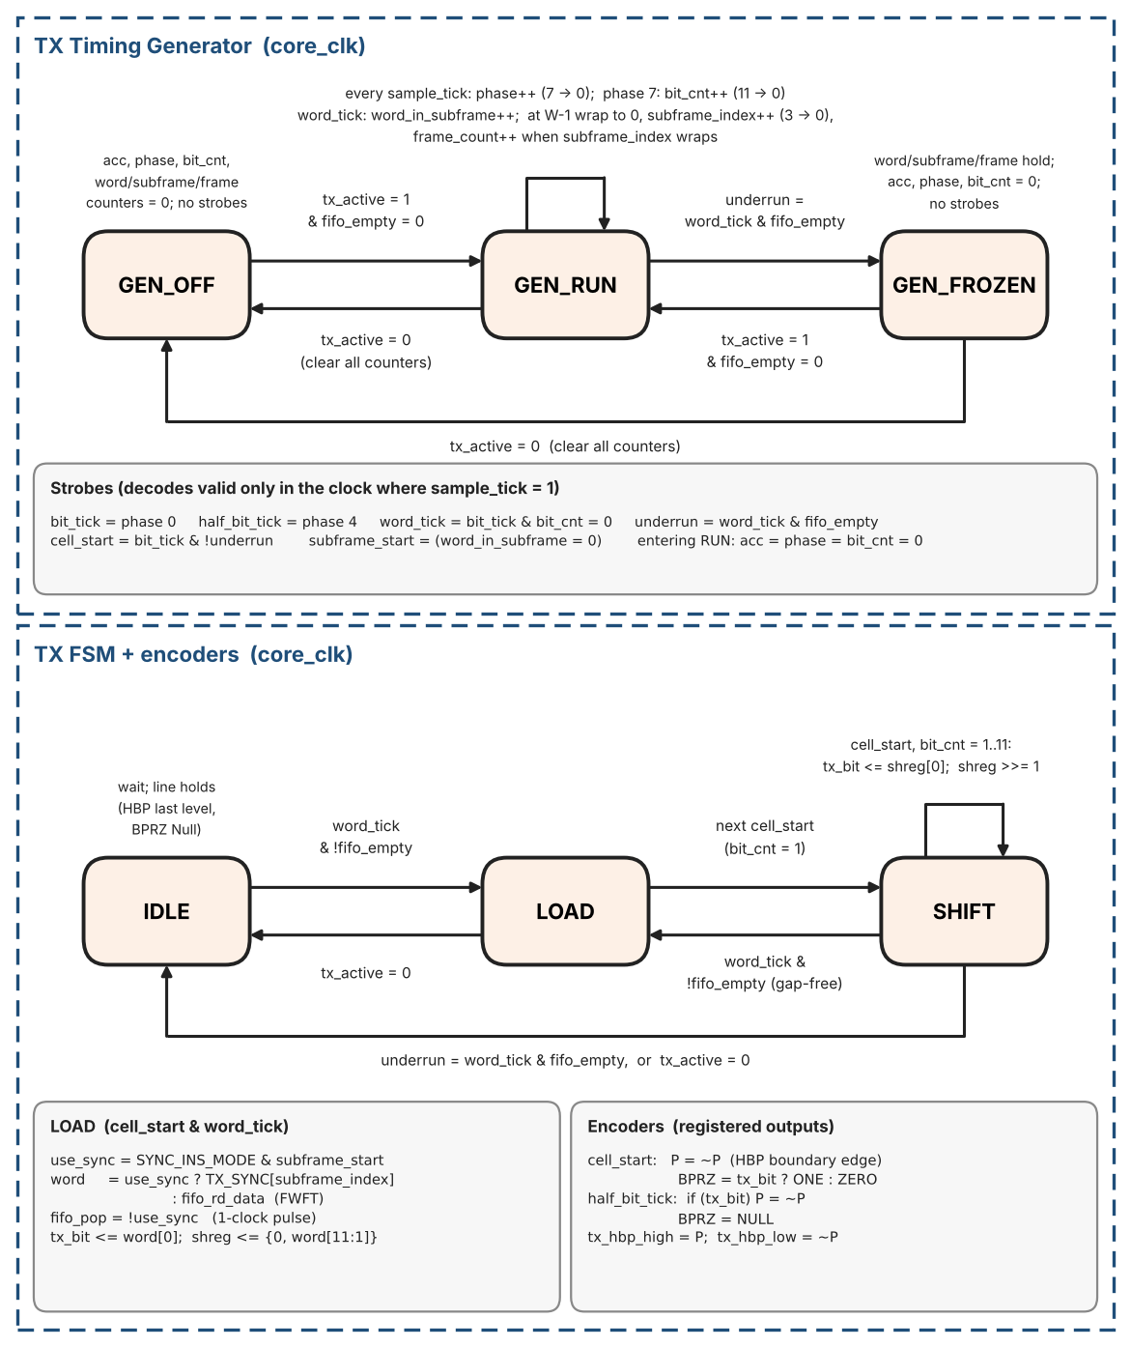
Figure 4. TX Timing Generator and TX FSM / encoder state diagrams
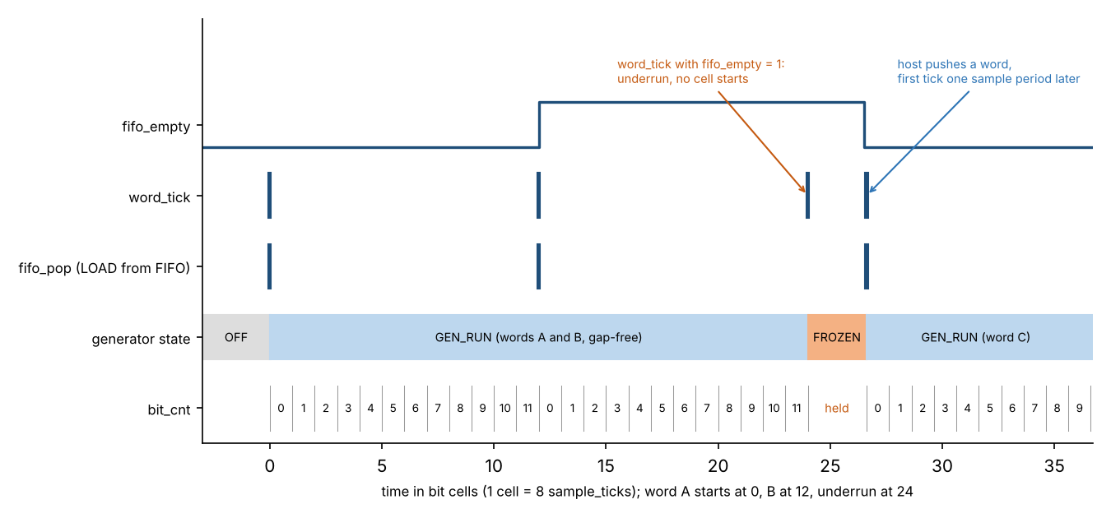
Figure 5. TX Timing Generator and FSM: gap-free load, underrun (GEN_FROZEN) and resume

3.1.3 HBP Encoder (detailed)
Harvard Bi-Phase (HBP) for ARINC 717 encodes each data bit by the presence or absence of a mid-cell transition. Encoder and decoder share one rule: mid-cell transition = logic 1; no mid-cell transition = logic 0. A boundary transition at the start of every bit cell is always generated so the receiver can maintain lock.
Digital outputs: tx_hbp_high and tx_hbp_low are complementary during active bits. Idle and reset: P = 0, i.e. tx_hbp_high = 0 and tx_hbp_low = 1 (Section 2.4).
Algorithm (polarity state P, initial P=0 after reset/enable):
- At cell_start (start of cell): P := not P; drive tx_hbp_high=P, tx_hbp_low=!P. // boundary edge always
- At half_bit_tick (mid-cell): if tx_bit==1 then P := not P; drive outputs. // mid-cell edge only for 1
- If tx_bit==0: no change at half_bit_tick; level stays constant through the second half.
Waveform (one bit cell, time left to right):
- Bit 0: edge at t=0 only; second half is flat.
- Bit 1: edge at t=0 and edge at t=T/2.
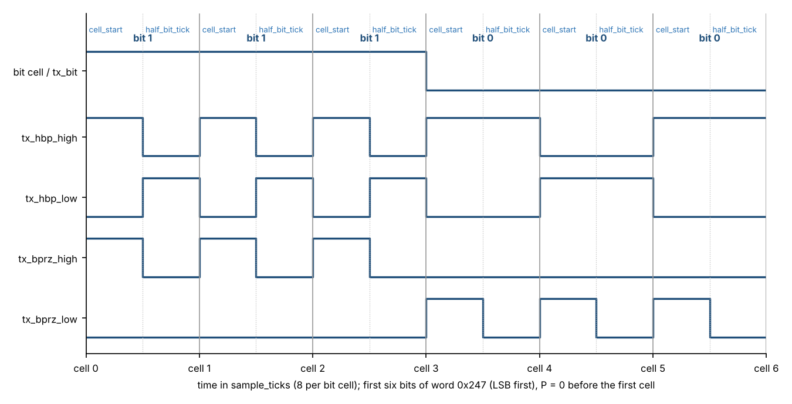
Figure 6. HBP and BPRZ transmit waveforms (first six bits of word 0x247, LSB first)
Waveforms of every cell are listed in Table 42 (Section 12.7).
half_bit_tick is produced by the TX Timing Generator at the midpoint of each bit period. TX and RX rates match.
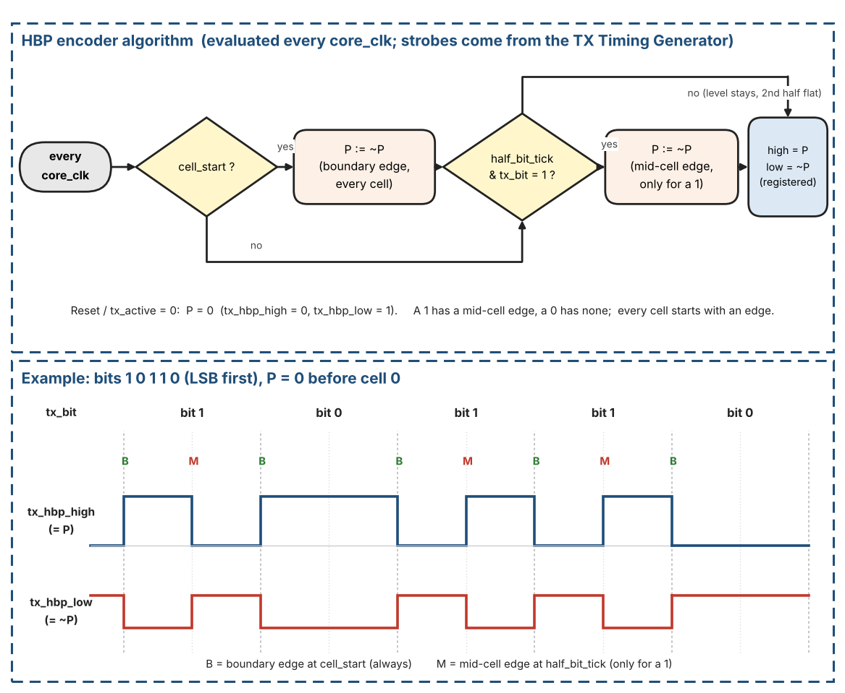
Figure 7. HBP encoder: algorithm and example (bits 1 0 1 1 0)

3.1.4 BPRZ Encoder (detailed)
Bi-Polar Return-to-Zero encoding uses three levels (One / Zero / Null) inside every bit period:
- A logic 1 is sent as a positive pulse (One) for the first half of the bit period, then returns to Null for the second half.
- A logic 0 is sent as a negative pulse (Zero) for the first half of the bit period, then returns to Null for the second half.
- Null is the idle level between pulses and between words.
Implementation inside the core (all digital):
- Two digital outputs, tx_bprz_high and tx_bprz_low, represent the three states: One, Zero, Null. There is no separate Null pin or Null signal: Null is the combination in which both outputs are 0 (Table 3).
Where Null comes from. The BPRZ interface has exactly two digital wires per direction (tx_bprz_high / tx_bprz_low on transmit, rx_bprz_high / rx_bprz_low on receive). The third state, Null, is not a wire: it is what the pair looks like when neither wire is active. On the physical bus Null is about 0 V; the external line driver produces that level when both tx_bprz_* outputs are 0, and the external line receiver drives both rx_bprz_* inputs to 0 when it sees about 0 V. Inside the core, "Null" is only a name for the pair (high, low) = (0, 0): the receiver classifies it as the NULL class (Table 8, Section 3.2.1.1) and, after the 2-sample dwell, raises the internal flag valid_NULL.
Table 3. BPRZ line states and the two digital pins
State | high pin | low pin | Analogue bus level | Internal name in the receiver
One | 1 | 0 | positive pulse | class HI, flag valid_HI
Zero | 0 | 1 | negative pulse | class LO, flag valid_LO
Null | 0 | 0 | about 0 V | class NULL, flag valid_NULL
(not allowed) | 1 | 1 | - | class INVALID: never a legal level

In HBP mode the same two pins carry the two complementary levels of the HBP signal, so (0, 0) is not a legal state there and is classified INVALID.
- During the first half of the bit period the encoder drives One if the data bit = 1, or Zero if the data bit = 0.
- During the second half of the bit period the encoder always drives Null.
- The half-bit boundary is taken from the same phase-accumulator timing used by the HBP encoder, so both encodings stay perfectly aligned.
The digital BPRZ stream appears on tx_bprz_high and tx_bprz_low. External line drivers (if present) translate the One/Zero/Null codes into the analogue ±10 V / 0 V levels required by the physical bus; the IP core itself never generates analogue voltages.
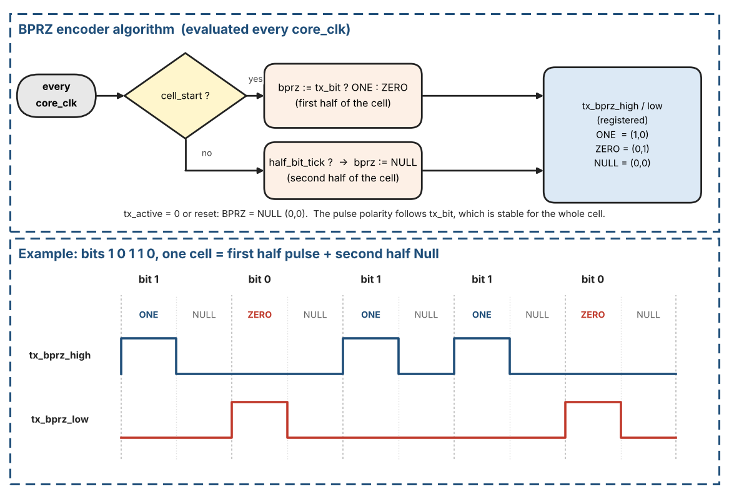
Figure 8. BPRZ encoder: algorithm and example (bits 1 0 1 1 0)

3.1.5 Continuous transmission (no inter-word gap)
Unlike ARINC 429, ARINC 717 does not insert Null gaps between successive words. Within a subframe the bit stream is continuous: the LSB of word N+1 is transmitted in the bit period that immediately follows the MSB of word N. The TX FSM therefore issues the next Load as soon as the current word’s last bit has been shifted out, provided the FIFO is not empty.
The host must keep the TX FIFO from running dry for longer than one word-time; otherwise a momentary pause appears on the line until the next word is written. At subframe boundaries the host is still responsible for supplying the correct sync mark as the first word of the new subframe.

Host rule for the TX FIFO
- Keep at least 2 words queued in the TX FIFO while transmitting. Before enabling, push at least 2 words (plus the sync word in software mode).
- Refill when ST_LOW (TX_IRQ_STATUS bit 1: level falls below FIFO_DEPTH/2) is raised, or poll TX_STATUS.HALF. When HALF = 0 at least FIFO_DEPTH/2 words are free, so push up to FIFO_DEPTH/2 words per refill; never push while TX_STATUS.FULL = 1.
- Reason: the core-side EMPTY flag is computed from the synchronised write pointer (Section 4.2.4), so a word pushed just before a word_tick may become visible a few clocks too late. The load decision at word_tick would then see EMPTY and cause a false underrun (GEN_FROZEN, line pause). A word that is already in the FIFO one word-time ahead is always visible. The CDC latency is far shorter than one word-time (122 us at 8192 wps), so one queued word is the minimum and 2 words give margin.
- Hardware sync-insertion mode: the same rule applies to the payload words; the sync word itself is never popped from the FIFO.

3.1.6 TX status flags
EMPTY, HALF and FULL are generated from the FIFO fill level on both clock domains. The core_clk side uses them to decide whether a Load is permitted; the s_axi_clk side reports them through the TX_STATUS flags for software. A push attempted while FULL returns SLVERR and discards the word.

3.2 Receive Path
The RX path recovers the bit clock from the selected digital input stream (HBP or BPRZ), performs serial-to-parallel conversion, detects subframe synchronisation marks, and writes accepted 12-bit words into the RX FIFO. Key blocks:
- Data Sampler & Hold – 8× oversampling relative to the programmed data-bit rate.
- HBP Decoder / BPRZ Decoder – selected by RXSEL (CTRL bit OR-ed with external RSEL pin).
- Sync Detection FSM – 4-sync-word (default), 2-sync-word (SFTSYNC=1) or No-Sync (NOSYNC=1).
- Word-count & subframe tracking – drives MATCH pin and RX_STATUS.SYNC[1:0].
- FIFO_DEPTH × 12-bit Async FIFO RX (default 128) – write side core_clk; overflow sets sticky ROVF.

Receive path at a glance
The receive path is a chain of stages. Each stage works on a slower time scale than the one before it: core_clk (24 MHz) in the synchronisers, sample_tick (8 per bit) in the sampler and the decoders, one bit_valid pulse per bit in the sync detector, one word (12 bits) in the counters and the FIFO.
Table 4. Receive path: stages and the signals between them
Stage | Input | Output | Section
1. Input synchronisers | rx_hbp_high/low, rx_bprz_high/low, rsel (asynchronous pins) | the same signals in the core_clk domain | 4.2.0
2. Sample generator | RX_RATE (applied while rx_active = 0) | sample_tick, 8 per bit cell | 3.2.1.1
3. Sampler | pair (hi, lo) chosen by rxsel_eff; sample_tick | valid_HI, valid_LO, valid_NULL (dwell-validated levels) | 3.2.1.1
4. HBP or BPRZ decoder (chosen by rxsel_eff) | valid_HI, valid_LO (HBP); valid_HI, valid_LO, valid_NULL (BPRZ) | bit_valid, bit_data, framing_error | 3.2.1.2, 3.2.1.3
5. 12-bit window and sync detector | bit_valid, bit_data | candidate sync, INSYNC, subframe_index | 3.2.2.1 to 3.2.2.4
6. RX timing generator and word counters | recovered bits, INSYNC | accepted 12-bit words, word_in_subframe, MATCH | 3.2.3.1
7. RX FIFO | accepted 12-bit words | words popped by the host through the AXI-Lite slave | 3.2.3.2, 6

3.2.1 Bit Front-End: Sampler and Decoders
The front-end turns the raw line inputs into a stream of recovered bits. It has four parts: the Data Sampler & Hold (Section 3.2.1.1), the HBP decoder (Section 3.2.1.2), the BPRZ decoder (Section 3.2.1.3) and the hand-off to the sync detector (Section 3.2.1.4).

3.2.1.1 Data Sampler & Hold (detailed)
The sampler is the first digital stage after the external line-receiver (or digital isolator). It runs from a sample clock that is exactly eight times the programmed data-bit rate. Because both HBP and BPRZ encodings place a transition opportunity in the middle of every data-bit period, the 8× sample clock is equivalent to a 4× oversample of the maximum transition rate.
Clock domains: see Section 2. All timing calculations below assume core_clk = 24.000 MHz exactly.

Sample-clock derivation – exact calculation from 24 MHz core_clk
Formulas used throughout this section (core_clk = 24.000 MHz):
- Data-bit rate (bps) = Words/s × 12
- Sample rate (Hz) = Data-bit rate × 8 = Words/s × 96
- Ideal cycles/sample = core_clk / Sample rate = 24 000 000 / (Words/s × 96) = 250 000 / Words/s
- Phase-accumulator residual error < 1 core_clk period = < 41.667 ns
- Relative error (%) ≈ (1 / Ideal_cycles_per_sample) × 100 (accumulator residual bound)
Table 5 is the single definition of the rate-code encoding used by both TX_RATE and RX_RATE, INC and the sample-clock parameters (it also gives the ideal cycles/sample). Implement the tick generator with the phase accumulator below; the edge jitter is bound by one core_clk period.
Table 5. Rate-code encoding (TX_RATE and RX_RATE) and sample-clock parameters (core_clk = 24 MHz) - single definition
Rate code | Words/s (W) | Bit rate (bps) | Bit period (us) | Sample period (us) | Cycles/sample (core_clk, exact) | INC = W x 96 | Max edge jitter (%)
0000 | 64 | 768 | 1302.0833 | 162.7604 | 3906.25 | 6144 | 0.0256
0001 | 128 | 1536 | 651.0417 | 81.3802 | 1953.125 | 12288 | 0.0512
0010 | 256 | 3072 | 325.5208 | 40.6901 | 976.5625 | 24576 | 0.1024
0011 | 512 | 6144 | 162.7604 | 20.3451 | 488.28125 | 49152 | 0.2048
0100 | 1024 | 12288 | 81.3802 | 10.1725 | 244.140625 | 98304 | 0.4096
0101 | 2048 | 24576 | 40.6901 | 5.0863 | 122.0703125 | 196608 | 0.8192
0110 | 4096 | 49152 | 20.3451 | 2.5431 | 61.03515625 | 393216 | 1.6384
0111 | 8192 | 98304 | 10.1725 | 1.2716 | 30.517578125 | 786432 | 3.2768
1000-1111 | 64 (reserved codes) | 768 | as code 0000 | as code 0000 | 3906.25 | 6144 | 0.0256

Sample-tick generation (phase accumulator)
Both TX Timing Generator and RX sample-clock generator use the same algorithm on core_clk:
- Every core_clk: acc := acc + INC(rate); if acc >= 24000000 then sample_tick=1, acc := acc - 24000000; else sample_tick=0.
- INC(rate) = W * 96, with W = words/s from the applied rate code (Table 5): TX_RATE for the TX Timing Generator, RX_RATE for the RX sample generator. Each path has its own accumulator. acc is 25 bits wide (24,000,000 + 786,432 < 2^25); the constant 24,000,000 is core_clk in Hz.
A phase counter (0..7) increments on each sample_tick. Derived strobes:
- bit_tick = sample_tick when phase==0 (start of bit cell).
- half_bit_tick = sample_tick when phase==4 (mid-cell).
Edge jitter is < 1 core_clk period (accumulator residual); the long-term average rate is exact. Implement with the accumulator above, not a dual-modulus integer divider. The RX sample-clock generator uses only sample_tick; the HBP decoder keeps its own phase counter (Section 3.2.1.2), independent of the TX phase counter.

How the accumulator works (step by step)
What is needed. The sampler (and the transmit timing generator) needs exactly 8 sample_ticks per bit cell, evenly spread over time. The distance between two ticks is core_clk / sample rate = 24 000 000 / (W x 96) core_clk periods. This is usually not an integer (3906.25 for W = 64). A counter that always counts the integer 3906 would lose 0.25 clock at every tick: after one second (6144 ticks) the sampling point would have drifted by 1536 clocks and the receiver would slowly slide out of the bit cell. The accumulator avoids this by keeping the remainder of every division and carrying it to the next tick.
Where the numbers come from (W = 64 words/s, core_clk = 24 MHz):
- 64 words/s x 12 bits = 768 bit/s.
- 768 bit/s x 8 samples per bit = 6144 samples/s. This is INC = W x 96 (12 x 8 = 96).
- core_clk = 24 000 000 clocks/s. This is the threshold of the accumulator.
- One sample therefore lasts 24 000 000 / 6144 = 3906.25 clocks.
- Meaning of acc. In one clock the line advances by 6144 / 24 000 000 of a sample. Multiplied by 24 000 000 this means: every clock adds INC = 6144 units to acc, and one complete sample is worth 24 000 000 units. acc is the number of units collected towards the next sample. When acc reaches 24 000 000 one sample has elapsed: sample_tick is raised for exactly one core_clk period and 24 000 000 is subtracted. The units above the threshold are NOT discarded; they stay in acc and count towards the next sample.
Worked example with small numbers: core_clk = 10 clocks/s, 4 samples/s needed (ideal distance 2.5 clocks); so INC = 4 and threshold = 10. acc starts at 0.
Table 6. Accumulator example with small numbers (INC = 4, threshold = 10)
Clock | acc after adding INC | sample_tick | acc after subtract
1 | 4 | 0 | 4
2 | 8 | 0 | 8
3 | 12 (>= 10) | 1 | 2
4 | 6 | 0 | 6
5 | 10 (>= 10) | 1 | 0
6 | 4 | 0 | 4
7 | 8 | 0 | 8
8 | 12 (>= 10) | 1 | 2
9 | 6 | 0 | 6
10 | 10 (>= 10) | 1 | 0

Ticks occur at clocks 3, 5, 8 and 10, i.e. at distances 3, 2, 3, 2 clocks. The mean distance is 2.5 clocks and acc returns to 0 after 10 clocks, so the pattern repeats without any drift.
The same calculation with the real numbers (W = 64, INC = 6144, threshold = 24 000 000, acc starts at 0):
Table 7. Sample_tick distances for W = 64 (INC = 6144)
Tick | Clocks since previous tick | acc before subtract | acc after subtract
1 | 3907 | 24 004 608 | 4 608
2 | 3906 | 24 003 072 | 3 072
3 | 3906 | 24 001 536 | 1 536
4 | 3906 | 24 000 000 | 0

- Tick 1 needs 3907 clocks: 3906 x 6144 = 23 998 464 is still below 24 000 000, and 3907 x 6144 = 24 004 608 is the first value at or above it. The remainder 4 608 stays in acc.
- Ticks 2 to 4 need only 3906 clocks, because the remainder of the previous tick (4 608, 3 072, 1 536) already counts: for example 4 608 + 3906 x 6144 = 24 003 072.
- After tick 4 the remainder is 0 and the pattern repeats every 4 ticks: 3907 + 3906 + 3906 + 3906 = 15 625 clocks = 4 x 3906.25. Each single distance differs from the ideal 3906.25 by less than 1 clock (< 41.667 ns), and the error never accumulates.

How sample_tick is used
sample_tick is not a clock. All logic keeps running from core_clk. sample_tick is a clock enable: it is 1 for exactly one core_clk period and 0 in all other clocks. The sampler, the decoders and the phase counter change their state only in the clocks where sample_tick = 1 (about once every 3906 clocks for W = 64) and hold their state otherwise. No second clock domain is created.
// every core_clk (separate accumulator for TX and for RX)
acc_next = acc + INC; // INC = W x 96
if (acc_next >= 24000000) { acc <= acc_next - 24000000; sample_tick = 1; }
else { acc <= acc_next; sample_tick = 0; }

// downstream logic (sampler, decoders, phase counter), every core_clk
if (sample_tick) {
// one step: read the line pair, classify it, shift ONES/ZEROS/NULL, run the decoder
}

Level classification (per sample)
Step 1 - select the input pair. After the 2FF synchronisers (Section 4.2.0) the sampler works on one pair of signals, (hi, lo). The pair is chosen by rxsel_eff = RX_CTRL.RXSEL OR rsel:
- rxsel_eff = 0 (HBP): hi = rx_hbp_high, lo = rx_hbp_low.
- rxsel_eff = 1 (BPRZ): hi = rx_bprz_high, lo = rx_bprz_low.
- TEST = 1: the pair comes from the selected TX encoder instead (Section 3.4).
About rxsel_eff. rxsel_eff is an internal one-bit signal of the RX path (Table 39). It is neither a register bit nor a pin. It is defined as rxsel_eff = RX_CTRL.RXSEL OR rsel, where rsel is the external format-select pin after its 2FF synchroniser (Section 4.2.0). The register bit and the pin are two equal ways to choose the format: if either of them is 1 the receiver uses BPRZ, and only when both are 0 it uses HBP.
rxsel_eff does two things: it selects the input pair of the sampler (Step 1) and it selects which decoder is active (bprz_decoder when 1, hbp_decoder when 0; the other decoder is not used). Like the other RX_CTRL fields it is applied only while rx_active = 0 (Section 2.4): if RXSEL or rsel is changed while a reception is running, the new format is used after rx_active has fallen.
Step 2 - classify the pair. On every RX sample_tick the pair is classified once, as in Table 8: HI, LO, NULL or INVALID. NULL is not an input pin: it is the sample in which both hi and lo are 0, and it exists only in BPRZ mode (Table 3, Section 3.1.4).
Table 8. Sample classification of (hi, lo)
hi | lo | HBP mode (rxsel_eff = 0) | BPRZ mode (rxsel_eff = 1)
1 | 0 | HI | HI (One)
0 | 1 | LO | LO (Zero)
0 | 0 | INVALID | NULL
1 | 1 | INVALID | INVALID

INVALID is never a legal line state (hi = lo = 1 in both modes, or hi = lo = 0 in HBP mode). An INVALID sample clears the history of all three levels (Step 3), so a glitch cannot build up a valid level.

Dwell filter (2-sample minimum)
Step 3 - keep the history. Each class has its own 4-bit shift register: ONES (HI / One), ZEROS (LO / Zero) and NULL (Null). On every sample_tick each register shifts left by one position and its new bit 0 is 1 if the current sample belongs to that class, otherwise 0:
- ONES <<= 1; ONES[0] = 1 if the sample is HI / One, else 0.
- ZEROS <<= 1; ZEROS[0] = 1 if the sample is LO / Zero, else 0.
- NULL <<= 1; NULL[0] = 1 if the sample is NULL, else 0.
- INVALID sample: ONES[0] = ZEROS[0] = NULL[0] = 0.
Step 4 - dwell check. A level is accepted only when it has been seen in two consecutive samples (bits [1:0] of its register): valid_HI = (ONES[1:0] == 2'b11); valid_LO = (ZEROS[1:0] == 2'b11); valid_NULL = (NULL[1:0] == 2'b11). A one-sample glitch therefore never produces a valid flag. The valid_* flags are levels: each stays 1 for as long as its line level lasts, and at most one of them is 1 at any time because the classes exclude each other.
Step 5 - hand-over. The three valid_* flags are the only outputs of the sampler. The HBP decoder uses valid_HI and valid_LO (Section 3.2.1.2). The BPRZ decoder uses valid_HI as a One pulse, valid_LO as a Zero pulse and valid_NULL as the Null half of the cell (Section 3.2.1.3).
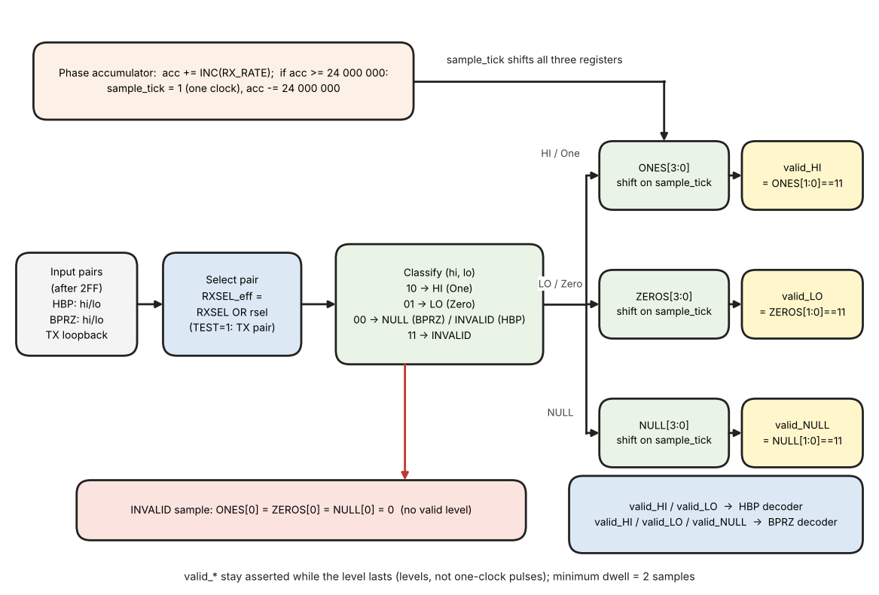
Figure 9. Data sampler datapath: pair select, classification, shift registers and 2-sample dwell

Timing tolerance of the sampler
Decoder tolerance: the received bit period may be up to 2 samples (25 %) longer or 1 sample (12.5 %) shorter than nominal. Outside this range the behaviour is not guaranteed (the reference model of Section 12.10 still decodes ideal streams at 6 and 11 samples per cell, but this is not a requirement). The core_clk accuracy (+/-0.1 %) and the accumulator residual (< 1 core_clk) are far inside this window.

3.2.1.2 HBP Decoder
What it does. The HBP decoder turns the stream of validated line levels coming from the sampler (Section 3.2.1.1) into one data bit per bit cell. It uses only the two dwell-validated flags valid_HI and valid_LO; it never looks at raw samples. For every recovered bit it produces one clock-wide pulse bit_valid together with the value bit_data, and it produces framing_error when the line does not follow the HBP rule. One bit cell lasts 8 sample_ticks at the nominal rate.
The coding rule (the same rule as the TX encoder, Section 3.1.3). Every bit cell starts with a transition (the boundary edge). A logic 1 has a second transition in the middle of the cell (the mid-cell edge); a logic 0 has none. The decoder therefore has to answer only one question per cell: was there a mid-cell edge or not?

Big picture: what the decoder does in three steps
- Step A - find where the cells are (ACQUISITION). After start-up the decoder does not know where a bit cell begins. It measures the distance between validated edges. A distance of about 8 samples can only be a bit 0 (boundary edge, nothing in the middle, next boundary edge), so the second of the two edges is a cell boundary. The decoder locks: it starts its own phase counter at that edge.
- Step B - count the 8 samples of every cell (TRACKING). The phase counter runs 0..7 and wraps to 0 at the end of every cell. Every edge that arrives at an expected place re-aligns the counter (boundary edge: phase := 1, mid-cell edge: phase := 5), so a small bit-rate error never accumulates.
- Step C - decide the bit. If an edge arrives in the middle of the cell (phases 4 to 6) the bit is a 1, otherwise it is a 0. The bit is output when the counter wraps to 0.
- Anything that does not fit (an edge at phase 7, or no edge for more than 12 samples) is a framing error: the decoder clears its window and trackers and goes back to Step A.
Figure 10 shows the three steps on one real stream (bits 0 1 1 0 1 0 0, 8 samples per cell, produced with the reference model of Section 12.10). Read it from left to right. In the blue part the decoder only measures the distance between edges; four distances of 4 samples tell it nothing, then a distance of 8 samples can only be two cell starts, so it locks. In the green part the phase counter runs 0..7 in every cell; an edge at phase 5 is a mid-cell edge, and at the end of the cell the bit is 1 if such an edge was seen and 0 if not. The bits that passed while the decoder was still searching are not output.
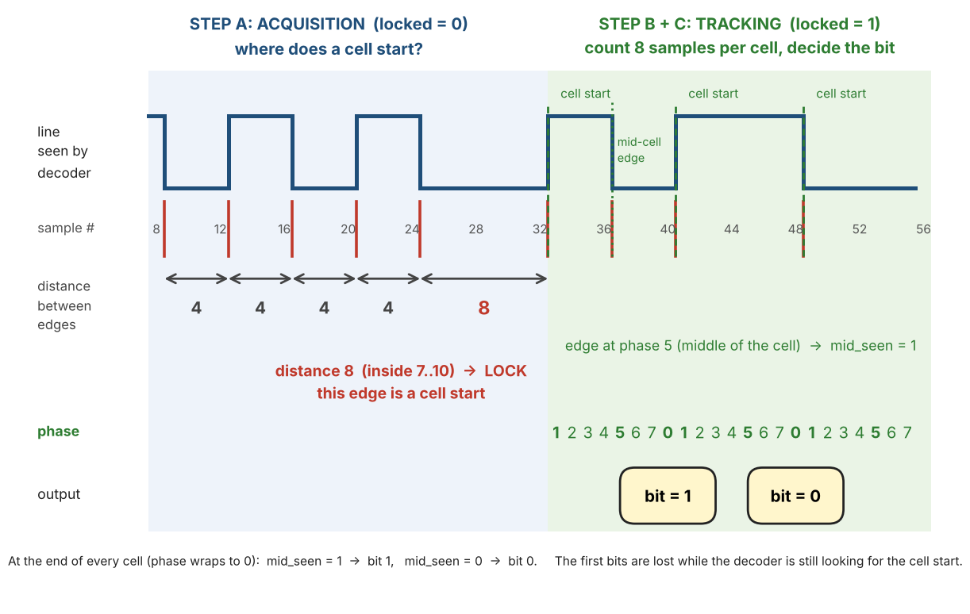
Figure 10. HBP decoder idea: finding the cell start (distance between edges), then counting 8 samples per cell and deciding the bit
Table 9. Distance between two consecutive validated edges (nominal cell = 8 samples)
Distance | Where it comes from (HBP rule) | Use in the decoder
about 4 samples | boundary edge to mid-cell edge, or mid-cell edge to the next boundary edge (the bit is a 1) | tracking: re-aligns the counter; acquisition: ignored
about 8 samples | boundary edge to the next boundary edge, with nothing in between (the bit is a 0) | acquisition: lock (distance 7 to 10); tracking: re-aligns the counter
more than 12 samples | no edge for more than one and a half cells: line idle, stopped or not HBP | tracking: framing error

Inputs, outputs and registers
Table 10. HBP decoder: inputs, outputs and registers
Name | Kind | Meaning | After reset / when rx_active rises
valid_HI, valid_LO | input | Dwell-validated line level from the sampler (Section 3.2.1.1), evaluated on every RX sample_tick while rx_active = 1. They are levels (they stay 1 while the line level lasts) and are never both 1. | -
bit_valid | output | One-clock pulse, one per recovered bit. | 0
bit_data | output | Recovered bit, valid together with bit_valid: 1 = a mid-cell edge was seen in this cell, 0 = none. | 0
framing_error | output | One-clock pulse when the line does not follow the HBP rule. | 0
level | register | HI or LO: the last validated line level. It changes only when the opposite flag is asserted (valid_LO after HI, valid_HI after LO). Samples that are not yet valid leave it unchanged and never create an edge. | not used (level_known = 0)
level_known | 1 bit | 0 until the first validated level. That first level only sets level and is not an edge. | 0
edge | this sample | 1 in the sample where level changes (a validated edge). | -
phase | 0..7 | The decoder's own sample counter inside the current cell; independent of the TX phase counter. Phase 0 is the sample of the true cell start. | not used until locked
mid_seen | 1 bit | Set when a mid-cell edge is observed in the current cell, cleared at every end of cell. It becomes bit_data. | 0
locked | 1 bit | 1 when the decoder knows where the bit cells are (bit lock). | 0
samples_since_edge | 0..15 | Samples since the last validated edge (saturates at 15). Used for the distance measurement in acquisition and for the no-edge timeout in tracking. 15 means "no edge seen yet". | 15

Why the observed edge is late. Because of the 2-sample dwell (Section 3.2.1.1) a validated edge is seen one sample after the true line transition. All windows below are therefore defined for the OBSERVED edge: the true cell start is phase 0, so a nominal boundary edge is observed at phase 1 and a nominal mid-cell edge (true phase 4) at phase 5.

Acceptance windows (observed edges, tracking mode)
Table 11. HBP decoder: acceptance windows (phase at which an edge is observed, tracking mode)
Phase | Meaning | Action | Nominal
0, 1, 2, 3 | Boundary edge: the start of a cell. It is not a bit; it only re-aligns the counter. | phase := 1 | 1
4, 5, 6 | Mid-cell edge: the bit of this cell is a 1. | mid_seen := 1; phase := 5 | 5
7 | Forbidden: too late for a boundary edge of this cell and too late for a mid-cell edge. | framing error | -

- Why these limits. The mid window is nominal phase 5 plus or minus 1 sample. The boundary window ends at phase 3, which allows a cell that is up to 2 samples longer than 8 (the next boundary edge is then observed at phase 3); a cell that is 1 sample shorter than 8 puts the next boundary edge at phase 0 (just after the wrap). This gives the capture range stated below: -1 / +2 samples per 8.

Algorithm: one evaluation per sample_tick
- Step 1 – update the level. new_level = HI if valid_HI, LO if valid_LO, otherwise unchanged. edge = level_known AND (new_level differs from level). Then level := new_level and level_known := level_known OR valid_HI OR valid_LO.
- Step 2 – age the last edge: samples_since_edge := min(samples_since_edge + 1, 15). bit_valid and framing_error default to 0.
- Step 3 – if locked = 0 go to ACQUISITION, otherwise to TRACKING.

ACQUISITION (locked = 0)
- A. Nothing is decoded; no bit_valid is produced. Only the distance between validated edges is measured.
- B. At a validated edge: gap := samples_since_edge, then samples_since_edge := 0.
- C. If gap is 7, 8, 9 or 10: the two edges are consecutive boundary edges around a bit 0 (a mid-cell edge always lies about 4 samples from its neighbours, so a distance of about 8 can only come from a bit 0). Set locked := 1, phase := 1, mid_seen := 0. The edge that was just seen is the boundary edge of a new cell, hence phase = 1.
- D. Any other gap (for example about 4 for a 1, or a long gap at the start) is ignored and the decoder keeps waiting.
- E. Start condition. samples_since_edge is 15 after reset and whenever rx_active rises ("no edge seen yet"). The first validated edge therefore only starts the measurement (its gap is 15 and is ignored); a lock needs two edges that really are 7 to 10 samples apart.

TRACKING (locked = 1)
- A. Advance the cell counter: phase := (phase + 1) mod 8.
- B. End of cell: if the new phase is 0 the cell has finished. In this sample bit_valid := 1 and bit_data := mid_seen; then mid_seen := 0. This happens exactly once per cell, independent of any edge.
- C. If a validated edge occurs in this same sample, classify it by the CURRENT phase value (after step A) and never by the gap to the previous edge: phase 0..3 = boundary edge, phase := 1 (no bit is created); phase 4..6 = mid-cell edge, mid_seen := 1, phase := 5; phase 7 = framing error.
- D. Whenever an edge was classified, samples_since_edge := 0.
- E. Timeout: if samples_since_edge is greater than 12 (no edge for more than one and a half cells) the line has stopped or is not HBP: framing error.
- F. Framing error (rule C phase 7, or timeout E): locked := 0, bit_valid is suppressed (it is 0 even if step B had set it), framing_error pulses, the 12-bit RX shift window and all sync trackers are cleared (SHALL, REQ-RX-03) and the decoder returns to acquisition.
- Order matters: step B uses the phase after the increment, so a boundary edge observed in the sample where the phase wraps to 0 gives one bit_valid (from the wrap) and is then classified as a boundary edge (phase := 1). It never produces a second bit.
A sample-by-sample trace of this decoder (the line, the valid flag and every register at every sample_tick, taken from the reference model) is given in Table 45, Section 12.10. Figure 10 above shows the same behaviour as a picture.
- Runs of identical bits stay aligned: for all ones every gap is about 4 samples, and both the boundary edges and the mid-cell edges re-align the phase.
Capture range: the bit period may be 1 sample shorter or 2 samples longer than 8 samples (-12.5 % / +25 %), as required for the supported rates; the core_clk accuracy and the accumulator residual are far inside this range. The HBP waveform rule is consistent with the Harvard biphase definition; see Section 1.5 for what is not publicly defined.
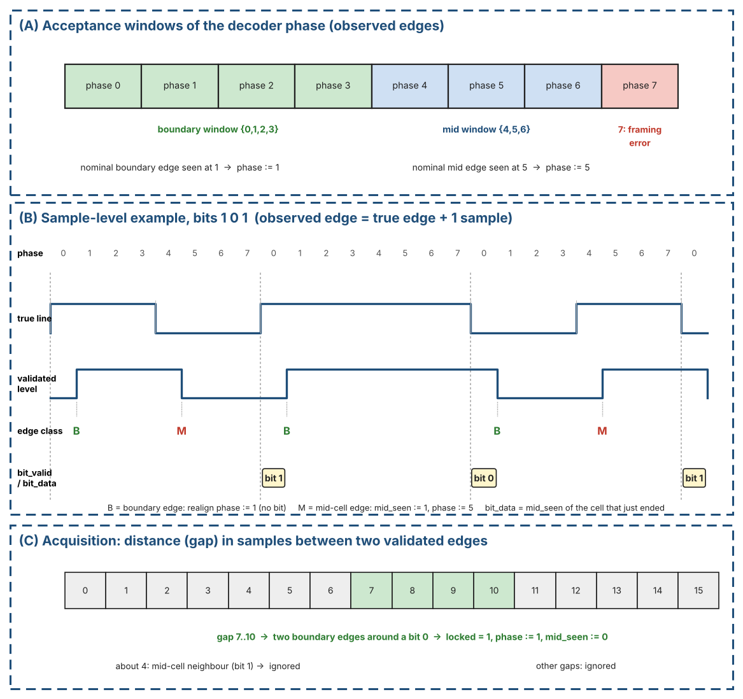
Figure 11. HBP decoder: acceptance windows, sample-level example and acquisition gap
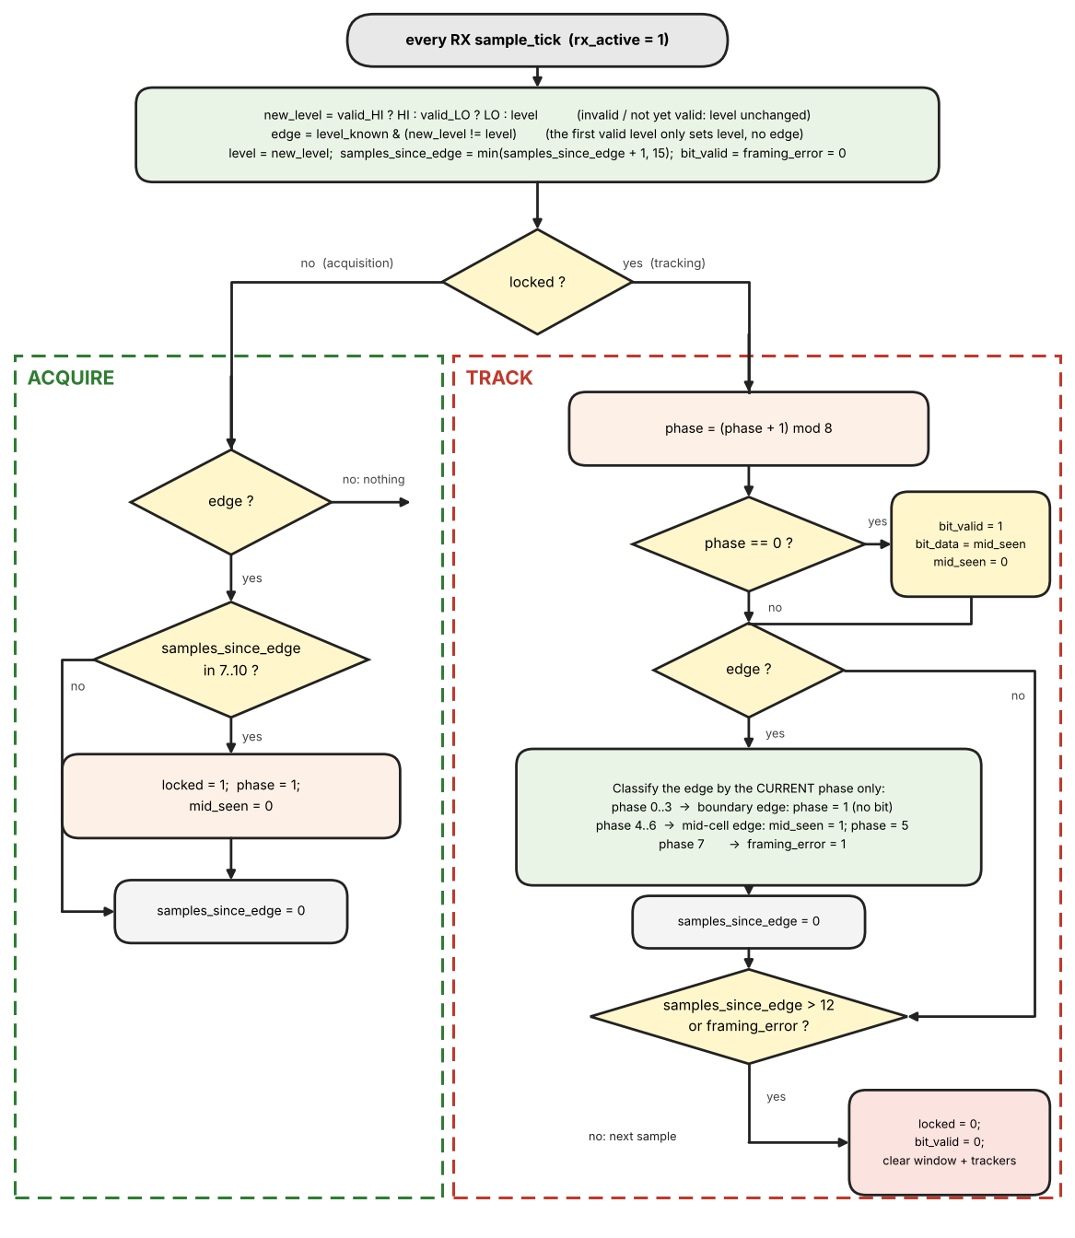
Figure 12. HBP decoder: flowchart of one evaluation per RX sample_tick

HBP decoder reference pseudo-code
// one evaluation per RX sample_tick (rx_active = 1); constants: boundary window {0,1,2,3}, mid
window {4,5,6}
// reset / when rx_active rises: locked = 0; level_known = 0; mid_seen = 0;
// samples_since_edge = 15 (no edge seen yet)
new_level = valid_HI ? HI : valid_LO ? LO : level // from Table 8 detectors
edge = level_known & (new_level != level) // first valid level only
sets 'level'
level = new_level; level_known = level_known | valid_HI | valid_LO
bit_valid = 0; framing_error = 0
samples_since_edge = min(samples_since_edge + 1, 15)
if (!locked) {
if (edge) { if (samples_since_edge in 7..10) { locked = 1; phase = 1; mid_seen = 0 }
samples_since_edge = 0 }
} else {
phase = phase + 1 // mod 8
if (phase == 0) { bit_valid = 1; bit_data = mid_seen; mid_seen = 0 } // end_of_cell
if (edge) {
if (phase in {0,1,2,3}) phase = 1 // boundary edge: realign,
never emits
else if (phase in {4,5,6}) { mid_seen = 1; phase = 5 } // mid-cell edge: realign
else framing_error = 1 // phase 7
samples_since_edge = 0
}
if (samples_since_edge > 12) framing_error = 1
if (framing_error) { locked = 0; bit_valid = 0 } // window and trackers are
cleared (REQ-RX-03)
}

3.2.1.3 BPRZ Decoder
The BPRZ decoder turns the three validated level flags of the sampler into one data bit per bit cell. Figure 13 shows the whole decoder on one page: the two-state machine on top, and below it what the line, the valid flags, the state and the output do over two consecutive bit cells (a 1 and a 0). The text that follows explains the figure step by step.
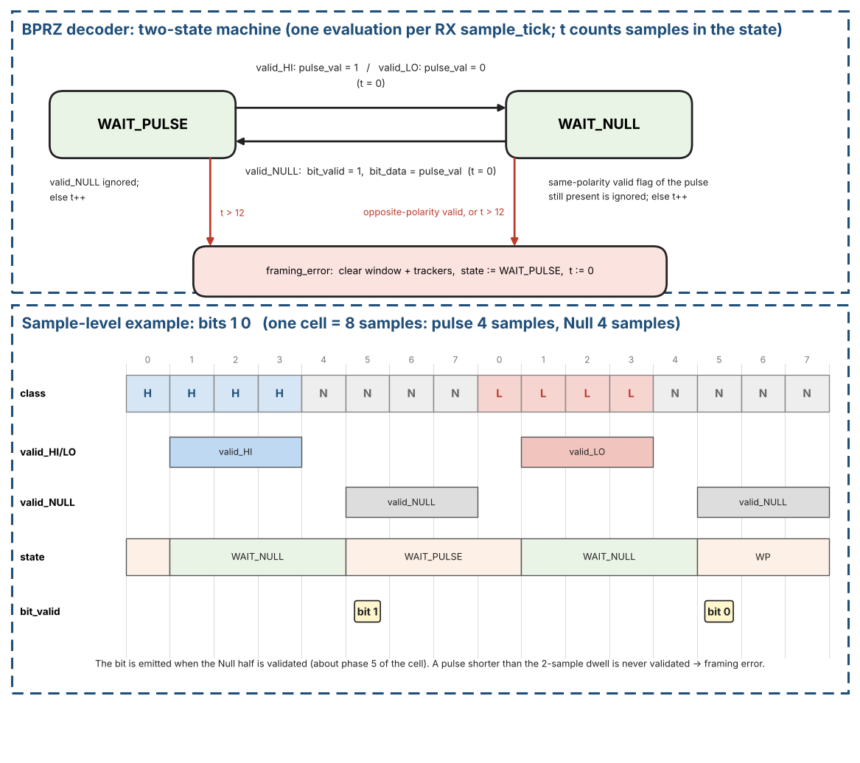
Figure 13. BPRZ decoder: the two-state machine (top) and what the flags and the state do over two bit cells, bits 1 and 0 (bottom)
What it does. The BPRZ decoder recovers one data bit per bit cell from the three dwell-validated level flags valid_HI (One), valid_LO (Zero) and valid_NULL (Section 3.2.1.1). Each cell on the line is a pulse in the first half (One for a 1, Zero for a 0) followed by Null in the second half, so the decoder only has to see "a pulse, then a Null" and remember the polarity of the pulse. No phase counter and no separate bit-lock state are needed: the Null that always follows a pulse re-synchronises the decoder in every cell, so each emitted bit is its own recovered bit-clock. valid_NULL is not a separate input: it is derived inside the sampler from rx_bprz_high = rx_bprz_low = 0 (Section 3.2.1.1).

Step by step (follow the figure from left to right)
- Step 1 - Wait for a pulse (state WAIT_PULSE). After reset, after every recovered bit and after every framing error the decoder is here. It looks only at valid_HI and valid_LO. A Null (the idle level and the second half of every cell) tells it nothing, so it is ignored; the counter t only counts how many samples have passed without a pulse.
- Step 2 - Remember the polarity (WAIT_PULSE -> WAIT_NULL). When valid_HI appears (a One pulse) the decoder stores pulse_val = 1; when valid_LO appears (a Zero pulse) it stores pulse_val = 0. It clears t and moves to WAIT_NULL. Because of the 2-sample dwell this happens at the second sample of the pulse (sample 1 of the cell in the figure). The decoder does not measure how long the pulse lasts.
- Step 3 - Wait for the Null half (state WAIT_NULL). The valid flag of the pulse stays asserted for as long as the pulse lasts. This is normal: a flag of the same polarity as pulse_val is ignored (without this rule every bit would raise a framing error). t counts the samples spent waiting.
- Step 4 - Output the bit (WAIT_NULL -> WAIT_PULSE). When valid_NULL appears the cell is complete: bit_valid pulses for one clock with bit_data = pulse_val, t is cleared and the decoder returns to WAIT_PULSE. This happens at the second sample of the Null (sample 5 of the cell, about phase 5), roughly 4 samples before the next pulse is validated. The Null that follows every pulse is what puts the decoder back into a known state, so no phase counter and no bit-lock search are needed.
- Step 5 - Framing errors. Three things are errors: (a) in WAIT_NULL a pulse of the OPPOSITE polarity is validated before the Null; (b) in WAIT_NULL, t becomes greater than 12 (the Null never came); (c) in WAIT_PULSE, t becomes greater than 12 (no pulse at all). On an error framing_error pulses, the decoder goes back to WAIT_PULSE with t = 0, and the 12-bit RX window and all sync trackers are cleared.
- Step 6 - What is ignored on purpose. A valid_NULL while in WAIT_PULSE; the same-polarity flag in WAIT_NULL (Step 3); and any glitch shorter than the 2-sample dwell, because a flag is never raised for it. Such a glitch can only delay the next valid flag by a sample or two; it is an error only if the wait exceeds 12 samples. A worked sample-by-sample example, including a one-sample glitch, is given in Table 46, Section 12.10.

Inputs, outputs and registers
Table 12. BPRZ decoder: inputs, outputs and registers
Name | Kind | Meaning | After reset / when rx_active rises
valid_HI, valid_LO, valid_NULL | input | Dwell-validated line levels from the sampler (Section 3.2.1.1), evaluated on every RX sample_tick while rx_active = 1. They are levels, not pulses: each stays asserted for as long as its level lasts. | -
bit_valid | output | One-clock pulse, one per recovered bit. | 0
bit_data | output | Recovered bit (1 = One pulse, 0 = Zero pulse), valid together with bit_valid. | 0
framing_error | output | One-clock pulse when the line does not follow the BPRZ rule. | 0
st | 1 bit | State: WAIT_PULSE or WAIT_NULL. | WAIT_PULSE (also after every framing error)
pulse_val | 1 bit | Polarity of the pulse that was seen (1 = One, 0 = Zero). Meaningful only in WAIT_NULL. | 0
t | 0..13 | Number of samples spent in the current state; cleared at every state change. | 0

Algorithm: one evaluation per sample_tick
- State WAIT_PULSE (waiting for the first half of a cell). If valid_HI: pulse_val := 1, st := WAIT_NULL, t := 0. Else if valid_LO: pulse_val := 0, st := WAIT_NULL, t := 0. Otherwise (Null or nothing valid yet): t := t + 1; if t is greater than 12 the line has no pulse: framing error. A valid_NULL in this state is simply ignored.
- State WAIT_NULL (a pulse was seen, waiting for the Null half). If valid_NULL: bit_valid := 1, bit_data := pulse_val, st := WAIT_PULSE, t := 0. Otherwise t := t + 1 and two error checks are made: (a) a pulse of the OPPOSITE polarity is validated before the Null (valid_LO while pulse_val = 1, or valid_HI while pulse_val = 0); (b) t is greater than 12 (the Null never came). Either one is a framing error.
- The valid flag of the SAME polarity as pulse_val is still asserted for as long as the pulse lasts; it is ignored and is not an error. Without this rule every bit would raise a framing error.
- Framing error: st := WAIT_PULSE, t := 0, framing_error pulses, and the 12-bit RX shift window and all sync trackers are cleared (SHALL, REQ-RX-03). The decoder then waits for the next pulse.

Timing of a nominal cell (8 samples, 4 pulse + 4 Null; Figure 13)
- Samples 0 to 3 carry the pulse. valid_HI (or valid_LO) is asserted at sample 1, the second consecutive pulse sample (2-sample dwell); the decoder leaves WAIT_PULSE there and stores pulse_val.
- Samples 4 to 7 carry the Null. valid_NULL is asserted at sample 5; the decoder emits bit_valid in that sample (about phase 5 of the cell) and returns to WAIT_PULSE, about 4 samples before the next pulse is validated.
- Tolerance. The decoder only needs a pulse of at least 2 samples and a Null of at least 2 samples, and never waits more than 12 samples in a state, so it does not depend on an exact 8-sample cell; it is more tolerant of rate error than the HBP decoder.
- A pulse shorter than the 2-sample dwell is never validated; it counts as a missing pulse and ends in a framing error (WAIT_PULSE timeout, or WAIT_NULL timeout if the pulse was seen).
- Idle line. An idle line in BPRZ mode (both inputs low = Null) is a missing pulse: WAIT_PULSE times out and raises a framing error every 13 samples. This is harmless, because the window and trackers are already clear and INSYNC is 0.
A sample-by-sample trace of this decoder (bits 1, 0, 1 with a one-sample glitch in the last cell: the line, the valid flag, the state, pulse_val and t at every sample_tick, taken from the reference model) is given in Table 46, Section 12.10.

BPRZ decoder reference pseudo-code
// one evaluation per RX sample_tick (rx_active = 1); t counts samples in the current state.
// valid_HI / valid_LO / valid_NULL stay asserted for as long as the level lasts (not one-clock
pulses).
bit_valid = 0; framing_error = 0
WAIT_PULSE: if (valid_HI) { pulse_val = 1; st = WAIT_NULL; t = 0 }
else if (valid_LO) { pulse_val = 0; st = WAIT_NULL; t = 0 }
else { t = t + 1; if (t > 12) framing_error = 1 }
WAIT_NULL : if (valid_NULL) { bit_valid = 1; bit_data = pulse_val; st = WAIT_PULSE; t = 0 }
else { t = t + 1
// same-polarity valid flag of the pulse that is still present is ignored
if ((pulse_val ? valid_LO : valid_HI) | (t > 12)) framing_error = 1 }
on framing_error: st = WAIT_PULSE; t = 0 // window and trackers are cleared (REQ-RX-03)

3.2.1.4 Hand-off to the Sync Detector
Both decoders present an identical interface to the rest of the receive path: a serial data-bit stream and a recovered bit-clock. The 12-bit sliding window of the sync detector is clocked exclusively by this recovered bit-clock, guaranteeing that every shift occurs on a validated data boundary. Consequently the sync state machine never has to deal with raw sample-level timing; it only sees clean, already-decoded bits.

3.2.2 Sync Detection
The sync detector finds the sync marks in the recovered bit stream and aligns the word boundaries. Section 3.2.2.1 describes the sliding window and the four code comparators, Section 3.2.2.2 the tracker algorithm of the default 4-sync mode, Section 3.2.2.3 the 2-sync mode (SFTSYNC = 1) and Section 3.2.2.4 the no-sync mode (NOSYNC = 1).

3.2.2.1 Sliding Window and Sync-Code Comparison
The sync detector operates on the stream of recovered data bits that leave the HBP/BPRZ decoder. Every recovered bit is shifted into a 12-bit sliding window (shift register). After each new bit the window is compared in parallel against the four legal subframe sync codes:
Table 13. Sync detection comparison codes (12-bit window)
Code | Octal | Binary (MSB←LSB of window) | Subframe
SYNC1 | 1107 | 001 001 000 111 | Subframe 1
SYNC2 | 2670 | 010 110 111 000 | Subframe 2
SYNC3 | 5107 | 101 001 000 111 | Subframe 3
SYNC4 | 6670 | 110 110 111 000 | Subframe 4

Because the ARINC 717 bus transmits LSB first, the first bit that enters the shift register is the LSB of the 12-bit word; after twelve shifts the register holds a complete candidate word with the original LSB at the bottom and the MSB at the top. The four comparators examine this window every bit period.
on every bit_valid: win <= {bit_data, win[11:1]}; // new bit enters at the MSB; after 12
shifts win[0] is the first received bit (LSB)

Figure 14 shows what the paragraphs above and the next section describe: every recovered bit pushes the 12-bit window one place, the four comparators look at all 12 bits at once, and a match produces a candidate sync event together with the code that matched. In the example the window holds 001 001 000 111, which is SYNC1.
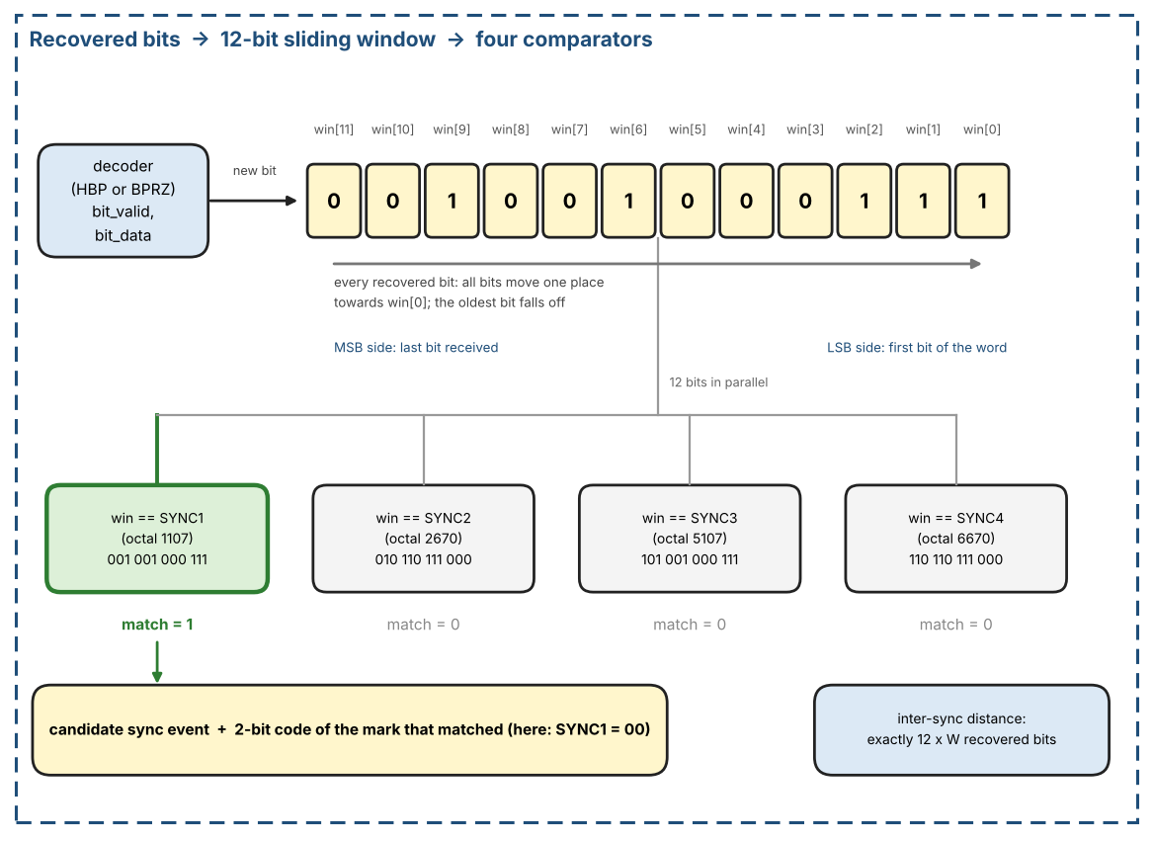
Figure 14. Sync detector: recovered bits enter a 12-bit window that is compared with the four sync codes after every bit
- On every recovered bit clock the oldest bit is discarded and the newest bit is shifted in (serial-in, parallel-out 12-bit shift register).
- Immediately after the shift, the 12-bit parallel value is presented to four equality comparators (one for each sync code).
- If any comparator asserts, a “candidate sync” event is generated together with a 2-bit code identifying which of the four marks was recognised.
- A free-running word-period counter (clocked by the recovered bit clock and reset by a successful sync match) measures the exact number of bit periods that have elapsed since the previous accepted sync mark. For a given programmed word rate the legal inter-sync distance is exactly one second, i.e. N words × 12 bits, where N is the number of words per subframe (64, 128, … 8192).

3.2.2.2 Sync Acquisition with Trackers (4-sync mode)
Idea
In a real ARINC 717 stream the four sync words follow one another at exactly one subframe distance, 12 x W recovered bits, where W is the words per subframe of the applied RX_RATE (Table 5). The same 12-bit pattern can also appear by chance inside the data, so a single match proves nothing. A tracker is a small counter that tells the two cases apart: it waits for the next sync code in the expected order and accepts it only if it arrives exactly 12 x W bits after the previous mark. A candidate that keeps this rhythm for the required number of marks is a real sync sequence; a candidate that breaks it is dropped. Random matches therefore never disturb a tracker that is following the real sequence.
Tracker slot
The detector has four tracker slots, so up to four candidates are followed in parallel. Acquisition uses only these slots (there is no separate primary state during acquisition).
Table 14. Fields of one tracker slot
Field | Width | Meaning
next_code | 2 bits | Index k (0..3 = SYNC1..SYNC4) of the sync code this tracker expects next
bit_count | 17 bits | Recovered bits since the last mark; 12 x 8192 = 98 304 < 2^17, so 17 bits cover the slowest rate
marks | 3 bits | Number of correct marks collected so far (1..5)
active | 1 bit | 1 = slot in use, 0 = free; a new tracker takes the lowest-numbered free slot

Operation on every recovered bit
Figure 15 shows what happens on every recovered bit_valid while INSYNC = 0. The steps (a) to (d) are executed in this order within the same core_clk cycle:
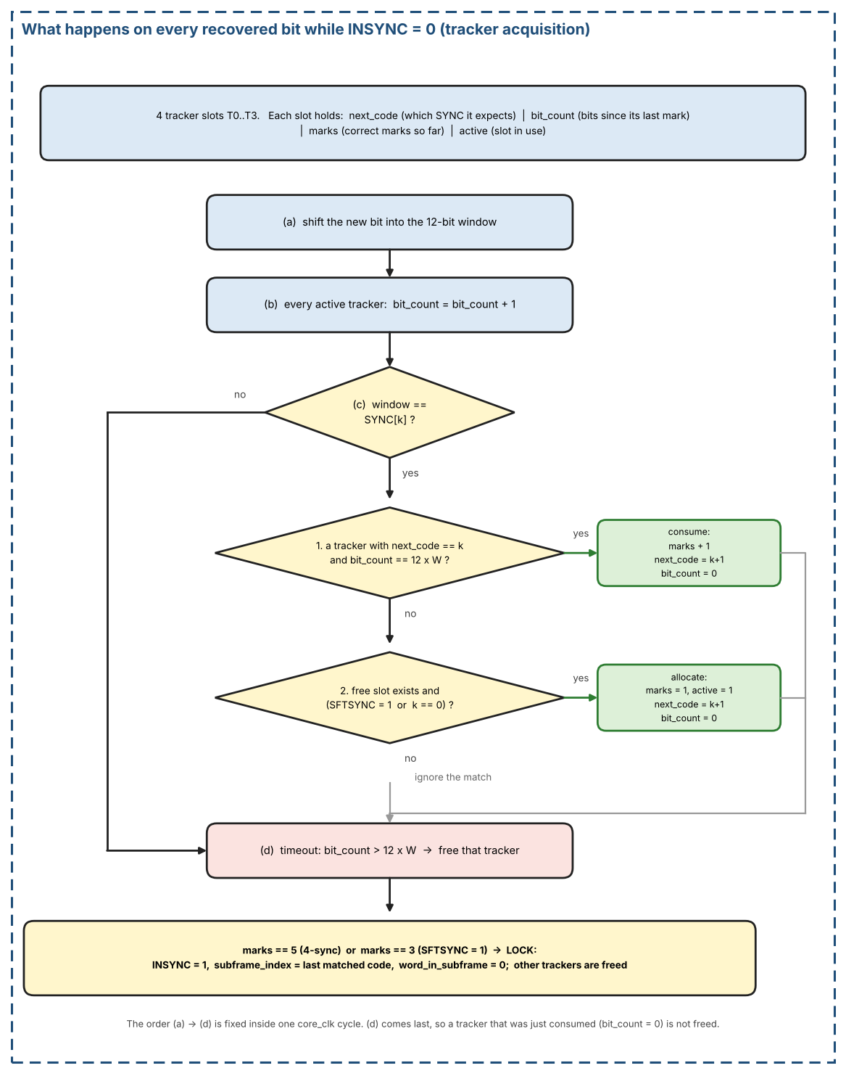
Figure 15. Per-bit operation of the tracker acquisition: window shift, bit_count update, code match (consume or allocate) and timeout
- (a) The new bit is shifted into the 12-bit window (Section 3.2.2.1).
- (b) Every active tracker increments bit_count. A tracker therefore matches when bit_count = 12 x W after this step.
- (c) If the window equals SYNC[k] (k = 0..3 for SYNC1..SYNC4), evaluate in order: (1) Consume: every active tracker with next_code = k and bit_count = 12 x W gets marks + 1, next_code = (k + 1) mod 4, bit_count = 0. (2) Allocate: if no tracker consumed the match and a free slot exists, a new tracker is started with marks = 1, next_code = (k + 1) mod 4, bit_count = 0, active = 1; this is allowed only if SFTSYNC = 1, or SFTSYNC = 0 and k = 0 (Table 15). Otherwise the match is ignored.
- (d) Timeout, evaluated last: a tracker whose bit_count exceeds 12 x W (exact, no extra tolerance) is freed. Because (d) comes after (c), a tracker that was just consumed (bit_count = 0) is never freed in the same cycle. A match that arrives at a wrong distance does not penalise a tracker; the tracker simply keeps counting until it either matches at the right distance or times out.
Lock conditions
Table 15. Acquisition parameters of the two modes
Mode | SFTSYNC | Marks needed for lock | Codes that may start a tracker
4-sync (default) | 0 | 5: SYNC1, SYNC2, SYNC3, SYNC4, SYNC1 | SYNC1 only (k = 0)
2-sync | 1 | 3: any three consecutive codes of the cycle | Any code SYNC[k]

When any tracker reaches the required number of marks: INSYNC = 1, subframe_index = index of the last matched code, word_in_subframe = 0. That tracker becomes the primary one and all other trackers are freed. From then on lock is maintained solely by the word-0 check of Section 3.2.3.1 (the assembled word must equal RX_SYNC[subframe_index] at each subframe start); the tracker machinery is idle until INSYNC drops.
Decoder errors and acquisition time
A decoder framing error or loss of bit lock (Sections 3.2.1.2 and 3.2.1.3) frees all trackers and clears the window and the bit counters, because their bit_count values are no longer meaningful. If INSYNC = 1 the framing error also de-asserts INSYNC (bit alignment is lost) and raises ST_INSYNC_LOST; acquisition then restarts.
Worst-case acquisition takes on the order of two frames, when the first examined bit falls just after a SYNC1. A typical acquisition takes about one frame.
Implementation notes
- Trackers and the window run only while rx_active = 1 and INSYNC = 0.
- The window, the trackers and the lock logic are all clocked by core_clk and advance once per recovered bit_valid.

Worked example: 4-sync mode, W = 64 words per subframe
The distance between two sync words is 12 x W = 768 recovered bits. The receiver starts at bit 0 in the middle of a subframe (29 bits before the first SYNC1). Two words inside the data happen to equal a sync code (a false SYNC1 in the first subframe and a false SYNC3 in the second). The table lists the events in the order they happen. The bit index is the index of the last bit of the matching window; T0 and T1 are tracker slots after the evaluation of that bit.
Figure 16 draws the same events as the table below on a bit axis. Green dots are real sync marks, red circles are false hits inside the data. T0 advances only when the next code arrives exactly 768 bits after the previous one; T1, started by a false SYNC1, never sees SYNC2 at the right distance and times out.
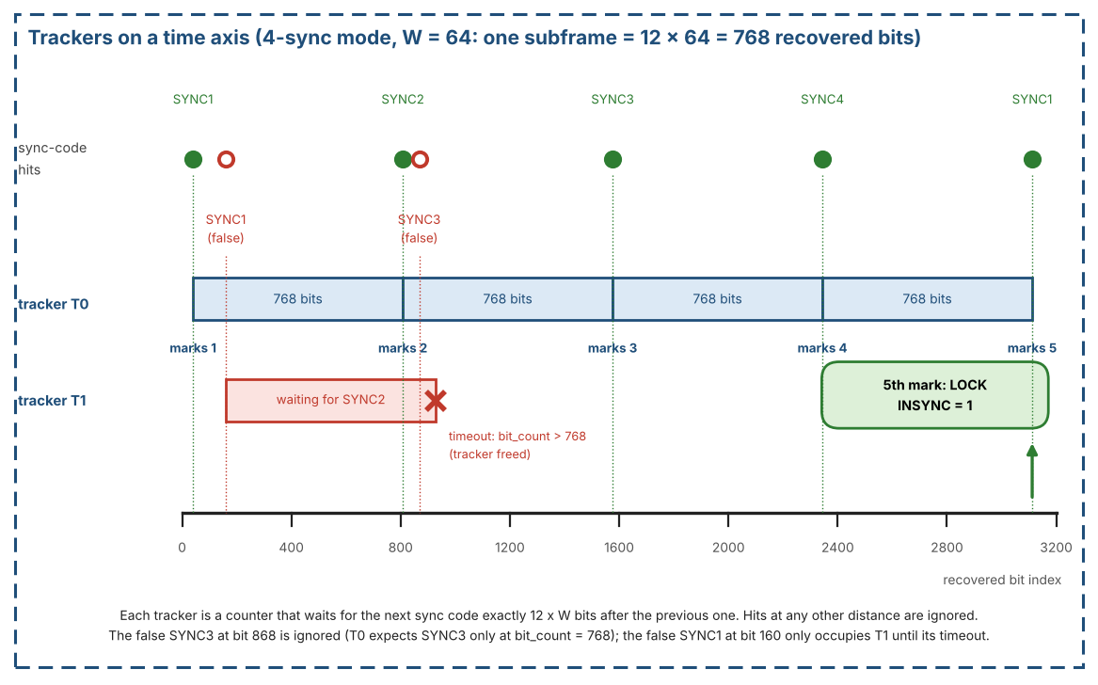
Figure 16. Sync acquisition on a time axis: tracker T0 reaches 5 marks and locks, tracker T1 times out (4-sync mode, W = 64)
Table 16. Sync acquisition example (4-sync mode, W = 64)
Bit | Window | T0 | T1 | Result
40 | SYNC1 | next SYNC2, bit_count 0, marks 1 | free | No tracker expects it. SYNC1 may allocate: T0 allocated.
160 | SYNC1 | next SYNC2, bit_count 120, marks 1 | next SYNC2, bit_count 0, marks 1 | False mark inside the subframe. T0 expects SYNC2 and its bit_count is 120, not 768, so it is not consumed. SYNC1 allocates T1.
808 | SYNC2 | next SYNC3, bit_count 0, marks 2 | next SYNC2, bit_count 648, marks 1 | T0: bit_count = 768 = 12 x W, code matches: consumed, marks = 2. T1 (bit_count 648) does not match.
868 | SYNC3 | next SYNC3, bit_count 60, marks 2 | next SYNC2, bit_count 708, marks 1 | False SYNC3 (T0 expects SYNC3 only at bit_count 768, and SYNC3 cannot allocate in 4-sync mode): ignored.
929 | - | next SYNC3, bit_count 121, marks 2 | free | T1: bit_count exceeds 12 x W = 768: tracker freed (timeout).
1576 | SYNC3 | next SYNC4, bit_count 0, marks 3 | free | T0 consumed, marks = 3.
2344 | SYNC4 | next SYNC1, bit_count 0, marks 4 | free | T0 consumed, marks = 4.
3112 | SYNC1 | locked (primary) | free | T0 consumed, marks = 5: LOCK. INSYNC = 1, subframe_index = 0, this window is word 0. The other trackers are freed.

- Random matches do no harm. The false SYNC1 only costs a tracker slot until it times out (bit 929); the false SYNC3 is ignored. Neither one changes T0.
- Lock needs five marks, each exactly 768 bits after the previous one: SYNC1, SYNC2, SYNC3, SYNC4 and SYNC1 again. The first mark starts the tracker, so after it four consecutive correct distances are needed.

Sync Detection FSM and tracker state diagram
The Sync Detection FSM and the tracker slots follow the state diagrams of Figure 17. Within one recovered bit the order of steps (a) to (d) in the diagram is fixed. W is the words per subframe of the applied RX_RATE (Table 5).
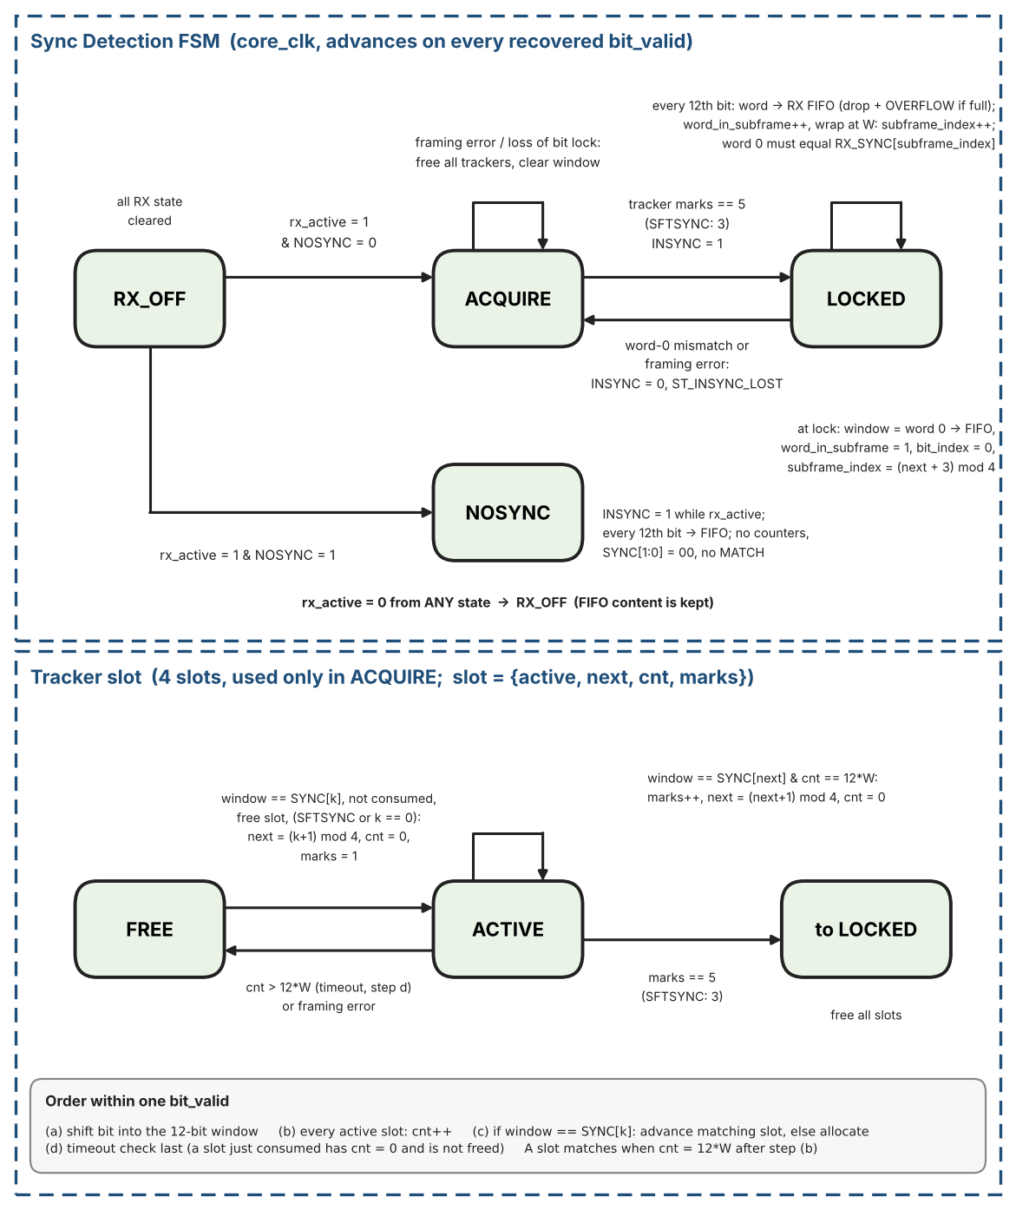
Figure 17. Sync Detection FSM and tracker slot state diagrams

3.2.2.3 Two-Sync-Word Mode (SFTSYNC = 1)
When RX_CTRL.SFTSYNC=1 the tracker rules of 3.2.2.2 use marks==3 for lock and may allocate a tracker on any SYNC[k] (not only SYNC1). Maintenance while INSYNC remains the word-0 check in 3.2.3.1.
Use when the absolute identity of the first observed subframe is unimportant.

3.2.2.4 No-Sync Mode (NOSYNC = 1)
When RX_CTRL.NOSYNC = 1 the trackers and the word-0 check are bypassed. INSYNC reads 1 while rx_active = 1. bit_index counts recovered bits from 0 at the first bit_valid after rx_active rises or after a decoder framing error, so the word alignment is arbitrary and software must locate subframe marks in the data. Every 12th recovered bit the assembled word is written to the RX FIFO. word_in_subframe and subframe_index do not run: SYNC[1:0] = 00, MATCH is never asserted and ST_INSYNC_LOST is not generated.
Figure 18 compares the three modes of Sections 3.2.2.2 to 3.2.2.4 side by side: how many marks are needed to lock, which codes may start a tracker, and what happens in no-sync mode.
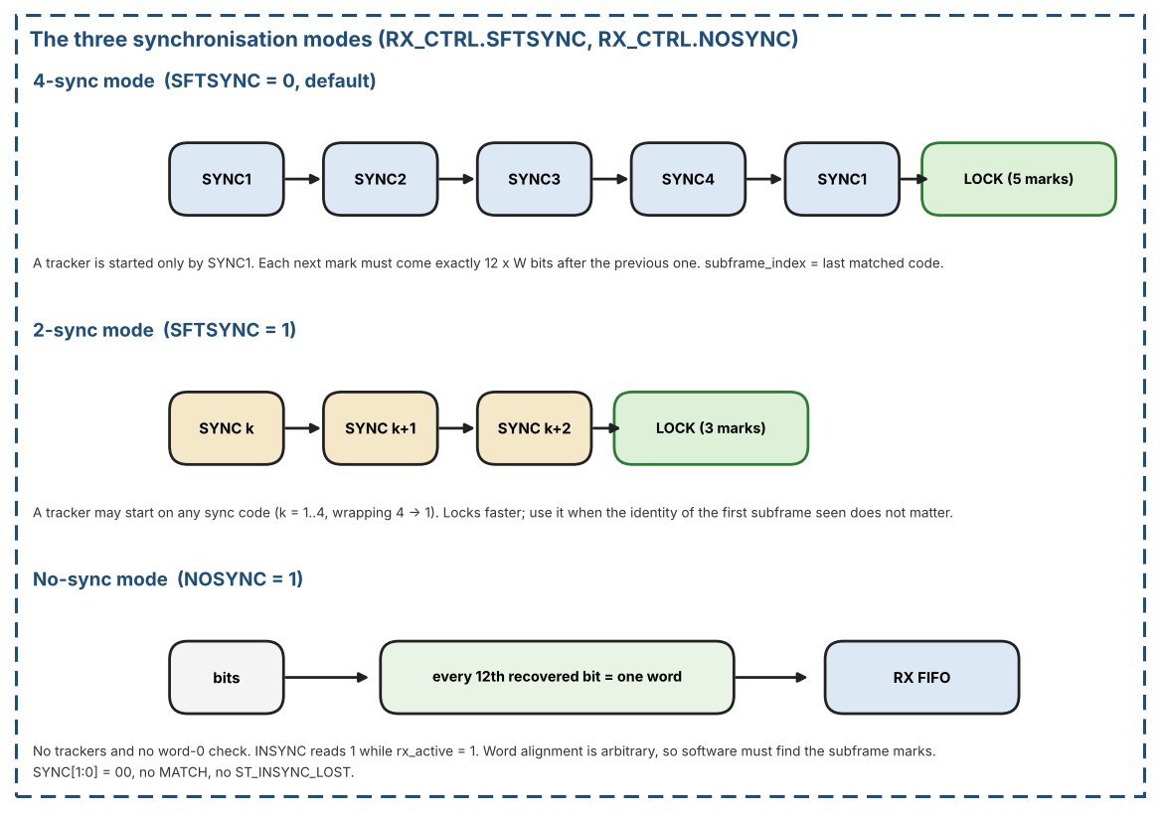
Figure 18. The three synchronisation modes: 4-sync, 2-sync and no-sync

3.2.3 Word Framing After Lock
After lock the receiver counts bits and words from the matched sync mark: Section 3.2.3.1 describes the RX Timing Generator and its counters, Section 3.2.3.2 how each completed word is delivered to the RX FIFO.

3.2.3.1 RX Timing Generator and word counters
Once INSYNC is asserted, the RX Timing Generator produces recovered bit_tick/word_tick locked to the decoder.
Figure 19 shows the timing in units of recovered bits. Part A: at lock the window that matched the sync code is word 0 and is written to the RX FIFO in the same cycle; from then on bit_index counts 0..11, and every 12th recovered bit completes a word, increments word_in_subframe and writes the word. Part B: when word_in_subframe wraps to 0, the assembled word must equal RX_SYNC[subframe_index]; a mismatch drops INSYNC and the word is not written.
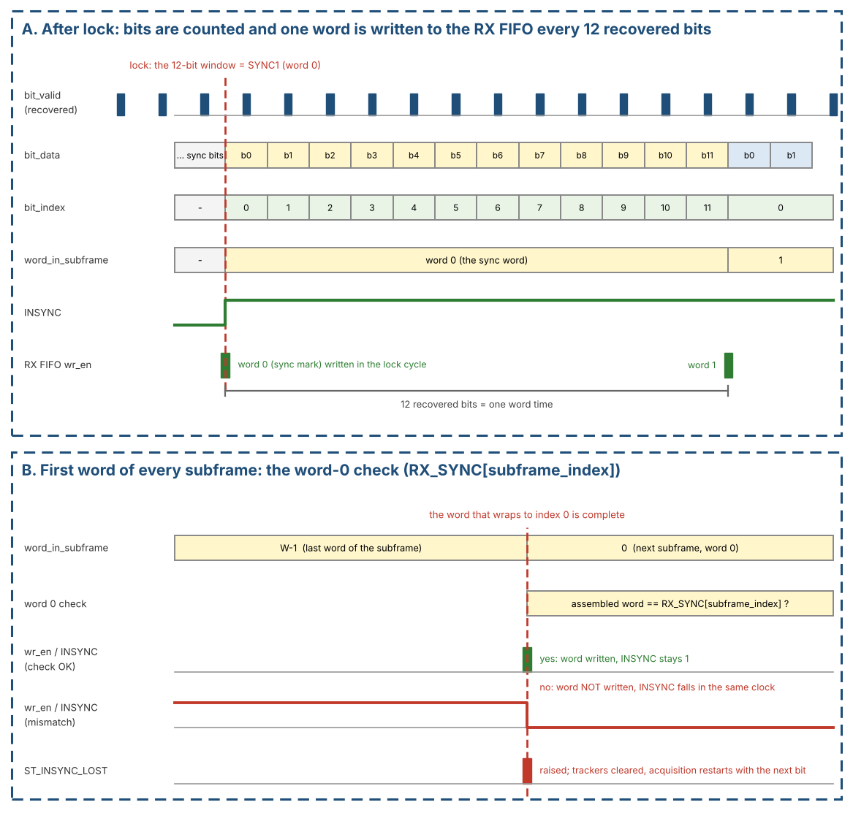
Figure 19. RX timing after lock: bit_index, word_in_subframe, FIFO write, and the word-0 check at the start of a subframe
Counters:
- bit_index (mod 12): counts recovered bits in the current word; resets to 0 at lock and after each completed word.
- word_in_subframe resets to 0 on the word that caused lock (that sync mark is word 0).
- Each subsequent accepted word increments word_in_subframe; at W words/s it wraps and subframe_index advances 0->1->2->3->0.
- At word_in_subframe = 0 of every subframe (the word whose index wraps to 0) the assembled word SHALL equal RX_SYNC[subframe_index]. On a mismatch the word is NOT written to the RX FIFO, INSYNC falls in the same clock, ST_INSYNC_LOST is raised, all trackers are cleared and acquisition restarts with the next bit (the 12-bit window keeps shifting).
- SFTSYNC lock: subframe_index initialises to the index of the last matched code. NOSYNC: see Section 3.2.2.4 (the counters do not run).
- SYNC[1:0] status mirrors subframe_index while INSYNC=1.
- RX FIFO write: when bit_index reaches 12 and the word is accepted it is written in that core_clk cycle; if the FIFO is full the word is dropped and OVERFLOW is signalled.
- A decoder framing error while INSYNC = 1 also de-asserts INSYNC (same actions as a word-0 mismatch).
- MATCH compares (subframe_index, word_in_subframe) of the word being written against WRDCNT; word 0 is the sync word. The match pin and RX_STATUS.MATCH are registered high in the clock where the matching word is written to the RX FIFO and stay high until the next word is written (one word-time); a one-clock event goes to the CPU IF for ST_MATCH. WORD_CNT >= W never matches.

3.2.3.2 Word Delivery After Lock
Once INSYNC rises, the 12-bit window that caused the lock (SYNC1 in 4-sync-word mode, the third matching mark in 2-sync-word mode) is word 0 and is written to the RX FIFO in the same core_clk cycle. Subsequent words are written every 12 recovered bits. RX_STATUS.EMPTY therefore falls shortly after INSYNC asserts (FIFO pointer CDC latency, Section 4.2.4). If the receiver later loses lock, the FIFO write port is gated off immediately; words already stored remain readable by the host.
Worst-case acquisition is about two frames (8 s). If INSYNC remains de-asserted for much longer, software may clear and set RX_EN (or use SOFT_RESET, which also flushes the FIFOs) to force a clean re-acquisition.

3.3 Bit Rate and Clock Requirements
A 24 MHz ±0.1 % reference (core_clk) is required. The sample-tick generator of Section 3.2.1.1 derives all bit and word timing from a 4-bit rate field: TX_CTRL.TX_RATE[3:0] for the transmitter and RX_CTRL.RX_RATE[3:0] for the receiver (same bit positions, same encoding). The encoding (rate code to words/s, bits/s and INC) is defined once, in Table 5.
Changing the rate on-the-fly is not supported; follow the rate-change procedure of Section 2.4 (separately for TX and RX).

3.4 Digital Loopback
Setting TEST = 1 disconnects the external RX inputs inside the FPGA and routes the TX encoder outputs selected by RX_CTRL.RXSEL into the RX sampler/decoder: RXSEL=0 loops HBP (tx_hbp_high/low); RXSEL=1 loops BPRZ (tx_bprz_high/low). External TX pins continue to drive; they are not high-impedance. All status flags and FIFOs operate normally, allowing a pure digital self-test. The loopback pair is already in the core_clk domain and bypasses the pin synchronisers. In loopback TX_RATE and RX_RATE SHALL be programmed to the same code, otherwise the receiver samples at a different rate than the transmitter and will not lock. The board self-test of Section 12.13 uses this loopback.

4. AXI4-Lite Protocol & Clock-Domain Crossing

4.1 AXI4-Lite Protocol
- At most one outstanding transaction.
- AW and W may arrive on different cycles; BVALID held until BREADY; RVALID held until RREADY.
- Write to a read-only register, or access outside the decode window 0x0000-0x014F -> SLVERR. Read of a pure write-only register (e.g. FIFO_CLEAR) -> SLVERR. Reserved offsets inside a block return OKAY (Table 19). TX_DATA is a read/write latch: a read returns the last latched word with OKAY, and a write alone never pushes (Section 7.5).
- TX push (TX_WR_ADDR write while TX_WR_EN = 1) when write-side FULL → BRESP = SLVERR, word not written.
- RX data read when read-side EMPTY → RRESP = SLVERR, no pop.

4.1.1 Register access rules (normative)
- Address decode: AWADDR/ARADDR[1:0] are ignored (word access); [15:2] is decoded. Addresses above 0x014F are unmapped.
- WSTRB: only 4'b1111 is accepted on writes; any other value returns BRESP = SLVERR with no side effect.
- A read and a write request that arrive together are served one at a time, write first.
- While GLOBAL_STATUS.CLR_BUSY = 1 (SOFT_RESET or a FIFO clear in progress): TX pushes (TX_WR_ADDR writes while TX_WR_EN = 1), RX_RD_DATA accesses and writes to TX_FIFO_CLEAR / RX_FIFO_CLEAR return SLVERR with no side effect, and a new SOFT_RESET write is ignored. All other accesses behave normally.
Table 17. Register access rules
Register / range | Read | Write
CORE_VERSION, GLOBAL_STATUS, TX_STATUS, RX_STATUS, INJ_STATUS | value, OKAY | SLVERR, no effect
GLOBAL_CTRL, TX_CTRL, RX_CTRL, TX_WR_EN, RX_RD_EN, RX_RD_ADDR, TX_SYNCx, RX_SYNCx, WRDCNT, INJ_CTRL, TX/RX_IRQ_ENABLE | value, OKAY | OKAY (reserved bits ignored, read 0)
TX_IRQ_STATUS, RX_IRQ_STATUS | value, OKAY | OKAY; writing 1 clears that bit (W1C), writing 0 has no effect
TX_FIFO_CLEAR, RX_FIFO_CLEAR | SLVERR | OKAY; writing 1 starts the clear (SLVERR if CLR_BUSY = 1), writing 0 has no effect
TX_DATA | last latched word, OKAY | latch bits[11:0], OKAY (no push)
TX_WR_ADDR | value, OKAY | store value; if TX_WR_EN = 1 push the latched TX_DATA word, SLVERR if FULL or CLR_BUSY = 1; if TX_WR_EN = 0 OKAY, no push
RX_RD_DATA | pop; SLVERR if EMPTY or CLR_BUSY = 1 | SLVERR, no effect
Reserved offsets inside defined blocks (Table 18) | 0, OKAY | OKAY, ignored
Outside 0x0000-0x014F | SLVERR | SLVERR

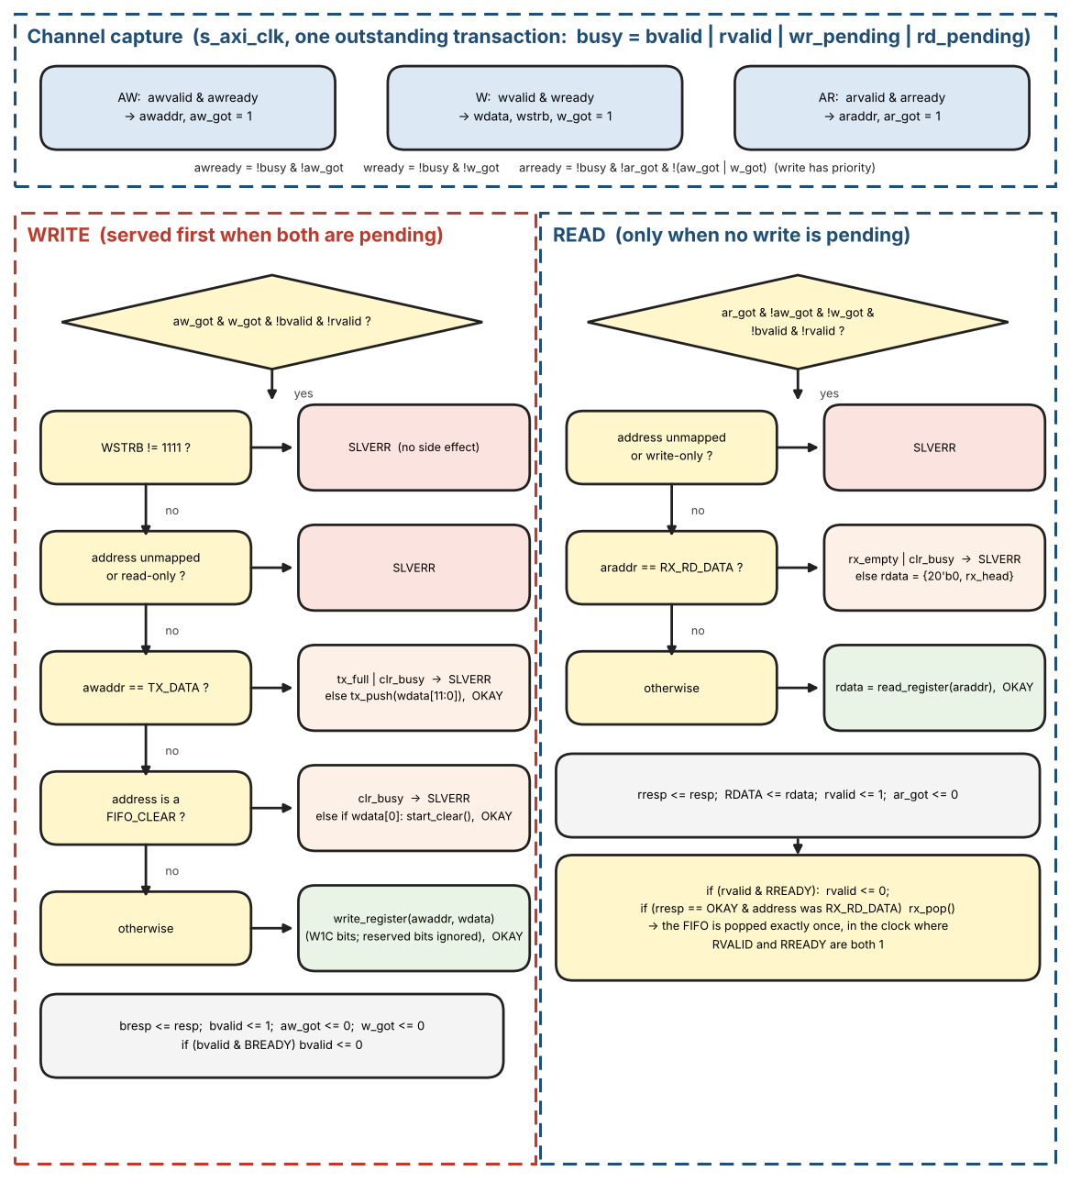
Figure 20. AXI-Lite slave: channel capture, write ladder and read ladder

AXI-Lite slave reference pseudo-code
The slave accepts one transaction at a time. RDATA stays stable while RVALID waits for RREADY because the FWFT head does not change before the pop; the pop happens in the clock where RVALID and RREADY are both 1.
// s_axi_clk. One outstanding transaction: busy = bvalid | rvalid | wr_pending | rd_pending
awready = !busy & !aw_got; wready = !busy & !w_got; arready = !busy & !ar_got & !(aw_got |
w_got)
on (awvalid & awready) { awaddr <= AWADDR; aw_got <= 1 }
on (wvalid & wready ) { wdata <= WDATA; wstrb <= WSTRB; w_got <= 1 }
on (arvalid & arready) { araddr <= ARADDR; ar_got <= 1 }

// WRITE (served first when both are pending)
if (aw_got & w_got & !bvalid & !rvalid) {
resp = OKAY
if (wstrb != 4'b1111) resp = SLVERR // no side effect
else if (!mapped(awaddr) | read_only(awaddr)) resp = SLVERR
else if (awaddr == TX_DATA) tx_data <= wdata[11:0] // latch only, no push
else if (awaddr == TX_WR_ADDR) { tx_wr_addr <= wdata // index, no hardware meaning
if (tx_wr_en) { if (tx_full | clr_busy) resp = SLVERR else tx_push(tx_data) } }
else if (is_fifo_clear(awaddr)) { if (clr_busy) resp = SLVERR else if (wdata[0])
start_clear() }
else write_register(awaddr, wdata) // W1C, reserved
bits ignored
bresp <= resp; bvalid <= 1; aw_got <= 0; w_got <= 0
}
if (bvalid & BREADY) bvalid <= 0

// READ
if (ar_got & !aw_got & !w_got & !bvalid & !rvalid) {
resp = OKAY; rdata = 0
if (!mapped(araddr) | write_only(araddr)) resp = SLVERR
else if (araddr == RX_RD_DATA) { if (rx_empty | clr_busy) resp = SLVERR else
rdata = {20'b0, rx_head} }
else rdata = read_register(araddr)
rresp <= resp; RDATA <= rdata; rvalid <= 1; ar_got <= 0
}
if (rvalid & RREADY) { rvalid <= 0; if (rresp == OKAY & raddr_was_RX_RD_DATA) rx_pop() } //
pop exactly once

4.2 Clock-Domain Crossing

4.2.0 Input pin synchronisers
rx_hbp_high, rx_hbp_low, rx_bprz_high, rx_bprz_low, and rsel SHALL each pass through a 2FF synchroniser into core_clk before the sampler/classifier. These are single-bit CDC paths.

4.2.1 Config / Status
All configuration registers used by the core_clk logic cross as ONE configuration bundle with a single request/acknowledge handshake: GLOBAL_CTRL (GLOBAL_EN, TX_EN, RX_EN), TX_CTRL (including TX_RATE), RX_CTRL (including RX_RATE), WRDCNT, TX_SYNC1..4 and RX_SYNC1..4. The bundle is applied atomically on the core_clk side, so enables can never overtake TX_RATE / RX_RATE or the sync codes and software needs no CFG_BUSY bit or ordering rule. SOFT_RESET and the FIFO_CLEAR bits are not part of the bundle; they use their own handshakes (Section 5). GLOBAL_CTRL.IRQ_ENABLE and the per-source IRQ_ENABLE registers stay in the s_axi_clk domain (Section 8).
Handshake: any write to a bundle register sets cfg_dirty (s_axi_clk). When no handshake is in flight and cfg_dirty = 1, the s_axi side copies the whole bundle into cfg_hold, clears cfg_dirty and toggles cfg_req. The core side synchronises cfg_req (2FF), loads cfg_hold into its working registers in one clock cycle and toggles cfg_ack; the s_axi side synchronises cfg_ack (2FF). cfg_hold SHALL NOT change between cfg_req and cfg_ack. A write that arrives while a handshake is in flight only updates the register and sets cfg_dirty again; a new handshake starts after cfg_ack, so the last value written always reaches the core.
The AXI write response is OKAY as soon as the register is written (it does not wait for the handshake). Bounded latency: after the last write the final bundle is applied on the core_clk side within 2 x (3 core_clk + 3 s_axi_clk) + 2 s_axi_clk cycles. Because the bundle is atomic no write ordering is required; the bound only tells software how long to wait before relying on a change (for example before expecting TX to start after enabling, or before re-enabling after a rate change).

Configuration handshake reference pseudo-code
// ---- s_axi_clk ----
on write to a bundle register: cfg_dirty <= 1
if (cfg_dirty & !inflight) {
cfg_hold <= bundle; cfg_dirty <= 0 // a write in this same clock keeps cfg_dirty =
1
cfg_req <= ~cfg_req; inflight <= 1 }
ack_s <= {ack_s[0], cfg_ack}
if (ack_s[1] != ack_seen) { ack_seen <= ack_s[1]; inflight <= 0 }

// ---- core_clk ----
req_s <= {req_s[0], cfg_req}
if (req_s[1] != req_seen) {
req_seen <= req_s[1]
cfg_applied <= cfg_hold // all fields in one clock
cfg_ack <= ~cfg_ack }

// latch rules (Section 2.4), core_clk:
if (!tx_active) tx_rate_applied <= cfg_applied.TX_RATE
if (!rx_active) rx_rate_applied <= cfg_applied.RX_RATE
if (!tx_active) sync_ins_applied <= cfg_applied.SYNC_INS_MODE
if (!rx_active) rxsel/nosync/sftsync/test_applied <= cfg_applied.(same fields)

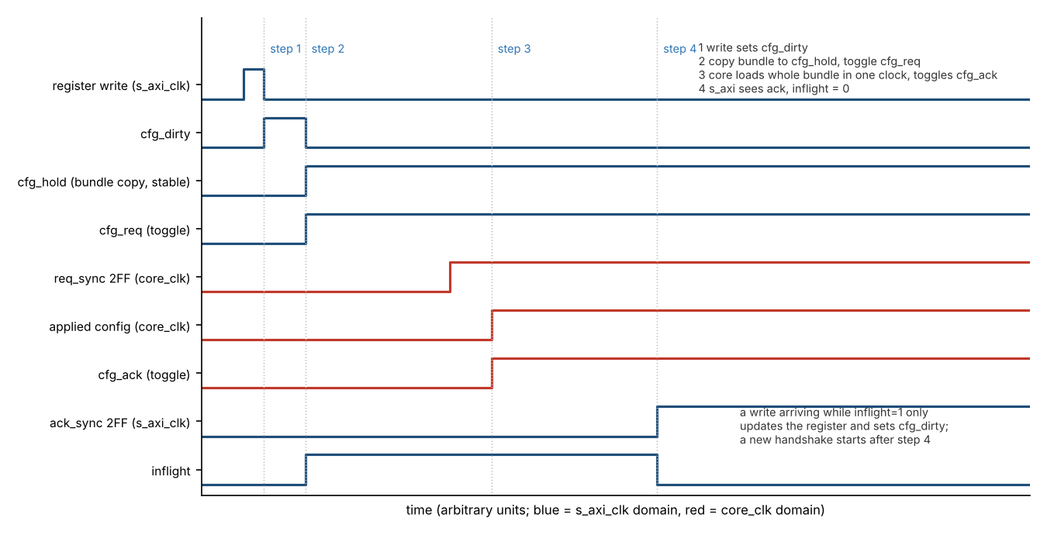
Figure 21. Configuration bundle handshake (s_axi_clk to core_clk)
Core to s_axi_clk: INSYNC and SYNC[1:0] cross as one coherent snapshot; core-originated interrupt events cross as toggle pulses (Section 8). Single-bit status uses 2FF.

4.2.2 Data Path
Data movement uses only the dual-clock asynchronous FIFOs. Push/pop accept/reject decisions are taken from the native same-clock FULL (TX write side) or EMPTY (RX read side) flags; they never depend on CDC-lagged STATUS registers.

4.2.3 Direction Map (frozen)
- Config write (s_axi_clk to core_clk): the atomic configuration bundle (Section 4.2.1); soft-reset and FIFO-clear requests (Section 5).
- Core to s_axi_clk: INSYNC / SYNC[1:0] snapshot and core interrupt event pulses (OVERFLOW, MATCH, INSYNC_LOST). FIFO flags, levels and the FIFO bits of TX_STATUS / RX_STATUS are computed on s_axi_clk from the FIFO pointers (Section 4.2.4).
- Push/pop accept: native FIFO flags on s_axi_clk only.

4.2.4 FIFO level and flag computation
Each async FIFO has a binary write pointer and read pointer of ceil(log2(FIFO_DEPTH))+1 bits (8 bits at the default depth 128); the extra MSB distinguishes full from empty. Gray-coded copies cross to the other domain through 2FF synchronisers.
- TX FIFO, s_axi_clk side: level = wr_ptr - rd_ptr_sync (Gray to binary after synchronisation). rd_ptr_sync lags, so level is never lower than the true occupancy. FULL = (level = FIFO_DEPTH) guards pushes, so a push can never overflow the FIFO. the TX_STATUS flags and the TX interrupt events all use this value.
- TX FIFO, core_clk side: EMPTY is computed from rd_ptr and wr_ptr_sync. The lag makes EMPTY pessimistic: the core may see EMPTY a few cycles after a word was pushed, but never reads a word that is not yet written.
- RX FIFO, s_axi_clk side: level = wr_ptr_sync - rd_ptr; it is never higher than the true occupancy. EMPTY guards pops. the RX_STATUS flags use this value.
- RX FIFO, core_clk side: FULL is computed from wr_ptr and rd_ptr_sync (conservative). A word arriving while FULL is dropped and OVERFLOW is signalled.
The FIFO fields of TX_STATUS / RX_STATUS and the interrupt events are therefore s_axi_clk-computed values, conservative by at most a few clock cycles.
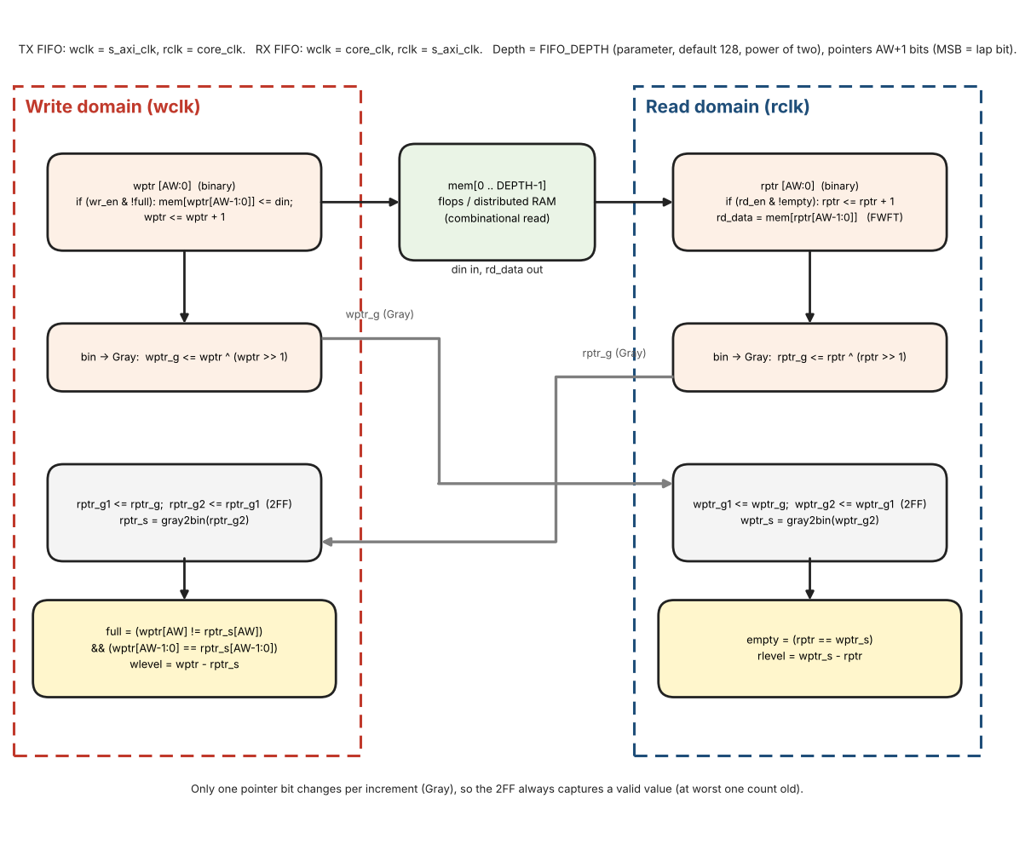
Figure 22. Async FIFO: binary pointers, Gray-code crossing and full / empty flags

Async FIFO reference pseudo-code
Full and empty use the extra-MSB pointer scheme (the lap bit toggles each time a pointer wraps): the FIFO is empty when the full pointers are equal and full when the MSBs differ while the lower bits are equal. All FIFO_DEPTH entries are usable (the simple scheme without the extra bit, which reports full one entry early, is NOT used). The comparison is made on binary pointers: the remote pointer is crossed as Gray code through a 2FF synchroniser and converted back to binary before the comparison. TX FIFO: write side = s_axi_clk, read side = core_clk. RX FIFO: write side = core_clk, read side = s_axi_clk. FIFO_DEPTH is a power of two (16 or more; default 128), so the pointers wrap naturally. Use flops or distributed RAM for the memory so that rd_data is a combinational read (FWFT).
AW = clog2(FIFO_DEPTH) // 7 for depth 128 (default); pointers are AW+1 bits, MSB = lap bit
reg [AW:0] wptr, rptr // binary pointers; memory index = ptr[AW-1:0]

// write domain (wclk)
if (wr_en & !full) { mem[wptr[AW-1:0]] <= din; wptr <= wptr + 1 }
wptr_g <= wptr ^ (wptr >> 1) // Gray code, registered
rptr_g1 <= rptr_g; rptr_g2 <= rptr_g1 // 2FF of the read pointer (rptr_g comes from rclk)
rptr_s = gray2bin(rptr_g2)

// read domain (rclk)
if (rd_en & !empty) rptr <= rptr + 1
rd_data = mem[rptr[AW-1:0]] // FWFT: combinational read, valid while !empty
rptr_g <= rptr ^ (rptr >> 1)
wptr_g1 <= wptr_g; wptr_g2 <= wptr_g1 // 2FF of the write pointer (wptr_g comes from wclk)
wptr_s = gray2bin(wptr_g2)

// flags: same detection as the extra-MSB version in the chipverify tutorial (Full and Empty
Detection)
full = (wptr[AW] != rptr_s[AW]) && (wptr[AW-1:0] == rptr_s[AW-1:0]) // write domain
empty = (rptr == wptr_s) // read domain
wlevel = wptr - rptr_s // write domain, never lower than the true occupancy
rlevel = wptr_s - rptr // read domain, never higher than the true occupancy

s_axi side: TX_STATUS.FULL = full, TX_STATUS.HALF = (wlevel >= FIFO_DEPTH/2); RX_STATUS.EMPTY = empty, RX_STATUS.HALF = (rlevel >= FIFO_DEPTH/2). HALF = (level >= FIFO_DEPTH/2). The pointers are cleared by the sequences of Section 5.2.

5. Reset & FIFO Clear

5.1 Hardware Reset
Assertion of s_axi_aresetn or core_aresetn (asynchronous assert, synchronous de-assert) returns every register to its reset value, empties both FIFOs and clears the sync-detection logic. GLOBAL_EN is forced to 0.

5.2 Soft Reset & FIFO Clear
Writing SOFT_RESET = 1 in GLOBAL_CTRL initiates a dual-clock clear sequence: both sides of the TX and RX FIFOs are flushed, sync logic is reset, and sticky IRQ bits are cleared. All other configuration registers remain unchanged. The bit is self-clearing once the clear handshake completes. A per-FIFO clear is also available via TX_FIFO_CLEAR / RX_FIFO_CLEAR.

SOFT_RESET sequence (normative)
Goal: both pointer sets of a FIFO and the flops that synchronise them are cleared while the opposite side is also in reset, so no stale pointer can be re-captured. Handshake signals: srst_req, srst_ack, axi_clr_done (toggles) and core_rst_active (level, core_clk to s_axi_clk, 2FF).
- 1. s_axi side: a write of SOFT_RESET = 1 sets CLR_BUSY = 1; SOFT_RESET reads 1. Data-port accesses return SLVERR. The side toggles srst_req.
- 2. core side (after 2FF of srst_req): asserts srst_core and HOLDS it. tx_active and rx_active become 0: the TX Timing Generator (GEN_OFF), TX FSM, both sample accumulators, decoders, trackers, INSYNC, RX counters, the core-side FIFO pointers and the flops that synchronise the s_axi-side pointers are cleared. core_rst_active = 1.
- 3. s_axi side (after 2FF of core_rst_active = 1): asserts srst_axi for 4 s_axi_clk cycles. It clears the s_axi-side FIFO pointers, their synchroniser flops, all sticky IRQ bits and OVERFLOW, then toggles axi_clr_done.
- 4. core side (after 2FF of axi_clr_done AND 4 more core_clk cycles, so the synchronisers capture the cleared pointers): releases srst_core, clears core_rst_active and toggles srst_ack.
- 5. s_axi side (after 2FF of srst_ack): SOFT_RESET reads 0, CLR_BUSY = 0, data ports are enabled again.
The core is released last, so it never sees a stale s_axi-side pointer, and a TX that is still enabled finds an empty FIFO (GEN_OFF) instead of transmitting garbage. Configuration registers (TX_RATE, RX_RATE, enables, SYNC codes, ...) are unchanged.
// ---- s_axi_clk ----
S0: write SOFT_RESET = 1 while CLR_BUSY = 0: CLR_BUSY <= 1; srst_req <= ~srst_req
S1: when core_rst_active_s[1] == 1: srst_axi <= 1 for 4 clocks, clearing the s_axi side
(FIFO pointers + sync flops, sticky IRQ, OVERFLOW); then axi_clr_done <= ~axi_clr_done
S5: when srst_ack_s[1] != srst_ack_seen: CLR_BUSY <= 0 (SOFT_RESET reads 0)

// ---- core_clk ----
S2: when srst_req_s[1] != srst_req_seen: srst_core <= 1 (HELD); core_rst_active <= 1;
clear the core side
S4: when clr_done_s[1] != clr_done_seen: wait 4 core_clk; srst_core <= 0; core_rst_active
<= 0
srst_ack <= ~srst_ack

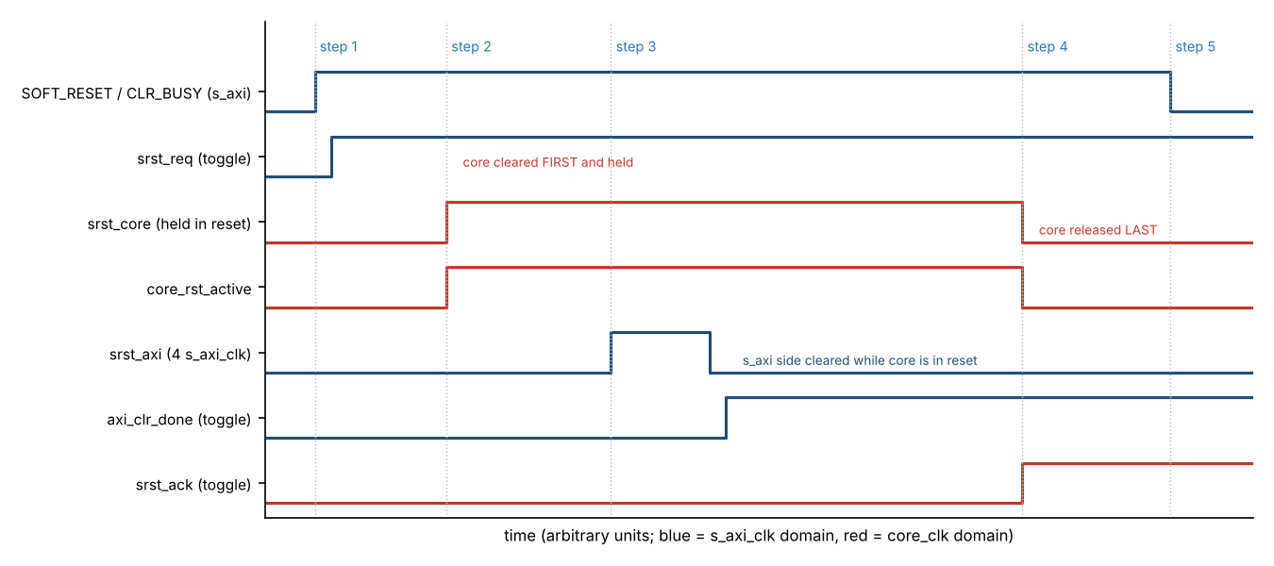
Figure 23. SOFT_RESET sequence: core cleared first and held, s_axi side cleared, core released last

FIFO_CLEAR sequence
TX_FIFO_CLEAR and RX_FIFO_CLEAR use the same five steps with fclr_req / fclr_ack, but only the selected FIFO is involved: TX FIFO = s_axi wr_ptr and core rd_ptr with their synchroniser flops; RX FIFO = core wr_ptr and s_axi rd_ptr with their synchroniser flops. CLR_BUSY = 1 and that FIFO data port returns SLVERR while busy. Sticky IRQ bits are not cleared. A TX_FIFO_CLEAR during transmission lets the word already loaded in shreg finish; at the next word_tick the Generator sees fifo_empty = 1 and freezes (underrun). Words that the receiver delivers while the RX FIFO is being cleared are discarded without setting OVERFLOW.

Hardware reset
s_axi_aresetn and core_aresetn may release at different times. Each domain exports a reset-done flag, synchronised into the other domain. The FIFO data ports return SLVERR and the core stays in GEN_OFF / IDLE until both flags are set.

6. FIFO Behaviour
Both FIFOs are FIFO_DEPTH words x 12 bits (synthesis parameter, default 128; legal: a power of two, 16 or more). LEVEL = 0..FIFO_DEPTH. HALF when LEVEL >= FIFO_DEPTH/2. FULL when LEVEL = FIFO_DEPTH. EMPTY when LEVEL = 0.
- RX FIFO: a word that arrives while FULL is discarded and the sticky OVERFLOW bit is set.
- TX FIFO: a push attempted while FULL returns SLVERR and the word is not written.
- FIFO_CLEAR flushes the selected FIFO; it does not clear sticky IRQ bits.
- Full / empty detection uses the extra-MSB pointer scheme of Section 4.2.4 (all FIFO_DEPTH entries usable).

7. Memory Map & Register Reference

7.1 Memory Map Organisation
Register tables list block-relative Off. Absolute byte address = 0x0001_0000 + block_base + Off. Example: TX_SYNC4 Off 0x28 at TX base 0x0020 -> absolute 0x0001_0048. AXI AWADDR/ARADDR are 16-bit and decode 0x0000-0x014F; SoC maps that window onto absolute 0x0001_0000.
Control and status registers (Global, TX Control/Status, RX Control/Status) occupy the contiguous window 0x0001_0000 – 0x0001_00FF. Both data ports live in the 0x0001_01xx range: TX Data Port at 0x0001_0100, then a reserved gap, then RX Data Port at 0x0001_0140. Reserved gaps separate the blocks so that future registers can be inserted without moving existing addresses.
Table 18. Memory map organisation
Base Offset | Block | Description
0x0001_0000 | Global Registers | Version, Soft-Reset, Enables, IRQ (within 0x00–0x0F)
0x0001_0010–0x0001_001F | Reserved gap | OKAY; write ignored; read 0
0x0001_0020 | TX Control / Status | TX_CTRL … TX_SYNC4 (within 0x20–0x4F)
0x0001_0050–0x0001_005F | Reserved gap | OKAY; write ignored; read 0
0x0001_0060 | RX Control / Status | RX_CTRL … RX_SYNC4, WRDCNT (within 0x60–0x9F)
0x0001_00A0–0x0001_00FF | Reserved gap | OKAY; write ignored; read 0
0x0001_0100 | TX Data Port | Push 12-bit words into TX FIFO (0x100–0x10F)
0x0001_0110–0x0001_013F | Reserved gap | OKAY; write ignored; read 0
0x0001_0140 | RX Data Port | Pop 12-bit words from RX FIFO (0x140–0x14F)

7.2 Global Registers (base 0x0001_0000)
Table 19. Global registers
Off | Abs. address | Name | Acc | Rst | Description
0x00 | 0x0001_0000 | CORE_VERSION | R | 0x00010000 | RTL version (constant): Major[31:16] = 1, Minor[15:0] = 0. Not tied to the document revision.
0x04 | 0x0001_0004 | GLOBAL_CTRL | R/W | 0x0 | SOFT_RESET, GLOBAL_EN, TX_EN, RX_EN, IRQ_ENABLE
0x08 | 0x0001_0008 | GLOBAL_STATUS | R | 0x0 | bit 0 core_pending – any enabled sticky IRQ source is set; bit 1 CLR_BUSY – 1 while SOFT_RESET or a FIFO clear is in progress; [31:2] reserved, read 0
0x0C | 0x0001_000C | Reserved | — | 0 | Write 0; read 0

GLOBAL_CTRL bits
Table 20. GLOBAL_CTRL bit fields
Bit | Name | Rst | Meaning
0 | SOFT_RESET | 0 | Write 1 starts soft-reset (flush FIFOs, clear sync/sticky). Stays 1 while busy, self-clears to 0 when done. Poll until 0 before further config.
1 | GLOBAL_EN | 0 | 1 = core operational; 0 = all TX/RX activity gated off
2 | TX_EN | 0 | 1 = enable transmit path (also requires GLOBAL_EN)
3 | RX_EN | 0 | 1 = enable receive path (also requires GLOBAL_EN)
4 | IRQ_ENABLE | 0 | 1 = enable aggregated IRQ output
31:5 | Reserved | 0 | Write 0; read 0

7.3 Transmit – Control / Status (base 0x0001_0020)
Table 21. TX Control / Status registers
Off | Abs. address | Name | Acc | Rst | Description
0x00 | 0x0001_0020 | TX_CTRL | R/W | 0x0 | TX_RATE[3:0] (bits 11:8), SYNC_INS_MODE (bit 0)
0x04 | 0x0001_0024 | TX_STATUS | R | 0x01 | EMPTY / HALF / FULL flags (computed on s_axi_clk, Section 4.2.4). Reset = EMPTY set.
0x08 | 0x0001_0028 | Reserved | — | 0 | Write ignored; read 0; response OKAY (not SLVERR). Former FIFO level / room register, removed in v1.40.
0x0C | 0x0001_002C | Reserved | — | 0 | Write ignored; read 0; response OKAY (not SLVERR). Former FIFO level / room register, removed in v1.40.
0x10 | 0x0001_0030 | TX_IRQ_ENABLE | R/W | 0 | EN_EMPTY / EN_LOW / EN_FULL
0x14 | 0x0001_0034 | TX_IRQ_STATUS | R/W1C | 0 | Sticky EMPTY / LOW / FULL (edge-triggered)
0x18 | 0x0001_0038 | TX_FIFO_CLEAR | W | 0 | Write 1 to flush TX FIFO only
0x1C | 0x0001_003C | TX_SYNC1 | R/W | 0x247 | Programmable SYNC1 code (12-bit, default octal 1107 = 0x247)
0x20 | 0x0001_0040 | TX_SYNC2 | R/W | 0x5B8 | Programmable SYNC2 code (12-bit, default octal 2670 = 0x5B8)
0x24 | 0x0001_0044 | TX_SYNC3 | R/W | 0xA47 | Programmable SYNC3 code (12-bit, default octal 5107 = 0xA47)
0x28 | 0x0001_0048 | TX_SYNC4 | R/W | 0xDB8 | Programmable SYNC4 code (12-bit, default octal 6670 = 0xDB8)
0x2C–0x2F | 0x0001_004C–0x0001_004F | Reserved | — | 0 | Write ignored; read 0; response OKAY (not SLVERR).

TX_CTRL bits
Table 22. TX_CTRL bit fields
Bit | Name | Rst | Meaning
0 | SYNC_INS_MODE | 0 | 0 = software inserts sync into FIFO; 1 = hardware auto-inserts TX_SYNCx at subframe start
7:1 | Reserved | 0 | Write 0; read 0
11:8 | TX_RATE[3:0] | 0000 | Transmit word-rate select (encoding: Table 5). Applied only while tx_active = 0 (Section 2.4). Codes 1000–1111 are reserved and behave as code 0000 (64 wps).
31:12 | Reserved | 0 | Write 0; read 0

TX_RATE[3:0] and RX_RATE[3:0] are symmetric: both sit at bits 11:8 of their own control register (TX_CTRL / RX_CTRL), reset to 0000 and use the same encoding (Table 5). They are independent: writing TX_CTRL never changes RX_RATE and vice versa. The TX Timing Generator reads the applied TX_RATE, the RX sample generator reads the applied RX_RATE.

TX_STATUS bits
Table 23. TX_STATUS bit fields
Bit | Name | Rst | Meaning
0 | EMPTY | 1 | 1 when TX FIFO contains 0 words
1 | HALF | 0 | 1 when LEVEL >= FIFO_DEPTH/2. (The TX interrupt for this condition is ST_LOW: level falls below FIFO_DEPTH/2, Section 8.4.)
2 | FULL | 0 | 1 when LEVEL = FIFO_DEPTH
31:3 | Reserved | 0 | Read 0

7.4 Receive – Control / Status (base 0x0001_0060)
Table 24. RX Control / Status registers
Off | Abs. address | Name | Acc | Rst | Description
0x00 | 0x0001_0060 | RX_CTRL | R/W | 0x0 | RX_RATE[3:0] (bits 11:8), RXSEL, NOSYNC, SFTSYNC, TEST
0x04 | 0x0001_0064 | RX_STATUS | R | 0x01 | INSYNC, SYNC[1:0], EMPTY/HALF/FULL, OVERFLOW. Reset = EMPTY set.
0x08 | 0x0001_0068 | INJ_CTRL | R/W | 0x0 | Built-in pattern injector control: INJ_EN, INJ_START, INJ_MODE (Section 12.14, bits below)
0x0C | 0x0001_006C | INJ_STATUS | R | 0x0 | Built-in pattern injector status: INJ_BUSY, INJ_DONE (bits below)
0x10 | 0x0001_0070 | RX_IRQ_ENABLE | R/W | 0 | EN_EMPTY/HALF/FULL/OVERFLOW/MATCH/INSYNC_LOST
0x14 | 0x0001_0074 | RX_IRQ_STATUS | R/W1C | 0 | Sticky bits (edge-triggered)
0x18 | 0x0001_0078 | RX_FIFO_CLEAR | W | 0 | Write 1 to flush RX FIFO only
0x1C | 0x0001_007C | WRDCNT | R/W | 0 | Word-count / subframe match utility
0x20 | 0x0001_0080 | RX_SYNC1 | R/W | 0x247 | Programmable SYNC1 code (12-bit, default octal 1107 = 0x247)
0x24 | 0x0001_0084 | RX_SYNC2 | R/W | 0x5B8 | Programmable SYNC2 code (12-bit, default octal 2670 = 0x5B8)
0x28 | 0x0001_0088 | RX_SYNC3 | R/W | 0xA47 | Programmable SYNC3 code (12-bit, default octal 5107 = 0xA47)
0x2C | 0x0001_008C | RX_SYNC4 | R/W | 0xDB8 | Programmable SYNC4 code (12-bit, default octal 6670 = 0xDB8)
0x30–0x3F | 0x0001_0090–0x0001_009F | Reserved | — | 0 | Write ignored; read 0; response OKAY (not SLVERR).

RX_CTRL bits
Table 25. RX_CTRL bit fields
Bit | Name | Rst | Meaning
0 | RXSEL | 0 | 0 = HBP decoder; 1 = BPRZ decoder (OR-ed with external RSEL pin)
1 | NOSYNC | 0 | 1 = disable sync detection; all recovered words enter FIFO
2 | SFTSYNC | 0 | 1 = 2-sync-word mode; 0 = 4-sync-word mode
3 | TEST | 0 | 1 = digital loopback (TX encoders → RX decoder)
7:4 | Reserved | 0 | Write 0; read 0
11:8 | RX_RATE[3:0] | 0000 | Receive word-rate select (encoding: Table 5, same as TX_RATE). Applied only while rx_active = 0 (Section 2.4). Codes 1000–1111 are reserved and behave as code 0000 (64 wps).
31:12 | Reserved | 0 | Write 0; read 0

RX_STATUS bits
Table 26. RX_STATUS bit fields
Bit | Name | Rst | Meaning
0 | EMPTY | 1 | 1 when RX FIFO contains 0 words
1 | HALF | 0 | 1 when LEVEL >= FIFO_DEPTH/2. RX ST_HALF interrupt on the rising edge.
2 | FULL | 0 | 1 when LEVEL = FIFO_DEPTH
3 | OVERFLOW | 0 | Sticky: set when a valid word arrives while FULL. Cleared by W1C on RX_IRQ_STATUS.ST_OVERFLOW, or by SOFT_RESET / hard reset.
4 | INSYNC | 0 | 1 when receiver is frame-synchronised
6:5 | SYNC[1:0] | 00 | Realtime subframe indicator (valid only while INSYNC=1): 00=SYNC1, 01=SYNC2, 10=SYNC3, 11=SYNC4
7 | MATCH | 0 | 1 for one word-time when word-count/subframe matches WRDCNT
31:8 | Reserved | 0 | Read 0

WRDCNT bits (Word-Count Utility)
Table 27. WRDCNT bit fields
Bit | Name | Rst | Meaning
1:0 | SUBFRAME[1:0] | 00 | Target subframe: 00=subframe 1 (SYNC1), 01=subframe 2 (SYNC2), 10=subframe 3 (SYNC3), 11=subframe 4 (SYNC4).
14:2 | WORD_CNT[12:0] | 0 | Target word count inside the selected subframe (0…8191). Compared against the running word counter when INSYNC is high.
31:15 | Reserved | 0 | Write 0; read 0

When the running subframe index matches SUBFRAME[1:0] and the running word count matches WORD_CNT[12:0], the MATCH flag (RX_STATUS bit and external match pin) is asserted for one word-time. WORD_CNT >= W (words per subframe at the applied RX_RATE) never matches.
INJ_CTRL and INJ_STATUS (built-in pattern injector, Section 12.14). Both registers are cleared by SOFT_RESET.
Table 28. INJ_CTRL bit fields (RX base + 0x08, absolute 0x0001_0068)
Bit | Name | Rst | Meaning
0 | INJ_EN | 0 | 1 = the injector drives TP5 instead of the loopback tap or the pins; RX_CTRL.RXSEL selects the HBP or BPRZ pair. Applied only while rx_active = 0 (Section 2.4).
1 | INJ_START | 0 | Write 1 starts a run; self-clearing, always reads 0. Ignored if INJ_EN = 0 or INJ_BUSY = 1. RX_EN SHALL be set before the start.
2 | INJ_MODE | 0 | 0 = run once (1 + 6 x W words, then idle); 1 = continuous until INJ_EN is cleared.
31:3 | Reserved | 0 | Write 0; read 0

Table 29. INJ_STATUS bit fields (RX base + 0x0C, absolute 0x0001_006C), read only
Bit | Name | Rst | Meaning
0 | INJ_BUSY | 0 | 1 while a run is in progress; in continuous mode it stays 1 until INJ_EN is cleared.
1 | INJ_DONE | 0 | Set when a run-once has ended. Cleared by the next INJ_START, by clearing INJ_EN, or by SOFT_RESET.
31:2 | Reserved | 0 | Read 0

7.5 TX Data Port (base 0x0001_0100)
Table 30. TX Data Port registers
Off | Abs. address | Name | Description
0x00 | 0x0001_0100 | TX_DATA | R/W, reset 0. Write bits[11:0]: LATCHES the 12-bit word to be pushed. A write here alone does NOT push the FIFO and always returns OKAY; bits[31:12] are ignored. Read returns the last latched word (bits[31:12] = 0).
0x04 | 0x0001_0104 | TX_WR_EN | R/W, reset 0, bit 0 only (bits[31:1] reserved, read 0). Level arm: may stay 1 for a burst of pushes. Alone it does not write the FIFO. While it is 0 a TX_WR_ADDR write pushes nothing.
0x08 | 0x0001_0108 | TX_WR_ADDR | R/W, reset 0. Software word index 0, 1, 2, ... (bookkeeping only: it is not the FIFO write pointer and does not select a location). A write while TX_WR_EN = 1 is the push strobe: the word latched in TX_DATA is pushed into the TX FIFO. !FULL and CLR_BUSY = 0 -> OKAY; FULL or CLR_BUSY = 1 -> SLVERR and the word is not written. A write while TX_WR_EN = 0 -> OKAY, nothing is pushed.
0x0C–0x0F | 0x0001_010C–0x0001_010F | Reserved | Write 0; read 0 (OKAY).

TX push (two steps, same scheme as Core429): TX_DATA only latches the word; the push itself happens on a write to TX_WR_ADDR while TX_WR_EN = 1. Writing a new word to TX_DATA before TX_WR_ADDR replaces the latched word (an unpushed word is lost); two TX_WR_ADDR writes without a TX_DATA write in between push the same word twice. TX_DATA, TX_WR_EN and TX_WR_ADDR live in s_axi_clk, are not part of the configuration bundle that crosses into core_clk, are cleared by hardware reset and are left unchanged by SOFT_RESET (like every other configuration register).
- TX push flow:
- 1. Optional: read TX_STATUS (FULL flag). It is CDC telemetry and may lag; the OKAY/SLVERR of step 4 is decided from the live FIFO flag.
- 2. Write TX_WR_EN = 1 (once per burst).
- 3. For each word: write TX_DATA = word, then write TX_WR_ADDR = i (i = 0, 1, 2, ...).
- 4. On the TX_WR_ADDR write: if the FIFO is not FULL and CLR_BUSY = 0 the latched word is pushed (OKAY); otherwise BRESP = SLVERR and nothing is written.
- 5. Optional: write TX_WR_EN = 0 when the burst is finished.

7.6 RX Data Port (base 0x0001_0140)
Table 31. RX Data Port registers
Off | Abs. address | Name | Description
0x00 | 0x0001_0140 | RX_RD_DATA | AXI READ = one pop from RX FIFO. Lower 12 bits = ARINC word; bits[31:12]=0. OKAY+data, or SLVERR if EMPTY or CLR_BUSY = 1. A write is SLVERR with no effect.
0x04 | 0x0001_0144 | RX_RD_EN | R/W, reset 0, bit 0 only (bits[31:1] reserved, read 0). Optional, kept for symmetry with TX_WR_EN: software may set it, but it does NOT gate the pop. The pop is always done by a read of RX_RD_DATA. A read of this register never returns FIFO data.
0x08 | 0x0001_0148 | RX_RD_ADDR | R/W, reset 0. Software word index 0, 1, 2, ... (bookkeeping only, same as TX_WR_ADDR): it is not the FIFO read pointer, does not select a word, and reading or writing it never pops the FIFO. The pop is done only by a read of RX_RD_DATA.
0x0C–0x0F | 0x0001_014C–0x0001_014F | Reserved | Write 0; read 0 (OKAY).

RX pop: On AR handshake sample read-side EMPTY. If EMPTY -> RRESP=SLVERR, RDATA=0, no pop. If !EMPTY -> capture RDATA, RRESP=OKAY; pop once when RVALID && RREADY complete.
RX_RD_EN and RX_RD_ADDR mirror TX_WR_EN and TX_WR_ADDR, so the RX data port has the same register set as the TX data port (and as Core429). Neither affects the pop: reading RX_RD_DATA is enough to pop one word, and software may ignore both (RX_RD_ADDR can serve as a software word counter). Both are cleared by hardware reset and left unchanged by SOFT_RESET.

7.7 From register accesses to FIFO signals
The registers of the data ports (TX_DATA, TX_WR_EN, TX_WR_ADDR, RX_RD_DATA, RX_RD_EN, RX_RD_ADDR) are an AXI view. The FIFO itself knows nothing about them: it only has the write-side ports wr_en, din and full, and the read-side ports rd_en, dout and empty (Section 4.2.4). Figure 24 and Table 32 show how an AXI access becomes those signals; the data-port logic of the AXI slave (Section 4.1.1) generates them.
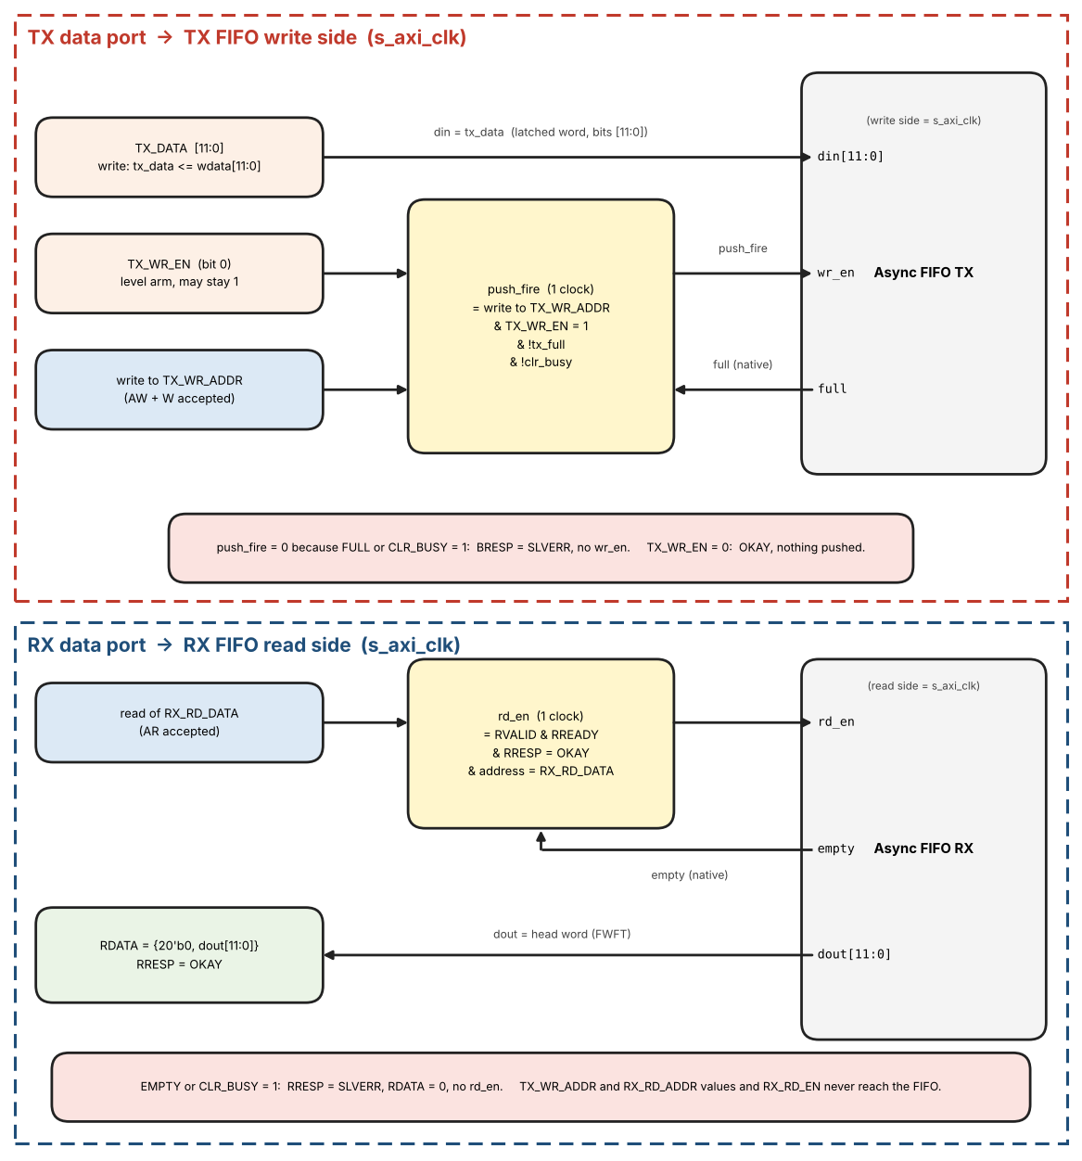
Figure 24. Data ports: from AXI register accesses to the TX and RX FIFO ports
Table 32. AXI access and the FIFO signals it produces
AXI access | FIFO signals and response
Write TX_DATA | tx_data <= wdata[11:0]. No FIFO signal. BRESP = OKAY.
Write TX_WR_EN | tx_wr_en <= wdata[0]. No FIFO signal. BRESP = OKAY.
Write TX_WR_ADDR with TX_WR_EN = 1, FIFO not FULL, CLR_BUSY = 0 | TX FIFO wr_en = 1 for exactly one s_axi_clk, din = tx_data. BRESP = OKAY.
Write TX_WR_ADDR with TX_WR_EN = 1, FIFO FULL or CLR_BUSY = 1 | wr_en stays 0, the word is not written. BRESP = SLVERR.
Write TX_WR_ADDR with TX_WR_EN = 0 | wr_en stays 0. BRESP = OKAY.
Read RX_RD_DATA, FIFO not EMPTY, CLR_BUSY = 0 | RDATA = {20'b0, dout[11:0]}, RRESP = OKAY. RX FIFO rd_en = 1 for exactly one s_axi_clk, in the clock where RVALID and RREADY are both 1.
Read RX_RD_DATA, FIFO EMPTY or CLR_BUSY = 1 | rd_en stays 0, RDATA = 0. RRESP = SLVERR.
Write or read RX_RD_EN, RX_RD_ADDR | Stored only (read returns the stored value). No FIFO signal.

- full and empty used to choose OKAY or SLVERR are the FIFO's own native flags in the same clock (Section 4.2.4), not the TX_STATUS / RX_STATUS bits, which have crossed a clock domain and lag.
- The FIFO keeps its own write and read pointers. The values written to TX_WR_ADDR and RX_RD_ADDR are never sent to the FIFO.
- Each push and each pop is a single-clock pulse per transaction. A transaction that has to wait (BVALID or RVALID held until BREADY or RREADY) must not repeat the pulse.

8. Interrupt System
Policy: every monitored condition produces an edge-triggered sticky bit. All sticky bits, the IRQ_ENABLE registers and the aggregation live in the s_axi_clk domain; a W1C write clears bits locally, so no clear pulse crosses clock domains. FIFO events are derived on s_axi_clk from the FIFO levels of Section 4.2.4 by detecting transitions of the registered flags. Core-originated events (OVERFLOW, MATCH, INSYNC_LOST) are signalled by a toggle in core_clk, synchronised with 2FF and edge-detected in s_axi_clk.

8.1 TX_IRQ_ENABLE / TX_IRQ_STATUS
- Bit 0 – EN_EMPTY / ST_EMPTY
- Bit 1 – EN_LOW / ST_LOW
- Bit 2 – EN_FULL / ST_FULL
- Bits 31:3 – reserved

8.2 RX_IRQ_ENABLE / RX_IRQ_STATUS
- Bit 0 – EN_EMPTY / ST_EMPTY
- Bit 1 – EN_HALF / ST_HALF
- Bit 2 – EN_FULL / ST_FULL
- Bit 3 – EN_OVERFLOW / ST_OVERFLOW
- Bit 4 – EN_MATCH / ST_MATCH
- Bit 5 – EN_INSYNC_LOST / ST_INSYNC_LOST (falling edge of INSYNC)
- Bits 31:6 – reserved

8.3 Aggregation
irq = (OR over TX and RX of (sticky[k] AND enable[k])) AND GLOBAL_CTRL.IRQ_ENABLE, computed entirely in s_axi_clk. GLOBAL_STATUS.core_pending is the same OR before the IRQ_ENABLE gate.

8.4 Sticky Edge Rules (frozen)
Sticky bits are set only on a transition of the event condition, never while it persists. After a W1C clear a new transition is required before the bit can be set again; this prevents IRQ storms. If a W1C write and a new event arrive in the same s_axi_clk cycle the new event wins (the bit stays set). Event definitions:
- TX: ST_EMPTY = level becomes 0; ST_LOW = level falls below FIFO_DEPTH/2 (the FIFO needs refilling); ST_FULL = level reaches FIFO_DEPTH.
- RX: ST_EMPTY = level becomes 0; ST_HALF = level rises to FIFO_DEPTH/2 or more; ST_FULL = level reaches FIFO_DEPTH.
- RX: ST_OVERFLOW = a word is dropped because the FIFO is full; ST_MATCH = MATCH event (Section 3.2.3.1); ST_INSYNC_LOST = falling edge of INSYNC.
- The reset value of a flag does not create an event (for example TX EMPTY = 1 after reset does not set ST_EMPTY).
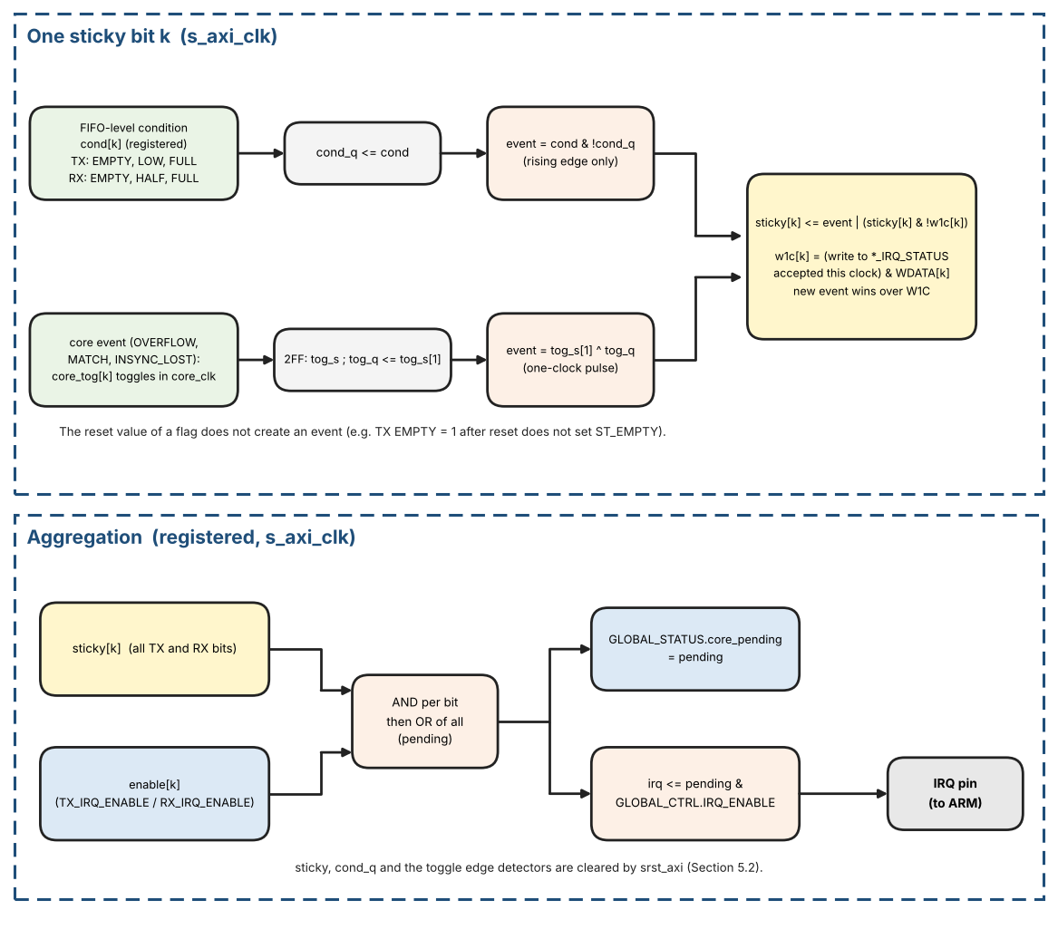
Figure 25. Interrupt logic: edge event, sticky bit with W1C, aggregation and IRQ

Interrupt reference pseudo-code
After a W1C clear the condition must go false and true again before the bit can be set again, because the event is an edge. If the condition is still true when software clears the bit, no new event is generated.
// s_axi_clk, one block per sticky bit k. TX bits: EMPTY, LOW, FULL. RX bits: EMPTY, HALF,
FULL, OVERFLOW, MATCH, INSYNC_LOST.
// Registered conditions (from the FIFO levels of Section 4.2.4):
// TX: cond_EMPTY = (wlevel == 0) cond_LOW = (wlevel < FIFO_DEPTH/2) cond_FULL = (wlevel ==
FIFO_DEPTH)
// RX: cond_EMPTY = (rlevel == 0) cond_HALF = (rlevel >= FIFO_DEPTH/2) cond_FULL = (rlevel ==
FIFO_DEPTH)
cond_q[k] <= cond[k] // reset value = reset value of cond[k]: EMPTY = 1, TX
LOW = 1, others 0
event[k] = cond[k] & !cond_q[k] // rising edge only: never while the condition persists

// core events (OVERFLOW, MATCH, INSYNC_LOST): a toggle in core_clk, 2FF-synchronised, then
edge-detected
tog_s <= {tog_s[0], core_tog[k]}; tog_q <= tog_s[1]
event[k] = tog_s[1] ^ tog_q // one-clock pulse; the reset value of core_tog and
tog_q is 0

// sticky bit: the new event wins over a W1C in the same clock
w1c[k] = (write to *_IRQ_STATUS accepted in this clock) & WDATA[k]
sticky[k] <= event[k] | (sticky[k] & !w1c[k])

// aggregation (registered)
pending = |(sticky[k] & enable[k]) // over all TX and RX bits; GLOBAL_STATUS.core_pending
irq <= pending & GLOBAL_CTRL.IRQ_ENABLE
// sticky, cond_q and the toggle edge detectors are cleared by srst_axi (Section 5.2)

9. AXI Error Handling
Table 33. AXI error response matrix
Condition | AXI Response | Side Effect
Unmapped address (outside 0x0000–0x014F decode window) | SLVERR | None
TX push (TX_WR_ADDR write, TX_WR_EN = 1) while write-side FULL | BRESP=SLVERR | Word not written
RX read while read-side EMPTY | RRESP=SLVERR | No pop
RX word arrives while FIFO FULL | N/A | Word dropped; OVERFLOW sticky set
Reserved offset inside a defined block | OKAY | Write ignored; read returns 0
Write to a read-only register, or read of a write-only register (Table 17) | SLVERR | None
WSTRB != 4'b1111 on a write | BRESP=SLVERR | None
Data-port access or FIFO_CLEAR write while CLR_BUSY = 1 | SLVERR | None

10. Interface Description

10.1 Configuration Parameters (synthesis-time)
Table 34. Synthesis-time configuration parameters
Parameter | Description | Allowed | Default
FIFO_DEPTH | Depth of TX and RX FIFOs in 12-bit words (power of two) | power of 2, >= 16 | 128
CORE_VERSION | RTL version reported by the CORE_VERSION register (major[31:16], minor[15:0]); changed only by RTL or register-map changes | 32-bit | 0x0001_0000

10.2 I/O Signal Descriptions

Clocks and Resets
Table 35. Clock and reset signals
Name | Dir | Description
s_axi_clk | In | AXI4-Lite and register-file clock; also TX-FIFO write / RX-FIFO read side
s_axi_aresetn | In | Active-low async-assert / sync-deassert reset of s_axi_clk domain
core_clk | In | Encode/decode/sync clock (24 MHz +/-0.1%)
core_aresetn | In | Active-low async-assert / sync-deassert reset of core_clk domain

ARINC Digital Interface
Table 36. ARINC digital interface signals
Name | Dir | Description
rx_hbp_high | In | HBP receive High leg (digital, from external line receiver)
rx_hbp_low | In | HBP receive Low leg (digital)
rx_bprz_high | In | BPRZ receive High/One (digital)
rx_bprz_low | In | BPRZ receive Low/Zero (digital). Null is not a pin: Null = rx_bprz_high and rx_bprz_low both 0 (Table 3)
tx_hbp_high | Out | HBP transmit High leg (digital, to external line driver)
tx_hbp_low | Out | HBP transmit Low leg (digital, complement of tx_hbp_high during data)
tx_bprz_high | Out | BPRZ transmit High/One (digital)
tx_bprz_low | Out | BPRZ transmit Low/Zero (digital); both low = Null
rsel | In | External RX format select (OR-ed with RX_CTRL.RXSEL)
insync | Out | Receiver subframe lock indicator
sync[1:0] | Out | Current subframe index while insync=1
match | Out | WRDCNT match pulse (one word-time)
rovf | Out | RX FIFO overflow (level, mirrors sticky until cleared)

Output timing: tx_hbp_*, tx_bprz_*, insync, sync[1:0] and match are registered in core_clk (match is a one-word-time pulse). irq is registered in s_axi_clk. rovf is the s_axi_clk-domain OVERFLOW sticky level. External logic SHALL synchronise insync, sync, match and rovf to its own clock.

AXI4-Lite Slave (s_axi_clk domain)
Standard AXI4-Lite 32-bit signals: AWADDR[15:0], AWVALID/AWREADY, WDATA[31:0], WSTRB[3:0], WVALID/WREADY, BRESP[1:0], BVALID/BREADY, ARADDR[15:0], ARVALID/ARREADY, RDATA[31:0], RRESP[1:0], RVALID/RREADY. Address width may be extended by the SoC; only the lower bits are decoded by the core.

Interrupt
IRQ – single aggregated interrupt output (core_pending AND GLOBAL_CTRL.IRQ_ENABLE).

10.3 Suggested RTL Module Hierarchy
Recommended hierarchy. Clock domain is noted in parentheses.
- core717_top (s_axi_clk + core_clk)
- cpu_if_top (s_axi_clk) – AXI-Lite slave, address decode, register file, IRQ aggregate
- cdc_cfg (axi to core, one configuration bundle with Req/Ack, Section 4.2.1) / cdc_status (core to axi: INSYNC/SYNC snapshot, event toggles) / cdc_rst (soft-reset and FIFO-clear handshakes, Section 5.2)
- async_fifo_tx (wr=s_axi_clk, rd=core_clk) – depth FIFO_DEPTH, width 12
- async_fifo_rx (wr=core_clk, rd=s_axi_clk)
- tx_path (core_clk): tx_timing_gen, tx_fsm_enc (TX FSM, sync insertion, shift register, HBP encoder and BPRZ encoder; ports in Table 40)
- rx_path (core_clk): rx_sampler, hbp_decoder, bprz_decoder, rx_sync_detect (12-bit window, trackers, word-0 check, RX counters, MATCH and RX FIFO write; ports in Table 41)
FIFO pointer width = ceil(log2(FIFO_DEPTH))+1, Gray-coded across domains. Default depth 128 → 8-bit Gray pointers.

10.4 FIFO Micro-Architecture
- Dual-clock async FIFO, FWFT (First-Word Fall-Through) on the read side so the first word is visible on rd_data as soon as empty deasserts — required for gap-free TX Load.
- HALF = (occupancy >= FIFO_DEPTH/2). FULL when occupancy = FIFO_DEPTH. EMPTY when occupancy = 0.
- TX underrun: finish current word, then freeze Timing Generator (Section 3.1.2b).

10.5 Subframe Index Mapping
Table 37. subframe_index to SYNC register mapping
subframe_index | TX/RX_SYNCx | Default octal | ARINC name
0 | SYNC1 | 1107 | Subframe 1
1 | SYNC2 | 2670 | Subframe 2
2 | SYNC3 | 5107 | Subframe 3
3 | SYNC4 | 6670 | Subframe 4

10.6 Module Port Tables
Ports of the main core_clk modules. Signals marked "from tx_timing_gen" etc. are internal; all widths in bits. Names follow the state diagrams (Sections 3.1.2b and 3.2.2.2) and the pseudo-code of Sections 3.2.1.2 and 3.2.1.3.
Table 38. TX path module ports (core_clk)
Module | Signal(s) | Dir | Width | Description
tx_timing_gen | tx_active, tx_rate_code[3:0], fifo_empty | in | 1 / 4 / 1 | tx_active (Section 2.4); applied TX_RATE (Table 5); core-side FIFO empty flag (Section 4.2.4)
tx_timing_gen | sample_tick | out | 1 | Registered, 1 clock wide
tx_timing_gen | phase, bit_cnt | out | 3 / 4 | Sample counter 0..7 and bit-cell index 0..11
tx_timing_gen | bit_tick, half_bit_tick, word_tick | out | 1 each | Decodes of sample_tick (valid only in the clock where sample_tick = 1)
tx_timing_gen | word_in_subframe, subframe_index, subframe_start | out | 13 / 2 / 1 | Index of the next word to load; subframe_start = (word_in_subframe == 0)
tx_timing_gen | gen_state | out | 2 | OFF / RUN / FROZEN
tx_fsm_enc | tx_active, bit_tick, half_bit_tick, word_tick, subframe_start, subframe_index | in | – | From tx_timing_gen
tx_fsm_enc | sync_ins_mode, tx_sync1..tx_sync4 | in | 1 / 12 each | Applied TX_CTRL.SYNC_INS_MODE and TX_SYNCx
tx_fsm_enc | fifo_rd_data, fifo_empty | in | 12 / 1 | FWFT head of the TX FIFO (valid while fifo_empty = 0)
tx_fsm_enc | fifo_pop | out | 1 | One-clock pop pulse, only for a LOAD from the FIFO
tx_fsm_enc | tx_hbp_high, tx_hbp_low | out | 1 each | Registered HBP pair, 1 core_clk after the strobe
tx_fsm_enc | tx_bprz_high, tx_bprz_low | out | 1 each | Registered BPRZ pair: One (1,0), Zero (0,1), Null (0,0)

Table 39. RX path module ports (core_clk)
Module | Signal(s) | Dir | Width | Description
rx_sampler | rx_active, rx_rate_code[3:0] | in | 1 / 4 | Section 2.4; applied RX_RATE
rx_sampler | rxsel_eff | in | 1 | RX_CTRL.RXSEL OR synchronised rsel (applied while rx_active = 0)
rx_sampler | hi, lo | in | 1 each | Selected input pair after the 2FF, or the TX loopback pair (Table 8)
rx_sampler | sample_tick | out | 1 | RX sample clock, runs only while rx_active = 1
rx_sampler | valid_HI, valid_LO, valid_NULL | out | 1 each | 2-sample dwell flags, per sample_tick
hbp_decoder / bprz_decoder | sample_tick, valid_HI, valid_LO, valid_NULL | in | – | From rx_sampler (only the decoder selected by rxsel_eff is active)
hbp_decoder / bprz_decoder | bit_valid, bit_data | out | 1 each | One-clock pulse per recovered bit and the bit
hbp_decoder / bprz_decoder | framing_error | out | 1 | One-clock pulse; clears window and trackers
rx_sync_detect | bit_valid, bit_data, framing_error, rx_active | in | – | From the decoder
rx_sync_detect | nosync, sftsync, rx_rate_code[3:0] | in | 1 / 1 / 4 | Applied RX_CTRL bits and RX_RATE (gives W)
rx_sync_detect | rx_sync1..rx_sync4, wrdcnt_subframe, wrdcnt_word | in | 12 each / 2 / 13 | Applied RX_SYNCx and WRDCNT
rx_sync_detect | rx_fifo_full | in | 1 | Core-side conservative FULL flag
rx_sync_detect | rx_wr_en, rx_wr_data | out | 1 / 12 | RX FIFO write strobe and word
rx_sync_detect | insync, sync[1:0], match | out | 1 / 2 / 1 | Status pins (core_clk)
rx_sync_detect | ev_overflow, ev_match, ev_insync_lost | out | 1 each | One-clock events; converted to toggles for the CPU IF

11. Frozen Decisions (Summary)
- Single TX FIFO + single RX FIFO (depth = FIFO_DEPTH, default 128 x 12-bit).
- Push/pop accept-reject uses native same-clock FULL/EMPTY – never CDC STATUS.
- TX push = write TX_DATA[11:0] (latch), then write TX_WR_ADDR while TX_WR_EN = 1; FULL returns SLVERR on the TX_WR_ADDR write.
- RX pop = AXI read of RX_RD_DATA; pop once at RVALID && RREADY when !EMPTY. RX_RD_EN is optional and does not gate the pop.
- TX_RATE[3:0] (TX_CTRL[11:8]) and RX_RATE[3:0] (RX_CTRL[11:8]) are symmetric and independent; TX Timing Generator and RX sample-clock are independent machines.
- Rate change (per path): clear TX_EN / RX_EN, write the new TX_RATE / RX_RATE, wait for the CDC latency, then enable (Section 2.4). Each rate is latched in the core only while its own path is inactive.
- SOFT_RESET flushes both FIFOs and clears sticky IRQs; other config preserved.
- FIFO_CLEAR flushes only that FIFO; sticky bits unchanged.
- Reserved offsets inside a block: OKAY, read 0. Unmapped: SLVERR.
- Loopback TEST=1 uses internal mux; external pins are not high-Z.
- WSTRB: only 0xF accepted; any other value -> SLVERR, no write.
- Configuration registers cross as one atomic bundle (Section 4.2.1); enables cannot overtake TX_RATE, RX_RATE or SYNC codes.
- Sticky interrupt bits live in s_axi_clk; core events cross as toggle pulses (Section 8).
- TX underrun: load decision at word_tick uses fifo_empty; Timing Generator goes to GEN_FROZEN (Section 3.1.2b).
- Soft reset and FIFO clear overlap both clock domains and release the core side last (Section 5.2); GLOBAL_STATUS.CLR_BUSY reports completion.
- NOSYNC: INSYNC = 1 while rx_active, a word every 12 bits, SYNC[1:0] = 00, no MATCH (Section 3.2.2.4).
- A word-0 mismatch or a decoder framing error while INSYNC = 1 drops INSYNC; the mismatching word is not written (Section 3.2.3.1).
- TX interrupt for the low-watermark condition is ST_LOW (level falls below FIFO_DEPTH/2).

12. Operational Flows

12.1 Reset Flow
- Assert s_axi_aresetn and core_aresetn (async). Registers at reset, FIFOs empty, GLOBAL_EN=0.
- Deassert resets synchronously in each domain (core_aresetn may release first or together).
- Host reads CORE_VERSION (expect 0x00010000).

12.2 Initialisation Sequence
- Write TX_CTRL (TX_RATE, SYNC_INS_MODE); write RX_CTRL (RX_RATE, RXSEL, NOSYNC, SFTSYNC, TEST=0).
- Program TX_SYNCx / RX_SYNCx if needed; optionally WRDCNT.
- Write IRQ enables.
- Write GLOBAL_CTRL with enables (SOFT_RESET=0). Wait for CDC settle before traffic.

12.3 FIFO_CLEAR versus SOFT_RESET
- FIFO_CLEAR: dual-clock clear of one FIFO only; push/pop SLVERR while clear in progress.
- SOFT_RESET: clear both FIFOs, clear sticky OVERFLOW/IRQ bits, hold timing gens in reset; CTRL (incl. TX_RATE/RX_RATE)/SYNCx preserved.

12.4 TX FSM States
Table 40. TX FSM states
State | Entry | Action / next
IDLE | tx_active = 0, or underrun (word_tick with fifo_empty = 1) | Wait. The Generator is in GEN_OFF or GEN_FROZEN and leaves it when tx_active = 1 and fifo_empty = 0; the first word_tick after that (one sample period later) moves the FSM to LOAD.
LOAD | word_tick and fifo_empty = 0 | Select source (TX_SYNCx if SYNC_INS_MODE and subframe_start, else FIFO pop). tx_bit <= word[0]; shreg <= word >> 1. Go to SHIFT.
SHIFT | After LOAD | At each cell_start with bit_cnt = 1..11: tx_bit <= shreg[0]; shreg >>= 1. At the next word_tick: fifo_empty = 0 -> LOAD (gap-free); fifo_empty = 1 -> IDLE. There is no bit_index in the FSM; bit_cnt belongs to the Generator.

The Timing Generator owns phase, bit_cnt, word_in_subframe, subframe_index and subframe_start; the FSM only owns IDLE / LOAD / SHIFT, shreg and tx_bit.

12.5 Sync Acquisition (tracker model)
Table 41. Sync acquisition (tracker model, see 3.2.2.2)
Event | Action | Notes
SYNC[k] window | Update matching tracker or allocate (4-sync: only k=0) | consumed flag prevents double-allocate
bit_count == 12*W | Expect next_code match | Exact count, no +/- window
bit_count > 12*W | Free tracker | Timeout
marks==5 or 3 | INSYNC=1; primary tracker kept | 5 for 4-sync; 3 for SFTSYNC
word0 mismatch | INSYNC=0; free all | Maintained by 3.2.3.1 only

RX shift register fills LSB-first (Section 3.2.2.1). bit_count is 17 bits wide (12 x 8192 = 98 304); a new tracker takes the lowest-numbered free slot.

12.6 RX Sample Phase
- HBP decoder phase counter 0..7: phase 0 = true cell start; observed boundary edge at phase 1, observed mid-cell edge at phase 5 (Section 3.2.1.2).
- Boundary edges (phases 0..3) realign phase to 1; mid-cell edges (phases 4..6) realign phase to 5; phase 7 is a framing error.
- BPRZ has no phase counter: it emits a bit when the Null half of a pulse is validated (Section 3.2.1.3).
- TX phase counter (0..7) lives in the TX Timing Generator: bit_tick at phase 0, half_bit_tick at phase 4 (Section 3.1.2b).

12.7 Worked Example – 64 wps, three words (SYNC_INS_MODE=0)
TX_RATE=0000 (64 wps), core_clk=24 MHz, software writes sync.
- 1. Configure TX_CTRL.TX_RATE = 0000 and GLOBAL_EN/TX_EN=1.
- 2. Write TX_WR_EN = 1; then for each word write TX_DATA (0x247 = SYNC1, then payload D0, D1) followed by TX_WR_ADDR = 0, 1, 2 (each TX_WR_ADDR write pushes one word).
- 3. Timing Generator starts; word period ~15.625 ms; LOAD/SHIFT each word with no inter-word gap.
- 4. After D1, FIFO empty -> IDLE; generator freezes.
- 5. RX (loopback or external) locks after full sync sequence; host reads RX_RD_DATA.

Tick-level data at 64 wps
- TX_RATE = 0000: W = 64, INC = 6144. A sample_tick occurs every 3906.25 core_clk on average (3907, 3906, 3906, 3906, ... starting from acc = 0, see Section 3.2.1.1). One bit = 8 ticks = 31 250 clocks = 1302.083 us; one word = 12 bits = 375 000 clocks = 15.625 ms; 64 words = 1 s.
- Start: the host pushes 0x247, D0, D1 and sets GLOBAL_EN = TX_EN = 1. The generator enters GEN_RUN when fifo_empty = 0; with acc = 0 the first sample_tick comes after about 3907 clocks (it is also bit_tick and word_tick: phase 0, bit_cnt 0). In that clock: LOAD of 0x247, fifo_pop = 1, word_in_subframe 0 -> 1, shreg = 0x123, tx_bit = 1. The outputs change one core_clk later.
- 0x247 is sent LSB first: 1,1,1,0,0,0,1,0,0,1,0,0. Table 42 lists the first six cells (P = 0 before cell 0); Figure 6 draws them.
- Twelve cells (375 000 clocks) later the next word_tick sees fifo_empty = 0 and loads D0 with no gap; D1 follows in the same way. After D1 the next word_tick sees fifo_empty = 1: underrun, GEN_FROZEN, outputs hold (HBP keeps its last P, BPRZ is Null), word_in_subframe = 3. A new push resumes transmission one sample period after the generator re-enters GEN_RUN.
- With SYNC_INS_MODE = 1 the host pushes only the W-1 payload words of a subframe (W = words per subframe = word rate in words/s, e.g. 63 payload words at 64 wps). The first LOAD (word_in_subframe = 0, subframe_index = 0) sends TX_SYNC1 and does not pop; the next W-1 LOADs pop the FIFO; the following LOAD wraps to word 0 of subframe 1 and sends TX_SYNC2. If the FIFO is empty at that word_tick the generator freezes with word_in_subframe = 0, subframe_index = 1, so no sync word is sent until a payload word is available. On resume nothing is reset: subframe_index and word_in_subframe keep the held values, so the first word sent is the held sync word (here TX_SYNC2), followed by the payload, and subframe_index continues 1 -> 2 -> 3 -> 0. Only a TX_EN toggle (GEN_OFF) restarts at subframe 0 / TX_SYNC1.
Table 42. First six bit cells of word 0x247 (HBP polarity P starts at 0)
Cell | tx_bit | HBP first half (high,low) | HBP second half | BPRZ first half | BPRZ second half
0 | 1 | (1,0) | (0,1) | (1,0) One | (0,0) Null
1 | 1 | (1,0) | (0,1) | (1,0) One | (0,0) Null
2 | 1 | (1,0) | (0,1) | (1,0) One | (0,0) Null
3 | 0 | (1,0) | (1,0) | (0,1) Zero | (0,0) Null
4 | 0 | (0,1) | (0,1) | (0,1) Zero | (0,0) Null
5 | 0 | (1,0) | (1,0) | (0,1) Zero | (0,0) Null

12.8 Verification Minimum Checklist
- Reset: CORE_VERSION=0x00010000; EMPTY=1; GLOBAL_EN=0.
- TX_WR_ADDR write (TX_WR_EN = 1) while FULL -> SLVERR; !FULL -> OKAY; a TX_DATA write alone, or TX_WR_EN = 0, never pushes.
- RX EMPTY pop -> SLVERR; !EMPTY -> OKAY + data.
- SYNC_INS_MODE=1 inserts SYNCx only if FIFO not empty at subframe_start.
- SOFT_RESET clears OVERFLOW; FIFO_CLEAR does not.
- Loopback: TX words appear on RX after INSYNC. The test points, test patterns and test cases are defined in Sections 12.11 and 12.12.
- INSYNC drops on first missed sync mark.
- Tick generator: for every rate code (TX_RATE and RX_RATE tested separately) the number of sample_ticks in 1 s equals W x 96 (+/-1); first tick after entering GEN_RUN after about ceil(24 000 000 / INC) clocks.
- TX bit-exact: words 0x000, 0xFFF and 0x247 on HBP and BPRZ (Figure 6, Table 42), no gap between words, outputs one clock after the strobe, idle levels HBP (0,1) / BPRZ Null on reset and when disabled.
- TX underrun and resume: counters held in GEN_FROZEN, resume one sample period after the push, TX_EN toggle clears counters.
- SYNC_INS_MODE = 1: order SYNC1..SYNC4, W-1 payload words per subframe, frozen with a sync word pending when the FIFO is empty.
- Rate change: TX_RATE is not applied while tx_active = 1 and RX_RATE not while rx_active = 1; each is applied once its own path is inactive; the procedure of Section 2.4 works. TX and RX run at different rates simultaneously (TEST = 0).
- Sampler: all (hi,lo) combinations in both modes (Table 8); a one-sample glitch is ignored by the 2-sample dwell.
- HBP decoder: lock on a gap of 7..10 samples; all-ones, all-zeros and alternating patterns; bit period -1 / +2 samples decodes cleanly; an edge at phase 7 gives a framing error; no double bit at the phase wrap.
- BPRZ decoder: missing pulse and missing Null give a framing error; an idle line causes no spurious bits.
- Sync: 0 to 3 false marks in the data still lock; lock after exactly 5 (4-sync) or 3 (2-sync) marks; word-0 mismatch drops INSYNC and the word is not written; a framing error with INSYNC = 1 drops INSYNC.
- NOSYNC: a word every 12 bits, SYNC[1:0] = 00, no MATCH. MATCH timing at W = 64 and WORD_CNT >= W never matches.
- Reset: SOFT_RESET with enables set during traffic transmits no garbage word, empties both sides of both FIFOs and CLR_BUSY returns to 0; FIFO_CLEAR during TX and during RX.
- AXI: WSTRB != 0xF, write to a read-only register, read of a write-only register, unaligned address, simultaneous read and write, accesses while CLR_BUSY = 1.
- CDC: random clock ratios; the last written bundle value always reaches the core; enables never take effect before TX_RATE / RX_RATE.
- Interrupts: sticky bits set only on a transition; a W1C and a new event in the same cycle keep the bit set; reset values create no event.

12.9 Requirement Index
Normative requirements with IDs for test cases and traceability. The referenced section holds the full rule.
Table 43. Requirement index
ID | Requirement | Section
REQ-CFG-01 | Configuration crosses as one atomic Req/Ack bundle; the last value written always reaches the core | 4.2.1
REQ-CFG-02 | TX_RATE is applied only while tx_active = 0 and RX_RATE only while rx_active = 0; mode bits only while their path is inactive | 2.4
REQ-CFG-03 | Rate change (per path) = clear the enable, write the rate, wait for the latency bound, enable again | 2.4
REQ-TICK-01 | sample_tick uses the phase accumulator (THRESH = 24 000 000, INC from Table 5) | 3.2.1.1
REQ-TICK-02 | Edge jitter < 1 core_clk; long-term rate exact | 3.2.1.1
REQ-TX-01 | LOAD only at word_tick with fifo_empty = 0; otherwise underrun and GEN_FROZEN | 3.1.2b
REQ-TX-02 | Words are sent back-to-back with no gap while the FIFO is not empty | 3.1.5
REQ-TX-03 | Hardware sync insertion only when the FIFO is not empty; W-1 payload words per subframe | 3.1.2a
REQ-TX-04 | Idle levels HBP (0,1), BPRZ Null on reset and when tx_active = 0 | 2.4
REQ-TX-06 | Host keeps at least 2 words queued in the TX FIFO while transmitting and refills on ST_LOW (core-side EMPTY is pessimistic by the CDC latency) | 3.1.5
REQ-TX-05 | TX outputs are registered, one core_clk after the strobe | 3.1.2b
REQ-HBP-01 | HBP encoder: boundary edge in every cell, mid-cell edge for a 1 | 3.1.3
REQ-BPRZ-01 | BPRZ encoder: One/Zero in the first half, Null in the second half | 3.1.4
REQ-RX-01 | Inputs pass 2FF; (hi,lo) classified as in Table 8 | 3.2.1.1, 4.2.0
REQ-RX-02 | Decoders emit one bit_valid per bit cell (HBP never twice per cell) | 3.2.1.2
REQ-RX-03 | Framing error clears window and trackers and, if INSYNC = 1, drops INSYNC | 3.2.1.2, 3.2.2.2, 3.2.3.1
REQ-RX-04 | Window shifts as {bit, win[11:1]}; the first received bit is the LSB | 3.2.2.1
REQ-RX-05 | Decoders accept a bit period of -1 / +2 samples (8 nominal) without error | 3.2.1.1, 3.2.1.2
REQ-SYNC-01 | Trackers: ordering, allocation (k = 0 only in 4-sync mode), exact 12*W timeout | 3.2.2.2
REQ-SYNC-02 | Lock after 5 (4-sync) or 3 (2-sync) ordered marks | 3.2.2.2
REQ-SYNC-03 | The locking window is word 0 and is written to the RX FIFO | 3.2.3.2
REQ-SYNC-04 | Word-0 mismatch: word not written, INSYNC falls, trackers cleared | 3.2.3.1
REQ-SYNC-05 | NOSYNC: INSYNC = 1, a word every 12 bits, SYNC = 00, no MATCH | 3.2.2.4
REQ-FIFO-01 | Push/pop decisions use the native same-clock flags | 4.2.2
REQ-FIFO-04 | Full/empty by the extra-MSB pointer scheme (all FIFO_DEPTH entries usable); remote pointer crossed as Gray code + 2FF | 4.2.4
REQ-FIFO-02 | Level and flags are conservative as in 4.2.4 | 4.2.4
REQ-FIFO-03 | An RX word arriving while FULL is dropped and OVERFLOW signalled | 6
REQ-AXI-01 | One outstanding transaction; write served before read | 4.1.1
REQ-AXI-02 | WSTRB must be 4'b1111 | 4.1.1
REQ-AXI-03 | SLVERR matrix as Table 17 and Table 33 | 4.1.1, 9
REQ-AXI-04 | RX_RD_DATA pops exactly once, at RVALID && RREADY, when not EMPTY | 7.6
REQ-AXI-05 | A TX push happens only on a TX_WR_ADDR write while TX_WR_EN = 1 (a TX_DATA write only latches); FULL or CLR_BUSY returns SLVERR; RX_RD_EN does not gate the RX pop | 7.5, 7.6
REQ-RST-01 | Soft reset and FIFO clear overlap both domains; the core side is released last | 5.2
REQ-RST-02 | While CLR_BUSY = 1 the data ports return SLVERR | 4.1.1
REQ-VER-01 | CORE_VERSION is an RTL constant, independent of the document revision | 7.2
REQ-IRQ-03 | Sticky = (event OR sticky) AND NOT W1C, event from edge detection of the registered condition; irq = (OR of sticky AND enable) AND IRQ_ENABLE | 8.4
REQ-IRQ-01 | Sticky bits are set only on a transition; reset values create no event | 8.4
REQ-IRQ-02 | A new event wins over a simultaneous W1C | 8.4

12.10 Reference Model and Test Vectors
A Python reference model (arinc717_model.py, delivered with this document, plus arinc717_vectors.json) mirrors the state diagrams and pseudo-code of Sections 3.1.2b, 3.1.3, 3.1.4, 3.2.1.1, 3.2.1.2, 3.2.1.3 and 3.2.2.2 at sample_tick level. Run it with python3 arinc717_model.py: it prints PASS/FAIL for every row of Table 44 and writes the vector file. RTL simulation SHALL reproduce the same results; test benches may read the JSON vectors.
Scope: the model is a sample-level golden model of the algorithms, not a cycle-accurate model of the RTL; it does not model the AXI interface, FIFO CDC or the registered-output delay of one core_clk. Running it already found and fixed one defect in the BPRZ decoder pseudo-code of v1.6 (the valid flag of the pulse that is still present was treated as a framing error).
Table 44. Self-test vectors of the reference model
Stimulus | Expected result | Checks
W = 64 .. 8192 (8 rates) | core_clk index of sample_tick number W x 96 is exactly 24 000 000 | tick generator
64 wps, first sample_ticks | core_clk 3907, 7813, 11719, 15625, 19532, 23438 (gaps 3906/3907 follow the phase accumulator) | tick generator
HBP, word 0x247, first six cells | Table 42 (P starts at 0) | encoder
HBP/BPRZ loopback of 8 words | decoded bit stream equals the transmitted stream (lock bits dropped at the start) | decoders
Cell length 7, 8, 9, 10 samples (-12.5 % .. +25 %) | HBP: clean decode, no framing error; BPRZ: clean decode | decoder tolerance
W = 64, 12 subframes, random payload | 4-sync lock (5 marks) and 2-sync lock (3 marks): word 0 is a sync word, words delivered back-to-back | trackers
Two false sync marks inside the data | 4-sync mode still locks on the real sequence | trackers
Word 0 of a later subframe replaced by 0x111 | INSYNC drops once, mismatching word not delivered | word-0 check

Worked example: HBP decoder, sample by sample (acquisition, then bits 1 and 0; compare Figure 11 B)
The receiver is switched on at sample 0 while the line already carries the bits 0, 0, 1, 0, 1 (the true cell starts are at samples 0, 8, 16, 24 and 32; the decoder does not know this). The column "Line" is the true level. A level becomes valid one sample after it changes (2-sample dwell), so every edge is seen one sample late. A dash means: no valid flag yet, or not locked yet. The columns show the values after the evaluation of that sample.
Table 45. HBP decoder example, sample by sample (taken from the reference model)
Sample | Line | Valid flag | level | edge | phase | mid_seen | since edge | Note
0 | HI | - | - | 0 | - | - | 15 | receiver starts, samples_since_edge = 15
1 | HI | HI | HI | 0 | - | - | 15 | first valid level: level set, not an edge
2 | HI | HI | HI | 0 | - | - | 15
3 | HI | HI | HI | 0 | - | - | 15
4 | HI | HI | HI | 0 | - | - | 15
5 | HI | HI | HI | 0 | - | - | 15
6 | HI | HI | HI | 0 | - | - | 15
7 | HI | HI | HI | 0 | - | - | 15
8 | LO | - | HI | 0 | - | - | 15 | line changes to LO (not valid yet)
9 | LO | LO | LO | 1 | - | - | 0 | edge 1: gap = 15, ignored; counter restarts
10 | LO | LO | LO | 0 | - | - | 1
11 | LO | LO | LO | 0 | - | - | 2
12 | LO | LO | LO | 0 | - | - | 3
13 | LO | LO | LO | 0 | - | - | 4
14 | LO | LO | LO | 0 | - | - | 5
15 | LO | LO | LO | 0 | - | - | 6
16 | HI | - | LO | 0 | - | - | 7 | line changes to HI (not valid yet)
17 | HI | HI | HI | 1 | 1 | 0 | 0 | edge 2: gap = 8 (7..10): locked, phase := 1
18 | HI | HI | HI | 0 | 2 | 0 | 1
19 | HI | HI | HI | 0 | 3 | 0 | 2
20 | LO | - | HI | 0 | 4 | 0 | 3 | line changes to LO (not valid yet)
21 | LO | LO | LO | 1 | 5 | 1 | 0 | edge at phase 5 (mid window): mid_seen := 1
22 | LO | LO | LO | 0 | 6 | 1 | 1
23 | LO | LO | LO | 0 | 7 | 1 | 2
24 | HI | - | LO | 0 | 0 | 0 | 3 | phase wraps to 0: bit_valid = 1, bit_data = 1
25 | HI | HI | HI | 1 | 1 | 0 | 0 | edge at phase 1: boundary edge, phase := 1
26 | HI | HI | HI | 0 | 2 | 0 | 1
27 | HI | HI | HI | 0 | 3 | 0 | 2
28 | HI | HI | HI | 0 | 4 | 0 | 3
29 | HI | HI | HI | 0 | 5 | 0 | 4 | phase 5 passes without an edge: mid_seen stays 0
30 | HI | HI | HI | 0 | 6 | 0 | 5
31 | HI | HI | HI | 0 | 7 | 0 | 6
32 | LO | - | HI | 0 | 0 | 0 | 7 | phase wraps to 0: bit_valid = 1, bit_data = 0
33 | LO | LO | LO | 1 | 1 | 0 | 0 | boundary edge of the next cell, phase := 1

- Samples 0 to 9 (searching). At sample 1 the first level (HI) becomes valid; it only sets level. At sample 9 the first edge arrives, but samples_since_edge is 15, so its gap does not count and the measurement starts from 0.
- Sample 17 (lock). The second edge arrives 8 samples after the first: two boundary edges around a bit 0. The decoder locks and sets phase := 1, because the edge is the boundary edge of a new cell seen one sample late. The bits 0, 0 before the lock are not output.
- Samples 18 to 24 (bit 1). The mid-cell edge is seen at sample 21 (phase 5, inside the mid window): mid_seen := 1. At sample 24 the phase wraps to 0: bit_valid = 1 and bit_data = mid_seen = 1; mid_seen is cleared.
- Samples 25 to 32 (bit 0). The boundary edge at sample 25 (phase 1) re-aligns the counter. No edge arrives while phase 4 to 6 pass, so mid_seen stays 0 and at sample 32 the decoder outputs bit_valid = 1 and bit_data = 0.

Worked example: BPRZ decoder, sample by sample (bits 1, 0, 1; the last cell contains a one-sample glitch)
The line is idle (Null) at the start and then carries three cells of 4 pulse samples and 4 Null samples. The column "Line" is the true level. A level becomes valid one sample after it changes (2-sample dwell). A dash means: no valid flag yet, or pulse_val not used. The columns show the values after the evaluation of that sample.
Table 46. BPRZ decoder example, sample by sample (taken from the reference model)
Sample | Line | Valid flag | State | pulse_val | t | Note
0 | NULL | - | WAIT_PULSE | - | 1
1 | NULL | NULL | WAIT_PULSE | - | 2
2 | NULL | NULL | WAIT_PULSE | - | 3
3 | HI | - | WAIT_PULSE | - | 4 | pulse starts (not valid yet)
4 | HI | HI | WAIT_NULL | 1 | 0 | valid_HI: pulse_val := 1, st := WAIT_NULL
5 | HI | HI | WAIT_NULL | 1 | 1
6 | HI | HI | WAIT_NULL | 1 | 2
7 | NULL | - | WAIT_NULL | 1 | 3 | Null starts (not valid yet)
8 | NULL | NULL | WAIT_PULSE | - | 0 | valid_NULL: bit_valid = 1, bit_data = 1
9 | NULL | NULL | WAIT_PULSE | - | 1
10 | NULL | NULL | WAIT_PULSE | - | 2
11 | LO | - | WAIT_PULSE | - | 3 | pulse starts (not valid yet)
12 | LO | LO | WAIT_NULL | 0 | 0 | valid_LO: pulse_val := 0, st := WAIT_NULL
13 | LO | LO | WAIT_NULL | 0 | 1
14 | LO | LO | WAIT_NULL | 0 | 2
15 | NULL | - | WAIT_NULL | 0 | 3 | Null starts (not valid yet)
16 | NULL | NULL | WAIT_PULSE | - | 0 | valid_NULL: bit_valid = 1, bit_data = 0
17 | NULL | NULL | WAIT_PULSE | - | 1
18 | NULL | NULL | WAIT_PULSE | - | 2
19 | HI | - | WAIT_PULSE | - | 3 | pulse starts (not valid yet)
20 | HI | HI | WAIT_NULL | 1 | 0 | valid_HI: pulse_val := 1, st := WAIT_NULL
21 | HI | HI | WAIT_NULL | 1 | 1
22 | HI | HI | WAIT_NULL | 1 | 2
23 | NULL | - | WAIT_NULL | 1 | 3 | Null starts
24 | HI | - | WAIT_NULL | 1 | 4 | one-sample glitch (HI): never valid, ignored
25 | NULL | - | WAIT_NULL | 1 | 5
26 | NULL | NULL | WAIT_PULSE | - | 0 | valid_NULL (two Null samples in a row again): bit_valid = 1, bit_data = 1

- Each bit is output when the Null half of its cell becomes valid (samples 8, 16 and 26), about phase 5 of the cell. No phase counter is needed: the Null that follows every pulse puts the decoder back in WAIT_PULSE.
- The one-sample HI glitch at sample 24 is shorter than the 2-sample dwell, so valid_HI never rises and the glitch is ignored. It only delays valid_NULL (sample 26 instead of 24); the bit is still correct and there is no framing error.

12.11 Test Patterns and Test Points
This section defines the stimulus used to verify the core: the test points where a pattern enters or is observed (12.11.1) and the patterns themselves (12.11.2). The patterns are defined once, as rules, so that the simulation testbench and the board firmware generate and check exactly the same data. A pattern is a rule (a formula), not a stored table: the sender generates word n from the rule and the checker recomputes it, so no reference file has to be stored on the board. The test cases that combine patterns, test points and configurations are in Section 12.12; the self-test that runs on the board is in Section 12.13.

12.11.1 Test points
Figure 26 shows where a pattern is injected and where the result is observed. Eight test points (TP1 - TP8) are defined along the data path; Table 47 gives their signals and says whether they are available in simulation and on the board.
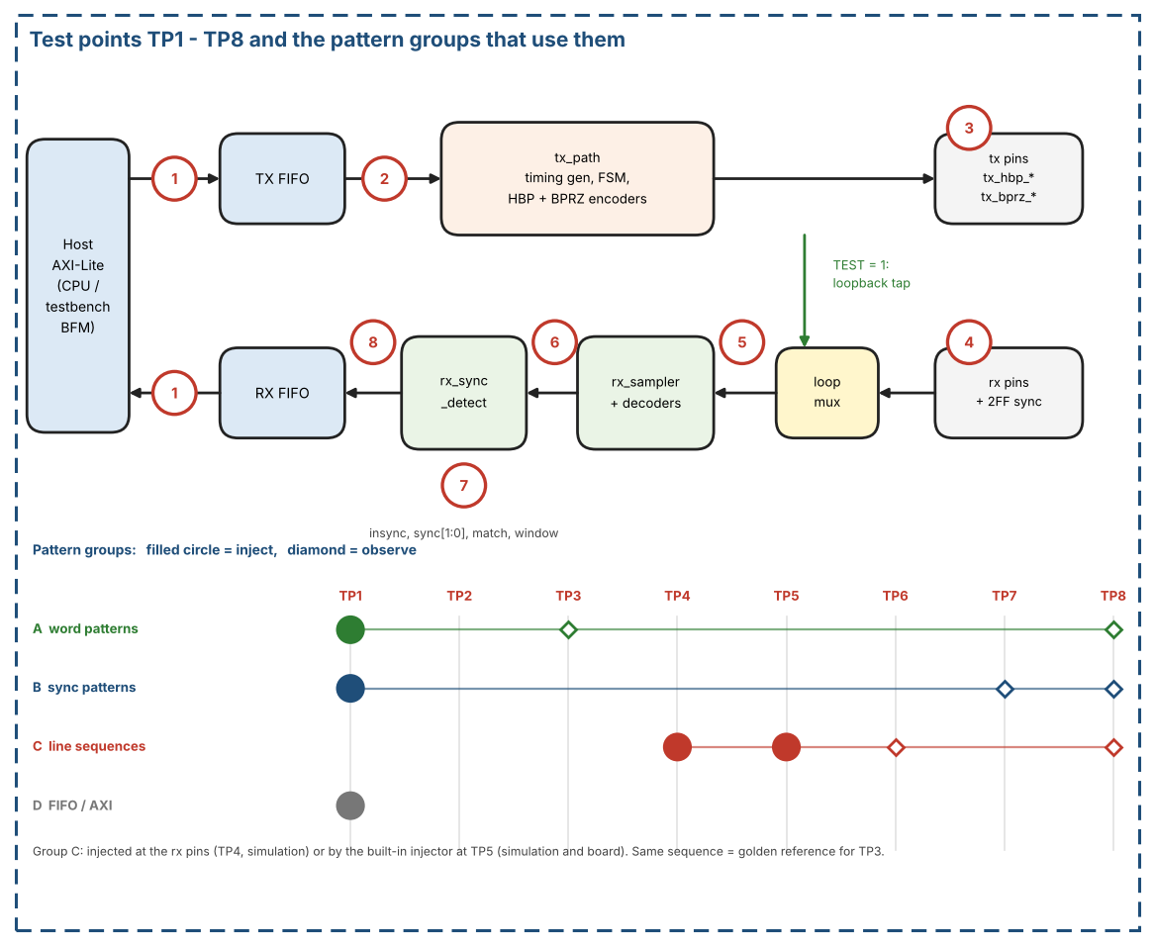
Figure 26. Test points TP1 - TP8 and the pattern groups that use them
Table 47. Test points
TP | Location | Signals | Simulation | Board
TP1 | Host side of the data ports | AXI-Lite writes to TX_DATA / TX_WR_ADDR, reads of RX_RD_DATA, status flags and SLVERR responses | Yes | Yes (firmware)
TP2 | TX FIFO output | async_fifo_tx rd_data | Yes | No
TP3 | TX line pins | tx_hbp_high/low, tx_bprz_high/low (registered, one core_clk after the strobe) | Yes | Pins only (logic analyser)
TP4 | RX line pins, before the pin synchronisers | rx_hbp_high/low, rx_bprz_high/low | Yes | Pins only
TP5 | Input of rx_sampler after the loopback mux | With TEST = 1 the loopback tap, which bypasses the pin synchronisers (Section 3.4); with TEST = 0 the synchronised pins. Also the injection point of the built-in pattern injector (Section 12.14) | Yes | No
TP6 | Decoder output | bit_valid, bit_data of the selected decoder | Yes | No
TP7 | Sync detector | insync, sync[1:0], match, 12-bit window, tracker state | Yes | Pins insync / sync / match and the status register
TP8 | RX FIFO write port | wr_en, wr_data | Yes | No (read back through TP1)

Because TEST = 1 bypasses the pin synchronisers, a loopback run never exercises them: they are covered only by injecting at TP4 in simulation.

12.11.2 Pattern definitions
Conventions
- A word is 12 bits, written in hexadecimal. Words are sent LSB first (Section 3.1.5).
- A stream is a sequence of subframes of W words. Word 0 of every subframe is the sync word of that subframe (subframe_index 0..3 = SYNC1..SYNC4 = 0x247, 0x5B8, 0xA47, 0xDB8, i.e. octal 1107, 2670, 5107, 6670, Table 37). The other words k = 1 .. W-1 are payload.
- n is the running number of the payload word in the stream, starting at 0 at the first payload word; k is the word index inside the subframe (word_in_subframe); s is subframe_index.
- Default for simulation: W = 64 (rate code 0000). A subframe lasts 1 s of line time at every rate, so a full lock sequence takes several seconds of line time whatever the rate (Section 12.12).
Group A - payload word patterns
Table 48. Payload word patterns (word value for payload word n)
Name | Word value | Purpose
P_ZERO | 0x000 | Constant level, no data transitions
P_ONES | 0xFFF | Constant level, opposite polarity
P_ALT | 0x555 for even n, 0xAAA for odd n | Most transitions, stresses the decoders
P_WALK1 | 1 << (n mod 12) | A single 1 moves through the word: finds swapped or shifted bits
P_WALK0 | 0xFFF xor (1 << (n mod 12)) | A single 0 moves through the word
P_COUNT | k (the word index inside the subframe) | A lost, repeated or moved word is visible at once
P_POS | { s[1:0], k[9:0] } | Each word carries its own position; helps to locate a fault
P_PRBS | 12-bit LFSR, seed 0xACE; next = (state << 1) | (b12 xor b6 xor b4 xor b1) over the 12-bit state, word n = state after n + 1 steps; if the value equals one of the four sync codes the word 0x000 is sent instead | Pseudo-random data with period 4095; first words 0x59C, 0xB39, 0x672, 0xCE5, 0x9CB, 0x397
P_BLK8 | B[(k - 1) mod 8] with B = 0x555, 0xAAA, 0x3C3, 0xC3C, 0x999, 0x666, 0x0F0, 0xF0F (k = word index inside the subframe) | Payload of the built-in pattern injector (Section 12.14); all words have an even number of ones

At W = 64 no pattern of Group A produces a sync code by accident (P_COUNT stays below 0x040; P_PRBS is handled by its replacement rule). The sender and the checker apply the same rules.
Group B - sync patterns
Group B streams are built from the sync words and P_COUNT payload; the host writes the sync words itself (SYNC_INS_MODE = 0) unless S6 says otherwise (Section 3.1.2a). Lead-in word: the HBP decoder needs about four bit cells to lock, and the bits of these cells are lost (Table 44). A stream written in software mode therefore starts with one lead-in word 0x000 before the first SYNC1; without it the first sync mark would be damaged and the HBP lock would be delayed by four subframes. The reference model locks and delivers all 128 words of S1 for both HBP and BPRZ with this lead-in.
Table 49. Sync pattern streams
Name | Stream | What it checks
S1 P_SYNC_OK | Lead-in word 0x000, then 6 subframes: SYNC1, SYNC2, SYNC3, SYNC4, SYNC1, SYNC2, each followed by 63 P_COUNT words (W = 64): 385 words | 4-sync lock at the 5th mark (start of subframe 5); delivered words: the 128 words of subframes 5 and 6
S2 P_SYNC_2 | As S1, with SFTSYNC = 1 | 2-sync lock at the 3rd mark (start of subframe 3, subframe_index = 2); delivery from that word onward
S3 P_FALSE_SYNC | As S1, plus a false SYNC1 (0x247) as word 20 of subframe 1 and a false SYNC3 (0xA47) as word 40 of subframe 2 | The false marks cost a tracker slot at most; lock still comes at the 5th real mark and no wrong word is delivered
S4 P_WORD0_BAD | As S1, with word 0 of subframe 6 replaced by 0x111 | After lock the word-0 check fails: INSYNC falls, ST_INSYNC_LOST is raised, the word is not written, acquisition restarts
S5 P_START_MID | S1 extended to at least 10 subframes; RX_EN is set while the transmitter is inside subframe 1 (about word 29) | Acquisition from an arbitrary point: INSYNC rises no later than two frames after RX_EN and the first delivered word is a SYNC1
S6 P_SYNC_HW | As S1 without the lead-in word, but with SYNC_INS_MODE = 1 and only 63 payload words written per subframe; 10 subframes | From SYNC1 on, the line sequence at TP3 is identical to the one of S1 (hardware insertion equals software insertion). Without a lead-in word the first sync mark is damaged for HBP, so the HBP receiver locks at subframe 9 and delivers 128 words
S7 P_NOSYNC | Continuous P_COUNT words, RX_CTRL.NOSYNC = 1 | INSYNC = 1 while rx_active, one word per 12 recovered bits, SYNC[1:0] = 00, no MATCH; the word alignment is arbitrary

Group C - line sequences (HBP and BPRZ, no errors)
Group C gives the complete, error-free line sequence of the stream S1, once for HBP (C_HBP) and once for BPRZ (C_BPRZ). It is written at sample level, 8 samples per bit cell, one (high, low) pair per sample, starting at the first cell of the first word:
- Coding rules: HBP as in Section 3.1.3 (polarity P starts at 0; boundary edge in every cell, mid-cell edge for a 1; half cells of 4 samples), BPRZ as in Section 3.1.4 (One or Zero in the first 4 samples, Null in the last 4). Table 42 lists the first six cells of the first word.
- Size at W = 64: 385 words (lead-in word and 6 subframes) x 12 bits x 8 samples = 36 960 samples (about 6 s of line time). Each sequence is preceded and followed by 32 idle samples (HBP (0,1), BPRZ Null).
- Use as a transmit reference: when the TX is loaded with S1 (or S6), the pins at TP3 shall equal the sequence sample by sample, with no gap between words.
- Use as a receive stimulus: the sequence is applied at TP4 (RXSEL selects the format). Expected at TP6: the bits of all words, LSB first, from the first decoded cell after the decoder has locked (the lock cells at the start are dropped, Table 44). Expected at TP8: the 128 words of subframes 5 and 6 (SYNC1, 63 P_COUNT words, SYNC2, 63 P_COUNT words).
- A system-level run needs about 144 million core_clk cycles (6 s x 24 MHz). For a fast run of the receiver alone, the sequence can be applied to rx_path with sample_tick driven directly: only 36 960 sample_ticks are then needed.
- The golden files (one line per sample) are generated from the reference model of Section 12.10 and are not part of this revision of the document.
- Built-in form: the same kind of sequence is available on the board and in simulation from the built-in pattern injector (Section 12.14). It plays a pre-encoded ROM at TP5 and uses the payload P_BLK8 instead of P_COUNT, so that the payload repeats and the ROM stays small.
Group D - FIFO and interface patterns
- D1: write words with TX disabled until the TX FIFO is FULL (FIFO_DEPTH words), then one more TX_WR_ADDR write (TX_WR_EN = 1).
- D2: pop RX_RD_DATA while EMPTY = 1.
- D3: TX_DATA and TX_WR_ADDR writes with TX_WR_EN = 0.
- D4: loopback with no host read until more than FIFO_DEPTH words have arrived.
- D5: FIFO_CLEAR and SOFT_RESET during TX and RX traffic.
- D6: AXI misuse: WSTRB != 0xF, write to a read-only register, read of a write-only register, unaligned address, accesses while CLR_BUSY = 1.

12.12 Test Plan
Table 50 combines the patterns of Section 12.11 with test points and configurations. Where: S = simulation, B = board (Section 12.13). In simulation the system tests use W = 64 only, because every subframe lasts 1 s of line time; on the board the rate sweep LB-05 covers all eight rates. Each case lists the requirements of Table 43 that it checks.
Table 50. Test plan
ID | Where | Inject -> observe | Configuration | Pattern and expected result | Requirements
TX-01 | S | TP1 -> TP3 | HBP, SYNC_INS_MODE = 0 | S1 words (including the lead-in word). TP3 equals C_HBP sample by sample; no gap between words; outputs one clock after the strobe | REQ-HBP-01, REQ-TX-02, REQ-TX-05
TX-02 | S | TP1 -> TP3 | BPRZ, SYNC_INS_MODE = 0 | S1 words. TP3 equals C_BPRZ sample by sample | REQ-BPRZ-01, REQ-TX-02
TX-03 | S | TP3 | Reset, TX_EN = 0 | No traffic. HBP (0,1), BPRZ Null | REQ-TX-04
TX-04 | S | TP1 -> TP3 | HBP | S1, stop writing mid-stream. Generator freezes, outputs hold, resumes one sample period after the next push | REQ-TX-01
RX-01 | S | TP4 -> TP6, TP8 | RXSEL = 0 (HBP) | C_HBP. TP6 bits = golden bits; TP8 = 128 words of subframes 5 and 6; INSYNC rises at the 5th mark | REQ-RX-01, REQ-RX-02, REQ-RX-04, REQ-SYNC-02, REQ-SYNC-03
RX-02 | S | TP4 -> TP6, TP8 | RXSEL = 1 (BPRZ) | C_BPRZ. Same expected result as RX-01 | As RX-01
RX-03 | S | TP5 -> TP8 | rx_path alone, sample_tick forced | C_HBP and C_BPRZ in 36 960 sample_ticks. Same words at TP8 as RX-01 and RX-02 | As RX-01
LB-01 | S, B | TP1 -> TP1 | TEST = 1, RXSEL = 0 | S1 words (P_COUNT). RX_RD_DATA returns the 128 expected words; INSYNC = 1 | REQ-SYNC-02, REQ-SYNC-03
LB-02 | S, B | TP1 -> TP1 | TEST = 1, RXSEL = 1 | As LB-01 for BPRZ | As LB-01
LB-03 | S, B | TP1 -> TP1 | TEST = 1, both formats | S1 with payload P_ZERO, P_ONES, P_ALT, P_WALK1, P_WALK0, P_POS, one run each. Zero word errors | REQ-RX-02, REQ-RX-05
LB-04 | B | TP1 -> TP1 | TEST = 1, both formats | S1 with P_PRBS, at least 60 subframes. Zero word errors, no INSYNC loss | REQ-SYNC-03
LB-05 | B | TP1 -> TP1 | TEST = 1, all eight rates | S1 with P_COUNT at each TX_RATE = RX_RATE. Lock and zero word errors at every rate | REQ-TICK-01, REQ-CFG-03
SY-01 | S, B | TP1 -> TP7, TP8 | 4-sync (SFTSYNC = 0) | S1. INSYNC rises exactly at the 5th mark, sync[1:0] = 0 (SYNC1) | REQ-SYNC-01, REQ-SYNC-02
SY-02 | S, B | TP1 -> TP7, TP8 | 2-sync (SFTSYNC = 1) | S2. INSYNC rises at the 3rd mark, subframe_index = 2 | REQ-SYNC-02
SY-03 | S, B | TP1 -> TP7, TP8 | 4-sync | S3. Lock at the 5th real mark; no wrong word delivered | REQ-SYNC-01
SY-04 | S, B | TP1 -> TP7, TP8 | 4-sync | S4. INSYNC falls once, ST_INSYNC_LOST raised, the word with 0x111 is not written | REQ-SYNC-04, REQ-RX-03
SY-05 | S, B | TP1 -> TP7, TP8 | 4-sync, RX_EN set late | S5. Lock within two frames; first delivered word is a SYNC1 | REQ-SYNC-01, REQ-SYNC-02
SY-06 | S | TP1 -> TP3 | HBP and BPRZ | S1 with SYNC_INS_MODE = 0, then S6 with SYNC_INS_MODE = 1. From SYNC1 on, the two sequences at TP3 are identical | REQ-TX-03
SY-07 | S, B | TP1 -> TP7, TP8 | NOSYNC = 1 | S7. INSYNC = 1, one word per 12 bits, SYNC[1:0] = 00, no MATCH | REQ-SYNC-05
IN-01 | S, B | TP5 -> TP7, TP8 | Injector, run once, RXSEL = 0 (HBP), 4-sync, W = 64 | Injector stream. INSYNC rises at the 5th mark; 128 words delivered: SYNC1, 63 words P_BLK8, SYNC2, 63 words P_BLK8 | REQ-RX-02, REQ-RX-04, REQ-SYNC-02, REQ-SYNC-03
IN-02 | S, B | TP5 -> TP7, TP8 | Injector, run once, RXSEL = 1 (BPRZ) | As IN-01 for BPRZ | As IN-01
IN-03 | S, B | TP5 -> TP7, TP8 | Injector, run once, RX_RATE = 0001 (W = 128) | As IN-01 with 256 words delivered (2 x W); the stream has 1 + 6 x W words | REQ-SYNC-01, REQ-SYNC-02
IN-04 | S, B | TP5 -> TP7, TP8 | Injector, continuous mode, both formats | At least 10 subframes: no INSYNC loss, every delivered word follows the sync / P_BLK8 rule | REQ-SYNC-03, REQ-SYNC-04
FI-01 | S, B | TP1 | TX disabled | D1. The write beyond FIFO_DEPTH returns SLVERR; no word is lost | REQ-AXI-05, REQ-FIFO-01
FI-02 | S, B | TP1 | RX empty | D2. SLVERR, no pop | REQ-AXI-04
FI-03 | S, B | TP1 | TX_WR_EN = 0 | D3. OKAY, no push | REQ-AXI-05
FI-04 | S, B | TP1 | TEST = 1 | D4. Words beyond FIFO_DEPTH are dropped and OVERFLOW is set; the stored words stay readable | REQ-FIFO-03
FI-05 | S | TP1 | Traffic running | D5. No garbage word, both FIFOs empty, CLR_BUSY returns to 0 | REQ-RST-01, REQ-RST-02
FI-06 | S | TP1 | Any | D6. SLVERR / error responses as in Table 17 and Table 33 | REQ-AXI-02, REQ-AXI-03

12.13 Board Self-Test
The board self-test runs on the target board with the digital loopback (TEST = 1) and needs no external cable or instrument. It is a sequence of cases from Section 12.12 driven by firmware through TP1 (Section 12.11.1); the core status (INSYNC, ST_INSYNC_LOST, OVERFLOW, EMPTY) is read back through the same ports.
Table 51. Board self-test sequence
Step | Action | Pass criterion
1 | Read CORE_VERSION and the status after reset | CORE_VERSION = 0x00010000; EMPTY = 1; GLOBAL_EN = 0
2 | Configure TEST = 1, RXSEL = 0 (HBP), TX_RATE = RX_RATE = 0000 (64 wps), 4-sync, SYNC_INS_MODE = 0; set GLOBAL_EN, RX_EN, then TX_EN | Configuration accepted; no error response
3 | Send S1 (lead-in word, then 6 subframes of a sync word and 63 P_COUNT words, 385 words in all); keep at least 2 words queued and refill on ST_LOW (REQ-TX-06) | No TX underrun
4 | Wait for INSYNC; record the lock time | INSYNC = 1 at the 5th mark (about 4 subframes after the start) and no later than 8 s
5 | Read all received words and compare them with the P_COUNT rule | 128 words; zero mismatches; first word = SYNC1
6 | Repeat steps 2 - 5 with RXSEL = 1 (BPRZ) | Same result
7 | Repeat 3 - 5 for both formats with P_ALT, P_WALK1, P_WALK0, P_POS and P_PRBS (6 subframes each) | Zero mismatches; no INSYNC loss
8 | Negative check: SYNC_INS_MODE = 0, S4 (word 0 of subframe 6 replaced by 0x111) | INSYNC falls and ST_INSYNC_LOST is raised: the detection chain is alive
9 | Optional: repeat steps 2 - 5 with SYNC_INS_MODE = 1 and S6 (10 subframes, 63 payload words per subframe) | Lock at subframe 9 for HBP (subframe 5 for BPRZ) and zero mismatches
10 | Optional: repeat steps 2 - 5 for the other seven rates (TX_RATE and RX_RATE changed with the procedure of Section 2.4) | Lock and zero mismatches at every rate
11 | Built-in injector (Section 12.14): run once at 64 wps for HBP and BPRZ | As IN-01 and IN-02: INSYNC at the 5th mark, 128 words, zero mismatches against the P_BLK8 rule
12 | Report | PASS only if all steps pass; report lock time, word error count, first error index, number of INSYNC losses, OVERFLOW

One run of steps 2 - 5 takes about 6 s of line time at any rate (about 4 s to lock, then two subframes of words). The self-test covers the digital path inside the core, the encoders and decoders, and the sync logic. It does not cover the pins, the line drivers and receivers or the pin synchronisers (the loopback tap bypasses them, Section 3.4). With the built-in pattern injector (step 11) the decoders and the sync detector are also tested independently of the transmit encoder.

12.14 Built-in Pattern Injector
The built-in pattern injector is a test block that feeds the receiver with a fixed, error-free line sequence stored in a small ROM. It makes the Group C patterns of Section 12.11.2 available on the board as well as in simulation, and it tests the decoders and the sync detector independently of the transmit encoder. It holds pre-encoded line values only: it contains no line coder.

12.14.1 Purpose and position
- Position: at TP5 (Figure 26). When enabled, the injector replaces the loopback tap or the synchronised pins at the input of rx_sampler. The pin synchronisers are therefore not tested by it.
- Both formats: the injector provides the HBP pair and the BPRZ pair at the same time; RX_CTRL.RXSEL selects the pair, as it does for the pins.
- Time base: the stored values change on the sample_tick of the receiver, so the edges are aligned with the sampling instants and the sampling phase is fixed. The result of a run is deterministic.
- Independence: the sequence does not come from tx_path. A failure with the injector but not in loopback points to the decoders or the sync detector; a failure in loopback but not with the injector points to the transmit side.

12.14.2 What the ROM stores
A bit cell lasts 8 sample_ticks, in two halves of 4. In each half the line pair is constant, so the ROM stores one value per half cell and the sequencer holds it for 4 sample_ticks. HBP needs 1 bit per half cell (the level of high; low is its inverse). BPRZ needs 2 bits per half cell, the pair (high, low), because it has three states: One = (1,0), Zero = (0,1) and Null = (0,0). The Null half is stored like any other value, so that no line coding is needed. Figure 27 shows the values for the first four bits of word 0x247; the first six cells agree with Table 42.
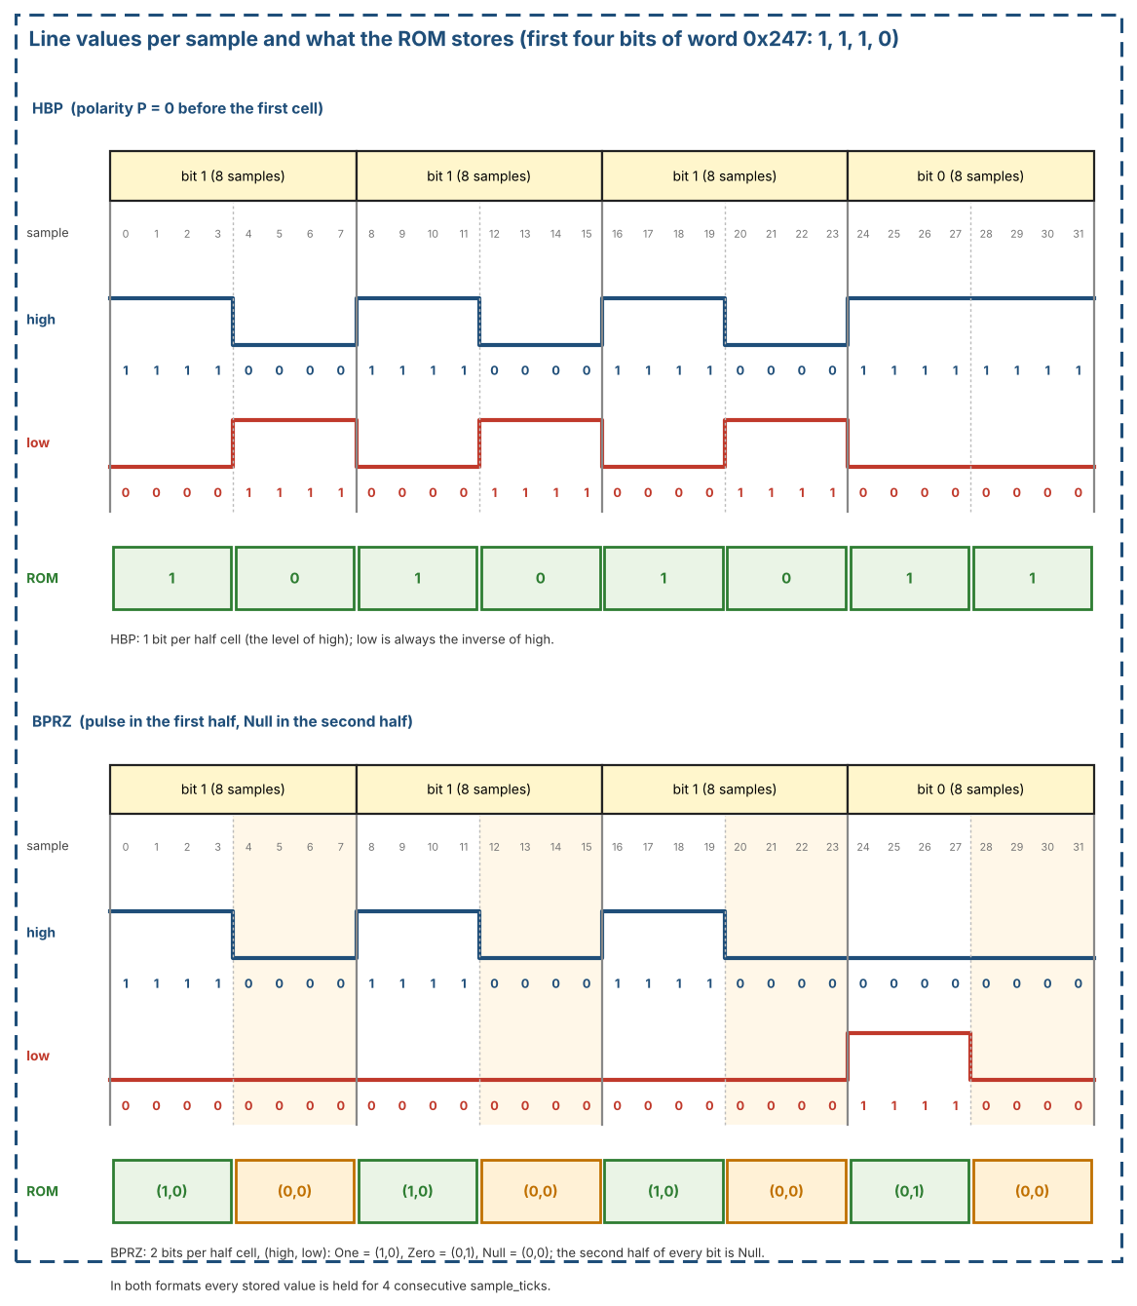
Figure 27. Line values per sample for HBP and BPRZ, and what the ROM stores (bits 1, 1, 1, 0)
The ROM holds whole words as segments of 12 cells (24 half-cell values). Table 52 lists the segments. P is the HBP polarity state before the first cell of the word (Section 3.1.3); P = 0 before the lead-in word.
Table 52. ROM segments
Segment | Word | HBP versions | BPRZ versions
LEAD | 0x000 | P = 0 | 1
SYNC1 | 0x247 | P = 0 | 1
SYNC2 | 0x5B8 | P = 1 | 1
SYNC3 | 0xA47 | P = 1 | 1
SYNC4 | 0xDB8 | P = 1 | 1
B1 .. B8 | 0x555, 0xAAA, 0x3C3, 0xC3C, 0x999, 0x666, 0x0F0, 0xF0F | P = 0 and P = 1 (16) | 1 each (8)
Total | 13 words | 21 segments | 13 segments

Why HBP needs two versions of the payload words: HBP has a memory. A word with an odd number of ones inverts the polarity P, a word with an even number of ones leaves it unchanged. All words of the block B have an even number of ones, so they can follow each other in any order and the block can be repeated or cut at any word. The payload words are stored for both values of P (the second version is the first one with high and low swapped); the sync words are stored only for the polarity at which they occur in the stream (Table 53). BPRZ has no polarity state, so one version of each word is enough.

12.14.3 Playback order
Figure 28 shows the ROM, the playback order and the output. The sequencer only selects addresses and counts; it computes no line coding.
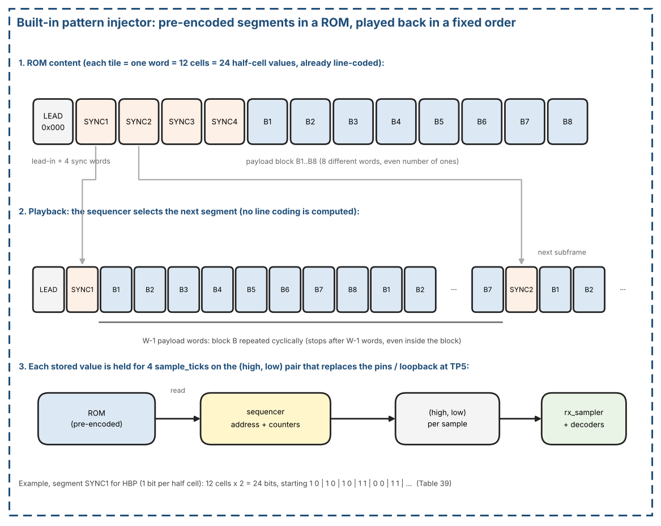
Figure 28. Built-in pattern injector: ROM segments, playback order and output
- A run starts with the lead-in word 0x000, followed by 6 subframes in the order SYNC1, SYNC2, SYNC3, SYNC4, SYNC1, SYNC2.
- A subframe is one sync segment followed by W - 1 payload words, where W is the words per subframe of the applied RX_RATE (Table 5). Payload word k (k = 1 .. W - 1) is the segment B[(k - 1) mod 8], so the block restarts at B1 in every subframe and is cut after W - 1 words.
- The HBP version of every segment follows Table 53. The pattern repeats every four subframes.
- Counters: sample (0..3, holding time of a value), half cell, cell (0..11), word in subframe (0..W - 1) and subframe (0..5, or free-running modulo 4 in continuous mode).
- Length of a run: 1 + 6 x W words; at W = 64 that is 385 words, 36 960 sample_ticks, about 6 s of line time.
Table 53. HBP polarity versions used in each subframe (P = state before the first cell of the word)
Subframe | Sync segment | P at the sync word | P at the payload words
1 | SYNC1 | 0 | 1
2 | SYNC2 | 1 | 1
3 | SYNC3 | 1 | 1
4 | SYNC4 | 1 | 0
5 | SYNC1 | 0 | 1
6 | SYNC2 | 1 | 1

12.14.4 ROM size
HBP: 21 segments x 24 values x 1 bit = 504 bits. BPRZ: 13 segments x 24 values x 2 bits = 624 bits. Together 1 128 bits. Storing the same HBP sequence sample by sample would need 36 960 bits.

12.14.5 Control and status
The injector is controlled through the bits of INJ_CTRL (RX base + 0x08) and INJ_STATUS (RX base + 0x0C), defined in Section 7.4 (Table 28 and Table 29). The bits are listed here with their use.
- INJ_EN: 1 = the injector drives TP5 instead of the loopback tap or the pins. Changed only while rx_active = 0.
- INJ_START: writing 1 starts a run (self-clearing). RX_EN must be set before the start, so that the decoders see the lead-in word.
- INJ_MODE: 0 = run once (1 + 6 x W words, then idle); 1 = continuous: the sequence goes on with SYNC3, SYNC4, SYNC1, ... until INJ_EN = 0.
- INJ_BUSY: 1 while a run is in progress. INJ_DONE: set when a run once has ended, cleared by the next start.

12.14.6 Expected result and checking
- The receiver locks at the 5th mark (the SYNC1 at the start of subframe 5) in 4-sync mode, for both formats.
- The delivered words are the 2 x W words of subframes 5 and 6: SYNC1, W - 1 words P_BLK8, SYNC2, W - 1 words P_BLK8 (128 words at W = 64).
- No checker is built in. The host (firmware or testbench) reads the words and compares them with the rule above; tests IN-01 to IN-04 in Table 50.
- Checked with the reference model of Section 12.10 (encode, decode, sync detector): at W = 64 and W = 128 both formats lock at the 5th mark and deliver 2 x W words without loss of lock.

12.14.7 Limits
- The payload repeats with a period of 8 words: wrong word values and wrong bits are detected, but a loss of exactly a multiple of 8 payload words cannot be seen in the payload values. The sync words and the word count still show it. The patterns of Group A, with P_COUNT, remain available in loopback.
- The ROM is written from the same specification as the transmit encoder. A common misreading (for example the initial polarity) would not be detected; the first cells of SYNC1 are therefore checked by hand against Table 42.
- Only error-free sequences are stored. Error injection (bit period, missing pulses) is not part of the injector.

13. Glossary
- HBP – Harvard Bi-Phase (ARINC 717 main bus).
- BPRZ – Bi-Polar Return-to-Zero.
- CDC – Clock-Domain Crossing.
- FWFT – First-Word Fall-Through FIFO.
- INSYNC – Receiver locked to subframe sequence.
- SYNC_INS_MODE – 0 software sync in FIFO; 1 hardware TX_SYNCx insert.
- SHALL – Mandatory requirement for a compliant implementation.
- W – words per second, equal to the words per subframe (64 … 8192), Table 5.
- Subframe – 1 second of W words; its first word is a sync mark. Frame – 4 subframes.
- sample_tick – generator pulse, 8 per bit cell (W x 96 per second).
- phase – sample counter 0..7 inside a bit cell. Bit cell – one data-bit period; cell_start marks its start.
- Dwell – a classified level must hold for 2 consecutive samples to become valid.
- Tracker – one of 4 slots following a candidate sync sequence (Section 3.2.2.2).
- Underrun – the TX FIFO is empty at a word_tick; the Timing Generator freezes.
- Sticky bit / W1C – IRQ status bit set by an event and cleared by writing 1 to it.
- Applied configuration – the values latched in core_clk from the configuration bundle (Section 4.2.1, Section 2.4).

14. Open Issues
- HBP waveform rule (boundary edge in every cell, mid-cell edge = 1) and the 64 ... 8192 wps set were checked against public device data and the Harvard biphase definition (Section 1.5). Decided: the HBP polarity at the start of the first cell is P = 0. Still open: any revision of ARINC 717 later than 717-15.
- OPEN QUESTION: the HBP idle/reset level (tx_hbp_high, tx_hbp_low) = (0,1) is kept for now as a design choice; the public sources do not define the idle level of the digital outputs. It SHALL be revisited when the line driver of the board is known.
- Decoder tolerance of -1 / +2 samples per bit is accepted for this version. Re-check it only if the line source is not derived from the same clock accuracy.
- Multi-channel expansion out of scope for v1.40.

