3. Design Approach
D.I.R.T.T. (Digital Instrument for Remote Terrain Testing) is designed to give farmers a quick, low-cost overview of soil conditions across a field. The system is an autonomous, mostly solar-powered rover that drives to GPS points about 100 m apart, pushes a 4-in-1 probe into the soil at each point, and reports pH, electrical conductivity (EC), temperature, and moisture to a base station over LoRa radio. By integrating autonomous navigation, automated soil probing, and long-range wireless telemetry, D.I.R.T.T. shows a farmer which areas of a field are worth testing by hand without walking every acre. It is a screening tool, not a replacement for lab-grade analysis.
Throughout the design process, the project requirements, constraints, and standards guided development decisions. The most critical requirements include driving autonomously to each GPS sampling point while avoiding obstacles; reaching each point within a few meters; measuring pH, EC, temperature, and moisture at every point; and returning each reading with its coordinates to the base station over LoRa. Key constraints include a total budget of about $1,000, a power system that is mostly solar with battery backup, and outdoor operation on farmland. Additionally, the design follows FCC Part 15 (§15.247) for unlicensed operation of the 915 MHz LoRa radios, IEC 60529 ingress protection ratings for components exposed to soil and weather, TIA-485-A and Modbus RTU for the soil sensor interface, and the safety principles of ISO 18497 for highly automated agricultural machines, which shaped the emergency stop, bump switches, and radio STOP command. The following subsections describe the design options evaluated and justify the selected system architecture.
3.1 Design Options
During concept development, the team evaluated two approaches to what D.I.R.T.T. should measure and how accurately. Each candidate was evaluated against the design requirements for the usefulness of its results to a farmer, durability in the field, ease of unattended operation, and cost. The most important design challenge was deciding how much soil analysis the rover itself should perform. The two approaches differ in the rover's role: a replacement for laboratory soil testing, or a screening tool that shows the farmer where laboratory testing is needed.
3.1.1 Design Option 1
The first design option considered was a full mobile lab. In this configuration, the system collects a sample of dirt via claw or drill and internally mixes it with water to perform chemical nutrient testing. This requires on-board storage for water, waste, and the necessary testing chemicals. Either moving parts or a piping system are responsible for transportation of substances within the system. The system must dock to a base station to charge and refill its water and chemicals, while also disposing of waste. This design utilizes LoRa to communicate with the base station, which connects to internet to read weather data and send a signal to the rover to dock in the event of inclement weather.
With the collected data from testing, the rover would create a heat-map of soil health, identifying which nutrients a given area needs. This heat map is transmitted to and displayed on the base station, which includes a user interface.
The primary advantage of this design is the fullness of information it provides: it serves as a full testing unit, alerting users of areas of concern while also informing users how to address potential soil fertility issues.
However, this approach presents significant limitations in cost. Internal moving parts are very expensive to produce, requiring multiple motors, and the test kits that are needed are similarly pricey. Because a $1000 budget is a core requirement of D.I.R.T.T., this limitation led to the consideration of an alternative design.
3.1.2 Design Option 2
The selected design approach, a field screening tool, uses a single probe to measure four properties that vary across a field and can be read reliably in seconds: pH, EC, temperature, and moisture. In this configuration, the rover drives to points on a grid about 100 m apart, inserts a 4-in-1 sensor, and reports each reading with its GPS coordinates. The result is a map that shows the farmer where conditions differ, so manual sampling and laboratory testing can be focused on the spots that need it.
This design provides significant advantages over Option 1. A 4-in-1 probe is mechanically simpler and easier to design on a tight budget. It fits within the budget, leaving funds for autonomy, solar power, and long-range communication, and each reading takes only seconds, keeping every sampling stop short. Because the rover's job is to point out where to look rather than to replace laboratory analysis, moderate sensor accuracy is acceptable.
Despite these advantages, this design gives up nutrient and organic-matter measurements, and its readings, particularly pH, are less accurate than laboratory results. However, these trade-offs are justified by the requirements for an affordable, durable, autonomous system, and the laboratory remains the right tool for the follow-up tests toward which the rover's map directs the farmer. For this reason, Design Option 2 was selected for D.I.R.T.T.
3.2 System Overview
Figure 3-1 presents a Level 0 overview of D.I.R.T.T. At this level, the rover and base station are treated as a single functional unit, showing the primary inputs and outputs without internal detail. The main inputs are the sampling points and commands the operator enters at the base station, GPS satellite signals, sunlight, the soil itself, obstacles and terrain in the rover's path, and an emergency-stop press. The primary outputs are soil readings tagged with GPS coordinates and logged on the laptop, the rover's motion between points, and status messages and alerts.
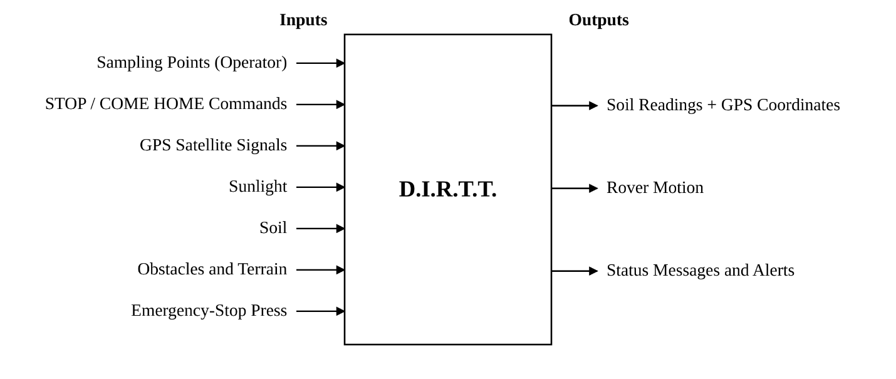
Fig. 3-1: D.I.R.T.T. System Overview (Level 0)
This high-level view shows the system boundary and how external inputs become outputs. Figure 3-2 expands it into the five subsystems and the base station, and shows how power and signals move between them
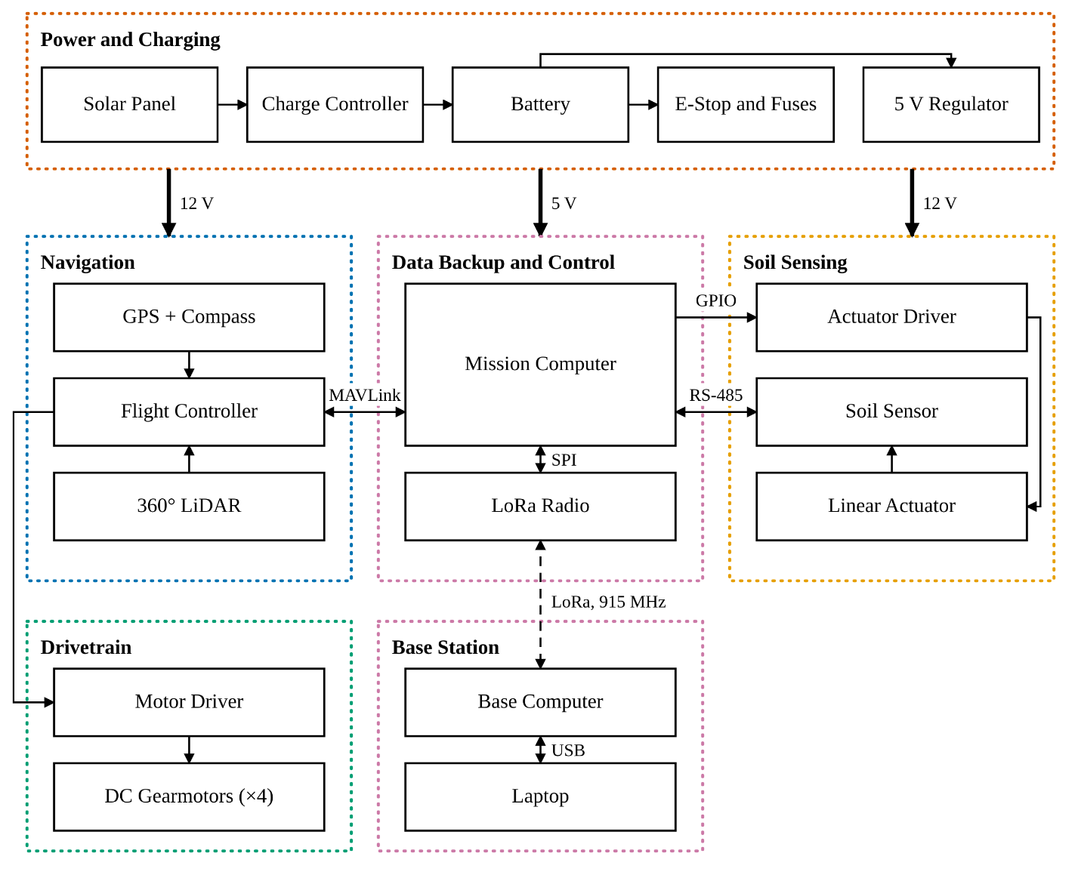Fig. 3-2: D.I.R.T.T. Functionality (Level 1)
The Level 1 diagram shows how D.I.R.T.T. integrates sensing, processing, actuation, and communication. The mission computer serves as the central controller: it passes sampling points to the flight controller, drives the soil probe through the actuator driver, reads the soil sensor, monitors the emergency stop and bump switches, and communicates with the base station through its LoRa radio. The flight controller combines GPS, compass, and LiDAR data and sends throttle commands to the motor driver, which drives the four gearmotors. Power comes from a solar panel through a charge controller to a 12 V LiFePO4 battery. The battery feeds a 12 V rail for the motor and actuator drivers through the emergency stop and fuses, and a 5 V regulator for the mission computer and sensors that stays on when the emergency stop is pressed, so the rover can still report its state. The specific components are selected in Sections 3.2.1 and 3.3 and shown in the Level 2 diagram in Section 3.4.1.

3.2.1 Mission Computer
The mission computer serves as the central processing unit for D.I.R.T.T. and is responsible for coordinating the sampling mission: it relays each sampling point to the flight controller, deploys and retracts the soil probe, reads and logs the soil sensor, monitors the safety switches, and handles all LoRa communication with the base station. It must run Linux so the team can use Python and the pymavlink library, and it must provide a UART for the flight controller, SPI for the LoRa radio, I2C for the current sensor, and a USB host port for the RS-485 adapter, while drawing as little power as possible from a solar-charged battery. Key design considerations included interfaces, power consumption, software support, availability, and cost. Table 3-1 compares the candidate processing platforms.
Table 3-1: Mission Computer Options
Product | Processor | Memory | Interfaces | Power (W) | Price ($) | Suitability
Requirements | 32-bit or better | ≥ 512 MB | UART, SPI, I2C, USB host | ≤ 2.5 | ≤ 40 | Runs pymavlink; all four interfaces
Raspberry Pi 3 Model B [1] | Quad Cortex-A53, 1.2 GHz | 1 GB | UART, SPI, I2C, 4 × USB | ≈ 2.0 | 35 | Meets all; in stock
Raspberry Pi  Zero 2 W [2] | Quad Cortex-  A53, 1 GHz | 512 MB | UART, SPI,  I2C, 1 ×  micro-USB  OTG | ≈ 1.75 | 15 | Meets all; out  of stock
ESP32 dev board  [3] | Dual Xtensa  LX6, 240 MHz | 520 KB | UART, SPI,  I2C, no USB  host | ≈ 0.5 | ≈ 10 | No Linux;  cannot host  the RS-485  adapter
Arduino Uno R3  [4] | ATmega328P,  16 MHz | 2 KB | 1 UART, SPI,  I2C | ≈ 0.25 | ≈ 27 | Too little  memory; one  UART
Based on the comparison in Table 3-1, the Raspberry Pi 3 Model B was selected because it meets every interface requirement on one board, runs Raspberry Pi OS with full Python and pymavlink support, and draws about 2 W for $35. Its four USB ports leave room for the RS-485 adapter and a future peripheral without a hub. Compared to the Raspberry Pi Zero 2 W, which would have saved a few dollars and about 0.25 W, it was available when parts were ordered, while the zero boards were out of stock. Although the ESP32 and Arduino Uno draw far less power, neither runs Linux, the ESP32 has no USB host for the RS-485 adapter, and the Uno has only 2 KB of RAM and a single serial port, which the flight controller link would occupy. Figure 3-3 shows the selected board.
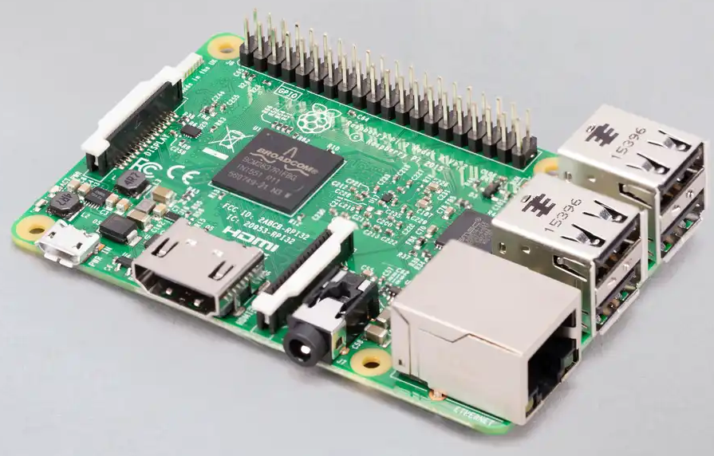
Fig. 3-3: Raspberry Pi 3 Model B [1]
The Raspberry Pi 3 Model B acts as the rover's mission computer: it decides what the rover does next, while the flight controller decides how to drive there.
3.3 Subsystems
The design for D.I.R.T.T. is divided into five primary subsystems. Together they are responsible for driving the rover to each sampling point, testing the soil, storing and reporting the results, and powering the system. The subsystems are listed as follows:
- Navigation – responsible for localization, waypoint following, and obstacle avoidance
- Drive Train – responsible for moving and steering the rover with four-wheel skid steering
- Soil Testing – responsible for driving the probe into the soil and measuring pH, EC, temperature, and moisture
- Data Backup and Control – responsible for coordinating the mission, logging data, and LoRa communication with the base station
- Power and Charging – responsible for solar charging, energy storage, and power distribution
3.3.1 Navigation
The Navigation subsystem guides D.I.R.T.T. from one sampling point to the next without operator input. It determines the rover's position and heading, follows a planned route of GPS waypoints spaced about 100 m apart, stops at each point so the soil probe can be deployed, and detects obstacles so the rover can stop or steer around them. This subsystem must satisfy requirements including stopping within 5 m of each target sampling point, detecting obstacles at least 3 m ahead in outdoor daylight, and halting within 1 s any of the following scenarios: losing GPS, leaving the geofence, receiving a LoRa STOP command, or the e-stop being pressed. Key design considerations included position accuracy, firmware support for autonomous ground vehicles, operation in direct sunlight, available serial ports, and cost.
Flight Controller
The flight controller estimates position and heading by fusing GPS, compass, and IMU data, and steers the rover along the route. It must run proven ground-vehicle autopilot firmware, accept the 12.8 V LiFePO4 battery, and provide enough serial ports for the GPS, LiDAR, and Raspberry Pi. Table 3-2 compares the candidate options.
Table 3-2: Navigation Flight Controller Options
Product | Flash (MB) | Serial Ports | ArduRover support | Input Voltage (V) | Price ($)
Requirements | ≥ 1 | ≥ 3 | Official Rover target | 12.8–14.6 | ≥ 60
MicoAir743v2 [5],  [6] | 2 | 8 UART | Official, full  feature set | 6–27 (2S–  6S) | 49.99
Holybro Pixhawk 6C  [7] | 2 | TELEM1–3,  GPS1–2 | Official, full  feature set | ≤ 6; needs  power  module | 219.99
Raspberry Pi +BNO085 IMU, no flight controller [8] | n/a | 1 UART +  USB | None; custom  Python | 5 | ≈ 25
Based on the comparison in Table 3-2, the MicoAir743v2 was selected because it has an official ArduPilot Rover firmware target, which already provides skid steering, waypoint missions, 360° object avoidance, geofencing, and failsafes. Its 2 MB of flash runs the full ArduPilot feature set, including object avoidance and the RPLIDAR driver, and its eight UARTs and 6–27 V input accept the GPS, LiDAR, Raspberry Pi, and 12.8 V battery directly, all for $49.99. Compared to the Holybro Pixhawk 6C, it gives up the redundant IO processor and locking connectors, but the Pixhawk with a power module would consume 22% of the $1,000 budget. Although the custom Raspberry Pi + IMU approach is the cheapest, it would require the team to write and validate sensor fusion, path following, and failsafes from scratch. The MicoAir743v2 is marketed for multirotor drones, but ArduPilot runs the same hardware as a rover by loading Rover firmware, so the main adaptation is mechanical: the board will sit in a 3D-printed enclosure on vibration dampers, with strain-relieved cables and a short adapter cable for battery power. Its built-in QMC5883L compass will be disabled in favor of the GPS module's compass on the mast, as the ArduPilot documentation recommends. Figure 3-4 shows the selected flight controller.
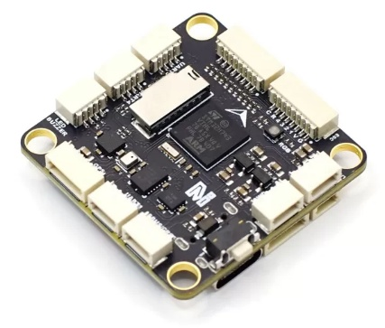
Fig. 3-4: MicoAir743v2 Flight Controller [6]
The MicoAir743v2 acts as the rover's autopilot: it turns each target point from the Pi into steering and throttle commands and stops the rover when any failsafe triggers.
GPS and Compass
The GPS and compass module provides the rover's absolute position and heading. Its accuracy must be well inside the 3 m waypoint tolerance, and the compass must be supported by ArduPilot so that heading is known even when the rover is stationary. Table 3-3 compares the candidate options.
Table 3-3: Navigation GPS and Compass Options
Product | Constellations | Horizontal accuracy (m CEP) | Compass | Price ($)
Requirements | ≥ 3 | ≤ 2 | Built-in, ArduPilot- supported | ≤ 40
Holybro Micro M10  [9] | GPS, GLONASS, Galileo, BeiDou | 1.5 [10] | IST8310 | 33.99
Matek M10Q-5883 [11] | GPS, GLONASS, Galileo, BeiDou | 1.5 [10] | QMC5883 | 47.99
Beitian BN-880 [12] | GPS, GLONASS,  Galileo, BeiDou | 2.5 | QMC5883 | 34.98
Holybro H-RTK F9P  [13] | GPS, GLONASS,  Galileo, BeiDou | 0.01 with RTK  base | IST8310 | > 200 each;  two needed

Based on the comparison in Table 3-3, the Holybro Micro M10 was selected because it pairs an accuracy of 1.5 m CEP with an ArduPilot- supported IST8310 compass at the lowest price of the M10 options. Compared to the Matek M10Q-5883, it offers the same receiver class for $14 less. Compared to the Beitian BN-880, it uses a newer receiver with better accuracy and lower power. Although the H-RTK F9P achieves centimeter accuracy, it requires a second unit as a base station and costs more than ten times as much, while a 1.5 m position error is only 1.5% of the 100 m sampling grid. The module will be mounted on a 15–20 cm mast to keep the compass away from motor and battery currents. Figure 3-5 shows the selected module.
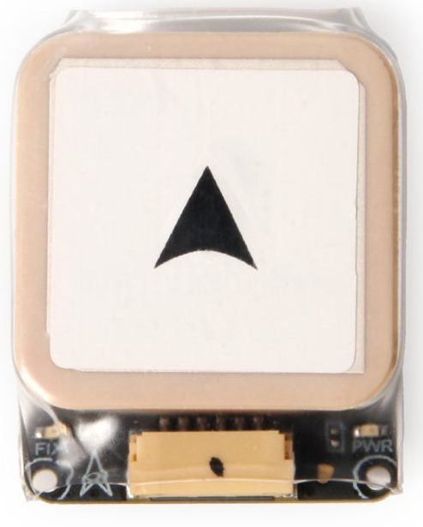
Fig. 3-5: Holybro Micro M10 GPS and Compass [9]
The Micro M10 gives the flight controller the position and heading it needs to follow the route and to tag every soil reading with its location.
Obstacle Sensor
The obstacle sensor detects objects around the rover so the flight controller can stop or steer around them before contact. It must see at least 3 m ahead, work outdoors in daylight, and be supported by ArduPilot's proximity drivers. Table 3-4 compares the candidate options.
Table 3-4: Navigation Obstacle Sensor Options
Product | Range (m) | Scan rate (Hz) | Sunlight tolerance (lux) | Price ($)
Requirements | ≥ 3 | ≥ 5 | Outdoor  daylight | ≤ 100
SLAMTEC RPLIDAR C1 [14] | 0.05–12 | 10 | 40,000 | 69.00
SLAMTEC RPLIDAR A1M8 [15] | 0.15–12 | 5.5 | Indoor use | 99.00
LDROBOT LD19 [16] | 0.02–12 | 10 | 30,000 | 129.99
Based on the comparison in Table 3-4, the RPLIDAR C1 was selected because it is rated for the highest ambient light, and it is supported directly by ArduPilot. Compared to the RPLIDAR A1M8, it costs $30 less and is designed for outdoor light, while the A1 is an indoor sensor. Compared to the LDROBOT LD19, it offers higher sunlight tolerance and is cheaper. Figure 3-6 shows the selected sensor.
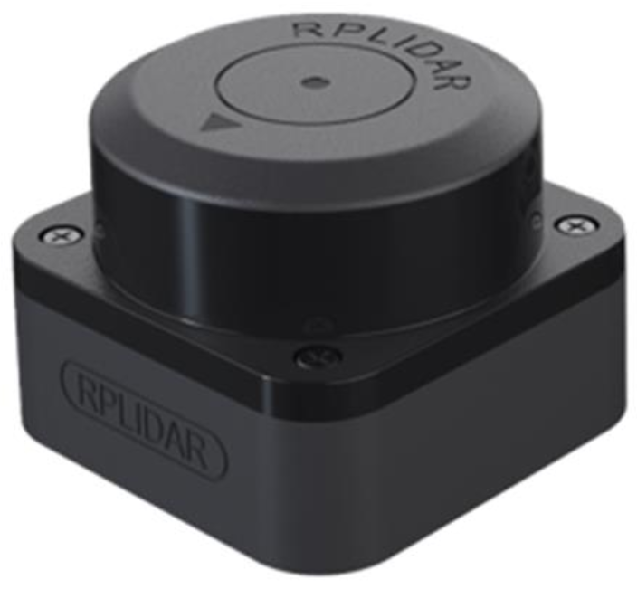
Fig. 3-6: PRLIDAR C1 [14]
The RPLIDAR C1 gives the flight controller a 360° picture of obstacles within 12 m, which ArduPilot's object avoidance uses to stop or route around them.
3.3.2 Drive Train
The Drive Train subsystem is responsible for fabricating and assembling the chassis with all four motors and wheels; the mass with ballast must be ≤ 20 kg. The robot must be under RC control and drive ≥ 0.5 m/s on grass and must turn in place. It must also climb a 15% grade with 20 kg on board and have a ground clearance of ≥ 3 in. Key design considerations included a choice of motors for the chassis.
Motor
The motor drives the robot and controls the speed and strength of the wheels.
Table 3-5: Drive Train Motor Options
Product | Rpm | Voltage(V) | Torque(kg.cm) | Price ($)
Requirements | ≥ 70 | 12 | ≥ 40 | ≤ 20
GB37Y3530 Motor with Encoder [17] | 83 | 12 | 45 | 16.50
Metal DC Geared Motor w/Encoder - x1  JST 6-Pin cable x1 [18] | 300 | 6 | 3.6 | 19.90
GB37Y3530-12V-90EN [25] | 122 | 12 | 38 | 29.00
Based on the comparisons in Table 3-5, the GB37Y3530 Motor with Encoder, shown in Fig. 3-7, was selected because it has the most optimal torque and price for the voltage rating needed. Its rmp is lower than that of the third option, GB37Y3530-12V-90EN, but its price was in our budget while the third option was not. The rpm for the Metal DC Geared Motor was much higher as well, but the voltage and torque both did not meet the project's requirements.
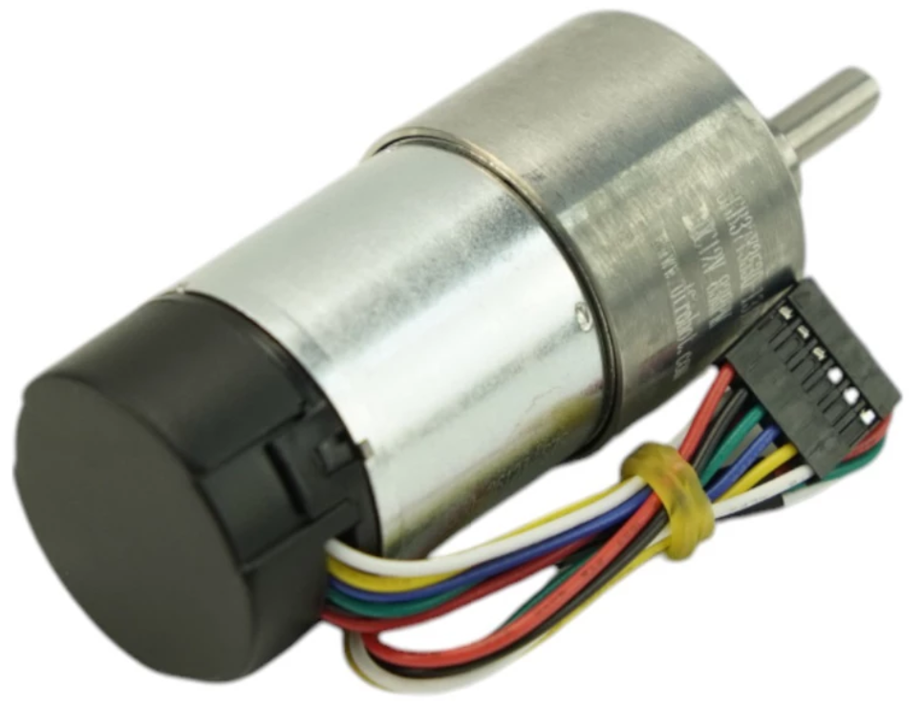
Fig. 3-7: GB37Y3530 Motor with Encoder [23]
Motor Driver
The motor driver is responsible for controlling the motors and helping the wheels change direction and regulate speed. It acts as an electrical power amplifier and an interface between the microcontroller and the motors.
Table 3-6: Drive Train Motor Driver Options
Product | Motor Current (A) | Voltage (V) | Dual DC Driver | Price ($)
Requirements | ≥ 3.6 | 12 | Yes | ≤ 45
Cytron 10A 7V-30V Dual DC Motor Driver for R/C [26] | 10 | 7 - 30 | Yes | 39.00
SparkFun Motor Driver - Dual TB6612FNG [27] | 1.2 | 2.7 - 5.5 | Yes | 14.50
Adafruit DRV8871 motor driver breakout board [28] | 3.6 | 6.5 - 45 | No | 7.50

Based on the comparisons in Table 3-6, the Cytron motor driver, shown in Fig. 3-8, was chosen because of its optimal motor current, voltage capacity, and the fact that it is a dual DC motor driver. The SparkFun Motor Driver was also a dual DC driver, but the motor current and voltage did not fit the requirements necessary for the project. The Adafruit DRV8871 was the cheapest of the three and fit the motor current requirements, although barely, but it did not meet the voltage requirement and was not a dual DC motor driver.
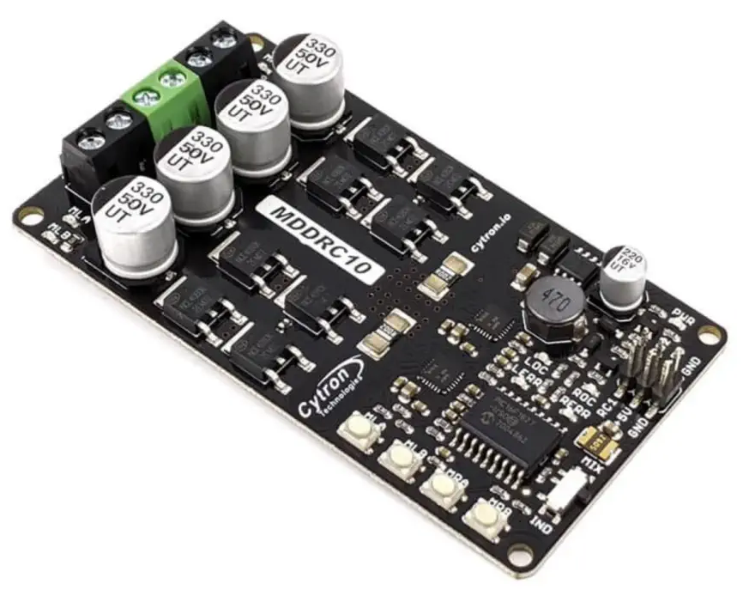
Fig. 3-8: Cytron Motor Driver [26]
3.3.3 Soil Testing
The Soil Testing subsystem is responsible for pushing a 4-in-1 soil probe into the ground at each sampling point with a linear actuator, reading the soil's pH, electrical conductivity (EC), temperature, and moisture, and retracting the probe before the rover moves on. This subsystem must satisfy requirements including reading all four values over Modbus at least every 5 s; agreeing with a handheld reference meter within ±0.15 pH and ±1 °C on 3 soil samples; completing an insert, read, and retract cycle in 60 s or less; and stopping the actuator within 3 s of stalling on a buried obstruction. Key design considerations included measuring all four properties with a single probe, a digital output the computer can read, sealing for wet soil, operation from the 12 V rail at low current, enough push force to insert the probe, a way to detect obstructions, and cost.
Probe Actuator
The probe actuator pushes the soil sensor into the ground, holds it in place while the mission computer takes readings, then pulls it back out. It must also provide feedback allowing the mission computer to detect when the probe hits something it cannot push through, such as a rock. It must provide at least 100 N of push force, move fast enough that the probe’s 150 mm of travel down and back plus a reading fit within the 60 s cycle, and run from the 12 V rail. Table 3-7 compares the candidate options.
Table 3-7: Probe Actuator Options
Product | Push Force (N) | Speed (mm/s) | Position Feedback | Stall Current @ 12 V (A) | Cost $
Requirements | ≥ 100 | ≥ 5.5 | Detectable by computer | ≤ 3.0 | ≤ 100
ECO-WORTHY 330 lb, 8 in stroke [23] | 1500 | 5.7 | Motor current (limit switches at both ends) | 3.0 | 43.99
Actuonix P16-150-256-12-P [24] | 300 (500 static) | 2.5 to 4.8 | Potentiometer | 1.0 | 106.59
Stepper motor + lead screw | 250 | Set by driver | None (homing switch only) | Draws holding current | 172

Based on the comparison in Table 3-7, the ECO-WORTHY 12 V linear actuator [23], shown in Fig. 3-9, was selected because it is the only option that meets every requirement. It provides 1500 N of push force, far more than the 100 N needed, and runs directly from the 12 V rail. Its metal gears and alloy steel rod suit repeated insertions in field soil, it is rated IP54, and its internal limit switches stop it at both ends of travel without extra hardware. At 5.7 mm/s, the probe’s 150 mm of travel takes about 26 s each way, so a full cycle fits within 60 s. Its 25% duty cycle [23] is not a limitation: the actuator runs for about 53 s at each sampling point, while the 100 m drive between points at 0.5 m/s takes about 200 s, so it runs about 21% of the time. Compared to the Actuonix P16 [24], it provides five times the push force and is faster. At 4.8 mm/s or less, the P16 needs 63 s or more for 150 mm of travel down and back, so it exceeds the 60 s cycle before any reading. Although a stepper motor and lead screw could produce similar force to the P16, it costs about $172, is unsealed, has no way to detect a stall beyond a homing switch, and draws holding current the entire time it is energized.
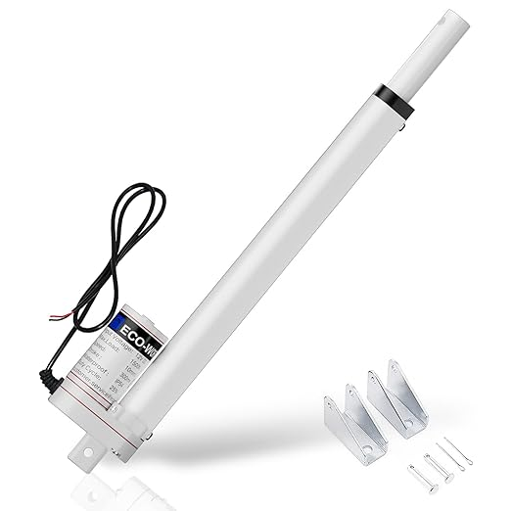
Fig.3-9: ECO-WORTHY Linear Actuator [23]
The ECO-WORTHY actuator helps drive the soil sensor into the ground at each sampling point and retracts it to its internal limit switch before the rover moves. Because it has no position feedback, insertion depth is set by drive time, and obstructions are detected from motor current as described below. With a 12 in stroke, the actuator will stand above its mount, so the solar panel mount must be designed to clear it.
Rock-strike detection
A current sensor on the actuator’s 12 V branch reports the actuator’s current to the computer over I2C every 100 ms. During normal insertion, the actuator draws close to its 0.8 A no-load current [23]; when the probe meets a rock, the load and the current rise. If the current stays above a threshold set during soil-bin testing for 0.3 s, the computer cuts drive, retracts the probe to its limit switch, and logs the point as obstructed. The threshold must be set below the current at which the actuator begins lifting the rover, about 1.1 A by a linear estimate for a 20 kg rover, because the actuator can lift the rover off its wheels before it stalls.
Soil Sensor
The soil sensor measures moisture, temperature, pH, and EC at each sampling point and sends the readings to the mission computer. It must report all four values from a single insertion, provide a digital output the mission computer can read, survive wet soil, and run from the 12 V rail at low current. Table 3-8 compares the candidate options
Table 3-8: Soil Sensor Options
Product | Measures pH | Supply Voltage V | Current Draw | Sealing | Cost $
Requirements | Yes | Includes 12 | ≤ 50 mA @ 12 V | IP68 | ≤ 75
DFRobot Sen0604 [25] | Yes | 5–30 | ~42 mA max @ 12 V​ | IP68 | 69
Seeed SenseCap MTEC-02A​[27] | No | 3.6–30 | 6 mA idle @ 24 V​ | IP68 | 99
METER TEROS 12 [28] | No | 4–15 | 3.6 mA typ.​ | Epoxy, no IP rating | 271

Based on the comparison in Table 3-8, the DFRobot SEN0604 [25] was selected because it is the only candidate that measures pH, and it is also the least expensive at $69. It reads all four properties in one insertion: moisture (±2% from 0 to 50%, ±3% from 50 to 100%), temperature (±0.5 °C), EC from 0 to 20,000 µS/cm (±3% FS up to 10,000 µS/cm, ±5% FS above) with built-in temperature compensation, and pH from 3 to 9 at 0.1 resolution [25]. It runs directly from the 12 V rail at about 0.5 W, is sealed to IP68, and communicates over RS-485 using Modbus RTU, which the mission computer reads through a USB-to-RS-485 adapter. Compared to the Seeed SenseCAP MTEC-02A [27], which draws much less current, it costs $30 less and adds pH. Although the METER TEROS 12 [28] is a research-grade sensor, it costs $271, does not measure pH, and uses SDI-12 rather than RS-485. Choosing either alternative would require a second pH probe, adding cost and a second insertion at every sampling point. Because the manufacturer does not publish a pH accuracy [25], the SEN0604's pH readings will be verified against a handheld reference meter on three prepared soil samples. Figure 3-10 shows the selected sensor.
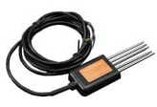
Fig. 3-10: DFRobot Sen0604 4-in1 Soil Sensor [25]
The SEN0604 is the subsystem's only sensing element: one insertion gives the computer all four soil values, which are tagged with GPS coordinates and sent to the base station.
3.3.4 Data Backup and Control
The Data Backup and Control subsystem is responsible for coordinating missions, logging data, and communicating with the base station. This subsystem must satisfy the requirements of maintaining the link of communication to the base station at ≥ 500m line of sight, store the measurement results with a timestamp and its current coordinates, and display at least 90% of all readings on a heatmap within 5 minutes of result packet arrival. Key design considerations included communication across farmland without WiFi, and microcontrollers that are capable of the set tasks for DIRTT and its base station, while reducing cost.
Communication Module
The communication module is the radio link between DIRTT and the base station. It carries each result packet, which holds the four soil values, the GPS coordinates, and a timestamp, from the rover to the base station for logging and display on the heatmap.
Table 3-9: Communication Module Options
Product | Range | Frequency Band | Interface | Price per Unit
Requirements | ≥ 500 m | 915 MHz  (License free) | SPI or UART | ≤ 50
Adafruit LoRa Radio Bonnet with OLED – RFM95W [29] | ≈ 2km | 915 MHz | SPI | 32.50
Waveshare SIM7600 4G HAT (cellular) [30] | Cell tower coverage | LTE cellular bands | UART | 84.95
Xbee-pro 900hp (s3b) 905/920mhz Rpsma  [31] | ≈ 6.4km | 915 MHz | Both | 61.23
Adafruit Bluefruit LE UART Friend (Bluetooth) [32] | ≈ 20m | 2.4 GHz | UART | 17.50

Based on the comparison in Table 3-9, the Adafruit LoRa Radio Bonnet with OLED (RFM95W) was selected because it is the only option that meets every requirement, at $32.50. Its range of about 2 km is four times the 500 m requirement, which leaves margin for crops, uneven ground, and antenna orientation in the field. It operates on the 915 MHz license-free band, needs no WiFi or cellular network, and connects over SPI [29]. Although the XBee-PRO 900HP offers the longest range at about 6.4 km and supports both interfaces, it costs $61.23, which exceeds the $50 limit, and its range goes well beyond what a 500 m link requires [31]. The Waveshare SIM7600 4G HAT does not rely on WiFi, but it depends on cellular coverage, which is unreliable in remote farmland, requires a data plan with recurring fees, and does not operate on the 915 MHz band [30]. The Bluetooth module is inexpensive and easy to interface, but its range of tens of meters falls far short of the 500 m requirement, so it could not maintain the link once the rover leaves the base station’s immediate area [32]. Each result packet contains only the four soil values, the GPS coordinates, and a timestamp, so the low data rate of LoRa is more than sufficient to deliver readings to the base station well within the 5-minute heatmap window. Figure 3-11 shows the selected module.
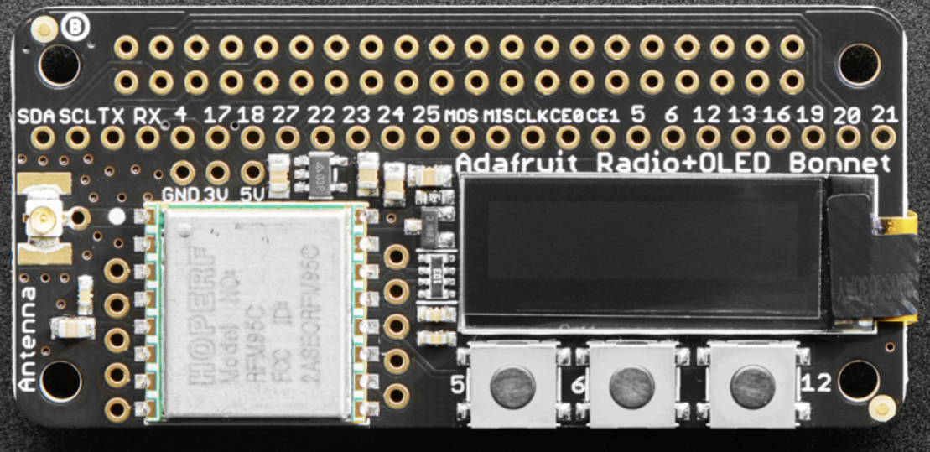
Fig. 3-11: Adafruit LoRa Radio Bonnet with OLED – RFM95W [29]
The bonnet is the subsystem’s link to the base station: it sends each reading, tagged with GPS coordinates and a timestamp, to the base station for logging and display on the heatmap.
3.3.5 Power
The power subsystem is responsible for delivering and regulating power to the rest of the subsystems. This subsystem must satisfy the requirements of delivering safe power to the other subsystems and storing/producing enough power to meet runtime requirements. Key design considerations include charge capacity of batteries, size of solar panels, and selection of voltage regulators, which are shown in table 3-10.

Table 3-10: Battery Options
Product | Battery Capacity (Ah) | Solar Panel (W) | Charge Controller | Output Regulation | Price ($)
Requirements | ≥ 20 | ≥ 50 | LiFePO4-compatible charge profile | 12.8–14.6 V main rail; regulated 5 V for logic | ≤ 200
12.8 V 20 Ah LiFePO4 [33] + 50 W panel [34] + 10 A MPPT controller [35] | 20 | 50 | MPPT, LiFePO4 profile | Buck converters (12 V to 5 V) | ≈ 165
12 V 12 Ah sealed lead-acid + 20 W panel + PWM controller | 12 | 20 | PWM, lead-acid profile only | Buck converters (12 V to 5 V) | ≈ 75
Power bank (USB-C PD) + 10 W panel, no dedicated regulator | 10 (5 V) | 10 | Built-in, not configurable | 5 V only; cannot supply the 12.8–14.6 V rail | ≈ 40

Based on the comparison in Table 3-10, the 12.8 V 20 Ah LiFePO4 battery paired with a 50 W solar panel and a 10 A MPPT charge controller was selected because it is the only option that meets every requirement, at approximately $165. Its 20 Ah capacity meets the minimum needed to power the rover through its required runtime, and the 12.8–14.6 V operating range of LiFePO4 matches the input voltage range of the flight controller directly. The MPPT controller uses a charge profile built for LiFePO4 chemistry and extracts more energy from the 50 W panel than a PWM controller would, which helps the system recharge in the limited sunlight available during field operation. Buck converters step the main rail down to a regulated 5 V for the logic-level subsystems, so each component receives safe power. The sealed lead-acid option is the cheapest battery-and-panel combination at approximately $75, but its 12 Ah capacity and 20 W panel fall short of the requirements. Its PWM controller supports only lead-acid charging, and lead-acid cells are heavier and degrade faster under deep discharge. The USB-C power bank with a 10 W panel is the lowest-cost option at approximately $40, but it can only supply 5 V and cannot deliver the 12.8–14.6 V rail the rover requires. Its built-in charging circuit also cannot be configured, and its 10 W panel could not replace the energy used during a typical run. The selected configuration stays within the $200 budget while leaving margin for wiring, fusing, and connectors. Figure 3-12 shows the selected battery.

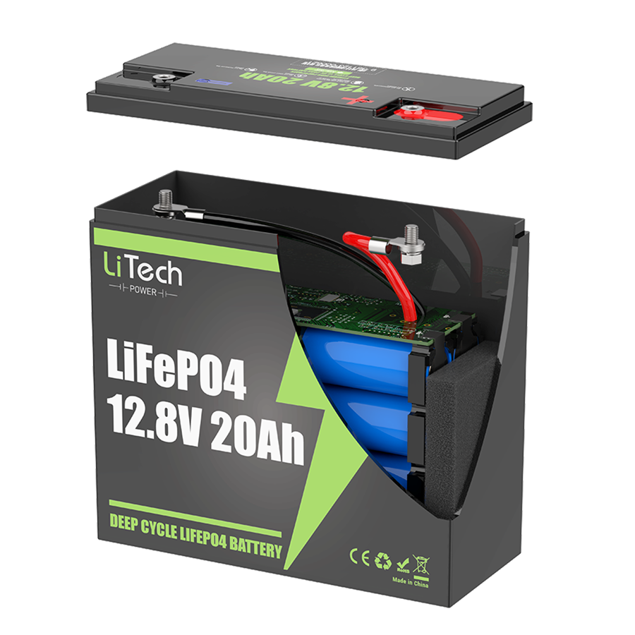
Fig. 3-12: 12.8 V 20 Ah LiFePO4 battery, [33]
Together, the LiFePO4 battery, 50 W solar panel, and MPPT charge controller form the power subsystem. They supply a stable 12.8–14.6 V main rail, with buck converters providing regulated 5 V for the logic-level components. This configuration meets the capacity, voltage, and budget requirements while leaving margin for field conditions. The next section describes how the rover’s remaining subsystems draw on this supply.
3.4 Level 2 Prototype Design
The completed Level 2 prototype of D.I.R.T.T. integrates all major electrical, mechanical, and software elements into a single rover. The battery sits low in the center of the plywood chassis to keep the center of gravity between the wheels, with the motor driver beside it on the motor branch. The linear actuator and soil probe are mounted vertically at the center of the chassis, between the wheels, so the reaction to the push is shared evenly by all four wheels. The mission computer, flight controller, and radio are grouped in a protected electronics bay, with the GPS and compass on a 15–20 cm mast away from motor currents, the LiDAR on top with a clear 360° view, and the LoRa antenna above the chassis. The solar panel is mounted above the top deck, clear of the actuator. In Design I, the team will build and test the Soil Sensing, Drivetrain, and Data Backup and Control subsystems, with an Arduino Uno generating the motor driver's RC signals in place of the flight controller. In Design II, the team will integrate the flight controller, GPS, and LiDAR for autonomous navigation, add solar charging, and complete full-system field tests.
3.4.1 Level 2 Diagram
Figure 3-13 shows the low-level prototype architecture. The 12.8 V LiFePO4 battery feeds a main fuse and switch, after which the system splits into two branches. The motor branch passes through the emergency stop to the Cytron MDDRC10 and the DRV8871. The electronics branch feeds the MicoAir743v2 flight controller directly through its 6–27 V input and the Pololu D36V28F5 regulator, which creates the 5 V rail for the Raspberry Pi 3 Model B and its sensors. The Raspberry Pi communicates with the flight controller over UART (GPIO 14/15) using MAVLink, with the LoRa Bonnet over SPI0 (CE1, reset on GPIO 25, interrupt on GPIO 22), with the INA219 current sensor and the Bonnet's OLED over I2C, and with the soil sensor over USB through the RS-485 adapter. It drives the DRV8871 with PWM on GPIO 18 and 13 and reads the probe-retracted switch (GPIO 17), the bump switches (GPIO 23 and 24), and the emergency-stop status (GPIO 27), and it drives the Buzzer on GPIO 16. The flight controller reads the GPS over UART, the compass over I2C, and the RPLIDAR C1 over UART, and sends two RC PWM signals to the motor driver for skid steering.
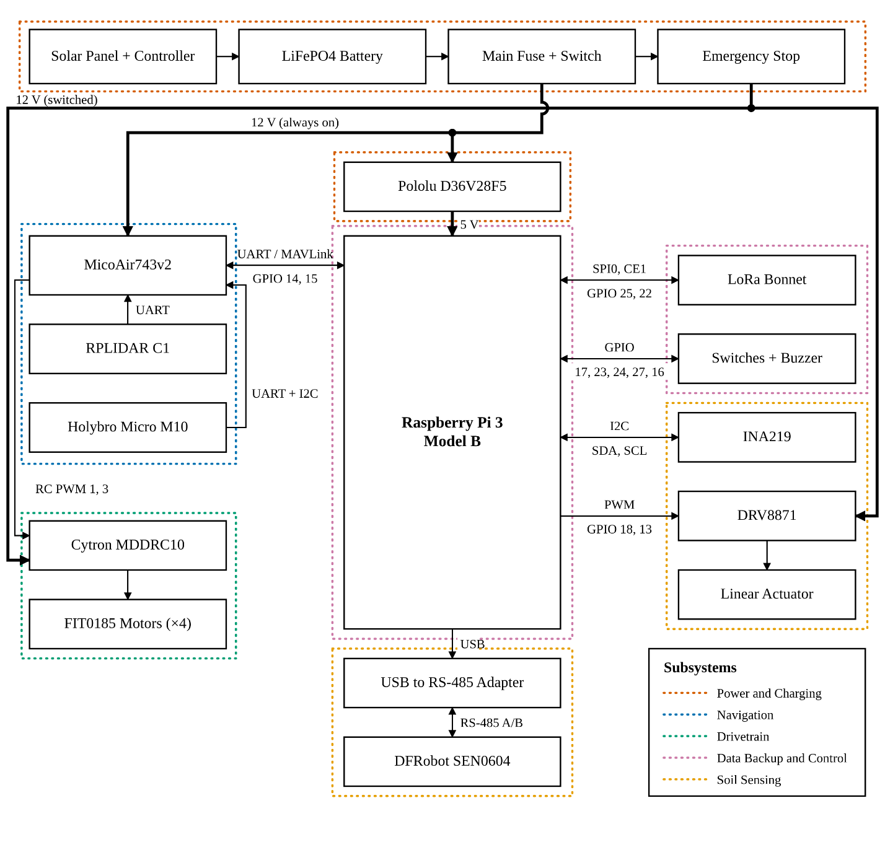
Fig. 3-13: D.I.R.T.T. Level 2 Prototype Diagram
This arrangement keeps the high-current motor wiring on its own fused, switchable branch, so the emergency stop removes all motion while the computers stay powered to log and report the stop. It also separates navigation from the mission software: if the Raspberry Pi fails, the flight controller's failsafe stops the rover. The Level 2 design also provides a clear path for subsystem testing, because each major function can be verified independently before full system integration.
Overall, the selected architecture provides a practical path toward an affordable autonomous soil-survey rover. It balances cost, safety, and expandability while remaining aligned with the requirements established in the design specification.
3.5 References
[1] “Raspberry Pi 3 Model B,” Raspberry Pi Ltd. https://www.raspberrypi.com/products/raspberry-pi-3-model-b/ (accessed Oct. 27, 2026).
[2] “Raspberry Pi Zero 2 W,” Raspberry Pi Ltd. https://www.raspberrypi.com/products/raspberry-pi-zero-2-w/ (accessed Oct. 27, 2026).
[3] “ESP32 Series Datasheet,” Espressif Systems. https://www.espressif.com/sites/default/files/documentation/esp32_datasheet_en.pdf (accessed Oct. 27, 2026).
[4] “Arduino UNO R3,” Arduino. https://store.arduino.cc/products/arduino-uno-rev3 (accessed Oct. 27, 2026).
[5] “MicoAir H743 V2 Flight Controller for ArduPilot & PX4,” RoboFusion. https://robofusion.net/products/micoair-h743-flight-controller (accessed Oct. 27, 2026).
[6] “MicoAir743v2,” ArduPilot Rover Documentation. https://ardupilot.org/rover/docs/common-MicoAir743v2.html (accessed Oct. 27, 2026).
[7] “Pixhawk 6C,” Holybro. https://holybro.com/products/pixhawk-6c (accessed Oct. 27, 2026).
[8] “Adafruit 9-DOF Orientation IMU Fusion Breakout – BNO085,” Adafruit Industries. https://www.adafruit.com/product/4754 (accessed Oct. 27, 2026).
[9] “Holybro M10 Micro GPS w/ IST8310 Compass,” RaceDayQuads. https://www.racedayquads.com/products/holybro-m10-micro-gps-w-ist8310-compass-10th-gen (accessed Oct. 27, 2026).
[10] u-blox AG, “MAX-M10S Data Sheet,” u-blox, Thalwil, Switzerland. [Add document number and URL.] (accessed Oct. 27, 2026)
[11] “Matek M10Q-5883 GNSS & Compass,” RaceDayQuads. https://www.racedayquads.com/products/matek-m10q-5883-gnss-compass (accessed Oct. 27, 2026).
[12] Beitian, “BN-880 GNSS Module Specification.” https://images-na.ssl-images-amazon.com/images/I/81xnOf7jqyL.pdf (accessed Oct. 27, 2026)
[13] Holybro, “H-RTK F9P.” https://xcopter.com/download/Holybro_H-RTK_F9P_GNSS_Spec.pdf (accessed Oct. 27, 2026)
[14] SLAMTEC, “RPLIDAR C1 Datasheet,” Shanghai Slamtec Co., Ltd. https://d229kd5ey79jzj.cloudfront.net/3157/SLAMTEC_rplidar_datasheet_C1_v1.0_en.pdf (accessed Oct. 27, 2026)
[15] SLAMTEC, “RPLIDAR A1 Datasheet,” Shanghai Slamtec Co., Ltd. https://cdn-shop.adafruit.com/product-files/4010/4010_datasheet.pdf (accessed Oct. 27, 2026)
[16] “DFRobot DTOF LD19 Laser Lidar Sensor Kit (12m),” RobotShop. https://www.robotshop.com/products/dfrobot-dtof-ld19-laser-lidar-sensor-kit-12m (accessed Oct. 27, 2026).
[17] “TEROS 12 Tech Specs,” METER Group. https://metergroup.com/products/teros-12/teros-12-tech-specs/ (accessed Nov. 3, 2026).
[18] DFRobot, “12V Metal DC Geared Motor with Encoder (131:1, 83RPM, 45Kg.cm), SKU: FIT0185.” DFRobot.com. Accessed: Nov. 3, 2026. [Online]. Available: https://www.dfrobot.com/product-633.html
[19] DFRobot, “Metal DC Geared Motor w/Encoder - 6V 300RPM 3.6Kg.cm, SKU: FIT0520.” DFRobot.com. Accessed: Nov. 3, 2026. [Online]. Available: https://www.dfrobot.com/product-1619.html
[20] DFRobot, “12V Metal DC Geared Motor with Encoder (90:1, 122RPM, 38Kg.cm), SKU: FIT0403.” DFRobot.com. Accessed: Nov. 3, 2026. [Online]. Available: https://www.dfrobot.com/product-1210.html
[21] RobotShop, “Cytron 10A 7V-30V Dual DC Motor Driver for R/C, SKU: RB-Cyt-288.” RobotShop.com. Accessed: Nov. 3, 2026. [Online]. Available: https://www.robotshop.com/products/cytron-10a-7v-30v-dual-dc-motor-driver-r-c
[22] SparkFun Electronics, “SparkFun Motor Driver - Dual TB6612FNG (with Headers), SKU: ROB-14450.” SparkFun.com. Accessed: Nov. 3, 2026. [Online]. Available: https://www.sparkfun.com/sparkfun-motor-driver-dual-tb6612fng-with-headers.html
[23] Adafruit Industries, “Adafruit DRV8871 DC Motor Driver Breakout Board - 3.6A Max, Product ID: 3190.” Adafruit.com. Accessed: Nov. 3, 2026. [Online]. Available: https://www.adafruit.com/product/3190
[24] “ECO-WORTHY Heavy Duty 330lbs Solar Tracker Linear Actuator Multi-function 12V,” Amazon.com. https://www.amazon.com/dp/B00NM8H5SC?th=1 (accessed Oct. 27, 2026).
[25] “Actuonix P16-P Linear Actuator w/ Feedback 150mm 256:1 12 Volts,” RobotShop. https://www.robotshop.com/products/actuonix-p16-p-linear-actuator-w-feedback-150mm-2561-12-volts (accessed Nov. 3, 2026).
[26] “RS485 4-in-1 Soil Moisture, Temperature, pH & EC Sensor (SEN0604),” DFRobot Wiki. https://wiki.dfrobot.com/SEN0604 (accessed Nov. 3, 2026).
[27] “DFRobot MODBUS-RTU RS485 4-in-1 Soil Moisture, Temperature, pH & EC Sensor (IP68, 5-30V),” RobotShop. https://www.robotshop.com/products/dfrobot-modbus-rtu-rs485-4-in-1-soil-moisture-temperature-ph-ec-sensor-ip68-5-30v (accessed Nov. 3, 2026).
[28] “Soil Moisture & Temperature & EC Sensor (S-Soil MTEC-02A),” Seeed Studio Wiki. https://wiki.seeedstudio.com/Sensor/SenseCAP/SenseCAP_Probe/Soil-Moisture-Temperature-EC-Sensor/ (accessed Nov. 3, 2026).
[29] Adafruit Industries, “Adafruit LoRa Radio Bonnet with OLED - RFM95W @ 915MHz - RadioFruit,” Adafruit Industries. https://www.adafruit.com/product/4074 (accessed Oct. 28, 2026).
[30] PiShop.us, “4G / 3G / 2G / GSM / GPRS / GNSS HAT for Raspberry Pi, LTE CAT4, the Global Version,” PiShop.us. https://www.pishop.us/product/4g-3g-2g-gsm-gprs-gnss-hat-for-raspberry-pi-lte-cat4-the-global-version/ (accessed Oct. 28, 2026).
[31] Electromaker, “Xbee-pro 900hp (s3b) 905/920mhz Rpsma,” Electromaker. https://www.electromaker.io/shop/product/xbee-pro-900hp-s3b-905920mhz-rpsma (accessed Oct. 28, 2026).
[32] Adafruit Industries, “Adafruit Bluefruit LE UART Friend - Bluetooth® Low Energy,” Adafruit Industries. https://www.adafruit.com/product/2479 (accessed Oct. 28, 2026).
[33] LiTech Power, “LiFePO4 12.8V 20Ah Battery Pack,” LiTech Power. [Online]. Available: https://litechpower.com/product/lifepo4-12-8v-20ah-battery-pack-lrl1220 (accessed Nov. 3, 2026).
[34] Lukvuzo, “50W 12V Solar Trickle Charger Maintainer, Waterproof,” Lukvuzo. [Online]. Available: https://www.lowes.com/pd/Lukvuzo-50W-12V-Solar-Trickle-Charger-Maintainer-Waterproof-Monocrystalline-Solar-Panel-with-Controller-for-Car-Boat-RV-Truck-Tractor/5023187326 (accessed Nov. 3, 2026).
[35] Bateria Power, “10A MPPT Solar Charge Controller,” Bateria Power. [Online]. Available: https://atwinengineering.com/product/10a-mppt-solar-charge-controller (accessed Nov. 3, 2026).

